Assessment of Flood Disaster Management and Public Policy in Wayanad Tourism
Abstract
The disaster struck the Indian coastal state of Kerala at an unprecedented scale in 2018. The worst flooding in living memory inundated large parts of the state, especially in Wayanad. Floods in Kerala are a wake-up call to examine the main reasons which are responsible for the 2018-2019 Kerala flood, in Wayanad. The tourism industry in Wayanad has been bourgeoning over the years and it is one of the highest contributors to the GDP of Wayanad. The 2018-2019 flood, among other reasons, crippled the tourism industry of Wayanad. The study centers around the tourism industry of Wayanad and the relationship between tourism and flooding in Wayanad. The study analyzes the various environmental, economic, and social reasons which are responsible for the cause of flood in Wayanad. A quantitative research method along with a comprehensive literature review was used for this research study. This chapter summarises, from a public policy perspective, the findings of the study and suggest suitable policy recommendations for disaster management.
Keywords: Disaster Management, Kerala Floods, Wayanad, Tourism Impact, Public Policy.
- Introduction
  - Tourism in India
India is geographically located in Southeast Asia, and is rich in culture and heritage. It is surrounded by the Himalayas, the Arabian Sea, the Bay of Bengal, and the Indian Ocean. India also has one of the Seven Wonders of the World, the Taj Mahal. India is one of the most popular tourist destinations due to its diverse culture, destinations, and so on.
The Travel and tourism industry in India has become one of the biggest service sectors in India. The aim is to develop tourism in India through different kinds of tourism like medical tourism and eco-tourism and to ensure economic growth as well as employment generation through the same. There are 29 states and 7 Union Territories in India, each state or Union territory comes with diverse geographical terrain and culture which makes it an attractive spot for tourists.
1.2 Tourism in Kerala
Kerala is located at the southern tip of India and has made it one of the top destinations in Asia for its well-established tourism. The state has been referred to as ‘God’s Own Country’. It has been deemed as one of the top 50 destinations of a lifetime and one of the thirteen paradises in the world (Editor’s Letter, 2009). Kerala is known for its hill stations, beaches, and backwaters and most of these places are a few hours away which makes it easier for tourists. There are many cultural aspects of the state to explore like its classical art form, colorful festivals, and the local Kerala-style cuisine. Ayurvedic treatments have also helped Kerala gain popularity in the tourism field (Saranya & Mariswamy, 2016)
Tourism in Wayanad
Wayanad is a district in Kerala that is known for its high rainfall, hilly terrain, plantations, and picturesque beauty making it one of the top destinations for tourism. The district is situated on the Western Ghats and is one of the Ecologically Sensitive Zones. The Wayanad Tourism Organization has taken the lead role in encouraging responsible and sustainable tourism in Wayanad. Wayanad has a rich history that dates back to the Neolithic age. It is famous for Edakkal caves which had human settlements. Wayanad is also known for its oldest temples. The district is also famous for its tribal population which adds to the specialty of this place and makes it a destination worth visiting. Wayanad is shown with its boundaries on a map.
District Tourism Promotion Council (DTPC) is an organization of Wayanad that works under the Department of Tourism, Government of Kerala and is responsible for tourism and related activities in Wayanad. Agriculture and tourism play an important role in contributing to the GDP of Wayanad. The tourism industry has experienced a boom in Wayanad, especially in Kalpetta with the increase in the number of hotels, resorts, and homestays (Experience Kerala, n.d.).
1.4. Hospitality Industry in Wayanad
The Hospitality industry in Wayanad is booming due to the increase in tourist-related activities in the district. Hotels, homestays, and resorts have become a top priority to invest in this region due to the rise in tourism as an industry. Wayanad did not have any 5-star hotels coming up until recently. In 2018, a new venture was set to come into place by the Kerala Land Reform and Development Co-operative Society (LADDER). The project is said to be a revolution since it’s the first to come. Their primary focus is on people who travel between Wayanad, Mysore, and Bengaluru. The hotel is expected to start in January 2020 (First Coop Sector Five-Star Hotel to Come up in Kerala’s Wayanad, n.d.). Homestays in Wayanad is known for the ‘home away from home’ experience that it offers to tourists. Wayanad has one of the best resorts that are tranquil and close to nature which gives the ultimate experience tourists are looking for. One of the most popular resorts in Wayanad is Vythiri Village Resort.
- Literature Review
The Tourism and hospitality sector is a rapidly growing service sector in the country. The rising demand has resulted in the establishment of tourism as an industry itself in India. It also contributes to the GDP of the country. According to a study done by the World Travel and Tourism Council (WTTC), tourism contributed 9.2 percent to India’s GDP in 2018 (Kumar et al., 2021). Studies say that tourism is going to contribute a lot more to the country’s GDP in the years to come as it has been growing rapidly. India has become one of the most desirable tourist destinations in the world.
2.1 Tourism Sector in Kerala
Tourism as a sector has been seeing major growth in Kerala in the recent few years. The tagline ‘God’s own Country’ has been gaining much popularity around the world. The lush green, picturesque and scenic beauty that the state offers is one of the few reasons tourists are rushing into Kerala. The hill stations, backwaters, and beaches are all only a few hours away from each other which makes it easier for tourists to cover these places with ease. The tourism sector in Kerala has been one of the top contributors to the state’s economy in recent years.
Wayanad falls in the Western Ghats region in Kerala, which is known for its highest rainfall in the state. Wayanad is known as one of the top destinations to visit for both domestic as well as foreign tourists. The place is known for its greenery, picturesque beauty, and paddy fields and it’s the right spot for tourists who love to trek and would like to experience nature’s shower at the Meenmutty falls in the district. Agriculture and Tourism are the major contributors to Wayanad’s economy. The tourist sector in Wayanad is booming with multiple hotels, resorts, and homestays coming into play.
2.2 Kerala Flood
In 2018, Kerala experienced one of its worst floods since the 1924 flood also known as the flood of 99. Kerala receives rainfall in its six months of monsoon, during which it receives an annual precipitation of 3000 mm. In 2018, the state experienced continuous rainfall from June 1 to August 19 which resulted in a flood. Alappuzha, Ernakulam, Idukki, Kottayam, Pathanamthitta, Thrissur and Wayanad are the districts which were worst hit by the flood as well as landslides which caused destruction and loss of lives. Studies conducted by the United Nations Development Programme (UNDP) tied up with the Government of Kerala stated that the total damage caused due to the 2018 flood is INR 10,557 crore.
In 2019, Kerala faced another flood which was as severe as the one in 2018. The worst hit districts were Wayanad, Kozhikode, Idukki and Malappuram (Rai, 2018).
Severe floods that occurred in the state, two years in a row were a major concern to experts. (Shaji, 2019) points out the reasons behind such a disaster. According to this study, the floods which occurred in Kerala were man-made and experts claim that climate change is one of the reasons that the state received such heavy rainfall which caused floods. They have also quoted the Gadgil report which was prepared under the guidance of Madhav Gadgil which mentions about the Western Ghats being ecologically Sensitive Zones (Thakur, 2021). The article also emphasizes on how the climate change has affected Wayanad, Nilambur and Idukki as a result of human activities in the Western Ghats and were worst affected due to the flood. Policy-related changes are suggested by experts as it’s the only solution to the issue which is currently being faced. Government should stop giving permission to human activities which would cause disequilibrium in environmentally sensitive zones (Jisha, 2014).
The Tourism industry in Kerala has been growing at a fast pace and the flood had a huge impact on the state’s economy. Due to the 2018 flood, the state incurred a loss of INR 2100 crore. The state government also incurred a loss of INR 80100 crore due to the flood. Tourist spots like the backwaters, Kumarokom, Munnar were some of the worst hit places. The tourism sector contributes about 10 percent to the GDP of the state. There has been a huge decrease in footfalls in the state due to the flood (Sethunath, 2018). Though the state’s tourism sector was doing well in 2017 with a growth of about 10.94 percent. In Kerala, the tourism sector generates about 25 percent of employment in the state. According to the Ministry of Tourism, there are about 418 hotels in Kerala, 12672 rooms, and out of these 46 percent are 4 star and above. An analysis by ICRA states that in august 2018 the occupancy was just 10 percent while it was about 60 percent the previous year.
One of the most visited tourist sites, Wayanad situated in the Western Ghats, has also been facing sluggishness in the tourism sector growth as an aftermath of the floods which occurred two years in a row during the monsoon season. There were plenty of cancellations and there was also a decrease in a footfall by 20 percent to 25 percent. The downfall in Wayanad tourism is being experienced also due to various other reasons like a ban on night traffic at the Bandipur region on the Kozhikore-Kollegal National highway. According to the Wayanad Tourism Organization (WTO), the natural calamities created huge losses to the Tourism Industry and it will take time to recover from it (Manoj, 2019).
Wayanad is a hill station in Kerala and is facing drastic climate change. Tourism and development in this mountain range have been one of the reasons. Unsustainable practices like mining, agriculture of crops that are unsuitable for the land type, and deforestation in order to expand tourism are adding to the issues.
Tourism is a major reason why there had been a rise in hotels and resorts in Wayanad. Laws ban three-storied buildings from being constructed in this region but there has been illegal construction of many such buildings. According to the Madhav Gadgil report the mountain pass comes under Zone-1 of the ecologically sensitive zone which does not permit the construction of dams and other activities to take place (Jisha, 2014)
2.6 Disaster Management during Flood
It is crucial to take necessary measures to prevent natural calamities like floods in flood-prone regions. In ancient times, flood control was done in different ways by planting vegetation so that they could retain water, terracing hills so that the flow of water is slowed down and also channels could be made to divert water. These are various natural methods used to control flooding (Flood Control and Disaster Management | IWA Publishing, n.d.).
When prevention does not work, the next step is disaster management which can be done during the flood and after the flood. The first step is Evacuation, which could be done before the flood gets worse, helping people to move to safer places during a flood and also rescuing them. To keep Emergency food supplies and other necessary items. To have an efficient emergency system to help people in time. Camps should be set up so that people can find shelter.
(Tingsanchali, 2012)study on urban floods speaks about how rapid urbanization and an increase in population have led to the frequent occurrence of floods in most places in Asia. Floods could also be caused due to other reasons like climate change, socio-economic reasons, and deforestation. Floods could be tackled using two different methods namely structural methods like the construction of dams to control it and non-structured methods like flood hazard, warnings, public participation and so on. The current method of disaster management in developing countries is response during emergencies and recovery from the flood but instead, there should be a proactive response to natural calamities to reduce the destruction caused and loss of life during the flood and in order to have a quicker response during a flood, the government, non-governmental organizations, and the public should make more efforts and increase the budget for disaster management during floods. In the study, they have taken examples of Thailand to study urban floods. India is a developing country and it is prone to many natural calamities which often leave the economy crippled the most frequent natural calamity the country faces are floods. India’s Geographical area is about 329mha out of which 40mha is prone to flooding. It takes plenty of time to recover from such natural calamities. In the last decade, the average amount spent on floods amounts to INR 5000 crore. The main reason why the country is prone to flooding is due to the growing population, and urbanization.
India has taken various steps to tackle floods since 1954. Starting from the policy statement in 1954, a high-level committee on flood 1957, the Ministerial committee on Flood control, 1964, National Disaster Management Authority, 2005 and National Disaster Management Guidelines 2008 among many others. Similar to the National Disaster Management Committee, more such committees should be formed to be better prepared for floods. There must be a more efficient and proactive mechanism in India to tackle such natural calamities (Alam & Muzzammil, 2011).
2.6.1 District Disaster Management Plan Wayanad– 2019
The Disaster Management plan for Wayanad was prepared under the Disaster Management Act of 2005. The disaster management plan has carefully laid down all the details of the previous natural calamities which took place in Wayanad. It has focused on the latest 2018 floods, the damages caused by them, and the measures which were taken during the flood like the relief camps which were set up at various places. The plan states the disaster risk reduction which is to be taken up in order to reduce damages in the future. The plan has also explored anticipated needs which are to be done before and after a flood or a landslide. Preventive measures like the prohibition of mining in case of a flood or a landslide, providing rescue operations, and other things required for relief measures. Mitigation measures like reconstruction, rehabilitation, and other mitigation measures are also mentioned as a part of the State Disaster Management Plan of Kerala (Kerala State Disaster Management Authority, n.d.).
2.7 Public Policy Perspective
The Rajiv Gandhi Institute of Development Studies (RGIDS) formed a committee to conduct a study on the Kerala Flood, 2018, the paper stated that the Kerala flood, 2018 was one of the biggest disasters of the century, the precautionary measures were not adequate, and the administrative machinery failed to manage the disaster in an effective manner, they were unable to identify safe places creating confusion in the communities. A committee was formed by RGIDS to conduct research regarding the 2018 floods at Wayanad. They suggested that high-rise buildings should not be permitted at steep slopes in the Western Ghats, the area being landslide-prone. The committee also suggested formulating new construction policies at flood-hit mountainous areas. The study goes on to say that out of the 247 landslides in Wayanad was mainly due to a lack of scientific designs in the construction of roads. It was pointed out that the drastic change in the land use pattern in Wayanad was one of the major reasons for the occurrence of landslides, Paddy cultivation had almost been wiped out from Wayanad district. The committee suggested that the government implement a new construction policy against building homestays and resorts in affected areas in Wayanad (Rajiv-Gandhi-Centre-Kerala-Flood-2018-The-Disaster-of-the-Century.Pdf, n.d.).
2.8 Research Gap
The flood in Kerala caused destruction to livelihood, businesses, and infrastructure and not to mention, the tourism sector. Tourism was affected during this time as it was impossible for tourists, both domestic as well as foreign tourists to visit the places. The area of study here is Wayanad, which comprises mountain ranges, a part of the Western Ghats. The Western Ghats have always been debated about since they are ecologically sensitive zones, and excessive human activities can trigger environmental issues in this region, as mentioned in the Gadgil Report. Wayanad Tourism has been growing over the years, in fact, agriculture and tourism are the two sectors contributing the most to its GDP. Although there is plenty of literature available in the form of government reports and articles regarding the immediate effect of floods on the Tourism sector. There is a dearth of literature on the long-term impact of the flood on Tourism. If Wayanad managed to bring back the tourists even after heavy floods and landslides is a question that is yet to be answered. If the district did manage to retrieve its tourism back, how long did it take for its revival? This case study focuses on data from government websites regarding tourist footfall to study the impact of floods on the tourism sector.
3. Objectives of the study
The main focus of the study was to analyze the causes of the 2018-19 flood in Wayanad and its relationship the disaster management strategies. An attempt has been made to suggest policy implications for Wayanad Tourism. The study is qualitative and quantitative which means that a triangulation method is used. The research design is descriptive, experimental, and diagnostic in nature. The study is conducted using secondary data sources from journal articles, government reports, newspaper articles, and Research papers. An extensive literature review is done for the study of the objectives.
On the basis of various factors which are responsible for the occurrence of floods in Wayanad. Since the objective seeks to analyze the causes, the immediate factors and long-term factors are examined using secondary data from government reports. The secondary data is analyzed to form a conclusion. The various causes are stated using secondary data. The immediate causes are examined on the basis of statistics from secondary sources and the long-term causes.
Tourist footfall and the Wayanad floods has been analysed. In order to study the relationship between the variables a null Hypothesis and an alternate hypothesis were formed. Based on the tourist arrival data and the precipitation level which measures the flood, a regression analysis is done in order to establish a relationship between the tourist arrival which represents the performance of the tourism industry, and the level of precipitation, which represents flood.
The tourist footfall is taken as the y variable and the precipitation level is the x variable. Through the regression analysis, the decision was made whether to reject or accept the alternate hypothesis.
5. Analysis of the study
5.1 Immediate Factors
There are many immediate reasons that caused the flood in Wayanad. They are the precipitation level/rainfall, overflow of dams, storms, and so on. Some of the reasons mentioned are attempted to prove through this objective.
Precipitation level/Rainfall
Rainfall in Wayanad from 1 June 2018 to 22 August 2018, Table 5.1
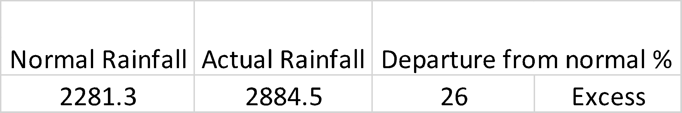
Source: IMD
The rainfall statistics shown in Table 5.1, shows an increase of 26 percent rainfall to the normal rainfall received in Wayanad. Therefore, there was an excess rainfall of 288.5 mm. During this time there were severe storms in Wayanad which caused landslides. Increased rainfall than the normal amount is one of the reasons for causing floods.
Warning system, Table 5.2
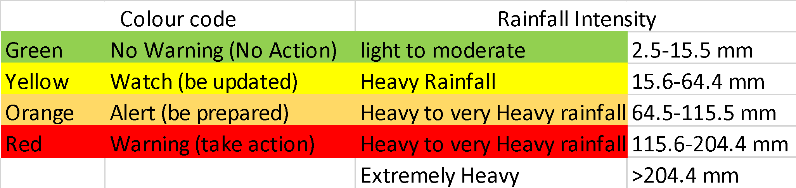
Source: sdma.kerala.gov.in
Rainfall and Runoff
The Banasura Sagar Dam is situated in Kalpetta, Wayanad. It is the largest earthen dam in India. The dam is across the tributary Karamanathodu River of River Kabini. On 9 August, the shutters of the dam had to be opened which led to the flooding of the nearby areas in Wayanad. The Kerala State Electricity Board (KSEB) manages the dam. Surface runoff can be defined as the overland flow of water that is, excess water flow over a surface.
Rainfall and runoff in Kabini sub-basin, Table 5.3
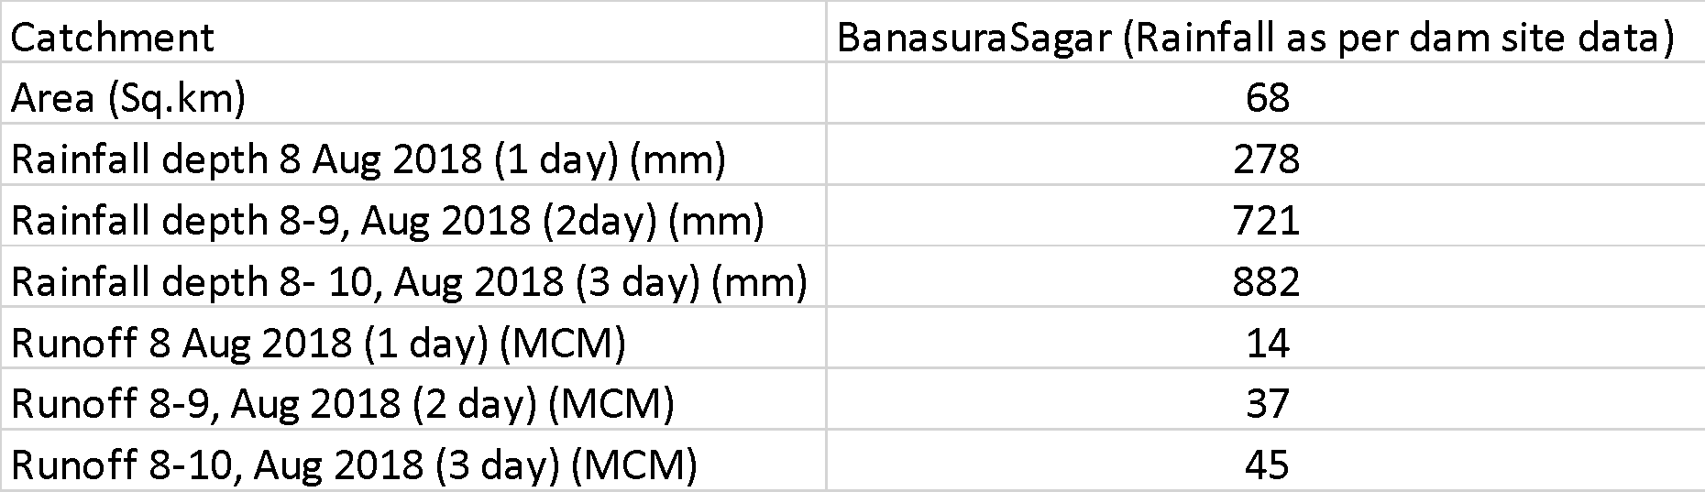
Source: CWC
Table 5.3 depicts the increase in rainfall from 8 August 2018 to 10 August 2018. The rainfall increased from 278 mm on 8 August to 882 mm in three days. There was an increase in surface runoff from 14 MCM (million cubic meters) to 45 MCM from 8 August to 10 August.
From the analysis done with the rainfall data from IMD and CWC, it was found that since the Western Ghats have steep slopes, the time required for the water from the reservoir to flow toward the main areas is only 2 to 3 hours.
5.2 Long-term Factors
There are several long-term factors responsible for causing the flood. Wayanad is known for its fragile ecology and it is also one of the ‘Ecologically Sensitive Zones’. Tampering with such a region poses a threat to the region. Deforestation, tourism, mining and population are some of the reasons why the area could be under a threat in the long run.
Forest land
As per the 2017-18 statistics by the forest department, the total forest area in Kerala under the administrative charge of the forest department is 11521.813-kilometre square. About 29.65 percent of Kerala’s land area comprises forest land.
Ecologically Fragile Land
‘Ecologically Fragile Land’ is defined as a part of the land which is encircled by forest land and is held by any person, which is owned by the Government and encourages natural vegetation in the land and also any land which is notified by the Government in the official Gazette, under section 4 of the Kerala Forest Act.
Ecologically Fragile land in Wayanad, Figure 5.2.1

Source: EFL wing
In Figure 5.2.1, the ecologically fragile land has been reducing from 2015 to 2018. This means that this land could be used for another purpose. Ecologically fragile regions according to experts should be left without any alterations because the natural vegetation in such areas is necessary.
Forest cover – Wayanad
Forest cover can be defined as the Kilometer square that is covered by forest land or the forest canopy. The Forest Survey of India (FSI) does a survey every two years to find out the forest cover of the state. Figure 5.2.2 contains the forest cover statistics from 2013 to 2017.
Forest cover in Wayanad, Figure 5.2.2

Source: FSI
Figure 5.2.2 states the Forest cover in Wayanad from 2013 to 2017 based on the FSI survey. Every two years, the forest cover has been dropping. The forest cover in Wayanad has been shrinking due to many reasons, some of which could be a spurt in population, clearing of forestlands for pasture land, overgrazing, increasing need for timber, industrialization, deforestation, rising infrastructure like tourist accommodation, businesses, etc.
Tourist Accommodation in Wayanad
Tourist accommodation comprises hotels, resorts, homestays, houseboats, and various other places of stay for tourists in an area. The rising number of tourist accommodations in Wayanad is resulting from rising tourist activities in the district.

Tourist accommodation in Wayanad, Figure 5.2.3

Source: keralatourism.org
In Figure 5.2.3 shows the rise in the number of tourist accommodations, from the year 2017 to 2018 there has been an increase of 118 tourist accommodations. This is one of the reasons why the forest cover has been decreasing in Wayanad, due to the greater number of hotels, resorts, and homestays have been increasing.

Hypothesis
Null Hypothesis Ho: The flood has not affected the tourist footfall in Wayanad.
Alternate Hypothesis H1: The flood affected the tourist footfall in Wayanad.
The number of tourists going into a place is directly proportional to the GDP contribution from the tourism sector. Although there are plenty of other factors which determine the tourist footfall in an area, the primary objective is to find out the impact of the flood which occurred in Kerala, on tourist footfall.
In this study, the Dependent variable is tourist footfall, which is influenced by the independent variable and is considered to be the flood which is an Environmental factor. There could be other factors affecting the dependent variable like economic and social factors.
The Tourism sector in Kerala was built over the last four decades. It has become a crucial part of the service sector of the state. There are two segments to the sector, one is the contribution from the domestic tourist arrival and the other is the foreign tourist arrival.
As mentioned earlier, the Tourism sector contributes a huge share of the state’s GDP. The tourist arrival in Kerala from the year 2007 to 2018 is stated in Table 4.4 below as per the data from the Kerala Tourism statistics 2018.
Tourist Arrival in Kerala for the last 12 years, Table 5.4
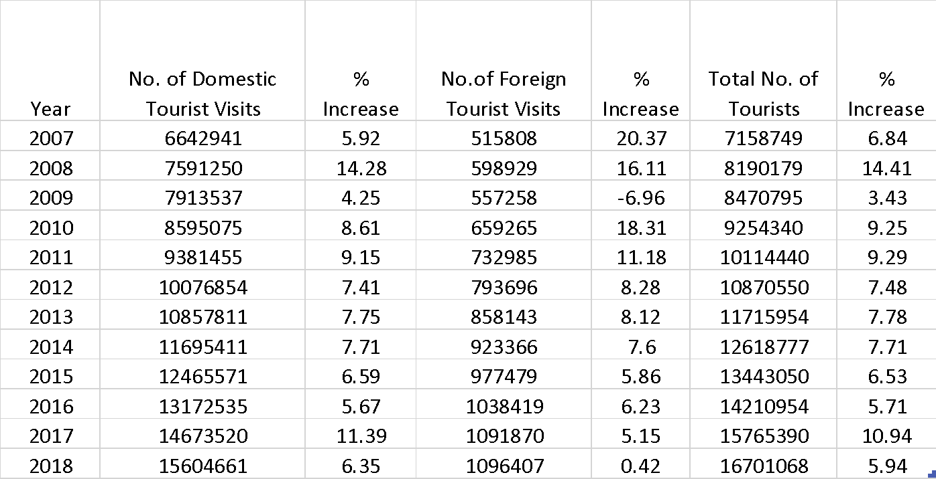
Source: keralatourism.org
The Table has shown the number of domestic Tourists who visited Kerala, the number of foreign Tourists who visited Kerala, and the total number of tourists in each year from 2007 to 2018 along with the percentage increase. Data suggests that in 2009 there was a decrease in foreign tourist arrival by 6.96 percent which is the only year that has shown a negative trend in the arrival of tourists. Considering that 2008 experienced an economic slowdown can be one of the reasons for the negative trend. In 2017, there was an 11.39 percent increase in domestic tourist arrival. Although, in 2018 there has only been an increase of 6.35 percent. The percentage increase of foreign tourists in 2018 is 0.42 percent which is quite insignificant.
Financial year-wise Tourist arrivals
The Financial year-wise data gives a better understanding of the number of tourists flowing in, over a period of 12 months.

Financial Year-wise Tourist arrivals to Kerala, Table 5.5
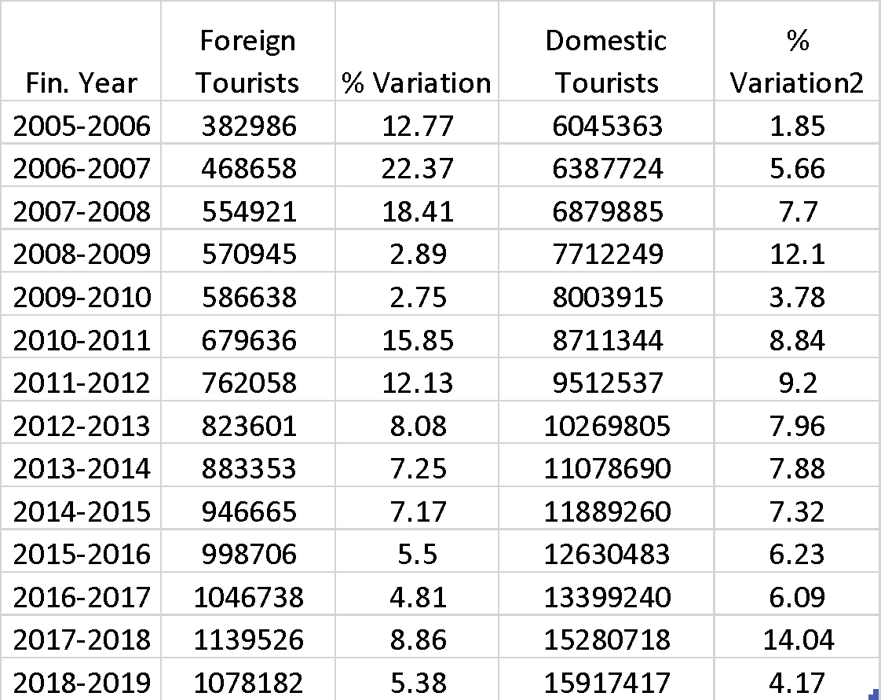

Source: keralatourism.org
Table 5.5 shows the financial year wise statistics of tourist arrival in Kerala. The data suggests that the number of foreign tourist arrival decreased in the year 2018-2019, though it has been increasing since 2005-2006 to 2017-2018. The domestic tourist arrival still increased in 2018-19 but comparatively has not increased much. Compared to a percentage variation on 14.04 percent in 2017-2018, it has only risen by 4.17 percent in the financial year 2018-2019.
District-wise Tourist arrival
Table 5.6 shows a rise in the number of domestic tourists in all districts except Thrissur in 2018 compared to 2017.
District-wise Foreign Tourist arrival, Table 5.6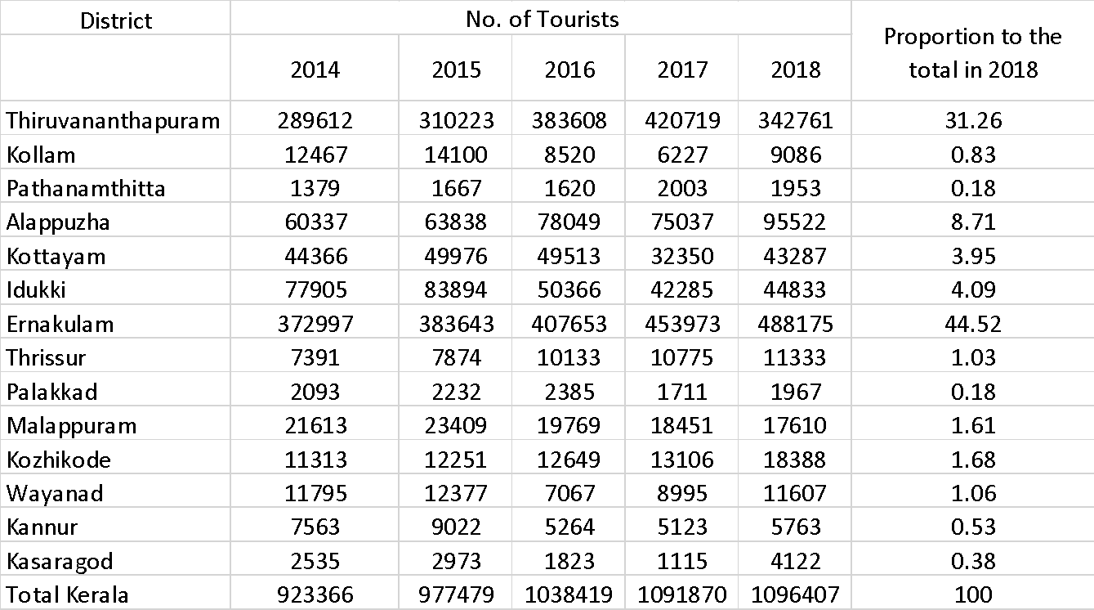
Source: keralatourism.org
Table 5.6 shows the number of foreign tourists who visited each district from 2014 to 2018. The highest number of tourist arrival is seen in Thiruvananthapuram and Ernakulam. In Ernakulam, there has been a steady increase. Except for the district, Pathanamthitta, tourist footfall has increased in 2018 in all the other districts. In Wayanad, tourist arrival has comparatively increased in 2018.
District-wise Domestic Tourist arrival, Table 5.7
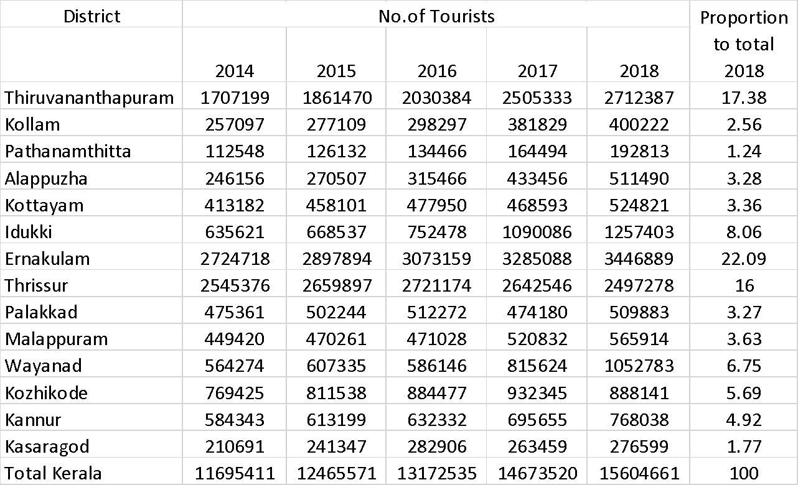
Source: keralatourism.org
Table 5.7 shows the district-wise domestic tourist arrival in the last five years. In all the districts except Thrissur and Kozhikode tourist arrival has increased. In Wayanad, domestic tourist arrival has comparatively increased in 2018.
District-wise Foreign Exchange Earnings
Figure 5.8 shows the district-wise foreign exchange earnings in 2017 and 2018. There is a notable difference in the Thiruvananthapuram district in 2018 as there is a significant decrease. On the other hand, in Ernakulam district, the earnings have increased. The area of study Wayanad shows a rise in Forex earnings as well.
District wise Foreign Exchange earnings from Tourism, Figure 5.8
Source: keralatourism.org

Month wise statistics of foreign tourist arrival – 2018, Table 5.9
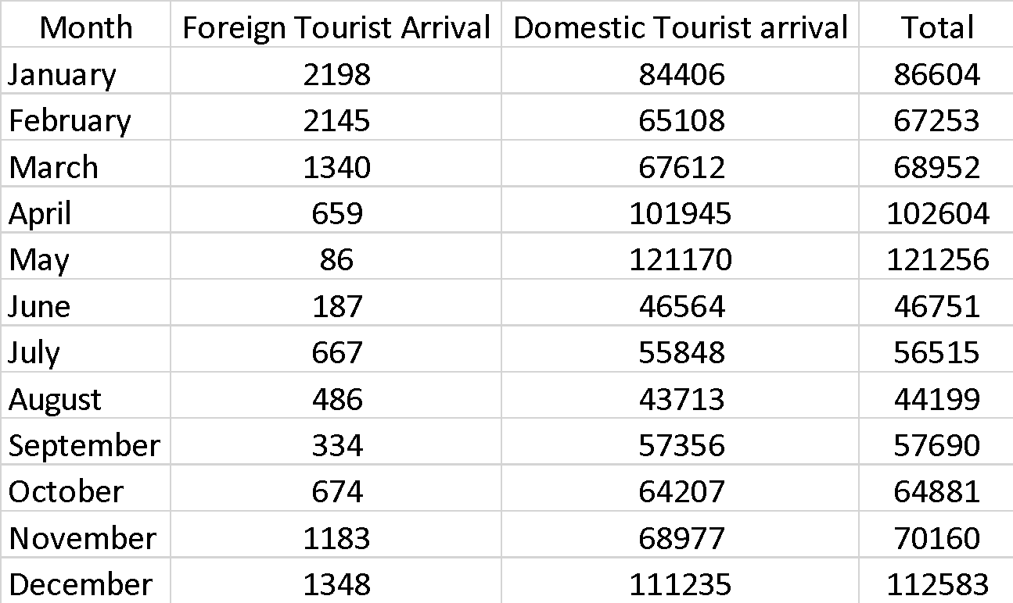
Source: keralatourism.org
Table 5.9, has statistics of month-wise foreign tourist arrival in Wayanad in 2018. There was a drop in tourist arrival from March and in May it shows the lowest number of tourist arrival that is, 86. It started picking up from there, in June. In August, it dropped again, but from October the tourist arrival rose.
The domestic tourist arrival in Table 5.9, was the maximum in the month of May, later it declined and was the least in the month of August, and started increasing again from September.
Factors influencing the tourism sector
There are different factors that influence tourist arrivals as well as the Investments made in the tourism sector. These factors could be environmental factors like natural calamities, Economic factors like a cash crunch in the economy, and social factors like crowd behaviour, crime-related activities, and so on.
Kerala Flood 2018
The devastating flood which occurred in Kerala, in August 2018, resulted in the loss of livelihood and life to many. It affected many as they lost their homes, businesses and so on, and it also made a huge impact on the state’s economy. According to the Kerala state disaster management report, around 339 lost their lives in the 2018 floods, in the state due to floods and landslides.
Monuments and cultural heritage sites are crucial for the tourism sector. The floods caused damage to many such heritage sites. In Wayanad, for instance, the Edakkal caves one of the heritage sites in the district was partially damaged and there was a loss of 7000 visitors per week. In Ernakulam, the Ramamangalam Temple was partially damaged with a loss of visitors 140 per week. The Chinese fishing nets in Thrissur were damaged, 9 were fully damaged, 11, were partially damaged, and about 80 employees and 500 workers were affected.
Flood-affected Tourism
Kerala Tourism has been a great contributor to the GDP of the state. Statistics prove that in the financial year 2016-2017, 10.38 lakh foreign tourists and 13.17 lakh domestic tourists visited Kerala with earnings of INR 7749.51 crore and INR 15348.64 crore respectively. Indirect income from tourism is INR 6560.41 crore. A total of 4.8 percent of Kerala’s GSDP is from the tourism sector. The flood in Kerala disrupted the tourism activities in the state in August and the repercussions were faced even after the flood for a few months. It was assumed that there had been a decrease in tourist arrival by 20-25 percent as per the UNDP report. This affected not only the sector, the employees at hotels, transportation, and restaurants as well. Tourism has been providing employment to many, but due to a drop in tourist arrivals in the period, many businesses were affected.
As per reports by UNDP the tourism sector did suffer a loss due to the flood. Though tourist footfall showed an increase even after the flood in 2018. The economic cost incurred by the tourism sector is shown in table 4.11.
Economic cost incurred from Tourism on Flood, Table 5.10
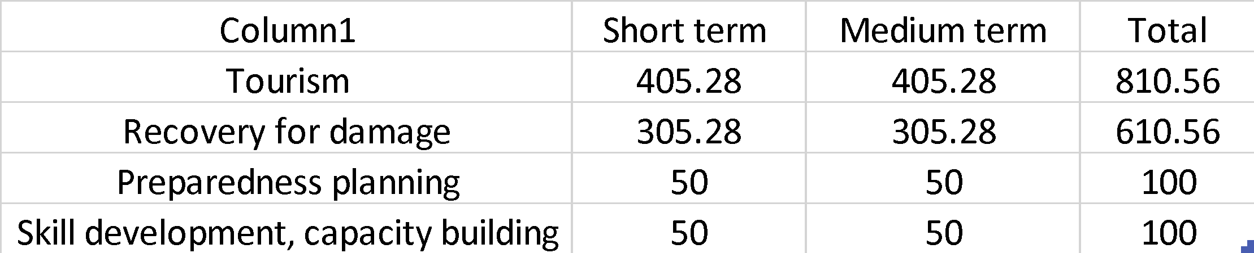
Source: undp.org
In Table 5.10, the recovery of damages includes reconstruction with green infrastructure such as solar panels, water, and waste management which is a total of 610.56 crores.
The preparedness planning and resilience also include insurance which lies at 100 crores. Skill development to promote environmentally friendly tourism in the state and capacity building for disaster management which is also 100 crores. The total cost incurred is 810.56 crore for tourism in Kerala after the flood (Kerala Post Disaster Needs Assessment Floods and Landslides-August 2018 European Union Civil Protection and Humanitarian Aid, 2018).
Precipitation level/Rainfall
The level of precipitation or rainfall can be taken as a measure to detect floods. The state disaster management authority has developed a warning system according to the level of precipitation.
Warning system by sdma, 2018, Table 5.11
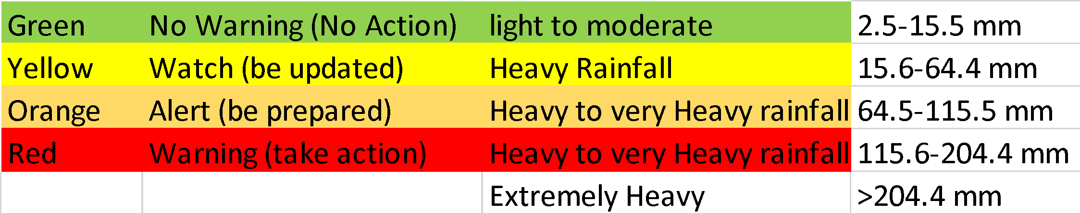
Source: sdma
Month wise precipitation level in Wayanad, 2018 Table 5.12
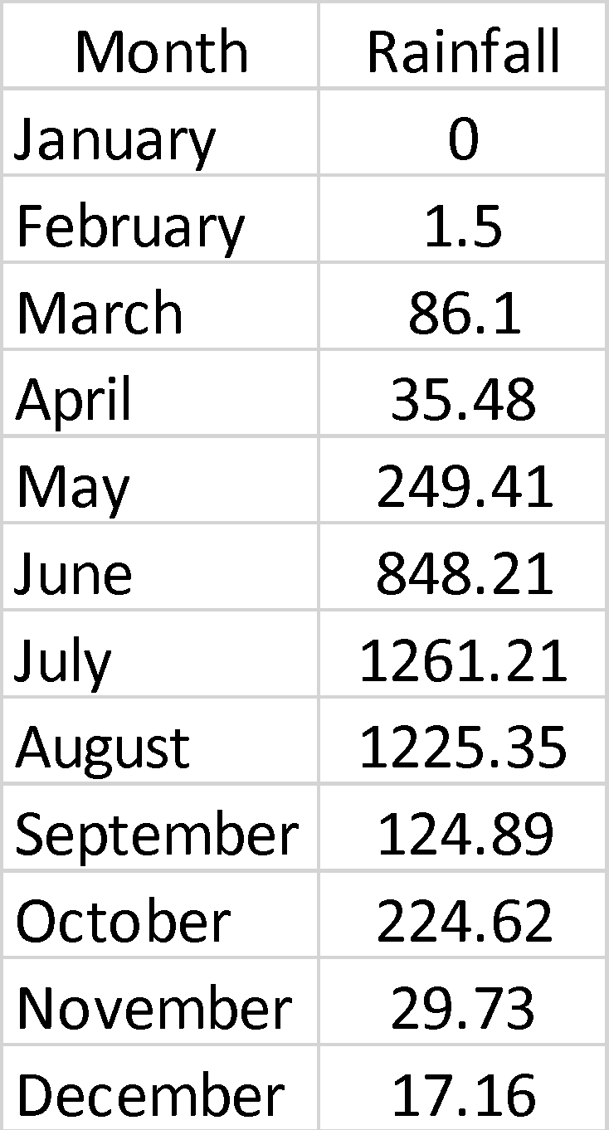
Source: ddma Wayanad
In the month of July and August the rainfall was 1261 mm and 1225 mm respectively. According to the warning system, if the precipitation level is more than 204.4 mm, it is detected to be extremely heavy rainfall which is the highest bar. According to the district disaster management plan, severe floods and landslides occurred in Wayanad from 8 August as a result of heavy rainfall which started in June.
Regression analysis was done on these two data and arrived at the following findings:-
- The coefficient in the Regression analysis is -30.151.
- For one mm increase in rainfall, the decrease in tourist footfall is by 30.151.
- The level of significance is 0.05 which means that it is not significant i.e. the probability of rejecting a true null hypothesis is low.
- The value of R square is 0.32 i.e. 32 percent of the tourist footfall is dependent on the level of precipitation. Hence 79 percent of the tourist footfall is dependent on other factors as well.
Here, the regression analysis helped to establish a relation between the tourist footfall in Wayanad and the level of precipitation. The result states that as the rainfall increases the tourist arrival in Wayanad decreases. Since here the flood is measured through the amount of rainfall, it can be concluded that the flood in Wayanad, affected tourism to a great extent. Therefore, the null hypothesis, the flood has no effect on the tourist footfall in Wayanad is proven wrong through the analysis, hence the null hypothesis is rejected and the alternate hypothesis, the flood has an effect on the tourist footfall is accepted.
6. Findings of the Study
- Flood can be assessed based on the precipitation level or rainfall. The increase in rainfall is one of the reasons for the occurrence of floods.
- Due to increased rainfall n Wayanad, the shutters of the Banasura Sagar Dam had to be opened, which led to surface runoff, and most areas were flooded in no time.
- There has been a huge decrease in the ecologically fragile land from 2015 to 2018. In Wayanad.
- There has also been a decrease in the Forest cover from 2013 to 2017 which suggests that a considerable number of trees are being cleared for different purposes in Wayanad.
- There has been a huge rise in tourist accommodation in Wayanad from 2017 to 2018 which is within a year.
- These long-term and short-term causes have led to the occurrence of a devastating flood in Wayanad.
- From the regression analysis, it can be concluded that the tourist footfall is dependent on the flood that occurred in Wayanad in 2018. During the month of June to August, there was heavy rainfall in Wayanad, which led to a decrease in the number of tourists in the district.
- Through the analysis, it was found out that 31 percent of the tourist arrival was dependent on the floods but the remaining 79 percent is due to other reasons. As discussed earlier, the Nipah virus outbreak and the road blockage of the Bandipur and Wayanad national park at night are factors that reduce tourist footfall.
- In the month of August, the tourist arrival dropped due to floods but Wayanad managed to bring the tourists back to the district by the end of the year. The marketing strategies adopted by the state as well as special tourism advertisement videos released by the Government of Kerala, coupled with private players, active management of tourism-related websites, and social media pages are reasons why Wayanad could restore its tourism sector without much delay.
- Even though the floods crippled the tourism industry of Kerala, it was restored fast enough in a few months due to the state’s marketing strategies.
- The foreign exchange earnings received from Kerala tourism rose over the years and the only year it faced a negative trend is during the year of the economic slowdown which was faced globally in 2009.
7. Conclusion
The tourism sector of Kerala contributes a fair amount to the GDP of the state and it has been growing rapidly over the past few decades. Though the flood affected the tourism sector to a great extent, Kerala was able to restore its tourism sector through the various marketing strategies used by them. Wayanad is a district that is dependent on Agriculture and Tourism.
Through this study, a relationship between flood and tourism was established taking into consideration two factors that determined both. The analysis helped establish a relationship between both, which proved that the performance of the tourism sector was dependent on the flood. Various other factors responsible for the performance of the tourism sector are also stated. Though it was proven that tourist arrival and flood were related, month-wise data suggested that the tourism sector recovered soon enough after the flood, with an increasing number of tourist footfalls. More such strategies to promote Kerala tourism would improve the sector even more. The highlight is the fact that the Government of Kerala tied up with private players to promote tourism which proved to be successful.
The Disaster management strategy in Wayanad during the flood was done in an effective manner but even then, the tourist arrival dropped during this period. Effective disaster management and alarming strategies should also be used in order to minimize the effect of floods in Wayanad. There should be proper forecasting done so that tourists can also plan their travel accordingly. While disaster management strategies are important, in order to avoid such natural calamities from occurring, there should be proper planning done at a place like Wayanad, which is prone to floods and landslides. It is crucial to perform developmental activities in a way that does not cause harm to the environment. As the saying goes ‘Prevention is better than cure’ so is the same in the case of the environment, it is always better to take necessary measures to curb any activities which may affect the environment in the long run. Tourism should be done responsibly embracing nature.
Wayanad is one of the rising tourist spots with increasing environmental risks, taking into consideration the recent flood and landslides in 2018 and 2019. In order to take measures to prevent further harm to the environment certain changes are to be made. There are many immediate and long-term reasons for the cause floods and landslides in Wayanad. It was also seen that the pre-disaster management measures taken by the state could be improved.
The policy recommendations like determining the carrying capacity of the destination which for Wayanad, limits the number of tourists and tourism-related activities. An NGO-Government model would help to recommend good policies and measures to protect all the stakeholders. An Eco-sustainable model, which would help to adopt eco-friendly sustainable tourism measures, is some of the policy suggestions which can be implemented to solve environmental degradation through tourism. Disaster management during a natural calamity can be more effective by using Forecasting, with the help of a mobile app or a website which alerts tourists as well as residents during a natural calamity like a flood or a landslide, would help tourists plan better and if in case of high risk, they can move away from such areas. There are many other steps that can be taken to have a better tourism model in Wayanad, but implementing the policies and initiatives that already exist, in an efficient manner, is important. If implemented effectively, the policy suggestions above would come a long way in helping tourism as well as the environment. The goal is to perform tourism in a sustainable manner.
5.2 Policy Recommendations
5.2.1 Introduction
Wayanad is known to be one of the ‘Eco-Sensitive Zones’ which is prone to floods and landslides due to its fragile ecology. Through the first objective, it was noticed that the development of tourism activities has affected the place to a large extent. The tourism industry has been performing well in Wayanad and though the flood affected tourism, the Government of Kerala, through their various marketing strategies, was able to mend the damages caused by the flood and bring the tourists back in no time. The various policy recommendations and suggestions in this chapter are to initially, reduce the harmful effect of the emerging tourism industry in Wayanad and to contain it in a sustainable manner benefitting all the stakeholders. Secondly, the study also seeks to suggest various disaster management strategies which would help as a precautionary measure in the occurrence of such natural calamities. The policy recommendations are to be viewed as an ethical decision-making process where no one gets worse off by it but benefit all the stakeholders. For this purpose, the recommendations are attempted to follow the common goods approach which focuses on the overall good of the society where certain sections in the society are willing to sacrifice a part of their self-interest to achieve the goal. The result is supposed to benefit the entire society.
5.2.2 Alternatives
5.2.2a Destination Carrying Capacity
Definition
The destination carrying capacity gained popularity in the 1970s. It defines the capacity of a destination to carry out tourist activities considering the environmental aspects of the place. It can also be defined as the maximum number of tourists a destination can contain at a time. The term carrying capacity of a destination can be defined as the number of tourists a place can accommodate at a time without degrading the resources in the area (Kennell, 2014). The number of people a destination can hold depends on its resources and the area if it’s a coastal area, fragile land, or a protected area. 52 The United Nations World Tourism Organization has defined carrying capacity for a destination as “The maximum number of people that may visit a tourist destination at the same time, without causing destruction of the physical, economic and socio-cultural environment and an unacceptable decrease in the quality of visitors' satisfaction”(Maggi & Fredella°, 2010). Importance Wayanad is one of the mountain ranges of the Western Ghats and is known for its lush green surroundings and paddy fields. It is one of the ‘Eco-Sensitive Zones’. It was mentioned in the second objective that tourist arrival has been increasing over the years and Wayanad is a place that should not be tampered with due to its fragile ecology (Rajeev, 2013), increasing tourism can be a threat to the people as well as the place, therefore tourism in Wayanad should be done according to the destination carrying capacity. Bhutan is a country that follows a ‘High Value, Low Volume Tourism’ which ensures that tourism does not harm the environment, though they do not have a quota system for the number of tourists, they have limited tourism by the seasonality of tourism and are regulated. They have also limited the carrying capacity in the country so that they don’t have more tourists than they can take (Ledesma, 2018)A similar approach can be adopted by the Kerala Government to have controlled tourism that does not have a negative impact on the environment. There are different steps to be taken to implement the destination carrying capacity.
Initially, a Research wing should be formed to conduct an extensive study regarding the carrying capacity of Wayanad. According to the number of tourists present in the area at a time. To also study how the residents are being affected by tourism in terms of resources. Secondly, the Kerala Tourism Development Corporation (KTDC) should regulate tourist accommodation in a way that, not more than a stipulated number of tourist accommodations like hotels, resorts, and homestays, should be present in Wayanad to accommodate more than what the carrying capacity states. The Department of Environment and Climate Change (DoECC) is responsible for environmental-related activities in Kerala, which should impose fines for deforestation and illegal construction of tourist accommodations. The KTDC and DoECC should work together to implement this in a better manner. There must be 53 strict rules for sustainable tourism practices at tourist accommodations. Another way to limit the number of tourists arriving would be to have only a limited number of guests at an accommodation at a time.
5.2.2b NGO-Government Partnership model
Definition
A partnership with a Non- Governmental Organization can help the Government adopt policies that can succeed better as they suggest people’s perspectives in the best interest of all the stakeholders. It involves taking into consideration the various policies and changes suggested by the NGO.
Importance
The local Government requires a partnership with the NGOs in order to come up with sustainable options for tourism in Wayanad. Responsible Tourism is one such project where the local Government has partnered with various NGOs, self-help groups, and Kudumbashree units.
Mechanics
The NGO EQUATIONS aims to fight against tourism lobbying and environmental issues related to tourism. There should be partnerships with such NGOs so as to adopt their recommendations in order to have a sustainable Eco-friendly model for tourism in Wayanad. EQUATIONS have raised concerns regarding the Eco-sensitive Zones. For instance, they have suggested expanding the scope of the guidelines for Forest and Eco-Tourism set up by the National Tourism Conservation Authority (NTCA) in 2011, as it was affecting the surrounding areas as well. They have raised the issue of the negative impact of tourist accommodation in the surrounding areas of National parks at such Eco-Sensitive Zones. They have also attempted to critique the Kerala Tourism Policy, 2011 in including the impacts of tourism as well in policy formulation and implementation. If their recommendations are adopted viewing it as a pathway for better policies, it would come a long way in making better policies for sustainable tourism.
5.2.2c Eco-Sustainable Model
Definition
An Eco-sustainable model is one which involves Eco-friendly methods in tourism which should be adopted by tourist accommodations and other stakeholders in order to make tourism responsible and sustainable.
Importance
Wayanad has become one of the most popular tourist spots which means, an increasing number of tourists. As the number of tourists increases it is important to take measures that help maintain and preserve the environment, hence, an eco-sustainable model is required in order to establish eco-friendly methods of tourism by all the stakeholders.
Mechanics
- For an Eco-friendly sustainable model of tourism, it involves different stakeholders participating and making necessary changes. The tourist accommodation in Wayanad like hotels, homestays, and resorts, should stop the use of plastic and other harmful substances. They should also discourage tourists from using the same in their establishment. They should adopt proper waste management techniques. Tourists may generate twice the amount of waste a local resident generates. While the waste management hierarchy i.e. Reduce, Reuse, sort and Recycle is one option, prevention is the way to go. Lesser waste generation starting from a ‘no plastic’ policy at tourist accommodations and other methods like providing electronic newspapers, refilling soap dispensers, providing water in a reusable glass bottle are some measures to be taken (Styles et al., 2013).
- An integrated Solid Waste management plan is to be developed by tourist accommodations.
- The Government should regulate the use of plastic by imposing fines and also incentivize the use of a better waste management system by providing waste treatment plants.
- The local government should be given complete authority over waste management in their area.
- Tourist accommodations should collaborate with companies of waste collection and waste management.
5.2.2d Forecasting
Definition
Forecasting is a pre-disaster management measure that should be adopted in order to prevent risks due to natural calamities. This enables tourists to plan their trips accordingly.
Importance
Forecasting a disaster is crucial as it notifies the people as well as the tourists to take preparedness strategies before a natural disaster.
Mechanics
Forecasting could be brought into action through a tie-up with the Indian Meteorological Department. A mobile application that would notify the tourists in Wayanad as well as other districts in Kerala and the official tourism websites should constantly have weather updates so that the tourists can plan their trips accordingly. If in case of an emergency, they can take the necessary precautionary steps before a flood or a landslide. The GIS mapping technique can be used for this purpose. During the time of a flood, the GIS mapping technique can show the path of the flood according to the flood risk zones. With the help of technology, tourists can plan their trip and prepare during time of calamity.

Mitigation Methods
Definition
Methods such as planting bamboo at riverbanks is known as a mitigation method during floods. Bamboo protects the riverbanks from getting washed away during events like flood.
Importance
Based on a study by the IGSSS, cutting down Bamboo trees from riverbanks had been a major cause of soil erosion during the 2018 flood in Wayanad. Bamboo can mitigate the impact of floods, landslides, and drought, it reduces the velocity of gushing water. The tribal population in Wayanad has been planting bamboo for generations but they have been cut off for other purposes.
Mechanics
‘The Community Led Disaster Resilient Project’ by IGSSS successfully planted 30,000 bamboo saplings along riverbanks after the 2018 floods until 2021 as a part of building resilience in the district. MGNREGA workers were also involved in the project to plant bamboo all over the district riverbanks (To Prevent Further Devastation from Floods, Kerala’s Wayanad Turns to Bamboo, 2022).
5.3 Conclusion
Wayanad is one of the rising tourist spots with increasing environmental risks, taking into consideration the recent flood and landslides in 2018 and 2019. In order to take measures to prevent further harm to the environment certain changes are to be made.
In the first objective, various reasons responsible for the cause of floods in Wayanad are studied. There are many immediate and long-term reasons for the cause floods and landslides in Wayanad. It was also seen that the pre-disaster management measures taken by the state could be improved.
The tourism sector in Wayanad took a plunge due to the flood but the tourist spot was quick enough to bounce back after a devastating calamity. By the end of 2018, Wayanad had a greater number of tourists than the previous year.
The policy recommendations like determining the carrying capacity of the destination which should be decided for Wayanad, to limit the number of tourists and tourism-related activities, at a place like Wayanad. An NGO-Government model would help to recommend good policies and measures to protect all the stakeholders. An Eco-sustainable model, which would help to adopt eco-friendly sustainable tourism measures in Wayanad, is some of the policy suggestions which can be implemented to solve environmental degradation through tourism.
Disaster management during a natural calamity is another problem discussed, which can be done more effectively using Forecasting, with the help of a mobile application or a website that alerts tourists as well as residents during a natural calamity like a flood or a landslide, would help tourists plan better and if, in case of high risk, they can move away from such areas.
There are many other steps that can be taken to have a better tourism model in Wayanad, but implementing the policies and initiatives that already exist, in an efficient manner, is important.
If implemented effectively, the policy suggestions above would come a long way in helping tourism as well as the environment. The goal is to perform tourism in a sustainable manner. Hence, the policies aimed at protecting the environment as well as carrying out responsible tourism benefitting all the stakeholders.
References
Alam, J., & Muzzammil, M. (2011). Flood Disaster Preparedness in Indian Scenario. 05.
Complete Tourism Info about Wayanad—Experience Kerala. (n.d.). Experience Kerala Holiday Planners. Retrieved February 8, 2023, from https://experiencekerala.in/kerala-tourist-destinations/attractions/wayanad-wayanad
Editor’s Letter: 50 Places of a Lifetime. (2009, September 17). National Geographic Traveller. https://www.nationalgeographic.com/travel/article/50_places_of_a_lifetime_1
First coop sector five-star hotel to come up in Kerala’s Wayanad. (n.d.). The New Indian Express. Retrieved February 8, 2023, from https://www.newindianexpress.com/states/kerala/2018/apr/18/first-coop-sector-five-star-hotel-to-come-up-in-keralas-wayanad-1802928.html
Flood Control and Disaster Management | IWA Publishing. (n.d.). Retrieved February 8, 2023, from https://www.iwapublishing.com/news/flood-control-and-disaster-management
Jisha, A. S. (2014, December 17). Wayanad: A case of Kerala’s environmental degradation. Climate South Asia Network. http://climatesouthasia.org/wayanad-a-case-of-keralas-environmental-degradation/
Kennell, J. (2014). Carrying capacity, tourism (pp. 1–3). https://doi.org/10.1007/978-3-319-01669-6_24-1
Kerala State Disaster Management Authority. (n.d.). Retrieved December 27, 2021, from https://sdma.kerala.gov.in/
Kumar, A., Yadav, A., & Raj, S. (2021). Impact of Tourism on the Economy: A Case Study of Indian Tourism Industry.
Ledesma, L. V. (2018). How Bhutan Avoids Being Overrun by Tourists | Condé Nast Traveler. https://www.cntraveler.com/story/how-bhutan-avoids-being-overrun-by-tourists
Maggi, E., & Fredella°, F. (2010, August 1). The carrying capacity of a tourist destination. The case of a coastal Italian city.
Manoj, E. M. (2019, October 19). Wayanad reels under ‘closure’ impact. The Hindu. https://www.thehindu.com/news/national/kerala/wayanad-reels-under-closure-impact/article29746536.ece
Rai, S. (2018). Kerala Flood: Repercussions of the Institutional Dysfunctionalism?
Rajeev, K. R. (2013, May 21). Tourism threatens Wayanad’s ecology. The Times of India. https://timesofindia.indiatimes.com/city/kozhikode/tourism-threatens-wayanads-ecology/articleshow/20163269.cms
Rajiv-Gandhi-Centre-Kerala-flood-2018-The-disaster-of-the-century.pdf. (n.d.). Retrieved February 8, 2023, from https://sdma.kerala.gov.in/wp-content/uploads/2020/08/Rajeev-Gandhi-Centre-Kerala-flood-2018-The-disaster-of-the-century.pdf
Saranya, T., & Mariswamy, H. K. (2016). The Role of Health Tourism on Tourism Development in Kerala State: An Evaluation. IRA-International Journal of Management & Social Sciences (ISSN 2455-2267), 4(2), 494–501. https://doi.org/10.21013/jmss.v4.n2.p20
Sethunath, K. (2018). Kerala tourism incurs Rs 2,100 crore loss due to floods. https://www.deccanchronicle.com/nation/current-affairs/280818/kerala-tourism-incurs-rs-2100-crore-loss-due-to-floods.html
Shaji, K. A. (2019). Is Climate Change Making Floods an Annual Affair in Kerala? The Wire. https://thewire.in/environment/floods-in-kerala-experts-point-to-climate-change
Styles, D., Schoenberger, H., & Luis, J. G. M. (2013). JRC Publications Repository—Best Environmental Management Practice in the Tourism Sector. https://publications.jrc.ec.europa.eu/repository/handle/JRC82602
Thakur, J. (2021, November 2). Gadgil report, kerala heavy rain, kerala flood, flood in kerala, heavy rain in kerala. IndiaTimes. https://www.indiatimes.com/explainers/news/gadgil-report-on-western-ghats-ecology-cop26-553094.html
Tingsanchali, T. (2012). Urban flood disaster management—ScienceDirect. https://www.sciencedirect.com/science/article/pii/S1877705812012647
To prevent further devastation from floods, Kerala’s Wayanad turns to bamboo. (2022, June 20). Deccan Herald. https://www.deccanherald.com/national/south/to-prevent-further-devastation-from-floods-keralas-wayanad-turns-to-bamboo-1119764.html

Dr. Sneha. N, Assistant Professor, Department of Professional Management Studies, Kristu Jayanti College Autonomous, K.Narayanapura Main Road, Bangalore-560077. 2. Ms. Aleena Shibu, Associate Project Coordinator, Altaire Insights Technologies Pvt. Ltd

