Surveying On Ubi-Based Smart Fish Farming Aquaculture Monitoring System
Prof. Swetha K B Dr. Vishwanath K C Dr. Kavitha H
Assistant Professor Associate Professor Associate Professor
Dept. of Information Science & Engineering Dept.of Robotics & Automation Dept. of Information Science & Engineering
Sapthagiri college of Engineering Rajarajeswari college of Engineering Siddaganga Institute of Technology,
Bangalore -560057 Bangalore-74 Tumkur, Karnataka, India - 572103.
Swetha.kb@sapthagiri.edu.in vishwa8160@gmail.com hkavitha@sit.ac.in

Prof Manasa P M
Assistant Professor
Department of ISE
Sapthagiri college of Engineering
Bangalore -560057
manasapm_ise@sapthagiri.edu.in

Abstract - Water is one of the main elements that has a major impact on ecosystems. However, it is now widely used, which contaminates the water, as a result of fast industrialization, human waste, and careless use of pesticides and chemical fertilisers in agriculture. Installing a water monitoring system is thus necessary to keep track of the water quality over a large area, such as a lake, river, or aquaculture. According to the state of the world today, To monitor, gather, and analyse data from remote locations, a range of subject fields use Internet of Things (IoT) and remote sensing techniques. In this study, a real-time, low-cost system for monitoring water quality in an IoT setting is proposed. Numerous sensors for detecting physical and chemical characteristics are included in this system. The pH, turbidity, conductivity, and dissolved oxygen levels in water can all be determined with these sensors. With the help of this technique, it is possible to analyse online-posted data and gauge the state of water bodies in the present.
- INTRODUCTION
India is struggling with a major problem of natural resource scarcity, particularly in the case of water, as a result of population growth and economic development [4]. The vast majority of unneeded contaminants that damage water bodies are produced by humans. It is therefore extremely difficult to confirm the purity of water. Rapid industrialization, a stronger focus on agricultural development using cutting-edge technology, increased fertiliser and pesticide use, and large-scale pollution of aquatic environments have all contributed to deteriorating water quality and the extinction of aquatic species [4]. Water bodies can get polluted by both point and non-point sources, including sewage discharge, industrial discharge, run-off from agricultural areas, urban run-off, and even floods, droughts, and a lack of user education and awareness [5]. To maintain the quality of water bodies, users must pay attention to issues like cleaning, environmental sanitation, storage, and disposal. The biological variety and tonicity of lakes, rivers, and other bodies of water have a direct impact on almost every element of the ecosystem. Ecosystem elements are using polluted water, which is causing waterborne diseases to proliferate throughout the environment, killing people and halting socioeconomic development. Worldwide, waterborne illnesses have claimed the lives of about 5 million people (Water Resource Information System of India, 2017) [5]. Rainwater can wash agricultural pesticides and fertilisers through the soil and into nearby bodies of water. Additionally, industrial effluents wash into bodies of water. Once they reach toxic levels, these contaminants accumulate in the food chain and harm fish, animals, and birds. For irrigation and industry, the quality of the water can be flexible, but it should be of excellent quality for drinking. River water is used by industries to cool down equipment and energise it. The amount of broken-down oxygen in the water decreases as the temperature rises, which has an impact on biotic life (Central Ground Water Board, 2017) [5]. The quantity of the aforementioned variables raises the significance of examining the water quality in our biological system. Water quality observation entails collecting information from the specified framework and deploying it at the assigned places at regular intervals in order to accurately characterise the ebb and flow conditions. The major component of a continuous water quality monitoring framework involves the evaluation of water quality metrics, such as physical, material qualities, with a clear purpose to notice variations in water parameters and to provide an early warning of the dangers. Additionally, the framework offers an ongoing analysis of the data acquired and recommends appropriate medical measures to minimise the water contamination. In order to illustrate a low-cost, recurring smart water quality monitoring system that uses an Arduino microcontroller with a Wi-Fi module to check parameters like pH, turbidity, temperature, water level, and conductivity, this paper will present a survey of the functions held in smart water quality monitoring systems with regard to application, communication technology used, sensors used, etc. The system also has a capability for notifying users and pertinent authorities when metrics for a water body change.
- LITERATURE SURVEY
1. Big Data and Machine Learning Techniques for Predicting River Water Quality: A Survey
Meeting the MDG drinking water and sanitation target: the urban and rural challenge of the decade, World Health Organisation, Geneva,
Use of grey system for assessment of drinking water quality: a case study of Jiaozuo city, China, Advances in Grey Systems Research, Springer Berlin Heidelberg, pp. 469-478, 2010Authors:Jitha P Nair Vijaya M S
Abstract: For life to exist on Earth, water is a crucial and indispensable component. The population is increasing, and industrialization is causing a greater pollution of the water resources. Industrial waste, The quality of the water resources is impacted by pollutants such as human waste, automobile waste, agricultural runoff from farmlands conveying chemical components, unwanted nutrients, and other pollutants from point and non-point sources. The increased pollution threatens the health of people and other living things on the planet by affecting the quantity and quality of water. As a result, it is now crucial and pertinent to do research on methods for evaluating, tracking, and predicting the quality of water. While many academics have used traditional techniques in the past, they are currently assessing and forecasting water quality using technologies like machine learning and big data analytics. Building water quality prediction models is aided by the modern big data implementation utilising sensor networks and machine learning with environmental data. In this paper, multiple prediction models for water prediction and evaluation that were created utilising machine learning and big data techniques are analysed. A number of challenges and issues are looked at, and prospective solutions for a number of research issues are offered.
2. Web-Based Water Pollution Management System Using Classification Techniques
Auckland University of Technology publication.
Auckland University of Technology wrote the article.
Abstract: This paper describes the development of a web-based system that employs classification algorithms to foretell the type of water pollution and the suitable treatments in accordance with the water quality index. Data mining's benefits lie in its ability to automatically uncover fresh data from the initial data in order to improve decision-making. (C4.5) The World Health Organization's guidelines were followed in using the decision tree to classify water quality into five groups based on fourteen characteristics. In each of the ten water stations that were chosen for the experiment, For each water sample, these measurements are made. Because the first two classes had water that was fit for human consumption Two different classification strategies ((c4.5) decision trees and artificial neural network, millstone machine learning technology) were suggested to generate a choice regarding the type of pollution and devise suggestions for the treatment of pollution, however the other classifications were not. An actual database that had been verified by the Iraqi Ministry of Environment was used for the experiment, which included information from ten certified treatment stations. The findings indicate that while the NNT technique produced somewhat better results in terms of accuracy and error percentages, the C4.5 decision tree classifier fared better in terms of execution time. The research also shows that data mining algorithms have the ability to quickly assess the water quality class if the presented data are an accurate reflection of the research topic.
3.A Review of IoT and AI Applications in Monitoring and Prediction of Water Quality
Publication: Miami University Libraries only, authorised, licenced use. downloaded from IEEE Xplore on June 14, 2021 at 19:35:51 UTC. R
Author: AbdullahiSalisu, Aisha MustaphaHauwa ,Mohammed Mustafa
ICICT 2021: Proceedings of the Sixth International Conference on Inventive Computation Technologies
CFP21F70-ART, IEEE Xplore Part Number; 978-1-7281-8501-9
Abstract: Nowadays, real-time data is collected by environmental sensors and other internet of things (IoT) devices, which can then be seen and evaluated using a visual format supported by a server computer. However, artificial intelligence (AI) technologies are effective in quickly statistically examining a large number of historical data series as well as complex non-linear systems, which makes modelling and forecasting possible. The selected research journals covered in this review article were published between 2014 and 2020. The results of earlier studies show that artificial neural networks (ANN) have proven to be effective and powerful tools that can be employed in the field of hydrology, despite their flaws. Similar to this, ANN algorithms have the capacity to quickly and accurately assess historical data collected from various river stations and wastewater treatment facilities. As a result, we discovered that various ANN algorithms, including feed-forward backpropagation (FFBP), gradient descent, Broyden-Fletcher-Goldfarb-Shanno (BFGS), conjugate gradient, radial basis function neural networks (RBFNN), neural network fitting (NNF), cascade forward back propagation (CFBP), ensemble ANN (EANN), and single AAN (SANN), have been used to predict and monitor water quakes. In order to achieve a safe and improved water quality for users, monitoring, decision-making, and regulation of waste discharged into natural water bodies would benefit significantly from modelling along with forecasting of water quality parameters.
4. Hydrological Modelling using Dissolved Oxygen (DO) Metre and Predictive Algorithms
Publication:uthorized licensed use limited to: Auckland University of Technology. Downloaded on June 03,2020 at 07:45:46 UTC from IEEE Xplore
Author:Aljay R. Lorenzo1, Allysa Y. Dula2, Neil Aldrin C. Valeroso3, John David C. Munda4, Brian Noli G. Supang5
Abstract: The amount of dissolved oxygen is one of the most crucial indicators of a body of water's health and water quality. This expression refers to the fact that water contains free, non-compound oxygen. It also has an impact on the growth and survival of the aquatic animals that live there. This study aims to develop a low-cost, multi-purpose device that could calculate the value of the dissolved oxygen (DO) level through hydrological modelling of water parameters like temperature, pH, and conductivity with the aid of machine learning algorithms such as Decision Tree, Decision Forest, and Multi-Layer Perceptron. Since the Random Forest method produced metrics that were more accurate than those produced by the other two algorithms, it was utilised to develop the most efficient model using a variety of metrics. The following metrics apply to the examined model: A model's ability to explain and predict future events, or its coefficient of determination, is 0.99. The average size of the errors in a series of forecasts, or the mean absolute error, is 0.32. The performance of an estimator is evaluated using the Mean Squared Error, which is 0.36. The data is 0.60 times as concentrated around the line of best fit, or the Root Mean Squared Error. The instrument has a 2.61% error margin when predicting the dissolved oxygen content of a specific water pond in comparison to Atlas Scientific's DO Sensor. The last gadget is a handheld device made up of sensors for the factors that influence DO the most, namely temperature, conductivity, and pH.
- METHODOLOGY
The average amount of fish consumed per person has increased from 9 kg in 1960 to 20 kg in 2020. Due to unforeseen climate vulnerability, which is causing water quality borders to shift and disease to spread, hydroponics is dealing with a number of problems. Sensors start to detect. The limit values for each sensor will then be determined at that point. If the value is more than the edge value, it will indicate an anomaly. The AI model should be sent off with the water quality. The proposed framework specifies that the microcontroller should gather and control the sensor network's data. The recommended outcomes are kept in the cloud. The cloud can be utilised to recover the managed data and use it for analysis. The acquired qualities and the water's condition are made available. Hydroponics atomization can lead to quality improvement, advancements in ecological management, and a reduction in cost as well as production costs. The primary parameters that must be controlled and monitored in the framework unique to hydroponics are the rate of development, use of food feed, rate of development, Salinity, Temperature, and pH. The temperature shift affects fish development and sets a good model for caring. The rise in temperature could make fish sick and stressed. The oxygen consumption is correlated with the temperature, amount of activity, feed rate, and fish size. The decrease of oxygen that has been broken up is caused by an increase in temperature, and vice versa. For analysing the data pertaining to water quality, we are using the Random Forest Algorithm and Support Vector Machine in an AI model. 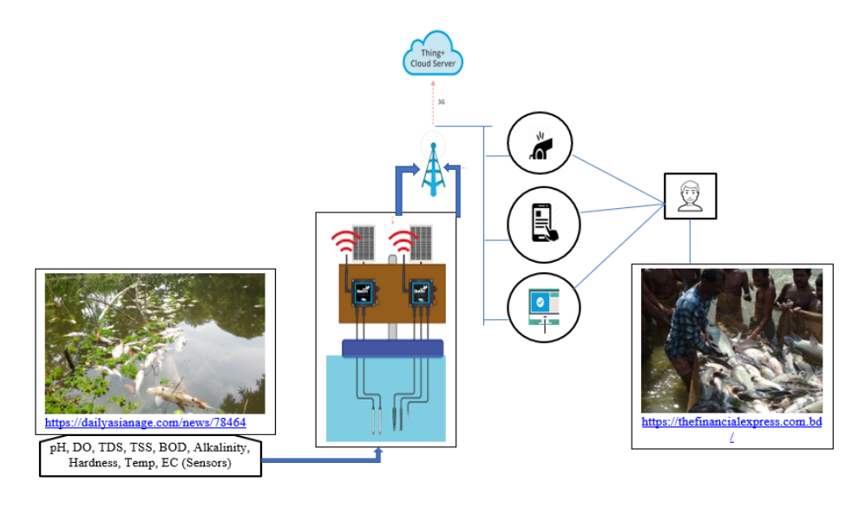
- CONCLUSION
In this study, the technology used in the current smart water quality monitoring system is briefly described and its workings are illustrated. Included is the system's standing on a worldwide scale. a comparison of the various real-time monitoring systems used. The suggested method can be put in place by the relevant authorities to raise the water's quality and increase its utility.These steps can lower the amount of pollutants in water, lower the hazards of using dirty water on a regular basis, and guarantee the water's acceptable attributes.
REFERENCES
[1] Hauwa Mohammed Mustafa, Aisha Mustapha, Gasim Hayder, Abdullahi Sailsu, “Application of IOT and Artificial Intelligence in water quality and Prediction”.2020 6th International Conference Inventive ComputationTechnologies[ICICT].-IEEE.
[2] Al-Akhir Nayan, Muhammad Golam Kibria, Md.Obaidur Rahman, Joyeta Saha, “River Water Quality Analysis and Prediction Using GBM”.2020 2ndInternational Conference on Advanced Information and Communication Technology [ICAICT]-IEEE.
[3] Yuelai Su, Yining Zaho, “Prediction of downstream BOD based on Light Gradient Boosting Machine Machine Method”, 2020 International Conference on Communications, Information System and Computer Engineering[CISCE]-IEEE.
[4] Dr.Naveen Tewari and Dr.Mukesh Joshi, “Water Quality Predicting System (WQPS) and Method using Fog of Thing (FOT)”,2020 9th International Conference System Modeling and Advanced in Research Trends [SMART]-IEEE.
[5] Praveen C Menon, “IOT enabled Aquaponics with wireless sensor smart monitoring”, 2020 4th International Conference on I-SMAC [IOT in Social, Mobile, Analytics and Cloud]-IEEE.
[6] Maxime Lafont, Samuel Dupont, Philippe Cousin, Ambre Vallauri and Charlotte Dupont, “Back to the future: IOT to improve aquaculture”,2019 IEEE.
[7] Carlin C.F. Chu, S.C. Yuen, Y.K Wong, “Deep neural network for marine water quality classification with the consideration of coastal current circulation effect”, International Conference on Intelligent Sustainable System (ICISS 2017)- IEEE.
[8] Jitha P Nair, Vijaya M S, “Predictive Models for River Water Quality using Machine learning and Big Data Techniques”,2021 International conference on Artificial Intelligence and Smart System [ICIAS]- IEEE.
[9] Yi-Fan Zhang, Peter Fitch and Peter J.Thorburn, “Predicting the Trend of Dissolved Oxygen Based on kPCA-RNN Model”, 2020 February, MDPI -IEEE.
[10] Jianzhuo Yan, Ya Gao, Yongchaun Yu, Hongxia Xu, Zongbao Xu, “A Prediction Model Based on Deep Belief network and Least Squares SVR Applied to Croos Section Water Quality”, 2020 May, MDPI -IEEE.
[11] Lukman Adewale Ajao, Blessing Olatunde Abisoye, James Agajo,Abdulzeez Olorundare Ajao, Muhammed Bashir Mua’zu, Abdulazeez Femi Salami, “Automated Multiple Water Tanks Control System Using ATMEGA and FPGA Technology”, IEEE MAC 2019.
[12] Weijian Cao, Yuwan Gu, Juan Huan, Yilin Qin, “A Hybrid Model of Empirical Wavelet Transform and Extreme Learning Machine for Dissolved Oxygen Forecasting”, 2018 IEEE Confs on Iternet of Things, Green Computing and Communications, Cyber, Physical and Social Computing, Smart Data, Blockchain, Computer and Information Technology, Congress on Cybermatics.

