EARLY DETECTION OF ALZHEIMER DISEASE USING DEEP LEARNING TECHNIQUES

Dr. Madhura K
School of CSE & IS
Presidency University
Banglore,India
madhura@presidencyuniversity.in
Mr. ALV Phaneendra
Computer Engineering
Presidency University
Bangalore,India
201910102050@presidencyuniversity.in
Mr. Gowtham R
Computer Engineering
Presidency University
Bangalore,India
201910100588@presidencyuniversity.in

Abstract

Alzheimer's disease is an incurable brain disease which affects thinking and memory. AD affects the entire liver, leading to its shrinkage and eventual death. Early diagnosis of AD is important for better treatment. Machine learning (ML) is an offshoot of artificial intelligence that uses multiple scenarios and optimization techniques to help computers extract results from large amounts of complex data. Therefore, the researchers focused on using machine learning to recognize the early stages of AD. Many methods achieved the expected accuracy, but were evaluated on different disease registries not proven by different models, making direct comparisons difficult. In addition, preprocessing, the number of features important for feature selection, class inequality, and many other factors can affect the accuracy of the estimation. To overcome these limitations, this article reviews, analyzes and evaluates recent work in the early stages of AD using machine learning techniques. The proposed model includes the first step in advance, followed by the importance of character selection and classification along with mining policy. In addition, the proposed study is conducted using a model based approach that provides opportunities for research into early detection of AD with the ability to distinguish AD from health management using deep learning algorithms. In current studies, DL techniques such as Enhanced CNN, VGG16, AlexNet, MobileNet are used.

Keywords—Alzheimer, Machine Learning, Deep Learning, CNN, VGG16, AlexNet, MobileNet.

Introduction
Alzheimer's disease (AD) is dementia typed characterized by cognitive and behavioral problems that begin in middle age. The pathology is characterized by the presence of neural plaques and overt brain cell degeneration in the brain. Symptoms usually develop slowly and are severe enough to affect daily life.AD is not just a geriatric disease, although the most important risk factor is old age. In the early stages, memory is mild, and in the later stages, the patient's ability to speak and feel is greatly reduced. Current treatments cannot stop Alzheimer's disease (AD), but early detection can help determine the severity of the disease and improve patients' quality of life. It has been reported that the number of Alzheimer's patients will double in the next 20 years (Zhang, 2011) and 1 out of 85 people will be affected by 2050 (Ron Brookmeyer, 2007). Therefore, a better accurate diagnosis is so important, especially in early stages of Alzheimer's disease. People with pneumonia often have a runny nose, fever with chills, shortness of breath, severe pain or chest pain when breathing deeply, and rapid breathing.

LITERATURE SURVEY

In 2019, Cui et al. published a paper on Combined 3-D Dense Net and image-based hippocampal targeting for Alzheimer's disease diagnosis.
Dense Net was developed to learn about the visual features of the hippocampal region. The final maps are processed with a combination of 3D dense meshes and image analysis. Comparison of experimental results and ADNI data with T1-weighted standard MR images shows that the proposed method is effective in diagnosing AD and MCI [1].

In 2020, a paper based on Detection of Alzheimer's disease using transfer learning and convolutional neural networks methods was presented at the International Multi-Conference on Systems, Signals and Devices. Here article, two methods were used to describe AD: CNN and transfer learning. The plan has two main points (interest extraction and distribution). The first step is to split the image into blocks to identify areas, including the brain's hippocampus. In the second step, we evaluate CNN and distinguish between learning methods. Then we can see better results showing image classification compared to CNN using adaptive learning [2].
Alzheimer’s disease (AD) remains a major public
health problem. This neurodegenerative pathology affects gen-
erally old people. Its symptoms are loss of memory followed
over the years by more hard ability of expression and various
handicaps. Therefore, early detection of AD is become an active
research area in recent years. In this paper, we propose a deep
based method for the detection of AD (i.e. classify brain images
into normal brain or brain with AD). The proposed method
contains two main steps. The ﬁrst step is region of interest
extraction; it is based on the partition of the image into separate
blocks to extract only the part that contains the hippocampus
of the brain. The second step is the classiﬁcation of images
using two deep based techniques namely convolutional neural
network (CNN) and Transfer Learning
Alzheimer’s disease (AD) remains a major public
health problem. This neurodegenerative pathology affects gen-
erally old people. Its symptoms are loss of memory followed
over the years by more hard ability of expression and various
handicaps. Therefore, early detection of AD is become an active
research area in recent years. In this paper, we propose a deep
based method for the detection of AD (i.e. classify brain images
into normal brain or brain with AD). The proposed method
contains two main steps. The ﬁrst step is region of interest
extraction; it is based on the partition of the image into separate
blocks to extract only the part that contains the hippocampus
of the brain. The second step is the classiﬁcation of images
using two deep based techniques namely convolutional neural
network (CNN) and Transfer Learning
IEEE published a paper based on Interactive Learning for Alzheimer's Disease Diagnosis of 3D-CNN and FSBI LSTM in 2019. In this paper, a new method consisting of 3D-CNN and FSBi-LSTM is proposed to control AD. In particular, a new LSTM network is proposed to replace the FC layer in 3D-CNN. This method stores as much spatial information as possible in the map specification [3].
In 2022, MDPI published a paper on MRI scanning-based Alzheimer's disease diagnosis through neural communication and adaptive learning. In this paper, we propose a GAN-CNN-TL model with some of the advantages of more data generation, reduced sample detection errors, enhanced auto-subtraction and hyper parameter transformation [4].
ICOSEC published an article in the IEEE Journal in 2020 on the CNN Model: Diagnosis and Classification of Alzheimer's Disease using The MRI. In this study, they propose a convolutional neural network classification algorithm for MRI imaging for AD use and all images in the three categories used in this study are 1512 bits, 2633 normal, and 2480 AD. An incredible 99% accuracy was achieved. Among all results over time, significant results were achieved at the 25 threshold with 99% accuracy [5].

In 2018, an article about the retrace History of 2D CNN's and ImageNet was published at the CVPR conference can spatiotemporal. The aim of this paper is to determine whether the available video data is informative enough to train ultra-deep convolutional neural networks (CNNs) with spatio-temporal three-dimensional (3D) kernels. As of now, the performance level of 3D CNNs in the recognition field has been greatly improved [6].

At the 2019 ITME conference, a paper was published on the 3D fully convolutional Dense Net-based Alzheimer's disease diagnostic model. For the real needs of Alzheimer's disease diagnosis, this article presents data with positive and negative test models as well as small studies to build a complete 3D convolutional Dense Net classification model. Better display of feature information can improve the overall capabilities of the model [7].
In 2019, a paper based on Alzheimer's Disease classification from MRI image data using a Hybrid Deep Convolutional Neural Networks Cluster was published at IEEE. In this paper, a new classification system is proposed to differentiate AD, little mild cognitive impairment (MLD) and cognitive impairment patients by using deep reciprocal learning method to process spatial data [8].
In 2018, IEEE published a report on Research Performance of Google Collaboration as a tool for Research on Research. This project is a feasibility study of the Google Collaborator to accelerate deep learning for computer vision. The results show that the integrated device can perform as well as the advanced medical device. The results also highlight that it is better to run tests Collaboratively if the research team does not have a more powerful GPU than the K80 [9].
A paper on Effective 3D Interactive Simulation using MR images for Alzheimer's Disease Diagnosis was published at the ISBI conference in 2017. In this study, they proposed a simple 3D convolutional network architecture which provides high-performance AD. ​detection in large data sets. The proposed 3D ConvNet consists of 5 convolutional layers for feature extraction and 3 fully connected layers for AD/NC classification [10].

EXISTING METHOD AND DRAW BACKS

This model reflects current methods of some algorithmic designs using deep learning. Here the process is performed using the Google Net, which is one of the transfer learning method, but this could not get the high accuracy. Google Net uses 1x1 convolution, Global average pooling and inception module. It takes input of image with 224x224 dimension.

3.1. Disadvantages of Existing System:
- Less feature compatibility
- Low accuracy

PROPOSED METHOD AND ADVANTAGES

In proposed system we are using Modified CNN, MobileNet, AlexNet and VGG16 for the Alzheimer’s disease classification. By using these algorithms, we can get better accuracy.
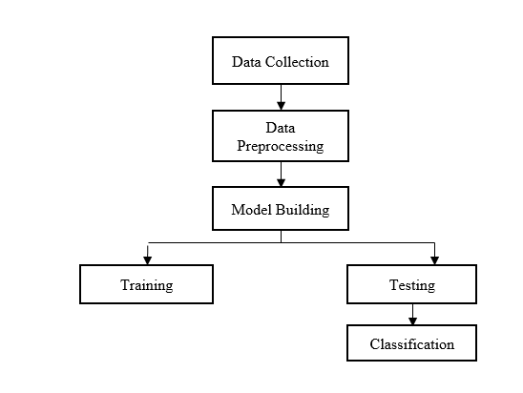
Fig 1. Block diagram of proposed method
4.1. Advantages of proposed system:
- Better Accurate classification
- Less complexity
- High performance
1.1 Creating Dataset:
The dataset contains MRI images with the Alzheimer’s diseases in training of 8062 images and testing of 4387 images.
1.2 Data Pre-processing:
Resize and reshape the image accordingly to show our style in order to shape our model.
1.3 Training:
By using the pre-processed training dataset, we train the model using Hybrid CNN algorithm along with other deep learning models.
1.4 Testing:
Testing the test dataset using the algorithms to get accuracy according to algorithm used
1.5 Classification:
The results will be displayed are which type of Alzheimer’s diseases.
- Mild Demented
- Moderate Demented
- Non-Demented
- Very Mild-Demented

Methodology

5.1. Convolutional Neural Network Algorithm
Step1: convolutional operation
The first block in concept capture is the convolution function. In this step, we will touch on detectors that act as filters for the neural network. We will also talk about maps, how to learn about maps, how to recognize patterns, how to report research and results.
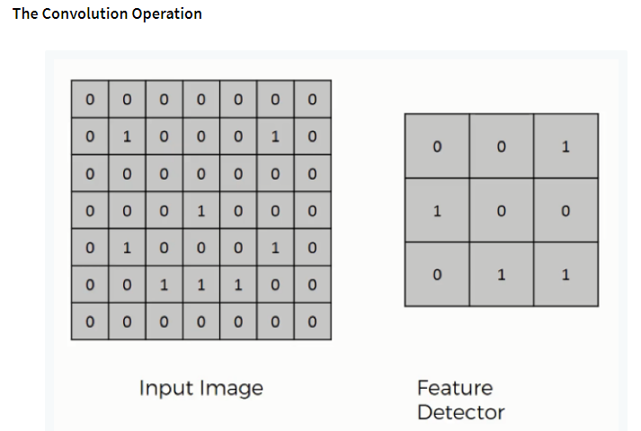
Fig 2. The Convolution Operation
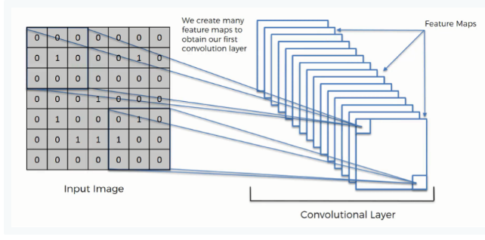
Fig 3 ReLU Layer
Step (1b): ReLU Layer
The second part of this step will involve correct linear units or Relook. We will teach Relook layers and explore the role of linearity in convolutional neural networks. Understanding CNNs is not necessary, but a quick run won't hurt your skills.
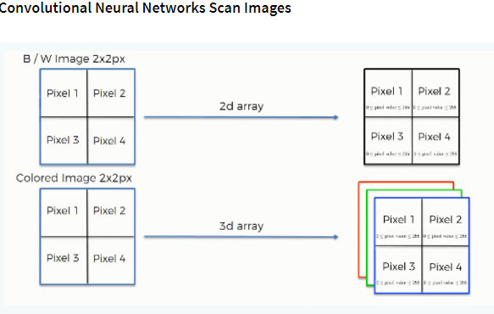
Fig 4. Convolutional Neural Network Scan Images

Step 2: Pooling Layer
In this section we will introduce the integration and see how it works. But our link here will be pooling, max pooling. However, we will focus on different methods, including average (or full) pooling. This will conclude with a demo using interactive tools that will blow your mind.
Step 3: The Flattening
This is a simple overview of smoothing process and how we should move from layer pooling to smoothing when using CNN.
Step 4: Full Connection Layer
Here section, we will provide everything in this section. By studying this, you will gain a better understanding of how neural networks work and how "neurons" learn to classify images.

5.2. Summary

Finally, we summarize everything below and give a quick rundown of what this chapter is about. If you think it's good for you (and maybe it will), you should check out more tricks like Softmax and cross-entropy. This course is not required, but when working with neural networks you will encounter these concepts and will help you understand them.
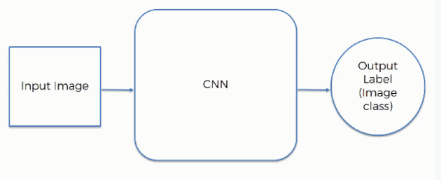
Fig 5. CNN Work Flow

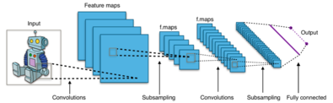

Fig 6. CNN Architecture

5.3. VGG16 Algorithm:
The network architecture of VGG was presented by Simonyan and Zisserman in their 2014 paper "Image Recognition in Large Scale Interactive Networks". This network is famous for its simplicity, with only 3x3 convolutional layers stacked together and growing in depth. Reduced volume is controlled to maximum. Both sets are bound to 4096 based on the Softmax classifier. "16" and "19" represent processes on the network.

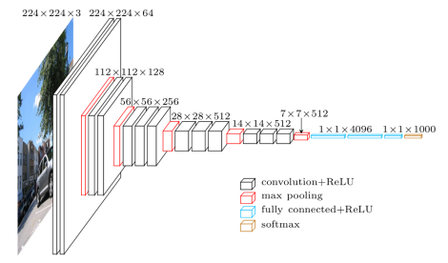
Fig 7.VGG Architecture

5.4. MobileNet Algorithm:

The MobileNet algorithm is created for mobile applications and also is Tensor Flow’s first mobile computing platform. MobileNet uses deep partitioning. This minimizes the count of inconsistencies contrast to communication with a network of the same depth. This facilitates deep neural networks.
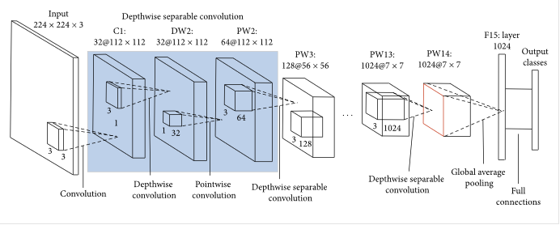
Fig 8. Depth wise separable Convolution Architecture
Depth separation convolution has two operations.
1. Depth-wise
2. Pointwise convolution.
MobileNet is an open source CNN class from Google so thisgives us a good starting point to introduce our small but very fast class.
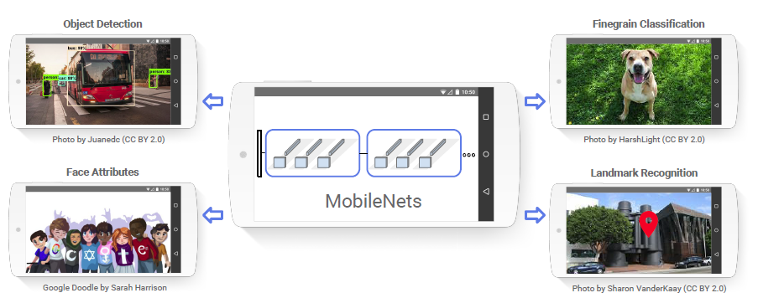

Fig 9. The Depth-wise Convolution

The argument stems from the point that the depth and length of the filter can be separated - hence the name separation. For example, use the Sobel filter to identify edges in an image.

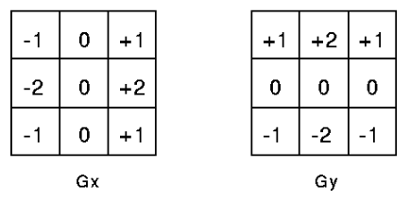
Fig 10. Sobel Filter

Sobel Filter. Gx is vertical edge, Gy is horizontal edge detections
The concept used to divide the depth dimension from the horizontal dimension (width * height) gives the division and creates the depth dimension. Then use 1*1 filter to avoid depth measurement. One thing to keep in mind is how many parameters have been reduced to make the difference in this match. channel. To create the channel, we need 3 * 3 * 3 without a depth difference and 1 * 3 without a depth difference. However, if we want the output, we only need to filter the depth of 31 * 3 for a total of 36 (= 279) parameters. Normal convolution output channel should have 33*3*3 filters and 81 parameters.
A deep discrete convolution is a deep convolution based on the point convolution
1. Depth convolution is a channel-based DK×DK spatial convolution.
For example, in the picture above, there are 5 paths. Then we have a spatial convolution of 5 MIN × DK.
2. The point convolution is a 1×1 convolution for scaling.
3. Depth convolution.

5.5. AlexNet
AlexNet is another type of neural network, a deep learning model. The model was proposed by Alex Krishevsky as part of a research project. Their work was overseen by Geoffrey E. Hinton, a geologist. Alex Krishevsky entered the 2012 ImageNet Large-Scale Recognition Contest (ILSVRC2012) and achieved 15 top 5 errors using the AlexNet model.3% is 10.8 points lower than its competitors. AlexNet 8,5and3 layers, as suggested by Alex Krizhevsky in his work. Some layer models are based on maximum consolidation layers. The network uses the ReLU function as the activation function, which outperforms the sigmoid and tangent functions.
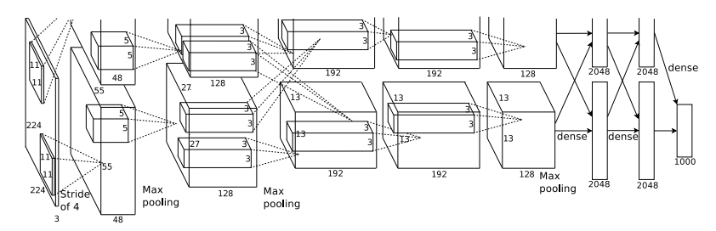
Fig 11. AlexNet Architecture
The mesh consists of a core or filter with five layers of dimensions 11 x 11.5, 5 x 5, 3 x 3, 3 x 3 and 3 x 3. Other parameters of the network can be adjusted accordingly; the teaching method works. It performs excellently with adaptive learning using weights from a pre-trained network on the ImageNet dataset. But in this paper, instead of using pre-trained weights, we can only define CNN based on the proposed architecture.

CONCLUSION

In this project we have successfully classified the images of MRI images of a person, is either Mild Demented or Moderate Demented or Non-Demented or Very Mild Demented using the deep learning algorithms. Here, we have considered the dataset of MRI images which will be of 4 different types and trained using Modified CNN with MobileNet, VGG16 algorithms. After the training we have tested by uploading the image and classified it.

References

- A. W. Salehi, P. Baglat, B. B. Sharma, G. Gupta and A. Upadhya, "A CNN Model: Earlier Diagnosis and Classification of Alzheimer Disease using MRI," 2020 International Conference on Smart Electronics and Communication (ICOSEC), Trichy, India, 2020, pp. 156-161, doi: 10.1109/ICOSEC49089.2020.9215402.
- Chiyu Feng, Ahmed Elazab, Peng Yang and Tianfu Wang, (2019) ‘Deep Learning Framework for Alzheimer’s Disease Diagnosis via 3D-CNN and FSBi-LSTM’, IEEE Access Volume 7,2019,pp.63605-63618.
- Cui R, Liu M. Hippocampus Analysis by Combination of 3-D DenseNet and Shapes for Alzheimer's Disease Diagnosis. IEEE J Biomed Health Inform. 2019 Sep;23(5):2099-2107. doi: 10.1109/JBHI.2018.2882392. Epub 2018 Nov 20. PMID: 30475734.
- Hara, K., Kataoka, H., & Satoh, Y. (2017). Can Spatiotemporal 3D CNNs Retrace the History of 2D CNNs and ImageNet? ArXiv. /abs/1711.09577.
- He, Guangyu & Ping, An & Wang, Xi & Zhu, Yufei. (2019). Alzheimer's Disease Diagnosis Model Based on Three-Dimensional Full Convolutional DenseNet. 13-17. 10.1109/ITME.2019.00014.
- G. Huang, Z. Liu, L. Van Der Maaten and K. Q. Weinberger, "Densely Connected Convolutional Networks," 2017 IEEE Conference on Computer Vision and Pattern Recognition (CVPR), Honolulu, HI, USA, 2017, pp. 2261-2269, doi: 10.1109/CVPR.2017.243.
- Jabason, Emimal & Ahmad, M. Omair & Swamy, M.N.s. (2019). Classification of Alzheimer’s Disease from MRI Data Using an Ensemble of Hybrid Deep Convolutional Neural Networks. 481-484. 10.1109/MWSCAS.2019.8884939.
- Khan, Salman & Rahmani, Hossein & Shah, Syed & Bennamoun, Mohammed. (2018). A Guide to Convolutional Neural Networks for Computer Vision. Synthesis Lectures on Computer Vision. 8. 1-207. 10.2200/S00822ED1V01Y201712COV015.
- Kollias, D., Tagaris, A., Stafylopatis, A. et al. Deep neural architectures for prediction in healthcare. Complex Intell. Syst. 4, 119–131 (2018). https://doi.org/10.1007/s40747-017-0064-6
- Kwok & Gupta, Brij B & Alhalabi, Wadee & Alzahrani, Fatma. (2022). An MRI Scans-Based Alzheimer’s Disease Detection via Convolutional Neural Network and Transfer Learning. Diagnostics. 12. 1531. 10.3390/diagnostics12071531.
- Zaabi, Marwa & Smaoui, Nadia & Derbel, Houda & Walid, Hariri. (2020). Alzheimer's disease detection using convolutional neural networks and transfer learning based methods. 939-943. 10.1109/SSD49366.2020.9364155.

