**A Numerical Approach towards Caputo-Fabrizio Fractional Derivatives on MHD Couette Flow**

**Dipen Saikia 1, Sumpi Saikia2**

1 Department of Mathematics, Salt Brook Academy, Boiragimoth-786003, Assam, India,

E-mail: deepsand2009@gmail.com

2 Centre for Computer Science and Applications, Dibrugarh University-78003, Assam,

India, E-mail: sumpisaikia@dibru.ac.in

Abstract: A numerical investigation has been carried out to analyze the consequences of variable viscosity and thermal conductivity using fractional derivatives of Caputo-Fabrizio (CF) on MHD coquette flow with heat transfer in presence of constant heat source. In this paper we have considered an unsteady two dimensional free convection couette flow of an incompressible, viscous, and electrically conducting fluid under the influence of magnetic field bounded by two infinite horizontal parallel plates. The leading partial differential equations together with the boundary conditions are transformed into ordinary form by similarity transformations ensure that physical parameters show up in the equations and interpretations on these parameters can be achieved appropriately. By the use of ordinary finite difference scheme, the equations thus obtained are discritized. These discritized equations are numerically solved by the approach derived from Gauss-Seidel iteration scheme. The consequences of all the physical parameters involved in the problem on velocity, temperature and magnetic field distribution are presented with the aid of graphs and offered in tabular form. It has been found that each parameter’s effects are prominent enough.

Keywords: CF fractional derivatives, Variable viscosity, Couette flow, Heat source.

**6.1 Introduction:**

The study of the MHD flow is very significant as the topic has diverse application in various fields of engineering and science. The applications of MHD include direct generation and the control of hyper velocity vehicles. MHD convection issues are quite relevant in the domains of stellar and planetary magneto spheres, chemical science and electronics engineering.

The inventive and electrical work of MHD channel flow was studied by Hartmann [1]. Two-dimensional steady MHD convective Poiseuille flow and heat transfer bounded by two porous plates with constant pressure gradient and heat source has been studied by many researchers of which Makinde and Mhone [2], Ganesh and Krishnambal [45] are noteworthy. Ahmed and Kalita [6] have investigated the unsteady MHD flow of conducting fluid through porous medium. In another paper of Ahmed with Talukdar [9], they deliberate the MHD Couette flow with heat transfer in presence of constant heat source.

In the study of heat transfer problems, it is seen that most of the investigations are based on constant physical properties of the fluids and it is obvious that these properties may change with temperature. In convection, heat transfer takes place when there is a vast temperature difference within the fluid, so in such studies it is very much essential to consider variable fluid properties. For diverse applications of convection in porous medium, one can refer the very excellent book by Nield and Bejan [8]. The heat transfer related problems through porous medium become very interesting under the application of magnetic field to the flow of an electrically conducting fluid.

Many of the current empirical work on this issue, viscosity and thermal conductivity were taken as constant. However it is known from the work of Herwig and Wickern [7] and Hazarika and Khound [4] that these properties may get change with temperature. To correctly forecast the flow and heat transfer rates, it is required to consider the variation in viscosity and thermal conductivity.

Recently, fractional calculus attracts the attention of scientists and researchers due to its significant role in daily life applications. Especially in fluid dynamics, it plays a significant role to generalize the models. Furthermore, a juxtaposition of AB and CF fractional derivative operators was reported by Sheikh et al.[13]. Recently Arif et al. [15] reported a comparative study on couette flow with couple stress fluids. They have also investigated a time-fractional model with a non-local kernel and Atangana-Baleanu and Caputo-Fabrizio fractional derivative operators are used for comparison. Moreover, Li et al.[9] have usesd the linear kernel for complementary maximal strip recovery. Recently, Abro et al. [2] have used the same fractional derivative operator for the comparative analysis of RL and RC electrical circuits. They have used Laplace technique to elaborate the solution. Fan et al. [9] investigated the fractal derivative model to study air permeability as a porous medium.

In this paper our main aim is to study the effects of variable viscosity and thermal conductivity using fractional derivatives CF on unsteady MHD free convective heat transfer flow between two horizontal parallel plates. The governing equations are transformed into non-dimensional form by using non-dimensional quantities and parameters. The effects of velocity and temperature profiles for different parameters are studied and presented graphically by CF fractional derivatives.

**6.2 Mathematical formulation of the problem:**

We consider an unsteady free convection couette flow of an incompressible, viscous, and electrically conducting fluid between two infinite horizontal parallel plates kept at a distance in presence of applied magnetic field and a constant heat source. The upper plate is moving with a uniform velocity 

A co-ordinate system is introduced with the origin at the lower plate coinciding with the -plane, -axis being taken horizontally along the main flow direction. The other plate is at  i.e. at a distance  from the lower plate and is subjected to a uniform motion  along the positive direction and -axis along the width of the plates. Let be the fluid velocity and  the applied magnetic field at  as shown in the figure-6.2.1.

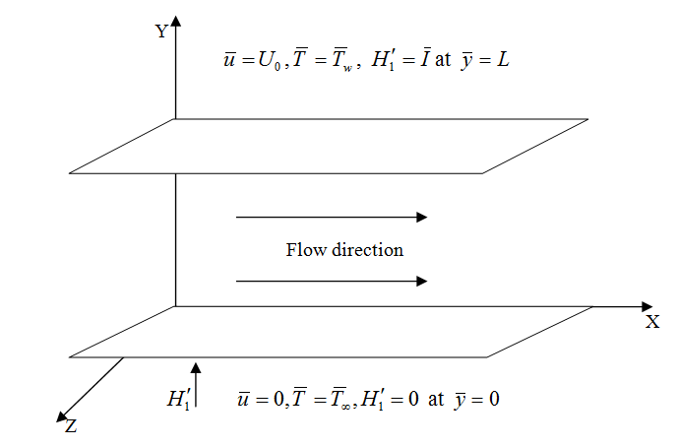

**Figure 6.2.1: Flow configuration**

Under the Boussinesq approximation, the flow is governed by the following boundary layer equations:

Continuity equation:

 (6.2.1)

Magnetic equation of continuity:

 (6.2.2)

Ampere’s law:

 (6.2.3)

Momentum equation:

 (6.2.4)

Magnetic induction equation:

 (6.2.5)

Energy equation:



Now from Ohm’s law:



Considering  the energy equation for the problem reduces to:

 (6.2.6)

The boundary conditions are:

 at 

,, at  (6.2.7)

We use the viscosity of the fluid as inverse linear function of the temperature as given by Lai and Kulacki [67]

 or  where  (6.2.8)

whereis the free stream viscosity and are constants whose values depend upon the reference state and thermal property of the fluid, is transformed reference temperature related to viscosity parameter, is a constant based on the thermal property of the fluid and  for gas and for liquid.

Following Hazarika and Khound [54] we suppose the thermal conductivity as

 or  where ,  (6.2.9)

where  and are constants and these values depend upon the reference state and thermal properties of the fluid.

We introduce the following non dimensional quantities in order to normalize the flow model:

  (6.2.10)

The non- dimensional form of governing equations are given below:

Momentum equation:

 (6.2.11)

where is the ratio of the magnetic energy with the kinetic energy in the uniform stream. The number can be expressed in terms of Hartman numberReynolds number (Re) and Magnetic Reynolds (Rm) as



where , , 

Magmetic Induction equation:

 (6.2.12)

Energy equation:

 (6.2.13)

Then the boundary condition (6.2.7) becomes:

  at y = 0

  at y = 1 (6.2.14)

**CF fractional derivatives:**

To initiate the CF fractional model, we do replace the governing partial differential equations with respect to time by the CF fractional derivative operator of order $0<β<1$, equations (6.2.11) to (6.2.13) become

 (6.2.15)

 (6.2.16)

 (6.2.17)

where



## Important physical parameters:

Two important physical parameters for the present problem are -

**Coefficient of Skin-friction:**

The shear stress at any point on the upper plate is offered by





The non-dimensional coefficient of skin-friction at the upper plate in the direction of the free stream can be presented as:

 (6.2.18)

**The Nusselt number:**

The heat flux from the upper plate to the fluid is given by the Fourier law of heat conduction as below



The co-efficient of rate of heat transfer from the plate to the fluid in terms of Nusselt number is given by



 (6.2.19)

**6.3 Results and discussion:**

The non-dimensional discretized governing equations together with the non-dimensional boundary conditions are solved with the help of CF fractional derivative method by developing suitable programming code in MATLAB using finite difference scheme and the resulting finite difference equations are solved numerically by the use of an iterative scheme based on Gauss-Seidel method. To acquire a clear perception of the physical problem, numerical solutions are presented with the aid of graphs.

* + 1. **Figures:**

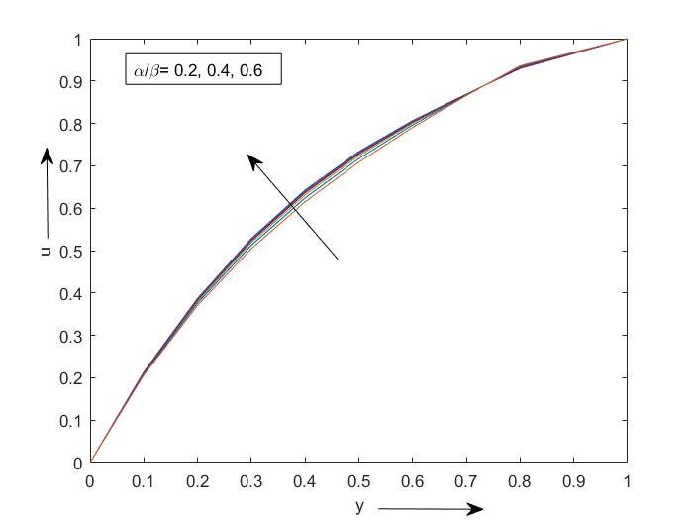

**Figure 6.3.1.1: Effect of $β$ on velocity profile**

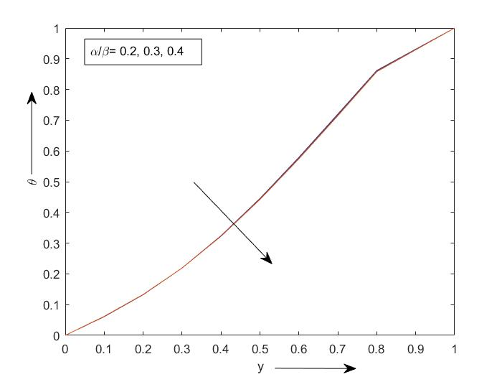

**Figure 6.3.1.2: Effect of $β$ on temperature profile**

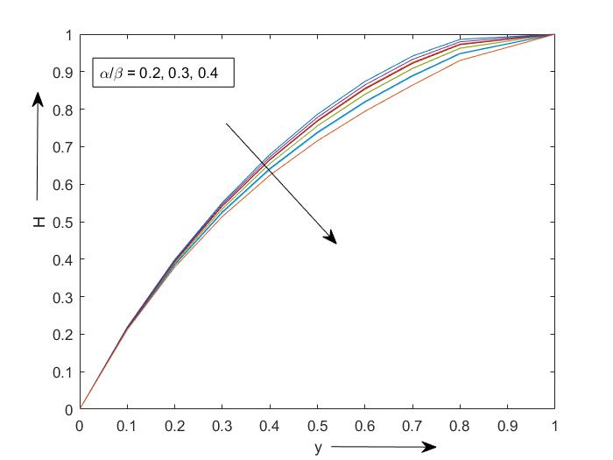

**Figure 6.3.1.3: Effect of $β$ on magnetic field distribution**

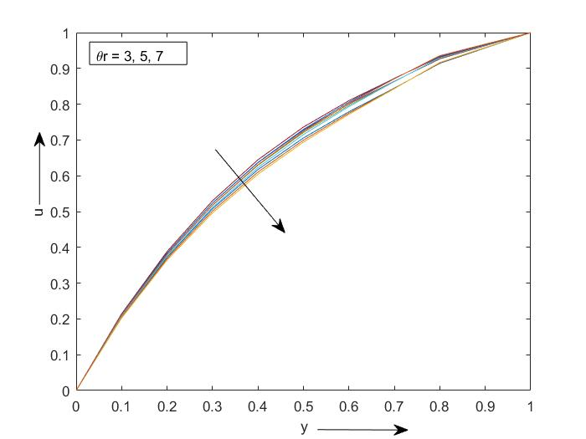

**Figure 6.3.1.4: Effect of on velocity profile**

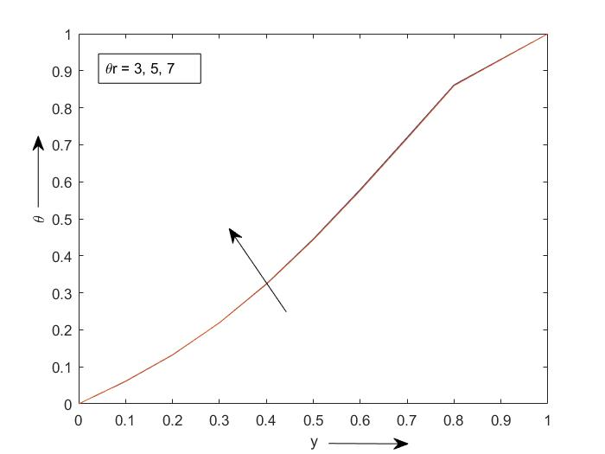

**Figure 6.3.1.5: Effect of on temperature profile**

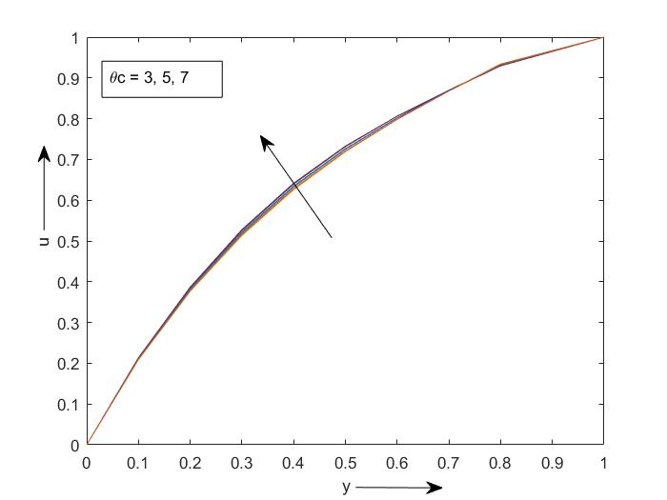

**Figure 6.3.1.6: Effect of** **on velocity profile**

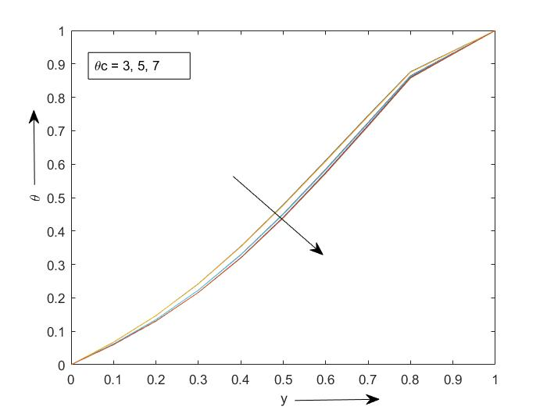

**Figure 6.3.1.7: Effect of** **on temperature profile**

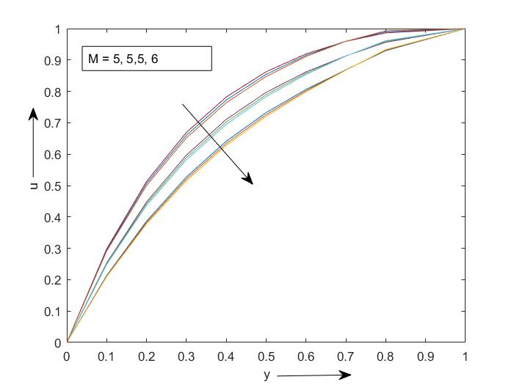

**Figure 6.3.1.8: Effect of** *M* **on velocity profile**

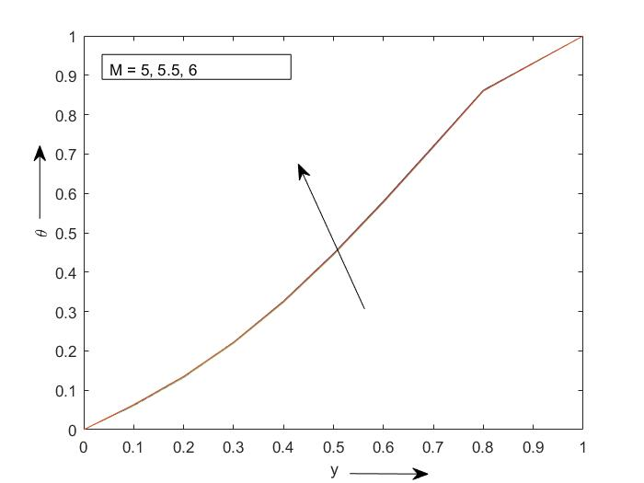

**Figure 6.3.1.9: Effect of** *M* **on temperature profile**

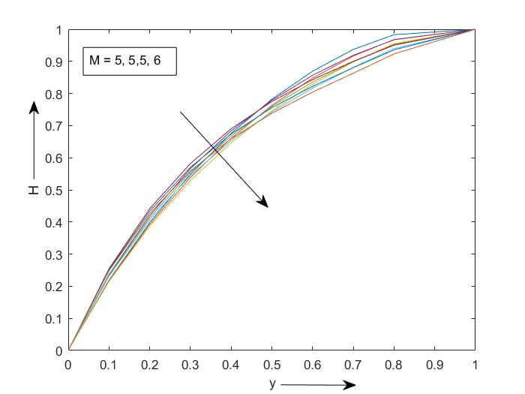

**Figure 6.3.1.10: Effect of** *M* **on magnetic field distribution**

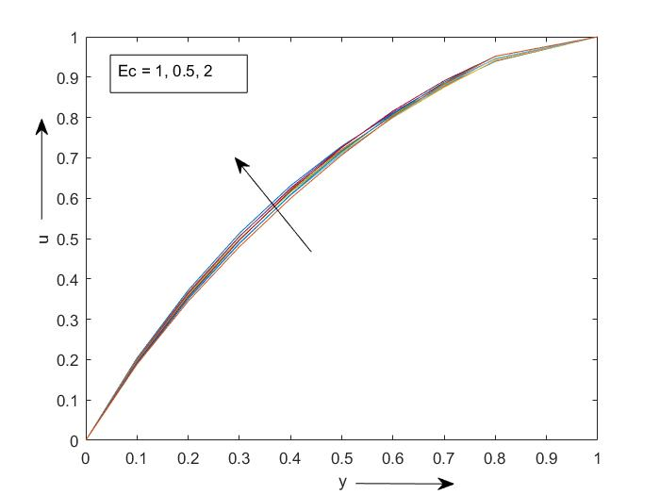

**Figure 6.3.1.11: Effect of** *Ec* **on velocity profile**

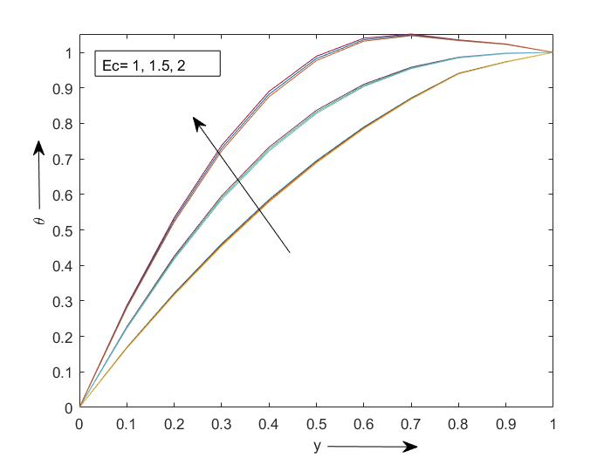

**Figure 6.3.1.12: Effect of** *Ec* **on temperature profile**

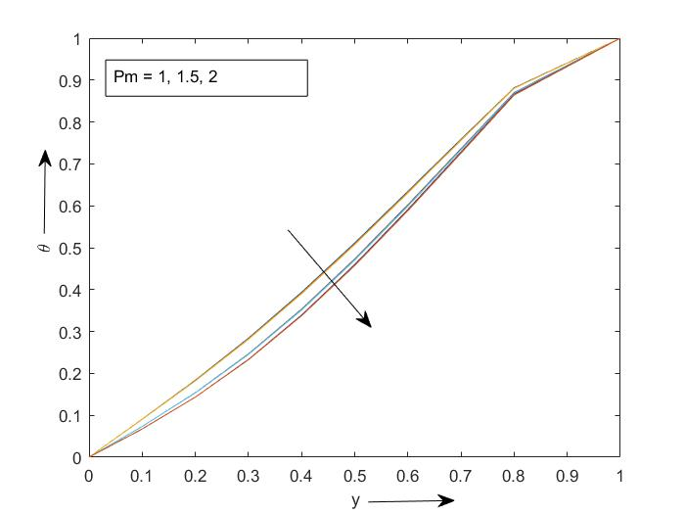

**Figure 6.3.1.13: Effect of** *Pm* **on temperature profile**

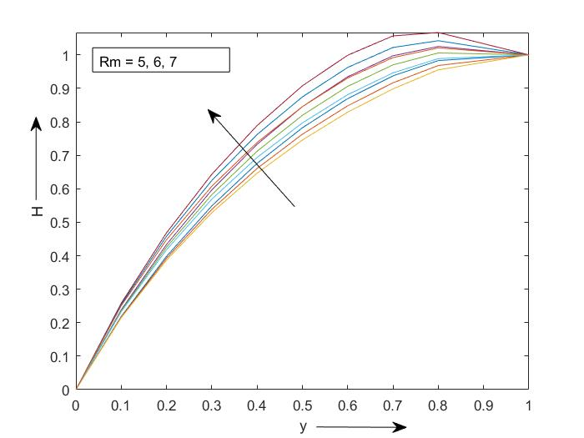

**Figure 6.3.1.14: Effect of *Rm* on magnetic field distribution**

The variations in velocity, temperature and magnetic field are illustrated in Figure (6.3.1.1) to (6.3.1.14) for the variation of distinct parameters such as fractional operator ( $β$), magnetic parameter viscosity variation parameter thermal conductivity parameter Echert number  magnetic Reynolds numberon velocity and temperature of fluid are expressed graphically in figures section.

Figures (6.3.1.1) to (6.3.1.3) exhibit the velocity, temperature and magnetic field distribution for different values of the CF fractional operator ($β$). It is noticed in the Figure (6.3.1.1.) that the velocity ($u$) increases for increasing values of $α$ and $β$ but Figure (6.3.1.2) and Figure (6.3.1.3) gives temperature ($θ$) and induced magnetic field distribution (*H*) decrease for increasing value of $β$.

Figures (6.3.1.4) illustrates the influence of viscosity variation paramerter on velocity distribution. From this figure we have seen that the velocity is decreasing with the rising value of viscosity variation parameter. It is because of the reason that the viscous force raises due to increasing values of viscosity. From Figure (6.3.1.5), it is clear that the temperature rises as viscosity variation parameter rises. This is because as viscosity increases the friction between the layers increases. When friction increases, the heat is produced from the friction on the surface which is transmitted to the flow. This results to an increase in the surface temperature and thus the flow is heated.

The effect of thermal conductivity variation parameter  on the velocity is shown in figure (6.3.1.6). This is clear from the figure that the velocity rises with the raising values of thermal conductivity parameter. Also in figure (6.3.1.7), we have noticed that temperature decreases on rising thermal conductivity parameter. Physically it means that as thermal conduction increases the transportation of heat from a hot region to an adjacent colder region increases. Since the temperature within the boundary layer is more than the outside, the temperature is decreased.

Figure (6.3.1.8) reveals that the velocity reduces on raising values of Hartmann number meaning thereby the magnetic field has a retarding effect on the velocity of the fluid. This is because the application of a magnetic field to an electrically conducting fluid gives rise to a force known as Lorentz force, that tends to resist the motion of the fluid. Again in figure (6.3.1.9), it is observed that the temperature increases on raising values of *M* but induced magnetic field distribution (*H*) decreases on increasing values of *M* (figure 6.3.1.10).

Figure (6.3.1.11) illustrates the effect of viscous dissipation on temperature profile. Viscous dissipation changes the temperature distribution by playing a role as an energy source, which leads to effect in heat transfer rates. Here the temperature rises with the raising values of , due to the heat energy that is stored in the liquid and frictional heating. Again temperature also increases on increasing values of *Ec* (figure 6.3.1.12).

The impact of magnetic Prandtl number  on temperature distribution has revealed in figure (6.3.1.13). It is clear that the temperature reduces with the raising values of . Figure (6.3.1.14) depicts the effect of magnetic Reynolds number  on the induced magnetic field distribution. It is shown that the induced magnetic field increases as  increases.

**6.4 Conclusion:**

Consequences of variable viscosity and thermal conductivity on unsteady MHD free convective heat transfer flow between two horizontal parallel plates has been investigated. The effects of applied magnetic field, viscosity variation parameter, thermal conductivity parameter, magnetic Prandtl number, Eckert number, magnetic parameter are also taken into account. Based on the above analysis we can conclude that:

* Magnetic field and viscosity have retarding effect in the flow.
* The temperature falls due to thermal conductivity, but it increases with increasing viscosity and Eckert number.
* The induced magnetic field increases as magnetic Reynolds number increases.

**References**

1. Hartmann J., Lazarus K., Dan Vidensk. (1937). Mat.-Fys. Medd., 15(6&7).
2. Makinde O. D., Phone P. Y., (2005). Heat Transfer to MHD Oscillatory Flow in a Channel Filled with Porous Medium. Rom. J. Phys, 50 (9-10): 931-938.
3. Ganesh S., Krishnambal S. (2006). Magnetohydrodynamic flow of a viscous fluid between two plates. J. Appl. Sci., 69(11): 2420-2425.
4. Ahmed N., Kalita D. (2009). Effect of thermal diffusion and magnetic field on an unsteady free convective flow with mass transfer through a porous medium in presence of heat source. IJMSEA, 3(11): 267-281.
5. Ahmed N., Talukdar S. (2012). MHD Couette flow with heat transfer in presence of constant heat source. IJEST, 4(06), ISSN: 0975-5462.
6. Nield D. A., Bejan A. (2006). Convection in Porous Media (3rd edition). Springer.
7. Herwig H., Wickern G. (1986). The effects of variable properties on laminar boundary layer flow. Warme and Staffbertr, 20: 47.
8. Hazarika G. C., Khound P. K. (2000). The effect of variable viscosity and thermal conductivity on liquid film on an unsteady stretching surface. Proc. Of 46th Annual Tech. Session, Ass.Sc.Soc: 47-56.
9. Sheikh N. A., Ali, F., Saqib, M., Khan, I., Jan, S. A. A. (2017). Comparison and analysis of the Atangana-Baleanu and Caputo-Fabrizio fractional derivatives for generalized Casson fluid model with heat generation and chemical reaction. Results in Physics, 7(1): 789-800.
10. Arif, M., Ali, F, Sheikh, N. A.; Khan, I.; Nisar, K. S. (2019). Fractional model of couple stress fluid for generalized Couette flow: a comparative analysis of AtanganaBaleanu and Caputo-Fabrizio fractional derivatives. The Institute of Electrical and Electronics Engineers Access, 7(1): 88643-88655.
11. Li, W. J.; Liu, H. Y.; Wang, J. X.; Xiang, L. Y.; Yang, Y. J. (2019). An improved linear kernel for complementary maximal strip recovery: Simpler and smaller. Theoretical Computer Science, 786: 55-66.
12. Abro, K. A.; Memon, A. A.; Abro, S. H.; Khan, I.; Tlili, I. (2019). Enhancement of heat transfer rate of solar energy via rotating Jeffrey nanofluids using Caputo-Fabrizio fractional operator: an application to solar energy. Energy Reports, 5(1): 41-49.
13. Abro, K. A.; Memon, A. A.; Uqaili, M. A. (2018). A comparative mathematical analysis of RL and RC electrical circuits via Atangana-Baleanu and Caputo-Fabrizio fractional derivatives. The European Physical Journal Plus, 133(3):113-122.
14. Fan, J.; He, J. (2012). Fractal derivative model for air permeability in hierarchic porous media. Abstract and Applied Analysis, 7(1): 1-7.
15. Lai, F.C., Kulacki, F. A. (1990). The effect of variable viscosity on convective heat and mass transfer along a vertical surface in standard porous media. Int. J. of Heat and Mass Transfer, 33:1028-1031.