INNOVATIVE TRENDS IN NEONATOLOGY
Dr. B.Ganga Bhavani*PrincipalMail.id :-gangabhavani259@gmail.com
U.Suhasini*Nursing faculty, Mail.id : umapathihasini007@gmail.com
*College of Nursing
Sri Padmavati Mahila VisvaVidyalayam,(Womens’ University )
Tirupati, Andhra Pradesh
India-517502

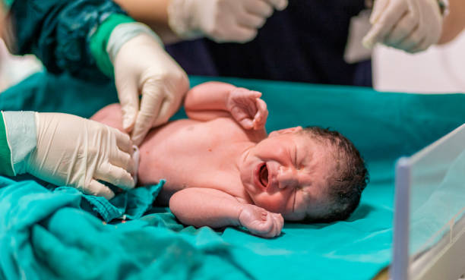
Abstract
Neonatal care is very much important part in every one’s life. Before technology therewas most practiced act of traditional prenatal and postnatal care of mother and baby. Most ofthe times that was very successful until innovative methods come. The new assessment guidelines and action plan of neonates as per IMNCI guidelines, neonatal procedures like EXIT, cord blood banking system is described in this chapter. The technological advancements of AI,VR, Chatbot, m health is elaborated. The new trends in research like TDR , translational research, concept of gene editing and designer babies are discussed.
key words:advancements in neonatology, neonatal care, innovative trends, designer babies and gene editing
Introduction
The world is moving radically on technology. Technology is there in every field. Particularly in the Science field it is inevitable
Although the United Nations Millennium Development Goals and all birth control programs are focusing on reducing infant mortality, the infant mortality rate for children under five is still high In 2019, approximately 2.4 million newborns lost their lives, resulting in an average of 17 fatalities for every 1,000 live births, equivalent to around 6,700 newborn deaths occurring each day. (As of 2021, the Neonatal Mortality Rate stands at 24.9 per 1,000 live births.)
The Neonatal Integrative Developmental Care Model
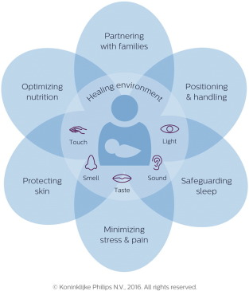

1. Parental engagement
Research indicates that parents with a solid education and a dedicated approach have a favorable, lasting influence on their children's well-being, resulting in improved long-term outcomes and a reduced likelihood of their children being readmitted to the hospital.

2.Breastmilk support
As reported in a JAMA article, milk analysis systems are capable of assessing fat, protein, total carbohydrate content, total solids, and energy content in breast milk. This analysis can be instrumental in detecting deficiencies in protein or energy levels in the breast milk of infants with heightened nutritional requirements. Subsequently, clinicians can take measures to fortify the milk when necessary.
3. Ex Utero Intrapartum Treatments (EXIT)
- Ex Utero Intrapartum Treatments refer to medical procedures performed by surgeons on an infant while they are still connected to the umbilical cord.
• The Exit procedure is designed to intervene and provide treatment for infants facing immediate and critical issues after birth, making it difficult for them to breathe or transition safely into independent life.
• The range of conditions warranting the EXIT procedure has expanded and now includes cases such as large fetal neck masses, lung or mediastinal tumors, congenital high airway obstruction syndrome, and EXIT to ECMO (extracorporeal membrane oxygenation)
. • The fundamental principles of the Ex Utero Intrapartum Treatment (EXIT) procedure were initially developed for reversing tracheal occlusion in fetuses with severe congenital diaphragmatic hernia
. • Additionally, the EXIT procedure ensures continued uteroplacental gas exchange while providing placental support.
4. Cord Blood Banking System
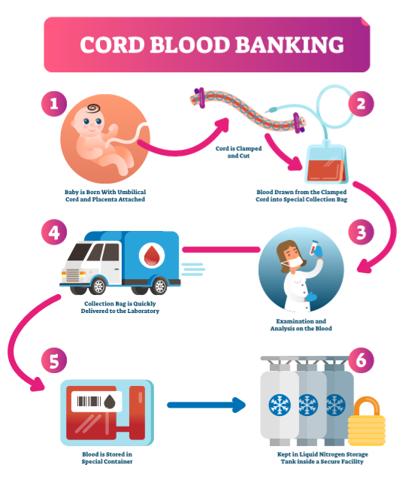
- People can choose whether to undergo a cord blood harvest after giving birth during pregnancy. It is safe to take cord blood from both the expectant mother and the baby.
- After collection, cord blood samples are frozen and stored by cord blood banks so they can be used later. Both public and private banks are available.Umbilical cord blood stem cell transplantation's capacity for regeneration is still being studied; hence it should only be used in accordance with protocols approved by the Institutional Review Board.

5. After-birth care for the umbilical cord
If immediate stabilization or resuscitation is not necessary, cord clamping can be postponed for at least 60 seconds. A longer time frame can be more advantageous.The best time to clamp is after the lungs have been aerated.

INITIAL ASSESSMENT

Classification according to initial assessment
Based on the initial evaluation, the infant can typically be categorized into one of three groups, as demonstrated by the following examples.
Group | Characteristics | Assessment Data | Group Actions  Required
Assessment group 1 | Healthy demeanor Energetic respiration or vocalization Elevated heart rate – rapid (≥100 /minute) | Adequate. Transition phase. – Unassisted breathing. Heart rate is within acceptable range. | Group 1- Actions  - Wait before clamping the cord  - Dry and wrap the baby in a warm towel  - Keep the baby with the mother and ensure they stay warm  - If the baby is stable, initiate early skin-to-skin care.
Assessment group 2 | Reduced tone  Breathing inadequately (or apneic)  Heart rate – slow (<100/ min) | Incomplete transition –  Breathing support necessary ,  slow heart rate may indicate hypoxia | Group 2- Actions  - Consider delaying cord clamping only when the infant can receive proper support.  - Dry and stimulate the baby, then wrap them in a warm towel.  - Ensure the airway is clear and provide lung inflation and ventilation as needed.  - Continuously monitor heart rate and breathing for any changes.  - If there is no improvement in heart rate, continue with ventilation.  - Be prepared to provide assistance if necessary.
Assessment group 3 | The infant appears limp and pale, with insufficient or absent breathing and an extremely slow heart rate (below 60 beats per minute) or no detectable heart rate. | The transition appears poor or unsuccessful, indicating the need for breathing support, and the heart rate suggests significant hypoxia, necessitating resuscitation. | Group 3- Actions  - Immediately clamp the cord and transfer the infant to the resuscitation platform.  - Commence resuscitation of the infant.  - Dry the infant, provide stimulation, and wrap in a warm towel.  - Ensure the airway is clear and perform lung inflation and ventilation.  - Continuously monitor the heart rate, breathing, and the impact of ventilation.  - Sustain newborn life support based on the infant's response.

Preterm infants’ life support
- Apply the same principles as mentioned above.
- Explore alternative or additional approaches for thermal care.
- Provide gentle support, starting with CPAP if the infant is breathing.
- Contemplate continuous monitoring instead of intermittent monitoring (pulse oximetry ± ECG).
INTEGRATED MANAGEMENT OF NEONATAL & CHILDHOOD ILLNESS
ASSESS, CLASSIFY AND TREAT THE SICK YOUNG INFANT
- Evaluate for Potential Bacterial Infection and Jaundice.
- Assess for the Presence of Diarrhea.
- Examine for Feeding Issues and Malnutrition.
- Review the Immunization Status of the Young Infant.
5. Address Any Additional Concerns and Provide Treatment for the Young Infant.
*Offer Guidance and Support to the Mother.
- Innovative Neonatal Care:

Now day’s technology has developed so much. From gully to Delhi, beggar to milliner everyone is using technology. Computers are the makers of everything. Humans are completely relaying on the computers. In the medical field technology plays very significant role. Predominantly in the files of neonatal child care its role is very essential. Some of them are discussed here.
Gene Edited Babies

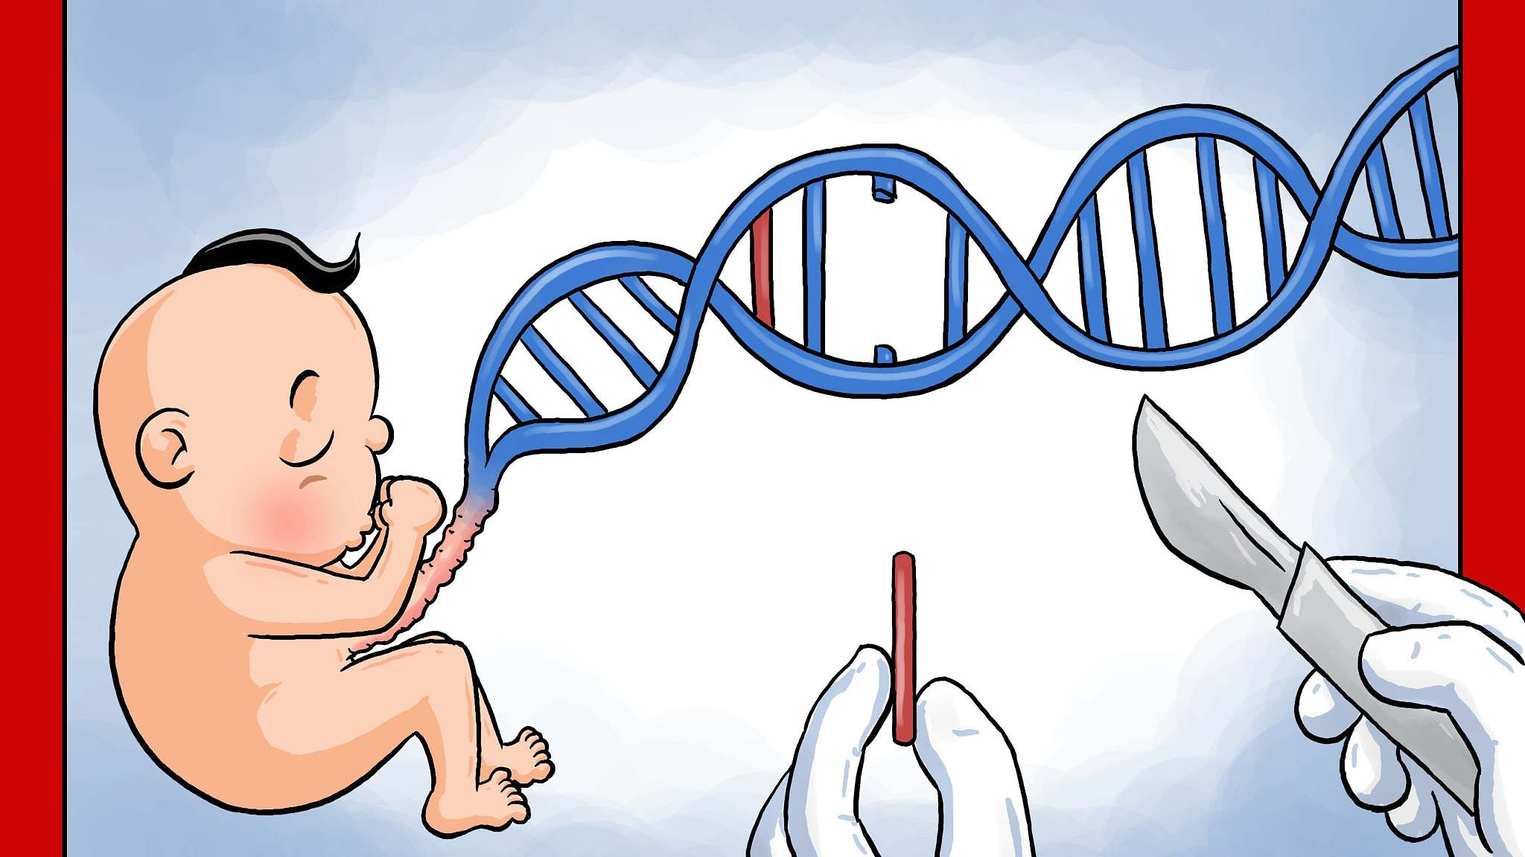
Courtesy :news.cgtn.com/news/3d3d414e3251544f30457a6333566d54/share_p.html
The blueprint for all life, including humans, are their genes. Humans can become stronger, weaker, wiser, or stupid by altering their genes. He Jiankui stated that it may render a person immune to AIDS, but it could also make them more susceptible to other lethal diseases.
The birth of the world's inaugural gene-edited babies occurred in China in November 2018, leading to the incarceration of the responsible scientist following a significant global outcry. The committee underscores the necessity for extensive further research. Gene-edited babies: Experts assert that current techniques are not secure. Source: news.cgtn.com/news/3d3d414e3251544f30457a6333566d54/share_p.html
- Designer Babies
Consumer-driven Model of Human Reproduction
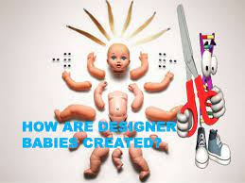
Courtesy :thelegalgeeks.com/2018/08/13/gattaca-and-the-designer-baby/
A designer baby is an embryo that has undergone genetic modification (gene-editing) to create a child with specific characteristics. This process involves the removal of undesirable traits, like hereditary diseases, and sometimes includes the addition of beneficial attributes such as enhanced strength or intelligence.
Designer babies, sometimes referred to as genetically modified babies, can be seen as a direct result of the continuous advancements in in-vitro fertilization (IVF) technology over several decades. Once scientists successfully achieved the conception of babies in laboratory settings, the idea of modifying embryos to produce healthy genetically modified infants naturally emerged. Scientists acknowledged the potential of selecting genes not only for disease prevention but also for traits related to personality and physical appearance.
An international committee asserts that existing scientific techniques are not sufficiently safe or effective for the creation of gene-edited offspring. They emphasize the need for extensive additional research, although this technology could potentially help prevent parents from passing on inheritable disorders to their children in the future.
- Artificial Intelligence and virtual Reality in new born care
Human emotions and interactions have been included into AI and VR technologies. In developed nations, these technologies are utilized to care for newbornsskin-to-skin(kangaroo care). Even before their symptoms become clinically obvious, machine learning algorithms can assist in identifying birth hypoxia, the necessity for neonatal resuscitation, the level of sepsis, and neonatal convulsions.
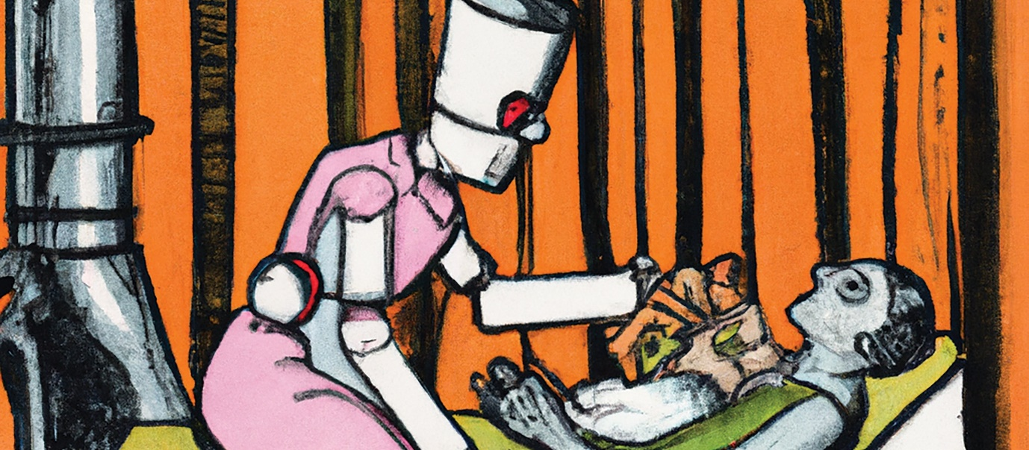
Courtesy: https://www.youtube.com/watch?v=6lcyBTis17g

- Telemedicine Robotics in New born care
The telemedicine robots are movable frames with cameras, screens, stethoscopes, and other features. A doctor can observe from any location while analyzing the patient's medical records because to the technology's ability to be connected to MRI (magnetic resonance imaging) scans and other imaging devices.
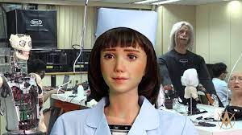
Courtesy Image: National Robotarium.

- Teladoc Robots
Teladoc Robots lend a hand to neonatologists for monitoring remotely baby’s
- Breathing
- Glucose levels
- Heart rate
- Temperature

- TRANS DISCIPLINARY RESEARCH IN NEONATAL CARE
Transdisciplinary research involves collaborative efforts by researchers from diverse disciplines to develop innovative approaches, theories, methodologies, programs, and policies. This interpretation of transdisciplinary aligns with Piaget's broader concept, describing it as a form of knowledge that surpasses the confines of individual disciplines.
Experts hailing from various fields, including medical, biomedical sciences, psychology, ethics, and law, actively engage in transdisciplinary research on topics like extreme prematurity. This research encompasses a range of responsibilities concerning parents and caregivers, ethical considerations centered on the child's best interests, legal aspects, and various psychosocial factors.

Chat GPT in Health care

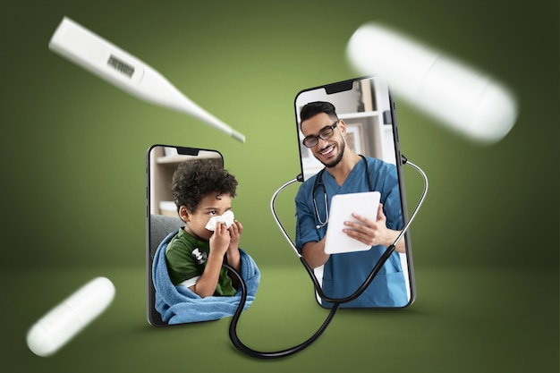
Courtesy: freepik.com/free-photo/creative-collage-telehealth-consultation
ChatGPT, a cutting-edge artificial intelligence chatbot, provides an intriguing peek into the healthcare landscape of the future. This innovative technology has the potential for diverse applications in neonatal health support, remote patient monitoring, medication management, disease surveillance, medical writing, patient triage, and beyond. Moreover, an essential medical application of ChatGPT is assisting mothers in managing their infants' health. Nonetheless, the utilization of ChatGPT raises pertinent ethical concerns and constraints, most notably related to credibility. As such, it is imperative to thoroughly contemplate and tackle these potential drawbacks and ethical issues prior to the widespread implementation of ChatGPT in the field of healthcare.
- TRANSLATIONAL RESEARCH IN NEONATAL CARE
Translating research results into practice for bridging the gapbetween new treatment and Procedures in order to improve thehealth of the neonates is the new trend.
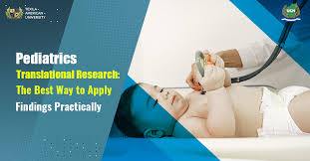
Courtesy :Texila American University
Elevated levels of sCD14-ST, specifically presepsin, are detected in sepsis cases, and increased sTREM-1 concentrations during early-onset neonatal sepsis (EOS) have been linked to higher mortality rates.
- m -Health in Neonatal care
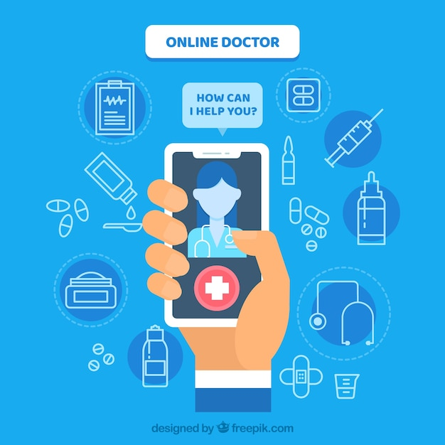
Courtesy :Freepic.com

Mobile health interventions (mHealth) have arisen as a possible remedy for the previously mentioned difficulties, offering immediate assistance to local neonatal care providers. These interventions aim to address the disparity in delivering evidence-based care in low- and middle-income nations, whether provided by trained or untrained personnel, until patients can access a facility capable of delivering appropriate care. Although there is encouraging data on the effectiveness of mHealth interventions in low- and middle-income countries, especially concerning neonatal healthcare, the available evidence remains somewhat restricted.
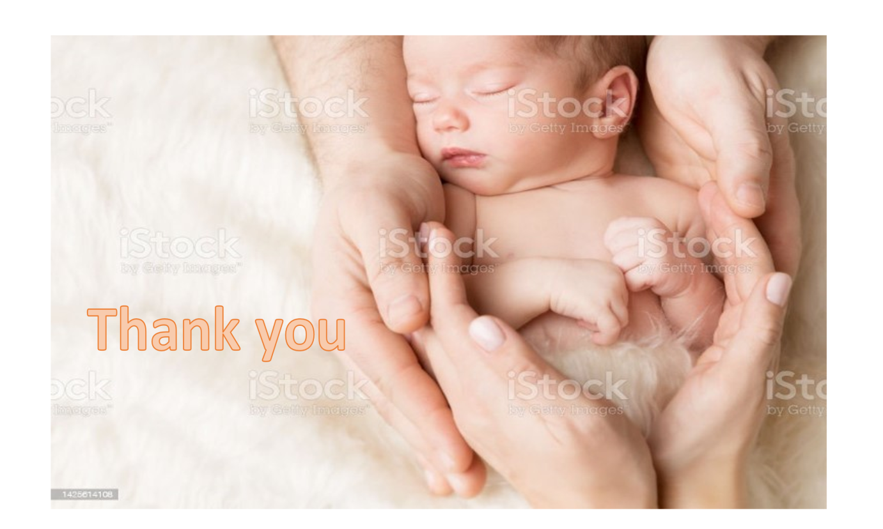
REFERENCES
1.Vivek Shukla.,Waldemar A. Carlo Technology-driven Neonatal Health Care in Low-resource Settings: Expectations and Reality:VOLUME 12, P2-3, JULY 2019June 25, 2019.https://doi.org/10.1016/j.eclinm.2019.06.005
2.Vivek V. Shukla, Waldemar A. Carlo, Susan Niermeyer, Ruth Guinsburg,Neonatal resuscitation from a global perspective,Seminars in Perinatology,Volume 46, Issue 6,2022,151630,ISSN 0146-0005,https://doi.org/10.1016/j.semperi.2022.151630.
3.Leslie Altimier DNP, RN, MSN, NE-BC ª, Raylene Phillips MD, FAAP, FABM, IBCLC ^{b} ¹The Neonatal Integrative Developmental Care Model: Advanced Clinical Applications of the Seven Core Measures for Neuroprotective Family-Centered Developmental CareNewborn and Infant Nursing Reviews:Volume 16, Issue 4, December 2016, Pages 230-244https://doi.org/10.1053/j.nainr.2016.09.030.
4.Munoz J, Shah N, Rezvani K, Hosing C, Bollard CM, Oran B, et al. Concise review: umbilical cord blood transplantation: past, present, and future. Stem Cells Transplantation Medicine, 2014; 3: 1435– 43.
5.Shearer WT, Lubin BH, Cairo MS, Notarangelo LD. Cord blood banking for potential future transplantation. Section on haematology/oncology, Section on allergy and immunology. Paediatrics 2017; 140: e20172695.
6.Lalan K Bharti ., A Prakash, Manish Jain .,Indian Academy of Paediatrics (IAP):STANDARD TREATMENT GUIDELINES 2022:Neonatal Resuscitation Program:
https://iapindia.org/pdf/Ch-104-Neonatal-Resuscitation-Program.pdf
7. Gene editing technique could transform future:6June2016.
https://www.bbc.com/news/health-36439260
8.Gene-edited babies: Current techniques not safe, say experts:4September 2020
https://www.bbc.com/news/health-54014969
9.https://www.newhopefertility.com/designer-babies/
10.UN panel warns against 'designer babies' and eugenics in 'editing' of human DNANews UN org 5th October 2015.
https://news.un.org/en/story/2015/10/511732#:~:text=Warning%20that%20rapid%20advances%20in,future%20generations%20or%20foster%20eugenics.
11.Are Designer Babies the Future Reality?Science Repository :Sep 08, 2021 10.31487/sr.blog.63https://www.sciencerepository.org/are-designer-babies-the-future-reality
12.L. Cabrera-Quiros, D. Kommers, M.K. Wolvers, L. Oosterwijk, N. Arents, J. van der Sluijs-Bens, et al. Prediction of late-onset sepsis in preterm infants using monitoring signals and machine learning Criti Care Explore, 3 (2021), Article e0302.
13. Telehealth & Telemedicine Provider | Teladoc Health®
https://www.teladoc.com/
14.Dave T, Athaluri SA, Singh S. ChatGPT in medicine: an overview of its applications, advantages, limitations, future prospects, and ethical considerations. Front ArtifIntell. 2023 May 4;6:1169595.
doi: 10.3389/frai.2023.1169595. PMID: 37215063; PMCID: PMC10192861).
15.Marc Simard,^{#1} Anne-Marie Gagné,^{#2} Raymond D Lambert,A transdisciplinary approach to the decision-making process in extreme prematurity BMC Res Notes. 2014; 7: 450.
16.Joris R. Delanghe, Marijn M. Speeckaert, Translational research and biomarkers in neonatal Sepsis, clinicalChimica Acta, Volume 451, Part A,2015,Pages 46-64,ISSN 0009-8981. https://www.sciencedirect.com/science/article/abs/pii/S0009898115000534
17.McNabb M. Chukwu E. Ojo O. et al.Assessment of the quality of antenatal care services provided by health workers using a mobile phone decision support application in northern Nigeria: a pre/post-intervention study. PLoS One. 2015; 10e012394
18.Sondaal S.F. Browne J.L. Amoakoh-Coleman M. et al.Assessing the effect of mHealth interventions in improving maternal and neonatal care in low- and middle-income countries: a systematic review.PLoS One. 2016; 11e0154664).
19. https://www.resus.org.uk/library/2021-resuscitation-guidelines/newborn-resuscitation-and-support-transition-infants-birth

