Environmental effects of Air Pollution and their Threats to Humans in the world

S.Rajesh Khanna, A. Omprakash and A.Sivaprakasam

Abstract

Air pollution is the greatest threat to public health on a worldwide basis, causing approximately 7 million premature deaths every year (WHO Reports). The term "air pollution" refers to the process through which the atmosphere becomes contaminated with particles and substances that are either poisonous or polluting. It contributes to global warming, as well as environmental problems such as pollution and acid rain, as well as health problems such as cancer and respiratory disorders. Both air pollution and global warming have been accelerated by human activities like transportation, electricity generation, industry emissions, and agricultural burning. Individuals' and politicians' concerns about the quality of the air they breathe are frequently a driving force behind their efforts to address the climate issue. When we have a desire for clean air, we speed up the process of addressing climate change.
In this age of industrialization, it is not possible to completely get rid of air pollution, but it is possible to cut back on it using a variety of methods. As part of an effort to cut down on the amount of pollution that is allowed to be discharged into the atmosphere, the government has established an air quality guidelines and is continuing to work on laws to restrict emissions.
The EPA has set National Ambient Air Quality Standards for six criteria pollutants: sulfur dioxide (S02), particulates (PM2.5/PM10), nitrogen oxides (NOx), carbon monoxide (CO), ozone (O3), and lead (Pb).

Key words: World Health Organization (WHO), National Ambient Air Quality Standard (NAAQS). Air Quality Index (AQI), Particulate Matter (PM2.5 microns/PM10microns)
______________________

1.1 INTRODUCTION:
Air toxics are a subset of air pollutants that are often found in trace amounts in the atmosphere. Despite this, air toxics possess toxic properties that make them capable of causing adverse health consequences even at exposure levels that are quite low.
Air quality is a fundamental requirement for human health and contentment where air pollution poses an extreme threat, and it is caused by smoke, gases, grit, and dust emitted by home and industrial chimneys, locomotives, and ships; exhaust gases emitted by motor vehicles; and solid and gaseous discharges from chemical plants and industrial operations. Both our physical and emotional health might suffer as a direct result of pollution. It maintains the fog, contributes to the spread of disease, and may even result in death. Flue gases that are high in sulphur are a leading cause of corrosion in structures and metals. The level of acidity in the soil rises, the growth of crops is stunted, and the health of farm animals is harmed. fly-ash, smoke, grit, sulphur oxides, and oxides of nitrogen (NOx) are the combustion byproducts that do the most damage to the environment. The exhaust from diesel engines and automobiles contains lead, which is known to cause brain damage in youngsters, as well as carbon monoxide and tars, both of which are known to cause cancer.
However, air pollution has been and will continue to be a major health danger during the process of economic development. Economic growth, urbanisation, energy consumption, transportation, motorization, and a rise in urban population are all factors that contribute to air pollution. The wide variety of air contaminants, the presence of negative consequences at varying degrees of pollution, and the large population at risk have made this an issue of growing concern. Even when air pollution levels are below the levels suggested by air quality rules, the consequences of air pollution can sometimes be noticed.

1.2 Pollutants types and its impacts
Particulate matter (PM) is a typical instance of a proxy indicator for air pollution. There is substantial evidence to support the notion that this pollutant can have a harmful effect on one's health if they are exposed to it. Sulphates, nitrates, ammonia, sodium chloride, black carbon, mineral dust, and water are the most common components found in particulate matter (PM).
Carbon monoxide (CO) is a colourless and odourless gas that is created when carbonaceous fuels such as wood, gasoline, coal, natural gas, and kerosene are burned in an incomplete manner in appliances such as simple stoves, open flames, wick lights, furnaces, and fireplaces. Carbon monoxide has no discernible taste or smell. The emissions of motor vehicles are the primary contributor to the presence of carbon monoxide (CO) in the surrounding air.It is more difficult for the body's cells to bind to oxygen when carbon monoxide is present because it is able to go through the lung tissues and into the bloodstream. This oxygen deficiency causes harm to the body's tissues and cells. Carbon monoxide exposure can result in a variety of flu-like symptoms, including difficulty breathing, tiredness, disorientation, and headaches. It is possible to die from being exposed to high doses of carbon monoxide.
Ozone-Smog is primarily composed of ground-level ozone, commonly referred to as O3. Photochemical reactions with pollutants such as volatile organic compounds, carbon monoxide, and nitrogen oxides (NOx) that come from cars and industry result in the formation of this molecule. Because of the photochemical nature, the levels of ozone in the atmosphere are at their peak when the weather is bright and sunny. It is important to point out that common household appliances, such as portable air cleaners, are also capable of producing ozone.

Nitrogen dioxide, also known as NO2, is a potent oxidant that appears reddish-brown in colour and is soluble in water. The combustion of fuels at high temperatures in operations such as those used for heating, transportation, industrial, and power generation are examples of ambient sources of nitrogen dioxide (NO2). Nitrogen oxides (NOx) can be produced in the home by appliances that burn fuels, such as furnaces, fireplaces, gas stoves and ovens, and even fireplace logs. Nitrogen dioxide can irritate the airways and make existing respiratory conditions worse when exposed to it.NO2 is an essential component in the formation of ozone, a pollutant that is strongly associated with asthma and other respiratory diseases.
Sulphur dioxide (SO2) is a gas that dissolves easily in water despite its inert appearance. Most of it comes from burning fossil fuels for things like home heating and commercial production of electricity. Hospitalisations and ER visits related to asthma have been linked to exposure to SO2.
Lead (Pb) and lead particulate compounds can be noticed in the dust which is produced in the home by items such as paints, ceramics, pipes and plumbing materials, solders, gasoline, batteries, ammunition, and cosmetics. These products can contaminate the dust in the home with lead (Pb) and lead particulate compounds. The exhaust of vehicles that run on lead-containing fuel can also contribute to the presence of lead in the surrounding air.
Children and women who are pregnant are particularly vulnerable to the adverse health effects that lead can cause. issues with behaviour and learning, a lower IQ and hyperactivity, delayed growth, hearing issues, and anaemia are some of the health effects that can occur in children who are exposed to lead. Ingestion of lead can, in extremely unusual circumstances, result in convulsions, coma, and even death. In pregnant women, the potential for health problems includes stunted foetal growth and delivery of the baby too soon. Adults who are exposed to lead have an increased risk of adverse cardiovascular effects, including elevated blood pressure, the incidence of hypertension, impaired renal function, and an increased risk of reproductive difficulties in both men and women.
Polycyclic Aromatic Hydrocarbons - Particulate forms of compounds known as polycyclic aromatic hydrocarbons, or PAH, can be found in the environment. They are a group of chemicals which are produced mostly by the incomplete combustion of organic matter (such as when meat is being cooked), as well as the incomplete combustion of fossil fuels in appliances such as coke ovens, diesel engines, and wood-burning stoves. In addition, they are produced when tobacco is burned. Eyes and respiratory passageways can get irritated after only a brief exposure. Lung cancer has been linked to PAH exposure that is prolonged over time.
Formaldehyde is a gas that is odourless but has an extremely terrible taste. It is one among the volatile organic compounds (VOCs) that can be observed indoors the most frequently. Formaldehyde can be emitted into the air by a number of different materials, including those used in construction (such as particleboard, plywood, glue, and paint), as well as those used in the home and for personal care (such as carpets, draperies, cleaning solutions, and hair sprays). Combustion processes, such as smoking, heating, cooking, or the burning of candles or incense, can also be additional sources of pollution found within.An irritation of the eyes, nose, and throat, as well as an increase in the body's sensitivity to allergens, can result with even a brief exposure to formaldehyde. On the other hand, formaldehyde exposure over a prolonged period of time has been linked to nasopharyngeal cancer.
Radon is a radioactive gas that can be found in natural environments. It is formed as a result of the natural radioactive decay of uranium that's present in rocks and soil, and it does not have a smell, colour, or taste. Radon can also be present in the environment's water supply. Radon undergoes decay, which results in the production of more radioactive particles. When we breathe, the particles are carried into the lungs and deposited on the cells lining the airways, where they can cause DNA damage which may lead to lung cancer. Depending on the average radon level and the smoking incidence in a country, radon can be responsible for anywhere from 3% to 14% of all cases of lung cancer. People who smoke have a significantly increased chance of developing lung cancer due to radon exposure; in fact, the risk is 25 times higher for smokers than it is for non-smokers.
1.3 Air Quality guidelines and standards
World Health Organization (WHO) daily average PM2.5 recommendation was developed to express the concentration at which a 24 hour exposure could entail health hazards that are comparable in severity to those associated with chronic exposure to levels that were in excess of the WHO annual average PM2.5 guideline level. When acute exposure to PM2.5 concentrations that are higher than the daily average guideline occurs more than three to four days in a given year for individuals in surroundings that otherwise support the yearly PM2.5 guideline level, the risks that are posed to human health increase quantitatively.
Particulate Matter(PM), often known as particle pollution, is a phrase used to describe a mixture of solid particles and liquid droplets that can be found in the air. Some particles, such as dust, dirt, soot, or smoke, are either sufficiently large or dark that they may be observed with the naked eye. Some are only discernible through the use of specialised equipment, such as an electron microscope.PM10 refers to inhalable particles with diameters that are generally 10 micrometres and smaller, while PM2.5 refers to fine inhalable particles with diameters that are generally 2.5 micrometres and less. How incredibly minute is a quarter of a millimetre? The diameter of a typical human hair is approximately 70 micrometres, which places it approximately thirty times larger than the diameter of the greatest fine particle.
While PM10 is more likely to settle on the surfaces of the bigger airways in the upper portion of the lung, PM2.5 is more likely to travel into and deposit on the surface of the deeper regions of the lung. Particles that become lodged on the surface of the lungs have the potential to cause damage to the surrounding tissue as well as inflammation. The biggest danger to people's health is posed by fine particles (PM2.5). These minute particles are able to travel to the deeper parts of the lungs, and some of them may even enter the circulation. The lungs and the heart of a person can be negatively impacted by exposure to these particles. Even though coarse particles (PM10-2.5) provide less of a health risk, they nonetheless have the potential to aggravate a person's eyes, nose, and throat.
Calculating the annual average concentration of PM2.5 based on an area based on the PM2.5 data at the city level and weighting the results using city populations provides a global context. The formula is (Σ city mean PM2.5 (μg/m³) X city population)/ Total regional population covered by available city data.
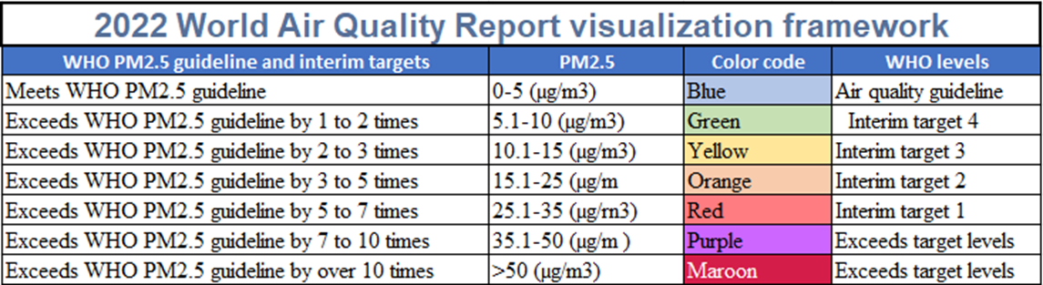

  - Air Pollution impact in India
The Central Pollution Control Board is responsible for the implementation of the National Air Quality Monitoring initiative (NAMP), which is an ambient air quality monitoring drive that spans the entirety of the nation of India. The network is made up of 804 operational stations, which are spread over 344 cities and towns across 28 states and 6 union territories of the country and it will assess the prevalence of three different air pollutants SO2, NO2, and PM10.
PM2.5, carbon monoxide (CO), ammonia (NH3), lead (Pb), ozone (O3), benzene (C6H6), benzo (a)pyrene (BaP), arsenic (AS), and nickel (Ni) are some of the other indicators monitored at strategic locations and gradually added to the NAMP monitoring network.
Over fifty percent of this pollution is caused by industry, followed by twenty-seven percent caused by automobiles, seventeen percent caused by the burning of crops, and seven percent caused by cooking in the home. Over two million people in India lose their lives each year to conditions that can be related to air pollution.
During the winter months, Delhi's air quality consistently falls into the "severe" category. This is the case year after year. The custom of burning the stubble after the harvest to clear the land in preparation for the planting of the crop for the next season is the primary cause of this phenomenon. It has been reported that this factor alone is responsible for 32% of the PM2.5 particulate matter in Delhi. The amount, which comes in at 292 micrograms per cubic metre, is five times higher than the safe limit that is advised by the World Health Organisation. The dispersal of airborne particles, which can be accomplished through wind or rain, is significantly influenced by the weather conditions.
Because the levels of the pollutant PM 2.5 are frequently much beyond the recommended range of exposure established by the World Health Organisation (sometimes over 5 times higher), persons who are exposed to it frequently experience severe problems with their respiratory systems. This is due to air pollution in the outside environment as well as inside the home.
According to the available data, there were over 1.6 million deaths in 2019 that could be attributable to excessive levels of air pollution. Strokes, diabetes, lung cancer, and myocardial infarctions are the diseases which led to people's deaths. Additionally in this year, the report titled "State of Global Air 2020" made the observation that air pollution is currently the form of pollution that poses the greatest risk of death compared to all other types.
Due to the fact that PM 2.5 particulates are so small, poor air quality has a significant impact on the human respiratory system. These particulates penetrate the lung tissue to such a depth that they reach the alveoli. From this point, It can travel through the tissue of the body and potentially attack the heart. Typical side effects of breathing in polluted air include a reduced lung capacity, coughing, sore throats, exhaustion, lung cancer, and headaches.
The Ministry of Earth Sciences has recently launched the cutting-edge Air Quality Early Warning System in collaboration with the Indian Institute of Tropical Meteorology (IITM), the India Meteorological Department, and the National Centre for Medium Range Weather Forecasting.
The government has launched the "PRATYUSH" High Power Computing (HPC) system at the Indian Institute of Tropical Meteorology (IITM), making it the first and fastest Multi Petaflop supercomputer in the world.
For larger metropolitan centres in India, the government has also implemented the System of Air Quality and Weather Forecasting Research (SAFAR) to offer location-specific information on air quality in near real-time.With its Smart Cities Mission, India has taken a significant step towards a more progressive urban future. The smart city has many applications for reducing air pollution.

  - Air Pollution Statistics India Cities (2022)
The PM2.5 level in India had a yearly average of 53.3 g/m3 in 2022, which was just a slight improvement from the average level of 58.1 g/m3 in 2021. Delhi had an average PM2.5 level of 92.6 μg/m3 in 2022, a little below the average of 96.4 μg/m3 in 2021.
The report makes a distinction between New Delhi and Delhi, with New Delhi having an annual average PM2.5 level of 89.1 μg/m3.Both Darbhanga and Asopur, which are both classified among the top 15 most polluting cities in the region, were each given a government station in the year 2022. Over sixty percent of the cities in India that were included in this analysis had annual PM2.5 levels that were at least seven times higher than the WHO threshold. The most polluted city in India is Bhiwadi, which had annual PM2.5 values of 92.7 g/m3.
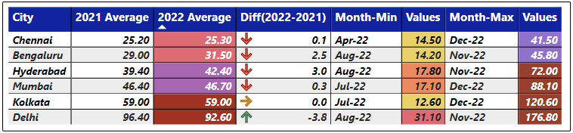
Data extracted from 5th Annual World Air Quality Report

The burning of crop stubble is another significant problem in the region; however, this is a sporadic occurrence that is restricted to a select number of places, including Delhi and North India. The environmental compliance regulations for coal mines in India were reduced in 2022, which allowed for increased production. This was done in reaction to power shortages that were made worse by extremely hot weather.46 The amount of steam coal and thermal coal imported reached a ten-month low in the month of November, while the overall amount of coal produced rose by 11.7 percent to 75.9 million tonnes.47,48
The bio decomposition method, also known as "Pusa decomposers," was developed by scientists as an alternative to the practise of burning stubble. This method turns agricultural residue into compost. This new information comes at a time when pollution is an issue in Delhi and many other regions of Northern India. Stubble burning causes the air to be filled with smoke during the winter months, making it difficult to see or breathe in certain areas.
Globally, air pollution is a silent killer. The air pollution levels in India are among the highest in the world, posing a heavy threat to the country's health and economy. All of India’s 1.4 billion people are exposed to unhealthy levels of ambient PM 2.5 – the most harmful pollutant - emanating from multiple sources. These small particulates with a diameter of less than 2.5 microns, is about one-thirtieth the width of a human hair. Exposure to PM 2.5 can cause such deadly illnesses as lung cancer, stroke, and heart disease. Ambient and indoor air pollution is estimated to have caused 1.7 million premature deaths in India in 2019. The health impacts of pollution also represent a heavy cost to the economy. Lost labor income due to fatal illness from PM 2.5 pollution in 2017 was in the range of $30-78 billion, equal in magnitude to about 0.3-0.9 percent of the country’s GDP

  - Paris Agreement's most polluted countries and PM2.5 data by region
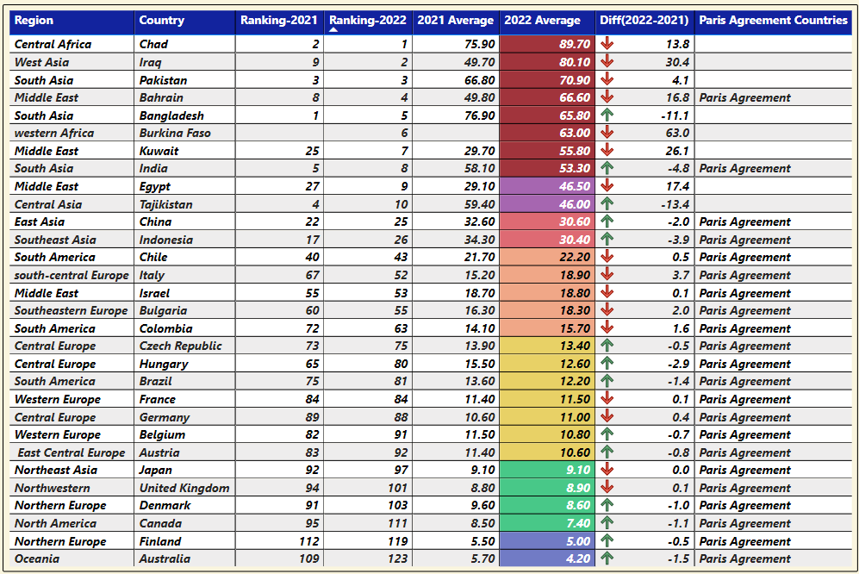
Data extracted from 5th Annual World Air Quality Report
The 5th Annual World Air Quality Report exposes alarming facts about the countries, territories, and regions of the world that have the highest levels of air pollution in 2022. Only five percent of countries, according to the IQAir World Air Quality Report 2022, meet the WHO PM2.5 Air Pollution Guideline.
The data from over 30,000 air quality monitoring stations in 7,323 locations throughout 131 nations, territories, and regions was analysed by IQAir's air quality scientists for this year's report. The locations ranged from the United States to Antarctica.
Out of a total of 131 countries and regions, 118 (or 90%) exceeded the annual PM2.5 guideline value set by the WHO, which was set at 5 g/m3. On the other hand, only six countries (Australia, Estonia, Finland, Grenada, Iceland, and New Zealand) fulfilled the WHO PM2.5 recommendation (annual average of 5 g/m3 or less).
Africa is still the continent with the fewest people living there. Only 19 out of the total 54 countries have adequate data on air quality.
Coffeyville, Kansas was the city with the highest pollution levels in the United States. The city of Columbus, Ohio, was the most polluted large metropolis in the United States.
Ten of the fifteen most polluted cities in the United States were located in the state of California, while Las Vegas was ranked as the cleanest significant city in the United States.

Eight of the world's ten cities with the worst levels of air pollution were located in Central and South Asia, making this region the most polluted in the world.
it is estimated to be the cause of approximately 7 million deaths annually across the globe, and this number is expected to continue to rise. Every year, air pollution is responsible for the premature deaths of 4 million people in Asia and the Pacific region alone, while 4 billion people throughout the world are exposed to levels of air pollution that are unhealthy.
Air pollution has repercussions beyond the human body. Up to 45% of modern-day global warming can be attributed to SLCPs, which also contribute to higher sea levels and more frequent and severe weather phenomena including droughts, fires, and storms. These pollutants contribute to global warming by a factor of 10 to a factor of a thousand or more, compared to carbon dioxide.

  - Initiatives taken by the Government of India to Combat Air Pollution
The government of India launched the National Clean Air Programme (NCAP) in the beginning of 2019. They have set a goal to lower the levels of air pollution by 20-30 percent by the year 2024 in about 122 of the cities that are the most severely afflicted. Implementation of health risk communications plans, an increase in the number of monitoring stations, and improved control of industrial emissions are some of the actions that are now being performed in New Delhi, Ahmedabad, and Pune respectively.
The four major air pollutants that are commonly monitored by NCAP are sulphur dioxide (SO2), oxides of nitrogen (both NO2 and NO), PM10 particles, and suspended particulate matter (SMP). These are going to be monitored at 308 stations spread out throughout 115 cities and towns across 25 states and 4 territories. Meteorological information, such as wind speed and direction, relative humidity, and temperature, are also captured during this process. On a consistent basis, measurements of both the particulate and gaseous contaminants that are present are gathered. These readings are obtained once per week, which results in 104 observations being generated over the course of one year.
The usage of kerosene as a fuel has almost been eliminated in Delhi, and nearly all of the city's citizens now prepare their meals with liquid petroleum gas (LPG or NPG). Wood, coal, and dried animal manure are still the primary sources of energy for the remaining 10% of the world's population.
One of the possible courses of action being contemplated is the establishment of a "green" corridor stretching from Gujarat to Delhi that would be 1,600 km long and five metres broad. This corridor would be created by the planting of 1.35 billion native trees over the course of the next ten years.
It is hoped that with the decrease of carbon emissions, CO2 gases will be reduced by twenty percent by the year 2030 and will reach zero by the year 2075.
In order to fulfil the strict BS6 criteria and achieve the goals that India has set for itself to reduce air pollution over the next several years, the country plans to implement over 1,000 buses that are powered by electricity and to upgrade engines that run on fossil fuels. By the year 2023, it is hoped that 25 percent of all privately owned vehicles that are driven on Indian roads would be Electric Vehicles (EVs), and that all power plants will also be using renewable energy. The use of municipal roads will be prohibited for any vehicle that is more than 15 years old or that does not meet the BS6 emission requirements.
The following are the primary policies that cover the prevention of air pollution and the movement towards clean air:Act of 1981 Relating to the Prevention and Control of Pollution in the Air
- NAMP stands for the National Air Quality Monitoring Programme.
- National Ambient Air Quality Standards (NAAQS)
- National Air Quality Index (AQI)
- Comprehensive Action Plan (CAP) in 2018 to identify timelines and implementing agencies for actions identified for the prevention, control, and mitigation of air pollution in Delhi and NCR Graded Response Action Plan (GRAP) for the prevention, control, and abatement of air pollution in Delhi and NCR.
- The National Clean Air Programme (NCAP) is a joint initiative between the Jawaharlal Nehru National Solar Mission (JNNSM) and the Environment Pollution (Prevention and Control) Authority (EPCA).
- Pradhan Mantri Ujjwala Yojana

Conclusion:
Determine the causes of air pollution and keep an eye on the air quality. Adopt, update, and put into practise national air quality standards in accordance with the most recent set of WHO Air Quality Guidelines. Encourage the shift towards the sole use of clean household energy for all domestic cooking, heating, and lighting needs. Establish more stringent regulations for the emissions and efficiency of automobiles, as well as obligatory inspection and maintenance requirements. Invest in power generation and homes that are more energy efficient. Develop transportation networks that are friendly to walkers and cyclists, as well as public transportation systems that are secure and cost-effective and more push the government transportation to Electric Vehicle (EV’s). Efforts should be made to improve industry and municipal waste management. Reduce the burning of agricultural waste, forest fires, and some agro-forestry operations (such as the manufacturing of charcoal, for example). Include education on air pollution in the training of health professionals and provide the health sector with the tools it needs to get involved. In order to prevent stubble burning, the Indian Agriculture Research Institute developed a bio-enzyme that is known as PUSA.This enzyme begins to break down the stubble between 20 and 25 days after it has been applied, changing it into manure that further enhances the soil's fertility. The government of Delhi has started using the Pusa decomposer, and it is also urging the governments of other states to follow it
The first four months of 2023 (Jan - April) have the highest proportion of Good to Moderate Air Quality days in Delhi compared to the equivalent period over the past seven years, starting in 2016.Delhi had 108 days of 'Poor to Severe' air quality in 2016, and it's expected to have 68 in 2023.In 2023, the average daily concentration of PM10 and PM2.5 was at its lowest, and the Daily Average AQI was also at its lowest.In the short, medium, and long term, Air Quality is predicted to improve thanks to persistent field-level efforts and targeted governmental initiatives.
Construction using Prefabricated Concrete Units Rapidly expanding cities have higher levels of air pollution due in large part to building dust.Niti Aayog has suggested using ready-made concrete as a means of addressing this issue and lowering the environmental impact of construction projects.
To achieve the NCAP's goal of a 40 percent decrease in particle concentrations by 2026, it is essential to have access to a complete national emission database. Emissions reduction efforts can be tracked more effectively if their source emissions can be identified.

References:

https://www.ncbi.nlm.nih.gov/pmc/articles/PMC7805008/
https://loksabhadocs.nic.in/Refinput/New_Reference_Notes/English/15072022_173626_102120463.pdf
https://pib.gov.in/PressReleasePage.aspx?PRID=1593056
https://thewire.in/environment/india-had-eight-worst-air-pollution-in-2022-report
https://www.greenpeace.org/india/en/press/15431/indias-air-quality-is-seven-times-worse-than-who-guideline-iqair-world-air-quality-report-2022/
Fundamentals of Air Pollution - Daniel A. Vallero - Google Books
https://www.who.int/news-room/fact-sheets/detail/ambient-(outdoor)-air-quality-and-health?gclid=Cj0KCQjw_O2lBhCFARIsAB0E8B-6JBOJL0XN9C9iap_2SMQSpi69iubNZbcfME0Jgu6LtlO6AZWJnnIaAjZ3EALw_wcB
https://environhealthprevmed.biomedcentral.com/articles/10.1007/s12199-007-0018-5
https://www.thelancet.com/journals/lanplh/article/PIIS2542-5196(20)30298-9/fulltext
India Air Quality Data Analysis. A report by Health Effects Institute on… | by Shubhankar Rawat | Towards Data Science
NAAQS Table | US EPA
India Air Quality Index (AQI) and Air Pollution information | IQAir
Air Pollution Note – Data you need to know (unep.org)
Climate and Clean Air Conference 2023 (unep.org)
pib.gov.in/PressReleaseIframePage.aspx?PRID=1920957
AQI Ranking: Real-Time Most Polluted Cities in The World

Ph.D Research Scholar (Part-Time), PG and Research Department of Economics, The New College (autonomous), Chennai-14. E.Mail: srajeshkanna@gmail.com
Ph.D Research Scholar (Part-Time), PG and Research Department of Economics, The New College (Autonomous), Chennai-14. omaprakash@gmail.com
Ph.D Research Scholar (Part-Time), PG and Research Department of Economics, The New College (Autonomous), Chennai-14. asivaprakasam@gmail.com

