Optimizing Wind Energy: Unleashing the Potential of AI in MPPT and Load Forecasting

Deepak Rathod
Research Scholar, Department of Renewable Energy, Rajasthan Technical University, Kota, Rajasthan Pin – 324010, India.
deepak.phd21@rtu.ac.in

Dr. Lata Gidwani
Associate Professor, Department of Electrical Engineering, Rajasthan Technical University, Kota, Rajasthan, Pin- 324010, India.
lgidwani@rtu.ac.in

Rohan Gupta
Assistant Professor, Department of Electrical and Electronics Engineering, Shri Vaishnav Vidyapeeth Vishwavidyalaya, Indore, Madhya Pradesh
Pin – 453111, India.
rohangupta@svvv.edu.in

ABSTRACT
In the contemporary global context, a significant transformative process is currently unfolding on a global scale. The ongoing revolution is causing a transformation in the lifestyles of individuals, leading to significant disruptions in traditional business structures and established processes. Like many other businesses, the power sector is currently experiencing a significant transformation. The power sector is undergoing transformation due to various factors like the adoption of distributed energy sources, the proliferation of electric vehicles, the implementation of advanced metering and communication infrastructure, the utilisation of management algorithms, the implementation of energy efficiency efforts, and the integration of new digital solutions. In recent years, there has been a growing utilisation of artificial intelligence approaches to tackle issues related to renewable energy due to its ability to effectively handle intricate nonlinear data structures. The prospective acceleration of worldwide renewable energy adoption in the future through technological advancements. Currently, artificial intelligence (AI) is the primary catalyst for the rapid technological revolution. In order to fully harness the potential of wind power, it is imperative that wind turbines exhibit optimal efficiency in converting energy. This paper provides a comprehensive examination of AI-based Maximum Power Point Tracking (MPPT) techniques in the context of wind energy systems. The impact of working conditions on yield is noteworthy due to the increasing sophistication of wind energy conversion systems (WECS) in response to unforeseen fluctuations in wind speed conditions. Attaining the optimal yield is frequently a formidable task. MPPT controllers are receiving significant interest due to this phenomenon. This article provides a comprehensive examination of both Artificial Neural Networks (ANN) and Fuzzy Logic (FL) as utilised in the context of Wind Energy Systems (WES). This study elucidates the commonly adopted ways to optimise yield under diverse scenarios. Both Artificial Neural Networks (ANN) and Fuzzy Logic (FL) can be utilised as alternatives to conventional methods for control and optimisation purposes. The selection and evaluation of both approaches are dependent on the specific application at hand. Statistical data is provided regarding both the existing methodologies employed in this particular subject, as well as their potential future advancements. The completion of a comprehensive bibliography, the provision of proposals for further research, and the emergence of other issues have transpired. Ultimately, this platform holds potential value for future research in wind power systems, serving as a valuable resource for scholars, energy planners, and lawmakers.

Keywords— Neural Networks, Soft Computing, Intelligent Control fuzzy logic systems of types 1 and 2, respectively.

ABBREVIATIONS

AI | Artificial Intelligence
ANN | Artificial Neural Networks
FL | Fuzzy Logic
MPPT | Maximum Power Point Tracking
WECS | Wind Energy Conversion Systems

INTRODUCTION

The global energy demand is projected to experience rapid growth. Regarding the phenomena of rapid industrialization, rapid population rise, and social development [1], [2]. Indeed, electrical energy plays a crucial role in contemporary society and is intricately linked to the functioning of modern industries. There is now a competition underway to develop a new generation of power. As a result of the escalating energy demand and the consequential environmental repercussions associated with traditional energy sources, the energy sector has been urged to expedite research efforts pertaining to alternative energy sources. The wind energy sector is considered to be highly promising and profitable, yet it necessitates advancements in technology and financial resources. Efforts pertaining to technology are focused on effectively using the power of wind [3]. Hence, MPPT algorithms can be employed to extract the maximum power under different wind speed situations. The structure of an MPPT approach basically comprises two fundamental components. During the initial stage, an algorithm is employed to identify the set point that exhibits the highest power. The generation of the control signal is accomplished inside the second part through the use of diverse control techniques. Hence, the enhancement of the efficiency of each component will enable the development of an effective Maximum Power Point Tracking (MPPT) technique [4]. Several scholars have documented various MPPT control techniques for wind energy systems in the literature. These methods encompass tip speed ratio [5], power-signal feedback [6], optimal torque control [7], and hill climbing search [8], along with their respective variations [9], [10], in order to tackle the aforementioned issues. The efficacy of these procedures in locating the Maximum Power Point (MPP) may be compromised due to the inherent unpredictability of environmental variables. The effectiveness of wind energy conversion systems (WECS) has been enhanced in many studies by the application of soft computing and artificial intelligence (AI) techniques. Several researchers have created a variety of methods utilising AI tools to effectively address complex systems and accurately depict increased levels of uncertainty. The maximum power point tracking (MPPT) problem can be effectively addressed through the utilisation of artificial intelligence (AI) techniques, which offer adaptability and computing intensity [11], [12]. Indeed, artificial intelligence has the potential to enhance the efficiency and cost-effectiveness of WES operations. The utilisation of AI technology in wind energy systems (WES) has the potential to optimise power output, reduce maintenance costs, enhance energy yield, and improve system stability and reliability. The field of artificial intelligence aims to gain an understanding of human cognition in order to create intelligent entities capable of effectively addressing complex problems [13]. Artificial intelligence finds applications in a wide range of domains, including but not limited to information retrieval, databases, medical science, business, robotics, and art. Various learning theories, including neural learning, statistical learning, and evolutionary learning, constitute the fundamental basis of artificial intelligence (AI) [14], [15]. This essay will primarily focus on the efficacy and use of artificial intelligence (AI) in the domain of wind energy system optimal control. This paper makes a significant contribution by conducting a comprehensive and detailed investigation of Maximum Power Point Tracking (MPPT) systems that are based on Artificial Intelligence (AI). Artificial Neural Networks (ANNs) and Fuzzy Logic Controllers (FLCs) are widely recognised as the two primary artificial intelligence techniques employed for Maximum Power Point Tracking (MPPT). These methods are visually represented in Figure 1. Furthermore, neural learning emerges as the predominant method employed across several industries [16].
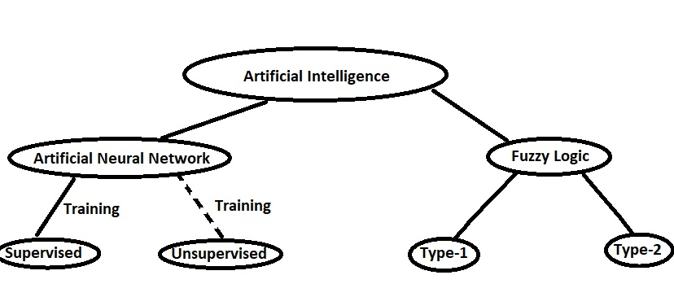
Figure 1: MPPT strategies based on artificial intelligence.

The sophisticated artificial neural networks (ANNs) are constructed using organic neurons as their foundation. These structures offer a viable resolution for issues that are not amenable to analytical solutions [3]. An artificial neural network (ANN) is comprised of individual computational units referred to as neurons, which are interconnected by weighted connections. Figure 2 presents a comprehensive depiction of the structure of the Artificial Neural Network (ANN). There are four primary attributes that can be employed to differentiate an Artificial Neural Network (ANN) from other models: the information display, input and output data linkages, training methodology, topology, and training strategy. Upon receiving a dataset and commencing the training phase, the artificial neural network (ANN) proceeds to adjust the weights associated with the connections between its constituent neurons. The training process can be classified as supervised training when the output is predetermined, whereas it is categorised as unsupervised training when the result is not known [3], [17] (see Figure 1). Furthermore, Zadeh made the inaugural introduction of fuzzy logic, also known as FL, in 1975 [18]. A Fuzzy Logic Controller (FLC) is a specific type of control system that utilises Fuzzy Logic (FL) to determine the most suitable control action. A fuzzy logic controller (FLC) has the capability to effectively govern the operational dynamics of a wind turbine within the domain of wind energy. The controller utilises fuzzy logic methods to determine the optimal control action, which may involve adjusting the generator torque or speed, as well as the blade pitch or yaw angle, in order to improve power generation. The controller receives data from many sensors installed on the turbine, including measurements of wind speed and direction. FLCs can also be employed for the purpose of predicting and overseeing the operations of wind farms. A Fuzzy Logic Controller (FLC) is comprised of three fundamental elements: a defuzzification module, an inference engine, and a fuzzification module (19). Figure 3 illustrates the essential construction of a Fuzzy Logic Controller (FLC). A fuzzy logic controller (FLC) utilises a series of rules to process the input variables and generate the output of the controller. In contrast to precise numerical values, linguistic expressions such as "low," "medium," and "high" are commonly employed to delineate regulatory measures. This feature allows the controller to consider a spectrum of values instead of a singular value for each input and output. In this review, we will focus on the correct functioning and potential utility of fuzzy logic in certain domains such as classification, control, and pattern recognition. Specifically, we will explore its application in tasks such as wind turbine optimal control. Type-2 fuzzy logic, an expanded version or extension of type-1 fuzzy logic, enables the representation of imprecision to a significant extent [20]. This paper begins with a concise introduction, followed by a section that explores the application of artificial intelligence in the context of forecasting. This section presents various methodologies for forecasting in Photovoltaic (PV) systems and wind energy systems. The subsequent step involves the utilisation of artificial intelligence in the process of maximum power point tracking. This section also encompasses an examination of diverse machine learning strategies that have been put out by multiple writers. The subsequent section pertains to inverters and the many artificial intelligence systems that have been developed to tackle distinct challenges associated with inverter systems. The concluding section provides an overview of the advantages and obstacles associated with the integration of artificial intelligence into renewable energy systems.
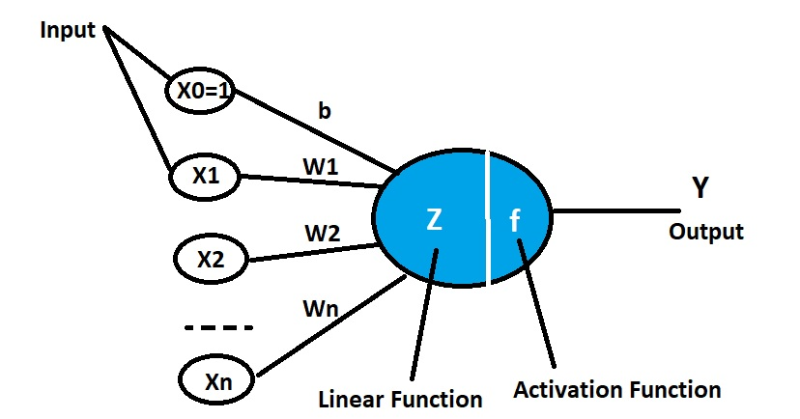

Figure 2: Structure of a biological neuron vs artificial neuron

.
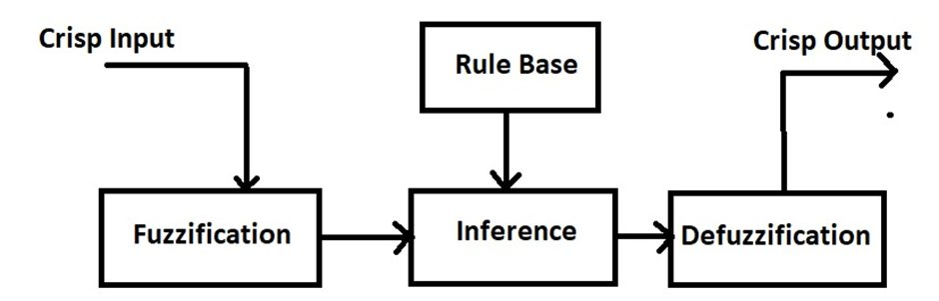

Figure 3: A basic structure of a FLC

WIND PREDICTION

DThe production of power in wind energy systems differs from standard thermal generation systems due to the stochastic nature of wind supply. The primary objective of forecasting in wind generation systems is to addressing the challenge of effectively managing the discrepancy between power generation and demand within the power system. The prevailing approach utilised in studies for wind forecasting is the neural network, namely the multi-layer perceptron. Multi-layer perceptrons are commonly advocated as the neural network designs of choice for short-term wind speed predictions. The concept of recurrent neural networks was introduced by Elman et al. In order to enhance their performance, a simultaneous recurrent neural network represented by particle swarm optimisation was suggested [21]. The adaptive neural fuzzy system model (ANFIS) is a hybrid approach that combines two artificial intelligence techniques, namely artificial neural networks (ANN) and fuzzy logic. The utilisation of fuzzy logic models is employed in cases where a significant amount of effort is required to determine the characteristics of a system and develop an accurate model. The Bayesian technique is also utilised in the prediction of wind speed. Fuzzy logic-based models are being developed at the wind farm to anticipate wind speed and power generation. Typically, the training of these models involves the utilisation of genetic algorithms as a learning mechanism. The efficacy of short-term forecasting has witnessed notable advancements, progressing from minute-scale to hour-scale predictions. The primary drawbacks of these models are their substantial computational demands and the presence of multiple fuzzy rule bases.

MAXIMUM POWER POINT TRACKING

Maximum power point tracking (MPPT) involves the utilisation of a control system that is equipped with a suitable algorithm to generate an optimal duty cycle. The power DC-DC converter employs the duty cycle in order to optimise power extraction from the photovoltaic (PV) array. When constructing the optimal maximum power point tracking (MPPT) technique for photovoltaic (PV) systems, several issues emerge, including concerns regarding efficiency, an escalation in overall cost, energy loss, challenges in implementation, and design-specific considerations. Various maximum power point tracking (MPPT) strategies have been devised for solar systems, such as perturbation and observation (P&O) [23], hill climbing [25], and incremental conductance [24]. Novel methodologies, such as fuzzy logic, exhibit enhanced efficacy compared to conventional methodologies in relation to response time and diminished oscillations at the maximum power point. However, these methodologies are susceptible to drift issues when confronted with varying irradiance data [22]. The selected input parameters for the artificial neural network-based maximum power point tracking (MPPT) technique in photovoltaic (PV) systems encompass various factors. These factors include the short circuit current, open circuit voltage, output current, terminal voltage, as well as environmental or ambient factors such as module temperature, solar irradiance incidence on the module, and wind speed. The input layer of the neural network model receives these parameters, which then propagate through the hidden layer before reaching the output layer. The output layer is responsible for generating the estimated duty cycle of the DC-DC converter, which is necessary for monitoring the maximum power point. During the process of training, the weights of neurons undergo modifications to establish a mapping between the input and output. The selection about the amount of input variables and nodes is significantly influenced by factors such as system complexity, data accessibility, and processing demands. The efficacy and precision of a neural network-driven approach The determination of the maximum power point tracker is contingent upon the design and implementation of the algorithm within the hidden layers [26]. Many suggested MPPT controllers that are based on artificial neural networks utilise a feed-forward-backpropagation strategy for training their models. In this type of artificial neural network (ANN), the transmission of information occurs bidirectionally, encompassing both forward and backward directions, in order to facilitate the modification of the weight link.Various sets of inputs are applied to the hidden layer using different weight magnitudes, and ultimately, the outcome is received by the output layer. In order to minimise the disparity between the observed and predicted outcomes of the Artificial Neural Network (ANN) model, a backpropagation network is employed, which utilises a gradient descent method to modify the weights between each layer [27], [28], and [29]. Both the fuzzy logic-based perturbation and the observed maximum power point tracking (MPPT) control system have been found to exhibit superior performance in solar photovoltaic (PV) systems. The power generated by the photovoltaic system is transferred to the load through the utilisation of a DC-DC converter. The fuzzy logic-based maximum power point tracking (MPPT) control system utilises the observed values of photovoltaic (PV) panel current and voltage to accurately track the maximum power point. The determination of the required voltage adjustment to achieve maximum power output is made by a control system based on fuzzy logic, utilising measurements of current and voltage obtained from the photovoltaic (PV) panel. The estimation of the new operating voltage for the PV panel in the P&O maximum power point tracking (MPPT) system can be achieved by modifying the duty cycle of the DC-DC converter [30]. The foundational basis of the fuzzy logic MPPT controller [31] is established through the assessment of the inference rule basis, which can be determined through a process of trial and error. Fuzzy logic is developed by employing a set of rules to derive perturbed voltage, while considering variations in power and power variations in relation to voltage as input parameters. One of the primary advantages of fuzzy logic-based maximum power point tracking (MPPT) techniques is their ability to operate without the need for precise knowledge of the photovoltaic (PV) module parameters or correct system modelling [32]. The development of fractional order fuzzy logic (FOFLC) has been undertaken with the aim of enhancing control capabilities in comparison to the conventional fuzzy logic-based maximum power point tracking (MPPT) approach. The FOFLC method is designed to expedite MPPT operations and mitigate any potential departure from the maximum power point, as indicated by previous research [33].
Table I presents a comprehensive overview of research investigations that have employed the Artificial Neural Network (ANN) technique for the Maximum Power Point Tracking (MPPT) unit. Artificial neural networks (ANNs) have been empirically proven to be beneficial in various domains, showcasing their utility across a range of applications. Furthermore, ANNs can be effectively integrated with other methodologies in hybrid systems, hence augmenting their overall efficacy and impact.

Table 1: A Brief Description of Some of The Literature’s Applicable ANN-MPPT

Reference /year | Type of Controller | Objective
copy | More table copy
[17] / 2022 | RBFNN | A RBFNN tracker offers a simple and effective method of enhancing WECS effectiveness
[9] / 2021 | ANN | A smart-sensor less controller for improving tracking of optimal torque by ANN for WECS
[36]/ 2021 | Type 2 FLC | Implemented a robust an interval type-2 FLC into WECS
[35]/ 2019 | RBFNN | Improved MPPT based on RBFNN using gradient descent algorithm and the modified PSO algorithm
[34]/ 2012 | Type 2 FLC/GA | designed an interval type-2 FLC using GA for velocity regulation in a DC motor

CHALLENGES AND FUTURE DIRECTIONS

The wind system's output is significantly affected by its surroundings. This causes fluctuations in the output yield. Without an MPPT controller, it is impossible for wind systems to produce the maximum amount of energy. Finding the MPPT techniques with the least amount of tracking error, the quickest performance, and the least amount of oscillation around the MMP is an essential criterion for selecting the best MPPT techniques [11]. Therefore, the primary objectives of an MPPT are speed, precision, resilience, and precision. Therefore, artificial intelligence (AI) optimisation techniques may be deemed preferable to conventional methods. Adjusting AI-based techniques, such as ANN, to produce the optimal MPP requires significant effort. In addition, before ANN can be used in the MPPT control unit, it must be correctly trained with a large number of measurements to ensure accurate results. Other than that, FL controllers rely on rule base development and membership operations. There is no accepted method for defining the controller's parameters precisely [11]. The AI algorithms are more complex than conventional ones and are more effective at tracking. In fact, the adaptability and versatility of these technologies to address nonlinear problems are their primary benefits [11, 17]. Neural networks have disadvantages in real-world applications, such as the magnitude of the required inputs, extrapolation errors, overtraining of the networks, and difficulties in network optimisation [3, 17]. Fuzzy controllers can handle nonlinear situations robustly and do not require system-specific data, but their design is typically founded on trial and error [4]. Productivity and efficiency are the two most essential aspects of a good system in the industrial revolution, and technology and the environment are the focal points of research and investment. Thus, the fourth industrial revolution is heavily reliant on AI, and numerous machine learning approaches have seen significant evolution. Currently, the systems will be responsible, secure, and ultimately sustainable.

CONCLUSION

This study examines the utilisation of machine learning in several domains of the renewable energy system, while also assessing the potential advantages and challenges associated with its implementation. Machine learning presents a robust and adaptive framework for predictive analysis, exhibiting a high degree of precision, contingent upon the absence of any inherent biases. A multitude of research have provided evidence that the utilisation of a precise model can lead to the improvement of load balancing in renewable energy systems. Consequently, this enhancement contributes to the augmentation of the desired integration of renewable energy sources within power networks. Machine learning has the potential to be employed in maximum power point tracking systems, offering notable advantages such as increased resilience to input noise and improved operational efficiency. Hybrid systems that incorporate both machine learning and conventional methods have been developed to achieve optimal power point tracking. Furthermore, machine learning has the potential to address many challenges in inverters, enabling them to deliver consistent output power in the presence of intermittent renewable energy sources. The substantial concern arises from the increasing expenses associated with machine learning systems, mostly attributable to the necessity of employing specialised computational gear. The execution of operations related to data preprocessing and data purification can result in substantial additional costs. Furthermore, it is worth noting that machine learning is prone to bias, a factor that has the potential to significantly undermine the effectiveness of entire models. Therefore, it can be argued that the careful design and implementation of machine learning is necessary. It is also worth noting that by utilising an appropriate machine learning model, several challenges related to renewable energy systems can be effectively addressed. The primary significance of this study is in its provision of a comprehensive examination of the diverse domains in which artificial intelligence has been implemented. Consequently, it facilitates a comprehensive comprehension of the manifold advantages that different domains derive from the utilisation of AI. This paper serves as a first reference for individuals seeking to delve deeper into the study of artificial intelligence within the context of renewable energy systems. In subsequent investigations, further exploration can be undertaken on a diverse range of topics pertaining to renewable energy systems, including the phenomenon of battery degradation. Furthermore, further investigation is necessary to explore the diverse concerns that can be addressed by the implementation of artificial intelligence.

REFERENCES

- R.-E. Precup, T. Kamal, and S. Z. Hassan, Advanced control and optimization paradigms for wind energy systems. Springer, 2019.
- M. Farooq, A. Ramli, and A. Naeem, “Biodiesel production from low ffa waste cooking oil using heterogeneous catalyst derived from chicken bones,” Renewable Energy, vol. 76, pp. 362–368, 2015.
- A. P. Marugan, F. P. G. M ´ arquez, J. M. P. Perez, and D. Ruiz-Hern ´ andez, ´ “A survey of artificial neural network in wind energy systems,” Applied energy, vol. 228, pp. 1822–1836, 2018.
- S. Ganjefar, A. A. Ghassemi, and M. M. Ahmadi, “Improving efficiency of two-type maximum power point tracking methods of tip-speed ratio and optimum torque in wind turbine system using a quantum neural network,” Energy, vol. 67, pp. 444–453, 2014.
- S. Eriksson, J. Kjellin, and H. Bernhoff, “Tip speed ratio control of a 200 kw vawt with synchronous generator and variable dc voltage,” Energy Science & Engineering, vol. 1, no. 3, pp. 135–143, 2013.
- D. Kumar and K. Chatterjee, “A review of conventional and advanced mppt algorithms for wind energy systems,” Renewable and sustainable energy reviews, vol. 55, pp. 957–970, 2016.
- M. Yin, W. Li, C. Y. Chung, L. Zhou, Z. Chen, and Y. Zou, “Optimal torque control based on effective tracking range for maximum power point tracking of wind turbines under varying wind conditions,” IET Renewable power generation, vol. 11, no. 4, pp. 501–510, 2017.
- S. Lalouni, D. Rekioua, K. Idjdarene, and A. Tounzi, “Maximum power point tracking based hybrid hill-climb search method applied to wind energy conversion system,” Electric Power Components and Systems, vol. 43, no. 8-10, pp. 1028–1038, 2015.
- D. Belkhiri and M. R. E. M. Alaoui, “Improved tracking of optimal torque by artificial neural network for wind energy systems,” International Review on Modelling and Simulations (IREMOS), vol. 14, no. 2, 2021.
- B. Driss, S. Farhat, K. Abdelilah, and E. M. A. M. Rachid, “Adaptive control for variable-speed wind generation systems using advanced rbf neural network,” in 2020 1st International Conference on Innovative Research in Applied Science, Engineering and Technology (IRASET). IEEE, 2020, pp. 1–5.
- A. O. Baba, G. Liu, and X. Chen, “Classification and evaluation review of maximum power point tracking methods,” Sustainable Futures, vol. 2, p. 100020, 2020.
- M. Seyedmahmoudian, B. Horan, T. K. Soon, R. Rahmani, A. M. T. Oo, S. Mekhilef, and A. Stojcevski, “State of the art artificial intelligencebased mppt techniques for mitigating partial shading effects on pv systems–a review,” Renewable and Sustainable Energy Reviews, vol. 64, pp. 435–455, 2016.
- R. S. Michalski, J. G. Carbonell, and T. M. Mitchell, Machine learning: An artificial intelligence approach. Springer Science & Business Media, 2013.
- S. R. P. Norvig, “Artificial intelligence: A modern approach 3rd ed,” Harlow Pearson Education, 2016.
- D. L. Poole and A. K. Mackworth, Artificial Intelligence: foundations of computational agents. Cambridge University Press, 2010.
- S. K. Jha, J. Bilalovic, A. Jha, N. Patel, and H. Zhang, “Renewable energy: Present research and future scope of artificial intelligence,” Renewable and Sustainable Energy Reviews, vol. 77, pp. 297–317, 2017.
- D. Belkhiri, L. Elmahni, and M. R. E. M. Alaoui, “Intelligent controller for maximum power extraction of wind generation systems using ann,” International Journal of Nonlinear Sciences and Numerical Simulation, 2022. [Online]. Available: https://doi.org/10.1515/ijnsns-2021-0198.
- [18] E. H. Mamdani, “Advances in the linguistic synthesis of fuzzy controllers,” International Journal of Man-Machine Studies, vol. 8, no. 6, pp. 669–678, 1976.
- S. Subiyanto, A. Mohamed, and M. Hannan, “Intelligent maximum power point tracking for pv system using hopfield neural network optimized fuzzy logic controller,” Energy and Buildings, vol. 51, pp. 29–38, 2012.
- K. Mittal, A. Jain, K. S. Vaisla, O. Castillo, and J. Kacprzyk, “A comprehensive review on type 2 fuzzy logic applications: Past, present and future,” Engineering Applications of Artificial Intelligence, vol. 95, p. 103916, 2020.
- A. M. Foley, P. G. Leahy, A. Marvuglia, and E. J. McKeogh, “Current methods and advances in forecasting of wind power generation,” Renewable Energy. 2012.
- S. D. Al-Majidi, M. F. Abbod, and H. S. Al-Raweshidy, “A novel maximum power point tracking technique based on fuzzy logic for photovoltaic systems,” Int. J. Hydrogen Energy, 2018.
- Jaipal and T. Ramesh, “Solar Powered Based Water Pumping System Using Perturb and Observation MPPT Technique,” in 2018 IEEE International Students’ Conference on Electrical, Electronics and Computer Science, SCEECS 2018, 2018.
- N. Kumar, I. Hussain, B. Singh, and B. K. Panigrahi, “Self-Adaptive Incremental Conductance Algorithm for Swift and Ripple-Free Maximum Power Harvesting from PV Array,” IEEE Trans. Ind. Informatics, 2018.
- M. Karabacak, L. M. Fernandez-Ramirez, T. Kamal, and S. Kamal, “A new hill climbing maximum power tracking control for wind turbines with inertial effect compensation,” IEEE Trans. Ind. Electron., 2019.
- M. Seyedmahmoudian et al., “State of the art artificial intelligencebased MPPT techniques for mitigating partial shading effects on PV systems – A review,” Renewable and Sustainable Energy Reviews. 2016.
- Syafaruddin, E. Karatepe, and T. Hiyama, “Artificial neural networkpolar coordinated fuzzy controller based maximum power point tracking control under partially shaded conditions,” IET Renew. Power Gener., 2009.
- S. J. Chiang, K. T. Chang, and C. Y. Yen, “Residential photovoltaic energy storage system,” IEEE Trans. Ind. Electron., 1998.
- M. M. Atiqur Rahman and A. H. M. A. Rahim, “An efficient wind speed sensor-less MPPT controller using artificial neural network,” in 2015 International Conference on Green Energy and Technology, ICGET 2015, 2015.
- C. S. Chim, P. Neelakantan, H. P. Yoong, and K. T. K. Teo, “Fuzzy logic based MPPT for photovoltaic modules influenced by solar irradiation and cell temperature,” in Proceedings - 2011 UKSim 13th International Conference on Modelling and Simulation, UKSim 2011, 2011.
- S. Padmanaban, N. Priyadarshi, M. Sagar Bhaskar, J. B. HolmNielsen, V. K. Ramachandaramurthy, and E. Hossain, “A Hybrid ANFIS-ABC Based MPPT Controller for PV System With AntiIslanding Grid Protection: Experimental Realization,” IEEE Access, 2019.
- F. Keyrouz, “Enhanced Bayesian Based MPPT Controller for PV Systems,” IEEE Power Energy Technol. Syst. J., 2018.
- S. Tang, Y. Sun, Y. Chen, Y. Zhao, Y. Yang, and W. Szeto, “An Enhanced MPPT Method Combining Fractional-Order and Fuzzy Logic Control,” IEEE J. Photovoltaics, 2017
- Y. Maldonado and O. Castillo, “Genetic design of an interval type-2 fuzzy controller for velocity regulation in a dc motor,” International Journal of Advanced Robotic Systems, vol. 9, no. 5, p. 204, 2012.
- R. Sitharthan, T. Parthasarathy, S. Sheeba Rani, and K. Ramya, “An improved radial basis function neural network control strategy-based maximum power point tracking controller for wind power generation system,” Transactions of the Institute of Measurement and Control, vol. 41, no. 11, pp. 3158–3170, 2019.
- A. V. Hemeyine, A. Abbou, A. Bakouri, M. Mokhlis, and S. M. o. M. El Moustapha, “A robust interval type-2 fuzzy logic controller forvariable speed wind turbines based on a doubly fed induction generator,” Inventions, vol. 6, no. 2, p. 21, 2021.

