High Altitude Pasture Management - A Preventive Measure for Transboundary and Zoonotic Diseases
Sapunii Stephen Hanah and Vijay Paul
ICAR-National Research Centre on Mithun, Medziphema - 797106, Chumukedima – Nagaland
&
ICAR-National Research Centre on Yak, Dirang - 790 101, West Kameng, Arunachal Pradesh

Livestock rearing on free-range/pasture is an age-old and integral component of land use system of high altitude livestock farming, practised in trans-Himalayan and Himalayan region of India and its neighboring countries. In this region, India shares its border with Bhutan, China (Tibet), Nepal and Pakistan, wherein nomadic livestock husbandry is practised to sustain the livelihood of inhabitants. Traditional nomadic animal husbandry has been the major adapted activity at high-mountains under harsh environmental conditions where agriculture virtually exists for several millennia. Therefore, temperate and alpine pastures on and above 1500 m elevations from mean sea level constitute the main grazing resources for high-altitude animals, like yak, yak-cattle hybrids, hill cattle, camel, sheep, goat, horse, donkey and mithun reared by various pastoral communities. This eco-friendly system of animal rearing plays a very important role in providing food and livelihood security, and inherently associated with social culture of transhumant pastoral communities. Hence, the pastoral nomads solely rely on the natural pasturelands for their livelihood and move along with their herds from one pasture to another with the aim of best utilization of available major feed resources.
Under transhumance, the pastoral nomads and their livestock don’t remain in the jurisdictional political boundaries and often utilize the shared pastures lying across the international borders. Pastoralists and animals, inevitably visit across the borders to use the water and fodder resources. Where, livestock acts as a potential source of disease transmission during trans-boundary movements. However, due to sensitive nature of many of the International boundaries, the restrictions have been enforced on the traditional migratory system of animal husbandry along the trans-borders. As a result, changes in terms of intensification of pasture use across the region on the reduced grazing area have over-exploited the pastures biomass. The intensified use of pasture have resulted in overgrazing and pasture degradation all over the trans-Himalayan and Himalayan regions.
Beside domestic animals, high-altitude pastures are also utilized by the wild herbivorous ungulates (Mishra et al 2004). Therefore, domestic and wild animals compete for the grazing resources while sharing the same rangeland and potentially transmit the infectious diseases. Infected wild animals could be the major source of diseases that could easily move and transmit the diseases across the trans-border wildlife-livestock interface.
High-ranges of trans-Himalaya and Himalaya, are the globally preferred destinations for adventure travels and eco-tourism. During such adventure travels, tourists and trekkers are camping in these high-rangelands, where they and their pack animals (mule, horse etc) are gathering at the high-altitude grazing lands with migratory livestock. This eco-tourism based venture has possibility of disease transmission and increased competition of feed at limited grazing resources (Chomel et al, 2007).
Therefore, a proper management and utilization strategy of high-altitude pastures are prerequisites for sustainable livestock production and prevention of some of the infectious diseases of livestock across trans-borders at high-altitude rangelands.
High-Altitude Pastures and Their Utilization Strategies:
In high altitude mountains of trans-Himalayan and Himalayan region, livestock is reared under migratory system of livestock rearing, the pastoral nomads migrate with their livestock from one hill to another and live in a continuous transhumance (Namgay et al., 2013). In general, they practice two-pasture utilization strategies viz., summer pastures and winter pastures. Animals used to graze in summer pastures from May to September when high-altitude pastures are lush after melting of snow and onset of full vegetative growth of the herbages. Winter pastures with fodder trees at low- and mid-altitudes are utilized in November to February. The availability of the herbage, its growth and nutritive values largely influences the production performance of the animals, as the supplementary feeding is rarely practiced for the animals raised on free ranges. Therefore, the productivity of animals are highest when grass is at its best in terms of quality and quantity during July and August. Before July, though the grass resume its growth after winter dormancy, the total herbage mass for grazing is not sufficient. After August, the nutritive value decline as the grass reaches towards maturity with high content of crude fibres. During winters, animals utilize the low quality dried pasture grasses and tree fodder.
However, this traditional pastoralist lifestyle has come under transformation due to socio-political and land use changes in certain high-rangelands of Asia (Singh et al, 2013; Kreutzmann H, 2013). The changes in term of intensification of pasture use across the trans-borders due to social reorganization and international border issues and policies. Therefore, nomads have started semi-sedentary system of livestock rearing besides the traditional transhumant pastoralism. Different types of the pasture utilization strategies (as described by Kreutzmann, 2013 in Transformation of high altitude livestock keeping in China’s mountain) based on combined mountain agriculture and nomadism have been adopted by the livestock rearers of Tibetan high mountainous region are :
- Combined mountain agriculture: Under this system of animal rearing, there is simultaneous fodder production in the permanent homesteads for herds that are grazed in the high-lying pastures during summers (Figure 1a).
- Classical mountain nomadism: Under this system of animal rearing, the nomadic groups exploit the natural resources at dispersed locations (Figure 1b).
- Detached mountain pastoralism: Under this system of animal rearing, which based on more recent strategy reflecting societal transformation, collectivization and forced sedentarisation and settlement in high - lying grazing grounds (Figure 1c). Basically long distance migrations ceased to exist and were replaced by short-distance migrations at a high altitude.
- Resettlement in high pastures: Under this system of animal rearing, attempts were made to bring urbanization to pastures and their inhabitants (Figure 1d).
- Agro-pastoral resettlement in lowland regions: Under this system of animal rearing, mountain dwellers are resettled at lowland close to urban areas while keeping in view the notion that development does not take place in remote mountains (Figure 1e).
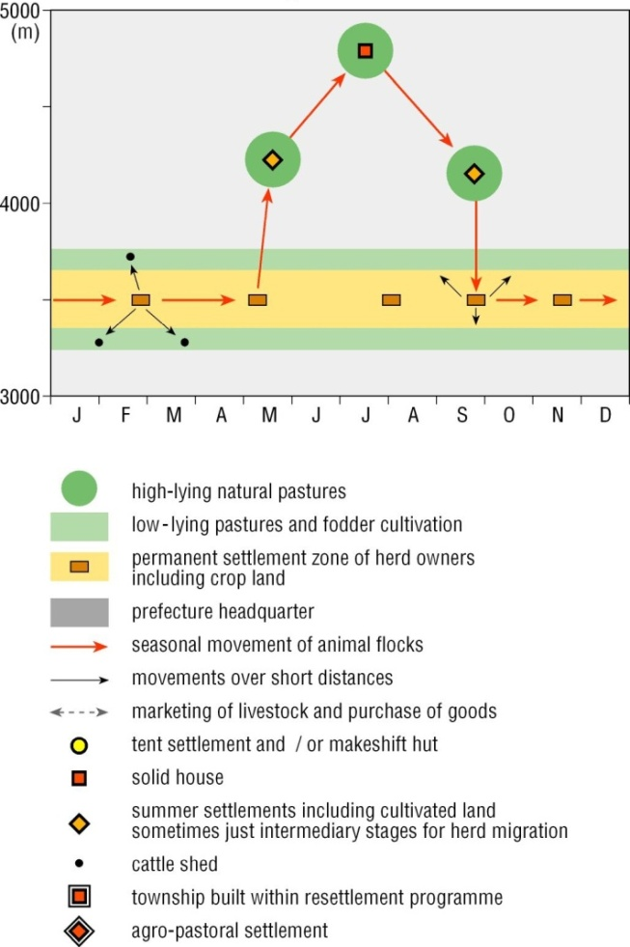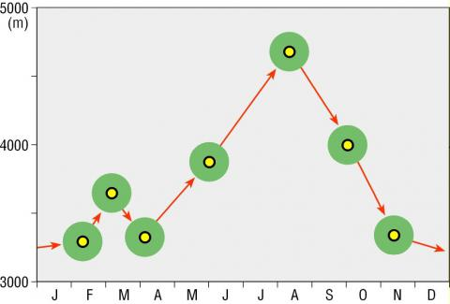
Figure 1a. Combined mountain agriculture Figure 1b. Classical mountain nomadism
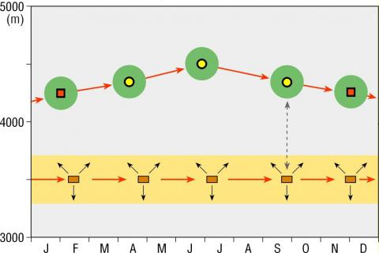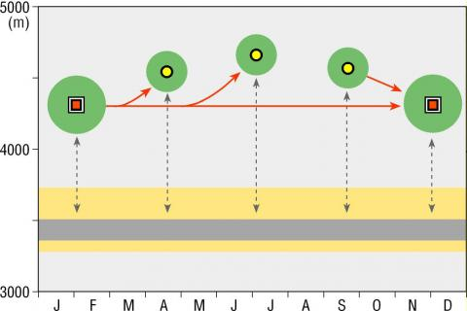
Figure 1c. Detached mountain pastoralism Figure 1d. Resettlement in high pastures
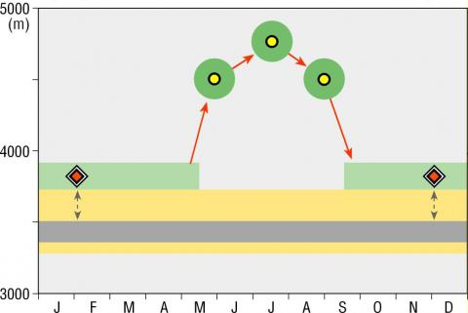
Figure 1e. Agro-pastoral resettlement in lowland region
Existing pasture quality and their status:
Livestock reared on pasturelands receive their nutritional supply through grazing pasture grasses and other herbages. Soil, climate, above ground biomass (grass and legume species) and pasture utilization by the grazing animals influence the quality and quantity of the mass of herbage on pastures. Based on the biomass production in particular grassland, a limited number of livestock can be accommodated for the efficient utilization of pastures grasses and their regrowth. At high rangeland, wild ungulates also compete with livestock for utilization available feed resources. The increased grazing pressure on the grazing lands replaces the edible perennial grasses and occupied by unpalatable grasses, obnoxious weeds and poisonous plants that lead to the degradation of their quality.
Transboundary animal diseases (TADs) and Livestock rearing on high altitude pastures:
The infectious diseases that are highly contagious and spread rapidly regardless of country borders are referred to as transboundary animal diseases (TADs). Domestic livestock, wildlife and humans share many similar pathogens, which originate in domestic or wild animals and infect humans, are known as zoonotic organisms. However, pathogens that originate from humans and cause diseases in animals are termed as anthroponotic organisms.
Livestock parasitism at high-elevation rangelands (>1800 m) is not well documented as at lower elevations because producers assume that the elevation limits parasite persistence and exposure of livestock to parasites (Scasta, 2015). However, the changing weather patterns, climate variability, and animal movements (during transhumance migrations) could shift some of the parasites and diseases into higher elevations.
High-elevation rangelands are unique from lower elevations due to wildlife and climatic dynamics. Grazing livestock on high altitude pastures may increase the opportunity for livestock – wildlife interactions and disease transmission (reviewed by Siembieda et al., 2011). Therefore, the animals carrying infection from low lands could potentially transmit the diseases and parasites among them (livestock-wild ungulates) while sharing the same rangelands. High-altitude animals migrate to low altitude pastures in winter season where they are exposed to various infectious and vector borne diseases of lower altitude animals. The same diseases are transmitted across trans-border at time of sharing same grazing and watering resources during nomadic migration and through wildlife – livestock – human interactions.
Most common transboundary diseases of livestock that are prevalent in trans-Himalayan and Himalayan region are foot and mouth disease (FMD), bluetongue (BT), rabies, brucellosis, babesiosis, bovine tuberculosis, anthrax, peste des petits (PPR) , infectious bovine rhinotracheitis (IBR), haemorrhagic septicaemia (HS) and black quarter (BQ) etc.
Role of Eco-tourism in transmission of disease:
Eco-tourism at high rangeland also plays an important role in transmission of diseases during human (tourists)-livestock (highland animals and pack animal) interaction. Beside the possibility of disease transmission, there is increased pressure on pastures for the limited available biomass, with the exponential rise in the number of trekkers and their pack animals during camping at high mountains.
Management of High altitude pastures and grasslands:
Grasslands are major forage reservoirs for high altitude animals, therefore, needs suitable management to meet the nutritional requirements of pasture biomass and grazing livestock without depleting the resources in the long-term. In other words, the management measures must obtain the maximum herbage yield with the highest possible nutritive value throughout the year at the lowest cost. There are different measures and strategies used for pasture management for sustainable livestock production at high-altitude.
- Grazing management:
Uncontrolled or over grazing will deplete the most of the palatable biomass and degrade the pasture quality with favoured growth of unpalatable weeds and grasses. Therefore, in order to maintain the vigour of the grasses and legumes and to meet out the needs of the livestock, the grazing must be regulated through adoption of proper grazing system. Uncontrolled and extensive grazing should be checked for proper growth and nutritive quality of the grasses in the pastureland. At high altitude regions, grazing should be managed through allowing the stay of nomads and their livestock on particular pastureland for a specified period during transhumance. Grazing pressure on higher mountains could be reduced by regulating and restricting the grazing on the selected sides of the pasture on a yearly basis. Some of the ways for suitable grazing management practices are rotational grazing through fencing and shepherd controlled grazing.

- Pasture establishment and rejuvenation:
The botanical composition and the overall percentage of the grasses present in the grasslands must be assessed and accordingly the decision must be taken to reseed the pastures with suitable grasses and promote their quick growth through fencing. Nutritive value of the pasture grasses is relatively low (contain around 6% crude protein), therefore, should be improved through introducing leguminous forage spices (containing around 15% crude protein). It is suggested that good pasture management should aim at least 20-30 percent legume component in total herbage.
Some of the suitable temperate grasses and legumes for establishment and regeneration of temperate/alpine pastures are cocksfoot (Dactylis glomerata), perennial ryegrass (Lolium perenne), tall fescue (Festuca arundinacea), Timothy (Phelum pretense), white clover (Trifolium repens) and red clover (Trifolium pretense). In the field trial conducted by ICAR-NRC on Yak, it was found that Dactylis glomerata is the most suited fast growing and high yielding temperate grass for temperate pastures, whereas Lolium perenne and Trifolium repens were the other grass and legume species with comparatively low yield but suitable for making grass-legume mix based grazing temperate pastures. Lucerne is another forage legume suitable for arid alpine region. Fodder tree could be planted for livestock feeding during feed scarcity period by establishing silvo-pastures.
Other grasses like hybrid napier (Pennisetum purpureum), thin napier (Pennisetum polystachyon), broom grass (Thysanolaena maxima) and aruna grass (Setaria palmifolia) are suitable for lower mid-altitudes. Some of the temperate grasses and legumes could be used for Horti-pastoral development of orchards in temperate region of Himalayas.
Forage crops like oats (Avena sativa) and maize (Zea mays) are also grown at lower altitudes in temperate regions of Himalaya and trans-Himalaya for supplementary feeding of the livestock.
Different strategies for pasture establishment and rejuvenation:
- Grass-legume balance:
Pastures with legume and grass mix should be established for overall increase in the nutritive value and palatability of biomass. It is suggested that good pasture management should aim to maintain at least 20-30% legume component. Taking all these into consideration, the inter- and -intra row spaces of the grasses should be utilized by adopting suitable seed rates of the compatible species of the legumes. White clover, red clover, alfa-alfa, siratro etc are some of the legumes used for growing legume-grass mix pastures.

- Reseeding and transplanting with better forage grass species:
If the grassland is in a completely degraded condition, reseeding or transplanting with better yield, adaptable, persistent and aggressive grass species become essential. Transplanting root slips or stem cuttings is always more successful than reseeding but costlier and require more skillful operations. Reseeding or transplantation is done by the beginning of rainy season.
- Over-seeding and sod seeding:
In natural grasslands, legumes may be planted along with the existing pasture grasses for improving the pasture quality. Sowing or planting a legume into existing native grasslands is a low cost pasture improvement method. Often, existing grasses are temporarily set back by heavy grazing, burning, ploughing or by applying herbicides. Then legumes and improved grasses can be sown or planted. This practice improves the feeding value of the pastures.

- Planting tree fodders in the pastures (silvo-pastures):
During winter fodder scarcity period when forage grasses and legumes are covered under snow and livestock does not have any other feed resources then tree fodder can be supplemented for the feeding of the animals. Fodder trees can also be used as fence material during protection from over-grazing.

- Manure and fertilization application:
Although small amounts of urine and manure are being added to the pastures while grazing, these are insufficient to make the losses of nutrients through forage cuts or grazing to maintain the optimum fertility of pasture soil. Therefore, a regular application of fertilizer is necessary to maintain soil fertility of pastures unless the soil is very fertile. Organic manures must also be used copiously in the form of compost, farmyard manure, sheep or goat manures, green manure for sustained production and productivity of pastures.

- Control of weeds and bushes:
Natural grasslands may become heavily encroached with undesirable weeds like Rumex asitosa etc and bushes. These weeds and bushes compete with the pasture grasses for space, light, nutrients, besides being unpalatable to the grazing animals. These weeds are detrimental to livestock production and need proper control measures for optimum management of natural pastures.

- Soil and water conservation measures:
Undulating topography of certain grasslands may pose serious problems in their improvement. Though grass sods give protection to soil from erosion but in steeper soils, mechanical measures are needed. In such areas, adequate soil and water conservation measures, viz., contour bunding, terracing, pitting contour trenching etc. should be adopted. In sloppy areas, contour planting system must be adopted for plating grasses and trees.

- Maintain optimum biomass growth and pasture quality:
Grasses at young leafy stage of growth contains higher protein content but less biomass yield as compared to the grasses at maturity (having less protein content and more yield). Therefore, it has to be compromised between the quality (high protein content of young growth) and quantity (high dry matter content of mature pastures) and accordingly pastures should be utilized. Over grazing can result in reduction in growth rate and weakening of plants. Poor or less grazing fails to maximize the plant’s potentiality to produce optimum feed thereby reducing the quantity available to the livestock.

- Maintain proper grazing or harvesting heights:
For most of the grasses, average grazing height is about 15 cm, however, grasses like carpet grass and lolium etc. are able to tolerate hard grazing down to 5 cm. Nevertheless, height is not the only criterion; maturity, protein content and stage of growth are also important.

- Assessment of forage yield :
It is not easy to estimate yield by observing each individual plant growing in the farm. Therefore, the yield for the whole farm can be calculated based on the samples collected from some specified areas of the farm-field. The simplest method to estimate the fodder yield of grasses and legumes is by using a quadrat. Sampling units, which are areas of definite size, are called quadrats. Famers can make a quadrat using wood or iron rod frame. Usually, a quadrat is of one meter square (1m x 1m). The fodder inside the quadrat is cut and collected. Sample as many number as possible and mean yield per quadrat is measured. Sampling should be done at the centre, diagonal crossing and edge of the field. Using this mean yield per square meter, estimate the yield per hectare by multiplying with 10,000.

- Proper forage utilization:
In a grassland or pasture, there are three possible ways of utilization. Most important is to allow the animals to graze the standing pasture through various grazing and stocking systems. Others are cut and carry the forage to the animal and cut, store and feed the forage to the animals at future dates. Although grazing is the usual method of harvesting pastures, it is rather inefficient in that only 50 % of the forage produced is actually consumed.
Preventive measures to control transboundary animal diseases:
- Proper fencing of pasturelands across the trans-borders and routine animal health checkup and vaccination of livestock reared on the pastures.
- Formulation of laws and regulations on interdisciplinary and international cooperation for animal disease surveillance and control across transboundaries.
- Establishment of the disease reporting system.
- Surveillance of exotic diseases in the livestock reared on international border areas.
- Emphasis on remote sensing and GIS based animal tracking and pasture management.
- Rehabilitation of low altitude temperate pastures through silvopasture practices.
- To rehabilitate the degraded pastures to meet out the feed and fodder requirements of the high-altitude animals.
Conclusion:
Livestock rearing on high altitude pasture is an eco-friendly and sustainable farming system practiced by the transhumant pastoral communities to support their livelihood. Therefore, to promote this sustainable livestock production system of high hills of Himalayas, requires judicious use of grazing resources, along with the suitable pasture management strategies, rejuvenation of degraded pastures and growing more fodder crops to ensure the livelihood of the nomads. The routine check up and monitoring of high-altitude livestock health and control of transboundary animal diseases may enhance the productivity of the livestock. Proper pasture management and animal tracking could be the possible solution for sustainable livestock rearing at high mountains of Himalayan and trans-Himalayan region.
References:
Mishra, C., Van Wiren, S.E, Ketner, P., Heitkoenig, I.M.A., and Prins, H.H.T. Competition between domestic livestock and wild bharal Pseudois nayaur in the Indian Trans-Himalaya. J. Applied Ecol., 2004: 41: 344-354.
Chomel, B.B., Belotto, A., and Meslin F.X. Wildlife, exotic pets, and emerging zoonoses. Emerging Infectious Disease, 2007 : 13 (1): 6-11
Siembieda, J.L., Kock, R.A., McCracken T.A., and Newman, S.H. The role of wildlife in transboundary animal diseases. Animal Health Research Reviews, 2011: 12 (1): 95-111. (doi:10.1017/S1466252311000041)

Kreutzmann, H. Transformation of high altitude livestock-keeping in China’s mountainous western periphery. 2013: 43-44

Namgay, K., Millar, J., Black, R., and Samdup, T. Transhumant agro-pastoralism in Bhutan: Exploring contemporary practices and socio-culture traditions. Pastoralism: Research, Policy and Practice, 2013: 3: 13

Singh, N.J., Bhatnagar, Y.V., Lecomte, N., Fox, J.L. and Yoccoz, N.G. No longer tracking greenery in high altitudes: Pastoral practices of Rupshu nomads and their implications for biodiversity conservation. Pastoralism: Research, Policy and Practice, 2013: 3: 16

Scasta, J.D. Livestock Parasite Management on High-Elevation Rangelands: Ecological Interactions of Climate, Habitat, and Wildlife. J. Integ. Pest Mngmt., 2015: 6(1):8

