A NOVEL TWO ELEMENTS MIMO ANTENNA FOR 5G
COMMUNICATION
¹RAJU THOMMANDRU, ²Dr M. PURNA KISHORE, ³DESIMALA PRABHAKARA RAO, ⁴ARUMALLA RAJA, ⁵SHAIK MAHABOOB SUBHANI
^{1,3}Associate Professor, Department of ECE, Chalapathi Institute of Technology, Mothadaka, Guntur,

Andhra Pradesh, India

²Professor, Department of ECE, KKR & KSR Institute of Technology & Sciences, Vinjanampadu, Guntur, Andhra Pradesh, India
^{4,5}Assistant Professor, Department of ECE, Chalapathi Institute of Technology, Mothadaka, Guntur,

Andhra Pradesh, India
Corresponding Email ID : raazu.thommandru@gmail.com

ABSTRACT: High speed data transfer, higher receive reception, and an improved bit error rate are requirements in the present age of communication technology. The next-generation technology known as 5G is quickly gaining attention because it increases capacity while also offering excellent service quality, very low latency, and fast data speeds. Antenna design and development are essential for the proper operation of any 5G devices. With increased bandwidth, gain, and reduced radiation losses, the antenna should be able to cover the proposed 5G bands. It also needs to be inexpensive and small in size. The desire for high-quality, continuous broad band communications is common, high data rates and bandwidth, in particular in countries that are developing like India. Wireless systems data rates, capacities, and connection dependability may all be significantly increased using MIMO (multiple input and multiple output) technology due to its ability to transmit and receive data over many paths. Currently used in 4G user equipment, the MIMO system is a promising technology for application in 5G mobile terminals. As a result, a novel two-element MIMO antenna for 5G communication is described in this work. Two radiating components with slits in the radiators are used in this design to create excellent isolation between the antenna radiators. Compared to earlier 5G antennas, the MIMO antenna will keep a typical small size.

KEYWORDS: fifth generation (5G), multiple input and multiple output (MIMO).
I. INTRODUCTION
Communication has become an essential component of life in the modern era, demanding the improvement of the communication system.

Over the past two years, wireless communication has developed into one of the most growing and quickly increasing technological sectors worldwide. It is frequently used in our homes and has a wide range of applications in the electrical devices we use every day, including computers, mobile phones, and televisions. They are now discussing "all connected" or The introduction of the fifth generation (5G) the Internet of Things (IOT) [1].These are electrical wirelessly linked devices that can share information with a computer, tablet, or smartphone that can detect, examine, and respond to their environment [7].

An unambiguous technological representation of the solution to the increasing need for high-speed connections and sophisticated wireless applications are the extensive research and development being done on fifth Generation (5G) technology. The next-generation technology known as 5G, is quickly gaining popularity because it increases capacity also offering excellent service quality, very low latency, and fast data rates. These domains of healthcare, education, business, and other social sectors are all benefit significantly from 5G [3]. With the quick development of current wireless technology, particularly with 5G, number of new features are now possible, including greater data rates and quickly high-quality transmission speeds.

Wireless systems have grown significantly over the years. The antenna, which uses ElectroMagnetic (EM) waves to send and receive data, represents the component of a wireless communication system that is most important. Transmitter, receiver, and medium make up the fundamental communication system. The medium is used in the communication system to transport radio frequencies from transmitter to receiver. An antenna is a device that transmits or receives signals in this context. As a result, the antenna is important to the wireless communication system. In order to function effectively, antennas need to be designed appropriately depending on their intended uses, and the parameters determine the extent to which the antenna performs [8].

Among the a wireless communication subsystem's most crucial components is an antenna because it is used for signals with a certain intensity and direction to be transmitted and received. Microwave, radio, and satellite signals can all be sent, received, and transmitted using a conductor known as an antenna. There is a need for the construction of a small size antenna due to the regular advancements in technology, particularly in the field of communication devices like mobile phones, radio sets, laptops with wireless connections, etc. [4].

Technology developments in communication have increased the use of wireless devices. Additionally, the requirement for the miniaturization of these wireless devices is constantly increasing, greater data rates, and operating speeds. The antenna design faces a number of difficulties depending on the application. Utilizing diversity through the use of many antennas simultaneously for transmission and in this case, enhancing reception is one way to speed up transmissions without increasing the given signal's strength or bandwidth. This MIMO (Multiple Inputs Multiple Outputs) technology is used. This process is well known and one of the essential 5G communication technologies.
To develop a suitable MIMO antenna system for smartphones, it is necessary to consider a number of antenna design parameters, such as low-profile, simple fabrication, and high-isolation [5]. Among the various antenna structures in demand are those with a number of interesting qualities, including low-profile, small in size, and requiring wide operational bandwidth, which are current requirements. As a result, it is necessary to develop an antenna that combines the important qualities listed above. The antenna has operating with specified standards established by regulatory bodies such as the Federal communications commission (FCC) of the united states and the European telecommunications standards institute (ETSI) in order to operate over a frequency band. The minimum gain and maximum effective isotropic radiated power (EIRP) of the antenna are two examples of parameters of the antenna that are constrained by these regulations [9].

Despite the possibility of using a typical microstrip patch antenna for 5G, the smaller antenna means that it has a narrower bandwidth. The antenna's bandwidth has to be expanded some techniques are implemented, such as the meta-surface, thick, stacking substrate, low permittivity substrate, shorting pins, folded patch, slots, slits and crossing stub structure [6]. There is a capacity restriction in standard single input single output systems (SISO). Multiplexing, diversity, gain, multipath fading reduction, and multiple-input, multiple-output (MIMO) antenna configurations are thought to increase all aspects of channel capacities. The MIMO approach, which offers high data rates, large capacity, good spectrum efficiency, and significant diversity is essential to next generation wireless/mobile communication systems [2].
MIMO systems allow simultaneous communication of several independent data streams. The limited space within mobile phones is a significant design difficulty for MIMO systems. The recent analysis has examined a number of MIMO systems and has provided examples of various MIMO-based mobile equipment antenna designs [12]. The fifth Generation (5G) wireless system designers require a unique concept and design method to support faster data rates, better dependability, more connection, reduced latency, and increased security features. Over the years, different MIMO antenna designs are described.

The growing demand for high data rates is represents a lot of interest in MIMO antennas have now regarded as a important component of millimeter-wave communication. Because of the expected characteristics of faster data transfer, higher coverage, and resistance to numerous fading paths, MIMO technology is strongly advised. Mutual coupling caused by surface wave propagation and insufficient separation between system components decrease the channel capacity of some MIMO systems, which results in poor impedance and radiation performance. Simply increasing the physical distance between the radiators will result in great isolation, but this causes the antenna to increase an large size.

Researchers have made an effort to create methods that maximize packing density while improving isolation between radiators. Therefore, it would be important to maximize mutual coupling in wireless networks for communication. To achieve better results, this analysis presents a novel two elements MIMO antenna for 5G communication is presented. The analyses remaining sections are structured as follows: In this Section II provides a explanation of the literature review. In the
Section III presents a novel two elements MIMO antenna for 5G communication. In the Section IV describes the results of the analysis. Finally, this analysis is completed in Section V.

II. LITERATURE SURVEY
R Rashmitha, Jugale Ajit Abhinandan, Niran N, Riyaz Mohammed Ahmed et. al., [13] for 5G communications on fixed, mobile, and satellite, offers a microstrip patch antenna architecture. This technique was used by the scientists to build and a microstrip patch antenna for 5G communications should be created. The antenna operates at 43.7GHz in the Extremely high frequency (EHF) bands. The design was applied to a 4.4 relative permittivity Fire Resistant 4 (FR4) epoxy substrate. The gain, radiated patterns, voltage standing wave ratio (VSWR) return losses, and current distributions of the antenna have all been investigated. The generated outcomes are checked against the specifications, and potential applications are described.
J. Colaco and R. Lohani et. al., [14] develops a rectangular patch with a dielectric constant of 2.2 and a dielectric loss tangent of 0.0010 for a microstrip patch antenna utilised in 5G applications. Modeling and analysis of the design is accomplished using the software named Feko. After modelling, the researchers discovered an antenna with a radiation efficiency of 99.5%, 3.56 GHz bandwidth, VSWR < 2, 10 dB gain, and 33.4 dB return loss are all present in appropriate quantities. This proposed architecture is advantageous in the current world state of lockdown.
Maheswari T., S.Sai Reddy, V.Uma Sankar, B.Pradeep Kumar, Rushendrababu K. et. al., [15] explains a micro-strip patch antenna for 5G wireless applications is designed. This study aims to develop a rectangular Microstrip patch antenna for wireless devices and radios are one of the 5G frequency bands is 4.5 GHz, which is used by small mobile devices. The dimensions of the antenna were determined using analytical (mathematical) procedures, and rogers Ultralam1217, in the design, a dielectric substrate with a dielectric constant of 2.17 was used. Transmission lines are used to achieve this models. In the High frequency structured simulator (HFSS), a microstrip patch antenna is developed and modeled.

Sudakshina Tiwari, Nitesh Kumar et. al., [16] an antenna for the 5G bands that uses MIMO. The problem of mutual coupling is one that has to be resolved with MIMO design, since MIMO antenna technology offers greater receive reception, a better bit error rate, and fast data transfer. In this analysis, authors have presented a 5G band MIMO antenna and a solution for problem of mutual coupling by using a decoupling element. The antenna's center frequency ranges from 38 to 39 GHz.

Zhao A., Ren Z., and Wu S. et.al, [17] generates a small, for 5G mobile terminals, a MIMO antenna with a decoupled antenna pair is used. In order to operate mobile terminals at fifth-generation (5G) multi-input and multi-output (MIMO) rates, this research provides a self-decoupled small antenna architecture. Along the identical side of the system grounding plane, two neighbouring antenna components are positioned close to one another (1.2 mm, or 0.014 inches) make up the antenna structure. The two adjacent antenna parts sharing a single common grounding branch can result in a small self-decoupled antenna pair. The 3.5GHz (3.4-3.6GHz) frequency band of the MIMO antenna system is its planned operational range with isolation better than -17dB. A working antenna prototype has been made, and measurements and simulations indicate good agreement.

Mahabub Atik, Sayedur Md. Rahman, Al-Amin Md., Mostafizur Md. Rahman, Md Rana Masud. et. al., [22] explains the construction of a multiband patch antenna for 5G communication networks. For each of the aforementioned systems operating frequencies, high gain, directivity, exceptionally low voltage standing wave ratios (VSWR), and directional radiation patterns were all features of the suggested antenna arrays. This antenna is intended for usage with several bands, making it useful for 5G applications in addition to Wi-Fi and WiMAX (Worldwide Interoperability for Microwave Access).

Gaikwad Pooja Mohan, Prof. Dr. Suhas S. Patil et. al., [23] discusses fractal microstrip patch antenna design and development for 5G communications. This method uses fractal technology to produce a microstrip patch antenna in the shape of a rectangle for 5G mobile communications. Compactness, multiband frequency, and impedance matching are utilizing fractal technology. 3.73GHz, 5.82GHz, and 8.85GHz are resonance frequencies for the antenna. For WLAN, WSN, Wi-Fi/Wi-Max, and Hiper LAN2, this antenna is helpful. To improve performance, researchers look at antenna features such radiation pattern, current distribution, VSWR, and S11. The HFSS programme is used to create the microstrip antenna.

Kumar Reddy N, Hazra Asish and Vinod Sukhadeve et. al., [24] The fifth generation (5G) of mobile communications is outlined in upcoming 5G mobile wireless using a small elliptical microstrip patch antenna for communications, they provide an elliptical inset fed microstrip patch antennas. With a relative permittivity of 4.4, the antenna is secured on a small Fr-4 substrate with dimensions of 5 x 5 x 1.6 mm. It is determined that the antenna operates at 28 GHz with a reflection coefficient (S11) of less than -10dB and rather steady emission patterns by simulating it using the HFSS software.
III. A NOVEL TWO ELEMENTS MIMO ANTENNA
This section introduces a novel two-element MIMO antenna for 5G communication. The configuration of the two-element MIMO antenna for 5G communication is shown in Fig. 1. There are several sending and receiving channels on the several Input Multiple Output antenna. This antenna utilizes the multipath propagation phenomenon, increasing the possibility of receiving reception. In comparison to single input and single output (SISO) and single input and multiple output (SIMO) antenna, it additionally increases data speed and has a very low bit error rate. Because of this, next-generation communication systems most frequently utilize

Using a coaxial probe, feed the radiating patch, use a surface that is parallel to the y-axis.; this surface is shown in Figure 1(c) as a feed line. The perfect electric conductor (PEC), the antenna's main radiating component, is protected by the inner conductor of the coaxial feed, which is afterwards soldered. The top radiating element and the bottom ground plane of the provided antenna are both adjacent to the outer conductor of the coaxial feed.

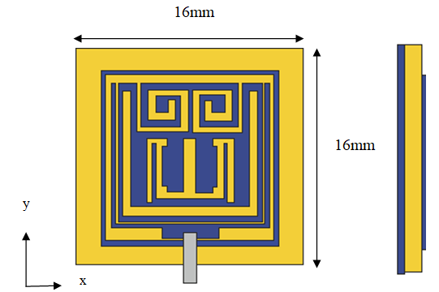
(a) (b)

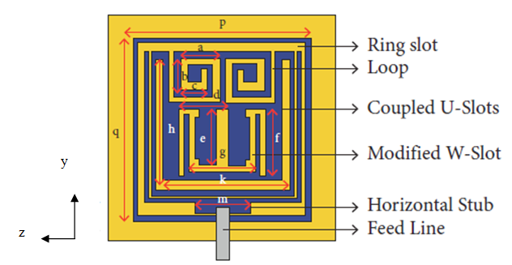
(c)

Dielectric
Perfect Electric Conductor

Fig. 1: The two-element MIMO antenna's configuration and material requirements are provided. Front view, side view, and geometrical information are shown in (a), (b), and (c), respectively, for the antenna: a = 3.18 mm, b = 2.55 mm, c = 2.15 mm, d = 4.03 mm, e = 5.5 mm, f = 5.4 mm, g = 5.5 mm, h = 10.45 mm, k = 10.9 mm, and m = 4.4 mm.

Increasing the inductive effect or expanding the radiator's stubs electrically,

This is the key factor in achieving resonance at a lower frequency. Figure 1(c) shows the labels and physical dimensions to help with understanding of the constructed patch antenna. Therefore, a
number of methods are used to strengthen this inductive impact.

This paper describes a two-element-based MIMO antenna system that is inexpensive, low-profile, and small with a significantly decreased S21 < − 36 dB mutual coupling. Two slots are added to the radiating portion of the antenna elements and In order to increase the isolation in these tightly packed components, a 45° clockwise rotation of the antenna components is applied. High isolation is achieved by extending the physical distance between the resonators through these slots. The basic architecture of the antenna is excited by a 50-Ω feed line. This pattern is used on a Rogers 4350B laminate that is 0.8 mm thick. Given that the radiators in the provided structure have minimal mutual coupling, considering the high level of agreement between the outcomes of the simulation and measurement, 5G communication may be feasible due to its high diversity gain and low envelope correlation.

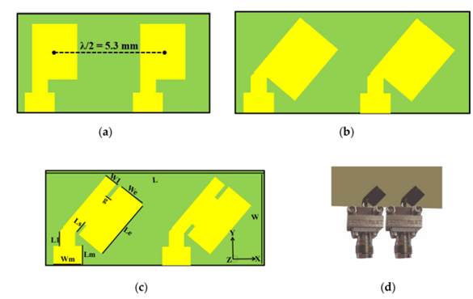
Figure 2: The provided MIMO antenna's design progression (a) Straight elements (b) Bend elements (c) provided (d) Prototype.

These antenna components that are currently being used are basic patch antennas with a rectangular form. Using the widely-accepted transmission line theories, the exact measurements of the MIMO antenna in the illustration have been determined.

The described theory, the Width (W) and effective resonant Length (Lre) are determined for a given resonant frequency (fr).

$$L_{re}=\frac{c}{{2f}_{r}\sqrt{\left[\frac{ε_{r}+1}{2}+\frac{ε_{r}-1}{2}(1+12\frac{h}{W})^{-0.5}\right]}} -2∆L (1)$$

$$W=\frac{1}{{2f}_{r}\sqrt{μ_{o}ε_{o}}}\sqrt{\frac{2}{ε_{r}+1}} (2)$$

Similar to that, h stands for the substrate's thickness, c for light's speed, fr for resonance, and $∆$L for the fringing-induced length difference. Permeability, relative permittivity, and free space permittivity are all represented by the letters εo, εr, and μo, respectively. The provided antenna's dimensions for 29 GHz were determined using the calculations above.

The presented MIMO antenna is smaller than existing antennas, with total measurements of 11.2x5.3x0.8 mm³. On Roger 4350B substrate, a 45° rotating element has a relative permittivity of 3.66, a thickness of 0.8 mm, and two radiating patches with slits printed. The radiators were 3.62 mm long and 2.7 mm wide, respectively. A shared ground plane supports the substrate. At first, only straight antenna components with mutual coupling of S₂₁<− 16 dB working at 38 GHz are planned. By adding slots and rotating them 45 degrees clockwise, there was found to be little mutual contact between the patches. Slots lengthened the current route, with the necessary frequency of 29 GHz, the mutual coupling reduced.

Utilizing the surface current distributions, mutual coupling performance of the proposed two-element MIMO antenna was investigated. In order to improve isolation in these packed tightly components, two slots were first added to the radiating section of the radiators and turned by 45 degrees clockwise. High isolation is achieved as a result of these slots are extension of the physical distance between the resonators.

A 50-Ω feedline is used to excite the antenna's simple form. This pattern is used on a Rogers 4350B laminate that is 0.8 mm thick. Given that the suggested design has a low envelope correlation, good diversity gain, and a minimal amount of reciprocal coupling between the radiators, this may be an effective candidate for 5G communication, this highlights the good consistency between the simulated and measured outcomes.

IV. RESULT ANALYSIS
A novel two element MIMO antenna for 5G communication is presented in this paper. The recommended millimeter-wave MIMO antenna's compatibility, usability, and efficacy were examined using Envelope correlation coefficient (ECC) analysis. Considering the ECC, or incoming signals and their connection at the antenna port, is required to determine the uncorrelated channel's channel quality. Antenna performance decreases as a result of high correlation and low isolation caused by a high ECC setting.

Additionally, ECC represents that the total S-parameters of the planned MIMO antennas interact with one another. Far field radiation, the S-parameter, or the received signal envelope can all be implemented to estimate complex cross correlation in order to find the ECC. The outcomes of the far field radiation patterns and S-parameter approaches used to calculate ECC in this section are listed below:

$$ECC=(|S_ii*S_ij+S_ji*S_jj |^2)/(1-|S_ii |^2-|S_ji |^2 )(1-|S_jj |^2-|S_ji |^2 ) (3)$$
$$ρ_{ij}=\frac{|\int{\int_{0}^{4π}{\left[\vec{F_{i}} \left(θ,ϕ\right)×\vec{F_{j}} \left(θ,ϕ\right)dΩ\right]|^{2}}}}{\int{\int_{0}^{4π}{\left[\vec{F_{i}} \left(θ,ϕ\right)|^{2}dΩ\int{\int_{0}^{4π}{|}}\vec{F_{j}} (θ,ϕ|^{2} \right]dΩ}}} (4)$$

the MIMO antenna's j-th and i-th elements emission patterns, respectively, indicate the ECC $\vec{F_{i}} \left(θ,ϕ\right)$ and $\vec{F_{j}} \left(θ,ϕ\right)$ radiation patterns, In the recommended design, I, j = 1, 2, which are represented.

When analyzing the effectiveness of MIMO antennas, another important factor that must be taken into consideration is Diversity Gain (DG). This metric presents as an estimate for the MIMO system's dependability. For high DG antenna systems, the radiators are isolated to a greater extent. For computing the DG of the MIMO antenna, apply the relation follows.

$$DG=10\sqrt{1-(ECC)^{2}} (5)$$

Multiplexing efficiency (ηMux) is measured as follows:
$$η_{Mux}=\sqrt{1-|ρ_{c}|^{2}}η_{1}η_{2} (6)$$

where the antenna patch's complex correlation coefficient is denoted by the symbols $ρ_{c}$. The radiator for the i-th antenna has a total efficiency of ECC$≈|ρ_{c}|^{2}$ and | $η_{i}|$. Since they had a MIMO array with two elements, they used i = 1, 2. The Fig. 3 shows the simulated radiation efficiency comparison.

Fig. 3: Simulated Radiation Efficiency Comparative Graph

Figure 3 represents the SISO and presented MIMO antenna's radiation efficiency. The described MIMO antenna achieves a radiation efficiency of over 87% over the working band. In the ideal scenario, the ECC value would be 0. Therefore, uncorrelated MIMO is restricted to an ECC limit of 0.5. The diversity gain and ECC of the presented antenna are shown in Figure 4 using simulation and measurement.
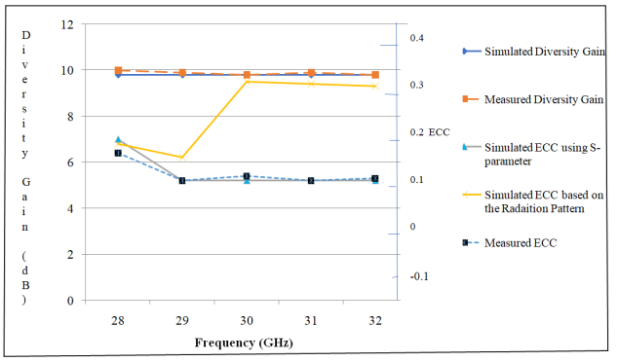
Fig. 4: Fig. 4 shows the reported MIMO antenna's simulated peak gain and multiplexing effectiveness.
The specified MIMO antenna's ECC value

The provided MIMO antenna's Diversity Gain (DG) for a number of frequencies is shown in Figure 3. A DG > 10 dB is found in the provided antenna across the operational band. With different frequencies, Figure 5 represents multiplexing effectiveness and peak gain.
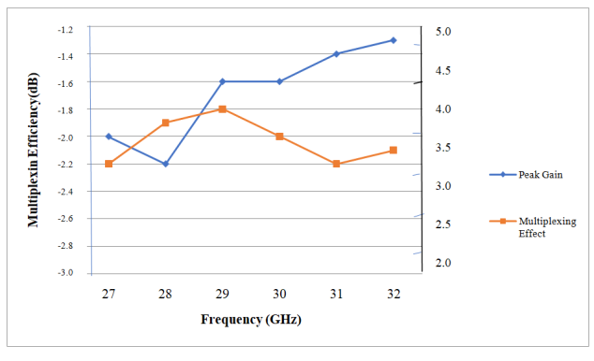
Fig. 5: The described MIMO antenna's simulated peak gain and multiplexing efficiency

Through utilizing slotted and inclined antenna radiators, this MIMO antenna was able to retain a small (11.2x5.3mm2) size. A lower ECC value of 0.00009, it was effective in improving isolation by 38 dB and attaining a high diversity gain of >9.9 dB. An effective option for 5G communications and applications, the described architecture shows good consistency between measured and simulated outcomes.
V. CONCLUSION
A novel two elements MIMO antenna for 5G communication is presented in this analysis. The 5G communication method discussed a novel 2x2 MIMO antenna. Despite the simple shape, slits in the radiators are added to extend the current route and result in a significant reduction in antenna area (11.2x5.3 mm²). The patches are slotted and rotated 45 degrees in the clockwise direction, high isolation between the resonators is achieved. The offered MIMO antenna is an excellent option for 5G applications, It is demonstrated by the simulation outcomes for ECC (ECC 0.00009), radiators are isolated from one another (> 38 dB), and
DG (DG > 9.9 dB). Even though the antenna is smaller than earlier 29 GHz millimeter-wave antennas, modeling and testing results showed good S-parameter, radiation pattern, diversity gain, and ECC performance.

VI. REFERENCES
[1] P. Singla, K. Kaur, M. Srivastava and R. Mittal, "Design and Implementation of Printed Antennas for 5G Applications," Greater Noida, India, 2023, Third International Conference on Advanced Computing and Innovative Technologies in Engineering (ICACITE), pp. 131–134, doi: 10.1109/ICACITE57410.2023.10182522.
[2] Neeta P. Kulkarni, Nilesh Bhaskarrao Bahadure, P. D. Patil, Jayshri S.Kulkarni, “Flexible MIMO Antennas for 5G Applications”, 2022, Research Square, 10.21203/rs.3.rs-1358314/v1
[3] Kanagasabai Malathi, Shanmuganathan Shanmathi, Nabi Gulam Alsath M., and Palaniswamy Sandeep Kumar, “A Novel Low-Profile 5G MIMO Antenna for Vehicular Communication”, Article ID 9431221, 12 pages, International Journal of Antennas and Propagation, Volume 2022, 10.1155/2022/9431221
[4] Monirujjaman Khan Mohammad, Arifur Rahman H. M., Alam Nakib Shovon Md., Myriam Hadjouni, Alhakami, Elmannai Hela, and Bourouis Sami, “Design and Analysis of a 5G Wideband Antenna for Wireless Body-Centric Network”, Volume 2022, Article ID 1558791, 16 pages, Hindawi Wireless Communications and Mobile Computing, doi:10.1155/2022/1558791
[5] Lijaddis GetnetAyalew, Fanuel MelakAsmare, “Design and optimization of pi-slotted dual-band rectangular microstrip patch antenna using surface response methodology for 5G applications”, Heliyon 8 (2022), e12030 (DOI:10.1016/j.heliyon.2022.e12030).
[6] García Dolores , O. Jesus Lacruz, Badini Damiano, De Donno Danilo , Widmer Joerg , “Wireless SISO/MIMO communications using model-free machine learning, Pages 192–202 of Computer Communications, Volume 181, First January 2022, DOI: 10.1016/j.comcom.2021.09.033
[7] Daghari Marwa, Essid Chaker ,and Sakli Hedi, “Muli-UWB Antenna System Design for 5G Wireless Applications with Diversity”, 18 pages, Article ID 9966581 in Hindawi Wireless Communications and Mobile Computing Volume 2021, doi:10.1155/2021/9966581
[8] Vivek Narukurthi, B Sandeep Kumar, Dr Shambavi K., “Design Of Wearable Antennas for 5G Applications”, IJEET (International Journal of Electrical Engineering and Technology), Volume 12, Issue 5, May 2021, pp. 148–156, ISSN Online: 0976–6553, DOI: 10.34218/IJEET.12.5.2021.014
[9] Shakir Mustafa, Aslam Sohaib, Usman Sarwar M., Adnan Muhammad and Rafay Muhammad Khan, “Performance evaluation and design of 5G communication‑based millimeter wave antenna”, 10.1186/s13638-021-02052-9, EURASIP Journal on Wireless Communication and Networking, 2021:179
[10] R.Shantha Selvakumari And R.Banu Sangari, “Design and Simulation of an Array Antenna For 5G Base Station”, Engineering and Technology International Research Journal (IRJET) E-ISSN: 2395-0056 April 2021, Volume: 08, Issue: 4.
[11] Prabhu T. and Chenthur Pandian S., “Design and Implementation of T-Shaped Planar Antenna for MIMO Applications”, Computers, Resources, and Continua
DOI:10.32604/cmc.2021.018793
[12] Bhargava D.S., Padmavathy T.V., Yadhamuri, Neelapareddy Kavitha, Vinitha Reddy Vuppalapati, Hema, “Design and Simulation of MIMO Antennas for Mobile Communication”, Materials Science and Engineering Conference Series, IOP Publishing, 994 (2020) 012033, doi:10.1088/1757-899X/994/1/01203
[13] R Rashmitha, N Niran, Ajit Jugale Abhinandan, Riyaz Mohammed Ahmed, “Microstrip Patch Antenna Design for Fixed Mobile and Satellite 5G Communications”, CoCoNet'19, the Third International Conference on Computing and Network Communications, Procedia Computer Science 171 (2020) 2073–2079, Elsevier, DOI: 10.1016/j.procs.2020.04.223
[14] Colaco J. and Lohani R., "Design and Implementation of Microstrip Patch Antenna for 5G applications," 10.1109/ICCES48766.2020.9137921. The 5th International Conference on Communication and Electronics Systems (ICCES) will be held in Coimbatore, India, in 2020, and will be held on pages 682–685.
[15] Maheswari T., Pradeep Kumar, Uma Sankar V., Sai ReddyB S.., Rushendrababu K., “Design of a Microstrip patch Antenna for 5G Wireless Applications”, March 2019, Volume 6, Issue 1, E-ISSN 2348-1269, IJRAR International Journal of Research and Analytical Reviews
[16] Tiwari Sudakshina, Nitesh Kumar, “A MIMO antenna for 5G band”, Volume 4, Issue 10, IJSDR1910009, ISSN: 2455-2631, International Journal of Scientific Development and Research, October 2019.
[17] Ren Z., Zhao A. and Wu S., "MIMO Antenna With Compact Decoupled Antenna Pairs for 5G Mobile Terminals," 10.1109/LAWP.2019.2916738, IEEE Antennas and Wireless Propagation Letters, vol. 18, no. 7, July 2019, pp. 1367–1371.
[18] Sandi E, Diamah A, Iqbal M W and Fajriah D N, “Design of substrate integrated waveguide to improve antenna performances for 5G mobile communication application”, Journal of Physics: Conference Series 1402, (2019) 044032, 4th Annual Applied Science and Engineering Conference
IOP Publishing, 10.1088/1742-6596/1402//4/044032
[19] al Abdulrahman Ayidh, Nadas J. B., Ghannam R., Zhao G. and. Imran M. A, "Communication and Control Co-Design Using MIMO Wireless Network," 10.1109/UCET.2019.8881847, 2019 UK/China Emerging Technologies (UCET), Glasgow, UK, pp. 1–5.
[20] Kiran T., Mounish N., Mythily Ch., Akhil D., Phani Kumar T.V.B., “Design of Microstrip Patch Antenna for 5g Applications”, The IOSR Journal of Electronics and Communication Engineering (IOSR-JECE) has an e-ISSN and a p-ISSN.Jan.-Feb. 2018, pp. 14-17, Volume 13, Issue 1, Version I
[21] Tang Wanwei, Jinlong Zhao, Shaoli Kang, Xiurong Zhang2, Yinpu Zhang, Zhenyu Zhang, “Design of MIMO-PDMA in 5G mobilecommunication system”, IET Communication, 2020, Volume 14, Issue 1, Pages 76–83, DOI: 10.1049/iet-com.2018.5837
[22] Atik Mahabub, Md. Mostafizur Rahman, Md. Al-Amin, Md. Sayedur Rahman, Md. Masud Rana, “Design of a Multiband Patch Antenna for 5G Communication Systems”, Open Journal of Antennas and Propagation, 2018, 6, 1-14, ISSN Online: 2329-8413, doi: /10.4236/ojapr.2018.61001
[23] Gaikwad Pooja Mohan, Prof. Dr. Suhas S. Patil, “Design and Development of Fractal Microstrip Patch Antenna for 5g Communication”, Advances in Wireless and Mobile Communications. ISSN 0973-6972 Volume 10, Number 1 (2017), pp. 13-25, doi:10.24113/ijoscience.v6i5.287
[24] N Kumar Reddy, Asish Hazra and Vinod Sukhadeve, “A Compact Elliptical Microstrip Patch Antenna for Future 5G Mobile Wireless Communication”, Transactions on Engineering & Applied Sciences, Vol. 1. No. 1, pp. 1-4, 2017, DOI: 10.24999/IJOAEM/02070036, ISSN 2456-8066
[25] W. Cheng, X. Zhang and H. Zhang, "Statistical-QoS Driven Energy-Efficiency Optimization Over Green 5G Mobile Wireless Networks," in IEEE Journal on Selected Areas in Communications, vol. 34, no. 12, pp. 3092-3107, Dec. 2016, doi: 10.1109/JSAC.2016.2599980.

