Posttraumatic stress disorder (PTSD)
Ruqeeb jan(Msc.Mental Health Nursing) tutor college of nursing ,GMC ,Srinagar,ruqeeb1235jan@gmail.com,8491864279/ 9622755489.
Introduction
It’s normal to have distressing memories, nervousness, or trouble in falling sleep after a Traumatic situation. At initial stage of trauma person may feel difficulty in activities of daily living. However most of the people feel better after a week or month. When remains greater than a month with clinical symptoms, it is called as Post Traumatic Stress Disorder. Previously it was considered as anxiety disorder which is now recognized as Trauma and Stress-related Disorders
Post-traumatic Stress Disorder is a depleting mental health problem that is caused by catastrophic and traumatic events, like earthquake, death of loved ones or sexual assault, e.t.c. presented with the following symptoms
Behavioral Symptoms | Agitations, irritability, hostility, self-destructive behavior, e.t.c.
Psychological symptoms | Fear, extreme anxiety, mistrust, and flashback
Mood and sleep | Insomnia, loss of interest, guilt, or loneliness

Defnitions:
PTSD as a reaction to extreme trauma which causes pervasive distress to everyone. PTSD symptoms are not related to common experiences such as bereavement, marital disharmony or chronic illnesses but are associated with events that markedly cause distress and individual may experience trauma alone or in presence of others.
Puri & Treasaden (2011)

PTSD is defined as protracted response to a stressful event or situation of exceptionally threatening or catastrophic nature, which is likely to cause pervasive distress in almost everyone.
ICD-10,
CLINICAL MANIFESTATIONS
DSM-V has divided PTSD into four categories
- Intrusion .
- Avoidance of thoughts and behavior.
- Negative changes in thought and mood.
- Change in arousal and reactivity.
Intrusion . | Re-experiencing the traumatic event,  Flashbacks  Nightmares  Distressed feeling. Physical symptoms to trauma
Avoidance  of thoughts  and behavior. | Avoiding daily activities, situations, notion, or feelings that recall you of event.  Inability to recollect main features of the agony.  Detached feeling from self and others
Negative changes in thought and mood | Guilt, , or self-blame  Alienated and alone feeling  Mistrust and betrayal feelings  Difficulty concentration .
4.Change in arousal and reactivity | Trouble in Sleep.  Irritability or anger outburst  Hyper-vigilance  Aggressive, self-destructive

PTSD symptoms seen in children
- Separation Anxiousness
- Forget obtained capabilities (such as toilet training)
- Sleep related issues ; nightmares.
- Sad and serious mood while playing.
- Unknown phobias and anxieties.
- Physical symptoms with no apparent cause
- Irritability and aggression

DSM-V PTSD Diagnostic Criteria:
Criteria A:Stressor: exposure to agonizing event.
Criteria B: Invasion: One or more manifestation.
Criteria C: Evasion of thoughts and behavior: one symptom needed.
Criteria D: Pessimistic changes in thought and emotional state (two symptoms required)
Criteria E: Alteration in high and receptiveness.
Criteria F: Manifestation remain for greater than one month.
Criteria G: Practical importance(social as well occupational)
Criteria H: Exclusion (medication or substance abuse are not responsible for present disorder).

ETIOLOGICAL FACTORS:
There are different causes — comprises of biological, neurological and psychosocial.
Neurobilogical cause:
Different Brain imaging studies have shown that amydala and hippocampus are activily involued .Amydala is associated with fear and it triggers with the traumatic situations among hyperactive people.While as hippocampus has role in memory formation, so it is found that people with this disorder have loss of volume in their structure, that may contribute memory deficits and other symptoms of this disorder. It is also evidenced that hypothalamic-pituitary-adrenal (HPA) axis is disrupted among people with PTSD.

Psychosocial Cause: PTSD is most likely caused by :
- Traumatic events especially when there is severe threat to life or personal safety.
- History of physical or sexual abuse, or substance abuse
- History of family PTSD Or Depression are leading causes of ptsd in person.

Other risk factors for PTSD include:
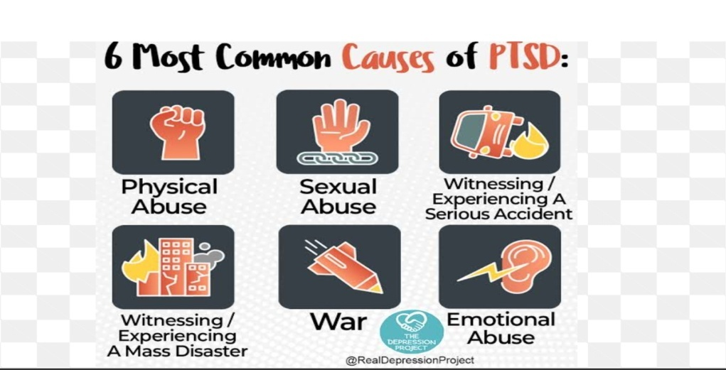

Types of post traumatic stress disorder:
Acute PTSD | Recovers after a period of few weeks to 3 months
Chronic PTSD | symptoms continue more than three months
Delayed PTSD | Improves from months to years after the event

There are five main types of post-traumatic stress disorder:
Normal Stress Response: occurs when exposed to distinct traumatic event in adulthood and experience extreme traumatic memories, feeling numb, unreal, being disconnected from relationships or bodily stress. within a few weeks individuals usually achieve complete recovery.
Acute Stress disorder: It is identified by panic response, mental disorientation, detachment, severe inability to sleep, mistrust, and unable to manage basic self care activity, work, and interpersonal relationship. Single traumas have more severe reaction. This occur within one month after experiencing a traumatic event. Treatment includes immediate support, taken out from the area of the hurt, medication to be given for grief, anxiety, and sleeplessness, also implementation of supportive psychotherapy..
Uncomplicated PTSD: Re-experiencing of persistent hurtful event, stimuli evasion related to hurt, apathy, and symptoms of increased high. Treatment includes group therapy, psychodynamic therapy, cognitive-behavioral therapy (CBT), pharmacological therapy or combination approaches.
Co-morbid PTSD: It should be identified with at least one other major psychiatric disorder such as depression, substance abuse disorder, panic disorder, and anxiety disorders. The best results are achieved when both PTSD and the other disorder(s) are treated together.
Complex PTSD: Complex PTSD (“Disorder of Extreme Stress”) is found in those exposed to long term traumatic circumstances, especially during childhood. They might have co morbidity with borderline or antisocial personality disorder or dissociative disorders. They manifest difficulties in behavior ,emotions & feelings

Management of PTSD

- This disorder is treated with selective serotonin reuptake inhibitor (SSRI) antidepressants like fluoxetine, sertraline and paroxetine.
- Other Medications: Commonly alternative antidepressants are the atypical antipsychotics like risperidone, olanzapine, and quetiapine
- Benzodiazepines are used for certain symptoms of PTSD.

Psychological intervention
Traumatic event-focused cognitive-behavioral therapy
Family therapy.
EMDR (Eye Movement Desensitization and Reprocessing)

NURSING MANAGEMENT OF PTSD
NURSING DIAGNOSIS FOR A PATIENT WITH PTSD
Nursing diagnoses that are appropriate to the patient suffering from PTSD include, but are not limited to includes:
* Melancholy.
* lack of coping skills
* Sleep disturbance
*Complicated grief..
* Dysfunctional social interaction
* Ineffectiveness to maintain healthy relationships
* Impaired individual resilience
* Risk for Attempted suicide

- CONCLUSION
It is one of the overlooked and depleting mental illness that results flawed state or maladjusted response to stressors ; characterized by partial or complete disintegration of individual's personality. Nurses have important role in noticing the symptoms of PTSD and application of different therapies .
REFERENCES:
- www.ptsd.va.gov | February 2018 cited on 5/5/2018
- Kukkonen Rinat Sharifullin , Bachelor’s Degree Programme in Nursing
- (Bachelor’s Thesis )May 2017
- LAHTI UNIVERSITY OF APPLIED SCIENCES ,cited on 6/5/18 cited on 10/5/18
- American Psychiatric Association. (2013). Diagnostic and statistical manual of mental disorders: Fifth edition. Arlington, VA.
- National Center for PTSD. (2018). DSM 5 Criteria for PTSD. Retrieved on February 20, 2018. PTSD causes cited on 10/5/18
- Hohn M. Grohol, Psy.D. on 9 Nov 2017 PsychCentral.com cited on 9/5/18
- Nurse Dedrey Ogunnoiki ,Management Of Post Traumatic Stress Disorder (PTSD) : January 05, 2018.
- Mary C. Townsend ,concepts of care in Evidence Based Practice (MHN) ,8TH Edition page no 560-561
- Dorothy D. Theodore Text Book of Mental Health Nursing 1st edition 2015 page no.227

- .

