PRODRUG DEVELOPMENT

1. Dr. Bhaskar K. Kurangi
Department of Pharmaceutics,
KLE College of Pharmacy, Belagavi.
KLE Academy of Higher Education and Research
Belagavi, Karnataka, India
Email: bhaskarkurangi19@gmail.com

- Mr. Soham Naik Gaonkar
Department of Pharmacognosy,
KLE College of Pharmacy, Belagavi.
KLE Academy of Higher Education and Research
Belagavi, Karnataka, India
Email: sohamnaikgaonkar01@gmail.com

ABSTRACT
Although more than 7000 medications are available to treat a wide range of disorders, in addition to organoleptic undesirable characteristics, various physico-chemical, pharmacokinetic, pharmacological, and toxicological properties can be obstacles to their clinical usage. Prodrug design is a technique involving the transformation of a substance before it exhibit its pharmacological effects. This approach offers solutions to challenges related to formulation, solubility, absorption, distribution, stability, targeted release, sustained action, and potential toxicity, among other factors. To maximise the therapeutic efficacy of a drug as well as minimize side effects and adverse effects, prodrug delivery technology should be developed
Keywords: Prodrug, Drug delivery, Polymers, Drug development, Drug carriers

- Introduction

A prodrug is a molecule that lacks biological action on its own but can produce a drug having biological activity through various stages of metabolism. A prodrug is a molecule that lacks intrinsic biological activity but can produce a physiologically active drug at various stages of its metabolism, according to Albert [1] who first coined the term in 1951. A prodrug is defined as any chemical that undergoes biotransformation before manifesting its pharmacological effects [2] in accordance with this definition and the definition acknowledged by IUPAC. Prodrugs can be thought of as medications that temporarily alter or eliminate undesired characteristics in the parent molecule by adding specialized non-toxic protecting groups.

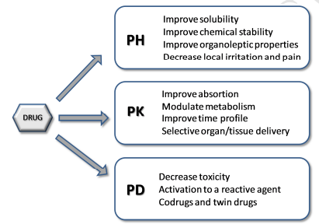
Fig. 1. A schematic categorization of prodrug research goals, organized based on objectives linked to the pharmaceutical (PH), pharmacokinetic (PK), and pharmacodynamic (PD) stages.
Typically, certain enzymes, primarily hydrolases, catalyse the metabolic process required to change the prodrug into the drug. Ideally, this should only happen at the site of targeting to prevent negative side effects. The prodrug concept has found a lot of valuable uses in drug research and development because it enables the fulfilment of numerous biological and/or physicochemical goals, some of which are at odds with one another. It is important to keep in mind how many of these goals are connected [4]. To achieve effectiveness, a prodrug must address the inherent challenge of simultaneously possessing hydrophilic and lipophilic properties, which are essential for meeting solubility, bioavailability, and transport prerequisites. 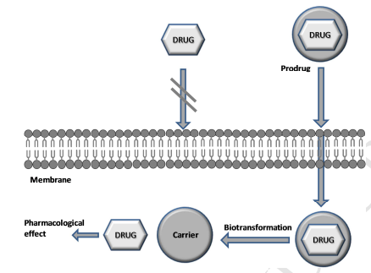
Fig. 2. Schematic depiction of various prodrugs engineered to bypass a cellular membrane.

The limited bioavailability of many valuable therapeutic drugs after oral administration is often due to inadequate absorption or susceptibility to first-pass metabolism, which can lead to drug inactivation or the formation of harmful metabolites. One potential approach to enhance oral absorption involves the formulation of a solution that utilizes suitable excipients to enhance gastrointestinal membrane permeability, thereby increasing oral bioavailability. Surfactants, fatty acids, glycerides, steroidal detergents, and amino acid derivatives are some instances of these permeation enhancers. However, it's important to note that these excipients can sometimes cause significant damage to the intestinal epithelium [7]. A chemical remedy utilising a prodrug strategy is a tempting substitute. By modifying physico-chemical factors that affect absorption or by focusing on certain enzymes or membrane transporters, the prodrug method has also been frequently employed to enhance drug delivery to its site of action [8]. Addressing a deficiency in a drug candidate can be achieved through the utilization of prodrug design as a lead modification strategy. This approach can prove beneficial in mitigating challenges related to formulation, solubility, absorption and distribution, instability, targeted release, extended action, and potential toxicity, among other factors [9].

- Objectives of the prodrug approach:
The principal objectives of the prodrug approach can be summarized as follows:

- Enhancement of drug water solubility.
- Augmentation of absorption and membrane permeability.
- Precise and targeted release.
- Minimization of metabolism and associated side effects.

- Types of prodrugs
The two primary categories of prodrugs are bioprecursor prodrugs and classic prodrugs (carrier-linked prodrugs). In carrier-linked prodrugs, the drug is temporarily covalently bonded to a carrier moiety. A carrier prodrug goes through a process where it breaks down, resulting in the production of at least one byproduct, which can be either biologically inactive (like polyethylene glycol, PEG) or possess targeting properties (such as antibodies). Simultaneously, this process yields a molecular entity with heightened bioactivity, which is the active drug. The bioprecursors are stimulated by the metabolic alteration of a functional group because they lack a carrier group. Prodrugs can be further subclassified into :
- Mixed prodrugs
- Mutual prodrugs
- Targetted producgs
- Polymer and drug carriers
- Mordern selective latentiation systems

  - Classic prodrugs:
A classic prodrug, also known as a carrier-linked prodrug, refers to a prodrug in which an active compound is temporarily bound to a transient carrier group. This association enhances the compound's physicochemical or pharmacokinetic characteristics and can be readily eliminated within the body, typically through hydrolytic cleavage.
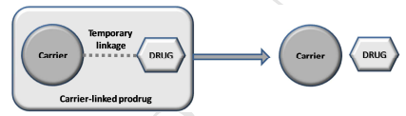
Fig. 3. Schematic representation of a carrier-linked prodrug.

A well-designed carried-prodrug may satisfy the following criteria [10]:
• Typically, a covalent bond forms the connection between the drug ingredient and the transport moiety.
• The prodrug typically has less or no activity than the parent molecule.
• In vivo dissociation of the transport moiety from the medicinal molecule is required.
• Both the prodrug and the transport moiety released in vivo must exhibit non-toxic properties.
• In order to attain optimal drug concentrations at the intended target and minimize the potential for either alternative prodrug metabolism or gradual drug inactivation, it is essential for the conversion to the active form to proceed rapidly.

Although carrier connected prodrugs have been employed for all of the aforementioned purposes, improving bioavailability has been their primary target. A drug's limited bioavailability often stems from an unfavorable partition coefficient, but choosing the right transporter can enhance either its liposolubility or hydrosolubility. A historical example is the case of ampicillin ester prodrugs. Due to its pronounced polarity and resulting hydrosolubility, the beta-lactam antibiotic exhibits a modest absorption rate of approximately 40%. By employing a latentiation process to create lipophilic acyloxyalkyl esters, absorption was substantially improved to around 90%, resulting in a notable enhancement in the antibiotic's bioavailability. This modification allowed for the rapid absorption and release of ampicillin, the compound responsible for the antibiotic activity, occurring within just 15 minutes.
Reducing the presence of intra- or intermolecular hydrogen bonds can be a means to enhance hydrosolubility, as these interactions lead to more structured arrangements that are less soluble in water. Improved water solubility can be achieved through the introduction of hydroxymethyl derivatives for acidic drugs like amides. These derivatives also serve as intermediate forms for ester-based pharmaceuticals with adjusted partition coefficients.

  - Bioprecursor prodrugs

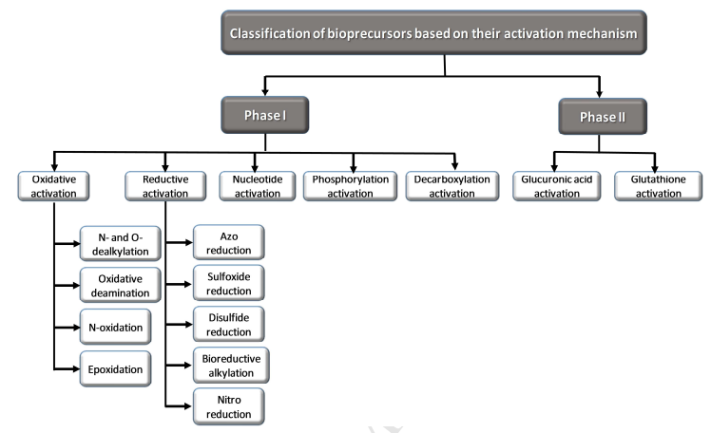
Fig. 4. Classification of bioprecursor prodrugs based on their activation mechanisms

Latent medications called bioprecursors has to be biotransformed in vivo, though typically not by hydrolytic enzyme systems. The active principle is molecularly modified to produce bioprecursor prodrugs. The modification leads to the formation of the expected active chemical, which acts as a substrate for metabolic enzymes. [3,10,11]. As an example, the bioprecursor might be an alcohol that undergoes oxidation to form the aldehyde and then proceeds to become the drug if the compound contains a carboxylic acid group. While phase I reactions (oxidation, reduction, or phosphorylation) generally generate pharmacologically active metabolites, phase II conjugation processes can also yield physiologically active compounds.

3.3 Mixed Prodrugs (12,13,14)
Mixed prodrugs build up bioprecursors and traditional prodrug traits, necessitating biotransformation through chemical or enzyme processes, and boosting the drug's concentration at a particular site of action. In other cases, such as the Chemical delivey System (CDS), the carrier needs to undergo biotransformation before being absorbed. This central nervous system (CNS) has been employed for prodrugs since Bodor and Abdelalim idealised it in 1985. In this system, before entering the brain through the blood-brain barrier, the carrier, in its reduced form as methylnicotinic acid, must undergo biotransformation through an aerobic enzyme process. The blood-brain barrier poses a challenge for positively charged molecules attempting to reverse their passage, leading to the accumulation of the prodrug within the brain . Despite the fact that this biotransformation also takes place in the periphery, the concentration in the brain.

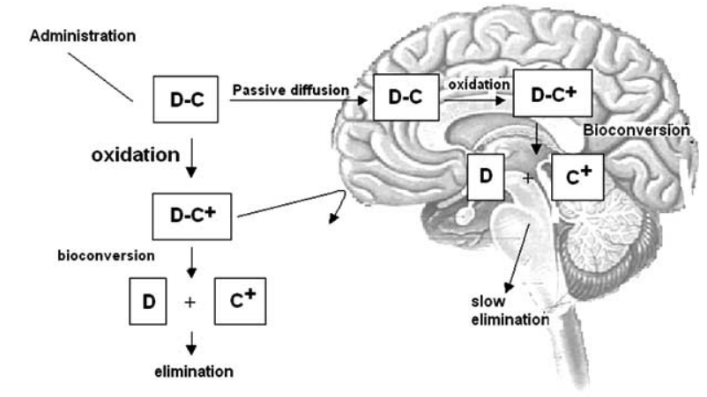
Fig no. 5 CDS(Chemical Delivery System) in SNC. D – drug; C – carrier; C+ - charged carrier.

3.4 Mutual Prodrugs (14,15)
These "latent drugs" consist of two or more medications, with one medication serving as the carrier for the other. This differs from conventional prodrugs, where carriers typically do not possess any biological activity. Their benefit is the ability to combine various therapeutic activities to provide a synergistic impact or increased efficacy. In 1994 [30], Singh and Sharma published a review that included numerous cases of shared prodrugs. It's interesting to note that the development of this category of prodrugs before the idea of the prodrug. For instance, sulfasalazine was first used in 1942 to treat rheumatoid arthritis and is now being used to treat ulcerative colitisHowever, this medication, initially presumed to be a mutual prodrug, ultimately revealed itself as a classic prodrug. Its activity was exclusively triggered by the anti-inflammatory properties of aminosalicyclic acid. (Fig. 6).

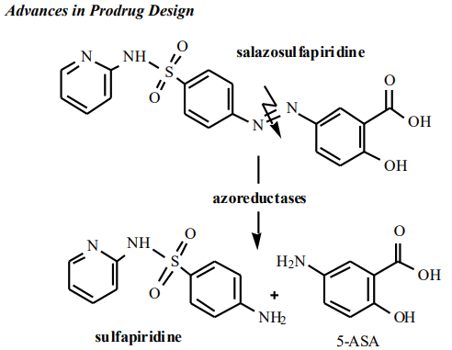
Fig 6: Salazosulfapiridine, formerly considered as mutual prodrug of sulfapyridine and aminosalycilic acid

3.5 Targeted Drugs(16,17)
Lately, there has been an increasing focus on the latentiation technique for delivering medications to specific cells. In targeted drug delivery, carriers play a pivotal role by providing the necessary selectivity to interact with receptors or enzymes, typically located on cell membranes, thus minimizing adverse effects on organs or tissues unrelated to the desired biological action. Targeted drugs can be composed of polymers functioning either as distinct entities or as scaffolds for directing groups. The latter are often identified as antibodies within specific macromolecules.
With the primary objective of achieving specific distribution in the liver, Nishikawa and colleagues employed carboxymethyl and succinyldextrans as carriers with attached directing groups. When used in conjunction with mitomycin, these transporters demonstrated significant advantages for drug delivery.

3.6 POLYMERS AS DRUG CARRIERS (22-25)
The prolonging of action while reducing toxicity is one of the goals for using macromolecules in prodrug creation. Due to the compounds' growing significance in drug development, the polymer chemistry and biomedical research can now interact, giving rise to the "polymer therapeutics" of the twenty-first century. A wide range of biological macromolecules, both natural and synthetic, has found utility as carriers for various chemotherapy drugs, including antineoplastic medications. This application relies on leveraging the differences in anatomical and physiological characteristics between cancer cells and normal cells.
The anatomical configuration of tumor blood vessels plays a critical role in drug distribution within the interstitial space, facilitating:
1. Enhanced microvascular permeability compared to normal vessels, thereby improving the penetration of macromolecules.
2. Elevated interstitial pressure, potentially causing a delay in the efflux of macromolecules.
3. Absence of a lymphatic drainage system, resulting in the accumulation of macromolecules within the tumor tissues. To be suitable as carriers in the latentiation approach, polymers should possess the following characteristics:
- Ability to undergo biodegradation.
- Absence of toxicity or inherent antigenic properties.
- Inability to accumulate within the body.
- Presence of functional groups for bioreversible chemical linkage.
- Maintenance of drug linkage stability until the polymer prodrug reaches its intended site of action.

Table 1: shows some examples of most used as carriers with the purpose of prolonging action and decreasing toxicity, besides being used for director group support in targeted drugs.
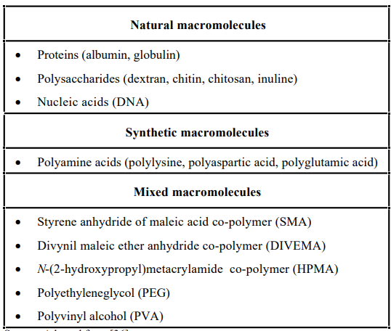

3.7 MODERN SELECTIVE LATENTIATION SYSTEMS
The development of gene-controlled transcription in mammalian cells and the discovery of membrane transporters' tridimensional structure have made it possible to develop highly targeted, highly selective medications. The following systems are recognised by these advanced latent forms.:
- CSDDS – Colon Specific Drug Delivery System.
- ADEPT – Antibody Directed Enzyme Prodrug Therapy.
- GDEPT/VDEPT – Gene-Directed Enzyme Prodrug Therapy/Virus Directed Enzyme Prodrug Therapy.
- ODDS – Osteotropic Drug Delivery System.

- CSDDS – Colon Specific Drug Delivery System.(16)
This approach is predicated on the discovery of typical intestinal microbiota enzymes that can be utilised to facilitate colon medication delivery. Utilizing prodrugs containing azo linkages was considered an attractive approach for drug targeting to the colon due to the established presence of normal gastrointestinal microbiota and the presence of azoreductases in this environment.
II.ADEPT – Antibody Directed Enzyme Prodrug Therapy. (25,26)
It is well knowledge that substantial drug side effects severely restrict the effectiveness of cancer chemotherapy because the drugs don't target neoplastic cells specifically. Therefore, specific antineoplastic chemotherapeutic drugs are the focus of the majority of investigations conducted in this field. However, parasites, germs, and other infectious organisms can also be treated using this strategy.

III.GDEPT/VDEPT – Gene-Directed Enzyme Prodrug Therapy/Virus Directed Enzyme Prodrug Therapy. (27,28)
IV. This technique relies on gene expression to generate enzymes capable of activating prodrugs. The genes can be delivered using carriers such as viruses (retrovirus or adenovirus), cationic lipids, or liposomes, which target both tumor and healthy cells. This approach is referred to as VDEPT when using virus-derived genes. By placing these genes downstream at the transcriptional unit ends of tumors, it becomes possible to activate gene expression. This approach has been explored extensively in cancer therapy, aiming to create exceptionally selective antineoplastic drugs, and it has demonstrated encouraging results in initial investigations.
V.ODDS – Osteotropic Drug Delivery System.(29,30)
While numerous efforts have been made to develop prodrugs for potential use in addressing bone disorders, bone tissue has remained a relatively underexplored target. This limitation is attributed to the unique biological characteristics of bone tissue and its lack of a circulatory system, unlike other body tissues. Recently, a novel and promising prodrug approach has emerged for delivering medications specifically to bone tissue. This approach, known as the Osteotropic Drug Delivery System (ODDS), involves linking bisphosphonate molecules to certain drugs used to treat bone-related conditions. Bisphosphonates belong to a new class of synthetic chemicals and are structurally related to pyrophosphate, an endogenous regulator of calcium homeostasis. These compounds have demonstrated clinical utility in several bone-related disorders, including Paget's disease, malignancy-induced hypercalcemia, bone metastases, and osteoporosis.The tissues that have calcified are the principal sites for these substances' accumulation following delivery because of their strong affinity for hydroxyapatite. The ODDS mechanism enables medication release from the bones or bone marrow based on biphosphonate tropism.

CONCLUSION AND PERSPECTIVES
Numerous viral or physiologically induced disorders have been successfully treated with the prodrug strategy. Due to the tremendous advancement in the biotechnological sector and in the identification of organic compounds, this strategy has become a significant, logical, and potential option to bring improved medications in therapy. The existing methodologies utilized in prodrug development are gaining increasing attention, driven both by their simplicity in synthesis and their potential to yield highly selective molecules that hold promise for therapeutic purposes.
Due to the increasing demand for selective antineoplastic medications, studies on enhanced systems of prodrug creation have focused on the cancer field. However, it is crucial to apply these contemporary methods to infectious illnesses such as tropical endemics and tuberculosis, for example. New and better medications must be developed because these diseases primarily afflict the underprivileged in developing nations. In order to enhance their effectiveness and create selective derivatives, we have been actively advancing prodrug design for a range of medications, including those used in the treatment of malaria, leishmaniasis, Chagas disease, and tuberculosis.

Reference
- A. Albert, Chemical aspects of selective toxicity, Nature 182 (1958) 421–423. c) J. Rautio, Prodrug strategies and drug design, in Methods and principles in medicinal chemistry, Prodrugs and targeted delivery, Wiley-VCH, Weinheim, 2011, pp 3–26.
- International Union of Pure and Applied Chemistry. http://www.chem.qmul.ac.uk/iupac/medchem (accessed 7.06.2016).
- R.B. Silverman, Prodrugs and drug delivery systems, in The Organic Chemistry of drug design and drug action, J. Hayhurst (Ed.), Elsevier Academic Press: San Diego, 2004, pp 497–544.
- B. Testa, Prodrugs: bridging pharmacodynamic/pharmacokinetic gaps, Curr. Opin. Cell. Biol. 13 (2009) 338–344.
- C. Anastasi, G. Quelever, S. Burlet, C. Garino, F. Souard, J.-L. Kraus, New antiviral nucleoside prodrugs await application, Curr. Med. Chem. 10 (2003) 1825–1843.
- V.L. Campo, I. Carvalho, Prodrugs: principles, design and therapeutic application, Curr. Methods Med. Chem. Biol. Phys. 2 (2008) 187–214.
- N.N. Salama, A. Fasano, M. Thakar, N.D. Eddington, The impact of ∆G on the oral bioavailability of low bioavailable therapeutic agents, J. Pharmacol. Exp. Ther. 312 (2005) 199–205.
- H.K. Han, G.L. Amidon, Targeted prodrug design to optimize drug delivery, AAPS PharmSci 2 (2000) E6.
- J. Rautio, H. Kumpulainen, T. Heimbach, R. Oliyai, D. Oh, T. Jaervinen, J. Savolainen, Prodrugs: design and clinical applications, Nat. Rev. Drug Discov. 7 (2008) 255–270.
- C.G. Wermuth, Designing prodrugs and bioprecursors, in The Practice of Medicinal Chemistry, 3rd ed; C.G. Wermuth (Ed), Elsevier Academic Press: Amsterdam, 2008, pp 561–585.
- G.R. Kokil, P.V. Rewatkar, Bioprecursor prodrugs: molecular modification of the active principle, Mini Rev. Med. Chem. 10 (2010) 1316–1330.
- de Albuquerque Silva AT, Chung MC, Castro LF, Carvalho Guido RV, Ferreira EI. Advances in prodrug design. Mini reviews in medicinal chemistry. 2005 Oct 1;5(10):893-914.
- Bodor, N.; Abdelalim, A. M. J. Pharm. Sci., 1985, 74, 241.
- Prokai, L.; Prokai-Tatrai, K.; Bodor N. Med. Res. Rev., 2000, 20, 367.Singh, G.; Sharma, P.D. Indian J. Pharm. Sci., 1994, 56, 69.
- Vlieghe, P.; Clerc, T.; Pannecouque, C.; Witvrouw, M.; De Clercq, E.; Salles, J. P.; Kraus, J. L. J. Med. Chem., 2002, 45, 1275.
- Han, H. K.; Amidon, G. L. AAPS Pharm. Sci., 2000, 2, E6.
- Chung, M.-C.; Gonçalves, M. F.; Colli, W.; Ferreira, E. I.; Miranda, M. T. J. Pharm. Sci., 1997, 86, 1127.
- Takakura, Y.; Hashida, M. Crit. Rev. Oncol. Hematol., 1995, 18, 207.
- Chen, X.; Wu, B.; Wang, P. G. Curr. Med. Chem. Anti-Cancer Agents, 2003, 3,139.
- Hoste, K.; De Winne, K.; Schacht, E. Int. J. Pharm., 2004, 277, 119.
- Heinis, C.; Alessi, P.; Neri, D. Biochemistry, 2004, 43, 6293.
- Bouvier, E.; Thirot, S.; Schmidt, F.; Monneret, C. Org Biomol Chem., 2003, 7, 3343.
- Duncan, R. Nat. Rev. Drug Discov., 2003, 2, 347.
- Takakura, Y.; Takagi, A.; Hashida, M.; Sezaki, H. Pharm. Res., 1987, 4, 293.
- Xu, G.; Mcleod, H. L. Clin. Cancer Res., 2001, 7, 3314.
- Houba, P. H. J.; Leenders, R. G. G.; Boven, E.; Scheeren, J. W.; Pinedo, H. M.; Haisma, H. J. Biochem. Pharmacol., 1996, 52, 455.
- Grove, J. I.; Searle, P. F.; Weedon, S. J.; Green, N. K.; Mcneish, I. A.; Kerr, D. J. Anticancer Drug Des., 1999, 14, 461.
- Kerr, D. J.; Young, L. S.; Searle, P. F.; Mcneish, I. A. Adv. Drug Deliv. Rev., 1997, 26, 173.
- Castro, L. F.; Silva, A.T. A.; Ferreira, A. G.; Ferreira, E. I.; Chung, M. C. Quim. Nova, 2004, 27, 456.
- Hirabayashi, H.; Takahashi, T.; Fujisaki, J.; Masunaga, T.; Sato, S.; Hiroi, J.; Tokunaga, Y.; Kimura, S.; Hata, T. J. Controlled Release, 2001, 70, 183.

