MODELLING OF THE PARTICLE MIXING IN SEAD COATER USING DEM SOFTWARE
VALLE NAVYA
Department of processing and food engineering
College of Agricultural engineering kandhi, sangareddy.
Telangana, India
Vallenavya1999@gmail.com

GATTU SRIHARIKA
Department of processing and food engineering
College of Agricultural Engineering kandhi, sangareddy.
Telangana, India

ABSTRACT

In numerous industrial applications like seed and tablet coating, there is significant interest in coating particulate solids with a thin film layer. Seed processing commonly involves applying a protective coating to seeds using fertilizers, and disease-control agents like pesticides and fungicides. This process is often carried out using batch coaters, typically comprised of a cylindrical drum rotating horizontally. The coating material is fed into the drum simultaneously with the seeds driven around it by the horizontal rotation. Three baffles, positioned on either side of the drum, help to mix the seeds during the coating process. This study focuses on modeling the seed coating process using the Distinct Element Method (DEM) simulations. Groundnut seeds are used as the model material, and their shape and size are approximated as clumped spheres in the DEM. The DEM coating model predicts the velocity of the seeds as they are projected tangentially from an opening in the drum. The seed velocity is measured using high-speed video imaging and incorporated into the DEM simulations to validate the results. In the simulations, the velocity of seeds is represented using different colors. The study evaluates the distribution of seeds and their coefficient of variation under various process conditions, such as the rotational speed of the drum, baffle arrangement, and designs. The findings indicate that the speed of the drum, the angle of the baffles, and the clearance to the wall have the most significant impact on the process, while the baffle width and curvature have only a minimal effect.

Ⅰ. INTRODUCTION
In agriculture and horticulture, seed treatment or seed dressing involves applying chemical substances, typically antimicrobial or fungicidal, to seeds before planting. In some cases, insecticides are also used, though less frequently. Seed treatments offer an environmentally friendly way to use pesticides, as only small amounts are required. To discourage birds from consuming treated seeds and facilitate easy visibility and cleanup in case of accidental spills, colorants are often added to the treatment. The application of these chemicals to the seeds requires specialized machinery to ensure safe and efficient handling. A seed coating, on the other hand, is a thicker covering for seeds that may contain fertilizers, growth promoters, seed treatments, an inert carrier, and a polymer outer shell. Additionally, the term "seed dressing" is used to describe the process of removing chaff, weed seeds, and straw from seed stocks.
The application of a thin film layer to particulate solids is extensively employed in diverse industrial sectors, notably in seed coating processes. For seed processing, rotary drum batch coaters are the primary choice for applying a protective layer comprising fertilizers and crop protection materials onto the seeds. The quality of the final product is directly influenced by the drum's speed, which impacts the velocity, motion, and mixing of the seeds. The drum speed and design are crucial factors under the direct control of the process operation, ultimately affecting the overall effectiveness of the coating process.
Dust arising from treated seeds has been known to cause certain issues, especially when crops like maize are planted during the main honey flows. In response to this problem, improvements have been made to pneumatic drills to minimize dust release, and advancements in seed treatment compounds have been introduced in Europe, with Germany and the Netherlands taking the lead between 2009 and 2012. These developments aimed to prevent the compounds from breaking up into dust during planting. Detailed information regarding seed treatments, including the aforementioned improvements, can be found on registration authority databases [7]. For farmers seeking the United States Department of Agriculture Organic certification, it is a requirement to use organic seed. If organic seed is not available, farmers are permitted to use conventional, untreated seed. However, the use of treated seeds is strictly prohibited for organic certification [8].
Ⅱ. MATERIALS AND METHODOLOGY
- Ground Nut
Groundnut, classified under the genus Arachis in the subtribe Stylosanthinae of the tribe Aeschynomenea in the family Leguminosae, is a self-pollinated tropical annual legume. It holds significant importance as one of the most crucial cash crops in our country. Despite its low cost, groundnut is a highly valuable source of essential nutrients. Globally, it ranks as the sixth most important oilseed crop. With oil content ranging from 48% to 50% and protein content ranging from 26% to 28%, groundnut serves as a rich reservoir of dietary fiber, minerals, and vitamins. Groundnut is cultivated worldwide, covering an extensive area of 26.4 million hectares, with a total production of 37.1 million metric tonnes and an average productivity of 1.4 metric tonnes per hectare. This crop is grown in over 100 countries across the globe. Remarkably, developing countries dominate its cultivation, accounting for 97% of the global groundnut area and 94% of its total production Groundnut holds the position of the largest oilseed in India in terms of production, contributing to 35.99 percent of the country's oilseed production during 2007-08. On average, groundnut contains 40.10 percent fat and 25.30 percent protein, making it a valuable source of calcium, iron, and essential vitamins like thiamine, riboflavin, niacin, and vitamin A. Its applications are diverse and multifaceted.
- Seed Drum Description
The seed treatment drum comprises a frame, handle, and a cylindrical drum, which is mounted on a tripod angle iron frame. To ensure uniform mixing, three pieces of mild steel flat are welded inside the drum. Before commencing the chemical mixing, workers are advised to wear plastic hand gloves and nose masks for their health protection. Once the chemicals are added to the drum, a small amount of water is introduced, and the drum's lid is tightly closed. The drum is then rotated for approximately 20 to 25 revolutions. After completing the process, which takes around 1-2 minutes, the lid is opened, and the treated seeds are transferred to a separate bag or container. The entire operation for a 20kg seed batch typically takes about 5-6 minutes to complete.
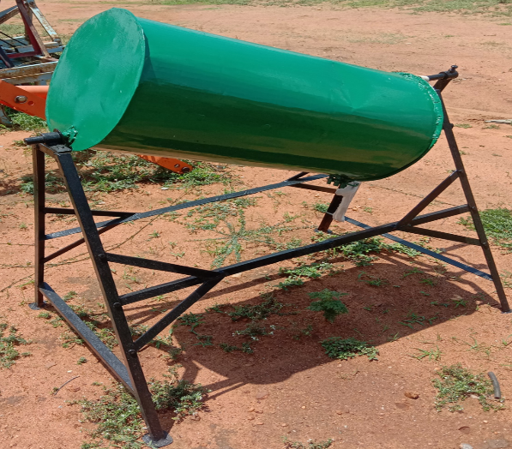
Fig .1 Seed coating Drum
- Physical properties
Bulk density
Bulk density is the measure of the mass of groundnut seeds in relation to its total volume. This parameter was established by filling a measuring cylinder with groundnut seeds without applying any compaction, using a known volume for measurement.
Bulk density (ρ_{b}) = $\frac{mass of the groundnut seeds, kg}{volume of the container, m^{3}}$
True density
The true density (ρ_{t}) is the ratio of the mass of the ground nut to its true volume. It was determined using the toluene displacement method. Toluene (C₇H₈) was used in place of water because ground nut absorbed toluene to a lesser extent. (Ravi et al. 2015).
Porosity
Porosity is a measurement of the empty spaces or voids within a substance, indicating the volume they occupy in relation to the total volume. Denoted by the symbol 'θ', porosity is calculated by considering the relationship between bulk density and true density (Muralidhar et al. 2012).
Angle of repose
The angle of repose (θ) signifies the degree angle with the horizontal at which a material naturally forms a heap. This angle is determined by measuring the height of the heap at its center and the base diameter of the heap (Chidanand et al. 2015).
θ = $\tan^{-1}$($\frac{2h}{d}$)
Where,
h - Height of the pile or heap, m
d - diameter of the pile or heap, m
D. Dem Introduction
The discrete element method (DEM), also known as the distinct element method, belongs to a group of numerical techniques used to calculate the motion and interactions of numerous small particles. While closely related to molecular dynamics, DEM stands out due to its incorporation of rotational degrees of freedom, as well as stateful contact and intricate geometries, such as polyhedral shapes. With advancements in computing power and algorithms for nearest-neighbor sorting, it has become feasible to simulate millions of particles on a single processor. Presently, DEM is widely recognized as an effective approach for addressing engineering challenges related to granular and fragmented materials, particularly in scenarios involving granular flows and powder mechanics.

Ⅲ. Results And Discussion

This chapter deals with the results obtained from the various tests conducted during the experiments.

- Bulk density (ρ_{b}):
The bulk density was calculated with a known volume of the container. The average of three replications is 648.06kg/m³.
- angle of repose:
The angle of the pile was measured at eight different positions and the experiment repeated four times. The angle of repose ranged between 26.1° and 25.2° with an average value of 25.4°(Fig.2)

Fig .2. Angle of repose test of groundnuts.

- velocity of the groundnut particles simulated with DEM:

The drum was given a rotational motion in the DEM and velocity profiles formed during the simulation were studied. The velocity of the simulated particles varied between 0.2 and 2.5 m/s. the results showed that initially the velocity increased constantly until 0.23 s and stabilized afterward with minor fluctuations as shown in fig. 3 average velocities at different time steps showed a steady increase with time. However, it should be observed that the average.

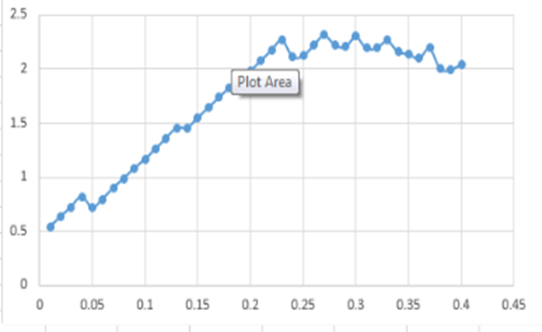
Fig.3 Variation of maximum velocity of the particles with simulation time

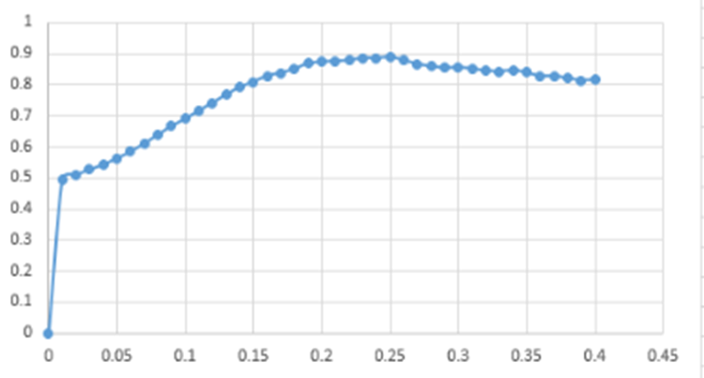

Fig. 4 Variation of the average velocity of the particles with simulation time

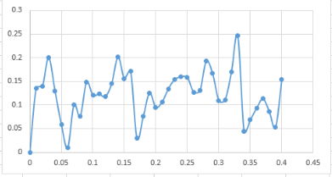
Fig .5 Variation of the minimum velocity of the particles with simulation

Ⅳ. CONCLUSION

The impact of various process parameters on the velocity variation of groundnut seeds in a batch seed coater was explored through DEM simulations. In this model, seeds were represented as small spheres. Upon contact with the drum surface, seed velocities were recorded in memory as maximum, minimum, and average values, and then the seeds were removed from the simulation. The coating uniformity was assessed based on the coefficient of variation of coating mass on each seed. This approach provided valuable insights into seed velocities at different time intervals, offering information on maximum, minimum, and average speeds concerning drum speed and time. Among the studied process parameters, it was concluded that positioning the drum at a 45º angle with the horizontal, a drum speed of 30m/s, a maximum seed velocity of 2.5m/s, and a minimum seed velocity of 0.4m/s yielded optimal results.

Ⅴ. REFERENCE

[1] Chidanand, D. V., Shanmuga sundram, S., and Sunil, C. K.2015. some engineering properties of paddy: variety-ADT 46. Trends in Biosciences, 8(15): 3812-3815.

[2]. Murlidhar, M., and Goswami, T. K. 2012. Effect of moisture content on the physical and textural properties of fenugreek seed. Food, 6(1): 14-21.

[3]. Ravi, P., and Venkatachalam, T. 2015. Important engineering properties of paddy. Scientific journal agricultural engineering. 4(1): 73-83.

[4]. ‘Effect of particle shape on bulk particle motion in a seed coater’, M. Pasha, C. Hare, M. Ghadiri, P. M. Piccione, A. Gunadi. World Congress on Particle Technology. May 2014, Beijing, China.

[5]. ‘Analysis of seed processing by the Distinct Element Method’, M. Pasha, C. Hare, M. Ghadiri, P. M. Piccione, S. Taylor. Powders and Grains Conference. July 2013, Sydney, Australia.

[6]. ‘Analysis of seed processing by the Distinct Element Method’, M. Pasha, C. Hare, M. Ghadiri, P. M. Piccione, S. Taylor. PARTEC 2013 Conference. April 2013, Nurnberg, Germany.

[7]. Pandey P, Song Y, Kayihan F, Turton R. Simulation of particle movement in a Pan Coating Device using Discrete Element Modelling and its Comparison with Video-imaging Experiments. Powder Technol, 2006;161(2).

[8]. Li J, Wassgren C, Lister JD. Multi-scale Modelling of a Spray coating process in a paddle Mixer/Coater; The Effect of Particle Size Distribution on Particle Segregation and Coating Uniformity, ChemEng Sci. 2013 May;95:203-10.

