A comparative study of baffle insert type with Stairmand gas solid cyclone separators through computational technique

Kiran Kumar Rokhade^{1*}, Eshwar udbal², Anand K Joshi³, S. Karthik⁴

^{1,3}Department of Mechanical Engineering, University BDT College of Engineering, Davanagere
Karnataka India
²Department of Mechanical Engineering Poojya Doddappa Appa College of Engineering, Kalburgi, Karnataka, India
³Department of Mechanical Engineering, Presidency University, Bengaluru, Karnataka India

⁴Independent Consultant, Viswapriya layout, Bengaluru, Karnataka India

*Corresponding author: kprokhade@gmail.com

Abstract:
A gas-solid cyclone separator is used in a variety of lab-scale and industrial applications to separate the particles from the gas and increase the separator's efficiency. The CFD tool is used to determine the efficiency of the standard Stairmand cyclone and its modified design. Utilizing the turbulent module, i.e RNG k-ε model and DPM, one-way coupling is used to predict the pressure drop, velocity contour, and particle velocity. A three-dimensional numerical study is conducted, and using sawdust powder, a fixed inlet velocity of 11.5 m/s and particle sizes of 2 and 4 μm are taken into consideration. The simulation results were compared between the Stairmand stairmand and baffle types underneath the cyclone. The modified design collected 82–86% of the particles, and the velocity and pressure drop are lower when compared to the Stairmand cyclone.

Key words: Baffle, Cyclone Efficiency, Stairmand, Pressure drop.

I INTRODUCTION
Cyclone separators are low-cost and efficient particle control devices that have been applied in a variety of sectors, including the chemical, power, biomass, and other manufacturing industries. A reliable prediction of the two swirling motions of the fluid flow field is managed by the cyclone function inside the cylindrical structure, and particle tracking results in an estimation of the collection efficiency. [1-3] The gas, which consists of solid particles, enters the cyclone tangentially, and the centrifugal force created by the circular flow propels the particulates toward the cyclone's wall, where they eventually fall into a collection bin at the bottom of the cyclone [4-5].
Since their development of cyclone separators, many investigations have been conducted to maximize the collection efficiency. Pandey s et al [6] estimated the performance of various cone shapes and heights and found that the concave profile had only slightly improved collection efficiency. According to E. Fatahian et al [7], they changed the shape of the conical to square and identified that the efficiency is much higher due to swirl flow. Zhang et al [8] discovered that hexagonal shaped cyclones have higher collection efficiency and lower pressure drop than conventional cyclones.
In the present work, the gas solid flow in a typical cyclone is investigated using the RNG k-ε model swirl dominated flow and discrete phase injection. The results are then measured and compared for both cyclone designs in terms of pressure drop, flow fields, particle flow pattern, and cyclone efficiency. The decision to use CFD analysis was made because of cost-effective.

II DESIGN MODIFICATION OF CYCLONE
From the past few decades many researchers used standard Stairmand design (1951) [9-11] is shown in figure 1-(i), which includes a high performance cyclone and low pressure drop based on geometrical parameter ratio, is the most widely used gas solid separator in the industry. The modified design is depicted on the conical surface of the above the dust collector is shown in figure 1(ii). Table 1 shows the dimensions of the cyclone for the Standard Stairmand & modified design, same will be used for numerical simulation. The addition of a baffle to the modified design, which is shown in figure 1-(ii), addresses the design observation that the flow is moving tangentially across the cyclone cylinder, conical, and exit barrel. In this case, it is expected to improve collection efficiency and speed of delivery of gas in the barrel, which can be analyzed in the current work.
Table 1: The geometrical dimensions for Stairmand & Modified design of the cyclone

Parameters | Dimensions | Stairmand design | Modified Design
Diameter of the cyclone body | D | 290 mm | 290 mm
Diameter of the vortex barrel | D1 | 140 mm | 140 mm
Diameter of dust collector | D2 | 104 mm | 104 mm
Height of cyclone body | h1 | 435 mm | 435 mm
Height of conical Cyclone | h2 | 725 mm | 725 mm
Height of the dust collector | h3 | 100 mm | 100 mm
Width of the inlet | a | 58 mm | 58 mm
Height of the inlet | b | 105 mm | 105 mm
Length of the inlet | c | 290 mm | 290 mm
Width of the baffle | - | - | 25 mm
Thickness of the baffle | - | - | 10 mm
Length of the baffle | - | - | 100 mm
Baffle location from the bottom | - | - | 192 mm

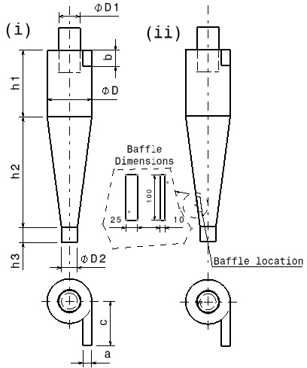

Figure 1:(i) Stairmand-type cyclone (ii) Modified (Baffle type) cyclone

III NUMERICAL STUDY
The numerical study is carried out using the commercial finite volume code Ansys fluent 23.0. The flow with the domain of the cyclone is assumed to be three-dimensional, turbulent, isothermal, incompressible, and steady state. The following steps define the boundary conditions, grid generation, and governing equations used to simulate the fluid domain.

(a) Boundary condition
The table 2 represents the various boundary conditions are being initiated, for single phase solution, air enters the inlet region with a uniform velocity. No slip boundary conditions are applied for walls. At the outlet of the vortex finder a zero gradient boundary condition is assumed, and gauge pressure is set to zero.
Table 2: boundary Conditions used for both design for CFD analysis
Parameter | Conditions
Inlet | Velocity Inlet (DPM-escape)
Oulet-1 | Pressure outlet (DPM-escape)
Outlet-2 | Pressure outlet (DPM-trap)
Wall | No slip (DPM-reflect)
(b) Grid Generation
Three-dimensional structure is used with hex dominate mesh method. A fine mesh has been generated across the entire fluid domain. Figure 2b depicts the structure mesh model for the Stairmand design; the total element number is 0.14 million, and the element or orthogonal quality is 0.65 for both designs.
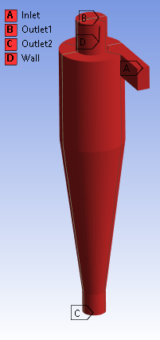
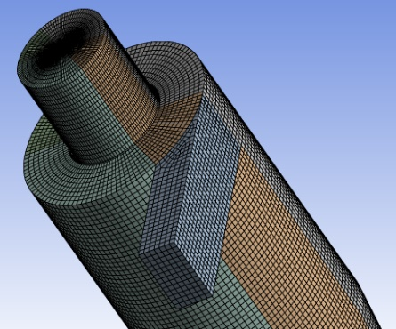
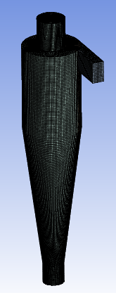
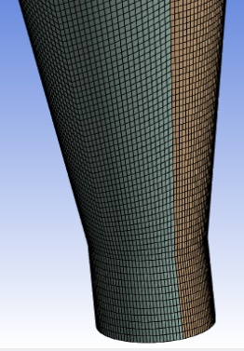
(a)
(b)

Figure 2:(a) Boundary Condition (b) Structured mesh

(c ) Fluent Setup
The density and viscosity of gas state were 1.225 kg/m³, and 1.7894 X10⁻⁵ Pa-s. The discrete phase has been initiated with a spherical particle with a density of 2650 kg/m³. For Fluid domain setup has been made, the Standard SIMPLE algorithm was used in pressure velocity coupling, the least squares cell based method and Quick algorithm was used for gradient evaluation & momentum respectively. Second order upwind scheme were used for pressure term, the complete setup is shown in the table-3

Table-3 Solver setting
Parameter | Type
Steady State | Time Constant
Energy | Temperature Constant
Turbulence model | k-ε (2 eq) RNGswirl dominated flow
Discrete Phase model | Injection
Solver | SIMPLE
Momentum, Turbulent KE & dissipation rate | Second-Order Upwind Scheme

(d) Governing Equations
Cyclone separator for both Stairmand & modified design, which consists of common main parts are inlet, cyclone body (separator), and vortex barrel, with addition of baffle at the bottom of conical section. The flow is considered as tangential inlet for both the designs which shown in figure 1, The above details provide the use of governing equations are same for both design, such as continuity, momentum & Re-Normalized Group k-ε (2 equation) model (Swirl dominated method) with DPM injection.

Continuity
$ρ∇.V=0$----------(1)
Momentum
$\left(u∙∇\right)u=-∇p+ϑ∇^{2}u+g$ -----(2)
RNG k-epsilon model
$$\frac{∂(ρk)}{∂t}+\frac{∂(ρku_{i})}{∂x_{i}}=\frac{∂\left[(μ+\frac{μ_{t}}{σ_{k}})\frac{∂k}{∂x_{j}}\right]}{∂x_{j}}+p_{k}+ρϵ----(3)$$
$$\frac{∂(ρϵ)}{∂t}+\frac{∂(ρϵu_{i})}{∂x_{i}}=\frac{∂\left[(μ+\frac{μ_{t}}{σ_{ϵ}})\frac{∂ϵ}{∂x_{j}}\right]}{∂x_{j}}+C_{1ϵ}\frac{ϵ}{k}p_{k}+C_{2ϵ}ρ\frac{ϵ^{2}}{k}-----(4)$$
Particle motion
$$\frac{du}{dt}=\frac{18μC_{d}Re}{ρ_{p}d^{2}24} \left(u-u_{p}\right)+\frac{(ρ_{p}-ρ)g_{i}}{ρ_{p}}-----(5)$$

IV RESULT AND DISCUSSION
(a) Collection Efficiency:
The efficiency of the cyclone is primarily determined by tiny particles diameter and density; in CFD, efficiency is measured by the number of particles trapped, injected, and incomplete. The same ambient conditions were considered in the study for both cyclone design simulation Figure - shows the collection efficiency It is observed that the modified design improves collection efficiency as the dimeter of the tiny particle increases, i.e. 84.0% & 86.0% for 2μm & 4 μm, respectively. A comparison of Stairmand cyclones yielded an overall collection efficiency of 27%.
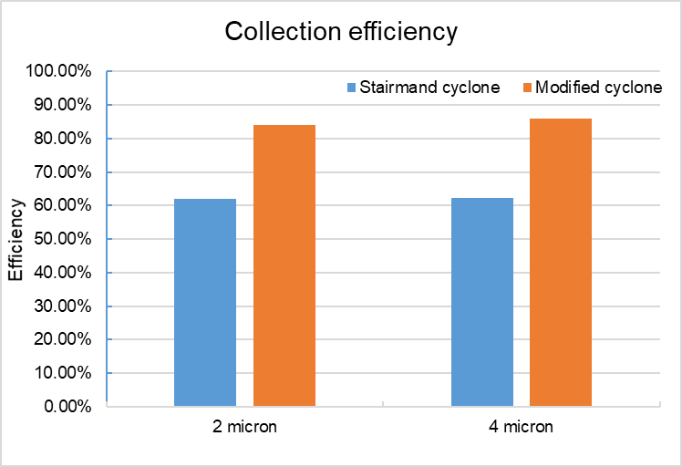

Figure 3: Collection efficiency
(b) Pressure Drop:
The pressure drop contour is chosen after a series of iterations that provide complete flow variation inside the cyclone. The pressure drop between the inlet and outlet is considered. Figures 4(a),4(b), and 4(c) show the pressure comparison of designs, as well as the pressure drop for the Stairmand cyclone and modified design at 4m particle diameter. The pressure drop in the modified design is drastically reduced, indicating that not much energy is required to make fluid flow in the domain [6]. The pressure near the wall is high for both designs, and the pressure level in the center (core) zone is very low in the Stairmand cyclone, indicating that the minimum flow exists when compared to the modified design. For both designs, the pressure drop is 140 and 80 Pa respectively.

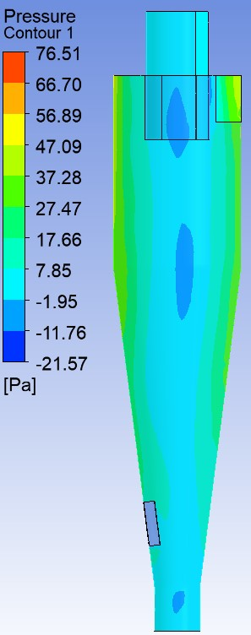
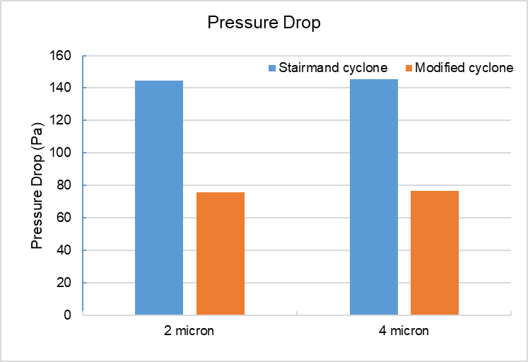
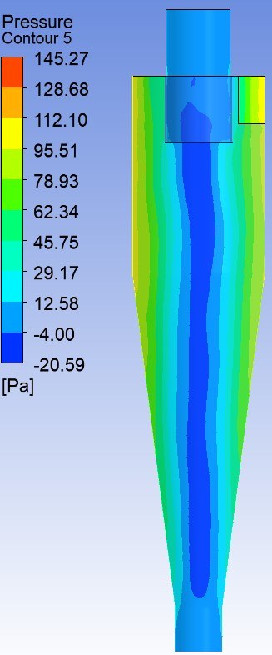
(a)
(b)
(c)

Figure 4: (a) Comparison of pressure drop (b) Pressure drop contour for Stairmand cyclone (4 micron) (c) Pressure drop for modified design (4 micron)
(c) Velocity Contour:
The figures 5(a), 5(b), and 5(c) show a comparison of velocity impression, velocity in Stairmand, and modified cyclone. The velocity profile is influenced by the Stairmand cyclone, which affects particle collection [13]; the maximum velocity that occurs is 58.83 m/s. The modified cyclone's velocity is not greatly affected, so particle collection is rapid; the maximum velocity that occurs is 13.62 m/s. The velocity is high in the zone of baffle addition (fig 5c), indicating that the flow is restricted and collection is increasing.
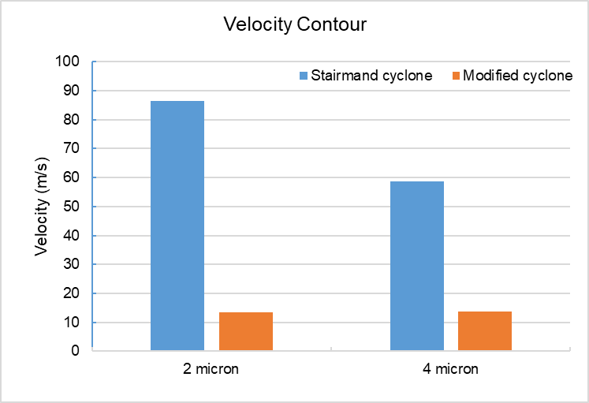
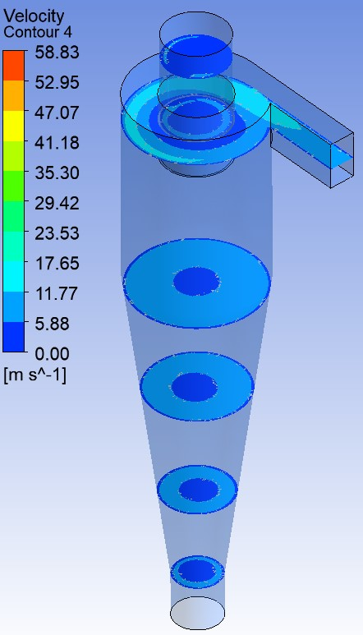
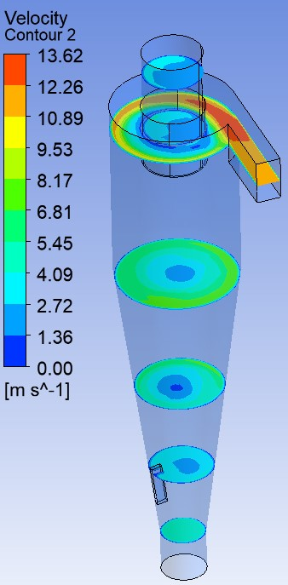
(a)
(b)
(c)

Figure 5: (a) Comparison of velocity impression (b) velocity in Stairmand cyclone
(c) velocity in Modified cyclone

(d) Particle motion contour:
Figures 6(a) and 6(b) shows the particle trajectory for a particle diameter of 4μm. The particle is observed to be tracking and moving in a swirling position, which is similar to air movement in tangential flow. The particle is directly collected on the bottom surface of the Stairmand cyclone design, In the modified design, the baffle plate reduces the kinetic energy of the particle, and due to an increase in particle potential energy, the particle accumulates quickly in the dust collector.

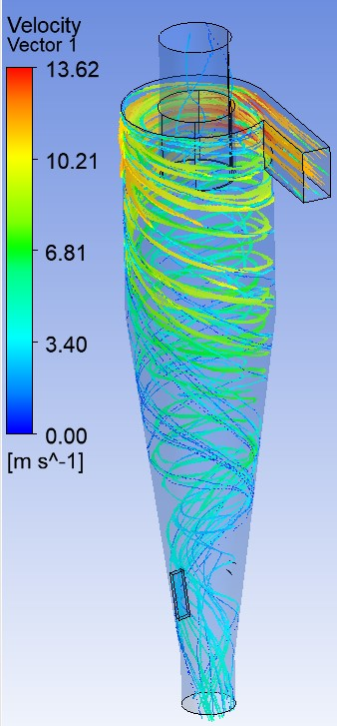
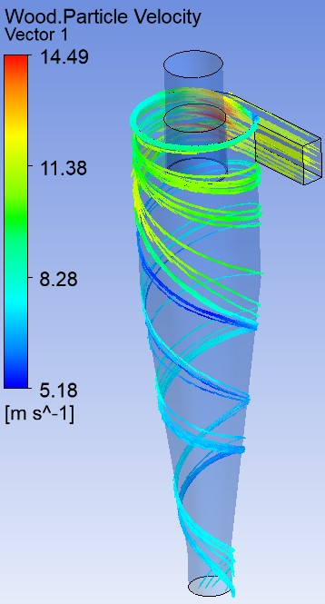
(b)
(a)

Figure 6: (a) Stairmand Model (b) Modified design
V CONCLUSION
Using the RNG k-model and the discrete phase model, the Stairmand and modified baffle type cyclones are being valid using CFD tool. The main findings for the models tested at two particle diameters and constant inlet velocity are as follows:
- The cyclone collection efficiency of the modified baffle type performs better than the standard cyclone.
- The new cyclone design has a lower pressure drop, which suggests that more energy is not required to supply fluid inside the fluid domain.
- As a result of the restriction on particle velocity at the baffle zone, the separation process will be hampered and particles will collect underneath of the cone.
- The particle trajectory near the cone's underneath suggests that the particle is being dragged or has begun to accumulate rapidly in the dust collector.
REFERENCES

- Moore, M. E., & McFarland, A. R. (1993). Performance modeling of single-inlet aerosol sampling cyclones. Environmental Science & Technology, 27(9), 1842–1848. doi:10.1021/es00046a012
- Haig, C. W., Hursthouse, A., McIlwain, S., & Sykes, D. (2014). The effect of particle agglomeration and attrition on the separation efficiency of a Stairmand cyclone. Powder technology, 258, 110-124.
- Bogodage, S. G., & Leung, A. Y. (2015). CFD simulation of cyclone separators to reduce air pollution. Powder Technology, 286, 488-506.
- Saputro, H., Firdani, T., Muslim, R., Estriyanto, Y., Wijayanto, D. S., & Lasmini, S. (2018). The CFD Simulation of Cyclone Separator without and with the Counter-cone in the Gasification Process. In IOP Conference Series: Materials Science and Engineering (Vol. 288, No. 1, p. 012142). IOP Publishing.
- Elsayed, K., & Lacor, C. (2014). Analysis and optimisation of cyclone separators geometry using RANS and LES methodologies. In Turbulence and Interactions: Proceedings of the TI 2012 conference (pp. 65-74). Springer Berlin Heidelberg.
- Pandey S, Saha I, Prakash O, Mukherjee T, Iqbal J, Roy AK, Wasilewski M, CFD Investigations of Cyclone Separators with Different Cone Heights & Shapes. Applied Sciences. 2022; 12(10):4904. https://doi.org/10.3390/app12104904
- Fatahian, E., & Fatahian, H. (2021). Computational fluid dynamics modeling of effect of dipleg geometry on separation efficiency of a square cyclone. AUT Journal of Mechanical Engineering, 5(3), 451-464. doi: 10.22060/ajme.2021.18498.5902
- Zhang, Ting; Liu, Chunjiang; Guo, Kai; Liu, Hui; Wang, Zhengchao (2016). Analysis of Flow Field in Optimal Cyclone Separators with Hexagonal Structure Using Mathematical Models and Computational Fluid Dynamics Simulation. Industrial & Engineering Chemistry Research, 55(1), 351–365. doi: 10.1021/acs.iecr.5b02813
- Stairmand, C.J., 1951. The design and performance of cyclone separators. Industrial & Engineering Chemistry 29, 356–383.
- Khairy Elsayed; Chris Lacor (2010). Optimization of the cyclone separator geometry for minimum pressure drop using mathematical models and CFD simulations., 65(22), 6048–6058. doi: 10.1016/j.ces.2010.08.042
- N. Prasanna, K. Subramanian, S. Ajay et al., CFD study on the performance of reducing pressure drop holes in cyclone separator, Materials Today: Proceedings, https://doi.org/10.1016/j.matpr.2020.11.425
- P, Kadeejathul Kubra and Poulose, Subin, 3D-Simulation of Cyclone Separator (August 22, 2019). In proceedings of the International Conference on Systems, Energy & Environment (ICSEE) 2019, GCE Kannur, Kerala, July 2019, http://dx.doi.org/10.2139/ssrn.3441345
- Mahmoud A. El-Emam;Ling Zhou;Weidong Shi;Chen Han; (2021). Performance evaluation of standard cyclone separators by using CFD–DEM simulation with realistic bio-particulate matter. Powder Technology, (357-374), doi: 10.1016/j.powtec.2021.03.006

