Chapter-8

Evidence based management of oral lesions
Abbreviations
- EBD- Evidence based dentistry
- OSMF- Oral submucous fibrosis
- OLK- Oral leukoplakia
- OLP- Oral lichen planus
- RAS- Recurrent aphthous stomatitis
- PDT- photodynamic therapy
- LLLT- low level laser therapy
- PBM- Photobiomodulation
- CS- corticosteroid
- CsA- cyclosporine
- AZA- Azathioprine

Chapter contents
- Definition of evidence based dentistry
- Aims and objectives
- The process of evidence based practice
- Drawbacks to Evidence based practice
- Management of potentially malignant disorders
- Management of Oral SUBMUCOUS fibrosis
- Management of Leukoplakia
- Management of Oral lichen planus
- Management of Recurrent aphthous ulcers
- Management of oral cancer
- Management of oral mucositis

Introduction
Evidence-based medicine has existed as a concept for many years, gaining recognition and respect especially in the past few decades. From its first appearance in the literature, the term “evidence-based medicine” quickly gained prominence, inspiring reviews and Clinical Practice Guidelines focused on using available, carefully gathered proof to define recommendations. These works have defined recommendations for and against medications, surgical interventions, management practices, and diagnostic testing modalities, and they have equally focused scientific awareness on areas in which convincing evidence does not yet exist.[1]

Oral medicine is “the discipline of dentistry concerned with the oral health care of medically complex patients, including the diagnosis and primarily nonsurgical treatment and/or management of medically related conditions affecting the oral and maxillofacial region.” In each of these areas, evidence-based medicine has shaped theoretic understanding and clinical practice. The available evidence allows for improved patient management. Further evidence, as it becomes available, should be reviewed on a regular basis to guide our clinical practice.[1]
Definition of evidence based dentistry (EBD)
The classic definition of Evidence-Based Practice (EBP) is from Dr David Sackett. EBP is “the conscientious, explicit and judicious use of current best evidence in making decisions about the care of the individual patient. It means integrating individual clinical expertise with the best available external clinical evidence from systematic research”.[2]
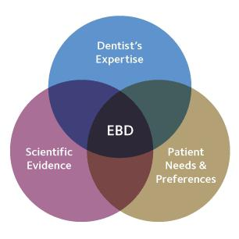
American dental association (ADA) defines EBD is an approach to oral healthcare that requires the judicious integration of: systematic assessments of clinically relevant scientific evidence, relating to the patient's oral and medical condition and history, with the dentist's clinical expertise, and the patient's treatment needs and preferences.[figure 1] [2]
Figure 1

Aims and objectives of Evidence based practice
- It aims to provide the most effective care that is available, with the aim of improving patient outcomes.
- EBP also plays a role in ensuring that finite health resources are used wisely and that relevant evidence is considered when decisions are made about funding health services.[3]
The Process of Evidence based practice (EBP) [figure2]
The EBD process includes “the conscientious, explicit and judicious use of current best evidence in making decisions about the care of individual patients. The practice of evidence-based dentistry means integrating individual clinical expertise with the best available external clinical evidence from systematic researches.”
Figure 2
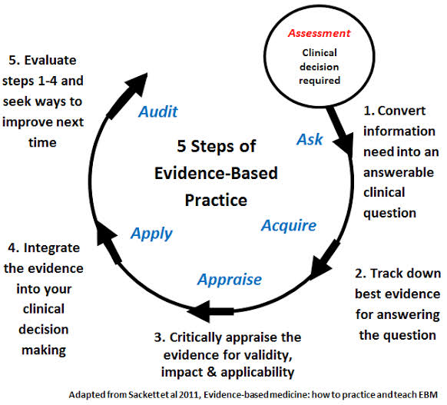
Available evidence will vary depending on the particular healthcare issue being addressed and the urgency demanded, with some clinical areas having little or no existing evidence base. Rapid reviews and classic systematic reviews are the foundations of healthcare decision-making, irrespective of whether they are pre-existent or developed specifically to inform a new policy or clinical practice guideline. A classic systematic review uses systematic and explicit methods to identify, select, critically appraise, and extract and analyze data from relevant research.[3]
A rapid review is a form of knowledge synthesis in which components of the systematic review process are simplified or omitted to produce information in a timely manner. Current systems and standards to assess the quality of evidence (i.e. the extent to which the estimates from clinical studies support a decision, recommendation or policy) and grade the strength of recommendations emphasize the need to consider the broadest range of study designs, depending on the type of decision to be made. This way, valuable information from government agencies, economic analysis, country or regional registries can serve in the process of formulating recommendations. [Figure 3]
Figure 3
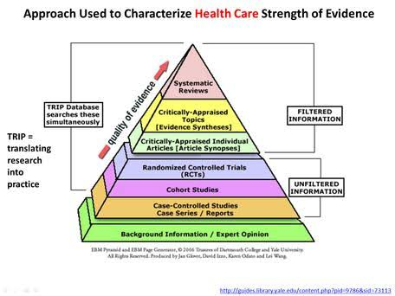
Drawbacks to Evidence based practice
Barriers exist to the implementation of EBD in daily clinical practice. These barriers include
- a lack of an evidence base to certain clinical questions
- a lack of access to evidence-based information; and for clinical questions
- a lack of evaluation of evidence and development of evidence-based information in a concise format that is useful to dentists.
Individual dentists are not expected to review all scientific evidence to inform practice. It is incumbent on the leadership of the profession to identify and address barriers to effective EBD implementation and to ensure there are systems and processes in place to ensure the rapid and effective dissemination of information as this becomes available.[3]
Management of potentially malignant disorders
Oral cavity is rightly described as mirror of the body as it reflects the health of the individual. Oral mucosa is a unique tissue, lined by keratinized and nonkeratinized stratified squamous epithelium and underlying connective tissue (lamina propria). The oral mucosa is continuously exposed to chemicals, microorganisms, thermal changes and mechanical irritants (tobacco, areca nut, alcohol, etc). The epithelial and connective tissue components of the oral mucosa demonstrate acute and chronic reactive changes in response to the above stressors.[4]
Clinical Pathway for the Evaluation of Potentially Malignant Disorders in the Oral Cavity- An evidence based approach – A REPORT BY American dental association (ADA)
Clinicians should obtain or update patient history and perform an intraoral and extraoral conventional visual and tactile examination in all adult patients. [Figure 4]
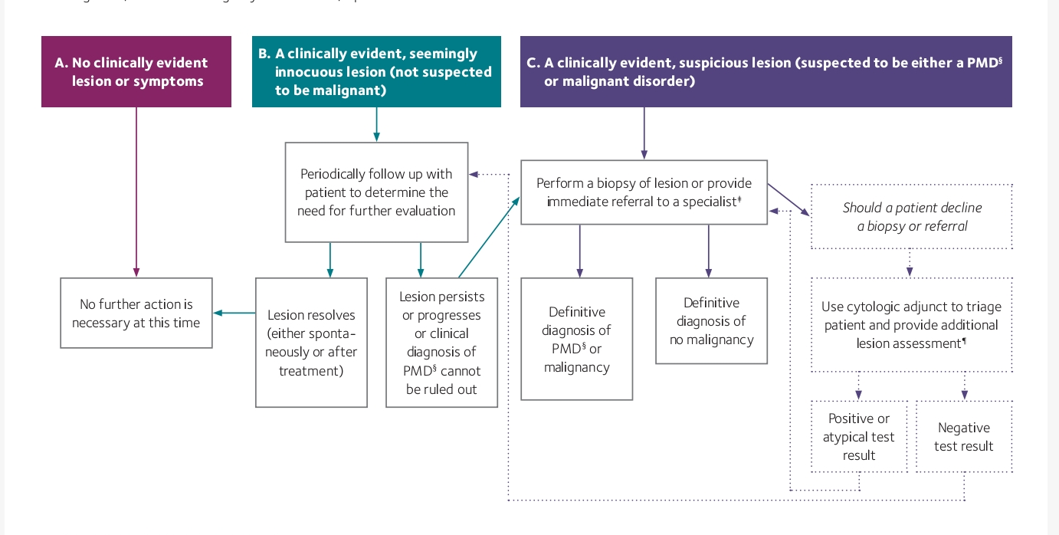
If during initial, routine or emergency examinations, a patient has:
Figure 4

MANAGEMENT OF ORAL SUBMUCOUS FIBROSIS
Oral submucous fibrosis (OSMF) is a chronic, insidious, progressive, debilitating, scarring, irreversible, complex and crippling disorder of the oral cavity.
OSMF affects the upper digestive tract – oral cavity, oropharynx and upper third of esophagus and is characterized by Juxta – epithelial inflammatory reaction, followed by fibroelastic changes due to progressive fibrosis of the submucosal tissues (lamina propria and deeper connective tissues) with epithelial atrophy leading to stiffness and rigidity of the oral mucosa and eventual inability to open the mouth.
The etiology of OSMF is obscure, although various hypotheses are proposed, suggesting multifactorial origins, such as chewing of areca nut and its flavored formulations (most common), chronic nutritional deficiencies (especially iron, Vitamin B complex and protein) and genetic predisposition, autoimmunity. Excessive use of areca nut and its flavored formulations disrupts the hemostatic equilibrium between synthesis and degeneration. The copper ion in areca nut increases the activity of lysyl oxidase leading to unregulated collagen production, thereby causing oral fibrosis.
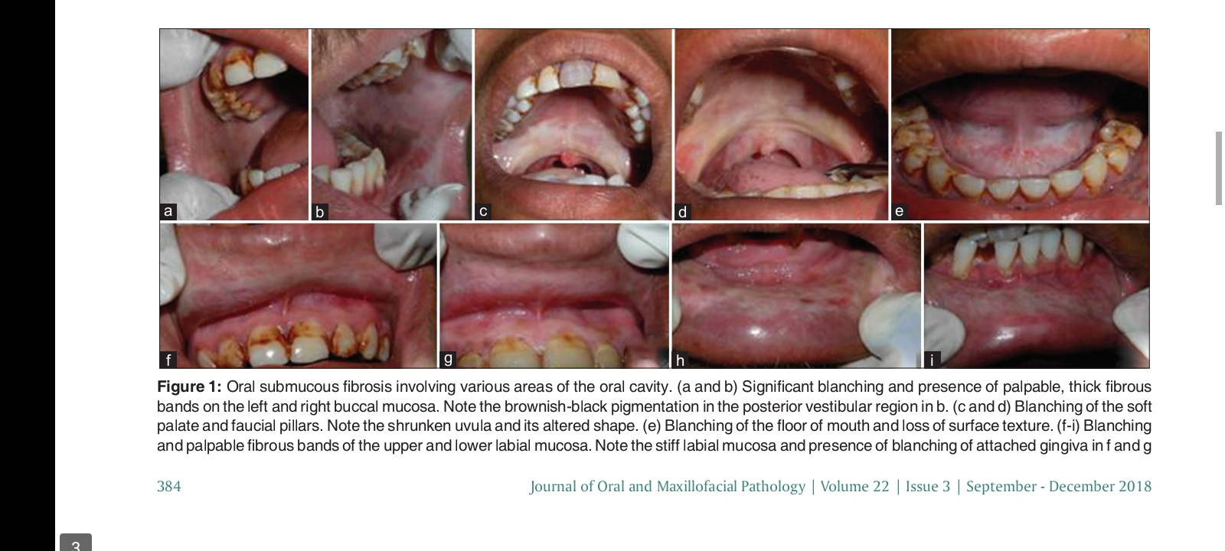
The sex distribution of OSMF varies geographically. The most common oral site for OSMF is buccal mucosa and retromolar region, followed by soft palate, faucial pillars, floor of mouth, tongue, labial mucosa and gingiva.[5] [Figure 5].
Figure 5
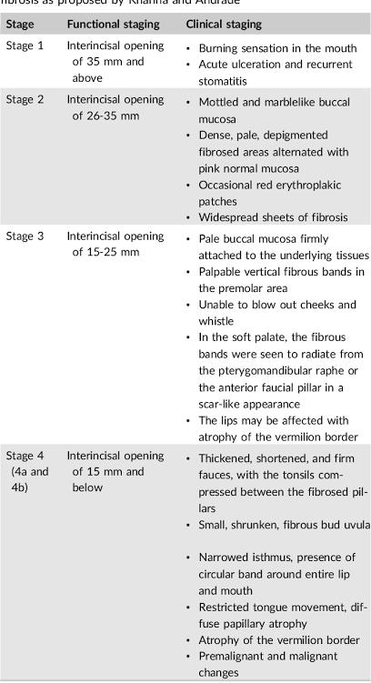
Staging of OSMF- BY KHANNA AND ANDRADE [Table 1]

PROPOSED STAGE WISE EVIDENCE BASED TREATMENT FOR OSMF
Various treatment regimens for OSMF are proposed to alleviate the signs and symptoms of the disease. Even after seven decades of its description as a precancerous condition, no substantial treatment is available because of its multimodal pathogenesis.[5]
In recent times, several medicinal (allopathic, homeopathic and Ayurvedic), surgical, physiotherapeutic, etc., have been tried, either alone or in combination, in the treatment of OSMF. In advance cases, surgical intervention is the only treatment modality, but relapse is a major problem. Discontinuation of harmful substance such as areca nut, tobacco and alcohol; increased intake of fresh red fruits and green leafy vegetables [Figure 6] and mineral-rich diet has also been advised.[5]
Figure 6
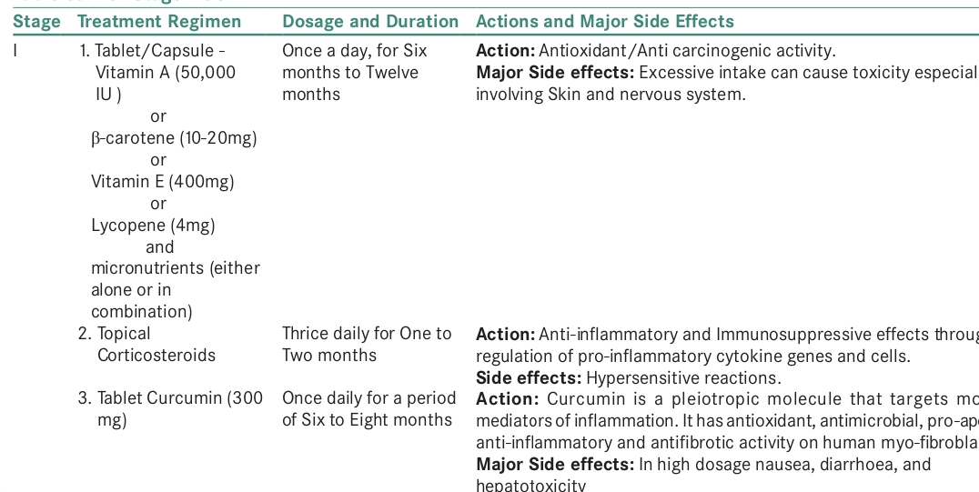
Stage 1 treatment [Table 2]
Stage 2 treatment [Table 3]

Stage 3 treatment[Table 3]

Stage 4a treatment [ Table 4]
Stage 4b treatment [Table 5]

Management of Oral leukoplakia
Oral leukoplakia (OLK) is defined as a predominantly white patch or plaque on the oral mucosa that cannot be wiped away and is not clinically or histologically characterized as any other definable disorder. OLK is a potentially malignant disorder (PMD). With a high risk of malignant transformation. OLK can affect the physical and mental health of patients to various degrees. [6]
According to the clinical manifestations, OLK can be classified into 2 types with significant differences in the rate of malignant transformation: homogeneous vs nonhomogeneous. The homogeneous type is usually a thin, flat, and uniform white plaque with at least 1 area that is well demarcated with or without fissuring (Figure 7]. Nonhomogeneous leukoplakia is characterized by the presence of speckled and nodular or verrucous areas.[figure 8]
Figure 7
Figure 8

Currently, there are many treatment options for OLK, including drug therapy, surgery, and laser ablation. However, none are curative. The goal of disease management is to relieve symptoms, improve quality of life, prevent malignant transformation, and gradually extend the interval between follow-up until the need for monitoring is eliminated.[6][Figure 9]
Figure 9

Evidence-based guidelines for the clinical management of OLK

OLK has a certain risk of malignant transformation. Regardless of whether malignant transformation occurs, some of the management measures should be performed depending on characteristics such as health education, control of local stimulating factors, initiation of drug therapy, lesion removal therapy, and regular follow-ups.[7]

Control of local stimulating factors

Smoking cessation: Strongly recommended
Results from a case-control study indicated that smoking is an independent risk factor for OLK.¹⁶ Results from a prospective cohort study showed that the incidence of OLK significantly decreased after smoking cessation. Some studies reported that the malignant transformation rate of OLK in smokers was unchanged, whereas other studies found that the malignant transformation rate was lower in smokers than in nonsmokers

Areca nut chewing cessation: Strongly recommended
Two case-control studies have shown that chewing areca nut is an independent risk factor for PMDs of the oral mucosa (not limited to OLK), and a dose–effect relationship was determined between chewing areca nut and the incidence of PMDs of the oral mucosa

Oral hygiene care: Strongly recommended
A case-control study²⁴ revealed more severe bleeding on probing and attachment loss in patients with OLK compared with the control group and both bleeding on probing and attachment loss were identified as risk factors for OLK. As the severity of periodontitis increased, the risk of OLK increased as well. However, the included study has serious limitations, and the level of evidence is extremely low.[7]

Non surgical treatment of OLK / Drug therapy
- Beta-carotene- Beta-carotene is a vitamin A precursor. The use of beta-carotene has been recommended in order to prevent OL and possibly oral cancer. The potential benefits and protective effects against cancer are possibly related to its antioxidizing action. This function is accomplished through a ligation between beta-carotene and oxygen, which is an unstable reactive molecule, thus diminishing the damaging effects of free radicals.

Twenty-four patients with OL were employed in a study with beta-carotene employed at a dose of 30 mg/day for six months. Only 2 patients (8.3%) presented a complete clinical response and 15 patients (62.5%) had partial clinical response

Garewal et al. evaluated 50 patients with OL, treated with beta-carotene at a dose of 60 mg/day, for six months. Only 2 patients (4%) demonstrated a complete clinical response. Relapses were found in 4 patients. A second biopsy was obtained after 6 months of therapy in 23 patients.[7]

- Lycopene- Lycopene is a carotenoid without provitamin A action. This is a fat-soluble red pigment found in some fruit and vegetables. The greatest known source of licopene is tomatoes, which are widely employed in cooking. Lycopene has the uncommon feature of becoming bound to chemical species that react to oxygen, thus being the most efficient biological antioxidizing agent. In addition to its antioxidizing property, lycopene also has the capacity to modify intercellular exchange junctions, and this is considered to be an anticancer mechanism.
Singh et al. [48] assessed the efficiency of lycopene in 58 cases of OL. The patients were divided into three groups, and received 8 mg/day, 4 mg/day, and placebo for a period of three months. The supplementation of lycopene (8 mg/day and 4 mg/day) reduced hyperkeratosis (clinically measured by the size of the lesion) with a similar efficiency in 80% of the cases. The complete clinical response of patients receiving 8 mg/day was 55% and 4 mg/day was 25%.[6,7]
- L-Ascorbic Acid (Vitamin C)- L-ascorbic acid (L-AA), the so-called vitamin C, is found in citrous fruits such as kiwi, strawberries, papaya, and mango. L-AA has antioxidizing properties and reacts with superoxide produced as a result of the cells’ normal metabolic processes; this inactivation of superoxide inhibits the formation of nitrosamines during protein digestion and helps avoid damage to DNA and cellular proteins. In a study, 24 OL patients were treated with an association of beta-carotene, vitamin E, and L-AA, and an increase was observed in the reversion of oral mucosa dysplasia. In 97.5% of patients, dysplasias were diminshed by use of antioxidant combinations

Alpha-Tocoferol (Vitamin E)- Alpha-Tocoferol (AT) is the commonest and most active form of vitamin E. It is found in plant oil, margarine, and green leaves. Alpha-Tocoferol is an effective antioxidant at high levels of oxygen, protecting cellular membranes from lipidic peroxidation. Benner et al, evaluated the toxicity and efficacy of AT in 43 patients with OL in use of 400 IU twice daily for 24 weeks. Follow-up was performed at 6, 12, and 24 weeks after the beginning of treatment to assess toxicity, clinical response, and serum AT levels. It was observed that 10 patients (23%) had complete clinical remission of lesion and 10 (23%) had a partial clinical response. Nine (21%) had histologic responses (complete reversal of dysplasia to normal epithelium).

Retinoic Acid (Vitamin A)- The current definition of retinoid includes all the natural and synthetic compounds with an activity similar to that of Vitamin A. Retinoic acid is obtained from carotene and animal products such as meat, milk, and eggs, which, while in the intestine, are converted, respectively, into retinal and retinol.

Topical administration of isotretinoin and its derivative: Weakly recommended- 13-cRA is the retinoid recommended for OL treatment. The use of 13-cRA has been shown to be effective in resolving OL [33, 34]. However, the high recurrence rates after short periods of discontinuance, together with its side effects, are limiting factors. In one study, of the 45 patients registered, 7 (15.5%) had OL. Patients received a fixed dose of 13-cRA (10 mg/day) plus an escalating dose (beginning at 800 IU/day, until 2000 IU/day) for 4 months. Seventy-one percent of OL patients had complete clinical responses [71]. A study conducted with retinoic supplementation (300.000 IU retinol acetate) for OL treatment demonstrated complete resolution in 52% of patients. An RCT revealed that topical administration of 0.1% 13-cis-retinoic acid (isotretinoin) gel reduced the lesion area. Another case series study (n = 26)²⁶ showed that topical administration of 0.05% vitamin A acid (tretinoin) gel caused complete clinical remission of a few OLK lesions.[6,7]

Lesion-removing therapy- Surgical therapy: Weakly recommended

A meta-analysis of 5 observational studies aimed at surgical therapy for OLK found that after the complete surgical removal of OLK lesions, the total recurrence rate was 25%. Clinicians should consider the following factors comprehensively when choosing surgical therapy for OLK treatment: the extent of epithelial dysplasia; clinical type of lesion; lesion location; lesion size; concomitant Candida infection; concomitant papillomavirus infection; patient's age and sex; and existence of other systemic diseases.

Laser therapy: Weakly recommended
A meta-analysis (n = 4292) of 27 observational studies aimed at laser management for OLK³² found that after complete remission of OLK lesions using laser therapy, the total recurrence rate was 24% (95% CI, 13%-43%) and the total malignant transformation rate was 4.9% (95% CI, 3.2%-7.3%) during an average follow-up period of 58.2 months.

Cryotherapy: Weakly recommended
A meta-analysis (n = 330) of 5 studies aimed at cryotherapy for OLK, found that after cryotherapy, the total recurrence rate was 16% (95% CI, 10%-25%) during an average follow-up period of 23 months. [7]

Photodynamic therapy: Weakly recommended
Photodynamic therapy (PDT) is a noninvasive method for the treatment of premalignant lesions and head and neck cancers [90, 91]. The principle of PDT is a nonthermal photochemical reaction, which requires the simultaneous presence of a photosensitising drug (photosensitiser), oxygen, and visible light. Mainly, the light source consists of a portable diode laser and the light is transmitted via laser fibres to or into the tumour. Illumination of the tumour by light at the activating wavelength results in the destruction of cells by a nonfree radical oxidative process. These reactive oxygen species may damage crucial cell components, such as structural proteins, enzymes, DNA, and phospholipids..
Several photosensitisers have been developed during the past. Haematoporphyrin and haematoporphyrin derivatives were the first photosensitisers. Four photosensitisers have been approved so far:
- photofrin has been approved in many countries for the treatment of oesophagus cancer and lung cancer
- 5-Aminolaevulinic acid (ALA) was also approved in several countries for the treatment of skin cancer.
- Verteporfin for the treatment of macular degeneration.
- foscan is the only photosensitiser that has been approved for the treatment of advanced squamous cell carcinoma of the head and neck in Europe in the year 2001.
The ALA is a naturally occurring compound in the haem biosynthetic pathway, which is metabolised to a photosensitive product, protoporphyrin IX (PpIX). The major advantage of ALA when compared to synthetic photosensitisers is the rapid metabolism, which significantly reduces the period of cutaneous photosensitivity. For most indications in head and neck surgery, the photosensitiser is administered systemically by intravenous injection. Only for very superficial skin lesions or premalignant lesions of the oral mucosa, the ALA can be applied topically.[7]
Chen et al. [97] treated 24 patients with OL using 20% ALA-PDT, once a week; another 24 patients used 20% ALA-PDT twice a week. In the latter group, 8 completely responded to the treatment, 16 partially responded, and 9 did not. All patients from the twice-a-week group responded significantly better than those treated only once a week.
A meta-analysis (n = 182) of 5 studies aimed at photodynamic therapy for OLK found that after photodynamic therapy, the total recurrence rate was 25% (95% CI, 19%-32%). An observational study⁴³ (n = 147) revealed that after photodynamic therapy, the overall recurrence rate of oral epithelial dysplasia was 11.6% and the malignant transformation rate was 7.5% during an average follow-up period of 87.6 months.[6,7]

Follow-up of all patients with OLK: Strongly recommended
Once diagnosed with OLK, regular follow-ups were strongly recommended regardless of whether the patients had any risk factors for malignant transformation or the treatment chosen. It is strongly recommended that OLK patients without specific risk factors should be followed every 3 months, and OLK patients with high-risk factors (advanced age, female sex, leukoplakia exceeding 200 mm², nonhomogeneous type, and higher grades of dysplasia) should be followed every 1 to 3 months.[7]

MANAGEMENT OF ORAL LICHEN PLANUS (OLP)

Lichen planus (LP) is a chronic inflammatory disease that can affect skin, mucous membranes, and skin appendages. LP can occur at any age, without sex or racial preferences . Mucosal LP (MLP) shows a prevalence of 0.89% and it is more commonly diagnosed in the female population. Oral LP (OLP) represents the most common form of MLP and can be diagnosed as isolated disease or in association with cutaneous, scalp, nail, or mucosal involvements, including the genital, gastrointestinal, and ocular mucosa.

Several clinical subtypes of OLP have been described, including reticular, plaque-like, papular, erosive, ulcerative, atrophic, and bullous OLP (figure 10) Oral involvement has been reported in up to 90% of the patients with cutaneous LP. On the one hand, reticular OLP is usually asymptomatic and is characterized by white streaks surrounded by well-defined erythematous borders. On the other hand, erosive OLP shows ulcerations and erosions surrounded by erythematous mucosa. While reticular OLP is relatively easy to control, erosive OLP is extremely painful and refractory to therapies, limiting the quality of life of the patients. [8]
Figure 10
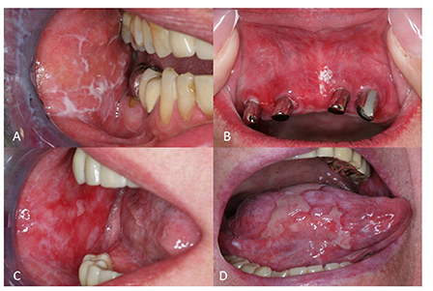
Figure 10: Clinical manifestation of oral lichen planus (OLP). (A) Reticular OLP with characteristic Wickham's striae (B) Erythema in a female patient with OLP (C) Multiple erosions on the left buccal mucosa in a patient with erosive OLP (D) Extreme painful ulcerations of the tongue in a patient with ulcerative OLP.

A regular screening for oral cancer in OLP is recommended. Indeed, several risk factors for malignant transformations in OLP have been reported, including erosive clinical phenotype, involvement of the tongue, female gender, and advanced age. . At this regard, Fitzpatrick et al. found that 85 (1.09%) of 7806 OLP patients and 4 (3.2%) of 125 patients with oral lichenoid lesions developed an oral squamous cell carcinoma.

Antigen-specific and non-specific mechanisms are involved in the pathogenesis of OLP. On the one hand, antigen presentation by keratinocytes and Langerhans cells to CD4+ helper and CD8+ cytotoxic T lymphocytes leads to their activation. The activated helper T cells produce IL-2 and interferon (IFN)-gamma and lead to the proliferation and activation of cytotoxic T lymphocytes, which cause the apoptosis of basal keratinocytes and the degeneration of basal epithelial cells typically found in OLP lesions.

The diagnosis of OLP relies on clinical and histological features. Clinical features of OLP are usually sufficient to establish the diagnosis, especially if patients show also typical skin lesions, such as Wickham's striae and symmetric, purplish, flat, polygonal, itchy papules on the extremities. However, a biopsy of oral lesions is recommended to confirm the clinical diagnosis and exclude malignancy.[8]

THERAPIES FOR MANAGING OLP [Table 6]
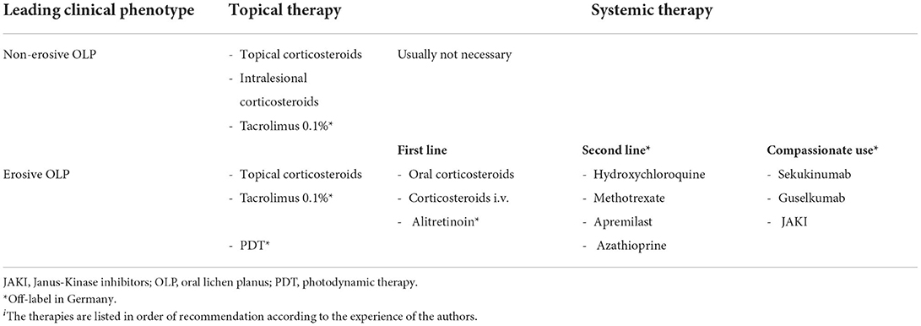

- Corticosteroids- Topical CS represent the first-line approach in OLP. In particular, clobetasol propionate 0.05% is often used as first therapy. In addition, triamcinolone, betamethasone, fluocinonide, fluticasone, dexamethasone, and prednisolone in different topical forms, such as ointment, oral suspension, aqueous solution, mouthwash, and adhesive paste, have been proven to be effective and safe. In a recent phase II RCT, a novel mucoadhesive clobetasol patch (Rivelin® -CLO) was tested on patients with erosive OLP. An improvement in OLP symptoms was reported in the verum group (25/32) compared to the placebo group (11/30).

Intralesional injection of CS, such as triamcinolone acetonide, hydrocortisone, dexamethasone, and methylprednisolone, are effective in erosive OLP, but this approach is extreme painful for the patient and only a few erosions can be treated in each session

Oral CS, such as dexamethasone or prednisone, are commonly prescribed in case of recalcitrant OLP. Usually, oral prednisone (0.5 mg/Kg) for 4–6 weeks is used. The side effects of prolonged oral CS therapy can be severe and include muscle weakness, sleep disorders, weight gain, pathologic fractures, anemia, acne, striae rubrae, and menstrual abnormalities.

To overcome or minimize these side effects, a new concept of oral mini-pulse therapy was proposed. Indeed, Malhotra et al. compared a mini-pulse therapy regimen (5 mg betamethasone orally on two consecutive days per week) to triamcinolone acetonide 0.1% paste in patients with OLP. The authors reported that the clinical response was similar in both groups, but the patients on oral betamethasone showed an earlier clinical improvement and the side-effects (e.g. facial edema, headache, and muscular weakness) were mild, transient, and reversible. [,8]

- Cyclosporine- Cyclosporine (CsA) is a calcineurin inhibitor, used as an immunosuppressant medication.

OLP its systemic use is reported only in some case reports. Furthermore, because of its adverse effects, including hypertension, dysregulation of the renal function, and gingival hyperplasia, systemic CsA is not recommended as routine therapy in OLP.

In a randomized, comparative, double-blind study on 40 patients, topical clobetasol was more effective in comparison to topical CsA in inducing a clinical improvement. In addition, the costs of a therapy with topical CsA is five times higher than one with clobetasol.

Apremilast- Apremilast is an oral phosphodiesterase type 4 inhibitor approved for the management of psoriasis and psoriasis arthritis. It reduces the production of TNF-alpha, IFN-gamma, IL-2, IL-5, IL-8, and IL-12, which contribute to the pathogenesis of OLP. In a multicentric, retrospective study on 11 OLP patients (8 of them with a coexistent cutaneous LP) , the authors reported that 55% of patients had an improvement of their symptoms at week 12.
- Azathioprine- Azathioprine (AZA) has been used in several skin diseases, such as pemphigus vulgaris, bullous pemphigoid, and pyoderma gangrenosum. AZA was successfully used as steroid sparing therapy only in a few patients with erosive OLP. Indeed, Verma et al. reported a good improvement in four patients with exclusive erosive OLP and in two patients with diffuse skin LP and OLP on AZA 50 mg twice daily orally (about 2 mg/kg day), for a period varying from three to seven months. Therefore, the use of AZA in OLP may be recommended as off-label therapy in OLP.[8]

- Biologics- Several biologic therapies have been used in patients with refractory OLP, including anti-CD2, anti-TNF-alpha, anti-IL2, anti-IL17, anti-IL12/23, and anti-IL23 drugs.[8][Table 7]

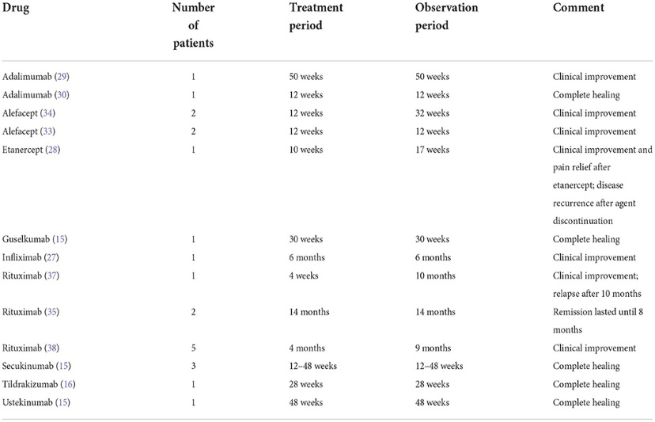
- calcineurin inhibitors- The use of topical calcineurin inhibitors, such as tacrolimus and pimecrolimus, in OLP is extremely diffuse in the clinical practice, although more placebo-controlled, randomized studies are needed to evaluate effectiveness and safety of topical calcineurin inhibitors in comparison to topical CS. In a recent meta-analysis, Sun et al. concluded that topical tacrolimus 0.1% should be the first choice within the group of topical calcineurin inhibitors for the short-term treatment of recalcitrant OLP. Volz et al. reported a significant reduction in oral erosions with topical pimecrolimus 1% compared to placebo in a prospective randomized double-blind vehicle-controlled study.
Table 7

- Janus kinases inhibitors- JAKI are emerging as a new class of drugs, which can be used in several dermatological diseases, including atopic dermatitis and alopecia areata. In OLP the use of JAKI is limited to case reports. Three OLP patients were successfully treated with JAKI, one of them with baricitinib and two others with upadacitinib.[8]

Hydroxychloroquine- HCQ is worldwide used as an anti-malarial agent. Because of its immunomodulatory action, HCQ is widely used in dermatology as therapy for different diseases, including systemic lupus erythematosus, polymorphous light eruption, and dermatomyositis. In a recent prospective clinical trial on 45 patients with erosive OLP, HCQ 200 mg p.o. twice daily as monotherapy was reported as effective and safe. In addition, Yeshurun et al. reported a moderate to marked improvement in 57% and a complete remission in 24% patients with erosive OLP on HCQ 400 mg/day p.o. as monotherapy

Methotrexate- Methotrexate (MTX) is a folate antimetabolite that inhibits DNA synthesis, repair, and cellular replication. MTX can be administered orally or subcutaneously and is useful in several inflammatory dermatoses, including psoriasis and bullous pemphigoid. Oral MTX was used in a prospective open trial in patients with unresponsive OLP. The authors reported a partial response in 83.3% of the patients. In a recent prospective, observational study, oral MTX in combination with triamcinolone 0.1% oral paste was reported as more effective in comparison to oral MTX and triamcinolone 0.1% oral paste as monotherapy in patients with severe OLP.[8]

Lasers- Lasers represent a non-pharmacological and non-invasive alternative option for the treatment of OLP.

Photobiomodulation(PBM) or low-level laser therapy (LLLT) as effective alternative- Low-level laser therapy (LLLT) is considered to have biostimulatory, antiinfective, and anti-ablation effects and has been proposed as a potential alternative treatment. PBM twice a week. during 1 month (8 sessions) with laser of wavelength 660+/-10nm; power 100mW; radiant energy 177J/cm2; 5sec exposure time per point and 0.5 J of energy per point is found to be effective as corticoid therapy in treating oral lichen planus. The number of points will be variable according to the lesion size. Erosive lichen planus is mainly treated by a 630 nm low-level laser for 10 sessions a month with the power of 1.5 J/cm2. PBMT with red diode lasers helps in analgesic effect in the patients without causing any significant side effects [12]. PBMT uses an infrared diode laserLow-level laser (LLL) includes various light sources such as helium neon (633 nm), ruby (694 nm), and argon (488 and 514 nm).

In a RCT, a comparative evaluation of LLL and CO2 laser was performed. Both methods were reported as effective in the treatment of OLP, but LLL led to a more rapid improvement of lesions than CO2 lasers. The effectiveness of CO2 laser was also reported by Van der Hem et al. and by Dalirsani et al.[13]

Photodynamic therapy- PDT combines the use of a photosensitive agent and a harmless light source with a particular wavelength. PDT is mainly used to treat non-melanoma skin cancers. Recently, the use of PDT has been growing as non-invasive therapy for OLP. Furthermore, PDT can be used as monotherapy or in combination with other treatment options. PDT with 5% methylene blue as photosensitizer was effectively used in a cohort of 20 patients with a long-standing OLP. Moreover, it was reported that the effectiveness of PDT depends on the localization of the lesion and is particularly reduced around the area of the masticatory oral mucosa. A decrease of CD4+, CD8+ and IL-17+ cells in the oral mucosa affected by OLP has been reported after PDT. In comparison to LLL, PDT was more effective in a study conducted on 45 OLP patients.[8]

Alternative medicines in the management of OLP
There have been several alternatives to steroid therapy in the management of OLP. Curcuminoids derived from turmeric has been the most extensively studied in the management of OLP. Apart from this, Aloe vera, lycopene, hyaluronic acid and BCG‑PSN have been assessed for efficacy in the management of OLP. Propolis, a derivative of beeswax, purslane, a herb, ignatia, a homeopathic medication and quercetin, have shown promise in the management of OLP.
- Curcumin has been shown to exhibit antioxidant, anti-inflammatory, antimicrobial, and anticarcinogenic activities. Given the numerous benefits of Curcumin in treating of lichen planus over steroids, several studies have been done in the past.The results of case-control studies demonstrated that topical treatment with Curcumin would improve lesions and reduced pain severity similar to triamcinolone cream.

Curcumin has limits in water solubility and bioavailability due to its hydrophobic nature, challenging Curcumin’s clinical translation into a practical therapeutic agent. Nanoparticles increase the dissolution rate of the hydrophobic agents by supplying a large surface-to-volume ratio.
The results of several studies demonstrated that oral lesion recovery rate in the OLP patients treated with Prednisone and Curcumin was higher than those received Prednisone alone. Based on the further research results, the group with Curcumin in three doses of 2000 mg per day and for 14 days demonstrated a noticeable recovery in clinical signs and symptoms in comparison with the control group.

In the research conducted by Thomas et al., Curcumin 1% gel 3 times a day and Curcumin 1% gel 6 times a day was compared to Triamcinolone cream. All the groups were treated for 3 months; they showed a decrease in burning sensation, redness, and ulcer.[9]
In a recent study curcumin was Nano-Curcumin, a dose of 80 mg was used, which was significantly less than the dose in other studies using non-nano silic forms. In vivo study showed that low-dose (20 mg/kg) Nano-Curcumin has an equivalent therapeutic effect as high-dose (400 mg/kg) pure Curcumin. This research results revealed that oral Nano-Curcumin could be used as an alternative treatment for OLP lesions in those who should not take oral Corticosteroids or in the patients who should take Corticosteroids cautiously. Moreover, oral Curcumin could be used for preventing the recurrence of OLP lesions after the treatment and initial control. Further studies are recommended concerning the latter issue.[9]

- Aloevera exhibits an anti-inflammatory effect, thereby inhibiting the cyclo-oxygenase pathway and the consequent decreased prostaglandin E2 production. It further impedes the release of histamine and leukotriene from mast cells that are triggered by antigen–antibody reactions, a critical element in OLP pathogenesis. However, there are insufficient data to arrive at a definitive conclusion on the substitution of aloe vera for conventional OLP treatment.

- Amlexanox is a topical anti-inflammatory agent (used as 5% oral paste) to treat recurrent aphthous stomatitis. It acts by inhibiting the synthesis and release of histamine,leukotrienes, and TNF alpha from mast cells, mononuclear cells, and neutrophils. A randomized clinical trial demonstrated comparable therapeutic effectiveness of 5% amlexanox paste with that of 0.043% dexamethasone paste in OLP.

- Hyaluronic acid (HA) plays a key role in several biological processes, such as cell signaling, cell proliferation, gene expression regulation, morphogenesis, matrix organization, lubrication, tissue hydration, and wound healing. One of the greatest advantages of hyaluronic acid is its safety profile, as it can be safely used in all patients, including infants and pregnant females. Additionally, it can be used in all grades of oral ulceration. A study by Yousef et al. concluded that topical HA (0.2%) demonstrated higher efficacy indiminishing OLP symptoms as compared to topical corticosteroids.[9]

- One potential alternative treatment option for OLP is platelet-rich plasma (PRP), which refers to human platelet concentrates derived from a patient’s blood (autologous),containing 3- to 5-times more platelets than the normal concentration found in whole blood. PRP contains bioactive molecules, such as growth factors, cytokines, and cell adhesion molecules. The biological justification for PRP use in regenerative medicine involves platelet degranulation, thus permitting the release of growth factors, amending the inflammatory reaction, and promoting cell proliferation and differentiation within the target tissue. The therapeutic effects of autologous platelet concentrates have been demonstrated in various autoimmune diseases in the published literature.
PRP also contains other growth factors, such as platelet-derived growth factor (PDGF), transforming growth factor beta (TGF-β), epithelial growth factor (EGF), insulin-like growth factor (IGF), vascular endothelial growth factor (VEGF), fibronectin, serotonin, dopamine, histamine,adenosine, and calcium, all of which have a variety of functions that promote cell differentiation, proliferation, and regeneration. PDGF and TGF-β, in particular, havebeen shown to stimulate fibroblast proliferation and increase collagen production, while TGF-α and EGF can regulate the propagation and migration of keratinocytes, which leads to an increase in the thickness of the epidermis. PRP additionally enhances the expression of matrix metalloproteinases (MMPs), which regulate remodeling [60]. Thus, these antiinflammatory, antioxidant, and immunomodulatory properties of PRP make it a promising therapy for OLP patients.
However, there is limited published literature on the therapeutic efficacy of PRP in OLP, with only a few case reports. A study involving systematic review demonstrated that PRP therapy resulted in a significant amelioration in objective and subjective symptoms in OLP patients, with minimal recurrences and adverse events. Nevertheless, it is imperative to conduct well-designed prospective clinical trials with large sample sizes to ascertain and substantiate the therapeutic role of PRP in OLP.[10]

MANAGEMENT OF ORAL ULCERS
Oral ulcerations is a common mucosal disorder. It may be caused by physical or chemical trauma, viral, fungal or bacterial infections, allergy, malignancy or a manifestation of systemic diseases. The process of oral ulceration causes a breach in the oral epithelium, which typically exposes nerve endings in the underlying lamina propria, resulting in pain or soreness, especially when eating spicy foods or citrus fruits [2]. As the majority of the ulcers require treatment of the underlying cause, proper diagnosis will lead to successful treatment and prevention of the lesions.[11]
MANAGEMENT OF RECURRENT APHTHOUS STOMATITIS
Recurrent aphthous stomatitis (RAS) is considered as the most common oral mucosal lesion. These present as recurrent, multiple, small, or ovoid ulcers, having yellow floors and are surrounded by erythematous haloes, present first in childhood or adolescence. The cause of aphthous ulcers is unknown, and therefore many factors are still implicated in the disease including hormonal changes, trauma, drugs, food hypersensitivity, nutritional deficiency, stress, and tobacco.[11]

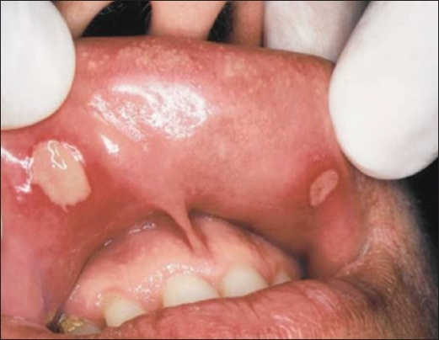
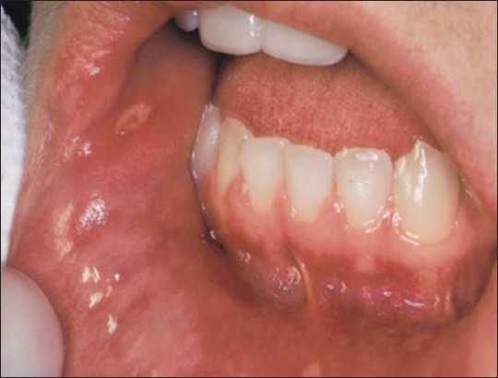
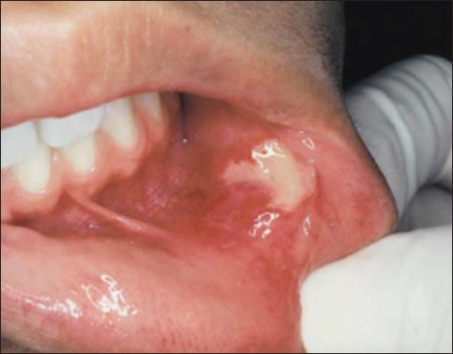
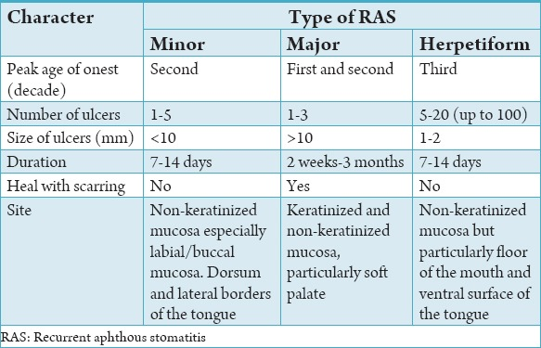
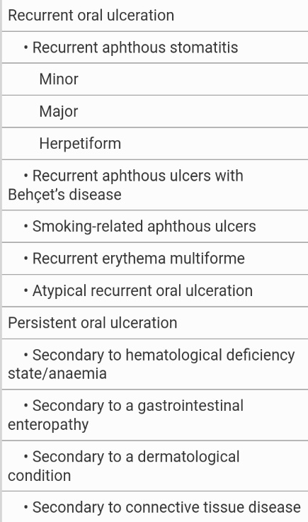
Classification and clinical presentation of RAS [12][Table 8 &9]
Figure 13- Herpetiform RAS
Figure 12-Major RAS
Figure 11-Minor RAS

Treatment therapies of RAS- evidence based
The etiology of RAS is still unknown. There is no agreement in the treatment of RAS therefore, many therapies have been tried, few have been subjected to double-blind randomized controlled. The aim of the treatment of RAS is to decrease symptoms; reduce ulcer number and size; increase disease-free periods. The treatment approach should be determined by disease severity (pain), the patient’s medical history, the frequency of flare-ups and the patient’s ability to tolerate the medication.
There are no internationally accepted guidelines for RAS treatment despite RAS being one of the most common oral disorders. Apart from the relief of pain, there are two main therapeutic approaches (a) to help heal current ulcers and (b) to prevent new episodes of ulceration. Many topical preparations attempt to help the healing process and many have claimed efficacy, whilst prevention of new occurrences usually requires systemic medications[12]
Topical agents
Several pastes and gels can be used to coat the surface of the ulcers and to form a protective barrier against secondary infection and further mechanical irritation. The topical agents are the first option of the treatment of RAS. Patient should apply a small amount of gel or cream after rinsing, and avoid eating or drinking for 30 min. This can be repeated 3 or 4 times daily.
Mouthwashes
Topical tetracycline mouthwash has been used alone or in combination with liquid anti-fungals or topical steroids, especially in the treatment of Herpetiform RAS and remains the treatment of choice in this type of RAS which appears largely resistant to steroids. It reduces the ulcer size, duration, and pain because of the ability of that one to block collagenase activity. In major and minor RAS, topical tetracycline or minocycline mouthwashes as a local anti-bacterial can be expected to reduce the severity of the ulcerations and pain but not prevent recurrences.[12]

Topical gels, creams, and ointments
Topical medications washes away from the target area; therefore, it is better to use different kinds of adhesive vehicles in combination with the drug.
Topical corticosteroids may limit the inflammatory process associated with the formation of aphthae. Those medications can act on the lymphocytes and alter the response of effector cells to precipitants of immunopathogenesis (e.g., trauma and food allergies). Steroid tablets used as a mouthwash are one of the most common treatments used in specialised clinics. It is a recognised therapy for RAS and generally accepted as effective in controlling this common oral condition [54], despite the limited clinical evidence to support its efficacy. Al Na’mah et al.,36 have concluded that the novel dexamucobase was found to be equally effective in treating oral aphthous ulceration, with some advantages, as the widely used preparation Kenalog in Orabase. Dexamethasone ointment applied three times a day for 5 days can reduce ulcer size and pain alongside an improvement in healing time.
Betnesol mouthwash is a betamethasone sodium phosphate tablet 500 mcg dissolved in 10 ml of water and used as a mouthwash for 3 min then discarded. It is administered four times a day (QID) in the presence of ulcers and twice a day (BID) in between ulcer attacks. A 3-month study by Tappuni et al.compared betnesol mouthwash (four times a day) with betnesol mouthwash plus colchicine tablets 0.5 mg a day. Using an ulcer severity scoring (USS) system, the authors showed significant improvement in USS of most patients in the betnesol group, as well as in the combined treatment of colchicine plus betnesol.
Amlexanox is an anti-inflammatory, anti-allergic and immunomodulatory (not currently available in the USA). Two reasonably sized double-blind trials (100–200 RAS patients) showed that Amlexanox oral adhesive tablets applied 4 times a day for 5 days were effective at promoting healing and reducing pain. Meng et al., have indicated that amlexanox oral adhesive pellicles are as effective and safe as amlexanox oral adhesive tablets in the treatment of minor RAS for this Chinese cohort. However, pellicles seem to be more comfortable to use when compared with the dosage form of tablets. Therefore, in clinical practice, amlexanox oral adhesive pellicles may be a better choice for RAS patients. Some topical glucocorticoids such as fluocinonide and clobetasol may be preferable when used alone or mixed with orabase.[12]
Systemic therapy for RAS [12] [Table 10]

RECOMMENDED TREATMENT FOR DIFFERENT TYPES OF RAS[12] [Table 11]
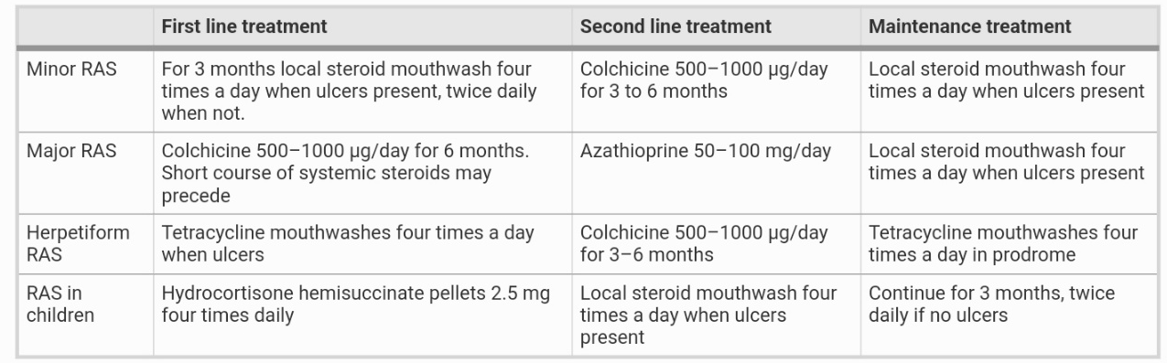

Other alternative therapies for treating RAS
Several topical herbal treatments have shown efficacy as alternative therapies including aloe vera gel, berberine gelatine, Yunnan baiyao , Myrtus communis and citrus oil with magnesium salts. All of these topical herbal therapies have been used for the treatment of minor RAS only. Lalla et al. demonstrated in a randomised, placebo-controlled, double-masked, parallel-arm, clinical trial that daily multivitamin supplements did not improve the number or duration of RAS episodes in 160 subjects.[12]
Photobiomodulation or Low level laser therapy(LLLT)
LASER (light amplification by stimulated emission of radiation) was first discovered by Theodore H. Maiman in 1960. The term photo biostimulation was coined by Endre Mester following his observation of the effects of low dose laser treatments on stimulation of wound healing. Later, it was also noted that along with stimulation, light therapy may also modify certain deleterious processes, such as inflammation or pain, and thereby the term photo biomodulation (PBM) was established. Currently, PBM includes a broad range of nonionizing light sources such as lasers, Light-Emitting Diodes (LEDs), and broadband visible light in the visible and near infrared spectrum at very low, non-thermal doses. PBM stimulates both positive tissue processes such as wound healing, regeneration, and immune responses and negative tissue processes such as inflammation, pain, and aberrant immune responses.[13]
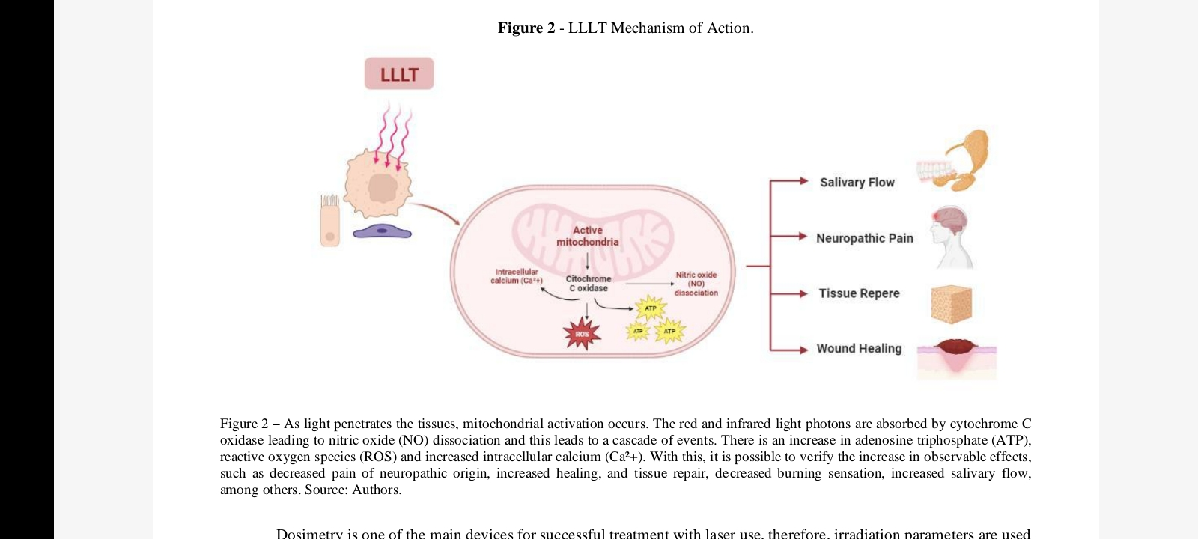
Mechanism of action [13]
Figure 14

PBMT is effective in the pain relief and healing of these lesions when used with a diode laser of 645 nm wavelength, power 100mw onto the lesion of spot size 1cm2 for a duration of 30sec per cm2 and energy density 10J/cm2 used in continuous mode for 3 consecutive days. PBMT with a diode laser of 940nmused in noncontact mode for 30-45 seconds with a pause for 10-20 seconds and a total of 2 minutes in a single session has shown faster reduction of pain and healing of ulcers.
Aphthous stomatitis is one of the most common pathologies of the oral cavity, being multifactorial and manifesting as painful necrotizing ulcers that can last for up to two weeks, affecting the patient's eating, hygienic and communicative habits. Due to the analgesic, anti-inflammatory and regenerative efficacy effects, PBM has been an ally in the treatment of aphthous stomatitis. In a recently published case report authors showed a patient submitted to PBM with a wavelength of 808 nm at the site of the lesion, as well as on the submandibular and cervical lymph nodes for lymphatic drainage on the side of the lesion. The patient report the end of recurrences for about two years, and the results showed the effectiveness of PBM in tissue repair, analgesia and recurrence of lesions quickly, painlessly and reliably.[13]

Management of oral cancer or malignancy
Oral cancer is the eighth and 13th most common malignancy in the world for males and females, respectively. Up to 80% of these cancers occur in Asia. Precancerous and cancerous oral lesions may mimic any number of benign oral lesions, and as such may be left without investigation and treatment until well advanced.
The five-year survival following the diagnosis of oral malignancy can be as low as 15–50% as most cancers are advanced and associated with lymphatic spreapd at the time of discovery. Most patients with oral cancer or a potentially malignant oral mucosal lesion are often asymptomatic at the time of diagnosis.2 Some patients do not seek care until pain, persistent ulceration, unexplained bleeding or an oral or neck mass is discovered at which time the disease is very advanced. Most cancer deaths occur in patients 55 years orolder. Thus, oral cancer is predominantly a disease of the elderly and for those with known epidemiologic risk factors, sufficient time exists to examine patients, detect precursor lesions and treat prior to the development of malignancy.[14]
Histopathological assessment of oral mucosal lesions describe a spectrum of tissue and cytological changes indicative of epithelial dysplasia that are thought to represent disease progression from mild to moderate and severe dysplasia depending on the number and extent of these changes. Currently, epithelial dysplasia using light microscopy is the gold standard prognostic predictor of malignant transformation.
Oral squamous cell carcinoma (OSCC) is the 16th most common neoplasm worldwide, with almost 355,000 newly diagnosed cases and over 177,000 deaths estimated in 2018. The incidence of oral squamous cell carcinoma predominantly includes tongue, gum, floor of mouth and oropharynx, excluding lip.
Figure 15
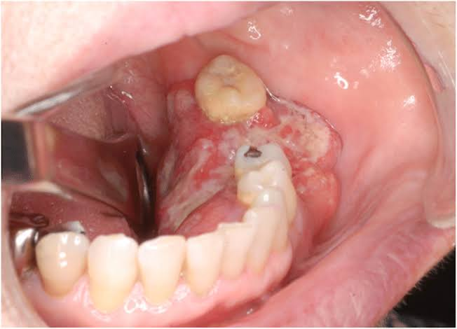
There are several known risk factors in the development of oral cancer with the most studied and well established being the use of tobacco. There is increasing evidence of the role of alcohol consumption in the development of oral cancer. Dentists can increase survival rates, and decrease the morbidity associated with the treatment of oral cancer, if lesions are detected at an early stage, or preferably if the precursor lesion is discovered, diagnosed, treated and monitored for malignant progression.[14]

Diagnosis and management of OSCC
Proper and timely diagnosis remains a weak point in management of OSCC. Tumors are often referred to specialists with significant delay and after reaching advanced stages. This factor has a significant impact on prognosis and is the first variable that should be optimized. Bioendoscopic filters such as Narrow Band Imaging (NBI) can improve the diagnostic potential of conventional oral examination. However, these techniques require a significant learning curve and are burdened by subjectivity in interpretation. The study by Paderno et al. showed for the first time the possibility to apply fully convolutional neural networks to NBI endoscopic frames of oral lesions in order to automatically identify tumors and delineate their margins. This preliminary report confirms the potential of the newly developing field of “Videomics” for diagnosis and in-depth characterization of OSCC.
A significant step forward in the diagnostic, therapeutic, and rehabilitative approach of OSCC (and head and neck cancers in general) has been the broad recognition of the fundamental role of multidisciplinary teams. This concept has been confirmed by the current evaluation from Shang et al. showing that patients undergoing proper multidisciplinary management had a significantly higher survival rate.
Treatment of patients with oral cancers using a multidisciplinary approach has shown no significant improvement over the past several decades with poorer survival associated with increased age and advanced stage disease. A multimodal approach consisting of surgery followed by postoperative radio or chemotherapy, seems superior to non-surgical treatment protocols. Recurrences and new cancer development in the area of the excised lesion after surgery have been reported to be as high as 10–20% and 3–9%, respectively.[14]
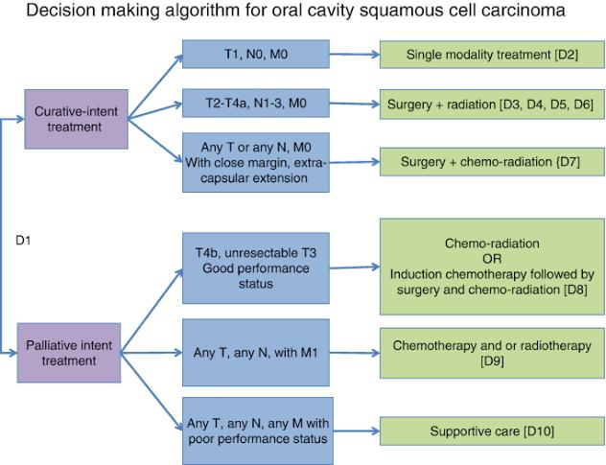
Figure 16

When considering OSCC treatment, surgery still remains the first-line option, potentially followed by adjuvant therapies. However, surgery is not a static discipline, and techniques should be refined and evolve according to new evidence and technologies. In recent years, the concept of compartmental surgery for OSCC has gained significant momentum (7–9). In this regard, Carta et al. and Grammatica et al., respectively, provided a retrospective analysis confirming the good oncologic outcomes obtainable by compartmental tongue resections and a step-by-step guide describing such a surgical technique.
At the same time, the growing acceptance of sentinel lymph node biopsy in oral oncology may lead to improvements in prophylactic management of contralateral neck metastases. As Mahieu et al. reported, the contralateral neck is generally not addressed by elective neck dissection in early stage OSCC not involving the midline, while sentinel lymph node biopsy may stage both the ipsilateral and contralateral neck. Interestingly, the authors described a higher rate of contralateral regional recurrence in patients receiving elective neck dissection than those who underwent sentinel lymph node biopsy. This result shows the effectiveness of such a procedure in detecting unexpected contralateral nodal spread, possibly opening new applications for this technique in the setting of minimally invasive contralateral neck staging.[14]
In adjunction, non-surgical therapies have also been assessed, given the progressive improvements of radiation techniques and chemotherapy regimens. Kim et al. compared postoperative chemoradiation with radiotherapy alone using new generation techniques, showing comparable results except for tumors with extranodal extension. Different schedules of induction chemotherapy have been presented, attesting the better tolerability of weekly induction taxane – platinum – fluorouracil in comparison to a 3-week schedule (Tousif et al.).
Looking to drug repurposing, a potential synergic effect has been found when low molecular weight heparin is added to cisplatin (Camacho-Alonso et al.). Still, drug discovery may conceivably offer novel tools for treatment of OSCC. In this regard, melatonin can exert anti-proliferative, anti-invasive, and anti-migrative effects on OSCC via the miR-25-5p/NEDD9 pathway, thus warranting further assessment of its potential.
Lambert et al. reported a single-center experience on the use of photodynamic therapy as an alternative treatment tool in inoperable oral and oropharyngeal cancer. While limited to highly selected patients, functional and oncologic outcomes were satisfying considering the specific setting. Swallowing and airway patency were preserved in 77% and 96% of patients, respectively, and the recurrence-free rate at two years was 32%.
The management of OSCC has significant room for improvement, and this should be primarily obtained by optimizing current strategies. Indeed, many factors that decrease survival are related to late diagnosis or inadequate treatment and could be addressed by prompt referral to leading oncologic centers. Once this issue has been solved, the introduction of molecular analyses and artificial intelligence tools have the potential to further improve treatment personalization and outcomes.[14]

EVIDENCE BASED MANAGEMENT OF ORAL MUCOSITIS
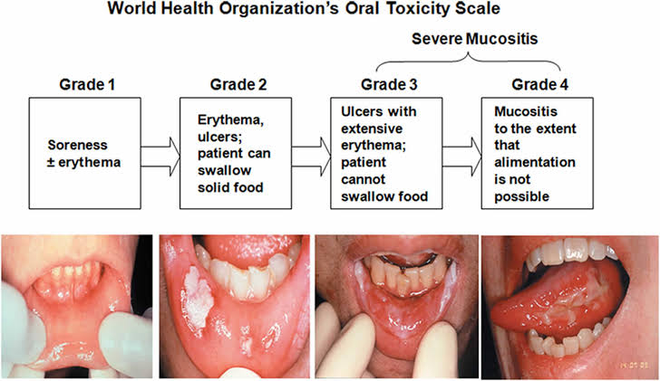
Oral mucositis is a common toxicity of cancer therapy. The morbidity of oral mucositis includes pain, nutritional compromise, and infection risk, which potentially result in breaks or dose reductions in cancer therapy. Historically, management was focused mainly on pain control and nutritional support. However, evidence-based clinical practice guidelines for oral and GI mucositis were recently updated. These guidelines are developed by the Mucositis Study Group of the Multinational Association of Supportive Care in Cancer (MASCC) and the International Society of Oral Oncology. [15]
Figure 17

For oral mucositis in patients receiving systemic chemotherapy, the guidelines include:
• Recommendations for oral cryotherapy in patients receiving bolus fluorouracil and high-dose melphalan
• A recommendation for intravenous keratinocyte growth factor-1 in patients with hematologic cancer receiving high-dose chemotherapy for autologous hematopoietic stem-cell transplantation (HSCT)
• A recommendation for intra-oral low-level laser therapy in patients receiving high-dose chemotherapy for HSCT.
For oral mucositis in patients receiving head and neck radiation therapy (H&N RT), the guidelines include:
• Recommendations for intra-oral low-level laser therapy in patients receiving H&N RT with or without concurrent chemotherapy
• A suggestion for benzydamine mouthwash in patients receiving H&N RT with concurrent chemotherapy6
• A recommendation for benzydamine mouthwash in patients receiving moderate-dose H&N RT
• A suggestion for oral glutamine in patients receiving H&N RT with concurrent chemotherapy.
In two randomized, placebo-controlled trials conducted in head/neck cancer patients undergoing postoperative chemoradiotherapy and in patients receiving definitive chemoradiotherapy for locally advanced head/neck cancer, intravenous palifermin administered weekly for 8 weeks decreased severe oral mucositis. Evidence from several studies has supported the potential efficacy of low-level laser therapy in addition to oral care to decrease the duration of chemotherapy-induced oral mucositis in children.[15]

Mucositis Management
- Bland rinses:
  - 0.9% saline solution.
  - Sodium bicarbonate solution.
  - 0.9% saline/sodium bicarbonate solution.
- Topical anesthetics:
  - Lidocaine: viscous, ointments, sprays.
  - Benzocaine: sprays, gels.
  - 0.5% or 1.0% dyclonine hydrochloride (HCl).
  - Diphenhydramine solution.
- Mucosal coating agents:
  - Amphojel.
  - Kaopectate.
  - Hydroxypropyl methylcellulose film-forming agents (e.g., Zilactin).
  - Gelclair (approved by the U.S. Food and Drug Administration [FDA] as a device).
- Analgesics:
  - Benzydamine HCl topical rinse (not approved in the United States).
  - Opioid drugs: oral, intravenous (e.g., bolus, continuous infusion, patient-controlled analgesia [PCA]), patches, transmucosal.
- Growth factor (keratinocyte growth factor-1):
  - Palifermin (approved by the FDA in December 2004 to decrease the incidence and duration of severe oral mucositis in patients undergoing high-dose chemotherapy with or without radiation therapy followed by bone marrow transplant for hematologic cancers).[15]
REFERENCES
- K France, T.P.Sollecito. How Evidence-Based Dentistry Has Shaped the Practice of Oral Medicine. Dent Clin N Am 63 (2019) 83–95.
- Evidence-based Dentistry (EBD) Published on FDI World Dental Federation (https://www.fdiworlddental.org)
- Dhar V. Evidence-based dentistry: An overview. Contemp Clin Dent 2016;7:293-4.
- Evidence-Based Clinical Practice Guideline for the Evaluation of Potentially Malignant Disorders in the Oral Cavity: A Report of the American Dental Association. JADA.ADA.org/article/S0002-8177(17)30701-8/fulltext.
- More CB, Gavli N, Chen Y, Rao NR. A novel clinical protocol for therapeutic intervention in oral submucous fibrosis: An evidence based approach. J Oral Maxillofac Pathol. 2018 Sep-Dec; 22(3): 382–391.
- Chen Q, Dan H, Pan W, Lu Jiang, Yu Zhou, Xiaobo Luo, Xin Zeng. Management of oral leukoplakia: a position paper of the Society of Oral Medicine, Chinese Stomatological Association. and may require further modification as new evidence is produced. Oral Surg Oral Med Oral Pathol Oral Radiol 2021;132:3243.
- Ribeiro AS, PR Salles, T Aparecida da Silva, RA Mesquita. A Review of the Nonsurgical Treatment of Oral Leukoplakia. International journal of dentistry. Jan 2010.
- Didona D, Caposiena Caro RD, Sequeira Santos AM, Solimani F and Hertl M (2022) Therapeutic strategies for oral lichen planus: State of the art and new insights. Front. Med. 9:997190.
- Vadivel JK, Ezhilarasan D, Govindarajan M, Somasundaram E. Therapeutic effectiveness of alternative medications in oral lichen planus: A systematic review. J Oral Maxillofac Pathol 2020;24:344-51.
- Sriram, S.; Hasan, S.; Alqarni, A.; Alam, T.; Kaleem, S.M.; Aziz, S.; Durrani, H.K.; Ajmal, M.;Dawasaz, A.A.; Saeed, S. Efficacy of Platelet-Rich Plasma Therapy in Oral Lichen Planus: A Systematic Review. Medicina 2023, 59, 746.
- Sh.A. Ali, H.I. Saudi. An expert system for the diagnosis and management of oral ulcers. Tanta dental journal 11; 2014: 42-46.
- Stephen J. C, Surab Alsahaf , Anwar Tappuni. Recurrent Aphthous Stomatitis: Towards Evidence-Based Treatment? Curr Oral Health Rep (2015) 2:158–167
- Cassia Alves de et al. Photobiomodulation in the treatment of oral diseases. Research, Society and Development, 12, 3, e9512338070, 2023.
- Paderno A, Bossi P and Piazza C (2021) Editorial: Advances in the Multidisciplinary Management of Oral Cancer. Front. Oncol. 11:817756.
- Rajesh V L. Evidence based management of oral mucositis. Journal of oncology practice, 16;3, 2023.

