Impact Of Nano Silica Powder And Silica Fume In Chemical And Physical Property Of Concrete

Mohammad Irshad Ansari
Department of civil Engineering
Kalinga University
Naya Raipur CG India
Irshad.ansari@kalingauniversity.ac.in

Piyush Das
Department of civil Engineering
Kalinga University
Naya Raipur CG India
Piyush.das@kalingauniversity.ac.in

ABSTRACT

The property of fresh and hardened concrete is different but after the adding some admixture the property of these material is enhance according to the property of admixture. Agricultural waste are also used in the building material. To reduced the cost of construction we are using industial waste in this experiment. Nano silica particles (NSP) and silica fumes is a waste material which occure from industries. One of the main property of cement is that when the cement particles is finner than the normal cement then the strength of material is more. In this experimental work we are using Nano silica particles and silica fumes in the partially replacement of the cement in the percentage of 1%, 2%, 3%, 4% and 5% resp. There are two types of concrete is design nano silica concrete (NSC) and silica fume concrete (SFC) with the help of NSP and SF. When we add the 1% of nano silica particles the porosity is decreased 46% and after adding the 5% of nano silica particles the porosity is increased by 10.34% and after adding the 1% of silica fume and 5% of silica fumes it is seen that the porosity is decreased by 48% and 4.28% respectively. After the adding 1% of NSP and 5% of nano silica particles the compressive strength is increased by 4.69% and 12.56% and after adding the silica fumes it is increased by 1.10% and 12.58% respectively. The flexural strength is also increased when we add the nano silica particles by 4.82% and 14.03%. after adding the silica fume it primarly decreased but later increased by 1.10% and 11.24%.
Keywords— Nano Silica particles, silica fumes, nano silica concrete, silica fumes concrete. Porosity, compressive strength, flexural strength.

INTRODUCTION

Concrete is used around us every day in building, dam, canal and roads etc. concrete is a phenomenon by it self. China has to used black colour paste which is made up of sand ,broken pottery and bomd with water. After that the red mud was used for binding of dried bricks (Heinn, 2013). After the many year use of mud as a binding material hydraulic lime was used in 1822 by james frost, they called that cement british cement.
In 1824 the joshep asphadin was made a cement from stone or rock of portland area of England they know that place “Portland Island”. In construction technology, the material are used in different types of construction is different. generally the mortar have cement and sand and concrete have cement, sand and aggregate are used. Here the material have property that if the material have fine graded then the strength of that material will be good. If the fineness of cement is good then the compressive strength of that cement is high with low water cement ration (Khogi, 2019). Concrete is a mixture of cement, sand, and aggregate (coarse aggregate and fine aggregate) in a definite proportion with a fixed proportion of water. The ingredient of concrete and there proportion is known as design mix. The first concrete structure was built by Nabataea traders in a controlled manner in regions of southern Syria in around 6500 BC. The concrete was first used by josheph aspdin in 1824.
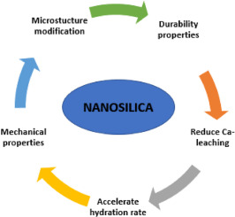
Fig 1.1: Role of Nano Silica in materials
In construction industries, there are many admixture are used to enhance the property of concrete and mortar. Some materials are found from agricultural and domestic. And some material which are occurring from industries. There are some new types of waste material which nano in nature. The size of that types of nano particles are 1 nanometer to 100 nanometer. It is property of material that the finer material gives the more strength to the structure as compare the coarser material.

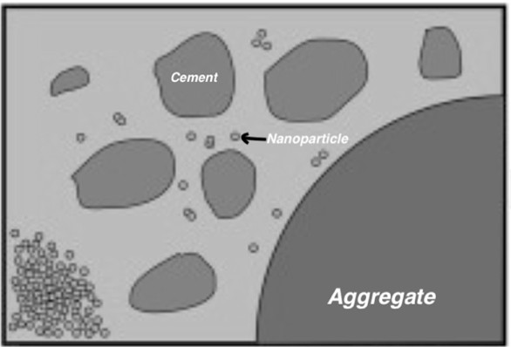
Fig 1.2: the size of Nano particles as compare to cement and aggregate

LITRETURE REVIEW

In this chapter the literature are review on nano silica particles and silica fumes which is used in mortar and concrete. The different methods and test were conducted in the literature by researcher are conducted in many percentage of nano-silica particles and silica fumes particles.
- P. Di Maida et al. (2015): investigated how colloidal and powdered nano-silica affected the characteristics of cement mortar.
Nano silica powder was shown by SEM and XRD to be amorphous. whereas colloidal nature is agglomerated. When colloidal Nano-silica was utilised, there was an increase in compressive strength of between 27 to 37%, but when Nano silica powder was employed, there was only a 19% increase.
- L.P. Singh et al. in 2013: The impacts of nano-silica on cement hydration, microstructure refinement, new characteristics, strength qualities, and durability were reviewed. The authors came to the conclusion that nano-silica dispersion should be researched and that a suitable nano-silica dispersion mechanism is needed. The ideal replacement % for Nano-silica cannot be established since it depends on the kind of Nano-silica, such as whether it is colloidal or dry powder.
- Sayed et al. (2013) employed 19 nm nanosilica particles as cement additives in amounts of 1, 3, 5, 7 and 10% by weight of cement composition.
Findings showed that adding more Nano-silica decreased the cement mortar's workability. Yet, when compressive and flexural strength of cement mortar containing Nano-silica was evaluated, a percentage of 7% was found to be the ideal level. Particularly at young ages, the improvement in compressive and flexure strength measured as 55.7% and 46.9%, respectively, in comparison with the standard mortar.
- Peng-kun A.M. Said et.al., (2012) : examined the combined impacts of Colloidal Nano-silica \sand fly ash on cement mortars. The fly ash utilised was class F and the nano-silica employed was of size 10nm.
- A.Sadrmotazi et al. (2010): examined the impact of polypropylene fibres and nanosilica particles in another paper.
The compressive strength of cement mortar was increased by 6.49% as a result of replacing the Nano silica up to 7%.Above 0.3% of Polypropylene fibres, the compressive strength is reduced, while the flexural strength is increased, demonstrating the efficiency of Nano-Silica particles. Moreover, up to 0.5% Polypropylene fibres in mortar cause a reduction in water absorption, which suggests refined pores.

MATERIAL AND METHODOLOY

Concrete is a most commonly used material in construction material. It have different application in civil engineering structure like cast-in situ type construction and pre-cast type construction. We are always try to enhance the physical property and chemical property of composite material that’s why we were used many types of admixture, who retard the property of mortar and concrete. we are are try to enhance the property of concrete after using the silica particle and silica fumes in the concrete. The percentage of nano silica particle and silica fumes are to be 0%, 1%, 2%, 3%, 4% and 5% with the partially replacement of cement particles. The grade of concrete were M25 which have the proportion of cement, sand and aggregate are 1:1:2 As per IS 456:2000.
The experimental frame of the research is shown below figure.

Fig 3.1:Frame of mixing nano silica and silica fumes

Fig 3.2: Flow chart of Manufacturing of cement (OPC)
Nano silica particles of silicon dia-oxide is an amorphous substance which is produced in different variety of shapes and they can be easily change in any types of shape according to requirement. It is abrasive and absorbent in nature due to its non porous form. Nano silica particles (NSP) are generally fills the voids in cement particles with mix design, and mixes becomes dense with low water percentage. Denser hydration hydration paste have low porosity and due to less porosity compressive strength may be increased.

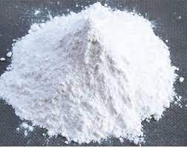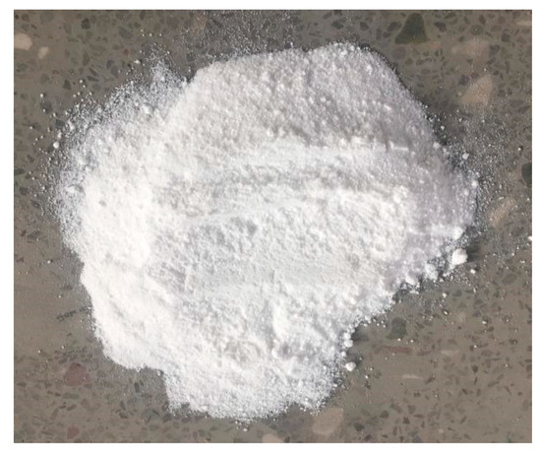
Figure 3.3: Nano silica Particle (NSP)
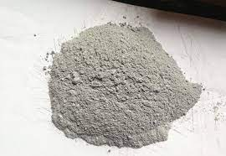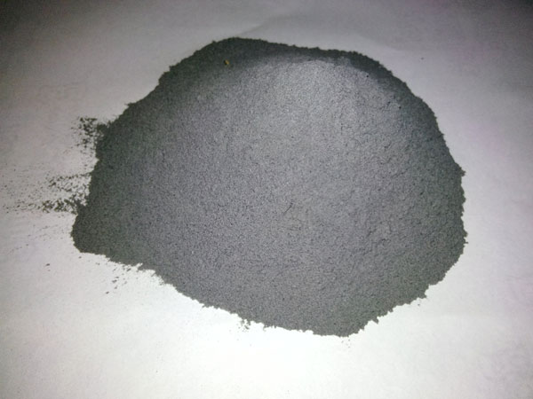
Figure 3.4: Silica Fumes particles
Concrete is a versatile material which is used in the construction. The main ingriedient of concrete are cement, sand and aggregate. For the enhance the property of concrete we can used many types of admixture in the concrete. But we are using here nano silica particales and silica fumes.
The percentage of nano silica particles NSP and silica fumes SF were 0%. 1%, 2%, 3%, 4% and 5% respectively. There are two types of concrete are design in this experiment with nano silica and silica fumes:
- Nano silica concrete (NSC)
- Silica fumes concrete (SFC)

Nano silica concrete are design with nano silica particles with partial replacement of cement with 0%, 1%, 2%, 3%, 4% and 5% respectively. And silica fumes concrete is design with the partial replacement of cement with silica fumes 0%, 1%, 2%, 3%, 4% and 5%.

RESULT AND DISCUSSION

The porosity test conducted on nano silica concrete and silica fume concrete was analyzed and compressive strength test were conducted on the concrete and modified concrete and also the flexural test were also carried out in the previous chapter.
- Result analysis of Nano silica concete (NSC)

Fig 4.1: Analysis of NSC of Porosity
- Result analysis of Silica fumes concrete (SFC)

Fig 4.2: Result analysis of SFC of Porosity
- Result analysis of Compressive strength of Nano silica concrete NSC and silica fumes concrete SFC

Fig 4.3: Compressive strength of NSC with nano silica

Fig 4.4: Compressive strength of SFC with SF
- Flexural strength of Concrete analysis

Fig 4.5: Flexural strength of nano silica concrete

Fig 4.6: Flexural strength of Silica fume concrete

CONCLUSION
Nano silica particles and silica fumes are used in the concrete to the change its properties of fresh and hardened concrete. The percentage of nano silica particles and silica fumes are 1%, 2%, 3%, 4% and 5% respectively.
The porosity test on nano silica concrete and silica fume concrete, compressive strength of nano silica concrete and silica fumes concrete and flexural strength test on NSC and SFC are conducted. The following conclusion are carried out:
- The porosity of normal cement concrete (NCC) is 1.64 %. When we add the 1% of nano silica particles it is decreased by 46% and after adding the 5% of NSP it is decreased by 10.34%.
- When we add the 1% of silica fumes it is decreased by 48% and after the adding of 5% of SF it is decreased by 4.28%.
- The compressive strength of nano silica concrete and silica fume concrete is gradually increased when we add the NSP and SF in the percentage of 1% to 5%. When we add the 1% of NSP and SF it is increased by 4.69% and 1.10%. after the adding 5% of NSP and SF Compressive strength is increased by 12.56% and 12.58% respectively.
- The flexural strength is also increased when we add the NSP and SF. When we add the 1% of NSP and SF flexural strength is increased by 4.82% and decreased 1.10%. after adding the 5% of NSP it is increased by 14.03% and 11.24% respectively.

REFERENCES

- IS:2386-1963 (Part-III). Methods of Test for aggregates for concrete Part III specific gravity, density, voids, absorption and bulking. Bureau of Indian Standards.
- IS:383-1970. Specification for coarse aggregate and fine aggregate from natural sources for concrete. Burea of Indian Standards.
- IS:455-1989. Portland Slag Cement- Specification. Burea of Indian Standards.
- IS:456-2000. Plain and Reinforced concrete- code of practice (Fourth Revision). Bureau of Indian Standards.
- Hui Li, Hui-gang Xiao, Jie Yuan and Jinping Ou. (2004). Microstructure of cement mortar with nanoparticles. Composites: Part B 35, 185-189.
- Ji, Tao. (2005). Preliminary study on the water permeability and microstructure of concrete incorporating nano-SiO2. Cement and Concrete Research 35, 1943-1947.
- Byung-Wan Jo, Chang-Hyun Kim, Ghi-ho Tae and Jang-Bin Park. (2007). Characteristics of cement mortar with nano-SiO2 particles. Construction and Building Materials 21, 1351-1355.
- Nilli, M., Ehsani, A. and Shabani, K. (2009). Influence of nano SiO2 and micro silics on concrete performance. Bu-Ali Sina University Iran.
- Ali Nazari, Shadi Riahi, Shirin Riahi, Saydeh Fatemeh Shamekhi and A. Khademno. (2010). Embedded ZrO2 nanoparticles mechanical properties monitoring in cementitious composites. Journal of American Science 6(4), 86-89.
- Ali Nazari, Shadi Riahi, Shirin Riahi, Saydeh Fatemeh Shamekhi and A. Khademno. (2010). Improvement of the mechanical properties of the cementitious composites by using TiO2 nanoparticles. Journal of American Science 6(4), 98-101.
- Ali Nazari, Shadi Riahi, Shirin Riahi, Saydeh Fatemeh Shamekhi and A. Khademno. (2010). Mechanical properties of cement mortar with Al2O3 nanoparticles. Journal of American Science 6(4), 94-97.
- Alireza Naji Givi, Suraya Abdul Rashid, Farah Nora A. Aziz and Mohamad Amra Mohd Salleh (2010). Experimental investigation of the size effects of SiO2 nano particles on the mechanical properties of binary blended concrete. Composites: Part B 41, 673-677.
- G.Quercia and H.J.H.Brouwers (2010). Application of nanosilica(nS) in concrete mixtures. 8th fib PhD symposium in Kgs. Lyngby, Denmark.
- M.S. Morsy, S.H. Alsayed and M. Aqel. (2010). Effect of Nano clay on mechanical properties and microstructure of Ordinary Portland Cement mortar. International Journal on Civil Engineering & Environmental Engineeering IJCEE-IJENS Vol. 10 No. 01

