FORMULATION AND DEVELOPMENT OF MICROEMULSION BASED TOPICAL DRUG DELIVERY OF KETOCONAZOLE
Rushikesh B. Katkar¹*, Pradip Kolekar², Dr. Abhijit S. Kulkarni³, Sumit A. Shinde⁴, Rajesh V. Kulkarni⁵
Assistant Professor, Ashokrao Mane Pharmaceutical Institute of Research and Sciences, Save Kolhapur, Maharashtra^{1*}
Associate Professor, Ashokrao Mane Pharmaceutical Institute of Research and Sciences, Save Kolhapur, Maharashtra^{4,5}
Senior Officer Q.A., Glenmark Pharmaceutical Ltd, Indore²
Principal, Ashokrao Mane Pharmaceutical Institute of Research and Sciences, Save Kolhapur, Maharashtra³

Abstract:
This study used microemulsion-based ketoconazole topical delivery to improve solubility and permeability. Ketoconazole permeates poorly topically. Ketoconazole containing microemulsion using oleic acid, Tween-80, and isopropyl alcohol was prepared. Pseudo-ternary and ternary phase diagrams prepared microemulsion. Surfactant, cosurfactant, water, globule size, in-vitro drug release, and permeability were examined. The globule size and in-vitro drug release as well as the permeability study were two of the three factors examined.
All of the prepared microemulsion had a globule size between 0 and 254 nm, with the F13 formulation having the smallest globule size. The malvern Zeta sizer was used to determine the droplet size distribution of the F13 formulation.
Keywords: Microemulsion; Ketoconazole; Phase diagram; Optimization; In-vitro drug release.
Introduction:
Because they can solubilizes weakly water-soluble drugs and increase systemic and topical availability, microemulsion on thermodynamically more stable and optically isotropic systems of water, oil, surfactant, and/or co-surfactant—have been investigated to drug delivery techniques¹. It swiftly penetrates skin and solubilizes lipophilic drug moiety. It enhances topical medication delivery. Topical microemulsion extends skin contact. Creams, ointments, and lotions can create stickiness, irritation, and instability². Topical pharmaceutical application increases microemulsion viscosity and stratum corneum hydration, improving drug dermal penetration and skin flux. Transparent hydrogels are being used in cosmetics and pharmaceuticals because to these semisolid characteristics³. Hydrogels cannot deliver lipophilic medicines despite their many benefits. Thus, microemulsion-based hydrogels can contain and distribute hydrophobic medicinal molecules. Drug/oil/water emulsions can integrate hydrophobic medicines into microemulsion-based hydrogel. Microemulsion-based hydrogel incorporates hydrophobic medicines in oil phase and distributes oily globules in aqueous phase to formation of oil and water emulsion⁴⁻⁵.
Ketoconazole, an imidazole-containing fungistatic chemical, is used as a systemic and topical antifungal. Because of its effect on 14-alpha demothylase, a cytochrome P-450 enzyme required for the conversion of lanosterol to ergosterol, it is particularly effective against candidiasis. The main mechanism of action is blocking the activity of cytochrome P450 14-demethylase (P450, 14DM). Synthetic imidazole-derived antifungal drug. Mainly used as antifungal infections⁶⁻⁷.
This study used microemulsion-based ketoconazole topical delivery to improve solubility and permeability.
METHODS
Preformulation studies
Characterization of ketoconazole
Physical examination like colour, nature and melting point was determined. Fourier transform infrared spectrophotometer measured ketoconazole infrared spectrum (Shimadzu MIRacle10). IR platform received a small sample. Spectra were scanned at 4 cm⁻¹ resolution from 4000 to 400 cm⁻¹. IR spectra of ketoconazole shown in Fig.1
UV spectroscopy
a. Determination of λ_{max} of ketoconazole⁷
100 mg ketoconazole was added to 100 ml volumetric flask. Methanol and PBS Isotonic (7.4) filled 100 ml (Stock I). 10 ml from Stock I was transferred to a 100 ml volumetric flask and filled with methanol, PBS Isotonic (7.4). (Stock II). Finally, 10 ml methanol, PBS Isotonic, and 1 ml Stock II solution were added to a 10 ml volumetric flask (7.4). UV spectrophotometric study (200-400 nm) determined λ_{max} for the solution. Fig. 2 shows the λmax of ketoconazole in methanol and PBS Isotonic.
Calibration curve of ketoconazole in methanol⁸
Dissolved 100 mg of medication in 100 ml of methanol which observed yielded 1 mg/ml stock solution. Second stock solution made by diluting 5ml in 100ml methanol to produce 50μg/ml. This was aliquoted and diluted to 5–40μg/ml. All solutions were scanned with a Shimadzu UV1800 spectrophotometer at 243 nm against methanol as a blank ( Fig.3). Readings were tripled. Recorded mean values. Regressed absorbance values were graphed against concentration.
Calibration curve of ketoconazole in Isotonic PBS (pH 7.4)
Dissolving 100 mg of medication in 100 ml of methanol yielded 1 mg/ml stock solution. Second stock solution made by diluting 4ml in 100ml isotonic PBS (pH 7.4) to produce 40μg/ml. These aliquots were diluted to 2–20 μg/ml. All solutions were scanned with a Shimadzu UV1800 spectrophotometer at 225 nm against a blank of isotonic PBS (pH 7.4) ( Fig.3). Readings were tripled. Recorded mean values. Regressed absorbance values were graphed against concentration.
Selection of oils, surfactants and co-surfactant for formulation study Solubility determination of ketoconazole in various oils, surfactant and cosurfactant:⁹⁻¹²
Ketoconazole solubility screening microemulsion oils. Oleic acid dissolved ketoconazole well. Solubilizing microemulsion improved dermal flow. Oleic acid increased stratum corneum lipid fluidity and permeability in ketoconazole microemulsion. According to literature, oleic acid, castor oil, eucalyptus oil, and olive oil are good microemulsion excipients. Choose micro-emulsion oils, surfactants, and co-surfactants. Oils, surfactants, and co-surfactants chosen ketoconazole solubility. Tween-80, 40, 20, and 60 surfactants and co-surfactants tested OA, eucalyptus, castor, and olive oils (including isopropyl alcohol, Ethanol, n-butanol and n-propanol). In 10 ml stopper vials, extra ketoconazole was mixed with 5 ml of oil, surfactants, and co-surfactants to test solubility. 72-hour rotating shakers agitated mixtures at room temperature. 24-hour equilibrium. A 0.45-μm membrane filter filtered equilibrated samples. UV spectrophotometers measured max 243 nm ketoconazole solubility after methanol dilution¹³⁻¹⁴. Results are listed in Table 4.
Construction of pseudoternary phase diagram¹⁵
Phase diagram and microemulsion area determined surfactant-cosurfactant ratio (Km). kilometres simplified pseudoternary phase diagram. Titration of homogeneous liquid solutions of water, surfactant, and cosurfactant with oil phase at ambient temperature gave the phase diagram. The surfactant and co-surfactant were combined from 1:9 to 9:1, the nine results were mixed with water equally and separately, and oleic acid was added drop-by-drop. 2.0 g water, surfactant, cosurfactant (Table 1). A magnetic stirrer equilibrated samples during titration. After adding an aliquot of oil, the liquid was visually tested for transparency until it clouded. Clear window microemulsions. Oil, surfactant, and cosurfactant created the pseudoternary phase diagram with constant water ratio. This simplified phase diagram revealed the optimal surfactant-co-surfactant ratio for water and oil solubility, Km. Water-shaped phase diagrams. Oil-compatible low-water-content mixed surfactant. Low oil-water compatibility. Both hindered Km discovery. Water scatters pseudoternary phase diagrams. Water titrates oil. Untitrated liquid crystal phase. Pseudoternary phase diagrams determined the correct surfactant-cosurfactant weight ratio (Km). Km was fixed and combinations were 9:1–1:9. 1.0 g. Each mixture received filtered water drop-by-drop. A magnetic stirrer equilibrated samples during titration. Water-tested transparency. Semi-opaque may mean end. Pseudoternary phases diagram is showed in Fig.4
Table 1: Optimization of Smix (Km) ratio
Sr. No. | Water (ml) | Smix ratio | Tween 80 (ml) | Isopropyl alcohol (ml) | Oleic Acid
1 | 2 | 9:1 | 1.70 | 0.25 | 0.1
2 | 2 | 8:2 | 1.51 | 0.51 | 0.2
3 | 2 | 7:3 | 1.32 | 0.76 | 0.5
4 | 2 | 6:4 | 1.13 | 1.02 | 1.3
5 | 2 | 5:5 | 0.94 | 1.27 | 1.6
6 | 2 | 4:6 | 0.752 | 1.52 | 1.4
7 | 2 | 3:7 | 0.56 | 1.78 | 0.9
8 | 2 | 2:8 | 0.37 | 2.03 | 0.5
9 | 2 | 1:9 | 0.18 | 2.29 | 0.4

Ternary phase diagram
Based on pseudoternary phase diagram results, the best weight ratio of surfactant and cosurfactant (Km) was selected. A homogenous oil surfactant–cosurfactant blend was prepared, where Km was fixed, contents of mixed surfactant and oil blend in the mixtures varied from 9:1 to 1:9.The total quantity maintained in 1.0 g. Purified water was added drop by drop to each mixture (Table 2). During the titration, samples were stirred by a magnetic stirrer to allow equilibration. Following addition of an aliquot of water, the mixture was visually examined for transparency. The slightly opaque could present the end. In the pseudoternary phase diagram, transparent, single-phase mixtures were designated as microemulsion. Ternary phase diagram showed in Fig.5.
Table 2: Ternary phase diagram
Sr. No | Oleic acid | Smix(1:1) | Water
1 | 0.9 | 0.1 | 0.1
2 | 0.8 | 0.2 | 0.1
3 | 0.7 | 0.3 | 0.1
4 | 0.6 | 0.4 | 0.1
5 | 0.5 | 0.5 | 0.2
6 | 0.4 | 0.6 | 0.2
7 | 0.3 | 0.7 | 0.2
8 | 0.2 | 0.8 | 0.5
9 | 0.1 | 0.9 | 0.8

Preparation of ketoconazole loaded microemulsion: ¹⁶⁻¹⁷
Drop by drop, the oil-water microemulsion system was added. Magnetically stirred microemulsion. Ketoconazole was dissolved in oleic acid. Ketoconazole was 2%w/w in microemulsion.
The microemulsion was prepared as per following table 3, according to water titration method of constructing phase diagram. The drug was dissolved with the aid of ultrasonication.
Table 3: Composition of microemulsion formulations
Batch | Ketoconazole (mg) | Oleic acid (ml) | Smix (ml) | Water (ml)
F1 | 600 | 0.957509 | 17.95028 | 11.14062
F2 | 600 | 1.596201 | 17.02557 | 11.4288
F3 | 600 | 1.598352 | 16.53179 | 11.92114
F4 | 600 | 1.602654 | 15.54036 | 12.90938
F5 | 600 | 0.319358 | 18.58017 | 11.14718
F6 | 600 | 1.589749 | 18.49827 | 9.959775
F7 | 600 | 0.962155 | 16.17144 | 12.91694
F8 | 600 | 0.639818 | 17.52654 | 11.88222
F9 | 600 | 0.747178 | 16.9768 | 12.32539
F10 | 600 | 0.955961 | 18.53922 | 10.55222
F11 | 600 | 0.957509 | 17.95028 | 11.14062
F12 | 600 | 0.320906 | 16.80324 | 12.9245
F13 | 600 | 1.6952 | 14.83 | 16.32

Design and optimization of ketoconazole microemulsion
Ketoconazole was formulated using D-Optimal Design Expert 8.0. Classical experimental designs lack experimental limitations and cannot predict better. In a three-component mixture design, an equilateral triangle illustrates possible experimental runs, and real responses can be represented as distance orthogonal to factor space. The design space's irregular polyhedron with extreme vertices limits component range. D-optimal design maximises prediction power in selected experimental runs and minimises model coefficient variance. Pseudo ternary phase diagrams and early tests determined the quantities of oil (X1), Smix (X2), and water (X3) in this inquiry. Oleic acid below 10% prevents skin irritation. Skin hydration affects drug penetration. To keep medication in the skin, we restricted water content to 55%. Design components included these.
5%≤ X1≤ 10%
40% ≤ X2≤ 60%
30% ≤ X3≤ 55%
The globule size (in nanometers; Y1) and In-vitro drug release of MEs (Y2), percent Permeability study (Y3) were selected as the dependent variables (responses). Formulation batches in a D-optimal design shown in table 6.

Characterization and evaluation of microemulsion¹⁸
The prepared microemulsion (F1-F13) was evaluated for the following characteristics.
A. Optical transparency
Viewing the sample in a clear container with good light against eye reflection and against a black and white illuminated background assessed the formulations' optical transparency (Table 10).
B. Measurement of globule size
The average globule/droplet size was measured using a malvern zeta sizer. The measurement was performed at 25°C¹⁹ (Table 10).
C. Phase Separation
Microemulsion system were subjected to centrifugations at 5,000 rpm for a period of 10 min. and examined for any change in phase separation (Table 10).
D. Viscosity measurement
The viscosities of microemulsion were measured using a Brookfield (LVDVE) rotational viscometer equipped with the spindle no.64. The measurement was performed at ambient temperature and in triplicate²⁰ (Table 12).
E. Determination of pH
A 10% dispersion of formulation was prepared in distilled water and pH was determined by using Chemiline CL-120 pH meter standardized with standard buffers of pH 4 and pH 7.4 (Table 12).
F. Zeta potential
Zeta potential is determined by using malvern zetasizer. Zeta potential is essentially useful for assessing flocculation since electrical charges on particles influence the rate of flocculation (Fig. 6).
In vitro drug release studies
Franz diffusion cells with cellophane sheets were used for in vitro drug release research. The receiver compartment held 30 ml and contained two arms for sampling and a thermometer. Donor compartments were 2 cm wide. Donor compartment touched receptor compartment diffusion medium. PBS 7.4 at 37°C ± 1°C was in the receptor compartment. Before applying the donor-side microemulsion with 10 mg of medication, the membrane was equilibrated. A spectrophotometer at 254 nm measured samples taken from the receptor compartment and replaced with the same amount of fresh isotonic PBS 7.4 solution^{10,17} (Fig. 7).
Permeation study
Franz diffusion cells were used to study permeation. Franz diffusion cells constricted the egg membrane between donor and receptor compartments. The donor compartment received 10mg ketoconazole microemulsion. The receptor compartment was filled with isotonic PBS pH 7.4 at 37°C with 100 rpm stirring. At predefined time intervals (30 min), 1 ml receptor medium was withdrawn and the same volume of pure medium was immediately reintroduced into the receptor compartment. The technique was repeated up to 5 h. All samples were filtered via Whatman filter paper and examined by UV spectrophotometer at 225 nm (Fig. 10).
Transmission electron microscopy (TEM) Analysis
Morphology and structure of the microemulsion were studied using transmission electron microscopy (TEM) (Technai 20, Philips, Holland) at an acceleration voltage of 200 kV. In order to perform the TEM observations, a drop of the microemulsion was directly deposited on the holey film grid and observed after drying (Fig. 13).

RESULTS AND DISCUSSIONS
Determination of melting point of drug:
It is white to pale yellow powder. The melting point of ketoconazole was found in the range of 149-151˚C.
IR spectra ketoconazole
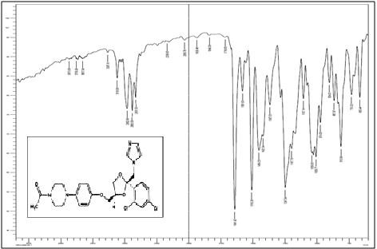

Fig. 1: IR spectra of ketoconazole
The FTIR spectrum of ketoconazole shows the presence of unique peaks at 1641cm⁻¹ (C=O stretch), 1672.28cm⁻¹ (C-Cl), 1247cm⁻¹ (3° amine) and 1381.28 cm⁻¹ (NH2 rocking).
Estimation of ketoconazole by UV spectroscopy
The λ max of ketoconazole was found to be 243 nm in methanol and225 nm in isotonic phosphate buffer 7.4
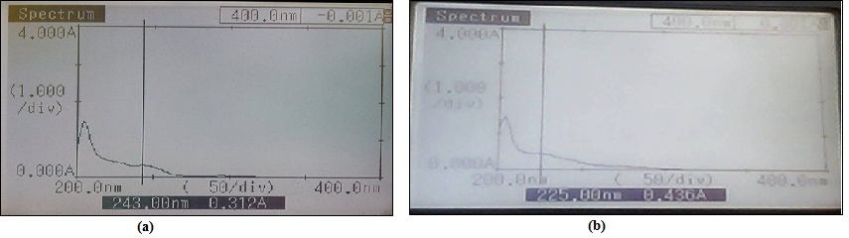
Figure 2: λmax of ketoconazole in methanol (a) and in isotonic phosphate buffer 7.4

Calibration curve of ketoconazole in methanol and isotonic PBS 7.4
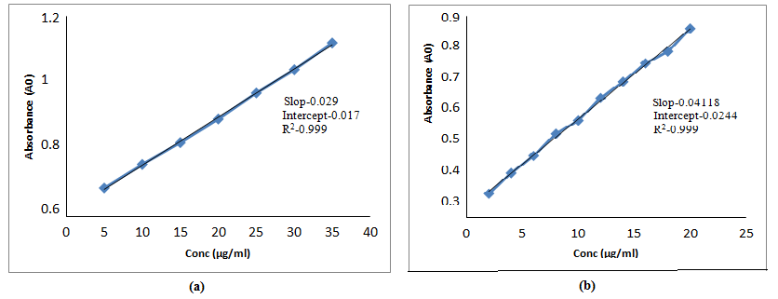
Figure 3: Calibration curve of ketoconazole in methanol (a) and in isotonic PBS 7.4
Slope | 0.04118
Intercept | 0.0244
R² | 0.999
Solubility determination of ketoconazole:
Details of solubility of oil shoed in table 2.
Table 4: Solubility data of ketoconazole in various oils, surfactant and co-surfactants:
Sr. No. | Phase | Oils | Solubility (µg /ml)
1 | Oils | Oleic acid | 41.36
2 |  | Eucalyptus oil | 25.79
3 |  | Castor oil | 25.44
4 |  | Olive oil | 23.24
5 | Surfactants | Tween-80 | 42.81
6 |  | Tween-60 | 34.62
7 |  | Tween-40 | 31.27
8 |  | Tween-20 | 26.41
9 |  | Span-80 | 13.44
10 | Co- Surfactants | Isopropyl alcohol | 30.03
11 |  | Ethanol | 15.87
12 |  | n-butanol | 17.72

Tween-80 and isopropyl alcohol act as penetration enhancer. So oleic acid, Tween-80 and Isopropyl alcohol were subsequently used as oil, surfactant and co- surfactant for the formulation of microemulsion containing ketoconazole in present study.
Microemulsion is an optically transparent system hence one of the important criteria for microemulsion preparation is that the selected oil and surfactant combination should show very high % transmittance (~ 99%). It was observed (Table 5) that the combination of oleic acid and Tween-80 showed % transmittance above 99 % and hence were selected for the preparation of microemulsion.
Table 5: % Transmittance study of oil and surfactant
Oil : surfactant | % Transmittance
Oleic acid: Tween 80 | 99.42

Pseudo-ternary phase diagrams
Pseudo-ternary phase diagrams were constructed to examine the formation of micro-emulsion using four-component system consisting of an oil phase (oleic acid), a non-ionic surfactant Tween-80, a cosurfactant isopropyl alcohol and purified water (aqueous phase).The pseudo-ternary phase diagram was constructed with help of sigma plot 12.0 software.

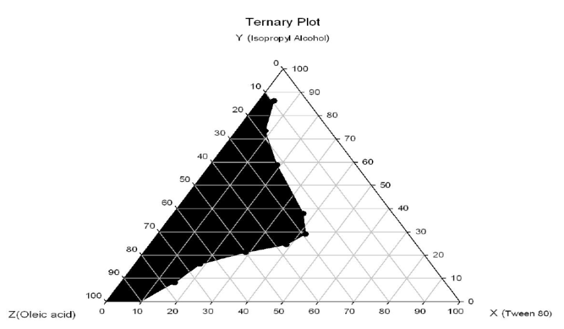
Figure 4: Optimization of Smix (Km) ratio
From the above table 1 and figure 4, the optimized surfactant, co surfactant ratio (Smix) was found to be 1:1.

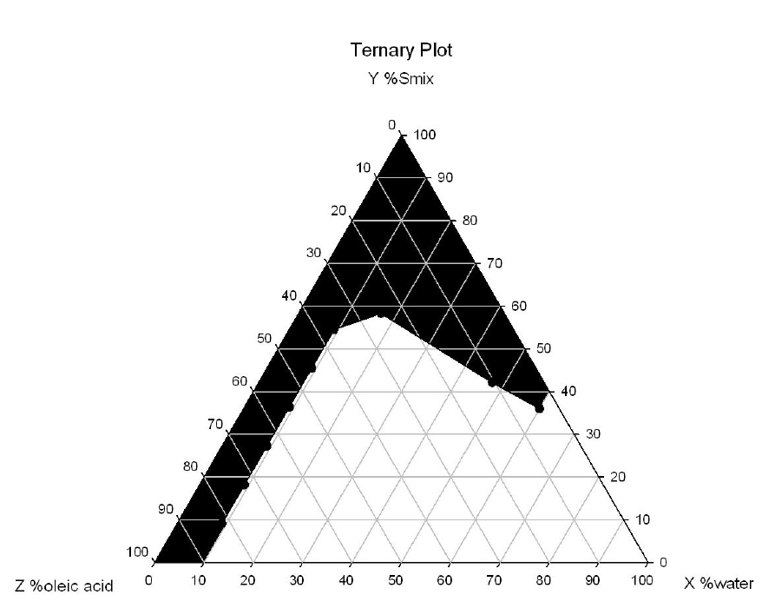
Figure 5: Ternary phase diagram
Unshaded part in each phase diagram indicates the region of two immiscible phases, whereas all plotted points indicates the instantaneous formation of microemulsions for respective oil to water ratios with specific amount of surfactant/cosurfactant ratio.
The ternary diagram indicated that the surfactant, cosurfactant was required up to 50-60% to form a microemulsion. From diagrams it was concluded that microemulsion existing zone was more with the surfactant: cosurfactant ratio of 1:1 as compared to the other ratios. Hence 1:1 ratio of surfactant and co-surfactant was promising for preparation of microemulsion. The increasing concentration of surfactant in S/Co ratio leads to rise in the microemulsion region because of enhanced hydrolipophilicity, where as further rise in the surfactant concentration leads to too much hydrophilicity (Tween-80, HLB-15) which fells to emulsification with oil phase.
Optimization of formulation
A D-optimal experiment design was adopted to optimize the composition of microemulsion (W. Zhu et al) .In this design three factors were evaluated by changing their concentration simultaneously and keeping their total concentration constant. The D-optimal design for three-component system is represented. The concentration of surfactant, cosurfactant and water were selected as independent variables. The globule size (in nanometers; Y1) and In-vitro drug release (percent; Y2) of MEs, permeability study (percent; Y3) were selected as the dependent variables (responses).
Because of high content, oleic acid could cause skin irritation, 5% oleic acid was chosen as oil phase in this study. Also it was well reported the relationship between hydration effect of stratum corneum and dermal permeation, 40-65% water content was chosen as water phase.
Table 6: Formulation batches in a D-optimal design
Sr. No. | Run | Oleic Acid | Smix (1:1) | Water
1 | 1 | 3 | 58 | 39
2 | 2 | 5 | 55 | 40
3 | 3 | 5 | 53.33 | 41.667
4 | 4 | 5 | 50 | 45
5 | 5 | 1 | 60 | 39
6 | 6 | 5 | 60 | 35
7 | 7 | 3 | 52 | 45
8 | 8 | 2 | 56.5 | 41.4
9 | 9 | 2 | 54 | 43
10 | 10 | 3 | 60 | 37
11 | 11 | 3 | 58 | 39
12 | 12 | 1 | 54 | 45
Design summary
The formulation were prepared using a D-optimal design, with the help of Design-Expert 8.0.7.1.Here three factors were evaluated and experimental trials were performed at twelve possible combinations with one optimized trial. The concentration of oleic acid (X1) ,concentration of Smix (X2) and concentration of water were selected as independent variables, while globule size, % cumulative drug release and % permeability were selected as dependent variables.
The prepared microemulsion contains oleic acid as an oil phase at different concentrations to assess the controlled release effect. Again concentration of Surfactant cosurfactant (Smix) also plays an important role in the globule size and drug release. Concentration of water also shows predominant effect on the drug release profile of the microemulsion.
Table 7: Coded level as per D-optimal design.
Coded factor | Actual factor | Unit | Type | Limits (%)
 |  |  |  | Lower | Higher
X1 | Oleic acid | % | Numerical | 1 | 5
X2 | Smix | % | Numerical | 50 | 60
X3 | Water | % | Numerical | 35 | 45

Table 8: Response summary
Factor | Response | Unit | Analysis | Minimum | Maximum
Y1 | Globule size | nm | Polynomial | 52.9 | 254.9
Y2 | Drug release | % | Polynomial | 57.31 | 85.05
Y3 | permeability | % | Polynomial | 55.85 | 83.44

Table 9: Coded level as D-optimal design with observed responses.
Runs | Oleic acid (%) | Smix (1:1)  (%) | Water (%) | Globule size(nm) | Drug  release (%) | Permeability y  (%)
1 | 3 | 58 | 39 | 121.1 | 79.94 | 79.50
2 | 5 | 55 | 40 | 254.9 | 63.73 | 63.88
3 | 5 | 53.33 | 41.66 | 123.5 | 71.03 | 69.71
4 | 5 | 54 | 45 | 197.3 | 78.62 | 77.34
5 | 1 | 67 | 39 | 155.7 | 63.15 | 61.69
6 | 5 | 60 | 36 | 168.4 | 85.05 | 83.44
7 | 3 | 51 | 44 | 99.7 | 69.86 | 68.87
8 | 2 | 56.5 | 41.5 | 57.07 | 61.54 | 60.54
9 | 2.33 | 54.66 | 41 | 63.4 | 63.44 | 61.64
10 | 3 | 60 | 36 | 52.9 | 57.31 | 55.85
11 | 3 | 57 | 38 | 77.6 | 64.75 | 62.40
12 | 1 | 54 | 44 | 71.5 | 73.22 | 71.32
The data clearly indicates that globule size, % drug release and % permeability strongly dependant on selected independent variables such as oleic acid concentration, Smix concentration and water concentration.
Influence of independent variables on dependent variables
The influence of independent variables on dependent variables can be well explained by using 3D plot (surface response plot), 2D plot (contour plot) and polynomial equations of globule size, % drug release and % permeability.

Evaluation of prepared microemulsion:
Optical transparency, globule size and phase separation
All the formulation batches were analyzed for the optical transparency; the results were given in table10. All the batches were transparent in nature. Globule size of all prepared microemulsion observed in between 0-254 nm range which was acceptable range for microemulsion formulations. Formulation F13 shown the least globule size as compared to the all other microemulsions, This is due to presence of appropriate surfactant, cosurfactant and oil concentration. The surfactant and co-surfactant reduces the interfacial tension formed between oil and water phase and helps to reduce the globule size. Droplet size distribution of formulation F13 was given in figure 6, which were measured by malvern Zeta sizer (nanoseries). None of the microemulsion systems showed signs of phase separation on centrifugation at 1000 rpm for 30 minutes. This result provided a rapid and full proof identification of the system as microemulsion, and which was the sign of stability of microemulsion.
Table 10: Optical transparencies, globule size and Phase separation data
Formulation | Transparency | Globule size | Phase Separation
F1 | Transparent | 121.1 | No Phase Separation
F2 | Transparent | 254.9 | No Phase Separation
F3 | Transparent | 123.5 | No Phase Separation
F4 | Transparent | 197.3 | No Phase Separation
F5 | Transparent | 155.7 | No Phase Separation
F6 | Transparent | 168.4 | No Phase Separation
F7 | Transparent | 99.7 | No Phase Separation
F8 | Transparent | 57.0 | No Phase Separation
F9 | Transparent | 63.4 | No Phase Separation
F10 | Transparent | 52.9 | No Phase Separation
F11 | Transparent | 77.6 | No Phase Separation
F12 | Transparent | 71.5 | No Phase Separation
F13 | Transparent | 53.3 | No Phase Separation

Table 11: Summary of ANOVA for globule size
Source | Sum of squares | df | Mean square | F value | P-value probe>F
Model | 41383.18 | 9 | 4598.13 | 3.47 | 0.2435
Linear mixture | 17109.22 | 2 | 8554.61 | 6.46 | 0.1340
AB | 1005.71 | 1 | 1005.70 | 0.76 | 0.4754
AC | 1156.41 | 1 | 1156.41 | 0.87 | 0.4487
BC | 1218.11 | 1 | 1218.11 | 0.92 | 0.4387
ABC | 1004.53 | 1 | 1004.53 | 0.76 | 0.4756
AB(A-B) | 795.40 | 1 | 795.40 | 0.60 | 0.4756
AC(A-C) | 1081.05 | 1 | 1081.05 | 0.82 | 0.4616
BC(B-C) | 7180.01 | 1 | 7180.01 | 5.42 | 0.1453
Residual | 2648.10 | 2 | 1324.05 | - | -
Lack of fit | 1701.97 | 1 | 1701.97 | 1.80 | 0.4079
Pure error | 946.13 | 1 | 946.13 | - | -
Cor Total | 44031.28 | 11 | - | - | -
Above plots and polynomial equation shows that the Smix and water concentration has negative effect on globule size and as the concentration of Smix and water increases there is decreases in globule size of microemulsion. Also the concentration of water has significant positive effect on globule size of microemulsion and as the concentration of water increases there is increase in globule size of microemulsion.
Viscosity and pH measurement:
The values of viscosity and pH measurements of all formulations were listed in Table 12. The microemulsion being the combination of oil, surfactant, co-surfactant and water; these could affect the viscosity of the formulation. Formulation F13 which contains least amounts of water, with proper amount of surfactant, and it may be due to which it shows highest viscosity as compared to all formulations. Formulation F1 shows least viscosity this could be due to presence of high concentration of water in formulation and very low concentration of the surfactant. Also as the concentration of surfactant co-surfactant mixture increases the viscosity of formulation get increased. pH of all formulations were found in between 6-6.5 which was acceptable for pH of skin. This is an important parameter as the skin pH ranges between pH 5.5-6.5.
Table 12: Viscosity of microemulsion formulations
Batches | F1 | F2 | F3 | F4 | F5 | F6 | F7 | F8 | F9 | F10 | F11 | F12 | F13
Viscosity  (Cps) | 60 | 68 | 69 | 65 | 73 | 67 | 70 | 69 | 65 | 73 | 67 | 70 | 73
pH | 5.20 | 6.25 | 6.21 | 6.3 | 5.12 | 6.20 | 5.35 | 6.23 | 6.51 | 6.30 | 6.26 | 5.00 | 6.13

Zeta potential measurement:
Zeta potential of F13 was -40 mV. The negative Zeta potential indicate that droplets of the microemulsion having -40 charge on each globule, and that could responsible for the repulsion of globule from each other and that not allows the globule to settle down for longer period of time, indirectly causing the long stability of the formulations. Zeta potential was determined by using malvern zetasizer (Fig 6).
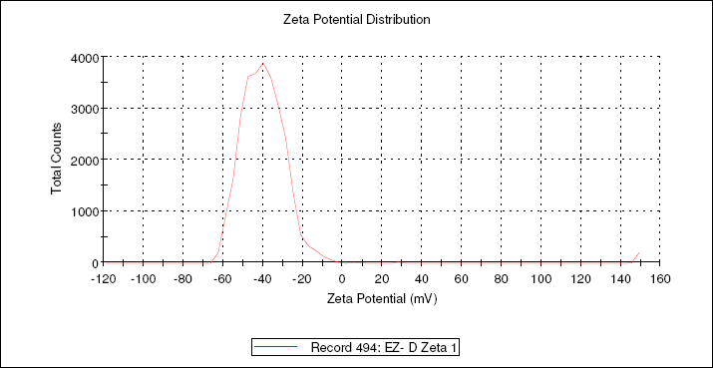
Figure 6: Zeta potential of microemulsion
In-vitro drug release study
The in vitro drug release profile of ketoconazole microemulsions through cellophane paper were represented in Fig. 7. All the formulation shown the drug release about 57-88% through cellophane membrane within the 5 hours time period, which was acceptable for the topical formulations and were meant for the localized effect, not the systemic effect. Formulation F13 had smallest droplet size with greater % drug release.
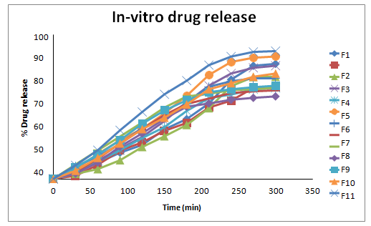
Figure 7: In-vitro diffusion study
Permeability study
3D plot (Response surface plot)
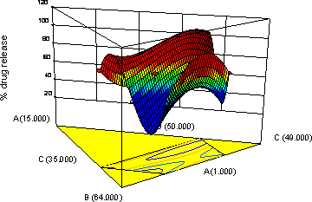
Figure 8: Response surface plot of in-vitro drug release
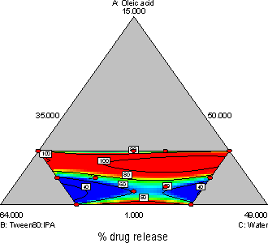
Figure 9: Contour plot of in-vitro drug release
Permeability study
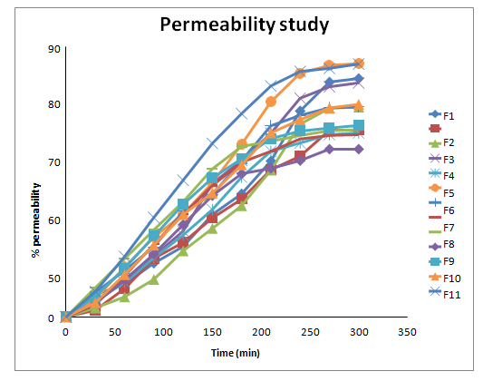
Figure 10: Permeability study
The permeability study of ketoconazole microemulsions through egg membrane were represented in above Fig. 10. All the formulation shown the % permeability about 55-84% through egg membrane within the 5 hours time period, which was acceptable for the topical formulations and were meant for the localized effect, not the systemic effect. Formulation F13 had smallest droplet size with greater % permeability.
Influence on in-vitro drug release
Influence on % permeability
3D plot (Response surface plot)
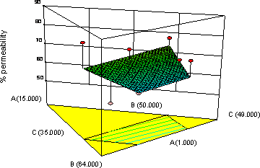
Figure 11: Response surface plot of % permeability
2D plot (Contour plot)

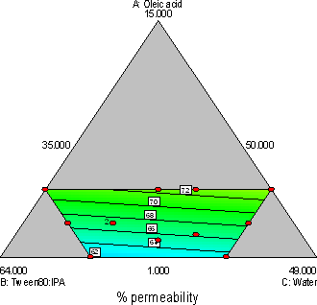
Figure 12: Contour plot of % permeability
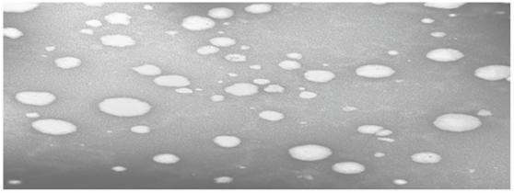
Transmission electron microscopy (TEM) Analysis
Figure 13: Transmission electron microscopy (TEM) Analysis
The result of TEM figure reveal that ketoconazole microglobules were almost spherical in shape.
Summary of ANOVA
Table 13: Summary of ANOVA for in-vitro drug release
Source | Sum of  squares | df | Mean square | F value | P-value  probe>F
Model | 675.73 | 9 | 75.08 | 1.26 | 0.5179
Linear Mixture | 142.26 | 2 | 71.13 | 1.20 | 0.4554
AB | 181.52 | 1 | 181.52 | 3.05 | 0.2227
AC | 175.71 | 1 | 175.71 | 2.95 | 0.2278
BC | 182.84 | 1 | 182.84 | 3.07 | 0.2216
ABC | 185.60 | 1 | 185.60 | 3.12 | 0.2193
AB(A-B) | 180.13 | 1 | 180.13 | 3.03 | 0.2239
AC(A-C) | 177.10 | 1 | 177.10 | 2.98 | 0.2266
BC(B-C) | 18.27 | 1 | 18.27 | 0.31 | 0.6351
Residual | 118.95 | 2 | 59.47 | - | -
Lack of fit | 3.58 | 1 | 3.58 | 0.031 | 0.8890
Pure error | 115.37 | 1 | 115.37 | - | -
Cor Total | 794.67 | 11 | - | - | -

Above plots and polynomial equation shows that the oleic acid concentration has significant negative effect on % drug release and as the concentration of oleic acid increases there is decreases in % in-vitro drug release of microemulsion. Also the concentration of oleic acid and Smix has significant positive effect on % in-vitro drug release of microemulsion and as the concentration of oleic acid and Smix increases there is increase in globule size of microemulsion.
Polynomial equation
Table 14. Summary of ANOVA for % permeability
Source | Sum of squares | df | Mean square | F value | P-value probe>F
Model | 160.92 | 2 | 80.46 | 1.13 | 0.3657
Linear mixture | 160.92 | 2 | 80.46 | 1.13 | 0.3657
Residual | 64240 | 9 | 71.38 | - | -
Lack of fit | 496.54 | 8 | 62.07 | 0.43 | 0.8362
Pure error | 145.86 | 1 | 145.86 | - | -
Cor Total | 803.32 | 11 | - | - | -
Above plots and polynomial equation shows that the oleic acid concentration has significant positive effect on % permeability and as the concentration of oleic acid increases there is increase in % permeability of microemulsion.
Conclusion:
The melting point of ketoconazole is between 149 and 151 degrees Celsius, and its calibration curve has the following characteristics: isotonic PBS 7.4, slope 0.04118, intercept 0.0244, R 2 0.999, and NH 2 1381. To create the drug-containing microemulsion, oleic acid, Tween-80, and isopropyl alcohol were used as the oil, surfactant, and co-sulphurant, respectively. A ternary phase diagram and a pseudo-ternary phase diagram were built as part of the microemulsion preparation process.
The globule size and in-vitro drug release as well as the permeability study were two of the three factors examined. The following is a list of the ingredients that went into making the microemulsions: Ketoconazole (mg) (mg) Acid oleic (ml) Smix (ml) (ml) Water (ml) (ml). All of the prepared microemulsion had a globule size between 0 and 254 nm, with the F13 formulation having the smallest globule size. The malvern Zeta sizer was used to determine the droplet size distribution of the F13 formulation.
Twelve experimental trials were conducted at different permutations of the three factors, and one trial was found to be optimal. Oleic acid concentration was found to have a negative effect on drug release, while oleic acid and Smix concentration had the opposite effect. A transmission electron microscopy study showed that the microglobules were nearly round.

References:

- Singh PK, Iqubal MK, Shukla VK, Shuaib M. Microemulsions: current trends in novel drug delivery systems. J Pharm Chem Biol Sci. 2014 Feb;1(1):39-51.
- Mehta DP, Rathod HJ, Shah DP. Design, development and characterization of microemulsion based hydrogel of clotrimazole for topical delivery system. Emerg Med J. 2019:1-0.
- Patel RR, Patel ZK, Patel KR, Patel MR. Micro emulsion based gel: recent expansions for topical drug delivery system. J Med Pharm Allied Sci. 2014;1:1-5.
- Mehta DP, Rathod HJ, Shah DP. Design, development and characterization of microemulsion based hydrogel of clotrimazole for topical delivery system. Emerg Med J. 2019:1-0.
- Grampurohit N, Ravikumar P, Mallya R. Microemulsions for topical use–a review. Ind J Pharm Edu Res. 2011 Jan;45(1):100-7.
- Patel A, Patel J. Mucoadhesive microemulsion based prolonged release vaginal gel for anti-fungal drug. American Journal of Pharma Tech. Research. 2012;2(4):650-61.
- Urmaliya H, Gupta M, Agrawal A, Jain NK, Dubey A. Formulation development and evaluation of microemulsion gel of Ketoconazole as an antifungal agent. Pharmacia: An Int J of Pharm Sci. 2016;2:120-30.
- Lewis GA, Mathieu D, Phan-Tan-Luu R. Pharmaceutical experimental design. CRC press; 1998 Sep 10.
- Chen H, Chang X, Du D, Li J, Xu H, Yang X. Microemulsion-based hydrogel formulation of ibuprofen for topical delivery. International journal of pharmaceutics. 2006 Jun 6;315(1-2):52-8.
- Barot BS, Parejiya PB, Patel HK, Gohel MC, Shelat PK. Microemulsion-based gel of terbinafine for the treatment of onychomycosis: optimization of formulation using D-optimal design. Aaps Pharmscitech. 2012 Mar;13:184-92.
- Hashem FM, Shaker DS, Ghorab MK, Nasr M, Ismail A. Formulation, characterization, and clinical evaluation of microemulsion containing clotrimazole for topical delivery. Aaps Pharmscitech. 2011 Sep;12:879-86.
- Glujoy M, Salerno C, Bregni C, Carlucci AM. Percutaneous drug delivery systems for improving antifungal therapy effectiveness: A review. Int. J. Pharm. Pharm. Sci. 2014;6:8-16.
- Rowe R, Sheskey PJ, Quinn ME. Handbook of Pharmaceutical Excipients.6th edition, Pharmaceutical Press and American Pharmaceutical Association,
London. 2006; 494, 624
- Sabale V, Vora S. Formulation and evaluation of microemulsion-based hydrogel for topical delivery. International journal of pharmaceutical investigation. 2012 Jul;2(3):140.
- Hou P, Cao S, Ni J, Zhang T, Cai Z, Liu J, Wang Y, Wang P, Lei H, Liu Y. In-vitro and in-vivo comparison of T-OA microemulsions and solid dispersions based on EPDC. Drug Development and Industrial Pharmacy. 2015 Feb 1;41(2):263-71.
- Chen H, Chang X, Du D, Li J, Xu H, Yang X. Microemulsion-based hydrogel formulation of ibuprofen for topical delivery. International journal of pharmaceutics. 2006 Jun 6;315(1-2):52-8.
- Hashem FM, Shaker DS, Ghorab MK, Nasr M, Ismail A. Formulation, characterization, and clinical evaluation of microemulsion containing clotrimazole for topical delivery. Aaps Pharmscitech. 2011 Sep;12:879-86.
- Chudasama A, Patel V, Nivsarkar M, Vasu K, Shishoo C. Investigation of microemulsion system for transdermal delivery of itraconazole. Journal of advanced pharmaceutical technology & research. 2011 Jan;2(1):30.
- Salerno C, Carlucci AM, Bregni C. Study of in vitro drug release and percutaneous absorption of fluconazole from topical dosage forms. Aaps Pharmscitech. 2010 Jun;11:986-93.
- Patel MR, Patel RB, Parikh JR, Solanki AB, Patel BG. Effect of formulation components on the in vitro permeation of microemulsion drug delivery system of fluconazole. AAPS PharmSciTech. 2009 Sep;10:917-23.
- Talegaonkar S, Azeem A, Ahmad FJ, Khar RK, Pathan SA, Khan ZI. Microemulsions: a novel approach to enhanced drug delivery. Recent patents on drug delivery & formulation. 2008 Nov 1;2(3):238-57.

