Analysis of surface runoff from Nandani River Basin using SCS-CN and Geospatial Techniques
Pavan Lokare¹, Abhijit Zende², Manali Kumthekar
^{1 & 3} Assistant Professor, Dept. of Civil Engineering, Dr. Daulatrao Aher college of Engineering,
Karad, India
Professor, Dept. of Civil Engineering, Dr. Daulatrao Aher college of Engineering, Karad, India

zenabhi31@yahoo.co.in

Abstract
The relationship between rainfall and runoff for any rainstorm depends on the dynamic interaction between rain intensity, soil infiltration and surface storage. Whenever the rain intensity exceeds the infiltration capacity of the soil the Runoff occurs, if there are no physical obstructions to the flow on surface. For ground water recharge rainfall is a major source. Apart from that there are other sources of recharge include seepage from tanks, canals, streams and functional irrigation. It is important to determine the availability of water by understanding rainfall and runoff. For the preparation and design of artificial recharging schemes, hydrometeorological and hydrological data play an important role in the assessment of water source accessibility. In the present study, study area is of Nandani River Basin, which is part of upper Krishna basin, Western Maharashtra, India. Using Soil Conservation Service-Curve Number (SCS-CN) and GIS, the monthly rainfall information from 3 rain gauge stations (1998-2019) was collected and used to estimate the runoff from the watershed. To understand the characteristics of the watershed and its runoff, the developed rainfall-runoff model has been used. The SCS-CN method is useful for the measurement of runoff volume from the surface of the land that meets the river or streams. This output is very useful for the watershed development and planning of water resources effectively.
Keywords :- Runoff, Curve number, Soil conservation service, Remote sensing, Watershed

1. Introduction
Surface runoff also known as overland flow is the water flow that occurs on the surface of the ground when the soil can no longer infiltrate enough easily with excess rainwater, stormwater, meltwater, or other sources. The land area producing runoff that drains to a common point is called a watershed. Each watershed has different characteristics in terms of scale, shape, slope, drainage, vegetation, geology, soil, geomorphology, climate and land use. Watershed management includes the proper use of water (from all resources), the estimation of runoff, etc. needed for the planning, development, management and scheduling of water use. Runoff is one of the most important hydrological variables used in watershed management. More time and effort is required for accurate estimation of runoff in the ungauged-watershed.

Different models based on SCS-CN are used by different researchers, such as the original SCS-CN, the Mishra-Singh (MS) model (2002), the Michel model (2005) and the Sahu model (2007), which are commonly used with some modifications on the basis of SCS-CN concepts. SCS–CN method is basically depends on remote sensing and GIS data as inputs and data for all the three antecedent moisture conditions (AMC I, AMC II and AMC III). Watershed management for conservation and development of natural resources is depends on the runoff information. Spatial data helps to accurately predict the runoff has led to important increases in its use in hydrological applications The SCS Curve Number Method is an adaptable and widely used method of runoff estimation (SCS-CN, 1972). In SCS-CN method the important properties of the watershed, such as soil permeability, land use and antecedent soil water conditions which are taken into consideration for calculation of runoff (Bansode et al. 2014). Sahu et al. (2005) modified the initial abstraction expression in the existing SCS-CN method. In this study, three modified CN methods with the original SCS-CN method is used with interface of ArcGIS for watershed runoff estimation for a ungauged watershed.

2. Study Area
The Nandani River is a major tributary of Yerala River. It originates from the hilly regions of Aundh, Maharashtra-India. It flows through rain shadow region of Satara and Sangli districts, which is confluence to Yerala at Shivni near Kadepur, Sangli. The study area is bounded by Latitude 16º 55’ to 17º 28’ N and Longitude 74º 20’ to 74º 40’ E. It covers total area of 492 km² (Figure 1). The watershed experiences tropical monsoon climate with normal temperature, humidity and evaporation throughout the year. The study area receives rainfall during South-West monsoon from June to September. The distribution of rainfall is not even all over the area. During July and August it rains more and significant runoff takes place. The rainfall data is collected from Karad, Kadegaon, & Vaduj raingauge stations. The study area receives about 20% rainfall during thunder shower and post monsoon. In the study area the temperature may rise up to 44ºC in summer season and may fall down to 20ºC during winter season. The climate of the region is defined as subtropical with hot and dry weather in the summer.
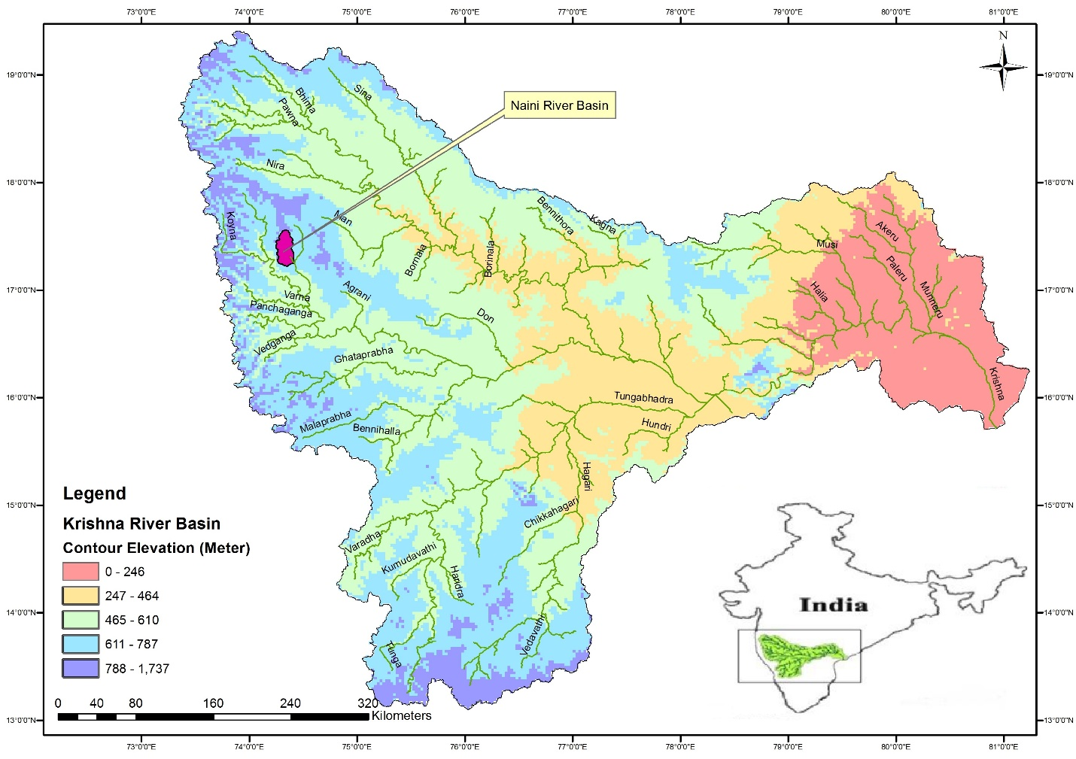
Figure 1: Location Map of Nandani River Basin
3. Methodology
In this study, to delineate the watershed boundary Survey of India topographical sheet no. 47 K – 5, 6, 7, 8, 10, 11, 12 and 47 L - 9 on the scale 1:50,000 were used. Remote sensing data of IRS P6 - LISS 3 sensor on a scale of 1:50,000 is used for delineating land use/land cover map (Fig. 3), and soil map. For the estimation of river basin runoff, the hydrologic soil group map (Fig. 4) was prepared according to soil characteristics and form of land use/land cover. For the calculation of runoff using the SCS-CN process, daily rainfall data from 3 rain-gauge stations for the years 1998 to 2019 (21 years) was used.
To date, eight improvements to the initial SCS-CN approaches have been recorded by researchers (Mishra and Singh, 2003). Three modified CN methods were selected for inclusion in the interface, as well as the original SCS-CN formulae, in view of the implementation of the modified CN methods under various topographic, hydrological soil community and land use conditions and their contrasting characteristics relating to initial abstraction and preceding moisture conditions. The methods are explained in the following subsections.

3.1 SCS Curve Number method
The Soil Conservation Service Curve Number (SCS-CN) method of estimating direct runoff from a watershed is the most widely used analytical method (USDA, 1972). As below (Mishra and Singh 2003), the SCS CN method describing the equation of water balance can be expressed:
$P=I_{a}+F+Q$ (1)

$\frac{Q}{P-I_{a}}=\frac{F}{S}$ (2)

$I_{a }= λS$ (3)

where, P is the total precipitation in mm; Q the direct runoff in mm, F the cumulative
infiltration in mm, Ia is the initial abstraction mm; S the potential maximum retention mm and the initial abstraction coefficient (0.3) and includes surface storage, interception, and infiltration prior to runoff in the watershed. The empirical relation was developed for the term Ia and it is given by,

$Q=\frac{{(P-I_{a })}^{2}}{(P-I_{a}+S)}$ (4)

Which is valid for P ≥ Ia. Otherwise, Q = 0. For a constant value of Ia (0.3S), S can be determined from the P-Q data. In practice S is derived from a mapping equation expresses in terms of the curve number (CN):

$S=\frac{25400}{CN}$ (5)

The CN is the dimensionless number ranging from 0 to 100 is determined from a table, based on land-cover, HSG and AMC. According to the soil after prolonged wetting, HSG is expressed in terms of four groups (A, B, C and D). AMC is expressed in three levels (1, 2 and 3), according to rainfall limits dormant and growing seasons.

Although SCS method is originally designed for use in watershed of 15 km2, for application to larger watersheds, it has been modified by weighing curve numbers with respect to watersheds/landcover area. In this study, the curve numbers are weighted with respect to the micro-watershed are weighed with respect to the micro-watershed area using the following equation:

$CN_{w}=\frac{∑(CN_{i}i*A_{i})}{A}$ (6)

Where, CNw is the weighted curve number; CNi is the curve number from 1 to any number N; Ai is the area with curve number CNi ; and A the total area of the watershed.

The SCS curve number is a function of soils' ability to enable water infiltration with regard to land use/land cover and previous soil moisture state (AMC). Soils are classified into four hydrological soil classes such as Group A, B, C & D with regard to the rate of runoff capacity and final infiltration rate, according to U.S. soil conservation service soils.

3.2 Modified SCS Curve Number method
3.2.1 Modified CN method (CN I)
The modified method of CN I is predicated on the concept of zero initial abstraction (Ia = 0), i.e. immediate ponding from a given rainfall depth P to measure the runoff depth Q. The resulting equation for surface runoff estimation was obtained by using this idea in the original SCS-CN proportionality hypothesis (i.e. Eq. (2)).:

$Q=\frac{P^{2}}{S+P}$ (7)

The two extremely dry and wet scenarios that could generate runoff were not included in the original SCS-CN system due to its definition of runoff occurring only after the initial abstraction Ia criteria had been met. This updated CN approach was therefore considered in this study to account for the conditions prevailing under high-intensity rainfall events in watershed systems.

3.2.2 Modified CN method (CN II)
In this modification of the CN method, the initial abstraction I_{a} was modified by associating a non-dimensional parameter $λ$ with the potential maximum retention S, which is represented as I_{a} = $λ$S. The parameter $λ$ depends on the time of ponding t_{p} and Horton’s constant α and are associated as: $λ$ = αt_{p}. In contrast to the hypothesis of the original SCS-CN system, which assumes that the ponding time is zero, the ponding time from the beginning of the rainfall to the start of the runoff process was taken into account in this adjustment. Under these changes, the equation for estimating the surface runoff using the modified CN II was used:

$Q= \frac{{(P-λS)}^{2}}{P-S(λ-1)}$ (8)

3.2.3 Modified CN method (CN III)
In this modification, During rainfall-runoff procedures, the cumulative infiltration Fc parameter used in the original SCS-CN system was split into simple and dynamic components. During the rainfall-runoff procedures, the modified CN III method highlighted the basic infiltration part, while the original SCS-CN method did not explicitly consider this parameter. However, in the hypothesis of the SCSCN method, the actual infiltration (F_{c}-I_{a}) was considered without any specific attention both basic and dynamic infiltration components in the runoff generation process. The updated CN III method could therefore provide practical and reliable forecasts of runoff for rainfall events of longer length, in which the basic infiltration component is more predominant. Therefore, in the original SCS-CN hypothesis, by substituting the components of F_{s} and F_{d} against appropriate parameters of Eq. (2), the final expression of surface runoff depth was :

$Q=\frac{{(P-F_{s})}^{2}}{(P-F_{s}+S)}$ (9)

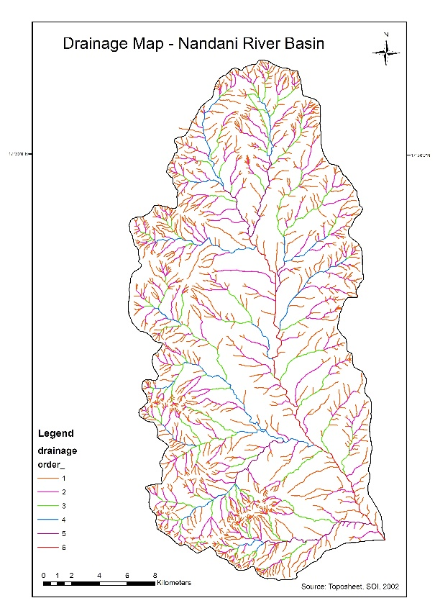
Figure 2: Drainage pattern map of Nandani river basin
Figure 3: Landuse/Landcover map
3.3 HSG and Antecedent Soil Moisture Condition (AMC)
According to the minimum soil infiltration rate obtained for a bare soil after prolonged wetting, HSG is expressed as four groups (Table 1). The previous soil moisture condition had a major impact on runoff consideration and three precedent soil moisture conditions such as AMC 1, AMC 2 and AMC 3 were developed by the Soil Conservation Service (SCS) in this aspect. The curve numbers were adjusted based on the season and average precipitation of 5 days prior to the prediction of runoff for a storm event. AMC is represented as three stages for dormant and rising seasons, according to rainfall limits (Table 2). While originally planned for 492 km2 river basin use some users have changed it for use in larger watersheds, primarily through land-cover-based area-weighting of curve numbers. (Rawls et al., 1981; Still and Shih, 1984, 1985, 1991).
Table 1 USDA-SCS Soil classification
Hydrologic  Soil Group | Type of Soil | Runoff  Potential | Final  Infiltration  Rate  mm/hr | Distribution  (%) | Remarks
Group A | Deep, well drained  sands and gravels | Low | >7.5 | 4.73 | High rate of  Water transmission
Group B | Moderately deep, well drained with moderately fine to coarse textures | Moderate | 3.8-7.5 | 25.54 | Moderate rate  of water  transmission
Group C | Clay loams, shallow sandy loam, soils with moderately fine to fine textures | Moderate | 1.3 – 3.8 | 52.04 | Moderate rate  of water  transmission
Group D | Clay soils that swell significantly when wet, heavy plastic and soils with a permanent high water table | High | < 1.3 | 18.69 | Moderate rate  of water  transmission

Table 2: Classification of Antecedent soil moisture classes (AMC II)
AMC  Group | Soil Characteristics | Total 5 day Antecedent Rainfall in mm
 |  | Dormant Season | Growing Season
1 | Soils are dry not to wilting point, satisfactory cultivation has taken place | Less than 13 | Less than 36
2 | Average condition | 13 - 28 | 36 – 53
3 | Heavy rainfalls or light rainfall and low  temperatures have occurred within the last  5 days; stared soil | Over 28 | Over 53
3.4 Area Weighted Curve Number
The various soil, HSG and land use/land cover layers were overlaid one by one and using Arc GIS 10, the new PAT (polygon attribute table) was obtained. To calculate the total area weighted curve number of the study area, the result obtained from this PAT was used to calculate the AMC 2 refer Table 3.
Table 3: Weighted curve number for Nandani river basin
Sr. No. | Land use | Soil Type | Area in km² | CN  AMC  I | CN  AMC II | CN  AMC  III | % area | Weighted Curve Number (WCN)
1 | Agricultural | B | 122 | 65.14 | 81 | 90.9 | 24.80 | AMC 1 = 72.60  AMC 2 = 85.38  AMC 3 = 93.08
 |  | C | 97 | 66.64 | 82 | 91.43 | 19.72
 |  | D | 79 | 87.29 | 94 | 97.35 | 16.06
2 | Settlement | B | 8 | 60.85 | 78 | 89.25 | 1.63
 |  | C | 14 | 69.71 | 84 | 92.48 | 2.85
 |  | D | 15 | 76.28 | 88 | 94.5 | 3.05
3 | Degraded Forest | C | 12 | 62.25 | 79 | 89.81 | 2.44
 |  | D | 18 | 63.68 | 80 | 90.35 | 3.66
4 | Dry Land | B | 25 | 71.3 | 85 | 92.99 | 5.08
 |  | C | 30 | 69.71 | 84 | 92.48 | 6.10
 |  | D | 34 | 78.01 | 89 | 94.99 | 6.91
5 | Rocky Land | D | 18 | 72.92 | 86 | 93.5 | 3.66
6 | Waterbodies | - | 20 | 100 | 100 | 100 | 4.07

3.5 Estimation of rain fall – runoff
The daily rainfall database of Nandani basin from 1998 to 2019 (for 22 years) and the area weighted curve number were inputs to the SCS and modified SCS formula and the results are obtained from the daily runoff values and monthly and annual runoff values are obtained. The detailed yearly (Monsoon period) rainfall and calculated runoff values for the 22 years are given below in Table 4. Average rainfall and average runoff of the period (1998-2011) shows increasing trend of the Nandani river basin shows in Fig.5

3.5.1 Rainfall Runoff using SCS CN Method (AMC II) :-

Table 4: Yearly runoff from Nandani river basin using SCS CN Method
Year | Rainfall | Runoff  (mm) | Runoff  (mm³)
1998 | 633.87 | 579.115 | 120.148
1999 | 539.77 | 485.595 | 100.746
2000 | 447.63 | 394.245 | 81.794
2001 | 532.83 | 478.711 | 99.318
2002 | 380.58 | 327.975 | 68.045
2003 | 289.26 | 238.249 | 49.429
2004 | 825.03 | 769.494 | 159.646
2005 | 893.71 | 837.963 | 173.851
2006 | 966.18 | 910.247 | 188.848
2007 | 791.40 | 735.976 | 152.692
2008 | 702.35 | 647.273 | 134.289
Year | Rainfall | Runoff  (mm) | Runoff  (mm³)
2009 | 894.27 | 838.521 | 173.967
2010 | 883.27 | 827.552 | 171.691
2011 | 488.17 | 434.400 | 90.124
2012 | 417.93 | 364.865 | 75.698
2013 | 528.27 | 474.179 | 98.377
2014 | 634.27 | 579.513 | 120.231
2015 | 465.67 | 412.102 | 85.498
2016 | 571.93 | 517.543 | 107.374
2017 | 669.77 | 614.835 | 127.559
2018 | 551.90 | 497.643 | 103.245
2019 | 1028.07 | 971.999 | 201.660

`

Figure 5: Average rainfall vs average runoff using SCS CN Method

3.5.2 Rainfall Runoff using Modified SCS CN Method (CN-I):-

Table 5: Yearly runoff from Nandani river basin using Modified SCS CN Method
(CN-I)
Year | Rainfall | Runoff  (mm) | Runoff  (mm³)
1998 | 633.87 | 547.924 | 113.677
1999 | 539.77 | 456.134 | 94.634
2000 | 447.63 | 366.995 | 76.140
2001 | 532.83 | 449.397 | 93.236
2002 | 380.58 | 302.804 | 62.822
2003 | 289.26 | 216.884 | 44.997
2004 | 825.03 | 735.804 | 152.657
2005 | 893.71 | 803.598 | 166.722
2006 | 966.18 | 875.259 | 181.589
2007 | 791.40 | 702.653 | 145.779
2008 | 702.35 | 615.059 | 127.606
Year | Rainfall | Runoff  (mm) | Runoff  (mm3)
2009 | 894.27 | 804.151 | 166.836
2010 | 883.27 | 793.284 | 164.582
2011 | 488.17 | 406.100 | 84.253
2012 | 417.93 | 338.477 | 70.223
2013 | 528.27 | 444.961 | 92.316
2014 | 634.27 | 548.315 | 113.758
2015 | 465.67 | 384.369 | 79.745
2016 | 571.93 | 487.441 | 101.129
2017 | 669.77 | 583.087 | 120.972
2018 | 551.90 | 467.933 | 97.082
2019 | 1028.07 | 936.538 | 194.303

Figure 6: Average rainfall vs average runoff using Modified SCS CN Method (CN-I)
3.5.3 Rainfall Runoff using Modified SCS CN Method (CN-II):-

Table 6: Yearly runoff from Nandani river basin using Modified SCS CN Method
(CN-II)
Year | Rainfall | Runoff  (mm) | Runoff  (mm³)
1998 | 633.87 | 561.296 | 116.451
1999 | 539.77 | 467.820 | 97.058
2000 | 447.63 | 376.542 | 78.121
2001 | 532.83 | 460.941 | 95.631
2002 | 380.58 | 310.357 | 64.389
2003 | 289.26 | 220.845 | 45.818
2004 | 825.03 | 751.625 | 155.939
2005 | 893.71 | 820.083 | 170.142
2006 | 966.18 | 892.359 | 185.137
2007 | 791.40 | 718.114 | 148.986
2008 | 702.35 | 629.431 | 130.587
Year | Rainfall | Runoff  (mm) | Runoff  (mm³)
2009 | 894.27 | 820.642 | 170.258
2010 | 883.27 | 809.674 | 167.982
2011 | 488.17 | 416.660 | 86.444
2012 | 417.93 | 347.195 | 72.032
2013 | 528.27 | 456.411 | 94.691
2014 | 634.27 | 561.694 | 116.534
2015 | 465.67 | 394.382 | 81.822
2016 | 571.93 | 499.751 | 103.683
2017 | 669.77 | 597.003 | 123.860
2018 | 551.90 | 479.861 | 99.556
2019 | 1028.07 | 954.104 | 197.947

Figure 7: Average rainfall vs average runoff using Modified SCS CN Method (CN-II)

3.5.4 Rainfall Runoff using Modified SCS CN Method (CN-III):-

Table 7: Yearly runoff from Nandani river basin using Modified SCS CN Method
(CN-III)
Year | Rainfall | Runoff  (mm) | Runoff  (mm³)
1998 | 633.87 | 605.815 | 125.688
1999 | 539.77 | 511.831 | 106.189
2000 | 447.63 | 419.857 | 87.107
2001 | 532.83 | 504.908 | 104.753
2002 | 380.58 | 352.963 | 73.229
2003 | 289.26 | 261.987 | 54.354
2004 | 825.03 | 796.827 | 165.317
2005 | 893.71 | 865.461 | 179.556
2006 | 966.18 | 937.895 | 194.584
2007 | 791.40 | 763.219 | 158.344
2008 | 702.35 | 674.237 | 139.883
Year | Rainfall | Runoff  (mm) | Runoff  (mm³)
2009 | 894.27 | 866.021 | 179.672
2010 | 883.27 | 855.027 | 177.391
2011 | 488.17 | 460.313 | 95.501
2012 | 417.93 | 390.223 | 80.959
2013 | 528.27 | 500.348 | 103.807
2014 | 634.27 | 606.215 | 125.771
2015 | 465.67 | 437.854 | 90.841
2016 | 571.93 | 543.954 | 112.854
2017 | 669.77 | 641.680 | 133.129
2018 | 551.90 | 523.947 | 108.703
2019 | 1028.07 | 999.759 | 207.419

Figure 8: Average rainfall vs average runoff using Modified SCS CN Method (CN-III)

4. Results and discussion
In the present study, SCS-CN method used for surface runoff estimation. The system of runoff generation is highly complex, nonlinear, dynamic in character, and influenced by various physical factors that are interconnected. In Nandani river basin to low average annual rainfall, high runoff and evapo-transpiration takes place due to this drought like situation prevails every year. In the hard rock areas like Nandani watershed, discontinuities (fractures/joints) play a vital role in groundwater recharge movement and discharge. The basin constitutes different land use/ land cover of about 60.57% of the area is occupied by agricultural land, 6.10% area covers forest land, 18.09% area of dry land and remaining 15.24% of the area is occupied by others such as water body, hills, settlement and tanks. In general, fallow land and open scrub land play a major role in direct surface runoff among the various types of land cover. While estimating the runoff potential which represents the soil characteristics, the hydrologic soil type and its infiltration capacity plays vital role. In the study area hydrologic soil type of ‘B’, ‘C’ and ‘D’ were delineated with reference to soil atlas map, soil series of Maharashtra, remote sensing data and other secondary data. The study found that the 'C' type of HSG mainly covered the entire region, consisting mainly of agricultural and cropland, followed by the 'B' and 'D' types. By intersecting the land use and the hydrological soil type, the curve number was allocated according to US SCS and the values of the prior moisture conditions are AMC 1, AMC 2 and AMC 3. The annual runoff calculated in both mm and mm3 and the study area is dominated by the southwestern monsoon. The monthly rainfall data is used for the analysis from the 1998-2019. The average annual rainfall has decreased from the year of 1998 to 2003 and suddenly increased between the years of 2004 to 2006 and gradually decreases and increases from the year 1998 to 2011. The trend line for the average rainfall is in the straight line form indicates that rainfall has increased from the year 2009 to 2019 even through to irregular climatic season in the recent years. The estimated annual rainfall fluctuated more over the years. The rainfall runoff outcome of the trend line indicates that high runoff is taking place on a comparative basis and that the projected trend line for the future runoff is continuing to increase.

5. Conclusion
Present study clearly shows that the SCS-CN method combined with GIS techniques is very useful for runoff estimation and can be used effectively in watershed management. The study demonstrates the significance of remotely sensed data in conjunction with GIS for the extraction of a model parameter for estimating surface runoff from the ungauged watershed. The results obtained clearly show the difference between different land use/land cover and different soil conditions in the runoff potential. Water conservation strategies such as percolation pond, control dam, etc can be recommended for better management of land and water supplies for the growth of the watershed area, based on a database such as runoff volume and morphometric parameters. The runoff estimation with morphometric analysis are very helpful for the design and development of various water retaining structures in the watershed.

6. References
- Abhijit M. Zende, Nagarajan R, Atal K.R. (2014), ‘Analysis of surface runoff from Yerala River Basin using SCS-CN and GIS’, INTERNATIONAL JOURNAL OF GEOMATICS AND GEOSCIENCES Volume 4, No 3, pp. 508-516.
- Ashish Pandey and Dabral. P.P. (2004), ‘Estimation of Runoff for Hilly Catchment Using Satellite Data’, Journal of Indian Society of Remote Sensing, Vol. 32, No. 2, pp. 236-240.
- Amutha R, Porchelvan P (2009), ‘Estimation of Surface Runoff in Malattar Sub-Watershed using SCSCN method’, Journal of Indian Society of Remote Sensing, Vol. 37, pp.291-304.
- Bansode A, Patil KA (2014), ‘Estimation of runoff by using SCS curve number method and arc GIS.’, Int Journal Sci Eng Res 5(7) pp. 1283–1287.
- Jasrotia A. S., Dhiman S. D., and Aggarwal S. P. (2002). ‘Rainfall-runoff and soil erosion modeling using remote sensing and GIS technique – A case study on tons watershed’, Journal of Indian Society of Remote Sensing, Vol.30(3), pp. 167–180.
- J.P. Patil, A. Sarangi, A.K. Singh, T. Ahmad (2008), ‘Evaluation of modified CN methods for watershed runoff estimation using a GIS-based interface’, BIOSYSTEMS ENGINEERING, pp. 137-146.
- K. Geetha, S. K. Mishra, T. I. Eldho, A. K. Rastogi, and R. P. Pandey (2007),‘Modifications to SCS-CN Method for Long-Term Hydrologic Simulation’,Journal of Irrigation and Drainage Engineering, pp. 475-486.
- Michel, C., Andréassian, V., and Perrin, C., (2005), ‘Soil conservation service curve number method: how to mend a wrong soil moisture accounting procedure?’, Water Resources Research, 41, W02011.
- R. Vijia, P. Rajesh Prasanna and R. Ilangovan (2015), ‘Modified SCS-CN and Green-Ampt Methods in Surface Runoff Modelling for the Kundahpallam Watershed, Nilgiris, Western Ghats, India’, INTERNATIONAL CONFERENCE ON WATER RESOURCES, COASTAL AND OCEAN ENGINEERING, pp. 677-684.
- S. K. MISHRA, VIJAY P. SINGH, J. J. SANSALONE and V. ARAVAMUTHAN (2003), ‘A Modified SCS-CN Method: Characterization and Testing’, Water Resources Management 17, pp. 37-68.
- R. K. Sahu, S. K. Mishra, T. I. Eldho (2010), ‘Comparative evaluation of SCS-CN-inspired models in applications to classified datasets’, Agricultural Water Management, pp. 749-756.
- Sindhu D, B L Shivakumar, A. S Ravikumar (2013), ‘ESTIMATION OF SURFACE RUNOFF IN NALLUR AMANIKERE WATERSHED USING SCS-CN METHOD’, International Journal of Research in Engineering and Technology, pp. 404-409.

