A Brief Report On Analytical Chemistry And Technical Aspects of Thermal Analytical Methods
Dr.N.Padmaja
Assistant Professor, Department of Chemistry, Lal Bahadur College, Warangal, Telangana, India.

ABSTRACT:- This article is a brief report on the various processes, methods and importance of analytical chemistry. It explains about the multiple ways in which analytical chemistry plays a key role in our day to day life. The various methods and techniques available are described and detail explanation is provided for one of the most used Technique- Thermal analytical methods.
Keywords: Analytical chemistry, Thermal methods, Thermogram, TGA, DTA, DSC, TMA.

Introduction and about Analytical Chemistry

Analytical Chemistry is a measurement science consisting of a set of powerful ideas and methods which are useful in all fields of science and medicine. The analytical process is a constructive attempt by chemists to determine the composition and to understand the nature of materials. Analytical Chemistry provides an elaborate study of instruments and methods to separate, identify and quantify matter(R).
Separation isolate analytes, Qualitative analysis identifies analytes while Quantitative analysis determines the numerical amount or concentrations of analytes. Analytical Chemistry consists of classical, wet chemical methods and modern instrumental methods.

Analytical Process :-

Analytical process consists the following steps ¹.
Definition :- Defining the analytical problems that needs to be solved.
Sampling:- Obtaining a representative sample.
Method:- Choosing an appropriate analytical method.
Separation:- Separating the substance being analyzed (the analyte) from any interfering substance.
Quantitation:- Performing a quantitative measurement.
Evaluation:- Evaluating the results.

In Detail:-
Definition:- The reason for the analysis will frequently dictate how the succeeding steps of the total
analysis process should be taken.
Sample:- Sample chosen for analysis will reflect the entire body from which it came.
And sampling is the basis for all other steps that follow in the total analysis process. If
it is not done carefully, the entire analysis will be invalidated.
Method:- The best method is the one most suited to the circumstances of analysis. While selecting
method, analyst have to consider accuracy, detection limit, selectivity, speed, cost and
legality.

Accuracy:- The analyte must assess the required level of accuracy and select the suitable method ,
which meet this requirement.
Detection limit:- Detection limit should be like that, the selected method must allow analyst to detect and
determine the desired constituent.
Selectivity :- The best selective method regarding selectivity is that, in the analysis of a sample only few
other substances of the sample should interfere, when they present at much higher
concentrations than that of the analyte.
Speed:- Speed of the method should give best in analysis result in various, different angels all
the times.
Cost:- An analyst always will try to complete analytical process with low cost but it is not possible
for all the times, an analyst to do analysis with low cost and to give best result.

The role of analytical chemistry/ Applications of Analytical chemistry ²:- Analytical chemistry plays a very significant role in multiple fields. Analytical chemistry is applied throughout industry, in medical field, in all the sciences and in our day to day life. To understand this, we consider a few outcomes and applications of analytical chemistry.
- The pathfinder mission is a spectacular example illustrating the application of analytical chemistry to practical problems. The pathfinder example demonstrates that, both qualitative information and quantitative information are required in an analyses.
- Everyday millions of body fluids are analyzed to diagnose to treat illnesses.
- Millions of food samples are analyzed everyday to give composition of the sample, concentrations of different chemical substances and presence of toxic substances.
- Analysis of steel during its production permits adjustment in the concentrations of elements such as carbon, nickel and chromium to achieve a desired strength, hardness, corrosion resistance and ductility.
- Analysis of the chemical composition of soil samples from moon and mars.
- Determination of nitrogen oxides, carbon dioxide, lead etc., present in the atmosphere, automobile exhausts and industrial exhausts.
- Measurement of the purity percentages and quality of all kinds of food products.
- Analysis of the composition, components and thermal behavior of drugs.
- Determination of the composition and thermal stabilities of explosives.
- In agriculture, fertilizer composition and amounts of different components are determined using analytical chemistry. This will help in its usage for best yield of crops.
- Body fluids of sports person and Olympic athletes are analyzed to monitor their health status.
- Determination of structure and properties of new molecules and new compounds.
- Analytical chemistry provides limit values for environmental pollution.
- Environmental and Pollution boards function by the information obtained through analysis of samples.

- Air in different living places is analysed and its quality information is given to people.
- Drinking water samples are analysed and quality information is provided to concerned authorities.
- Food ingredients, edibles and beverages are analysed and quality information is furnished to concern bodies. Example – Baby foods and packet foods were analysed to determine if they are edible.
The inter-disciplinary nature of chemical analysis makes it a vital tool in medical, industrial, government and academic laboratories through out the world.
Chemistry is often called the central science and its top centre position is given to analytical chemistry

Thermal Methods of Analysis
Introduction:
Thermal methods are group of multi component techniques in which chemical or physical properties of a substance, a mixture of substances or a reaction mixture are measured as a function of temperature or time, while the substances are subjected to a controlled temperature programmed heating or cooling rate.
A complete modern thermal analysis instrument measures temperatures of transitions, weight losses in materials, energies of transitions, dimensional changes, modulus, and viscoelastic properties. Any Thermal Analytical method may involve heating or cooling at a fixed rate of temperature change or holding the temperature constant at different time span. The graphical results obtained are called Thermo gram/Curve
These methods are usually applied to solids, liquids and gels to characterize the materials for quality control. Current applications include environmental measurements, product reliability, compositional analysis, stability, chemical reactions, and dynamic properties.

Thermal analytical Techniques:-
In these techniques basic components used in instrumentation are sensor, a controlled temperature programmed furnace and a recording devise which is either X-Y recorder or a micro computer.

According to measuring property the below are few Thermal Analytical Methods
Symbol | Name of Method | Property Measured
TGA | Thermogravimetry Analysis | Mass
DTG | Derivative Thermogravimetry | First derivative
DTA | Differential Thermal Analysis | Differential temperature
DSC | Differential Scanning Calorimetry | Enthalpy
TMA | Thermomechanical Analysis | Mechanical properties
DMA | Dynamic Mechanical Analysis | Visco-elastic properties
EGA | Evolved Gas Analysis | Identify and amount of gas/gases evolved
TL | Thermoluminescence | Light emission

Brief discripition of TG, DTA, DSC and TMA:-
Thermogravimetric analysis(TGA):- In this method a substance is heated from lower temperature to higher temperature at a fixed rate of heating. The changes in weight the sample undergoes as it is heated to higher temperature are recorded as a function of increasing temperature.
The graphical representation of weight changes the substances undergoes against temperature is called Thermogram.
The analysis of a thermogram gives us information about behavior of the substance while heating.

Thermogram

Horizontal portions Stands for no weight loss.
Vertical portions Stands for weight loss.

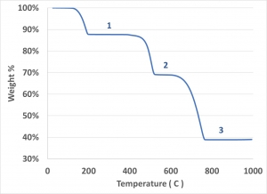

Instrumentation: - The basic components in TGA are:---
- Precision balance to make recordings of weight changes associated with a substance as it is heated.
- Furnace assembly used to heat the sample from lower temperature to higher temperature.
- Recorder – which records the weight changes and the increasing temperature.
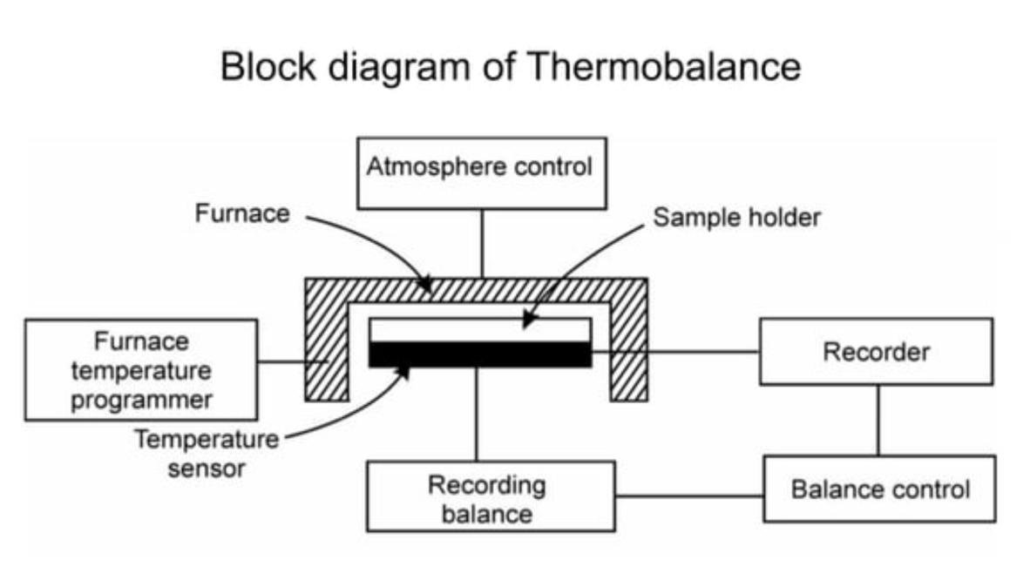

Few applications of TGA³:-
- Determining the purity and thermal stability of both primary and secondary standards.
- Investigating the correct drying temperatures and the stability of various weighing forms for gravimetric analysis.
- Direct application to analytical problems (automatic thermogravimetric analysis)
- Determining the composition of alloys and mixtures.
DTA:- In differential thermal analysis, the temperature of a sample and a thermally inert reference material are measured as a function of furnace temperature. Any transition which the sample undergoes will result in liberation or absorption of energy by the sample with a corresponding deviation of its temperature from that of the reference. As both the sample and reference are heated to elevated temperature, the differential temperature between the sample and reference is plotted against, programmed temperature (T). The resulting plot is called DTA curve. Analysis of the curve gives the information about the temperature of transition and whether the transition is exothermic or endothermic.
Instrumentation:- DTA equipment contains furnace sample block, temperature programmer, controller, preamplifier and a recorder. The sample block contains two identical and symmetrically located chambers. Temperature is increased in a linear rate. The differential temperature is measured continuously using a thermocouple and this ∆Т signal is amplified and is recorded. And to the furnace also, thermocouple connected to measure the temperature. And thermocouples is connected to the recorder.
While process, The difference in temperatures between sample and reference (S,R), thermocouple is continuously measured.
This differential signal is amplified by a high gain and low noise preamplifier and is recorded on the Y- axis of the recorder graph . The temperature of the furnace is measured by a separate thermocouple, which is connected to the X-axis of the recorder.

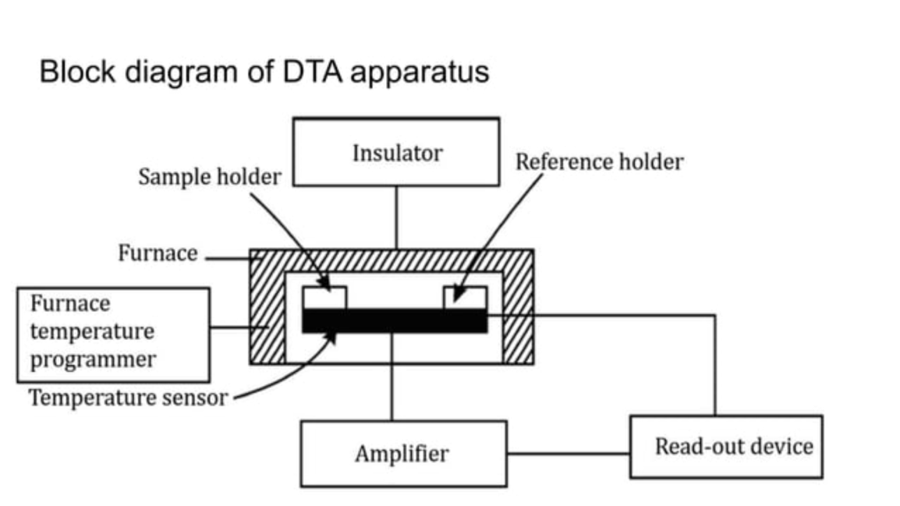

In differential thermal analysis, DTA curve consists of a series of endothermic and exothermic peaks corresponding to the heat changes associated with the samples.
*) Physical changes usually result in endothermic peak, whereas chemical reactions those of an oxidative
nature are exothermic.
*) Endothermic reaction (absorption of energy) includes vaporization, sublimation, and absorption and
gives downward peak.
*) Exothermic reaction (liberation of energy) includes Oxidization, polymerization, and catalytic reaction
and gives upward peak.

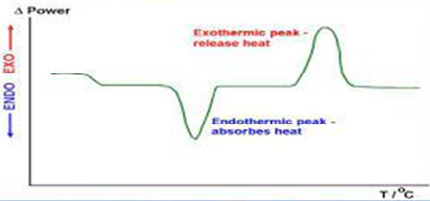

Few applications of DTA ³:-
- The qualitative analysis of materials
- A rapid method for the fingerprinting of minerals, clays and polymeric materials.
- DTA technique is used for the study of thermal stability of a large number of inorganic compounds and metal complexes. The compounds include oxalates, carbonates, metal amine complexes etc.
- DTA technique has been widely used for the quality control of a large number of substances like cement, glass, catalysts, resins, explosives etc.

Differential Scanning Calorimetry:- The sample and reference material are subjected to controlled programmed temperature. When a transition occurs in the sample, however thermal energy is added to or subtracted from the sample in order to maintain both sample and reference at the same temperature. Because this energy input is precisely equivalent in magnitude to the heat energy absorbed or evolved in the particular transition, a recording of this balancing energy yields a direct calorimetric measurement of the transition energy.
Thus DSC is the method, where the energy necessary to establish a zero temperature difference between a sample and a reference is recorded as a function of temperature, when both are heated or cooled at a fixed rate.
The DSC curve measures the total energy transfer to or from the sample.

Instrumentation: DSC equipment contains furnace sample block, temperature programmer, controller, preamplifier and a recorder. The sample and reference materials are supplied with separate heaters and maintain at the same temperature. While heating, when sample undergoes any endothermic or exothermic reaction ( the energy absorbed by the sample or released by the sample) the energy is given or are removed from the sample thus maintaining same temperature for sample and reference.

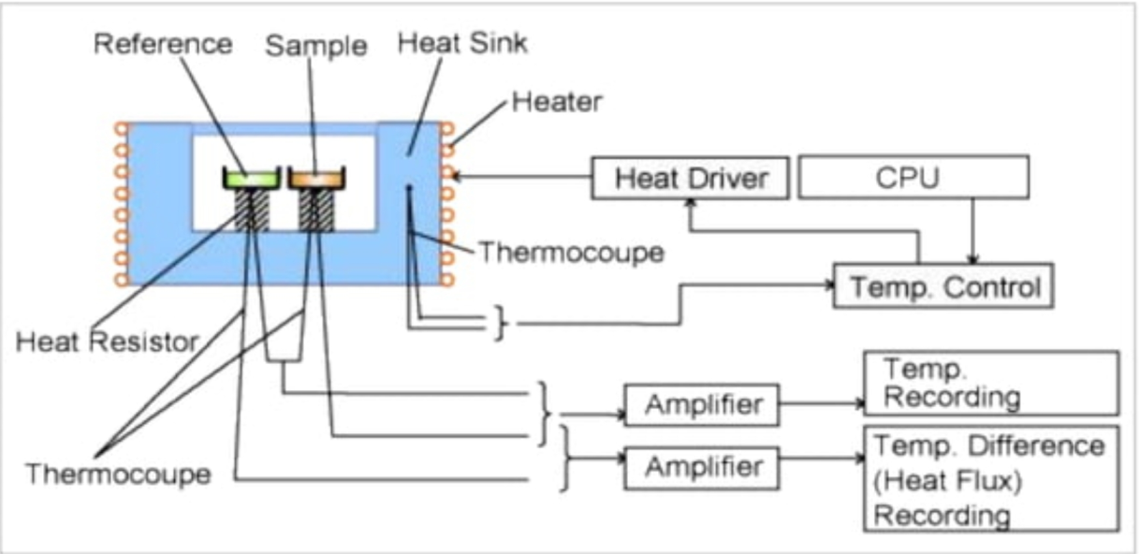

Block Diagram of DSC Apparatus

In differential Scanning calorimetry, DSC curve consists of a series of endothermic and exothermic peaks corresponding to the heat changes associated with the samples. Endothermic peaks stands for physical reactions and exothermic peaks stands for chemical reactions.
The heat capacity at any point is proportional to the displacement from the blank base line (∆T=0).

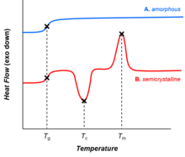

Few applications of DSC technique :-
- In Pharmaceutical chemistry – product purity identification of optical isomers, polymorphism and eutectic formation.
- In the food industry, edible fats and oils have been characterized by these methods.
- DTA is used for the high temperature studies of minerals, refractory materials and ceramics.
- DSC can be used to study the number and temperature range of polymorphs ³.
Thermomechanical Analysis⁴:--
Thermomechanical Analysis (TMA) provides measurements of penetration, expansion, contraction, and extension of materials as a function of temperature. Typical apparatus consists of a probe connected mechanically to the core of a linear variable differential transformer (LVDT). The core is coupled to the sample by means of a quartz probe containing a thermocouple for measurement of sample temperature. Any movement of the sample is translated into a movement of the transformer core and results in an output that is proportional to the displacement of the probe, and whose sign is indicative of the direction of movement. The temperature range is from that of liquid nitrogen to 85⁰C.

Few applications of TMA technique :-
- It is used for the measurement of the thermal expansion and the thermal shrinkage of the sample such as the film and the fiber⁵.
- Thermomechanical analysis (TMA) provides valuable characterization information on the dimensional properties of a wide range of materials⁶.

References:-
- John H. Kennedy University of California, Santa Barbara – Analytical Chemistry : Principles - Second Edition
- R- Skoog, Douglas A; West, Donald M; Holler, F. James, Crouch, Stanley R (2014). Fundamentals of Analytical Chemistry , Eight Edition.
- J Mendham, R C Denney, J D Barnes, M J K Thomas – Vogel’s Text book of Quantitative Chemical Analysis, Sixth Edition
- Willard, Merritt, Dean, Settle - Instrumental Methods of Analysis, Sixth Edition
- (http://www.hitachi-hightech.com>...)
- (Thermomechanical Analysis and Its Applications – ScienceDirect.com)

