BACTERIOPHAGES: COMPLEMENTARY THERAPY IN ANTIMICROBIAL RESISTANT BACTERIAL STRAINS
Taruna Bhati*, Sudesh Kumar, Shivali Khandelwal and Reshma Dhruw
*Senior Assistant Professor, Department of Veterinary Microbiology,
College of Veterinary and Animal Science, RAJUVAS, Bikaner-334 001, Rajasthan, India
email: vetcvas.bhati@gmail.com

Abstract: Bacteriophages, also known as phages, are viruses that infect and replicate within bacteria. Although phage therapy has been practiced for almost a century but the global increase in the antibiotic resistant bacterial strains has generated a renewed interest in phages to be used as a potential alternative or complementary therapy. Conventionally, phage therapy uses naturally-occurring phages to infect and kill bacteria at the site of infection. The parasitic and enzymatic bacterial killing by phages is different from the antibacterial mode of action by all other drugs, which allows them to be effective against most MDR bacteria. Biotechnological advances have led to novel approaches using bioengineered phages, phage cocktails and purified phage lytic proteins in the repertory of phage therapeutics. Phage therapy, either as an antibiotic alternative or in conjunction with antibiotic therapies, has the potential to reduce the rapidly expanding issue of infectious diseases as we deal with the current antibiotic crisis. But there is a strong need to know about the biology of phages and also for clinical trials of phage efficacy for multiple pathogens, infections, and diseases.
Introduction
Phages are one of the most abundant and ubiquitous biological entities existing on earth, which were discovered independently in the early twentieth century by Frederick Twort and Félix d’Hérelle. Phage therapy, among other alternatives to antibiotic treatment, has been found to be effective in treating a variety of bacterial infections in both animals and humans. This is due to the rapid rise of multi-drug-resistant bacteria worldwide coupled with a decline in the development and production of novel antibacterial agents. The use of phage therapy started a century back but there is still a substantial lack of randomized clinical trials that could, according to the current standards, confirm the efficacy of the application of bacterial viruses to combat bacterial infections. The difficulties in the treatment of many life-threatening bacterial infections have led scientists to reconsider bacteriophages. Several studies regarding phages use in vitro, in experimental animals and in humans have been performed in both the United States and Europe (Principi et al., 2019).
Phages typically bind to specific receptors on the bacterial cell surface, inject their genetic material into the host cell, and then either integrate this material into the bacterial genome (temperate phages) and replicate along with bacterial genome and passed onto daughter cells, or hijack the bacterial replication machinery to produce the next generation of phage progeny and mature phage particles are released by lysis of bacterial cells (lytic phages). The most common lytic phages associated with human pathogens and the gut microbiota are in the orders Caudovirales, commonly known as “tailed phages” which contain double-stranded DNA genomes, and Microviridae, which are tailless, single-stranded DNA viruses (Lin et al., 2017). Conventional phage therapy relies on strictly lytic phages, which obligately kill their bacterial host.
Bacteria are also known to form biofilm and the bacterial cells within the biofilm are protected and tolerant to antibiotics, antiseptic, antimicrobials, and host immune responses. The presence of biofilms consisting of common opportunistic and nosocomial, drug-resistant pathogens has been reported on medical devices like catheters and prosthetics, leading to many complications and secondary bacterial infections. Among several approaches under investigation, the use of bacteriophages is one of the promising approaches to invade biofilm that may expose bacteria to the conditions adverse for their growth (Singh et al., 2022). Increasingly, clinical trials are being conducted to evaluate the safety and efficacy of phage therapy in humans. As more data accumulates, regulatory bodies are also working to establish guidelines for the clinical use of phages as a therapeutic option.
Bacteriophages are not yet widely used. This therapy needs more research to find out how well it works. It’s not known if phages may harm people or animals in ways unrelated to direct toxicity. Phage therapy is still an emerging field, and while it shows great promise, there are challenges to overcome, such as the development of phage resistance and the need for a personalized approach to treatment. Nonetheless, biotechnological advancements play a central role in the research, development, and implementation of phage therapy to combat antibiotic-resistant bacteria.
Hence this chapter will discuss some of the ways in which bacteriophages are being explored in combating antimicrobial resistance along with the benefits and drawbacks of the use of baetriophages as complementary therapy.
Applications of bacteriophages
Bacteriophages are being actively explored as potential tools in combating antimicrobial resistance due to their unique ability to specifically target and infect bacteria. Some of the uses are :
- Phage Therapy or Targeting Specific Antibiotic-Resistant Bacteria: Phage therapy involves the use of specific bacteriophages to treat bacterial infections. Phages are selected or engineered to target and kill specific bacteria, including antibiotic-resistant strains. This specificity allows for precise treatment, avoiding disruption of beneficial bacteria in the microbiome, which is a common issue with broad-spectrum antibiotics. They can be applied topically, orally, or systemically, depending on the infection site. Phage therapy has shown promising results in some cases, particularly for localized infections.
Innovations in the gene editing tool CRISPR/Cas have created novel opportunities for phage therapy. One example of which is the use of bioengineered phage to deliver a CRISPR/Cas programmed system to disrupt antibiotic resistance genes and destroy antibiotic resistance plasmids (Yosef et al., 2015) thereby allowing programming of lytic phages to kill only antibiotic-resistant bacteria while protecting antibiotic-sensitized bacteria.
- Phage Cocktails: To overcome the disadvantage of phage therapy that a phage will only recognize and lyse a bacterial cell that is of a specific strain, phage cocktails which are mixtures of multiple phages that target different strains or species of bacteria, are used. This approach increases the chances of effectively treating infections caused by complex bacterial populations, including those with antimicrobial-resistant strains. Phage cocktails can enhance the spectrum and efficacy of phage therapy. Phage cocktails can target a broader range of strains and reduce the likelihood of bacterial resistance to phages.
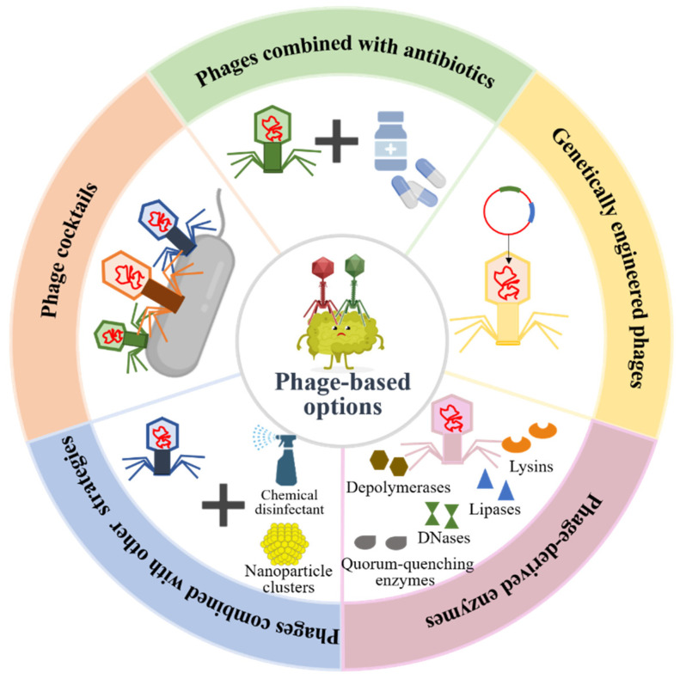
(Liu et al., 2022)
Fig 1. Phage-based therapeutic options

Phage cocktails can consist of individual phages which in aggregate can impact different bacterial species and by targeting multiple species, they can be used empirically to treat general disease states. For eg Pyophage-type cocktails can target multiple bacterial genera, such as Enterococcus, Escherichia, Proteus, Pseudomonas, Staphylococcus, and Streptococcus causing skin or soft-tissue infections (Abedon et al., 2021).
Single-species cocktails should consist, at a minimum, of one phage that targets one group of bacterial strains and a second phage targeting a somewhat different group of bacterial strains, with both groups of bacterial strains associated with the same species. A phage cocktail can also be formulated to explicitly contain more than one phage type that targets a single bacterial strain. Such cocktails may be used when a bacterial pathogen has been isolated from an individual patient, or may instead be used to target a specific pathogenic bacterial strain that is circulating within a community (Abedon et al., 2021).

- Biocontrol in Agriculture and Aquaculture: Bacteriophages can be used as biocontrol agents in agricultural settings to combat plant pathogens and foodborne pathogens. By targeting specific bacterial pathogens, phages can reduce the need for antibiotics in agriculture, thereby limiting the emergence and spread of antimicrobial resistance. Lytic phages infect and kill target bacterial species, are self-replicating while remaining biocompatible with animal and human species without causing environmental issues making them ideal candidates for food biocontrol and bio-preservation agents (Garvey, 2020).
For livestock application, phages can be administered via animal feed or sprayed on animal bodies prior to sacrifice/slaughter to prevent meat contamination at harvest. By post-harvest application, phages may offer disinfection of surfaces via spraying with phage enzymes potentially acting as food preservatives. Phages have also been successfully used in agriculture for control of different bacterial and fungal diseases of plants /crops.The use of phages as biocontrol agents in aquaculture has demonstrated efficacy via direct application in water, oral administration via food and injection
Hence phages are being investigated as a preventive measure to control bacterial infections in crops and livestock.
- Phage-Derived Enzymes: Phages encoded lytic enzymes which are functionally similar to the antimicrobial eukaryotic enzyme lysozyme, that degrade bacterial cell walls, allowing the release of phage progeny. Two major protein classes are employed by the majority of phage species during the lysis of the bacterial host. One of which is the transmembrane protein holin and the other is a peptidoglycan cell wall hydrolase called endolysin (lysin) (Lin et al., 2017). These two proteins work together in triggering the lysis of the bacterial cell. Phage endolysins produced towards the end of the lytic cycle of phage infection, alone are capable of bacterial cell lysis, whereas holins are not; therefore endolysins being fast acting, potent, and inactive against eukaryotic cells have received a lot of attention as potential antimicrobial agents. They have demonstrated efficacy against various bacteria, including antibiotic-resistant strains, and are being explored as potential alternatives to traditional antibiotics.
Bioengineered chimeric lysins have been developed capable of saving mice challenged with MRSA bacteremia (Yang et al., 2014). Endolysins are less effective against gram-negative bacteria with an impermeable lipopolysaccharide outer membrane. In an attempt to broaden lysin activity to target gram-negative pathogens, several researchers have begun to bioengineer artificial lysin molecules, termed Artilysins, that are capable of penetrating the outer membrane (Briers et al., 2014).
- Phage Sensitization or combination therapy: Phages can sensitize antibiotic-resistant bacteria to antibiotics, making them susceptible to the drugs that were previously ineffective against them. This approach, known as phage sensitization or phage-assisted antibiotic therapy, involves the combined use of phages and traditional antibiotics or other antimicrobial agents to enhance bacterial killing. It is thought that phages disrupt bacterial defense mechanisms, making them more susceptible to antibiotic action. This combination can have a synergistic effect, improving the overall effectiveness of treatment and reducing the likelihood of phage resistance. By using phages alongside antibiotics, lower antibiotic dosages may be effective, which could help minimize side effects and reduce the selective pressure for antibiotic resistance. Combining both agents may result in a more potent effect against the bacteria compared to using each treatment alone.
While the idea of combining phages and antibiotics holds promise, it's important to note that there are challenges and complexities associated with this approach. Some of these challenges include finding appropriate phages that effectively infect the targeted bacteria, understanding potential interactions between phages and antibiotics, and conducting thorough safety and efficacy studies in preclinical and clinical settings.
- Biofilm Disruption: Antibiotic-resistant bacteria often form biofilms, which are protective structures that make infections harder to treat. Phages have shown promise in disrupting and penetrating biofilms, making them a valuable tool in tackling biofilm-associated infections. About 160 putative depolymerases in 143 phages have been identified and these enzymes which can be divided into two main classes: hydrolases, including sialidase, levosidase, xylosidase, glucanase, rhamnosidase as well as peptidase; and lyases, including hyaluronidase, alginate lyase as well as pectin/pectin lyase (Pires et al., 2016). These depolymerases are mostly found as free enzymes or tail-spike proteins of phages and can specifically recognize, bind, and digest extracellular polymeric substances (EPSs) of the host bacterial cells to disturb the biofilm structure, facilitating their penetration to the cells within the inner biofilm layers. Endolysins, are highly evolved peptidoglycan hydrolases, which cause cell lysis and death by cleaving peptidoglycans in the bacterial cell wall and allowing the release of mature phage progenies from host cells (Vazquez et al., 2019).
Apart from using phage derived enzymes, phages can cause a significant reduction in biofilm viability when used in conjunction with antimicrobial drugs compared to each treatment alone, displaying either synergy or facilitation. A study on the potential synergistic effect of phage and chemical disinfection against the opportunistic pathogen P. aeruginosa has shown that phages can effectively combine with chemical disinfectants, such as sodium hypochlorite and benzalkonium chloride, to improve the removal of wet biofilms and bacterial spots on surfaces and prevent the regeneration of dry biofilms at the same time (Stachler et al., 2021).
- Genetically Engineered Phages: Natural phage therapy is limited due to their narrow host range and specificity. Hence, genetic engineering techniques are being employed to modify phages to enhance their therapeutic properties. This includes increasing phage stability, altering host range, alter the host specificity and minimizing the potential for resistance development providing long term efficacy. Researchers are developing biocontainment strategies that prevent the unintended spread of genetically engineered phages in the environment or the human body, providing an added layer of security. By using gene-editing tool CRISPR-Cas systems, researchers can precisely modify phage genomes, allowing for targeted and specific changes to enhance their therapeutic potential.
It's important to note that the development and use of genetically engineered phages are subject to strict regulatory oversight and rigorous safety assessments. This is to ensure that potential risks are minimized, and the engineered phages are safe and effective for therapeutic use.
Major Advantages of Phage Therapy
The phage properties contribute to the advantages of phage therapy over the use of antibiotics
- Lytic phages act as bactericidal agents.
- The phages themselves contribute to establishing the phage dose as during the bacterial-killing process, they are capable of increasing in number specifically where hosts are located (Abedon and Thomas-Abedon, 2010).
- Phages have low inherent toxicity as they are composed only of proteins and nucleic acids.
- Minimal disruption of normal flora owing to their host specificity.
- Narrow potential for inducing phage resistance due to narrow host range exhibited by most phages.
- Formulation and application versatility as they can be used in combination with certain antibiotics or used as phage cocktails. They can be applied as liquids, creams, impregnated into solids, etc., in addition to being suitable for most routes of administration (Loc-Carrillo and Abedon, 2011).
- The ability of phages to increase in density in situ, given sufficient bacterial densities, could potentially reduce treatment costs by reducing phage doses required to achieve efficacy (Abedon and Thomas-Abedon, 2010). This potential of phages is utilized in achieving efficacy through single dose treatment.
- Phages are natural products with low impact on the environment.
Potential disadvantages
- Phages are currently difficult to prepare and standardize for use in people and animals.
- It’s not known what dose or amount of phages should be used.
- It’s not known how long phage therapy may take to work.
- It may be difficult to find the exact phage needed to treat an infection.
- Phages may trigger the immune system to overreact or cause an imbalance.
- Bacteriophages are useful in managing diseases caused by a single bacterium, but the actual clinical cases are often infections that are caused by a variety of pathogenic bacteria.
- There may not be enough kinds of phages to treat all bacterial infections.
- The bacteria may develop resistance, if a single phage is used repeatedly for a long time.
- There is lack of adequate policies and regulations on the clinical application of phages.
- Phages are more difficult to administer than antibiotics. A physician needs special training in order to correctly prescribe and use phages.
Conclusion
In an era where antibiotic-resistant bacterial infections are on the rise, phages provide numerous advantages, along with relatively few disadvantages. It's important to note that while phages hold promise in combating antimicrobial resistance, challenges remain, such as the need for standardization, ensuring phage safety, optimizing phage selection and delivery methods, large-scale production, and a deeper understanding of phage-bacteria interactions considering the potential development of phage resistance. Ongoing research and technological advancements in this field continue to pave the way for the development of effective phage-based treatments against antibiotic-resistant bacteria.
References
- Abedon ST, Danis-Wlodarczyk KM, Wozniak DJ. Phage Cocktail Development for Bacteriophage Therapy: Toward Improving Spectrum of Activity Breadth and Depth. Pharmaceuticals (Basel). 2021 Oct 3;14(10):1019
- Singh A, Padmesh S, Dwivedi M, Kostova I. How Good are Bacteriophages as an Alternative Therapy to Mitigate Biofilms of Nosocomial Infections. Infect Drug Resist. 2022;15:503-532
- Lin DM, Koskella B, Lin HC. Phage therapy: An alternative to antibiotics in the age of multi-drug resistance. World J Gastrointest Pharmacol Ther. 2017 Aug 6;8(3):162-173.
- Yang H, Zhang Y, Yu J, Huang Y, Zhang XE, Wei H. Novel chimeric lysin with high-level antimicrobial activity against methicillin-resistant Staphylococcus aureus in vitro and in vivo. Antimicrob Agents Chemother. 2014;58:536–542
- Briers Y, Walmagh M, Van Puyenbroeck V, Cornelissen A, Cenens W, Aertsen A, Oliveira H, Azeredo J, Verween G, Pirnay JP, et al. Engineered endolysin-based “Artilysins” to combat multidrug-resistant gram-negative pathogens. MBio. 2014;5:e01379–e01314.
- Garvey M. Bacteriophages and the One Health Approach to Combat Multidrug Resistance: Is This the Way? Antibiotics. 2020;9:414.
- Liu S, Lu H, Zhang S, Shi Y, Chen Q. Phages against Pathogenic Bacterial Biofilms and Biofilm-Based Infections: A Review. Pharmaceutics. 2022 Feb 16;14(2):427.
- Pires D.P., Oliveira H., Melo L.D.R., Sillankorva S., Azeredo J. Bacteriophage-encoded depolymerases: Their diversity and biotechnological applications. Appl. Microbiol. Biotechnol. 2016;100:2141–2151.
- Vazquez R., Garcia P. Synergy between two chimeric lysins to kill Streptococcus pneumoniae. Front. Microbiol. 2019;10:1251.
- Stachler E., Kull A., Julian T.R. Bacteriophage treatment before chemical disinfection can enhance removal of plastic-surface-associated Pseudomonas aeruginosa. Appl. Environ. Microbiol. 2021;87:e00980-21.
- Abedon ST, Thomas-Abedon C. Phage therapy pharmacology. Curr Pharm Biotechnol. 2010;11:28–47
- Loc-Carrillo C, Abedon ST. Pros and cons of phage therapy. Bacteriophage. 2011 Mar;1(2):111-114.

