Experimental Investigation of Performance Analysis on Jatropha as Bio Diesel for a Single Cylinder Compression Ignition Engine
Manojkumar. N. Udgire¹,
¹Assistant Professor, Department of Mechanical Engineering, CSMU, Panvel, Navi Mumbai.
*Corresponding Author Email:udgiremanojkumar@gmail.com
Abstract
The creation of the cars in all over the world is increased due to the reliance on motor vehicles. The means of transport, energy is required, and most of them are based, and oil-based products, such as the main location in the series. In fact, it is a type of alternative fuel it is simply to any equipment with the exception of petroleum products, coal, and on the side, and the ground cover, which can be used as a fuel to operate a motor vehicle.Bio-diesel can be deleted from a variety of materials, such as oil, biomass, growth rate, greens, dairy products, debris, etc. Jatropha is one of the most promising in terms of small, perennial, and less pollution. Biodiesel is the name given to that perfect consuming option delivered from homegrown, inexhaustible assets. Biodiesel doesn't contain petrol. it tends to be mixed at some ideal level with ordinary diesel to make a biodiesel mix. Biodiesel can be utilized in C.I (diesel) motors with practically no alterations. Biodiesel is easy to utilize, biodegradable, nontoxic, and are liberated from sulfur and aromatics. Break power and thermal efficiency of biodiesel has better than diesel. It may be better alternative fuel for the petroleum products, coal, and on the side, and the ground cover, which can be used as a fuel to operate a motor vehicle.
Keywords: Jatropha; Blend; Transesterification; Petrol; Break power.

1. Introduction
Over 100 years prior R Diesel, the designer of the C.I motors that actually swallow his name, shown at a W Fair that agronomic ally delivered nut oil might be utilized as fuel [1]. The utilization of these horticulturally subsidiary oils as a energy was eliminated by petrol based diesel powers that turned out to be all the more generally accessible in light of the fact that they are less expensive in cost because of government appropriations in the 1920's [1]. In the current situation with the exhaustion of the petrol based diesel, the interest for options in contrast to oil based fills keeps on expanding. The expansion in the familiarity with these option biofuels isn't simply because of the consumption of petroleum derivatives, yet additionally on the grounds that these bio-energy assets have lower emanations than ordinary fills and more over they are produced using inexhaustible assets. In a nation like India where it is seen that biodiesel can be a practical option auto fuel. Biodiesel is a quickest developing elective fuel and India has better assets for its creation.
Many experts have long agreed that a plant-based oils, can be changed as an option in contrast to the conventional capabilities of the C. engines, And in [3, 4]. Many of the items are divided, that is, the oil can be used to reduce the power of the engine, under standard conditions. For the purpose, a scientist, took over for the path of a large car, with the engine running in the sunflower oil for up to 1000 hours of an 8% consumption [5], and a specialist was found that the oil is comparable to the energy output, and diesel fuel [6]. However, further studies have shown that there are problems associated with the use of vegetable oils, for example, significant reserves of wax or chewing gum, in a diesel engine, and the carbon dioxide in the combustion chamber during the burning of the oil, sunflower oil[7, 8].In addition to engines running on rapeseed oil, apparently, they had a lot of problems, due to the saving of coal, on a map of rings, the valves and the injectors at 100 hours [6]. Incineration reaction, and moreover, it was found that the coal reserves are an integral part of the oil, and creates, for example, a high concentration of [9]. Studies have shown that a blend of biodiesel with conventional diesel fuel and can, to varying degrees, reduce the reserves and service life of the engine [10, 11]. They have seen that it is possible to have motors with a mixture of biodiesel and diesel, without rapid and negative effects, and the long-term effects on the life-cycle, similar to that observed in the case of engines running on pure diesel fuel. In each case, the percentage of biodiesel in the blend was a significant variable in a great number of studies, mixtures, and with a high level of bio-diesel with diesel results of extensive coal reserves. Studies of a blend of biodiesel with conventional diesel fuel have shown that the expansion of the coal reserves that can be associated with a variety of the spray, and treatment characteristics, in particular, conceivable, however, due to the large thickness and low instability of bio-diesel [12, 13]. The development of bio-diesel fuel from vegetable oil.
The oil has all the capability to take account of the elective, diesel fuel; however, it has disadvantages, such as high stability, and low instability, the role of the properties of the viral flow, and the formation of carbon dioxide in the engines, [14, and 15]. These shortcomings have prompted the research to seek for the different secondary fuel with diesel, it is most well known for. The word bio-diesel, was introduced in the U.S. by default A mixture of the natural and the biodiesel is Oxo alkyl esters of long-chain unsaturated fatty acids, which are derived from one of its assets, or lipid [2].
2. Experimental details
Biodiesel is the name given to that perfect consuming option delivered from homegrown, inexhaustible assets. Biodiesel doesn't contain petrol, however it tends to be mixed at some ideal level with ordinary diesel to make a biodiesel mix. Biodiesel can be utilized in C.I (diesel) motors with practically no alterations. Biodiesel is easy to utilize, biodegradable, nontoxic, and are liberated from sulfur and aromatics.
Biodiesel is ready through a substance cycle called trans-esterification in which the glycerin is isolated from the fat or vegetable oil.
Process of extracting Biodiesel
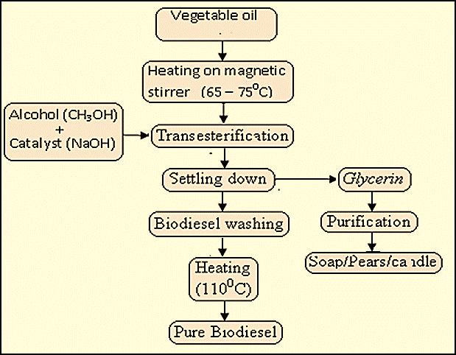

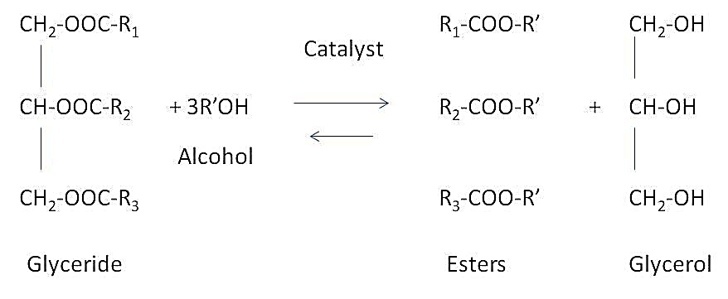

An impetus is usually added to build the yield and work on the pace of response. In transesterification there are a couple of choices for impetus. The most well-known strategy is soluble base catalyzed transesterification. In this response the anion of the liquor and the impetus assaults the carbonyl carbon iota of the fatty oil particle shaping a tetrahedral halfway that responds with the liquor to recover the particle of the liquor and impetus. The revision of the tetrahedral middle of the road brings about the development of an unsaturated fat ester and a triglyceride. The interaction is continued liberating two additional esters.
2.1. Experimental materials
The method the test generator to the configuration of the subject matter, which allows you to have the ability to assess the At this point, the total capacity was dictated by the insulation, and energy production through the use of bio-diesel.
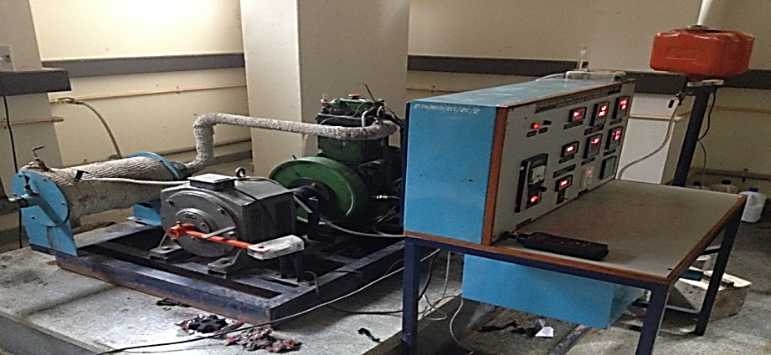
Fig. 1: Test Ring of C.I Engine for Experiment.

The engine can be found in Figure 3. In addition, it has been the engine of definitions is shown in the Table 1. Four mixes of biodiesel were tried in ordinary diesel. The four mixes of biodiesel were at weakening degrees of 5%, 10%, 20% and half.

Table 1: Engine and Dynamometer Specification
Sl.no | Considerations | Design
1 | Form | TV 1 (kirloskar made)
2 | Needle introductory  force | 200 to 225 bar
3 | Regulator style | Mechanical centrifugal
4 | cylinders | 1 cylinder
5 | strokes | 4
6 | Fuel type | Diesel
7 | CR | 16.5:1
8 | (Bore) | 80mm
9 | Stroke length | 110mm
Electrical
10 | Style |  | Foot mounted,  continuous rating
11 | Alternator rating |  | 3KVA
12 | RPM |  | 2800-3000RPM
13 | V |  | 220 V AC

3. Results
Fuel properties
Table 2 shows the fuel assets of the achieved biodiesel and Jatropha-oil. All of the fuel assets were firm in triplicate, and the results showed a mean value of three trials.
Table 2. A list of the fuel properties of the acquired biodiesel and Jatropha-oil.
Properties | Jatropha biodiesel | Jatropha Oil
AV (mg KOH/g) - | 0.34509 | 2.3
at 40C (mm2/s)- | 11.206 | 60
(MJ/kg) - | 34153
Saponification- | 169.12 | 184
M/V- | 867
CP (celsius)- | 16 | Room temperature
PP (celsius)- | 13
Iodine number- | 58.03 | 54
FP(celsius)- | 158
Ash content (%)- | 0.0039

BP, BTE, and BSFC at each heap for every one of the mixes and regular diesel fuel and furthermore recorded the fumes gas temperature (EGT) at each heap for each mix, in addition to the ordinary diesel fuel. The outcomes were diagramed the EGT (F-4 BTE (F- 3), and). BP VS BSFC (F- 2),

3.1. Break specific fuel efficiency and Break power
Brake specific fuel consumption measures how effectively fuel is used to produce braking power by comparing the mass flow rate of fuel delivered to the engine to the brake power obtained at a crankshaft.
The (Fig.2) demonstrate the variant of BSFE and BP for diesel and for blended fuels of B10% and B40% on diesel engine.

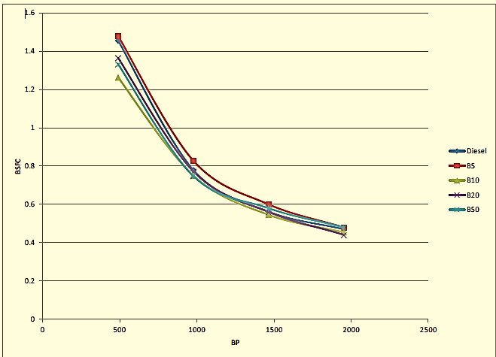
Fig. 2: Break specific fuel consumption Vs Break power.

3.2 Break Thermal efficiency and Break Power
The engine crankshaft's share of the overall power produced by the combustion of the fuel is shown by the brake thermal efficiency. Formula for brake thermal efficiency: The formula brake = brake power yields the engine's brake thermal efficiency. Using fuel brake force using fuel
The (Fig.3) demonstrate the variant of BTE and BP for diesel and for blended fuels of B10% and B40% on diesel engine.
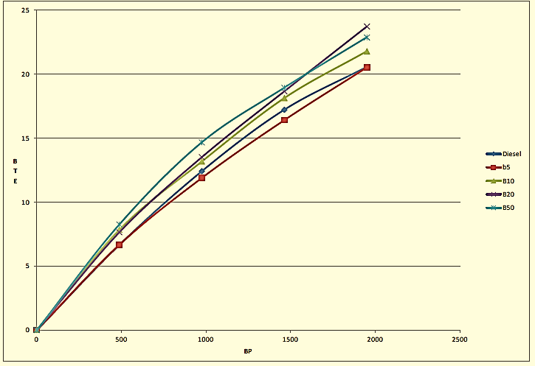
Fig. 3: Break Thermal Efficiency Vs Break power

3.3. EGT VS. BP
The relationship between brake power and the change of exhaust emission temperature for diesel, as well as other fuel biodiesel blends, is Figure 4 compares the exhaust gas temperature with braking performance.
The (Fig.4) demonstrate the variant of BSFE and BP for diesel and for blended fuels of B10% and B40% on diesel engine.

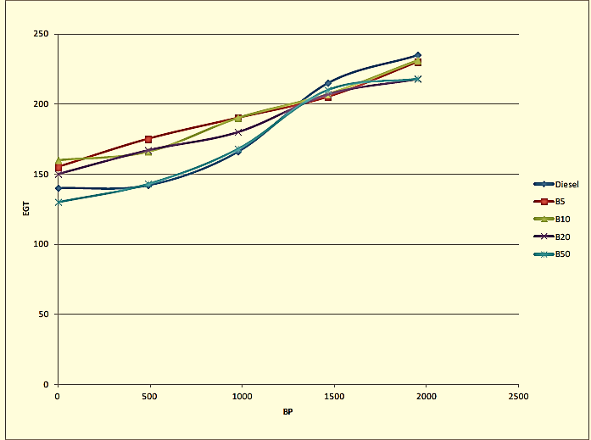
Fig. 4: Exhaust gas temperature Vs Break power

4. Conclusions
Jatropha biodiesel satisfies the important fuel properties that are required as per ASTM specification for biodiesel. During the test Engine works smoothly on simarouba methyl ester and the performance was comparative to that of diesel operation. The simarouba biodiesel is a promising biodiesel and can be a substituted as alternative fuel for CI engine in future.

References
[1] 1] Lim, S., & Teong, L. K., Recent trends, opportunities and challenges of biodiesel in Malaysia: An overview. Reviews of the renewable and Sustainable Energy 2010; 14, 938-954
[2] Singh, S., & Singh, D. the production of Biodiesel with the help of different sources and characterization of oils and their esters as diesel fuel oil: a review. Reviews of the renewable and sustainable energy 2010; 14, 200-216
[3] He is CE, Schwab AW, Doherty MJ, Pryde EH, EH, Heakin MACHINE. The fuel properties of eleven essential oils. Proceedings of the American Society of Agricultural Engineers, 1982; 25:1472-83.
[4] Bagby mo. Vegetable oils for diesel fuel, the development of business opportunities. In: the International Winter Meeting of the American Society of Agricultural Engineers; 1987.
[5] Bruwer j-j, Boshoff, BD, Hugo, JC, Du Plessis LM, Fuls J, k, C, Hawkins, et al. The use of sunflower oil as a renewable diesel fuel. Agriculture, Energy, 1981

