HOME AUTOMATION USING SENSORS
Vishruth M V ¹, Huzzaif Hassan ², Yashaswini S ³, Vishwanth ⁴
¹ ² ³ ⁴ Student, Dept. of CSE
BNMIT, Banglore, Karnataka, India
¹ vishruth.mv10@gmail.com, ² hassanhuzaif147@gmail.com, ³ yashaswinisrinivas586@gmail.com

ABSTRACT
I In recent years, advancements in Information and Communication Technologies (ICT) have predominantly revolved around the realm of the Internet of Things (IoT). In practical terms, IoT-based services have greatly enhanced the residential environment and found applications in various sectors. Among these applications, IoT-based home automation stands out as an exceptionally versatile and widely embraced concept. Within the realm of home automation, all household appliances are interconnected, enabling them to function seamlessly without requiring human intervention. This transformative technology brings about a substantial improvement in the quality of human life, empowering the intelligent operation of household devices.

This impetus drove our team to embark on the development of a model rooted in the fundamental principles of home automation. Leveraging an array of sensors, including the ultrasonic sensor, DHT11 sensor, and PIR sensor, we endeavoured to create a foundational home automation system.

The envisioned model relies on sensors to detect the presence or absence of human occupants within the household. Additionally, it actively monitors gas levels, issuing alerts and triggering a loud alarm in the event of a gas leak surpassing a certain threshold. The proposed solution has been meticulously deployed and rigorously tested across various environmental conditions.

Finally, in this paper, a working model of our proposed solution is developed as a prototype and explained as a working model.

Acknowledgment

We would like to place on record our sincere thanks and gratitude to the concerned people, whose suggestions and words of encouragement has been valuable.

We express our heartfelt gratitude to BNM Institute of Technology, for giving us the opportunity to pursue Degree of Computer Science. We would also thank Prof. T. J. Rama Murthy, Director, Dr. S.Y. Kulkarni, Additional Director, Prof. Eishwar N Maanay, Dean and Dr. Krishnamurthy G.N., Principal for their support and encouragement to pursue this project. We would like to thank Dr. R.V. Parimala, Professor and Head, Dept. of Electrical and Electronics Engineering, for her support and encouragement.

We would like to thank our Guide Ms. Kruthi Jayaram, Assistant Professor, Dept. of Electrical and Electronics Engineering, who has been the source of inspiration throughout our project work and has provided us with useful information at every stage of our project.

Finally, we are thankful to all the teaching and non-teaching staff of Department of Electrical and Electronics Engineering for their help in the successful completion of our project. Last but not the least we would like to extend our sincere gratitude to our parents and all our friends for being a constant source of inspiration.
VISHRUTH M V

VISHWANATH

WANI HUZZAIF HASSAN

YASHASWINI S

Table of Contents

Abstract
Acknowledgment
List of Figures
Introduction
Literature Survey
Methodology
Hardware and Software requirements
Results and Discussion
Conclusion and Future Scope

References

List of Figures
Figure No. | Description | Page No
1 | Circuit Connections of the Model | v
2 | Working Model and Circuit Connections | vii

- Introduction
The concept of the Internet of Things (IoT) revolves around the intricate connection of various computing devices embedded in everyday appliances to the internet, enabling them to communicate with each other. This integration enhances the end user's quality of life, augments wireless functionality, and bolsters sustainability in daily activities. In the near future, a multitude of smart devices will operate within the realm of IoT.
Gartner, a prominent analyst firm, forecasted that by 2020, over 20 billion devices would be linked to the IoT. As we approach this milestone, approximately $6 billion is expected to be invested across various IoT domains, including software development, device hardware, integration, data storage, security, and connectivity. It is projected that nearly $6 trillion will be expended on IoT solutions by 2025.
We find ourselves in a rapidly evolving world characterized by increasing automation. Automation entails the scheduling of tasks for devices connected to local networks or the internet, either based on timing or triggered by specific events. From large-scale industries to smaller setups, automation is being adopted to reduce human intervention, enhance energy efficiency, wireless connectivity, and productivity. Home automation, or smart homes, involves automating various household appliances, including heating, lighting, ventilation, climate control, and other internet-connected embedded devices. An important facet of modern home automation is the ability to remotely monitor and control these automated appliances. Thanks to the evolution of smartphones, tablets, and advances in communication technologies like Wi-Fi, Bluetooth, and ZigBee, homeowners can access their home networks even when they are away. One notable advantage of this is the significant potential for energy conservation and cost savings
An efficient home automation system is proposed in this paper. The significant contributions of this paper are as follows:
a) In the beginning, we begin the process of automation by targeting vital household appliances such as fans, lighting systems, air conditioners, and water heaters. This is achieved through the data collected by a range of sensors strategically placed throughout the house.
(b) These sensors are seamlessly linked to either the Node MCU ESP8266 or the Arduino Uno. These devices are responsible for analyzing the data gathered by the sensors and subsequently managing the relays that are connected to control the appliances.
- Literature Survey
Home automation is the use of technology to control various home appliances and systems. Home automation systems use sensors, controllers, and communication technologies to provide an automated home environment. Sensors play a critical role in home automation as they are responsible for monitoring different parameters and providing feedback to the controllers. In this literature survey, we will review some of the recent research work done in the area of home automation using sensors.
- "Smart home energy management using wireless sensors" by L. Han, J. Zhang, and L. Liu: The paper proposes a smart home energy management system that uses wireless sensors to monitor and control the energy consumption of home appliances. The system uses Zigbee wireless communication protocol for communication between sensors and controllers. The authors also present an energy consumption prediction model that uses machine learning algorithms to predict future energy consumption. The proposed system reduces energy consumption by up to 25%.
- "Smart home automation using IoT and cloud computing" by S. K. Patel and D. M. Patel: The paper proposes a smart home automation system that uses IoT and cloud computing. The system uses various sensors such as temperature sensors, motion sensors, and light sensors to monitor and control different parameters of the home environment. The authors also present a cloud-based architecture that provides remote access to the home automation system. The proposed system provides enhanced comfort, convenience, and security to the users.
- "A review of smart home sensing technologies" by C. M. Barnes and M. R. Hansen: The paper provides a comprehensive review of smart home sensing technologies. The authors discuss various types of sensors such as environmental sensors, occupancy sensors, and activity sensors. The paper also discusses different communication protocols used in smart home systems such as Zigbee, Z-Wave, and Wi-Fi. The authors conclude that smart home sensing technologies have significant potential to enhance the quality of life of people by providing a comfortable and secure living environment.
- "Smart home automation using machine learning algorithms" by S. K. Das and R. N. Mahapatra: The paper proposes a smart home automation system that uses machine learning algorithms to provide personalized services to the users. The system uses various sensors such as temperature sensors, humidity sensors, and light sensors to monitor the home environment. The authors also present a machine learning-based algorithm that provides personalized recommendations to the users based on their preferences. The proposed system provides enhanced comfort and convenience to the users.
Conclusion: The above literature survey provides a glimpse of recent research work done in the area of home automation using sensors. The papers reviewed in this survey demonstrate the potential of sensor-based home automation systems to provide enhanced comfort, convenience, and security to the users. Using the algorithms of machine learning and principles cloud computing has further enhanced the capabilities of home automation systems. In the future, we can expect more higher and complex home automation systems that would utilize advanced sensors and communication technologies.

- Methodology
The team's prototype primarily comprises three implemented layers:
- Sensor Node Layer
- Sensor Data and Database Interface Layer
- Notification Layer
Sensor Node Layer:
This setup comprises an array of sensors, specifically including temperature sensors, humidity sensors, Ultrasonic sensors, and PIR sensors. These sensors are interconnected with the NodeMCU ESP8266. They are tasked with collecting valuable data pertaining to various environmental variables within the home. This data is then transmitted to the NodeMCU for analysis. Subsequently, the NodeMCU takes action by activating the relays that control the lighting, blinds, fans, air conditioner, and heater when specific conditions are met.
A microcontroller serves as the central control unit, boasting integrated peripherals, memory, and a processor. It is the microcontroller that enables remote control and automation of these appliances. It is programmed to interpret the signals received from the various sensors and trigger the appliances in accordance with the predefined automation framework. Notably, the project utilizes the following microcontrollers:
Node MCU ESP8266: This microcontroller was selected for its cost-effectiveness, compact size, and the inclusion of a built-in Wi-Fi module, making it an ideal choice for the task at hand.

Sensor Data and Interface of the Data:
In this we have configured Blynk IoT Platform, to read the sensed data of the sensor and transmit it to a pictorial form on the blynk iot platform, it also acts like an interface through which certain defined actions can be controlled from the platform onto the NODEMCU ESP8266.

Notification Layer:
This layer acts as an alarm system, which is accomplished by the usage of a buzzer. The buzzer buzzes as soon as a movement is detected which is brought about using the PIR sensor.
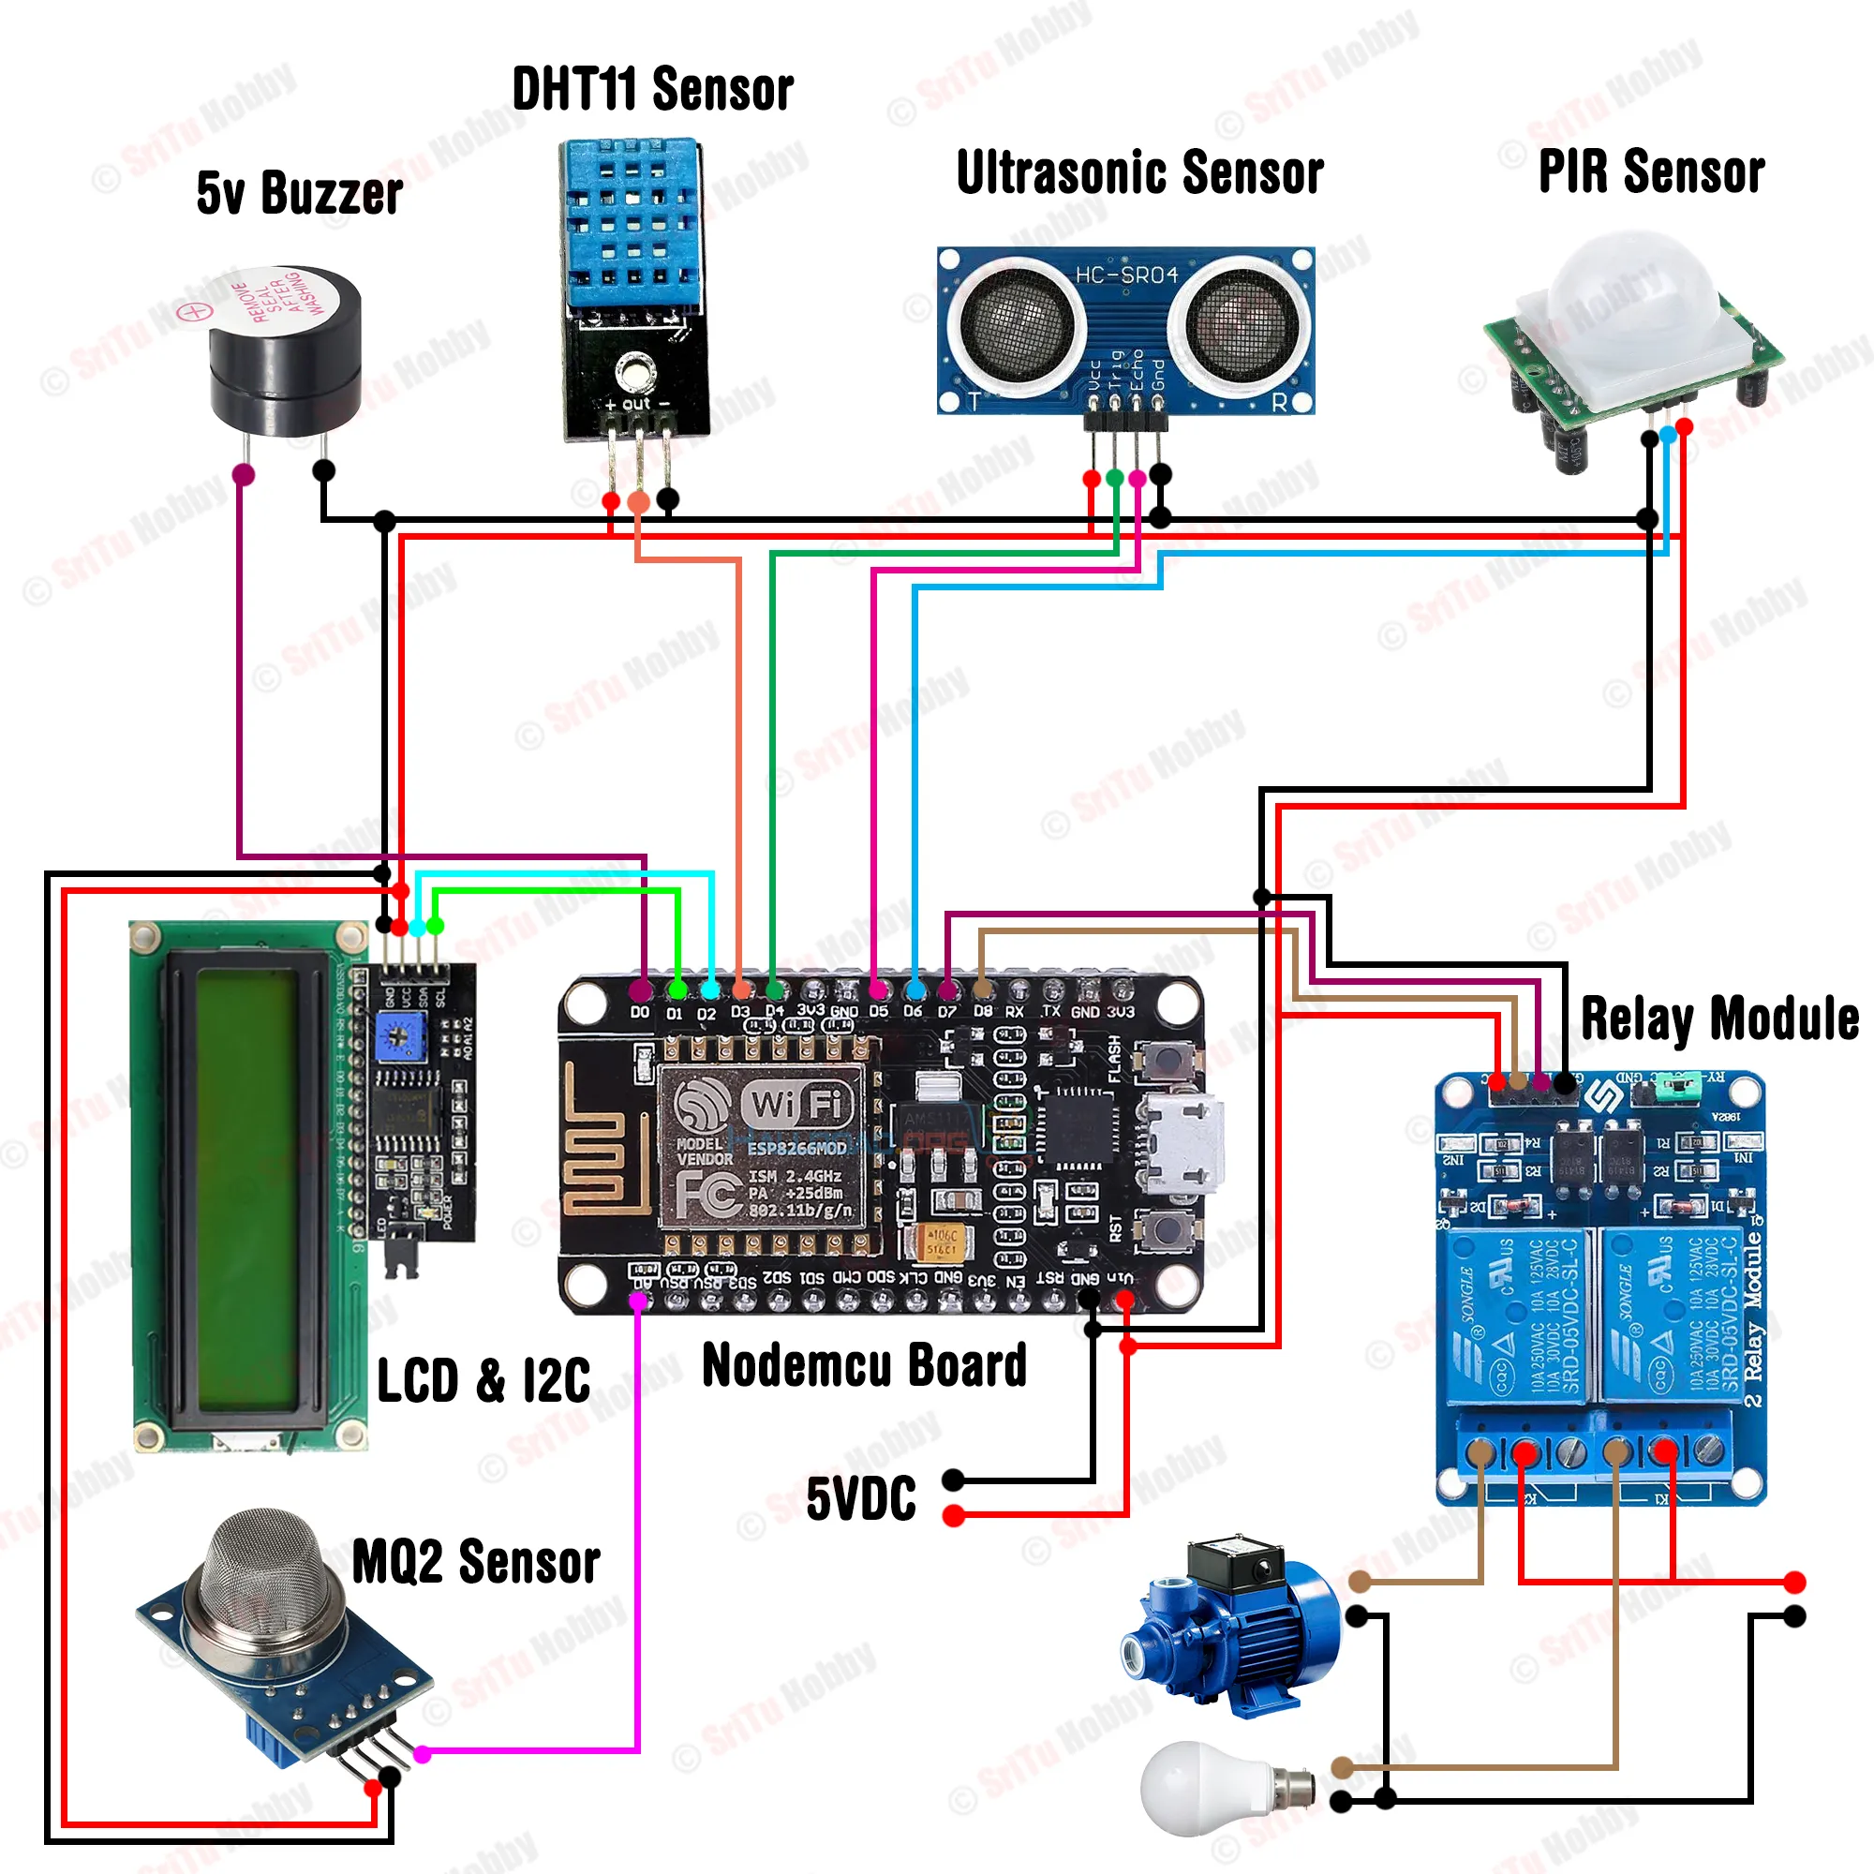
Figure 1: Circuit Diagram

- Hardware & Software Specifications

Hardware requirements
    - ESP8266 – A low power, energy efficient microcontroller with Wi-Fi enabled module where the program is loaded.
    - 5v Buzzer – used as a notification system that busses as per the defined conditions.
    - DHT11 Sensor – senses the temperature along with humidity in the environment.
    - Ultrasonic sensor – measures the level of water in the tank
    - PIR sensor – used to detect motion change in the environment and thus act like a security device.
    - Relay Module – used to isolate the voltages in the circuit connected to a different appliance
    - Breadboard – the base where all the foundations are laid
    - LCD and I2C – used to display the humidity and temperature readings

Software requirements
- Arduino IDE – open-source coding platform where the code is written and run for the prepared iot model.
- Blynk IoT Application App – open-source end-user interface that would aid us to display the desired output in the form of a gauge.

- Result and Discussion
In this research paper, we enhance domestic automation through the incorporation of a wireless sensor node. A sophisticated smart home harmonizes various electrical appliances within the household, automating their functions with minimal or zero human intervention.
This intelligent domicile diligently monitors a range of environmental variables and orchestrates the operation of appliances in accordance with user preferences. With these considerations in mind, we have successfully crafted a prototype and conducted comprehensive testing.
We have achieved the creation of a smart home by harnessing the power of Internet of Things (IoT) technology. Our experiments have demonstrated our ability to craft an economical, adaptable, and energy-efficient smart home, paving the way for a more environmentally conscious and sustainable future.
Some potential benefits of home automation could include:
- Energy efficiency: Automated lighting, heating, and cooling systems can help reduce energy usage and save on utility bills.
- Convenience: With home automation, you can control various aspects of your home from a single app or device, making it easier and more convenient to manage your household.
- Security: Automated security systems can monitor your home for potential threats and alert you if something is amiss.
- Entertainment: Home automation can also include smart home entertainment systems that allow you to control your home theater, music, and other entertainment devices from a single app or device.
Some of the discussion potential points being –
- Cost: How much did the project cost, and was it worth the investment in terms of energy savings, convenience, and security?
- Usability: How easy is it to use the home automation system, and are there any issues with reliability or connectivity?
- Future potential: What other home automation technologies could be implemented in the future, and how might they further improve the efficiency and convenience of the home environment?

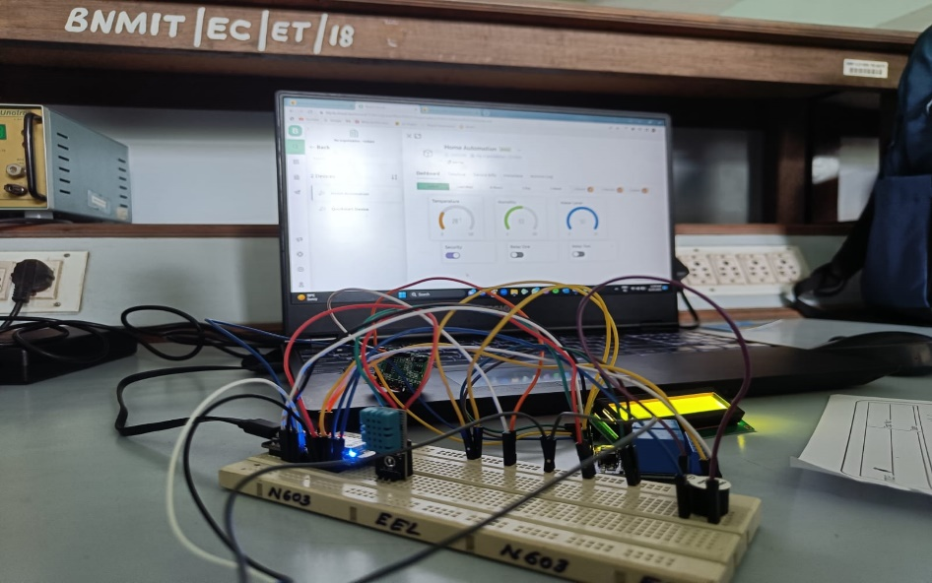
Figure 2: Working Model
- Conclusion and Future Scope
Conclusion:
In end, a home automation venture can bring many advantages to a household, consisting of elevated energy efficiency, comfort, security, and leisure. by using automating numerous systems and devices within the domestic, homeowners can shop cash on their software bills, streamline their day-by-day routines, and decorate their usual exceptional of lifestyles.
However, a successful domestic automation task calls for careful making plans and attention of things which include price, usability, and impact on the home environment and its occupants. homeowners must additionally be aware of capacity privacy and safety issues associated with clever domestic technology and take steps to guard their records and private statistics.
Overall, home automation generation is unexpectedly advancing and has the capacity to convert the way we live and engage with our houses. as the generation continues to enhance and become greater on hand, we are able to count on to look even more modern and exciting tendencies in the subject of domestic automation within the years to come.
Future Scope:
The future scope of home automation is quite promising, as technology continues to advance and improve. Here are some potential areas where we can expect to see further development in home automation:

- Increased integration:
Home automation systems are likely to become even more integrated, allowing homeowners to control multiple devices and systems from a single platform. This could include everything from lighting and HVAC to security and entertainment systems.
- Improved energy efficiency:
Home automation systems can help homeowners save energy by optimizing heating and cooling, turning off lights when rooms are empty, and managing appliances more efficiently. As energy costs continue to rise, this will become an increasingly important feature.

- Enhanced security:
Home automation systems can provide enhanced security features, including remote monitoring, access control, and video surveillance. As concerns about home security continue to grow, this will become an increasingly important feature.

Overall, the future of home automation looks very promising, with a wide range of potential applications and benefits.

REFERENCE

- "Smart home automation using machine learning algorithms" by S. K. Das and R. N. Mahapatra.

- "A review of smart home sensing technologies" by C. M. Barnes and M. R. Hansen: The paper provides a comprehensive review of smart home sensing technologies.

- “IoT Based Smart Home Automation System” from the Journal of Emerging Technologies and Innovative Research by J. Vijaya Kumari, Pavithra Neelam.

The above literature survey provides a glimpse of recent research work done in the area of home automation using sensors. The papers reviewed in this survey demonstrate the potential of sensor-based home automation systems to provide enhanced comfort, convenience, and security to the users.

