BOOK CHAPTER- Forensic & Criminology

SCIENTIFIC ART OF UNCOVERING THE TRUTH BY BRIDGING JUSTICE AND SCIENCE-SHINE THE TRUTH
Tanima Debnath Sarkar
Department of Zoology, Annamalai University, Annamalai Nagar-608002,TamilNadu,India.
Email-tanimadebnath06@yahoo.com

“In reality, those rare few cases with good forensic evidence are the ones that make it to court”.-Pat Brown.

Abstract:-Forensic science, untapped history, occupies a unique niche between law enforcement and the courts. Interpret the nature of evidence is analyzed through investigation in the reconstruction of the context of one way street criminal evidence. Fingerprint and DNA analysis( bloodstain patterns, firearms, ballistics, and toxicology) to the “ologies”-anthropology, entomology, and pathology, wildlife forensic compile in forensic science. The universal symbol of forensic science, “microscope” which is strongly modified to explore the depth of crime, reasons of criminal motivation and legal address to investigative questions study is the aim of criminal justice. Both ultraviolet (visible light),Ramman and infrared (IR) lights which help to promote absorption light of higher energy label and atomic bond of molecule are important sources of beam of light in forensic criminology. During autopsies study diseases, the interpretation taphonomic of information and trauma by the forensic odontologists and anthropologists know biological profile of skeleton which leads to identify of victim. Forensic entomologist is identified insects associate death and time of death and crime intersect (drugs, poisons, and location of stolen goods like paint, glass, hair, fiber, soil, impression). Biological evident through DNA fingerprint or 10 million profiling DNA (Combined DNA Indexing System) which is visualized by radio labeling or chemilunescence identify by restriction fragment length polymorphism (RFLP).The major effect of stimulants, depressant, narcotics, hallucinogen are represent by Illicit drugs (cocaine, heroin etc), alcohol are separate of stationary and mobile phase of molecule by both electrophoresis and chromatography by toxicologist to find cause of death.

Keywords:-bloodstain patterns, firearms, ballistics, CODIS, radio labeling, RFLP, hallucinogen.

Introduction:- Beside both fingerprints and DNA analyses, Hyperspectral imaging (HSI) offers significant potential for the detection, visualization, identification, and age estimation of forensic traces, mechanical, electrical, and chemical engineering, and fire science, at the identification of crime victims or criminals encounter frequently. Criminal investigation is an ancient science that may have roots as far back as c. 1700 BCE in the writings of the Code of Hammurabi. In the code, it is suggested that both the accuser and the accused had the right to present evidence they collected ^{[1]}. Analytical chemistry and biochemistry sample detection, mass determination, and structural analysis are acting a key role by Mass spectroscopy (MS). Potentiometric and potentiostatic under the Forensic Electrochemistry builds upon electroanalytical chemistry by focusing upon the detection of chemical species that are linked to crime scenes. Using firearms, the data collection regarding gunshot residue (GSR) during such forensic investigations is used to estimate firing distances, identify bullet holes, and, most pertinently, to determine whether a suspect has fired a gun or not, plays of homicides and violence has increased the role of forensic in criminal investigations. GSR plays to detect inorganic and organic components of barium, lead, and antimony are used of chemometric (combine of square waves of voltammetry (SWV), scanning electron microscopy (SEM), & energy dispersion X-ray(EDX).) treatment of analytical data. Cyborgs application implements the bridge of technology and the human brain. The criminal justice system based on Forensic chemical/biochemical analysis tool that are based subarea of forensic analysis, forensic serology (combine of immunoassays and DNA/RNA analysis), which identify on the type of sample, age, origin, or sex from biological fluids found at a crime scene. A mixture of endogenous and exogenous DNA analysis and PCR inhibitor from durable tissues of bone identify of individuals in crime scenes. To detect DNA polymorphisms using molecular genetics techniques has the major pathways involved in the correction of DNA damage include base excision repair (BER), nucleotide excision repair (NER), single strand break repair (SSBR), mismatch repair (MMR), direct reversal with the photoreactivation activity of photolyases, by recombination and rejoining pathways, or through tolerance with translesion synthesis (TLS). Forensic trace elements are examined by under Fourier transform infrared (FTIR) spectroscopy, UV/visible microspectrophotometry (MSP), pyrolysis gas chromatography/mass spectroscopy (PGC), Raman spectroscopy, X-ray diffraction (XRD), and scanning electron microscopy (SEM) instruments. Biometric indicators spoofing which focus on attacks on automated biometric recognition systems using by live scan technology , feasible in an operational scenario which develop anti-spoofing or liveness detection.

Origin of criminology:- Criminology (from Latin crimen, "accusation", and Ancient Greek -logia, from logos meaning: "word, reason") is the interdisciplinary study of crime and deviant behavior . More than 200 years ago, the root of criminology trace back from criminal justice and penal system. According to the National Criminal Justice Reference Service, Cesare Beccaries, wrote “On Crime and Punishments,” published in 1764 called for fitting the punishment to the severity of the crime. After moderate and developing in 20th century, criminology involved seeking to understand crime’s causes by studying sociological, psychological, and economic conditions. The view of J. Rank in “New Criminology” impacts on the base of conflicts between social and economic classes leading to social upheaval. The eyes of criminologist a multidisciplinary approach to criminology motive by greed, anger, jealousy, pride, emotion, want to control, revenge, power, materialistic gain, etc. The potential causes for criminal activity depend on parental relation, hereditary and brain activity, hormones, education, peer influence, drugs and alcohol, easy opportunity.
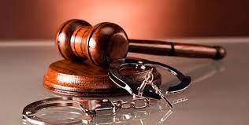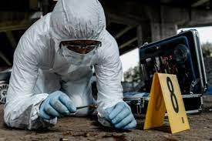
Fig:1-Criminal Justice. Fig:2- Criminology VS Criminalistics
Criminology and the legal perspective:- Criminologist focus on the causes of an illegal action society punish through the Government’s legal system, prevention and correction of crime. From J.Rank report that criminologist doesn’t violate existing law include economic exploitation, racial discrimination, and unsafe or unhealthy work environments. Criminology theory primarily depends on sociological and psychological. The Classical, Positivist and Chicago schools are three predominate theories are bases on Bentham’s Utilitarianism theory, applies scientific theory of criminology and social disorganization.
Criminology and Criminal justice:- Criminal justice develop by criminologists which is the application of enforcing of laws and investigating crimes to punish and rehabilitation of criminals. Criminology and Criminal justice are working together to against the crime. The goal of the Criminologists to addressing crime, victimization and relate governmental agendas and generate information.
In general difference between Detective and FBI (Federal Bureau of Investigation) Agent. [Sources: Pay Scale, U.S Bureau of Labor Statistics.]
Detective | FBI
Collect and analyze evidence in criminal investigations. | Investigate terrorism, organized crime, and other major crimes.
Interview suspects and witnesses. | Work with officials in local, state, and federal agencies.
Analyze archival records. | Analyze criminal data and maintain it in databases.
In general difference between Criminologist and Forensic Scientist.[ Sources: Pay Scale, U.S Bureau of Labor Statistics.]
Criminologist | Forensic Scientist
Conduct research on crimes and criminals. | Collect analyze physical evidence of crimes.
Identify causes of and solutions to crime. | Work at crime sites and criminal labs.
Predict crimes and suggest preventive measures. | Testify as an expert withness.

Different kinds of weapons and/or tools in crime:- Most common weapons for homicides are Ballistics, Projectiles, Sling, Bow, Catapult, Rocket, Fingerprint recovery, Serial number recovery, Magnetic particle inspection, Chemical restoration, Examination of cartridges, Handguns, Rifles, Shotguns, Firearms, Knives, Body parts including fists or feet, etc and some nitroaromatic explosives toxic substances such as 2,4,6-trinitrotoluene (TNT) and 2,4,6, N-tetranitro-N-methyl aniline (tetryl), nitrate esters, such as ethylene glycol dinitrate (EGDN), glycerol trinitrate (nitroglycerin, NG), and pentaerythritol tetranitrate (PETN), and nitramine explosives, such as 1,3,5- trinitro-1,3,5-triazacyclohexane, (RDX) and 1,3,5,7-tetranitro-1,3,5,7- tetrazacyclooctane (HMX), as well as mixtures containing one or more of these explosives. Additional explosives include triacetone triperoxide (TATP) and ammonium nitrate (AN), NH₄ NO₃ ^{[2]} . All explosives are toxic in nature.
Ballistics:-Ballistic means "to throw". Ballistics is the field of mechanics concerned with the launching, flight behavior and impact effects of projectiles, especially ranged weapon munitions such as bullets, unguided bombs, rockets or the like; the science or art of designing and accelerating projectiles so as to achieve a desired performance ^{[3]}. A ballistic body is a free-moving body with momentum which can be subject to forces such as the forces exerted by pressurized gases from a gun barrel or a propelling nozzle, normal force by rifling, and gravity and air drag during flight ^{[3]}. During the relative brief initial phase of powered flight and the trajectory is subsequently governed by the laws of classical mechanics are guided by ballistic missile only.
In ancient time near about 64,000 years ago, in Sibudu Cave, present daySouth Africa, stones and spears, and the thrown stick were used as a ballistic projectile. The first devices identified as guns appeared in China around 1000 AD, and by the 12th century the technology was spreading through the rest of Asia, and into Europe by the 13th century ^{[4]}.
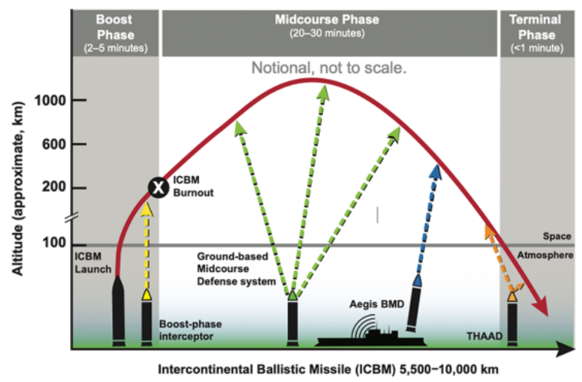
Fig:3 –U-M Physics Researcher Co-Chairs Ballistic Missile Defense Report.
Ballistics was throwing on a solid in scientific and mathematic basis by Sir Isaac Newton, with the publication of famous book Phikosophiae Naturalis Mathematica in 1687. It is fully depend on laws of motion and gravity.
Projectiles:-A projectile is any object projected into space (empty or not) by the exertion of a force. Although any object in motion through space (for example a thrown baseball) is a projectile, the term most commonly refers to a ranged weapon. Mathematical equations of motion are used to analyze projectile trajectory, e.g. arrows, bullets, artillery shells, balls, wingless rockets etc ^{[5]}.
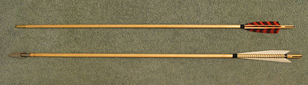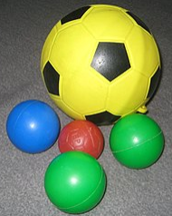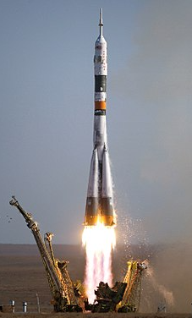
- (ii) (iii)
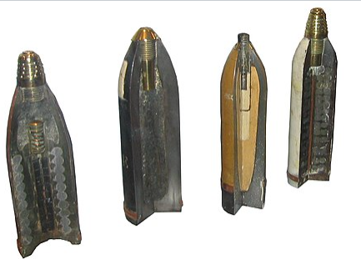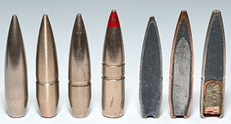
(iv) (v)
Fig:4- Projectiles- (i) Arrows,(ii)Balls, (iii)Wingless rockets, (iv)Artillery shells,(v)Bullets.

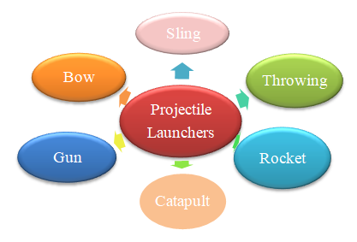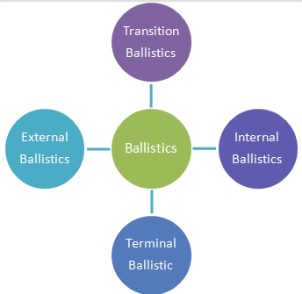
Fig:5-Types of Projectile Launcher. Fig:-6-Categories of Ballistics.
Projectiles Launcher:
Throwing:- Throwing is one of the projectile launcher by hand. The 90 mph throwing speed found in many athletes far exceeds the speed at which chimpanzees can throw things, which is about 20 mph ^{[6]}. This ability reflects the ability of the human shoulder muscles and tendons to store elasticity until it is needed to propel an object ^{[6]}.

Sling:- A sling is a blunt small cradle or pouch in the middle of two length of cord like stone, clay or lead “sling bullet” which is placed by the middle finger or thumb finger. This frees the projectile to fly to the target.
Bow and Arrow:- A bow is a flexible piece of material which shoots aerodynamic projectiles called arrows. A string joins the two ends and when the string is drawn back, the ends of the stick are flexed. When the string is released, the potential energy of the flexed stick is transformed into the velocity of the arrow. Archery is the art or sport of shooting arrows from bows ^{[7]}.
Catapult:-A catapult is a device used to launch a projectile a great distance without the aid of explosive devices — particularly various types of ancient and medieval siege engines. The catapult has been used since ancient times, because it was proven to be one of the most effective mechanisms during warfare ^{[3]}. The word “catapult” means ‘ kata’=“against” and ‘pallō’= "to toss, to hurl".
Gun:-A gun is a normally tubular weapon or other device designed to discharge projectiles or other material. This firearm projection varies according to design but is usually affected by the action of gas pressure. A weapons engineer or an armourer who applies the scientific principles of ballistics to design cartridges is often called a ballistician ^{[8]}.
There are three categories of firearms. These are (i)Handguns – includes pistols, revolvers and derringers,(ii) Long Guns – includes rifles and shotguns, and (iii) Mounted Guns – includes cannons and anti-aircraft gun.
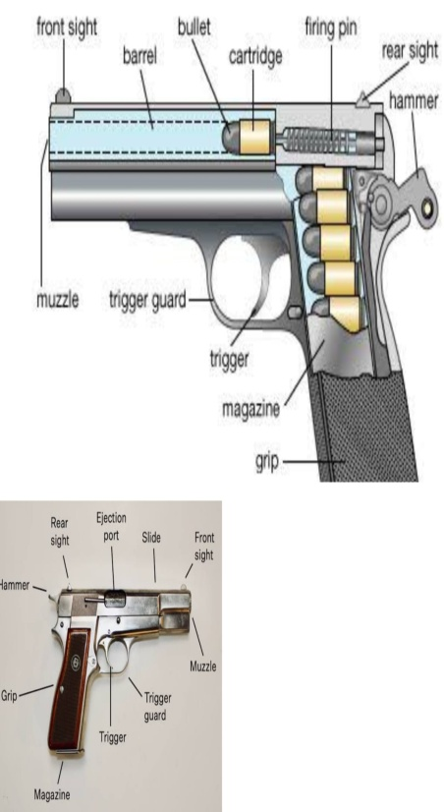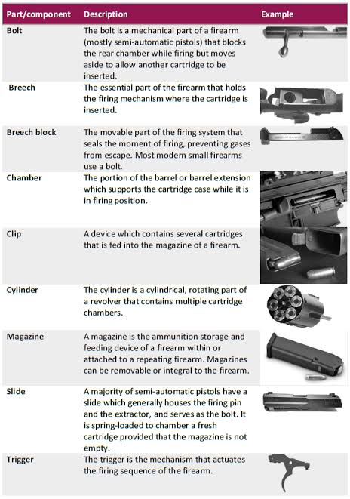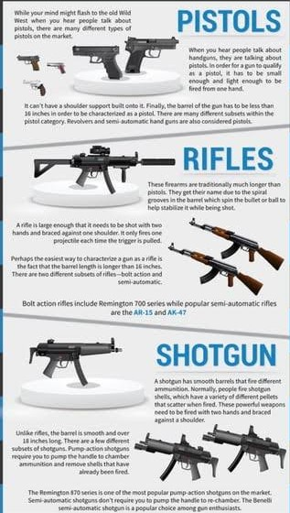
Fig;7-(i)Up=Pistol; Down=Rifle. (ii)Parts of Firearm. (iii)Different types of Guns.

For forensic firearm examination specific evidence that can be recovered includes weapon serial numbers and potentially fingerprints left on the weapon's surface.
Rocket:- A rocket is a missile, spacecraft, aircraft or other vehicle that obtains thrust from a rocket engine. Rocket engine exhaust is formed entirely from propellants carried within the rocket before use ^{[9]}. Rocket engines work by action and reaction and push lightweight and powerful rockets forward simply by throwing their exhaust backwards extremely fast. Rockets for military and recreational uses date back to at least 13th century China. Although rocket are used for fireworks, weaponry, launch vehicles, satellite, human spaceflight but rocket engineer needs careful design, testing, construction and use minimizes risks.
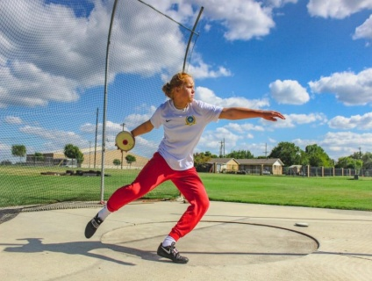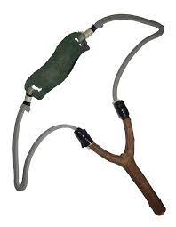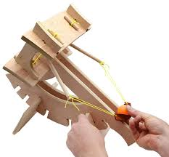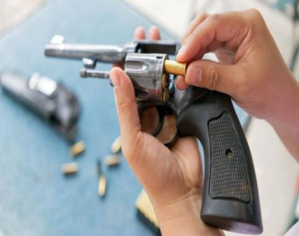
Fig:-8 (i) Throwing (ii) Sling (iii) Catapult (iv) Gun
Subfields of Ballistics:-
There are several distinct times in the journey of the Ballistics is further classified into four subfields. These are:- (a) Internal Ballistics, (b) Transitional Ballistics, (c) External Ballistics, (d)Terminal Ballistics.
(a)Internal Ballistics:- Internal ballistics (also interior ballistics =the moment the firing pin hits the primer till the time the bullet exits from the barrel), a sub-field of ballistics, is the study of the propulsion of a projectile. In guns internal ballistics covers the time from the propellant's ignition until the projectile exits the gun barrel ^{[11]} .e.g. small-bore rifles and pistols, to high-tech artillery.
Mechanism of Firing Process:- The trigger is squeezed, releasing the firing pin, which moves forward with great force. The firing pin strikes the primer, causing it to explode. The spark from the primer ignites the gunpowder rapidly expands in the cartridge. The expanding gas forces the bullet out of the cartridge and down the barrel with great speed. The rifling in the barrel causes the bullet to spin as it travels out of the barrel. The bullet’s speed and escaping gases produce a “bang”.
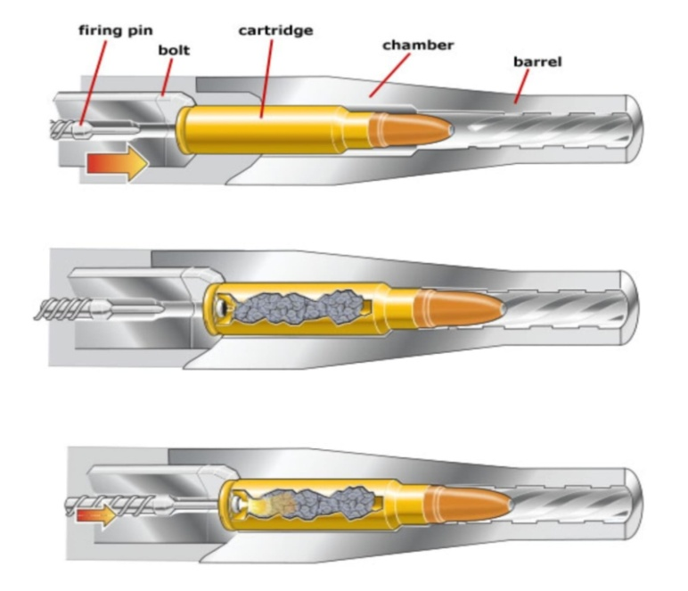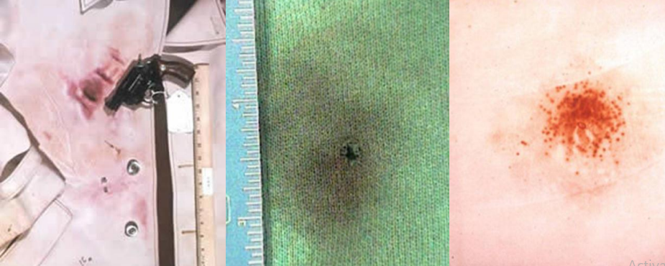
Fig:9- (i) Mechanism of firing process. (ii)Residue on clothing.
The National Integrated Ballistics Information Network (NIBIN), The Data Base of Firearm Information is formed with combine of the FBI and the ATF&E are two systems on 1999. NIBIN system has over 800,000 computerized images.
The distance between firearms and target depends on the distribution of powder patterns or the spread of a shot pattern (shotgun) which is reciprocal of distance and residue of gunpowder. Victim’s cloth is chemically tested for gunshot residue to confirm of determine the distance by the ‘Griess Test’ or using Barium and Antimny components. Ganshot residue (GSR) is the strong evidence of victim stay for approximately 2 hours by washing or wiping the hands on the thumb web and the back of the firing hand. Collection and preservation of firearms evidence keep safely for forensic experiment.
(b)Transitional Ballistics:- Transitional ballistics, also known as intermediate ballistics,^{[12]} is the study of a projectile's behavior from the time it leaves the muzzle until the pressure behind the projectile is equalized,^{[13]} so it lies between internal ballistics and external ballistics.
(c)External Ballistics:- External ballistics deals with the behavior of a non-powered projectile in flight. It is one of the firearms and deals with unpowered free-flight phase of the bullet after it exits the gun barrel and before it hits the target.
(d)Terminal Ballistics:- Terminal ballistics is the behavior and the effects of a projectile when it’s hits its target. It works extremely high velocity impacts.
Application:-
Forensic ballistic-At a court or other part of a legal system forensic ballistics involves to analysis of bullets and bullet impacts to determine information. Separately from ballistics information, firearm and tool mark examinations ("ballistic fingerprinting") involve analyzing firearm, ammunition, and tool mark evidence in order to establish whether a certain firearm or tool was used in the commission of a crime ^{[14]}.
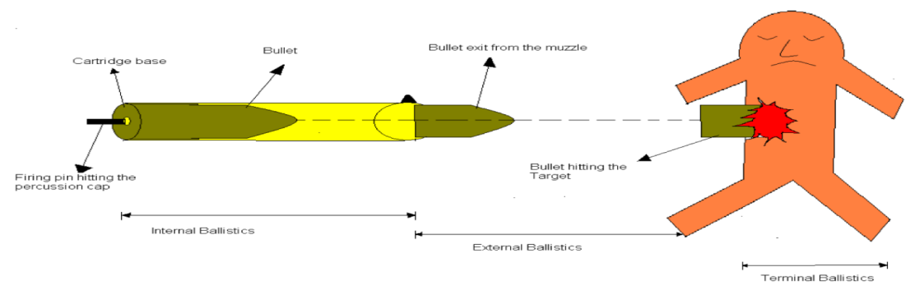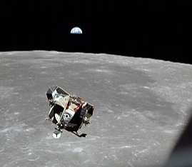
Fig:-10 (i) Forensic Ballistic (ii)Astrodynamics

Astrodynamics:- Astrodynamics is the application of ballistics and celestial mechanics to the practical problems concerning the motion of rockets and other spacecraft. The motion of these objects is usually calculated from Newton's laws of motion and Newton's law of universal gravitation. It is a core discipline within space mission design and control.
Fingerprint recovery:-Cyanoacrylate commonly name superglue is used to recover fingerprint from the surface of firearms which is placed spirally designed fume hood without touch any think. Until liquid superglue turns gaseous state, the circulating fumes adhere to the oils left behind by the fingerprint, turning to the print white which can be enhanced with finger print powder to contrast of the white print against the weapon’s finish. After recover evidence the fingerprints from the surfaces of a firearms is challenging due to the textured grip and general condition of weapons. Then it is processing Striation databases such as the Integrated Automated Fingerprint Identification System (IAFIS). By the southern blotting DNA is analyzed and reache to victim.
Serial number recovery or restoration: A serial number restoration (=find out to hide the identity of the numbered item) involves both use of the physical (electrolytic, ultrasonic cavitation etching, magnetic particle, and heat treatment) and chemical scientific techniques used for the retrieval, recovery, and/or revisualization of the manufacturer's identifier, in cases where the serial number has been obliterated in Forensic science. Restoring a serial number can provide law enforcement agencies with information about a firearm or other item and may offer a lead in an investigation. At the magnetic particle inspection time if fluorescent particles are added to the ferrous solution, ultraviolet light can be used to make it easier to visualize any recovered serial number ^{[15]}. Chemical restoration is only successful when the obliteration of the serial number is superficial in depth. The examiner chooses acid that can range from Fry's Reagent for a magnetic metal, which is a mixture of hydrochloric acid, cupric chloride, and distilled water, to an acidic ferric chloride solution for a non-magnetic, non-aluminium material which will be used to slowly bring the number back to the surface.
Examination of cartridges: The examination of the cartridge relies on the unique tool marks left by the various parts of the weapon including the firing pin and the ejector in semi and fully automatic firearms. These markings can be compared and matched to known exemplars fired from the same weapon using the same parts. Collect the finger print from cartridges are subjected to cyanoacrylate fuming and examined for any usable prints that are photographed and can be uploaded to fingerprint databases such as IAFIS for comparison with known exemplars ^{[16]}.
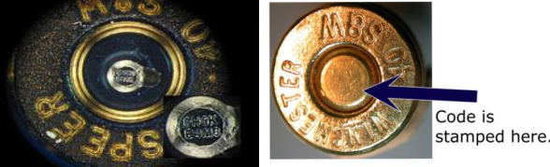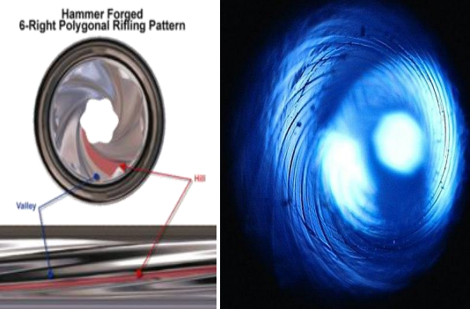
Fig: 11- (i) (ii)
(i)Example of micro stamping. Insert shows a close up of the seial number imprinted into the cartridge. (ii)Rifling pattern for a Remington rifle showing a clockwise (right-handed) twist.
Class and Individual characteristics: The make and model of the weapon is different into class characteristic and it classified into three, (a) the lands and grooves of barrel which are bumps and valley created when rifling is created, (b) the caliber of the bullet, and (iii) the rifling twist. All three can be tied directly and used in bullet. The twist is the direction of the striations left by the barrel's rifling, clockwise (right-handed) or counter clockwise (left-handed).
In order to compare individual striations, examiners must obtain a known sample using the seized weapon. For slower-traveling bullets, such as pistols or revolvers, known bullet exemplars are created by firing the weapon into a water tank ^{[17]}.
Chemical Warfare and Nerve Agents:- The most potent toxic synthetic organophosphorus compounds are used as a nerve agent gas. At ambient temperatures, nerve agents are liquids that readily penetrate the skin and enter the bloodstream; thus, dermal contact is an important route of exposure ^{[18]}. Inhalation is another exposure way of highly toxic nerve agent vapors and aerosol droplets which may appear within seconds to hours or days depending on the level and route of exposure. Nerve agent attacks the nervous system and as a result cholinergic crisis due to enzyme acetylcholinesterase, which is responsible for breakdown of acetylcholine (Ach) in the synapses that control muscle tissues.
Chemical weapons in World War I were primarily used to demoralize, injure and kill entrenched defenders, against whom the indiscriminate and generally slow moving or static nature of gas clouds would be most effective^{[18]} .Tear gas, mustard gas, lethal agent like phosgene and chlorine etc. are using in chemical warfare widely.
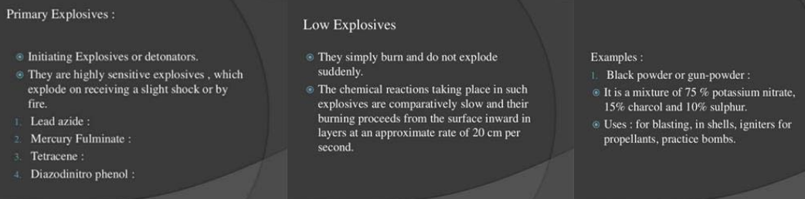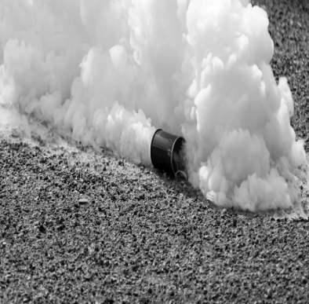
Fig:-12(i) Primary Explosive. (ii) Tear Gas.
After releasing of explosive material has great potential energy, which produces light, heat, sound, and pressure. Certain materials—dust, powders, gases, or volatile organic liquids—may be simply combustible or flammable under ordinary conditions, but become explosive in specific situations or forms, such as dispersed airborne clouds, confinement, or sudden release ^{[19]}.
Primary explosives are commonly used in blasting caps and percussion caps to translate a physical shock signal ^{[20]}. A small quantity, usually milligrams, is sufficient to initiate a larger charge of explosive that is usually safer to handle ^{[21]}. Example: Acetone peroxide, Alkali metal ozonide, Ammonium permanganate, Ammonium chlorate, Azidotetrazolates, Azoclathrates, Benzoyl peroxide, Benzvalene, 3,5-Bis(trinitromethyl)tetrazole, Chlorine oxides, Copper(I) acetylide, Copper(II) azide, Cumene hydroperoxide, Halogen azides: Fluorine azide, Chlorine azide, Bromine azide, Iodine azide, Hexamethylene triperoxide diamine Hydrazoic acid, Hypofluorous acid, Lead azide, lead styphnate, Lead picrate, Manganese heptoxide, Oxides of xenon: Xenon dioxide, Xenon oxytetrafluoride, Xenon tetroxide, etc.
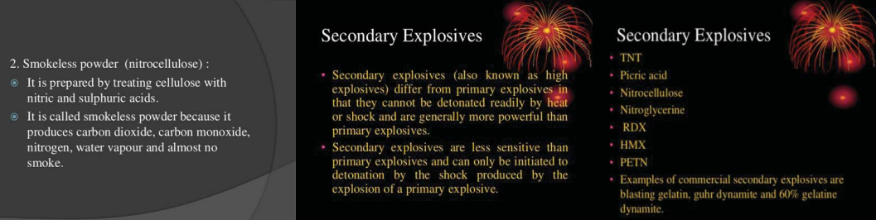
Fig: 13- Secondary Explosives.
Secondary Explosives:-Secondary explosive is less sensitive than primary explosive. It is used in larger quantities in an explosive train and is usually initiated by a smaller quantity of a primary explosive ^{[22]}. Examples of secondary explosives- TNT and RDX. RDX (abbreviation of “Research Department eXplosive” or “Royal Demolition eXplosive”).
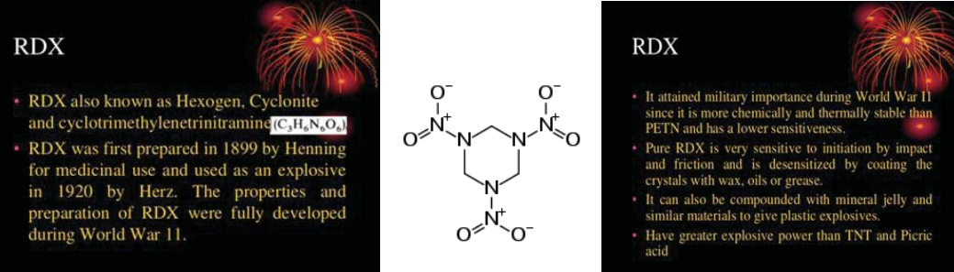
Fig: 14- RDX (Secondary Explosive).
Tertiary Explosives:- Blasting agents, intermediate secondary explosive booster, so insensitive, often use for safety and the typically lower costs of material and handling are Tertiary explosives. Example-ANFO (/ˈænfoʊ/ AN-foh) (or AN/FO, for ammonium nitrate/fuel oil) is a widely used bulk industrial explosive and in avalanche hazard mitigation ^{[23]}.
Cyanide gas: A gas chamber is an apparatus for killing humans or animals with gas, consisting of a sealed chamber into which a poisonous or asphyxiant gas is introduced. The most commonly used poisonous agent is hydrogen cyanide; carbon dioxide and carbon monoxide have also been used.Tear gas, also known as a lachrymator agent or lachrymator (from the Latin lacrima meaning “tear”), currently and formerly used as tear gas include pepper spray (OC gas), PAVA spray (nonivamide), CS gas, CR gas, CN gas (phenacyl chloride), bromoacetone, xylyl bromide, and Mace (a branded mixture) ^{[24]}. Lethal gases, Mustard gas, G-series nerve agent gases [GA (tabun), GB (sarin), and GF (cyclosarin)], etc are toxic gases for human health.
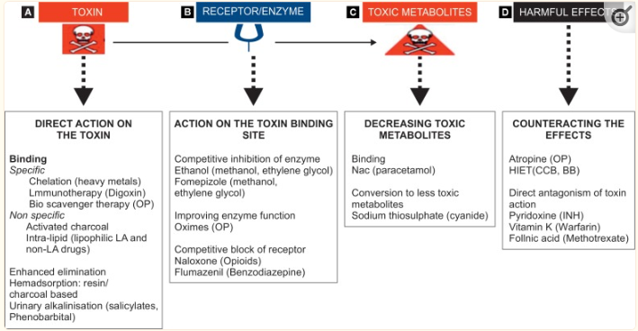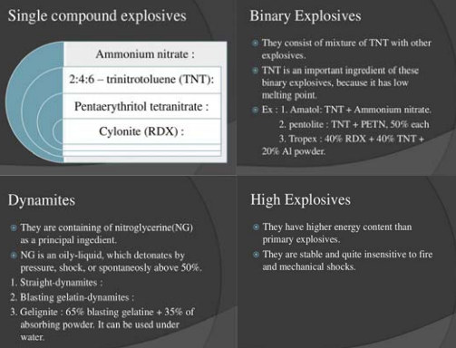
Fig: 15-(i) Mechanism of Antidotes. (ii) Tertiary Explosives
Antidotes:-An antidote is a drug, chelating substance, or a chemical that counteracts (neutralizes) the effects of another drug or poison, toxic in nature. Antidotes mediate its effect either by preventing the absorption of the toxin, by binding and neutralizaing the poison, antagonizing its end-organ effect, or by inhibition of conversion of the toxin to more toxic metabolites ^{[25]}. The duration of antidotal therapy depends on the type of toxin consumed, the estimated dose that the individual has been exposed to, route of exposure, clinical features of toxicity, half-life, and pharmacokinetics as well as the risk vs benefit for the use of the antidote ^{[25]}. Example-activated charcoal, acetylcysteine, naloxone, sodium bicarbonate, atropine, flumazenil, therapeutic antibodies and various vitamins etc.
Narcotics:- These are substances which lessen or eliminate pain to induce sleep and depress vital functions including blood pressure, pulse rate and breathing rate and produce psychological dependence ^{[26]}. Opium narcotics extract from poppies (Morphine, Heroin, Codeine etc.) is produces ‘high’ drowsiness and Hallucinogens (psychedelics, dissociatives and deliriants).
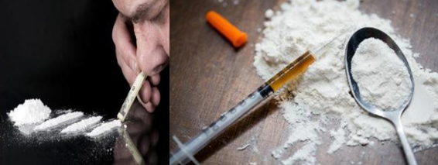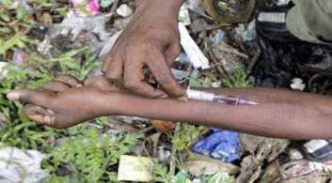
Fig:16- Drug addiction.
Hair analysis:-Hair analysis can be used for the determination of drug use months after drug consumption, hair analysis data can often act as important and even decisive evidence in the courtroom ^{[27]}. Hair analysis has been receiving increased attention during years and, currently, it has become the third most fundamental biological matrix used for drug testing in forensic toxicology, after blood and urine ^{[27]}.
Investigative Techniques:-Complete criminal investigations include searching, interviews, interrogations, evidence collection and preservation, and various methods of investigation ^{[1]}.
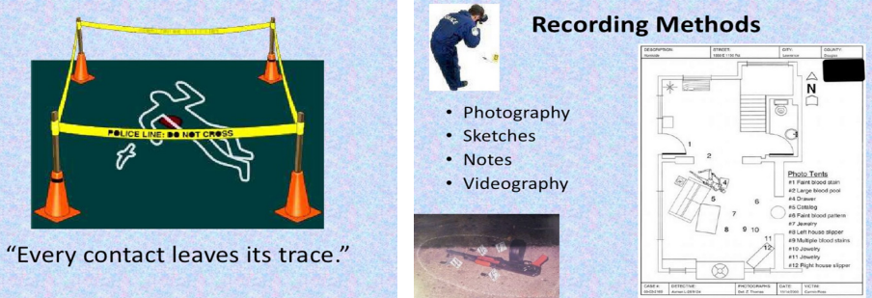
Fig: 16 - Investigation at crime place.
Investigation priority bias problems and proposed solutions are done by seeking of indicators of suspicion, Motive to commit the crime, Opportunity to commit the crime, and establish the relationships between the victim and any potential offenders.
Toxicology:-A forensic toxicologist must consider the context of an investigation, in particular any physical symptoms recorded, and any evidence collected at a crime scene that may narrow the search, such as pill bottles, powders, trace residue, and any available chemicals ^{[28]}. Provided with this information and samples with which to work, the forensic toxicologist must determine which toxic substances are present, in what concentrations, and the probable effect of those chemicals on the person ^{[28]}. Forensic toxicology depends on post mortem toxicology, human performance toxicology, and forensic drug testing (FDT).

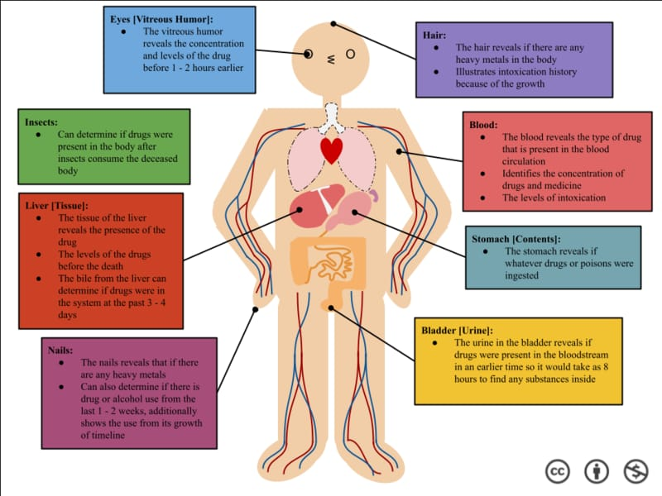
Fig:-17 – Drug location of the body.
Conclusion:- Essential design of biomedical implantable systems for telemetry and closed loop control of design approaches and noticeable milestones, with emphasis on implantable telemetry electronics. The science and technology of electronics and materials advances and human desires expand with medical needs; new challenges for novel implantable systems will evolve on future technological trends.

Reference:-
1. CSI (CRIME SCENE INVESTIGATION): FIRST STEP TO UNFOLD THE NETWORK OF CRIME Dhabal Sampa , Nandi Kushal , Chakraborty Amrita , Sen Jyoti Dhrubo , Bera Khokan , Biswas Arpita , Mandal Suprodip and Saha Dhananjoy, International Journal of Forensic Science and Legal Medicine. It is followed under these reference.
a. Herschel, William James (1880). “Skin furrows of the hand”. Nature. 23 (578): 76.
b. Faulds, Henry (1880). “On the skin–furrows of the hand”. Nature. 22 (574): 605.
c. Tewari, RK; Ravikumar, KV (2000). “History and development of forensic science in India”. J Postgrad Med. 46 (46): 303–308.
d. Sodhi, J.S.; Kaur, asjeed (2005). “The forgotten Indian pioneers of finger print science”. Current Science. 88 (1): 185–191.
e. Ruffell, A; McKinley, J (2014). “Forensic geomorphology”. Geomorphology. 206: 14–22.
f. Farrar, Andrew; Porter, Glenn; Renshaw, Adrian(2012). “Detection of Latent Bloodstains Beneath Painted Surfaces using Reflected Infrared Photography”. Journal of Forensic Sciences. 57 (5): 1190–1198.
g. Pringle, JK; Ruffell, A; Jervis, JR; Donnelly, L;McKinley, J; Hansen, J; Morgan, R; Pirrie, D; Harrison, M (2012). “The use of geoscience methods for terrestrial forensic searches”. Earth–Science Reviews. 114 (1–2): 108–123.
h. Saks, Michael J.; Faigman, David L. (2008).“Failed forensics: how forensic science lost its way and how it might yHerschel, William James (1880). “Skin furrows of the hand”. Nature. 23 (578): 76.

2. Saha, D., Dhabal, S., & Sen, D. J. (2022). Forensic science deals with safety armour during warfare explosives. Journal of Forensic Science and Research, 6(1), 024-041.
3. Nandi, K., Sen, D. J., & Mahanti, B. (2021). BALLISTICS: THE MODERN DAY FORENSIC WEAPON.
4. Heard, Brian (2013). Forensic Ballistics in Court: Interpretation and Presentation of Firearms Evidence. John Wiley & Sons, 33–42.
5. Heard, Brian (2013). Forensic Ballistics in Court: Interpretation and Presentation of Firearms Evidence. John Wiley & Sons, 41.
6. Melissa Hogenboom, "Origins of human throwing unlocked", BBC News (26 June 2013).
7. Steele, Lisa (2008). "Ballistics" (PDF). Science for Lawyers. American Bar Association.
8. Thompson, Robert (2010). "Firearm Identification in the Forensic Science Laboratory" (PDF). National District Attorneys Association.
9. Sutton, George (2001), Rocket Propulsion Elements (7th ed.), Chichester: John Wiley & Sons, ISBN 978-0-471-32642-7
10. MSFC History Office (2000), Rockets in Ancient Times (100 B.C. to 17th Century), Marshall Space Flight Center History Office, archived from the original on 2009-07-09, retrieved 2016-06-09.
11. US Army (February 1965), Interior Ballistics of Guns (PDF), Engineering Design Handbook: Ballistics Series, United States Army Materiel Command, AMCP 706-150, archived from the original (PDF) on September 24, 2020.
12. Ballistics at Encyclopædia Britannica Online, Accessed April 27, 2009
13. Physics 001 The Science of Ballistics Archived 2012-02-22 at the Wayback Machine accessed Apr 27, 2009
14. "Comparison Microscopy". National Forensic Science Technology Center.
15. O'Brien, John (2014). "The St. Valentine's Day Massacre". The Chicago Tribune.
16. Ashcroft, Brent. "St. Valentine's Day Massacre: Tale of two guns". WZZM13.
17. "Firearms and Toolmarks in the FBI Laboratory". Forensic Science Communications. 2 (2). April 2000. Archived from the original on September 20, 2015. Retrieved June 5, 2016.
18. Pritam Bakshi, Dr. Dhrubo Jyoti Sen and Dr. Beduin Mahanti (2022); “CHEMICAL WARFARE & NERVE AGENTS: MODERN WEAPON OF MASS DESTRUCTION”, World Journal of Pharmaceutical and Life Science, ISSN 2454-2229, Vol. 8, Issue 2, 133-143.133-142.
19. Krehl POK. History of Shock Waves, Explosions and Impact: A Chronological and Biographical Reference. Springer Science & Business Media. 1970; 2008
20. Saha, D., Dhabal, S., & Sen, D. J. (2022). Forensic science deals with safety armour during warfare explosives. Journal of Forensic Science and Research, 6(1), 024-041.
21. Cooper, Paul W. Chapter 4: Use forms of explosives. Explosives Engineering. Wiley-VCH. 1996; 51–66.
22. Assovskiy IG. Direct laser initiation of open secondary explosives. J Phys. 2015; 653: 012-014.
23. Ellison DH. Handbook of Chemical and Biological Warfare Agents, Second Edition. CRC Press. 2007; 456.
24. Hu H, Fine J, Epstein P, Kelsey K, Reynolds P, et al. Tear gas-- harassing agent or toxic chemical weapon? JAMA. 1989; 262: 660–663. PubMed://pubmed.ncbi.nlm.nih.gov/2501523/.
25. Chacko, B., & Peter, J. V. (2019). Antidotes in poisoning. Indian journal of critical care medicine: peer-reviewed, official publication of Indian Society of Critical Care Medicine, 23(Suppl 4), S241.
26. Dr. Dhananjoy Saha, Dr. Sampa Dhabal and Dr. Dhrubo Jyoti Sen, FORENSIC INVESTIGATION OF NARCOTIC DRUGS THROUGH ANALYTICAL METHODS; ISSN 2349-8870, ejbps, 2022, Volume 9, Issue 3, 415-423.
27. Tanistha Mumtaz Chatterjee, Dr. Dhrubo Jyoti Sen and Dr. Beduin Mahanti; HAIR SUGGESTS HEIR OF DNA ANALYTICAL REPORT IN FORENSIC SCIENCE CRIME SCENE, ISSN 2349-8870; ejbps, 2022, Volume 9, Issue 2, 325-330.
28. Dhabal, S., Nandi, K., Sen, D. J., & Saha, D. Insights of Herbal Medicine.

