Antimicrobial Activity of Lemon Grass Against Microbes of Environment
Rohit Oraon*, Abujur Ansari, Lady Rani, S K Jha, Rupa Verma
MSc Biotechnology, University Department of Botany, Ranchi University Ranchi, Jharkhand, 834008
Corresponding Author: rkkachhu28@gmail.com
Abstract
For many years, Cymbopogon citratus has been grown for therapeutic purposes in numerous parts of the world. Lemongrass is used in traditional medicines for coughs, alcoholism, elephantiasis, malaria, pneumonia, and vascular problems. Lemongrass, commonly known as lemongrass, is a member of the family of Poaceae and belongs to the genus Cymbopogon. The genus Cymbopogon includes about 140 species showing widespread growth in the semi-temperate and tropical regions of the Asian continent, the Americas, and Africa. Australia and Europe are home to only a few species of Lemongrass also known as "Squinant" in English, Lemongrass is known but many other household names around the world. The aim of this review was to evaluate the antibacterial activity of lemongrass extract against various microorganisms in the medium. The antibacterial properties of lemongrass extract have been the subject of numerous studies, with researchers exploring its potential as a natural alternative to chemical-based antibacterial agents.
Keywords: - Cymbopogon Citratus, Squinant, Antibacterial Agents, Lemongrass.
Introduction to Antimicrobial Activity
In the last many years, there has been increasing interest in the potential antibacterial properties of natural extracts from various plants. One of its eye-catching plants is lemongrass, known for its aroma and culinary uses. A lot of studies have reported the antibacterial effects of lemongrass extract on various microorganisms. The antibacterial properties of lemongrass extract have been proven by many researchers. Citronella oil, for example, a volatile active component derived from the leaves of Cymbopogon citratus (lemongrass), has been demonstrated to exhibit antibacterial action against a variety of microbes. Lemongrass oil extracted from Cymbopogon citratus leaves is attracting attention as one of the extracts. Many studies have reported the antibacterial properties of lemongrass oil against a variety of microorganisms, making it an attractive candidate for further studies. A study of (1) showed that lemongrass oil was effective against multi-drug resistant bacteria, with the exception of Pseudomonas aeruginosa, in the studies performed. This finding is important because Pseudomonas aeruginosa is inherently resistant to many antibiotics, which poses a major challenge in clinical practice. Furthermore (2) demonstrated that the antibacterial activity of lemongrass oil against the novel Salmonella was both concentration and time-dependent, emphasizing the importance of optimizing these factors for efficacy. Citral and terpenes, the two primary components of lemongrass oil, are responsible for the antibacterial activity. Other investigations have shown lemongrass oil's broad terms antibacterial efficacy against a number of microbes. In another study conducted by (4) Lemongrass essential oil was found to be effective against foodborne bacteria and mycotoxin-producing fungi, suggesting that it may have industrial applications as an antimicrobial agent for food preservation. He was Lemongrass oil is also known to have a number of biological functions, including anti-cancer and antioxidant effects (5). The antibacterial effects of lemongrass oil are invaluable not only in the medical field but also in various industrial applications. This in-depth examination focuses on the antibacterial properties of lemongrass oil against an extensive variety of microorganisms. The results highlight the potential of lemongrass oil as a natural alternative to traditional antimicrobial agents. As a result, these indicate that lemongrass oil has potent antibacterial activity against a wide range of microorganisms. In addition, the results demonstrate the potential of citronella oil as a natural alternative to conventional antimicrobials, especially in areas where drug resistance is abundant. The results of this review provide valuable information on the antibacterial activity of lemongrass oil and its potential applications in various fields.
Lemongrass essential oil is a volatile active ingredient extracted from C. citrate. These studies highlight the potential of lemongrass extract as a natural substitute for synthetic antimicrobial agents. In addition, lemongrass extract has been shown to have various biological activities, including (6):
B. Anticancer, antifungal and antioxidant activity Essential oil extracted from lemongrass leaves (6). An important compound in lemongrass oil responsible for its antibacterial properties is citral.
An important compound involved in the bioactivity of lemongrass oil is citral (5). Lemongrass oil extraction can be done in several ways, but steam distillation is the most common method.
Antimicrobial activity is the ability of a substance or drug to inhibit or kill microorganisms such as bacteria, fungi, and viruses. Various natural products have been studied for their antibacterial properties, including essential oils from plants. These essential oils are gaining attention for their potential as alternative and complementary treatments for bacterial infections. The aim of this review was to evaluate the antibacterial activity of lemongrass extract against various microorganisms in the medium. The antibacterial properties of lemongrass extract have been the subject of numerous studies, with researchers exploring its potential as a natural alternative to chemical-based antibacterial agents.
Amid growing concerns about antibiotic resistance and the need for alternative antimicrobial agents, research on natural plant extracts with potential antimicrobial properties has increased dramatically. . Lemongrass oil extracted from Cymbopogon citratus leaves is attracting attention as one of the extracts. Many studies have reported the antibacterial properties of lemongrass oil against a variety of microorganisms, making it an attractive candidate for further studies.
A study on (1). Found citronella oil to be effective against multi-drug resistant bacteria, except Pseudomonas aeruginosa, in the studies performed. This finding is important because Pseudomonas aeruginosa is inherently resistant to many antibiotics, which poses a major challenge in clinical practice. In addition, Moore-Neibel et al. demonstrated that the antibacterial activity of lemongrass oil against Salmonella Newport was concentration and time-dependent, emphasizing the importance of optimizing these factors for maximum efficacy. The antibacterial effect of lemongrass oil can be attributed to its main components, citral, and terpenes. A study by Bhattacharya et all shown that lemongrass oil has a significant effect on Gram-positive bacteria. In addition, lemongrass oil has been shown to have fungicidal effects against the genera Aspergillus, Chaetomium, Myrothecium, Penicillium, and Trichoderma (3). It belongs to me. Another study by (2). Lemongrass oil has been shown to be effective against foodborne bacteria and mycotoxin-producing fungi, suggesting that it may have industrial applications as an antibacterial agent for food preservation. The antibacterial effects of lemongrass oil are invaluable not only in the medical field but also in various industrial applications. This comprehensive review focuses on the antibacterial activity of lemongrass oil against various microorganisms. The results of these studies highlight the potential of lemongrass oil as a natural alternative to traditional antimicrobial agents. The results of these studies indicate that lemongrass oil has potent antibacterial activity against a wide range of microorganisms (38). In addition, the results demonstrate the potential of citronella oil as a natural alternative to conventional antimicrobials, especially in areas where drug resistance is abundant.
Properties of Lemon Grass
Lemongrass is a versatile herb with many properties that make it a valuable addition to any kitchen or garden. Lemongrass is best known for its unique taste and aroma. The leaves and roots of the plant are especially fragrant and add a unique touch to many dishes. Lemongrass not only improves the taste of the dish but also provides many health benefits. One of the most important properties of lemongrass is its antibacterial properties. Studies show that lemongrass extract contains antibacterial compounds that inhibit the growth of harmful bacteria. Lemongrass also has antiviral properties, so it is effective in preventing viral infections. In addition, lemongrass has been shown to have anti-cancer properties. According to studies, lemongrass extract includes substances that can stop the growth of cancer cells and trigger apoptosis, or cell death. In addition, lemongrass exhibits antioxidant properties and helps neutralize harmful free radicals in the body. These free radicals can damage cells and contribute to various chronic diseases. In addition to the health benefits, lemongrass also has practical uses. On a larger scale, citronella plants are often grown and harvested to produce citronella-derived products such as citronella essential oil and mosquito repellents.
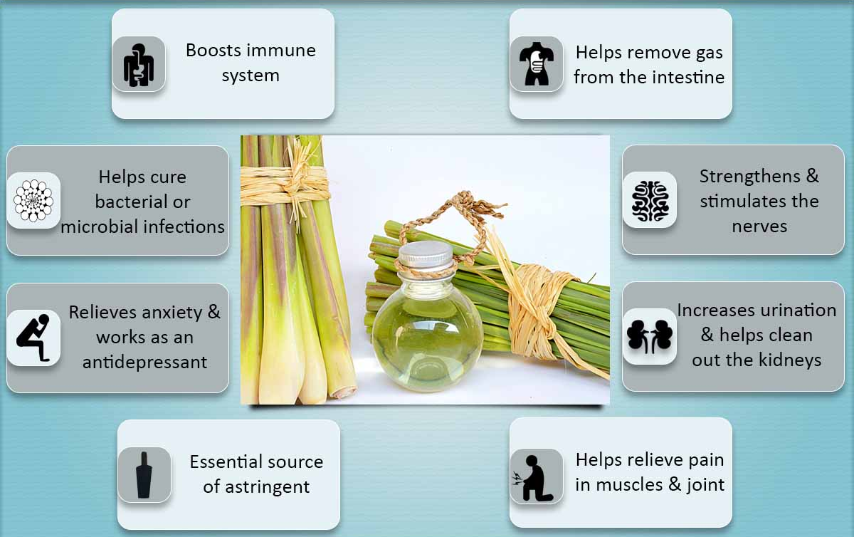
Figure 1: - Beneficial properties of lemongrass, it helps to boost the immune system in humans. Strengthens and stimulates the nerves. Helps cure bacterial or microbial infections. (6)
Lemongrass is a plant widely used in traditional medicine due to its various beneficial properties. The essential oil extracted from lemongrass leaves contains active compounds such as citral and terpenes that contribute to their antibacterial effects. Several studies have reported that lemongrass oil has broad-spectrum antibacterial activity against various microorganisms. Antibacterial activity of lemongrass against environmental microorganisms Several studies have examined the antibacterial activity of lemongrass against various environmental microorganisms. These studies show that lemongrass essential oil has superior antibacterial properties against Gram-positive and Gram-negative bacteria, as well as some fungi. For example, Cymbopogon citratus essential oil has shown high action against a number of Gram-positive bacteria (6). Many biological effects of lemongrass oil have been discovered, including antioxidant and anti-cancer effects (5). The antibacterial effects of lemongrass oil are invaluable not only in the medical field but also in various industrial applications. This comprehensive review focuses on the antibacterial effects of lemongrass oil against a variety of microorganisms. The results of these studies highlight the potential of lemongrass oil as a natural alternative to traditional antimicrobial agents. The results of these studies show that lemongrass oil has major antibacterial action against an array of microorganisms.
Lemon Grass and its Antimicrobial Capabilities
It is believed that the antibacterial effects of lemongrass are due to components such as citral and terpenes. These substances were identified as having antibacterial action against a wide range of microorganisms, including bacteria and fungus.
Antibiotic resistance has become a global health problem, necessitating the search for alternative strategies to combat bacterial infections. Lemongrass has long been known for its therapeutic benefits, including antibacterial activity. Several studies have reported the antibacterial properties of lemongrass extracts against various microorganisms (source). The antibacterial properties of lemongrass extract have been the subject of several studies in recent years. These studies demonstrate that lemongrass extract has potent antibacterial activity against a variety of microorganisms. For example, citronella essential oil extracted from the leaves of Cymbopogon citratus (lemongrass) has been shown to have antibacterial properties against the common fungal pathogen Candida albicans (7). In addition, the presence of essential oils contained in the lemongrass extract contributes to its antibacterial effects. The main compound responsible for the antibacterial effects of lemongrass extract is citral, which is present in large amounts. In addition to antibacterial properties, lemongrass extract also has other biological activities such as anti-cancer and antioxidant properties (5). These properties make lemongrass extract a potential candidate for a variety of uses, including as an herbicide, a food preservative, and for the treatment of orthopedic, muscle, and skin disorders (5).
In addition, lemongrass extract has been shown to have antibacterial activity against Salmonella enteritidis and Listeria monocytogenes. The conflicting results on the antibacterial activity of lemongrass extract against Listeria monocytogenes in Thai Tom Yum spice reported in a study were attributed to differences in extract composition and concentration production is used.
Lemongrass extract exhibits remarkable antibacterial activity against various microorganisms. These findings show that lemongrass extract has the potential to be used as a natural antibacterial agent in a variety of applications. In addition, the presence of citral and essential oils in lemongrass extract further contributes to its antibacterial properties. In addition, further research is needed to understand the specific mechanisms by which lemongrass extract exerts its antibacterial effects and to explore its potential as an alternative to synthetic antibacterial agents. The antibacterial effects of lemongrass extract on various microorganisms have been studied extensively. This study provides valuable insight into the potential of lemongrass extract as a natural antibacterial agent. In addition, studies have shown that lemongrass extract is effective against multidrug-resistant bacteria, with the exception of Pseudomonas aeruginosa. Lemongrass extract is a promising natural antibacterial agent as it exhibits remarkable activity against a wide range of microorganisms, including Candida albicans and Salmonella.
In summary, the antibacterial activity of lemongrass extract has been extensively studied and shown to be effective against a wide range of microorganisms (6). These results suggest that lemongrass extract can be used as a natural antibacterial agent in various applications such as food preservation and medicine. In addition, its effectiveness against drug-resistant bacteria makes it an attractive alternative to synthetic antimicrobials. Overall, research on the antibacterial activity of lemongrass extract highlights its potential as a natural and effective alternative to synthetic antibacterial agents.
Studies on the antibacterial activity of lemongrass extract show that it has great potential as a natural and effective substitute for synthetic antibacterial agents. This is supported by studies showing its effectiveness against a variety of bacteria, including Candida albicans and Salmonella Newport. In addition, the presence of citral and essential oils in lemongrass extract further contributes to its antibacterial properties.
Additionally, using lemongrass extract as a natural antibacterial can also benefit the environment as it reduces our dependence on synthetic chemicals that can negatively impact the ecosystem.
Overall, studies on the antimicrobial activity of lemongrass extract provide valuable insight into its potential as a natural alternative to synthetic antimicrobials.
The antibacterial quality of lemongrass extract against multiple varieties of microorganisms has been extensively studied and proven effective, making it a promising natural alternative to synthetic antibacterial agents. The antibacterial properties of lemongrass extract make it a valuable resource for various applications such as food preservation, medicine, and environmental protection. Essential oils extracted from lemongrass leaves have a wide range of biological activities, including anticancer, antibacterial, antifungal, and antioxidant properties (5).
Impact of Lemon Grass on Environmental Microbes
The antibacterial effects of lemongrass can have a significant impact on the bacteria in the environment. By inhibiting the growth and survival of bacteria and fungi, lemongrass essential oil helps prevent the spread of harmful microorganisms in a variety of environments. This is especially beneficial in environments where microbial contamination poses risks to human health, such as hospitals, food processing factories, and home environments. In addition, using lemongrass oil as a natural antibacterial agent can reduce dependence on synthetic chemicals and antibiotics, contributing to a sustainable and environmentally friendly method of bacterial control.

Table 1: - Impact of Lemongrass extracts/oil against the microbes of the environment (39).

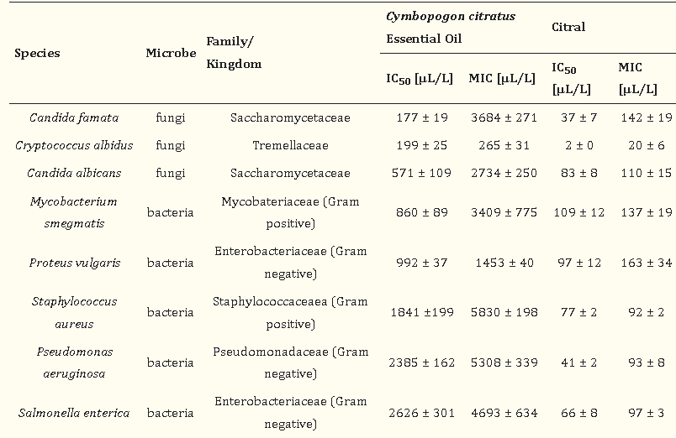

Implications for Further Research on Lemon Grass Antimicrobial Activity
Further study of antibacterial quality of lemongrass extract towards environmental bacteria is warranted. Understanding lemongrass extract and its ingredients
Lemongrass essential oil contains major compounds called ‐citral and ‐citral stereoisomers, as well as myrcene, which contribute to its antibacterial properties. These compounds exhibit antibacterial, antifungal, and insecticidal properties, making lemongrass extract a potential natural alternative to combat microbial growth.
The role of lemongrass extract in fighting germs
Due to its antibacterial properties, lemongrass extract has the potential to be used as a natural substitute for synthetic antimicrobial agents in various applications. Its wide range of biological activities, including antibacterial, antifungal, and antioxidant properties, make lemongrass oil possible for use as a herbicide and food preservative (5). In addition, lemongrass extract has also been used in chiropractic and treatment of muscle and skin problems.
Detailed Review of Antimicrobial Studies
Several studies have investigated the antibacterial effects of lemongrass against various microorganisms in the environment. These studies demonstrate that lemongrass oil has general-purpose antibacterial action against quite a few of pathogens, including Gram-positive as well as Gram-negative bacteria. For example, Cymbopogon citratus essential oil has been shown to be effective against various strains of Gram-positive bacteria (6).
Research on antibiotics plays an important role in understanding and combating the growing threat of drug-resistant infections. Researchers and public health are facing a global crisis due to the emergence and increasing resistance of bacteria (10). According to the Global Report 2021 on Antimicrobial Resistance and Surveillance Systems published by the World Health Organization, antibiotic resistance is among the top 10 global health problems threatening humanity (10).
The impact of antibiotic resistance is particularly pronounced in resource-poor countries, where bacterial infections are common and antibiotics play an important role in infectious disease control (9). To prevent the emergence of resistance, it is important to monitor drug resistance through surveys that regularly document the epidemiology and local prevalence of bacterial resistance (9). Today, the topic of antibiotic resistance is a top priority in the global medical and research community. Antibiotic resistance is a serious problem that needs urgent attention. As the World Health Organization's warning has pointed out, these drug-resistant strains pose a serious threat to human health.
Antibacterial ability: If we don't act today, there will be no cure tomorrow
To meet this urgent need, researchers and scientists around the world are focusing on the development of novel antibacterial agents with well-defined mechanisms of action against bacteria. And less likely to promote further resistance. Increase. Antibiotic research aims to discover new compounds and strategies that can effectively fight drug-resistant infections. One approach is to study natural compounds with antibacterial properties, such as plant extracts and essential oils(28) These studies aim to identify potential alternatives to conventional antibiotics and provide information on their efficacy and safety. In addition, researchers are studying combination therapies that use multiple antibiotics simultaneously to increase effectiveness and reduce resistance. In addition, it is increasingly clear that the judicious use of antimicrobials is critical to preventing the spread of resistant bacteria. In recent years, there has been increasing interest in the reuse of existing substances that were previously used for other purposes but have demonstrated antimicrobial activity(31). The researchers hope to explore these agents and conduct further studies to identify new applications for them in the treatment of drug-resistant infections.
The impact of antibiotic resistance goes beyond individual patients and healthcare settings. It has serious socioeconomic impacts as it can lead to increased health care costs, longer hospital stays, and higher mortality rates. Therefore, it is important to conduct detailed and comprehensive research on antibiotics to ensure their effectiveness in fighting resistant infections(33). These studies play an important role in informing clinical practice and policy decisions regarding the rational use of antibiotics. One notable research in this area is the study of natural products with antibacterial properties. The goal of this study is to look at the potential of natural chemicals like plant extracts and essential oils to give different treatments for drug-resistant sickness(25). These studies examine the antimicrobial activity of various natural compounds against resistant bacteria in the laboratory. The researchers evaluated the potency and potency of these compounds by performing experiments such as agar plate diffusion test and minimum inhibitory concentration test. In addition, in vivo studies are underway to evaluate the safety and efficacy of these natural compounds in animal models. By studying natural compounds, researchers have discovered several promising antibacterial agents. One notable area of ​​research in this area is the study of medicinal plants used in traditional and Ayurvedic medicine. These plants have been used in traditional practices for centuries and are believed to have antibacterial properties. Through rigorous scientific testing, researchers were able to identify specific compounds in these plants that exhibit potent antibacterial activity(27).
Discussion on Microbes of the Environment
The environment is full of microorganisms such as bacteria and fungi. Although these bacteria play an important role in various ecological processes, some species can also pose a threat to human health and well-being.
Infections in people and animals can be caused by harmful bacteria like Staphylococcus aureus and Escherichia coli, as well as fungus like Candida albicans. The antibacterial effect of lemongrass helps control the growth and spread of these harmful microorganisms in the environment. Additionally, other studies have shown that lemongrass oil is effective against keratolytic fungi, ringworm, and food-preserving fungi(24). Given these findings, it is undoubtedly that lemongrass oil shows promise as an organic antibacterial agent for environmental applications. In addition to antibacterial properties, lemongrass essential oil is also an herbicide and insect killer.
Analysis of Lemon Grass's Efficacy against Microbes
Based on the available evidence, it is undoubtedly that lemongrass oil has significant antibacterial activity against various microorganisms found in the environment.
Lemongrass essential oil has been shown to be effective against Aspergillus and Trichoderma fungi, as well as Gram-positive bacteria. Prove. This antibacterial activity may be due to the presence of components such as citral and terpenes that have been shown to have antibacterial properties. This suggests that lemongrass oil can maintain its potency using certain processing techniques(33). The antibacterial activity of lemongrass oil makes it a potential candidate for various environmental applications. For example, it can be used as a natural alternative to traditional chemical pesticides and herbicides. Additionally, lemongrass oil has many bioactivities, including anticancer and antioxidant properties, making it a versatile compound suitable for many applications (5). Overall, the antibacterial activity of lemongrass against microorganisms in the environment makes it a promising natural substitute for a variety of applications.
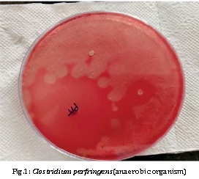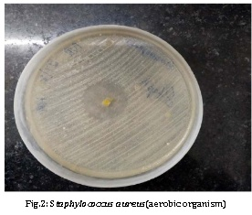
Figure 1and 2: -The extract of lemongrass shows the inhibitory effect against aerobic organisms like staphylococcus aureus and E.coli. Showing 24mm of zone of inhibition and no inhibitory effect against anaerobic organism clostridium perfringens. (Reference-https://www.researchgate.net/publication/348724390_ANTI-MICROBIAL_EFFECTIVENESS_OF_LEMON_GRASS_OIL_CYMBOPOGAN_CITRATE_AGAINST_AEROBIC_AND_ANAEROBIC_ORGANISMS)
The growing threat of antibiotic resistance highlights the need for alternative treatments for bacterial infections. One widely studied solution is the antibacterial activity of lemongrass extract. Several studies have reported the antibacterial properties of lemongrass extract against a variety of microorganisms. For example, a study performed on S. enteritidis showed that the crude ethanol extract of lemongrass had a zone of inhibition of these bacteria of 24 mm, showing significant antibacterial activity. Another study contradicted these results and found that lemongrass in Thai Tom Yum seasoning did not inhibit Listeria monocytogenes bacteria. However, in the present experiment, the results obtained showed the antibacterial activity of lemongrass extract against both types of bacteria. Enterica Enteritidis and L. monocytogenes. This difference in results could be due to different extraction methods, different concentrations of lemongrass extract used, or different strains of microorganisms tested. In addition, according to some sources, citronella oil extracted from the leaves of C. citratus has been shown to have antibacterial properties against a variety of microorganisms. The various antibacterial properties of lemongrass extract make it a promising candidate for an alternative treatment against bacterial infections.
Many studies have suggested that lemongrass extract and its essential oil have significant antibacterial activity against various microorganisms. This antibacterial effect has been demonstrated against bacteria such as Staphylococcus aureus, Streptococcus mutans, Porphyromonas gingivalis and Prevotella intermedia(26). In addition, lemongrass extract also showed inhibitory effects on fungi and yeasts. These findings emphasis lemongrass extract's usefulness as an organic antibacterial agent. The antibacterial activity of lemongrass extracts against various microorganisms in the environment has been studied extensively. Several studies have reported inhibitory and bactericidal effects of lemongrass extract against microorganisms such as Staphylococcus aureus, Streptococcus mutans, Porphyromonas gingivalis, and Prevotella intermedia. The antibacterial activity of lemongrass extracts against these microorganisms was observed at concentrations ranging from 100% to 0.025%. Moreover, lemongrass extract has not only antibacterial properties but also other biological activities such as anticancer, antifungal, and antioxidant. Taken together, the results of these studies suggest that lemongrass extract has significant antibacterial activity against a variety of microorganisms(29).
The Role of Lemon Grass in Environmental Health
The antibacterial properties of lemongrass oil make it a valuable tool for promoting environmental health. By effectively inhibiting the growth of harmful bacteria and fungi, lemongrass essential oil helps prevent the spread of infections and diseases in various environments. This natural antibacterial agent can be used in many applications, including disinfecting surfaces, treating water sources and controlling microbial growth in agriculture. In addition, (12) Lemongrass oil can be used as a natural substitute for synthetic herbicides and pesticides. Its effectiveness against keratolytic, ringworm and food preservation fungi open up potential applications in maintaining the health and safety of environments such as hospitals, food processing plants, and agricultural land. Further studies (24) should also examine the mechanism of action of lemongrass oil against different microorganisms to better understand its antibacterial properties. Additionally, more research is needed to determine the optimal concentration and formulation of lemongrass oil for different uses. As the antimicrobial potential of lemongrass oil is better understood, its effects can be exploited to develop green and sustainable solutions to combat pathogenic bacteria in a variety of environments. Harnessing the antibacterial properties of lemongrass oil could help create a cleaner, safer environment for human health and agricultural productivity.
Conclusion: Future Implications of Lemon Grass Antimicrobial Use
CONCLUSIONS AND FUTURE POINTS In conclusion, lemongrass essential oil has strong antibacterial action against an extensive number of environmental microorganisms. More research is needed to fully explore the potential of lemongrass oil as an antibacterial agent and to optimize its effectiveness in different environments.
Based on the findings of past research and our own, it is obvious that lemongrass oil has substantial antibacterial action against an extensive number of microorganisms prevalent in the environment. These findings emphasis lemongrass oil's potential as a natural and effective alternative to synthetic antibacterial agents. The continued research and development of antibacterial products based on lemongrass essential oil may lead to the development of environmentally friendly disinfectants, herbicides, and pesticides. In summary, the antibacterial effect of lemongrass against various environmental microorganisms has been well documented. These studies show that lemongrass essential oil is effective against Gram-negative and Gram-positive bacteria, as well as yeast and fungi. This non-selective activity makes lemongrass oil a valuable tool in fighting bacterial and fungal infections in the environment. Additionally, lemongrass oil has been shown to have herbicide and insecticidal effects, suggesting its potential for broader environmental health applications.
References.
- Ferreira M.S.C., Fonteles M.C. Aspectos etnobotânicos e farmacológicos do Cymbopogon citratus Stapf (capim limão). Revista Brasileira de Farmácia 1989; 70:94-7.
- Naik, M.I., Fomda, B.A., Jaykumar, E., & Bhat, J.A. (2010). Antibacterial activity of lemongrass (Cymbopogon citratus) oil against some selected pathogenic bacterias. Asian Pacific Journal of Tropical Medicine, 3, 535-538
- Mu’azu, K et al. (2019, April 17). Process intensification of lemongrass oil in a pilot plant.
- Luque, P.A., Soto-Robles, C.A., Nava, O. et al. Green synthesis of zinc oxide nanoparticles using Citrus sinensis extract. J Mater Sci: Mater Electron 29, 9764–9770 (2018).
- Mangalagiri, N. P., Panditi, S. K., & Jeevigunta, N. L. L.. (2021, April 1). Antimicrobial activity of essential plant oils and their major components.
- Tyagi, A. K., & Pant, K. K... (2012, January 1). Morphostructural Damage in Food-Spoiling Bacteria due to the Lemon Grass Oil and Its Vapour: SEM, TEM, and AFM Investigation.
- Alajmi, R. Z., Alfouzan, W. A., & Mustafa, A. S.. (2023, April 21). The Prevalence of Multidrug-Resistant Enterobacteriaceae among Neonates in Kuwait.
- Rosana, Y., Kiranasari, A., Ningsih, I., Kadarsih, R., & Wahid, M. H... (2007, February 1). Patterns of bacterial resistance against Ceftriaxone from 2002 to 2005 in the Clinical Microbiology Laboratory of the Faculty of Medicine, University of Indonesia.
- Minasari, & Nasution, D. L.. (2018, January 1). The Effectivity of Lemongrass (Cymbopogon Citratus) Extract Against Porphyromonas Gingivalis ATCCr 33277t (IN-VITRO).
- Gupta B K (1969), 'Studies in the Genus Cymbopogon Chromosome studies in Indian Cymbopogon', Proc. Ind. Acad. Sc., 70, 241-247
- Thappa, R.K., Bradu, B.L., Vashisht, V.N.andAtal, C.K. (1971). Screening of Cymbopogon species for useful constituents. Flavour Industry, 2(1): 49-51.
- Barnes, J., L.A. Anderson, S. Gibbons, J.D.Phillipson. 2005. Echinacea species (Echinacea angustifolia (DC.) Hell. Echinacea pallid (Nutt.) Nutt. Echinacea purpurea (L.) Moench): a review of their chemistry. Pharmacology and clinical properties. J Pharm Pharmacol. 57:929-954.
- Carlini E.A., Contar J.D.P., Silva-Filho A.R., et al. Pharmacology of lemongrass (Cymbopogon citratus Stapf). I. Effects of teas prepared from the leaves on laboratory animals. J Ethnopharmacol (1986); 17:37-64.
- Alam, K., Agua, T.D., Maven, H., Taie, R.A., Rao, K.S., Burrows, I.G., Huber, M.E., & Rali, T. (1994). Preliminary Screening of Seaweeds, Seagrass and Lemongrass Oil from Papua New Guinea for Antimicrobial and Antifungal Activity.
- Shah, Gagan et al. (2011, January 1). Scientific basis for the therapeutic use of Cymbopogon citratus, stapf (Lemon grass).
- Liu., J.B., Jiang, Yang, Z.X. and Gu, L. (1998). Studies on the chemical constituents of essential oil of Ziangxi cymbopogon by capillary gas chromatography. Mass spectrometry. Jishou daxue Xuebao Ziran Kexueban, 19(3): 43-45.
- Baratta, T., Dorman, H.J., Deans, S.G., Figueirodo, A.C. Barroso, J.G. and Roberto, G. (1998). Antimicrobial and antioxidant properties of some commercial essential oils. Flav Fragr J., 13:235-244.
- Chalchat, J.C., Garry, R. Ph., Harama, M. and Sidibe, L. (1998). Chemical composition of (Numero Special), 741-752. Cymbopogon citratus produced from plants collected in the Ivory Coast Rivista Ital. EPPOS, 16.
- Chisowa, E.H., Hall, D.R. and Farman, D.I. (1998). Volatile constituents of the essential oil Cymbopogon citratus Stapf grown in Zambia). Flav. Fragr. J., 13: 29-30.
- Oberhofer, A., Nikiforov, Buchbauer, G., Jirovetz, L., and Bicchi, C. (1999). Investigation of the alteration of the composition of various essential oils used on aroma lamp application flv. Fragr. J., 14: 293-299..
- Pino, A. and Rosado, A. (2000). Chemical composition ofthe essential oil of Cymbopogon citrates DC. Stapf form Cuba J. Essent. Oil Res., 12: 301-302.
- Chagonda, C. Makanda and Chalchat, J.C. (2000). Essential oils of cultivated cymbopogon winterianus jowitt and of C. citrates from Zimbabwe. J. Essent. Oil Res., 12: 4498-480.
- Kasali, A.A., Oyedeji, A.O. and Ashilokun, A.O. (2001). Volatile leaf oil constituents of Cymbopogon citrates DC. Stapf. Flav Fragr. J., 16: 377-378.
- Brian TS, Ikhlas AK (2002). Comparison of extraction methods for marker compounds in the essential oil of lemongrass by GC.J. Agric. Food Chem.50:1345-1349. Sharma A, Tayung K, (Steud) WATS] inflorescence oil. Indian Perfum. 47:389-393 Baruah AKS, Sharma TC (2003). Antibacterial activity of lemongrass [Cymbopogon fleuosus
- Chand, R., Jokhan, A.D., Gopalan, R.D., & Osborne, T. (2017). Antibacterial and Antifungal Activities of Essential Oils from Medicinal Plants Found in the South Pacific. The South Pacific Journal of Natural and Applied Sciences, 35, 10-19..
- Onawunmi, G.O., & Ogunlana, E.O. (1986). A Study of the Antibacterial Activity of the Essential Oil of Lemon Grass (Cymbopogon citratus (DC.) Stapf).
- Ushimaru PI, Mariama TN, Luiz C, Di Luciano B, Ary FJ (2007). Antibacterial activity of medicinal plant extract. Braz. J. Microbial. 38:717-719.
- Grace. O. Onawunmi & E.O. Oguneana (2008), a study of the antibacterial activity of the essential oil of the lemongrass (Cymbopogon Citratus (D.C) Stapf), 64-68.
- O. Oyedele, Lara O. Orafidiya, A. Lamikanra, J. I. Olaifa, Volatility and Mosquito Repellency of Hemizygia welwitschii Rolfe Oil and Its Formulations, International Journal of Tropical Insect Science.
- Majewska, E., Kozłowska, M., Gruczyńska-Sękowska, E., Kowalska, D.A., & Tarnowska, K. (2019). Lemongrass (Cymbopogon citratus) Essential Oil: Extraction, Composition, Bioactivity and Uses for Food Preservation – a Review. Polish Journal of Food and Nutrition Sciences, 69, 327-341.
- Kumar J, Verma V, Goyal A, Shahi AK, Sparoo R, SangwanRS, Qazi GN, Genetic diversity analysis in Cymbopogon species using DNA markers, Plant Omics Journal, 2, 2009, 20-29.
- Abdulazeez, M.A., Abdullahi, A., & James, B.D. (2016). Lemongrass (Cymbopogon spp.) Oils.
- Viktorová J., Stupák M., Řehořová K., Dobiasová S., Hoang L., Hajšlová J., Thanh T.V., Tri L.V., Tuan N.V., Ruml T. Lemon Grass Essential Oil Does not Modulate Cancer Cells Multidrug Resistance by Citral-Its Dominant and Strongly Antimicrobial Compound. Foods. 2020;9:585. doi: 10.3390/foods9050585.
- Badescu, B., Buda, V., Romanescu, M., Lombrea, A., Danciu, C., Dalleur, O., Dohou, A. M., Dumitrascu, V., Cretu, O., Licker, M., & Muntean, D. (2022). Current State of Knowledge Regarding WHO Critical Priority Pathogens: Mechanisms of Resistance and Proposed Solutions through Candidates Such as Essential Oils. Plants (Basel, Switzerland), 11(14), 1789.
- Inouye, S., Takizawa, T., & Yamaguchi, H. (2001). Antibacterial activity of essential oils and their major constituents against respiratory tract pathogens by gaseous contact. The Journal of antimicrobial chemotherapy, 47 5, 565-73.
- Ayse Usanmaz Bozhuyuk. (2020) Herbicidal Activity and Chemical Composition of Two Essential Oils on Seed Germinations and Seedling Growths of Three Weed Species. Journal of Essential Oil Bearing Plants 23:4, pages 821-831.
- Nguefack, J., Budde, B.B., & Jakobsen, M. (2004). Five essential oils from aromatic plants of Cameroon: their antibacterial activity and ability to permeabilize the cytoplasmic membrane of Listeria innocua examined by flow cytometry. Letters in Applied Microbiology, 39.
- Cimanga, K., Kambu, K., Tona, L., Apers, S., De Bruyne, T., Hermans, N., Totté, J., Pieters, L., & Vlietinck, A.J. (2002). Correlation between chemical composition and antibacterial activity of essential oils of some aromatic medicinal plants growing in the Democratic Republic of Congo. Journal of ethnopharmacology, 79 2, 213-20 .
- Dethier, M., Nduwimana, A., Cordier, Y., Menut, C., & Lamaty, G. (1994). Aromatic Plants of Tropical Central Africa. XVI. Studies on Essential Oils of Five Eucalyptus Species Grown in Burundi. Journal of Essential Oil Research, 6, 469-473.

