Brain Tumor Detection by using Machine Learning and Deep Learning Approach

DK Sahoo*¹, Mihir Narayan Mohanty², Satyasish Mishra³

¹Department of Electronics and Communication Engineering, Centurion University of Technology and Management, Odisha, India. Email: debu452@gmail.com,
https://orcid.org/0000-0003-3047-8630
²Department of Electronics and Communication Engineering, Siksha ‘O’ Anusandan (Deemed to be University), Bhubaneswar, Odisha, India. Email: researchmihir16@gmail.com
³Department of Electronics and Communication Engineering, Centurion University of Technology and Management, Odisha, India. Email: s.mishra@cutm.ac.in

* Corresponding author: Department of Electronics and Communication Engineering, Centurion University of Technology and Management, Odisha, India. Email: debu452@gmail.com

Abstract

The fast detection of brain-tumour contributes an important role in further developing therapeutic outcomes and hence functioning in endurance tolerance. Physically evaluating the various attractive Reversion Imaging (MRI) that are regularly distributed at the center is a problematic cycle. Along these lines, there is a significant need for PC-assisted strategies with improved accuracy for early detection of cancer. PC-based brain cancer detection from MRI images including their growth location, division, and order processes. In recent years, many inquiries have turned to zero in traditional or outdated AI procedures for brain development findings. Presently, there has been an interest in using in-depth learning strategies to detect cerebral growths with excellent accuracy and heart rate. This chapter presents a far-reaching audit of traditional AI strategies and in-depth study methods for diagnosing brain cancer. Also it distinguishes the main benefits reflected in the exhibition estimation measurements of the calculations applied in the detection processes.

Keywords: Brain Tumor, MRI, CT scan, Glioma analysis, Deep learning approach

- Introduction
Cancers develop as an unmanageable and unusual expansion of cells in the parts of the body. The development of unusual growth of cells inside the brain is said to be brain-tumour which is the most common cancer of all types (1). Glioma tumor is an important area for tumor-detection in brain cancer. It is defined as the most effective hostile primary brain tumors, astro-cytomas, oligodendro-gliomas, and high-grade glioblastoma multiform (GBM) (2). Chemotherapy and radiotherapy are some of the methods used to treat gliomas (3). Various medical applications like computerized tomography (CT), single-photon emission computed tomography (SPECT), magnetic-resonance spectroscopy (MRS), positron-emission tomography (PET) with magnetic-resonance imaging (MRI) have been used. For early prognosis of cancer in patients, various computer-aided diagnosis (CAD) systems have previously been introduced for the automatic diagnosis of a scan image for early detection of brain-tumors glioblastoma multiform (4, 5). Gliomas are the primary sort of cancer at present drawing in light of a legitimate concern for cerebrum growth analysts. The term glioma portrays various sorts of gliomas, going from HG (high-grade) cancers, called glioblastoma multiforme (GBM), to poor quality LG (low-grade) cancers, for example, astrocytomas or oligodendro-gliomas. Radiotherapy, Chemotherapy, or other medical procedures might be applied for treatment of gliomas (6).

MRI bestows a detail about the anatomy of human-tissue, as well as considered a common technique because of its wide accessibility with soft-tissue contrast. MRI uses powerful magnetic field of radio frequency signals to obtain images taken from of human brain cells (7, 8). Diagnosis of a brain-tumor involves the differentiation, detection, and classification of tumors. The detection methods are mostly employed to identify tumors from MRI image database, which has been considered as a basic and understandable method. On MRI scans, the brain tumour partitioning algorithms have been employed to localize and distinguish different tumour tissues. The clinical-acceptance of diagnostic system depends upon the extent of the user's observation and calculations (9). The practical uses, however, are still restricted, and despite substantial study, physicians continue to depend on manual tumour forecast, probably due to deficiency of communication between clinicians and researchers.

This chapter contributes an outline of the most key methods currently available to diagnose brain tumors. The survey pivots on the diagnosis of brain tumors using MRI with traditional methods of machine learning and deep learning study. Though there are numerous literature reviews, special attention is paid to a specific process, such as segmentation, classification, or diagnostics (10, 11-13). The present article provides a complete overview to diagnose brain tumor detection and classifications. Additionally, the study involves the application of the classic machine learning and deep learning algorithms. A summary of the progress of the survey is appeared in Figure 1.
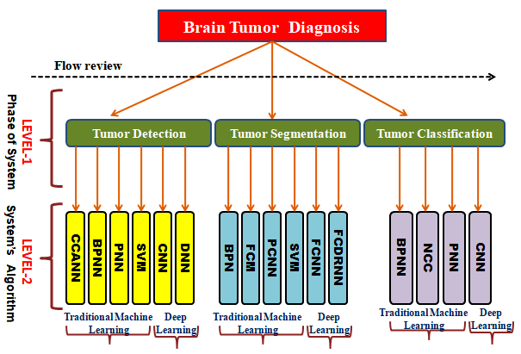
Figure 1. Tumor detection, division and information-level classification processes.
- Objectives
In this study, Machine learning and Deep Learning Approach has been used to analyze the brain tumour detection using in-depth learning strategies to detect cerebral growths.

- Methods

  - Groundwork
Un-sharp masking, median filters, and wiener filters are examples of preprocessing techniques. To safeguard the borders of an image, median filters are typically utilized in the pre-processing step (14).

As shown in Figure 2, the general structure of the CAD (computer-aided-design) system for diagnosing brain tumors using MRI-images includes data acquisition, pre-processing, segmentation, feature exclusion, and feature selection. Data-collection is an activity for obtaining images in the brain necessary for the diagnosis, which can be achieved using diagnostic methods. Many pre-processing approaches are used, like un-sharp masking, veneer-filters as well as median-filters. Median-filters are usually utilized during pre-processing phase to protect the boundaries of an image (15).

Fuzzy C-means pooling (FCM), median shift as well as expectation maximization algorithms are examples of such algorithms. The various extraction techniques such as violet transform, Gabor features, texture-features, boundary-feature extraction, principal component analysis (PCA) and spectroscopy are also used for segmentation of the tumor analysis as described (16-20). Increasing the size of the feature vector significantly reduces the system accuracy. Therefore, feature selection methods have been used in the literature to select the most important features like Genetic Algorithm (GA), Particle Swarm Optimization (PSO), Sequential Inverse Selection (SBS), Principal Component Analysis (PCA) and Sequential Forward Selection (SFS) (21-30).
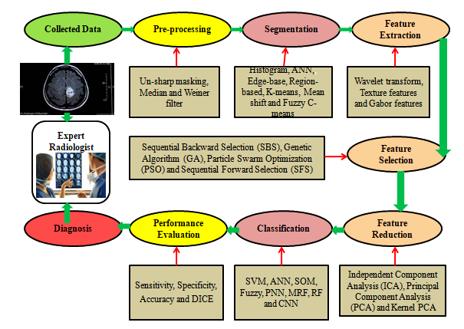
Figure 2. Flowchart of a Computer Aided Diagnosis (CAD) System for Brain Tumours.
  - A clinical perspective on Machine learning
Machine learning has ignited a considerable interest in modern computers in the field of medicine. In the area of brain-tumour recognition, a variety of advanced machine learning approaches are applied. Advanced methods are employed to identify the use of brain pictures and improve the quality of the information collected, such as image labeling, image reconstruction, skull removal and registration (31). As a result, machine learning has enabled clinics, engineers, and computer scientists to collaborate to develop semi-automated and eventually completely automated tumor diagnostic systems with improved accuracy and processing speed. The diagnosis of a semi-automated brain tumor frequently necessitates the manual intervention of radiologists and clinics to start the technology, analyze the results, and fix flaws in the procedure outcomes. Fully automated brain tumor diagnosis, on the other hand, relies on computers systems that employ prior information and human intelligence to complete tumor diagnosis procedures without the need for human interaction (32). These findings show that machine learning diagnostics outperform manual diagnoses in terms of processing-interval, accuracy with efforts of radiologists. Figure 3 displays an example of manual segmentation of a brain tumor by four separate specialists on the same MRI and in the same patient to demonstrate this point.
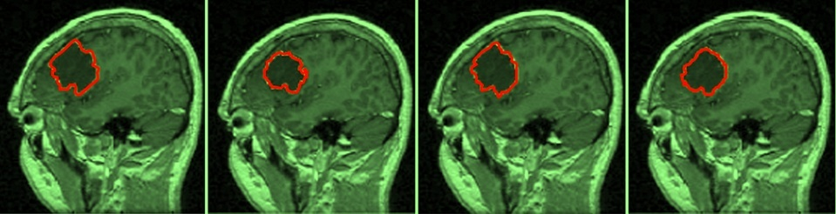
Figure 3. Four independent technicians manually segmented glioma on MRI scans

  - Brain MRI
A multitude of techniques like MRI, SPECT, CT and PET has been used to see the brain images. MRI, which was first used for medical imaging of the brain in nineteen seventy, is now the most widely utilized imaging modality which offers a number of advantages over other visualization techniques, including the ability to provide dependable and rich information. The benefits of MRI in allowing clinicians to diagnose physical problems in the brain are well established. It is, however, pricey, and it is not ideal for persons who are claustrophobic. During MRI imaging, a series of 2D pictures can be used to show the brain's volume in 3D. Each MRI approach contributes to the diagnosis in a different way. The different MRI techniques utilized for the diagnosis i.e. gadolinium contrast enhancement is observed in Figure 4.
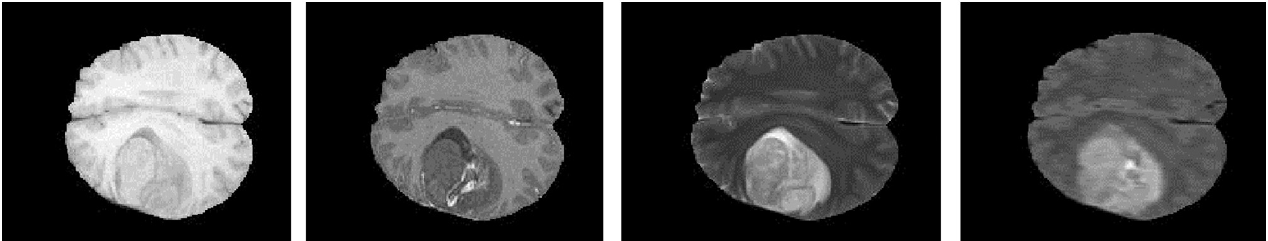
Figure 4. Various MRI-modalities registered to HG glioma: T1 MRI-image, T1-Gd MRI-image, T2 MRI-image and FLAIR MRI-image.
  - MRI database available
The AANLIB data set accessible from Harvard Medical School contains six principle areas: a neuro-imaging preliminary with segments of typical life structures, cerebro-vascular infection, neo-plastic illness, de-generative sickness and provocative illness. The Biomedical Image Analysis (SBIA) is utilized in creating PC based picture examination strategies with diagnosing brain infections like schizophrenia, Alzheimer's illness, chemical imbalance with horrible cerebrum injury. Each strategy should be approved by contrasting a quantitative record and a reality model to gauge the effectiveness. Regularly, a reality model is made by specialists. New techniques can be assessed by radiologists and doctors by utilizing engineered pictures. The different data bases used for the above models are AANLIB, ADNI, Allen Brain Atlas, Brain Web, braindevelopment.org, BRATS two thousand twelve, BRATS two thousand thirteen, BRATS two thousand fourteen, BRATS two thousand fifteen, BRATS two thousand sixteen, BRATS two thousand seventeen, cjdata, RIDER, The IBSR.
  - Deep Learning Model
Research on Deep Learning (DL) uses a Multilayer Neural Network with multiple hidden layers and independent parameters to conduct research. In contrast, in the repeatedly used MNN, each MRIs input has been passed via a convolutional layer, filters, fully connected (FC) layers, pooling layers and ultimately Soft-max to get the final judgment process. Although both the deep learning and regular machine learning belongs to AI technologies, deep learning has some advantages over traditional machine learning methodologies. Furthermore, depending on its structure and kind, each level can execute a variety of activities. Despite the benefits of deep learning, there are certain drawbacks. Despite the benefits of deep learning, there are still some drawbacks, like requirement of generate of complicated architecture and unseen layers, excessive training computational costs, and a huge amount of data to attain the desired training performance (33, 34). Furthermore, these flaws contribute to a longer training period.

As shown in Figure 5, deep learning network structures come in a variety of shapes and names, including convolutional neural networks, deep residual networks, deep feed forward networks, deep belief networks as well as de-convolutional networks. In the realm of image processing, The Convolutional Neural Network (CNN) became frequently used architecture in the area of image processing. The majority of its structure is made up of an input layers, feature extraction levels, convolutional layers, pooling layers with classification layers (35).

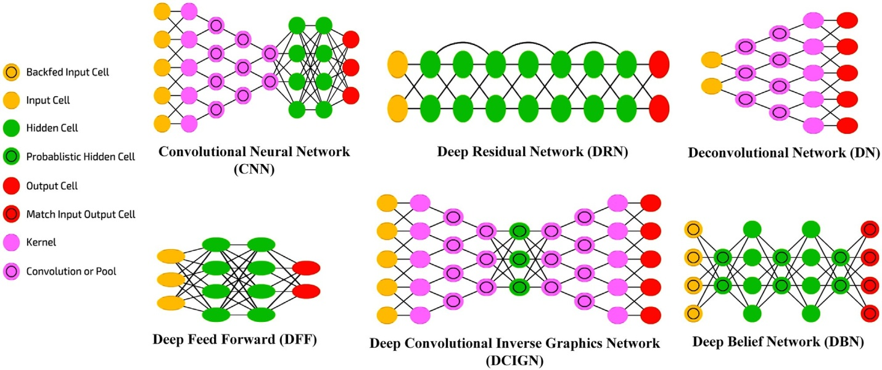
Figure 5. Neural Network Common Charts.
Deep learning techniques, particularly CNNs, have grown in favour of diagnosing brain imaging; As a result, deep learning is preferred over traditional machine learning methodologies. From brain MRI data, CNN learns recurring complicated properties, letting the focus to shift away from identifying and minimizing elements and onto network architecture design (36). Patches extracted from brain MRIs have been fed to the Convolutional Neural Network as input with representative complex features are recovered using local sub-amplification and bespoke filtering filters.

  - Diagnosis of a brain tumour
Many experts in the field of medical tomography made tremendous progress in the identification of brain tumours in recent years with both fully automatic and semi-automatic tactics. Diagnostic strategies' clinical acceptance is determined by their ease of computation with degree of monitoring. As appeared in Figure 2, brain tumour recognition could be divided into three stages: tumour detection, differentiation as well as classification that have all been clarified in detail in this section. There are additional performance distinctions for the given technology.

  - Detection of Tumour
The method of recognizing the absence or presence of tumor from MRI data base is called tumor detection. Diagnosis of brain tumour for its abnormality leads to benign and malignant types plays an essential role in medical field. Different techniques like ANN, SVM, KNN, and FFBPNN are adopted to recognize the abnormal and normal tumor by using MRI image. The most prevalent strategies are represented in Figure 2 with various diagnosis methods are summarized in Table 1. It shows the classification model, features used dataset and measurement of performance. A normal big data base is required to train the classifier as well as get the optimum feature extraction with detection approach for best detection method.

Table 1. MRI Brain Tumour Detection Using Machine Learning Techniques.
Reference | Review extraction | Methods of detection | Used data | Limitations
[1] | DWT | FPANN and KNN | AAN LIB | New-training sets are required.
[2] | 2D-DWT | BPNN | AANLIB | New training sets are required.
[3] | 2D-DWT | PNN | AANLIB | With each database modification, a new training set is necessary.
[4] | 2D-DWT | SVM | AANLIB | Other features are ignored in favour of computing the wavelet-energy feature.
[5] | DWT | SVM | AMDI, in Bertam, Pulau | Researchers suggest that choosing a small number of good texture elements is preferable than explaining how to do so.
[6] | SCICA and ICA | ICA, SC-ICA and SVM | MNI | Over clustering is caused by a low threshold, which raises the cost in feature-extraction.
[7] | DWT-features | SVM | AMDI | The classification error is increased by a large feature vector.
[30] | Gray scale, symmetry and texture | SVM | Randomly selected | SVM was trained on 46 MRI pictures (the majority of the dataset) to improve accuracy.
[8] | PSO based algorithm | PSO | Different hospitals (North India) | Method is problematic; some samples are incorrectly classified.
[9] | Grayscale, symmetry and texture feature | SVM, KNN and SVM-KNN | Brain Web | Due to changes in the dataset, a new training set is necessary; feature extraction is hard.
[10] | Texture-feature | ANN, KNN | AANLIB | There is no mention of the algorithm employed in the feature extraction stage.
[11] | DWTS GLDM | GASVM | AANLIB | Because the system is a complex one, it takes longer to compute.
[12] | LaV | KNN and CFCM | - | The cluster was mistakenly assigned to non-CSF pixels.
[13] | DWT | BPNN | CIPR | Stage of training that takes a long time.
[14] | Texture feature | BPN and RBFN | PSGIMS | Due to the minimal database size, performance is poor.
[15] | DWT | FFBPNN | AANLIB | Specificity is low.
[16] | GLCM | Hybrid neuro-fuzzy system | Brain Web AANLIB | Specificity is low.
[17] | DWT | KSVM | Randomly selected | Some characteristics aren't discussed at all.
[18,19] | DTDAUB-4 | SVM | AMDI, in Malaysia | Feature vectors were decreased without mentioning the features that were chosen or why they were chosen.
[20,21,22] | GLRLM | SVM, FCM | Different medical centers | The system is applied in a non-standard data base and is complex due to the skull stripping stage; the testing dataset is smaller than the training dataset, which improves accuracy.
[23,24] | Energy, entropy, contrast, homogeneity, correlation | Neuro-fuzzy | Brain Web | The database is quite modest.
[25,26] | GLCM | SMO | PSGIMS, Coimbatore | It's a little dataset.
[27] | Texture, GLCM | LSSVM | BRATS, 2013 | The performance will hampered with a small number of specified-features.
[28] | GLCM | LVQ, SOM, MLP and RBF classifier | UKM Medical | Due to intricacy of the system, it takes a long time to compute.
[29,30] | ICA | SOM neural network | Randomly selected | A smaller dataset may yield better results.
[31,32] | DWT | KNN, Parzen window and ANN | AANLIB and LONI | The method can only be used on T2 pictures and has a high level of classification difficulty.
[33] | Gabor-wavelets | CCANN | Diagnostic centers | The database is quite modest.
[34] | Intensity-texture | PCNN, BPN | - | The system has a high level of complexity due to the training and testing.
[35] | CNN | ECOC-SVM | RIDER | There are several layers, which adds to the system's complexity.
[36] | DWT | DNN | AANLIB | The database is quite modest.

  - Tumour identification with traditional machine learning process
There are several machine learning methodologies and methods to detect brain tumours by utilizing MRIs. During the discovery phase, an artificial feedback neural-network and KNN are used. Three features are extracted using wave let entropy based spider-web plots.

  - Segmentation of tumours
Division is the most common way of isolating an image into ROI to make easier the portrayal, outline with representation of the information. The objective in division of image is to vary the portrayal to became more signiﬁcant with more straightforward to investigate as far as the location and limits of cancers (37). Division isolates the growth tissues, for example, edema and necrotic from ordinary tissues, like dark matter (GM) and white matter (WM) as displayed in Figure 6. Furthermore, tumour segmentation algorithms depend on picture intensity similarities with differences. The intensity segmentation approach divides an MRI picture into sections based on differences in intensity, by dividing the sections depending on a set of specified parameters like those boundaries.

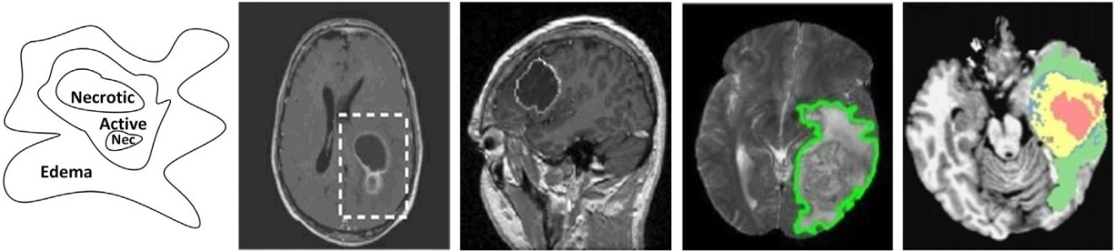
Figure 6. MRI modalities were segmented using several strategies.

Table 2 compares different segmentation strategies and methodologies depending on their performance and constraints. To improve segmentation performance, preliminary knowledge and artificial-intelligence are required. Deep learning approaches deliver the highest performances.
Table 2. Different MRI Approaches for Segmenting Brain Tumours.
Reference | Review extraction | Methods of detection | Used data | Limitations
[37] | GLCM | Neuro-fuzzy logy | Radiology Department(Tata Memorial) | For entire photos, dynamic change cannot be enhanced.
[38] | DCT | PNN | - | Only a few pictures were used to train and test the network. Due to the use of three approaches for feature extraction.
[39] | Gabor texture features | SVM | -
[40] | Grayscale, LoG and texture features | ANN | PGIMER | Performance measured with respect to individual class-accuracy.
[41] | DWT | KSVM | Non standard database | A conventional database is not used in this method.
[42] | Centralized moment calculations | NCC | AANLIB | There are only a few photos utilized.
[43] | Binary-feature extraction | BP-ANN | Medical-City of Martyr GhaziAl-hariri | There is no explanation for FS.
[44] | Supervised FS | SLPANN | INTERPRET | The accuracy of SLPs was improved by training them with the entire dataset.
[45] | CNN | CNN | BRATS2014 | Classification by grade.

  - Traditional machine learning used in tumor segmentation
A number of machine learning algorithms as well as methodologies are obtainable for partition of brain tumour utilizing MRIs data. The identification to present an automated brain tumour partitioning method. In this method, a registered brain book-map has been utilized to find out malignant areas, and therefore strong estimations have also been utilized. Shape and position restriction have been applied into the newly discovered tumour.

  - Tumor segmentation with Deep learning technique
Deep neural network (DNN) and Convolutional Neural Network (CNN) to reveal brain tumour localization with a dice score of 0.88. Two-pathway design has been adopted to train CNN efficiently using local facts and global context. The use of graphical processing unit (GPU) reduces segmentation time by a significant amount. A classification-based segmentation strategy based on deep learning networks. A stacked auto encoder network captures the features from classifies and input image patches to map a binary image. A morphological filters are then be utilized to construct the partitioned tumour.

  - Classification of tumours
The way of allocating different input information elements into various groups is classiﬁcation. Highlight extraction with choice became vital in classiﬁcation, especially cerebrum growth classiﬁcation that need numerous MRI checks collected from various database for preparation. The primary goal of the brain tumour categorization is to establish whether a tumour is benign or malignant, as well as its grade, utilizing MRI imaging. Brain tumours can also be classified using supervised techniques like SVM, KNN and ANN, as well as unsupervised techniques like FCM and SOM (38). The most often used strategies are summarized in Figure 2. Brain tumours can be classified in a variety of ways using magnetic resonance imaging (MRI).Table 3 examines the feature types, classification procedure, and performance of several classification strategies and approaches. The extraction of an optimal classification feature set, which is a difficult task procedure that involves the selection of the best classifier, is required to obtain the best classification.

Table 3. Brain Tumour Classification Techniques Using MRI
Reference | Review extraction | Methods for detection | Used data | Limitations
[7] | ROI histogram, co-occurrence matrices, and run-length matrices | LSFTPNN | Hellenic Air-Force Hospital | The method of external-cross validation has a lo- discriminatory accuracy.
[16] | Thresholding methods | Approximate reasoning- | - | Computational-cost, complexities and optimization are very high.
 |  | method
[19] | Boot strap sampling | Shelf classifier | INTERPRET | Various diseases and pathological groupings are involved in a number of concerns.
[23] | GLCM | Neuro-fuzzy logy | Department of Radiology(Tata Memorial) | For entire photos, dynamic change cannot be enhanced.
[33] | DCT | PNN | - | Only a few pictures were used to train and to test the net-work.
[35] | Gabor texture-features | SVM | - | Due to the use of three approaches for feature extraction, the system complexity has increased.
 |  |  |  | The process of extracting and selecting features is not discussed.
[41] | 7 texture features | MK-SVM | CHU de Caen | The use of FDCT to dis-sect the in-put image adds to the complexities because the data set is nonstandard
[43] | GLCM | PNN-RBF | -
[44] | CNN | CNN | BRATS2014

  - Tumor classification using traditional machine learning
For brain tumour classification using MRI scans, a variety of machine learning approaches and methodologies are available. In MRI scans, a software approach is used to distinguish between metastatic and basic brain cancers. The authors used a nonlinear LSFT in conjunction with a probabilistic neural-network-classifier (MPNN) that has been modified. With a window size of one-one-one-one pixels, PCA is used to limit the number of FS features to ten. The tumour region is classified using a multi-kernel SVM (MKSVM) (39, 40, 41). To improve the contour of the tumour zone, the distance and greatest probability measurements are used.

  - Tumor categorization with deep learning
A deep-learning method for brain-tumour classification is a very young field of study, with little contributions to date. A deep learning-based brain tumour categorization strategy was suggested by different researchers. A CNN's performance is compared to that of a back propagation neural network in terms of sensitivity and specificity. According to the findings, utilising the CNN enhanced the outcomes by eighteen to twenty percentages.

- Results
In the domain of medical imaging, brain tumours are still a popular issue. This research gives a thorough summary of the most up-to-date technology for diagnosing brain tumours. The tumor detection is the method for detecting the absence or presence of brain tumours applying MRI-scans. Multiple pictures require further examination using tumour segmentation and classification approaches as a result of the finding process. Tumor classification involves using HG or LG or tissue analysis to determine whether a tumour is malignant or a specific type of malignant tumour. The majority of the methods considered are for semi-automated and automated tumour diagnosis. Furthermore, the majority approach of them is being pre-processing, extraction of feature, feature-reduction, segmentation and classification. The level should be lowered down because most algorithms are sensitive to sound. KSVM, SVM, LVQ, NCC, PSO, SMO, MLP, FFBPNN, BPNN, SOMNN, PNN, PNN-RBF, ANN and SVM-KNM, as well as SC-ICA, SRC, FCM, ULDA, LSFT, FHNN and CNN use these detection, classification, and segmentation methods (42, 43).

Pathology and diffusion tensor-imaging (DTI) are used to create an artificial foundation for MRI-images of tumour tissues and edema. Table 1 shows the best results with respect to tumour detection versus efficacy. The best tumour detection versus efficacy scores was employed by standard machine learning techniques to achieve excellent tumour segmentation results. In-depth study technique, as shown in Table 2 and Table 3, had the best classification results for brain tumours, with hundred percentage classification accuracy. In comparison to the preceding methods, this one suffers from a lack of uniform datasets, particularly for tumour recognition and classification and a single application structure (44).

The deep-learning models have recently shown to be effective in the interpretation of medical images, particularly in the identification of brain-cancers. Deep learning net-works have outperformed traditional machine learning methods in terms of accuracy. Furthermore, deep learning networks outperform classical machine learning with sophisticated algorithms when dealing with massive amounts of data. Traditional machine learning methods necessitate sophisticated feature extraction and reduction techniques, which deep learning methods do not.

- Discussion
The primary goal of this analysis was to identify the most significant advances in brain tumour diagnosis to date in terms of tumour detection, differentiation, and categorization. Recognizing and improving the stated benefits and drawbacks could pave the way for future advancements in tumour diagnostics. Metrics like sensitivity, specificity, accuracy, and score will represent how well each approach is performing. Unbalanced research efforts in tumour diagnosis methods were discovered in this study. The majority of research is focused on tumour segmentation and categorization. However, some researchers have looked into using MRI imaging to detect tumours.

Deep learning algorithm is a type of machine-learning process that has more sophisticated-potentialities than typical approaches to machine learning. Deep learning is a novel and crucial research-tool that was identified to increase the performance of classic machine learning approaches. An in-depth examination of MRI images and their features is possible thanks to several layers of representation and abstraction. The current study discovered a scarcity of in-depth tumour detection research, few tumour classification implementations, and more in-depth tumour segmentation training applications (45). This issue is also depicted in Figure 1. This review shows how the correctness of certain scientists in characterizing the dataset, tumour type, and functional parameters of the algorithm, as well as measurements of accuracy, specificity and sensitivity, may be extrapolated in the tables provided. Many data-bases are listed in the Table 1, which contain multiple sorts of photos (normal and abnormal), while others only contain images. There are no databases that contain the fundamental realities of segmentation, typical photos, and all types of tumour images, as shown in Tables 2 and 3, forcing by many researchers to collect photographs from different hospitals and medical facilities. The need of large database from all sorts of brain imaging, including images having both HG and LG glioblastomas as well as different categories of tumours that can be verified as a standard criterion of tumour diagnosis. Overall, the massive MRI-database mentioned earlier, as well as the technology and instruments used in the various states of brain-tumour diagnosis using MRIs, are required to support correct diagnosis. For building competition for the best tools and technologies that can be utilised in a number of ways, a large database is required.

- Conclusion
The three steps of brain tumour detection, segmentation, and classification can be used to construct computational systems for diagnosing cancers from MRI images. When compared to manual procedures, these technologies give enhanced accuracy, volume reduction, and speed. As a result, these techniques have been thoroughly investigated in comparison to classic machine-learning applications and deep-learning methodologies. Various diagnostic applications for MRI-imaging of the brain were investigated in this work study. In addition, based on restrictions and performance criteria, a comparison study was done between traditional machine-learning and deep-learning. Across the three processes, the analysis discovered an im-balance in the utilization of databases and benchmarks. Tumors are separated and classified using standard databases. Traditional machine-learning approaches are being employed to detect cancers; however, incorporating deep-learning technologies into these processes is expected to produce favorable results, as seen below.
- In segmentation, many standard machine learning algorithms have achieved hundred percent maximum accuracy whereas deep-learning methods have achieved a maximum score of 96.8%.
- Deep learning algorithms should not be evaluated with glasses at this time. To classify tumours, researchers used both traditional machine learning and deep learning methods; however both studies achieved 100% accuracy.
- However, in order to minimize computing time, the pros and disadvantages of each approach, as well as the complexity and size of the network, must be considered. Machine learning deployments are generally preferred over deep learning deployments.
- While there is a desire to broaden the use of advanced tumour detection and classification studies, standard tumour detection and classification databases are required.

Reference
- Abd-Ellah MK, Awad AI, Khalaf AAM, Hamed HFA. Classiﬁcation of brain tumor MRIs using a kernel support vector machine. Building Sustainable Health Ecosystems: 6th International Conference on Well-Being in the Information Society, WIS 2016, CCIS 2016; 636: 151–160. https://doi.org/10.1007/978-3-319-44672-1_13.
- El-Dahshan ESA, Mohsen HM, Revett K, Salem A-BM. Computer-aided diagnosis of human brain tumor through MRI: a survey and a new algorithm. Expert Syst. Appl. 2014; 41(11):5526–5545. https://doi.org/10.1016/j.eswa.2014.01.021.
- Neelum N, Sellapan P, Abdul Q, Iftikhar A, Muhammad I, Muhammad S. A Deep Learning Model Based on Concatenation Approach for the Diagnosis of Brain Tumor. IEEE Access, 2020; 1–11. doi:10.1109/ACCESS.2020.2978629
- Nema S, Dudhane A, Subrahmanyam M, Srivatsava N. Rescue Net: An unpaired GAN for brain tumor segmentation. Biomedical Signal Processing and Control. 2020; 55(1): 101641–101652. doi:10.1016/j.bspc.2019.101641
- Ghahfarrokhi S, Sepehr Hamed K. Human brain tumor diagnosis using the combination of the complexity measures and texture features through magnetic resonance image. Biomedical Signal Processing and Control. 2020; 61(2): 102025–102029. doi:10.1016/j.bspc.2020.102025
- Gökay K, Aksahin MF. Brain tumor prediction on MR images with semantic segmentation by using deep learning network and 3D imaging of tumor region. Biomedical Signal Processing and Control, (online) 2021; doi:10.1016/j.bspc.2021.102458
- Rai HM, Chatterjee K, Dashkevich S. Automatic and accurate abnormality detection from brain MR images using a novel hybrid UnetResNext-50 deep CNN model. Biomedical Signal Processing and Control. 2021; 66: 102477. doi:10.1016/j.bspc.2021.102477
- Aghalari M, Aghagolzadeh A, Ezoji M. Brain tumor image segmentation via asymmetric/symmetric UNet based on two-pathway-residual blocks. Biomedical Signal Processing and Control. 2021; 69: 102841. doi:10.1016/j.bspc.2021.102841
- Gordillo N, Montseny E, Sobrevilla P. State of the art survey on MRI brain tumor segmentation. Magn. Reson. Imaging 2013; 31(8):1426–1438. https://doi.org/10.1016/j.mri.2013.05.002.
- Jayadevappa D, Kumar SS, Murty DS. Medical image segmentation algorithms using deformable models: a review. IETE Tech. Rev. 2011; 28(3):248–255. https://doi.org/10.4103/0256-4602.81244.
- Yazdani S, Yusof R, Karimian A, Pashna M, Hematian A. Image segmentation methods and applications in MRI brain images. IETE Tech. Rev. 2015; 32(6): 413–427. https://doi.org/10.1080/02564602.2015.1027307.
- Liu J, Li M, Wang J, Wu F, Liu T. A survey of MRI-based brain tumor seg- mentation methods. Tsinghua Sci. Technol. 2014; 19(6):578–595. https://doi.org/10.1109/TST.2014.6961028.
- Bauer S, Wiest R, Nolte LP, Reyes M. A survey of MRI-based medical image analysis for brain tumor studies. Phys. Med. Biol. 2013; 58(13):R97. https://doi.org/10.1088/0031-9155/58/13/R97.
- Mohan G, Subashini MM. MRI based medical image analysis: survey on brain tumor grade classiﬁcation. Biomed. Signal Process. Control 2018; 39(Supplement C):139–61. https://doi.org/10.1016/j.bspc.2017.07.007.
- Litjens G, Kooi T, Bejnordi BE, Setio AAA, Ciompi F, Ghafoorian M. A survey on deep learning in medical image analysis. Med. Image Anal. 2017; 42: 60–88. https://doi.org/10.1016/j.media.2017.07.005.
- Saini M, Tripathi P, Nath M. A survey on brain tumor identiﬁcation through medical images. Int. J. Adv. Res. Comput. Sci. 2017; 8(7):406–408. https://doi.org/10.26483/ijarcs.v8i7.4296.
- Hu J, Zhou J, Wu X. Non-local MRI denoising using random sampling. Magn. Reson. Imaging 2016; 34(7):990–999. https://doi.org/10.1016/j.mri.2016.04.008.
- Huang J, Chen C, Axel L. Fast multi-contrast MRI reconstruction. Magn. Reson. Imaging 2014; 32(10):1344–1352. https://doi.org/10.1016/j.mri.2014.08.025.
- Qu X, Guo D, Ning B, Hou Y, Lin Y, Cai S. Undersampled MRI reconstruction with patch-based directional wavelets. Magn. Reson. Imaging 2012; 30 (7):964–977. https://doi.org/10.1016/j.mri.2012.02.019.
- Kayvanrad MH, McLeod AJ, Baxter JS, McKenzie CA, Peters TM. Stationary wavelet transform for under-sampled MRI reconstruction. Magn. Reson. Imaging 2014; 32(10):1353–1364. https://doi.org/10.1016/j.mri.2014.08.004.
- Xing XX, Zhou YL, Adelstein JS, Zuo X-N. PDE-based spatial smoothing: a practical demonstration of impacts on MRI brain extraction, tissue segmentation and registration. Magn. Reson. Imaging 2011; 29(5):731–738. https://doi.org/10.1016/j.mri.2011.02.007.
- Balafar MA. Gaussian mixture model based segmentation methods for brain MRI images. Artif. Intell. Rev. 2014; 41(3):429–39. https://doi.org/10.1007/s10462-012-9317-3.
- Maier A, Syben C, Lasser T, Riess C. A gentle introduction to deep learning in medical image processing. Z. Med. Phys. 2019; 29(2):86–101. https://doi.org/10.1016/j.zemedi.2018.12.003.
- El-Dahshan ESA, HosnyT, SalemABM. Hybrid intelligent techniques for MRI brain images classiﬁcation. Digit. Signal Process. 2010; 20(2):433–441. https://doi.org/10.1016/j.dsp.2009.07.002.
- Saritha M, Joseph KP, Mathew AT. Classiﬁcation of MRI brain images using combined wavelet entropy based spider web plots and probabilistic neural net-work. Pattern Recogn. Lett. 2013; 34(16):2151–2156. https://doi.org/10.1016/j.patrec.2013.08.017.
- Mohsen H, El-Dahshan ESA, El-Horbaty ESM, Salem ABM. Classiﬁcation using deep learning neural networks for brain tumors. Future Comput. Inf. J.2018; 3:68–71. https://doi.org/10.1016/j.fcij.2017.12.001.
- Soltaninejad M, Yang G, Lambrou T, Allinson N, Jones TL, Barrick TR. Automated brain tumor detection and segmentation using super pixel-based extremely randomized trees in FLAIRMRI. Int. J. Comput. Assist. Radiol. Surg. Feb2017; 12(2):183–203. https://doi.org/10.1007/s11548-016-1483-3.
- Abdel-Maksoud E, Elmogy M, Al-Awadi R. Brain tumor segmentation based on a hybrid clustering technique. Egypt. Inf. J. 2015; 16(1):71–81. https://doi.org/10.1016/j.eij.2015.01.003.
- Tustison NJ, Shrinidhi KL, Wintermark M, Durst CR, Kandel BM, Gee JC. Optimal symmetric multimodal templates and concatenated random forests for supervised brain tumor segmentation (simpliﬁed) with ANTsR. Neuro informatics Apr2015;13(2):209–225. https://doi.org/10.1007/s12021-014-9245-2.
- Nabizadeh N, Kubat M. Brain tumors detection and segmentation in MR images: Gabor Waveletvs. Statistical features. Comput. Electr. Eng.2015; 45(Supplement C):286–301. https://doi.org/10.1016/j.compeleceng.2015.02.007.
- Huang M, Yang W, Wu Y, Jiang J, Chen W, Feng Q. Brain tumor segmentation based on local independent projection-based classiﬁcation. IEEE Trans. Biomed. Eng. 2014;61(10): 2633–2645. https://doi.org/10.1109/TBME.2014.2325410.
- Khayati R, Vafadust M, Towhidkhah F, Nabavi SM. A novel method for auto-matic determination of diﬀerent stages of multiples clerosis lesions in brain MRFLAIR images. Comput. Med. Imaging Graph. 2008; 32(2):124–33. https://doi.org/10.1016/j.compmedimag.2007.10.003.
- Lin GC, Wang WJ, Wang CM, Sun SY. Automated classiﬁcation of multi-spectral MR images using linear discriminate analysis. Comput. Med. Imaging Graph. 2010; 34(4):251–268. https://doi.org/10.1016/j.compmedimag.2009.11.001.
- Akram MU, Usman A. Computer aided system for brain tumor detection and segmentation. International Conference on Computer Networks and Information Technology 2011. 299–302. https://doi.org/10.1109/ICCNIT.2011.6020885.
- Badran EF, Mahmoud EG, Hamdy N. An algorithm for detecting brain tumors in MRI images. 2010 International Conference on Computer Engineering and Systems (ICCES) Nov 2010. 5: 368–373. https://doi.org/10.1109/ICCES.2010.5674887.
- Havaei M, Jodoin PM, Larochelle H. Eﬃcient interactive brain tumor segmentation as within-brain kNN classiﬁcation. 2014 22nd International Conference on Pattern Recognition 2014. 556–561. https://doi.org/10.1109/ICPR.2014.106.
- Li Y, Jia F, Qin J. Brain tumor segmentation from multi modal magnetic resonance images via sparse representation. Artif. Intell. Med. 2016; 73(Supplement C):1–13. https://doi.org/10.1016/j.artmed.2016.08.004.
- Rajendran A, Dhanasekaran R. Enhanced possibilistic fuzzy means algorithm for normal and pathological brain tissue segmentation on magnetic resonance brain image. Arab. J.Sci.Eng.2013; 38(9):2375–2388. https://doi.org/10.1007/s13369-013-0559-4.
- Pereira S, Oliveira A, Alves V, Silva CA. On hierarchical brain tumor segmentation in MRI using fully convolutional neural networks: a preliminary study. 2017 IEEE5th Portuguese Meeting on Bioengineering (ENBENG) Feb 2017. 1–4. https://doi.org/10.1109/ENBENG.2017.7889452.
- Pereira S, Pinto A, Alves V, Silva CA. Brain tumor segmentation using convolutional neural networks in MRI images. IEEE Transactions on Medical Imaging 2016; 35(5):1240–1251. https://doi.org/10.1109/TMI.2016.2538465.
- Prastaw, M, Bullitt E, Gerig G. Simulation of brain tumors in MR images for evaluation of segmentation eﬃcacy. Med. Image Anal. 2009; 13(2): 297-311. https://doi.org/10.1016/j.media.2008.11.002.
- Javid SMA, Buzdar SA. A novel computer aided diagnostic system for quantification of metabolites in brain cancer, Available online 12 February 2021, https://doi.org/10.1016/j.bspc.2020.102401.
- Raymundo Cassani, Falk TH. Alzheimer’s Disease Diagnosis and Severity Level Detection Based on Electro encephalography Modulation Spectral “Patch” Features, IEEE Journal of Biomedical and Health Informatics, 2020; 24(7): 455-461.
- Lundervold AS, Lundervold A. An overview of deep learning in medical imaging focusing on MRI, Zeit. Med. Phys. (2019; 29 (2): 102–127, http://dx.doi.org/10.1016/j.zemedi.2018.11.002.
- Razzak MI, Naz S, Zaib A. Deep learning for medical image processing: overview, challenges and the future. Classiﬁcation in Bio Apps: Automation of Decision Making Cham. 2018; 5686: 323–350.https://doi.org/10.1007/978-3-319-65981-7_12.

