Synthesis and Characterization of Zn_{1-x}Al_{x}O oxide Nanomaterials
Abstract
Aluminium (Al) substituted zinc oxide (ZnO) nanopowders with various proportions Zn_{1-x}Al_{x}O were synthesized by the co-precipitation method. All the samples were characterized using X-ray diffraction (XRD), Fourier Transform Infrared spectroscopy (FTIR), and scanning electron microscopy (SEM) confirming a single crystalline phase with a wurtzite structure. The effect of Al doping amount in ZnO samples has decreased average crystallite size and increased dielectric constant and electrical conductivity. The results of dielectric measurement indicate that the parameters dielectric constant, k, and dielectric loss, tanδ were decreasing with increasing of frequency.
Keywords: Nanostructures; Coprecipitation; Dielectric constant; Dielectric loss; Electrical conductivity;

Introduction
The field of nanotechnology plays a dominant role in several areas like electronics, medical technologies, etc. The changes in material properties at the nanometer scale has been explained in several ways by many researchers, that are used to develop novel, multifunctional nanomaterials suitable for device applications. Zinc oxide material attracted many researchers due to its several optical applications, such as solar cells, LEDs, photodetectors, spintronics, sensors, photocatalysis, etc. ZnO exists in three crystalline structures, namely cubic zinc blend, rock salt, and hexagonal wurtzite, among which the hexagonal wurtzite-type structure is the most stable at room temperature.
Due to large energy band gap, transparency to visible light (400-700 nm), and some of the properties of ZnO such as optical, acoustic, and electrical, it is employed in many applications. ZnO has been synthesized by many methods including the wet chemical method, hydrothermal method, chemical vapor deposition, etc. Transparent conducting materials such as indium oxide with other dopants have been developed so far, for many optical applications.
As an alternative approach, Al-doped ZnO has been developed in the current work due to its favourable properties like non-toxic, easy availability, environmental stability, cost-effectiveness, etc. The structural and morphological characterization was studied. The Al doping effect on electrical and dielectric properties was analyzed and reported.
- Experimental
Samples of ZnO with Al dopant having proportions, (Zn_{1-x}Al_{x}O, x=0, 0.01, 0.03, 0.05, 0.07, 0.09, 0.1), were synthesized by co-precipitation method. The starting materials used were Zn (NO₃)₂6H₂O and NaOH solution. Zinc nitrate of 0.3 M solution was prepared by dissolving Zn (NO₃)₂6H₂O in 100 ml of distilled water by continuous stirring. 0.3 M NaOH solution was added, then, dropwise. The stirring process was continued for 2 h at 75ºC and then cooled to room temperature. The resultant precipitate was filtered and washed with distilled water several times. Finally, the precipitate was again dried at 100ºC for 24 h and then calcinated at 700ºC for 3 h. Al (NO₃)₃9H₂O was added to zinc nitrate in different amounts from 0.01 to 1 mol%. The samples are named as ZnO, ZA01, ZA03, ZA05, ZA07, ZA09, and ZA1 for different wt% loading concentrations of Al (x=0, 0.01, 0.03, 0.05, 0.07, 0.09, 0.1), respectively. The doped samples were characterized using XRD (Philips PW-1730), FTIR (Brucker tensor 27), and SEM (LEICA, S440i, UK). The pellets of 10 mm diameter and 3 mm thickness were made from the sample powders and then sintered at 1100ºC for 3 h. The two surfaces of sintered pellets were coated with silver paste and then studied dielectric properties using a PSM1700 meter frequency response analyzer, Newton 4th Ltd.
- Results and Discussions
XRD patterns of ZnO samples doped with Al in different concentrations are shown in Fig. 1. The fig. shows characteristic peaks of zinc oxide with indexing (100), (002), (101), (102), (110), (103), (112), and (201) which correspond to hexagonal wurtzite structure of ZnO. In the fig., no XRD peaks related to secondary phases of Al₂O₃ or other impurities are observed which confirms the diffusion of Al³⁺ in ZnO. The figure depicts the shifting of diffraction characteristic peaks to higher angles with increasing dopant levels of Al³⁺. The crystallite size was calculated from relative intensity levels of peaks using the Scherrer equation.
$$D=kλ/(β cosθ)$$
Where, D is the average crystallite size, 𝛽 is the full width at the half maximum of the diffraction peak, 𝛉 is the Bragg angle, 𝜆 is the wavelength of the X-ray used and k is a constant.
Table 1 gives the average crystallite size of all samples and lattice parameters. Average crystallite size was found to decrease with the increase of Al doping which reveals the fact that Al³⁺ ions replaced Zn²⁺ ions successfully in the ZnO crystal structure.
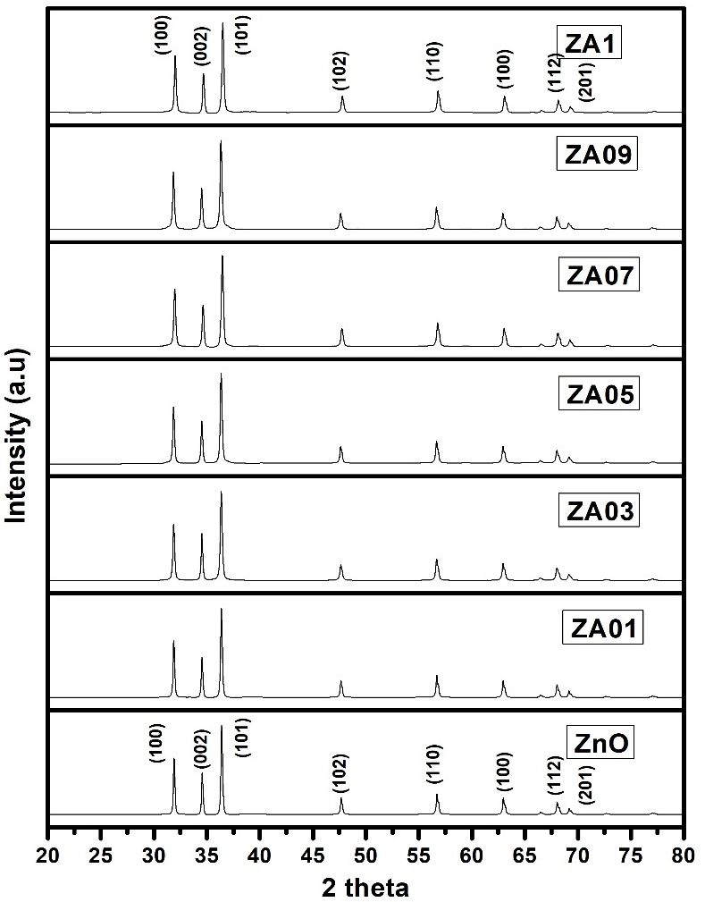
Figure 1. XRD patterns showing ZnO and ZnO nano-particles doped with Al.

ZnO doped with Al samples was analyzed by FTIR in the region 4000-400 cm⁻¹ and the spectra are shown in the fig.2. The absorption band observed between 3417 and 3479 cm⁻¹ , as seen from the fig., is attributed to OH group stretching vibrations which reveals the presence of H₂O on the surface of the samples. Zn-O stretching vibration, which supports the ZnO wurtzite structure formation, corresponds to the band near 500 cm⁻¹ in the fig. The bands near 2350 cm⁻¹ and 1445 cm⁻¹ are ascribed to CO₂, which is absorbed by metal cations from the atmosphere. The band of Al-O can be seen near 683 cm⁻¹ in the fig. The shift in the spectra of doped samples, as shown in the fig., may be due to crystal perturbation created by Al atoms into the crystalline lattice sites. The band around 445 cm⁻¹ , can be assigned to the Zn-O bond which is seen in all the samples. The bands near 960 cm⁻¹ with weak intensity and 1122 cm⁻¹ with strong intensity are found to increase in intensity with Al doping level, as can be seen from the fig. These bands correspond to Al-O stretching vibrations.

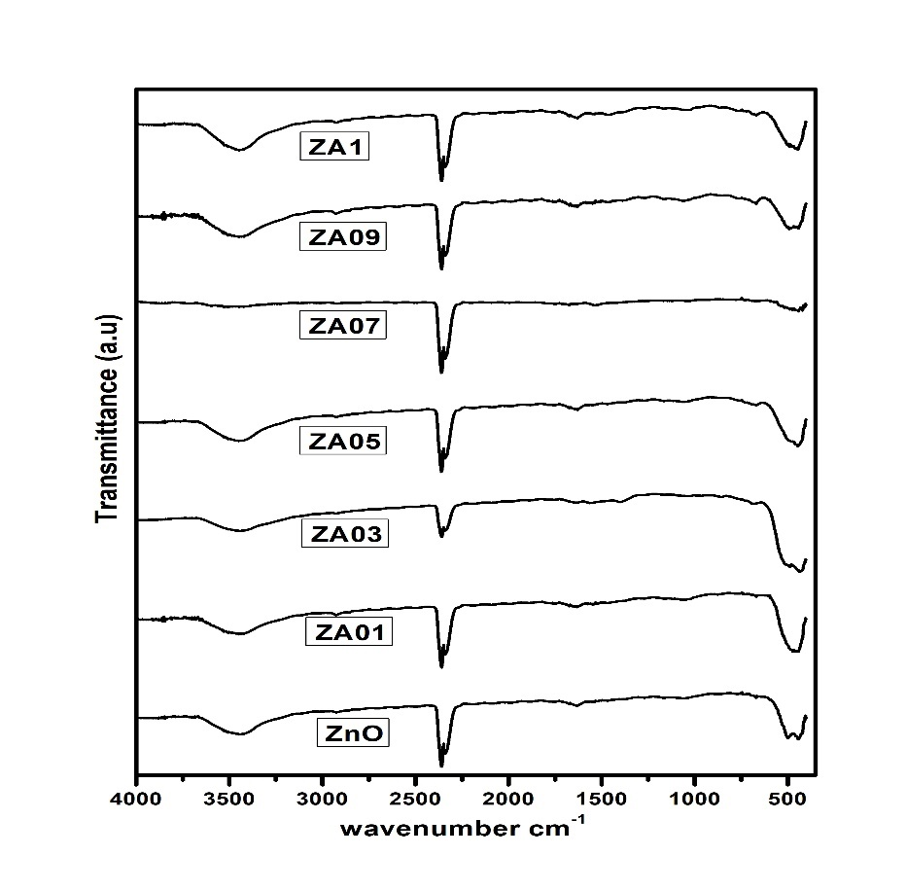
Figure 2. FTIR spectra of ZnO and ZnO nano-particles doped with Al.

The analysis of the morphological structure was performed using SEM for all samples. And the picture is shown in Fig. 3. The formation of nanoparticles of ZnO and AZO was seen in these micrographs. The nanoparticles have a nearly spherical shape, and their morphology does not change after doping. It was discovered that as the concentration of Al rises, so does the agglomeration.
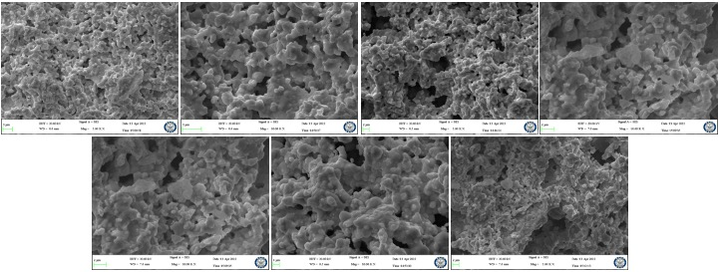
Fig. 3: SEM micrographs of ZnO and Al-doped ZnO nanostructures.
The plots of dielectric constant k and loss versus frequency are shown in Fig. (4). The fig shows that k decreases rapidly in lower frequencies and the fall off k is slow in higher frequencies. This feature is common for all oxide nanosamples.
Table 1 gives k values of all samples. The k is found to increase with Al doping amount which may be because the electro-negativity of Al (1.61) is less than that of Zn (1.78). This results in the weaker ionic bond of Zn-O-Al as compared with the Zn- O-Zn bond, which causes the increase of ionic polarization and hence dielectric constant. The average crystallite size decreases with Al concentration as noted in the table 1.
Figure 4b shows the frequency dependence of dielectric loss, tan𝛿. All samples exhibit the falling off dielectric loss with the increase of frequency at lower frequencies and at higher frequencies tan𝛿 become constant. This can be attributed to ionic hopping at low and moderate frequencies leading to ionic polarization or charge carrier-induced conduction losses.
At high frequencies, ionic vibrations are the only source that contributes to dielectric losses. The tan𝛿 values of Table 1 shows that the dielectric loss is highest for pure ZnO and decreases with the increase of the Al doping level. Hence, it is confirmed that doping of Al into ZnO increased the dielectric capability which is a desirable feature for high-frequency device applications.
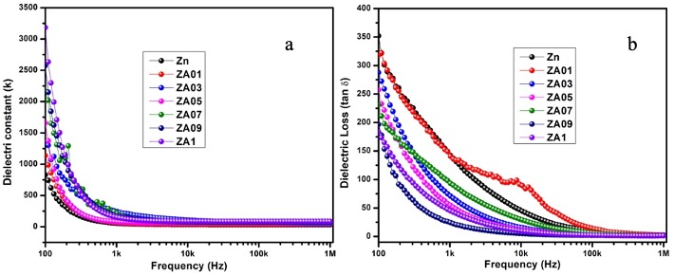
Fig. 4: Frequency variation of a) dielectric constant and b) dielectric loss (tan𝛿) of ZnO and Al-doped ZnO nanostructures.
AC conductivity variation with frequency is plotted for all samples and shown in Fig. 5. As frequency increases, the number of electrons hopping cases near grain boundaries also increases which reflects an increase in AC conductivity, as seen from the fig. It can be noted from the table 1 that conductivity increases with Al doping in ZnO samples. When Al ions are doped in the ZnO lattice, more free charge carriers are present near grain boundaries, contributing to conductivity at high frequencies.
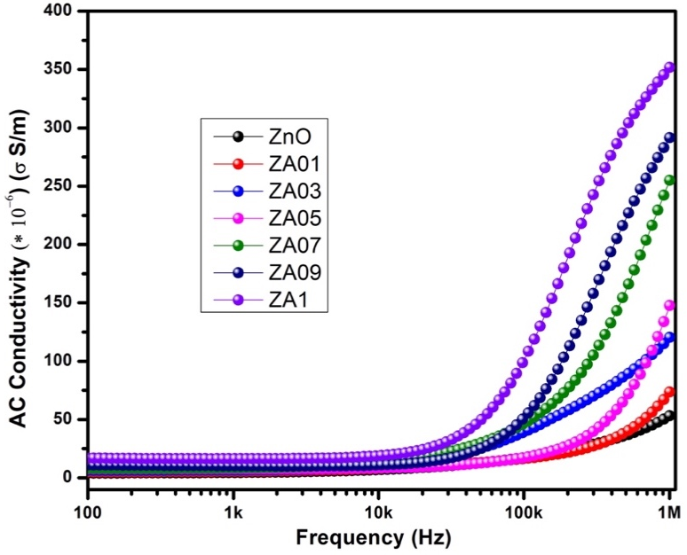
Fig. 5: Frequency variation of AC conductivity of ZnO and Al-doped ZnO nanostructures.

Table 1.Structural, electrical and dielectric data of ZnO and Al-doped ZnO nanostructures.
Sample | Crystallite Size (nm) | Lattice parameter  a (Å) | Lattice parameter  c (Å) | Conductivity (S/m) at 800 kHz | Dielectric constant at 800 kHz | Dielectric Loss at 800 kHz
ZnO | 79 | 3.2353 | 5.6037 | 47.5×10⁻⁶ | 31 | 2.51
ZA01 | 72 | 3.2381 | 5.6085 | 61.44×10⁻⁶ | 38 | 2.32
ZA03 | 68 | 3.2394 | 5.6108 | 110.21×10⁻⁶ | 45 | 1.94
ZA05 | 63 | 3.2405 | 5.6127 | 121.03×10⁻⁶ | 58 | 1.78
ZA07 | 59 | 3.2298 | 5.5941 | 229.43×10⁻⁶ | 67 | 1.45
ZA09 | 57 | 3.2415 | 5.6144 | 274.52×10⁻⁶ | 75 | 1.31
ZA1 | 54 | 3.2249 | 5.5858 | 339.22×10⁻⁶ | 84 | 1.14

- Conclusions
A series of samples of zinc oxide with aluminum doping, (Zn_{1-x}Al_{x}O, x=0, 0.01, 0.03, 0.05, 0.07, 0.09, 0.1), has been successfully prepared by co-precipitation method and confirmed by XRD, FTIR, SEM. It has proven that, the effect of Al doping in ZnO on dielectric and electrical properties of the prepared samples can show improvement in dielectric constant and electrical conductivity with low dielectric losses. These features are favourable for optoelectronics and spintronics devices.

References
[1] M. Y. Ali, M. Khan, A. T. Karim, M. M. Rahman and M. Kamruzzaman, Heliyon, 2020, 6, e03588.
[2] R. Sangeetha, S. Muthukumaran and M. Ashokkumar, Spectrochim. Acta, Part A, 2015, 144, 1–7.
[3] K. Karthika and K. Ravichandran, J. Mater. Sci. Technol., 2015, 31, 1111–1117.
[4] K. C. Verma, in Magnetic Materials and Magnetic Levitation, IntechOpen, 2020.
[5] A. B. Djuriˇsi´c, X. Chen, Y. H. Leung and A. M. C. Ng, J. Mater. Chem., 2012, 22, 6526–6535.
[6] R. Khan, C. I. L. de Araujo, T. Khan, S. A. Khattak, E. Ahmed, A. Khan, B. Ullah, G. Khan, K. Safeen and A. Safeen, J. Mater. Sci.: Mater. Electron., 2019, 30, 3396–3404.
[7] Nunes, P., Costa, D., Fortunato, E. and Martins, R. (2002), “Performances presented by zinc oxide thin films deposited by r.f. magnetron sputtering”, Vacuum, Vol. 64 No. 3-4, pp. 293-297.
[8] Ellmer, K. (2000), “Magnetron sputtering of transparent conductive zinc oxide: relation between the sputtering parameters and the electronic properties”, Journal of Physics D: Applied Physics, Vol. 33 No. 4, pp. 17-32.
[9] Lu, J.G., Ye, Z.Z., Zeng, Y.J., Zhu, L.P., Wang, L., Yuan, J., Zhao, B.H. and Liang, Q.L. (2006), “Sructural, optical, and electrical properties of (Zn, Al)O films over a wide range of compositions”, The Journal of Applied Physics, Vol. 100 No. 073714., pp. 1-11
[10] Kino, G.S. and Wagers, R.S. (1973), “Theory of interdigital couplers on non piezoelectric substrates” Journal of Applied Physics, Vol. 44 No. 4, pp. 1480-1488.
[11] Wang, R., King, L.L.H. and Sleight, A.W. (1996), “Highly conducting transparent thin films based on zinc oxide”, Journal of Materials Research, Vol. 11 No. 7, pp. 1659-1664.
﻿[12] Guang-hui Ning, Xiao-peng Zhao, Jia Li, Structure and optical properties of MgxZn1-xO Nanoparticles prepared by sol–gel method, Opt. Mater. 27 (2004) 1-5.
﻿[13] H. Liu, J. Yang, Y. Zhang, L. Yang, M. Wei, X. Ding, Structure and magnetic 444 properties of Fe-doped ZnO prepared by the sol–gel method, J. Phys.: Condens. 445 Matter 21 (2009) 145803–145807. 446
[14] S.S. Alias, A.B. Ismail, A.A. Mohamad, Effect of pH on ZnO nanoparticle 447 properties synthesized by sol–gel centrifugation, J. Alloy Compd. 499 (2010) 448 231–237
﻿[15] M. Ahmad, E. Ahmed, Y. Zhang, Y. Khalid, X. Jianfeng, M. Ullah, Preparation of highly efficient Al-doped ZnO photocatalyst by combustion synthesis, Curr Appl Phys 13 (2013) 697 704.
﻿[16] Y. Wang, F. Luo, L. Zhang, D. Zhu, W. Zhou, Microwave dieletric properties of Al-doped ZnO powders synthesized by coprecipitation method, Ceram Int 39 (2013) 8723-8727.
[17] A.A. Al-Ghamdi, O.A. Al-Hartomy, M. El-Okr, A.M. Nawar, S. El-Gazzar, F. ElTantawy, F. Yakuphanoglu, Semiconducting properties of Al doped ZnO thin films, Spectrochim Acta A 131 (2014) 512-517.
﻿[18] A. Djelloul, M. Aida, J. Bougdira, Photoluminescence, FTIR and X-ray diffraction studies on undoped and Al-doped ZnO thin films grown on polycrystalline α-alumina substrates by ultrasonic spray pyrolysis, J Lumin, 130 (2010) 2113-2117.
[19] S. Maensiri, P. Laokul, V. Promarak, Synthesis and optical properties of nanocrystalline
ZnO powders by a simple method using zinc acetate dihydrate and poly (vinyl pyrrolidone), J
Cryst Growth, 289 (2006) 102-106.
[20] A. Mishra, D. Das, Investigation on Fe-doped ZnO nanostructures prepared by a chemical
route, Mater Sci Eng B, 171 (2010) 5-10.
﻿[21] N.Rajeshwari Y, A.Chandra Bose, Absorption-emission study of hydrothermally grown Al: ZnO nanostructures, J. Alloy Compd. 509 (2011) 8493-8500.
﻿[22] Imran Khan, Shakeel Kahn, Razia Nongjai, Hilal Ahmed, Wasi Khan, Structural and optical properties of gel-combustion synthesized Zr doped ZnO nanoparticles, Opt. Mater. 35 (2013) 1189-1193.
﻿[23] W.T. Kaltchev, M. Tysoe, An infrared spectroscopic investigation of thin alumina films:
measurement of acid sites and surface reactivity, Surf. Sci. 430 (1999) 29–36.
[24] R. Khan, M.U. Zulfiqar, S.Fashu Rahman, Effect of annealing temperature on the dielectric and magnetic response of (Co, Zn) co-doped SnO2 nanoparticles. J. Mater. Sci.: Mater. Electron. (2016). doi:10.1007/s10854-016-5844-z
[25] R. Khan, Y. Zulfiqar, Zaman, Effect of annealing on structural, dielectric, transport and magnetic properties of (Zn, Co) co-doped SnO2 nanoparticles. J. Mater. Sci.: Mater. Electron. 27, 4003–4010 (2016). doi:10.1007/s10854-015-4254-y
[26] R. Khan, F.M. Hu, Dielectric and magnetic properties of (Zn, Co) co-doped SnO2 nanoparticles. Chin. Phys. B 24(12), 127803 (2015)
[27] ﻿Suresh Sagadevan, Kaushik Pal, Zaira Zaman Chowdhury, M. Enamul Hoque., ﻿J Sol-Gel Sci Technol DOI 10.1007/s10971-017-4418-8
﻿[28] Gupta MK, Sinha N, Singh BK, Singh N, Kumar K, Kumar B (2009) Piezoelectric, dielectric, optical and electrical characterization of solution grown flower-like ZnO nanocrystal. Mater Lett 63:1910–1913
[29] R. Khan, S. Zulfiqar, M.U.Rahman Fashu, Effects of Ni cooping concentrations on dielectric and magnetic properties of (Co, Ni) ﻿co-doped SnO2 nanoparticles. J. Mater. Sci.: Mater. Electron. (2016). doi:10.1007/s10854-016-4759-z
[30] R. Khan, S. Zulfiqar, Y.Zaman Fashu, Magnetic and dielectric properties of (Co, Zn) co-doped SnO2 diluted magnetic semiconducting nanoparticles. J. Mater. Sci.: Mater. Electron. (2016). doi:10.1007/s10854-016-4517-2
﻿[31] R. Zamiri, B. Singh, M.S. Belsleyc, J.M.F. Ferreiraa, Structural and dielectric properties of Al-doped ZnO nanostructures. Ceram. Int. 40, 6031–6036 (2014)
[32] C. Jayachandraiah, and G. Krishnaiah, ﻿Influence of cerium dopant on magnetic and dielectric properties of ZnO nanoparticles, ﻿J Mater Sci, ﻿DOI 10.1007/s10853-017-0938-4.

