A SMART WASTE MANAGEMENT SYSTEM FOR MONITORING, COLLECTION, AND PROPER DISPOSAL.
Shazia Akhtarª and Suman Naithaniª
ªDepartment of Environmental Science,Graphic Era deemed to be University Dehradun
Abstract
The ability of smart cities to deal with environmental issues in general, and trash management in particular, is an important topic that requires scientific investigation. Any unpleasant, harmful, or wasteful substance produced by daily human activities and municipal events is considered solid waste. Solid waste management is the approach for managing solid waste creation, storage, collection, transport, treatment, and disposal. Solid waste management is characterized based on the availability of economic capital and the degree of industrialization progress.
This article suggests and explains a smart solid waste monitoring and collection system. The system is composed of intelligent storage units, also known as smart bins, each of which has an Arduino Uno, an ultrasonic sensor, and an RF transmitter attached on top. A message (SMS) is delivered to the truck driver's mobile phone informing him or her which garbage bin has to be emptied when a container is full with waste. The control center receives this signal and has information on how much rubbish is in each container. Lastly, a productive system and waste disposal strategy are offered that might be used in the future to boost efficiency and cost-effectiveness.
Keywords: SolidWaste Management, Sustainable and Smart Cities, Environment, smart bins.

Introduction
The rapid growth of industrialisation and human population has resulted in increased amounts of rubbish generation in metropolitan areas. To conserve the environment, the number of garbage cans should be raised and strategically positioned for real-time monitoring and pickup. Without adequate trash collection and disposal, rubbish containers would be overfilled and spill out into the surrounding area, causing health hazards for humans and the environment (Akhil 2017). In city life one of the most important components is Municipal Solid Waste (MSW) . Annual solid waste creation is expected to exceed 1.3 billion tons, with a projected increase to 4.3 billion tons by 2025, when 50% of the world population would be present (Hoornweg and Bada, 2012).Coordinating garbage collection is one of the most challenging professions in the rural setting due to the enormous volume of solid waste produced by residential and commercial-industrial areas. Furthermore, garbage collection accounts for 50-70% of total solid waste management costs. Because of the enormous amount spent on collecting, there is only a little amount accessible for collection enhancement (Tchobanglas and Kreith ,2002). The waste management cycle begins with the production of rubbish from companies, homes, markets, and other sources, which is subsequently disposed of in garbage cans. Municipalities gather this trash and dispose of it in dumping zones and landfills. Some waste is not collected because to a lack of resources and an ineffective foundation, causing a significant health danger to the local environment. Cleaning at regular intervals may be able to solve this problem. Manually tracking the status of the bin, on the other hand, is a difficult operation (Singh et al,.2016). A smart garbage monitoring and collecting system is being created in order to save money and time on waste collection while simultaneously protecting the public environment,public health, and providing a safe living environment. Waste collection and monitoring employing cutting-edge technology such as Radio Frequency (RF), ultrasonic sensors, GSM/GPRS, and Arduino provide a fresh viewpoint on waste management system optimization.
Current status of India
According to the CPCB Report 2013, no city in India achieves 100% trash segregation, and only 70% of total garbage is collected and segregated at housing sites. The remaining 30% of uncollected rubbish is left in the environment or gets mixed up. The fundamental issue is that only 12.45 percent of the collected garbage is handled under scientific circumstances, while the rest is dumped in open places shown in figure 1.
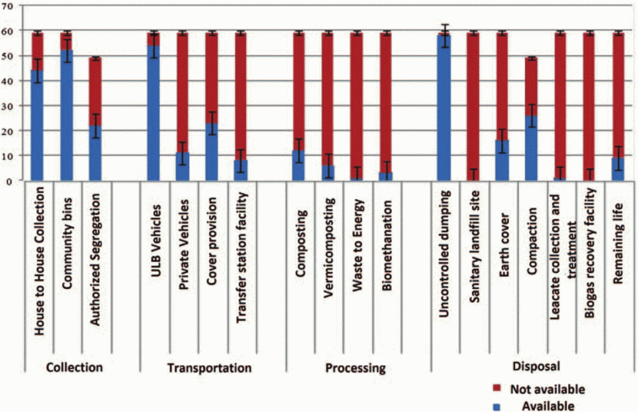
Figure :-1 Current waste management statistics of indian cities (Joshi et al., 2016).
India's waste generation
India is become more urbanized while preserving its diverse physical, climatic, geographic, ecological, social, cultural, and linguistic characteristics (Bhalla 2013). From 1028 million in 2001 to 1252 million in 2013, India's population rose. According to the 2011 Census of India, population increase in India is mostly to blame for rising MSW. The scale of India's megacities is expanding. A recent development linked to economic, cultural, and technological globalization is the emergence of megacities (ISWA) (International Solid Waste Association 2012). Ahmedabad (6.3 million people), Hyderabad (7.7 million), Bangalore (8.4 million), Chennai (8.6 million), Kolkata (14.1 million), Delhi (16.3 million), and Greater Mumbai are some of the megacities in India (18.4 million).
From generation to final disposal, municipal solid waste management operations may be divided into six functional areas (Ashish et al.,2014).

• Waste production
• Waste storage
• Gathering
• Transportation
• Sorting & Processing
• Disposal
Waste segregation
IoT for waste segregation was introduced by Lopes and Machado in 2019. Additionally, the framework separates trash at the family unit level into three categories: dry, moist, and metallic waste. It also helps with ongoing monitoring of trash levels in dustbins. Additionally, it makes use of GSM and Arduino to show the amount of trash in the trash cans on an LCD screen and send a message to clean up when it is full. A simple garbage monitoring system was developed to aid the Swachh Bharat Abhiyan by Bharadwaj B et al. The main goal of the project is to segregate trash of the same type and place it in a transit line with dry waste collected containers on one side and wet waste collected containers on the other. The broader public will have access to the data. Using this tool, we can quickly validate the information and locate the vehicle. Glouche and Couderc (2013) created intelligent garbage management using self-descriptive products. The major objective of the framework is to continuously reuse and minimize waste. The delivery of each item is tracked using RFID technology. Additionally, it uses inexpensive QR code technology. Glass, plastic, and paper/cardboard are the three categories into which rubbish is divided using the data collected. Throughout the recycling process, the details of the trash in each container are crucial. According to Singh et al. (2014), municipal solid waste has increased significantly. Municipal solid waste can be sorted using the handpicking method. It can only separate bulk materials; that is all it can do. Inorganic minerals are separated using trammel screens, whereas ferrous and nonferrous metals are separated using magnetic and electromechanical equipment. Segregated trash is burned to decrease waste and recover energy. The components of solid waste that are appropriate for the thermal conversion process can be classified and separated.
Waste collection
The researchers want to identify problems with the waste collection process and provide methods to increase efficiency. The model is divided into three sections: a data collecting layer, a waste disposal approach, and trash disposal zones. The ultimate product is a comprehensive framework with Inputs, Outputs, Guides, and Enables. The information is stored on a cloud server run by the regional administration (Lokuliyana et al., 2017). The proposed waste recognition system includes a camera, GPRS, RFID, and GPS. The system reads the RFID waste tag and transmits information about the garbage in the trash can. The sent information is stored in a centralized monitoring facility and utilized to regulate the waste disposal procedure. MATLAB image processing tools and the MySQL data server are used to gather the bin images (Islam et al., 2012). The developer created an IOT-based clean organization system that tracks garbage levels above dustbins using sensor structures. This system responded as soon as the GSM/GPRS concern was identified. The result is then shown in an Android app so that the user may learn where the trash can located. As part of the improvement interaction, the model looks at factors related to fuel consumption, toxin releases, truck speed, and carrying limit.
Waste collection using solar methods
Kabir et al.,2020 presented a smart waste system based on IOT and regulated by sunlight. There are five receptacles nearby that are wired to the Arduino Mega. The sun-oriented force provides each waste with controlled DC capability. When the canisters reach an abnormally high amount of waste, a warning is sent by both electronic and SMS alerts.
Waste collection using machine learning
An IOT-based system for clean organization was developed by the developer, and it uses sensor structures to detect rubbish levels above dustbins. When the GSM/GPRS issue was discovered, this system responded immediately. The outcome is then shown in an Android app so that the user may find the location of the trash can. The model examines variables linked to fuel usage, toxin emissions, truck speed, and carrying limit as part of the improvement interaction.Catania and Ventura (2014) created the Smart-M3 platform, which allows data to be exchanged between devices while remaining flexible. The clever framework depicted focuses on two structures: the first is aimed at governments and privately owned businesses in order to design an ideal asset management and waste collection arrangement; the second is aimed at residents in order to allow them to know the condition and location of the nearest canisters and encourage them to reuse.
Waste management using cloud
The method for controlling household waste was proposed by (Yusaf et al.,2017).The Arduino Uno receives data from the ultrasonic sensor, which counts the amount of trash in each container. Additionally, to show the threshold level, different colored LEDs are integrated onto the sensor platform of the bin. The framework developed is particularly useful in increasing local communities' proficiency in good waste management. The author creates a revolutionary garbage sorting system using deep learning to encourage reuse and elimination. In the Darknet neural organizing system, the YOLOv3 computation was employed to produce a distinct set of data. YOLOv3 has difficulty distinguishing between things made of more than two materials according to Kumar and his colleagues (2002) shown in figure 2.
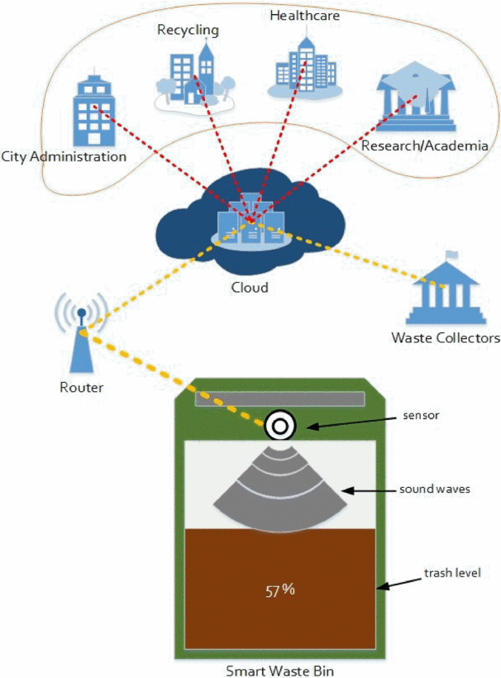
Figure: -2 Cloud-based smart waste management architecture (Aazam et al., 2016)

Sensors in each bin in the planned Cloud SWAM detect the amount of garbage in the container. Figure 3 shows the smart bin, with (A), (B), and (C) exhibiting several containers for each type of garbage, including organic, plastic/paper/bottle, and metal. The status shows the amount and kind of garbage being collected, and each form of trash is already separated in this way. This kind of pre-separated garbage is used, to name a few, in Korea, and it greatly aids trash management. In (D), an example of a warning message appears when the trash level exceeds a specified level at which garbage collectors must plan collection. While (E) shows that the bin is empty, the user and garbage collectors are kept up to date without having to reach for it or open it to verify the status.
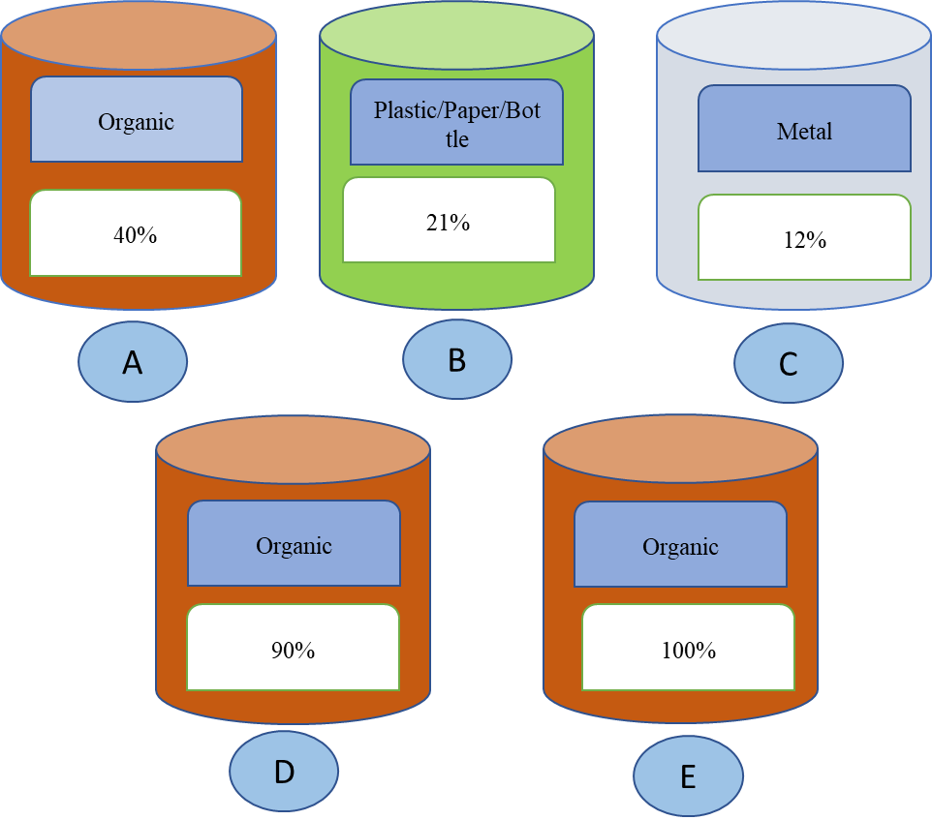Figure:-3 Smart bins for different waste categories, equipped with waste status notification.

Waste collection using Internet of Things (IoT)
Municipal governments and legislators are working hard to improve rubbish collection and disposal in cities. The bin is separated into three sub-canisters, each of which collects a distinct sort of rubbish. To recognize garbage in the bin, an infrared sensor is employed. A moisture and metal sensor is used to distinguish between wet and metal waste. Bins are located using GSM technology. The trash information obtained is transferred via the ESP8266 wife module. On the Thinkspeak server, the waste count is updated (Sowndharya and Savitha,2019) Chitluri Sai Srikanth et al. presented a smart waste management system-based rubbish collection solution based on IoT shown in Figure 4.As a result, we can maintain proper separation from the contaminants indicated by the trashcan, and waste stink is reduced (Jasmin et al.,2021). Waste management difficulties, according to the author, are increasingly deteriorating. Temperature and humidity sensors are used to distinguish between wet and dry waste. The junk data is processed using a Raspberry Pi microcontroller. The devices' master-slave design reduces connectivity problems in faraway locations (Elhassan et al.,2016).
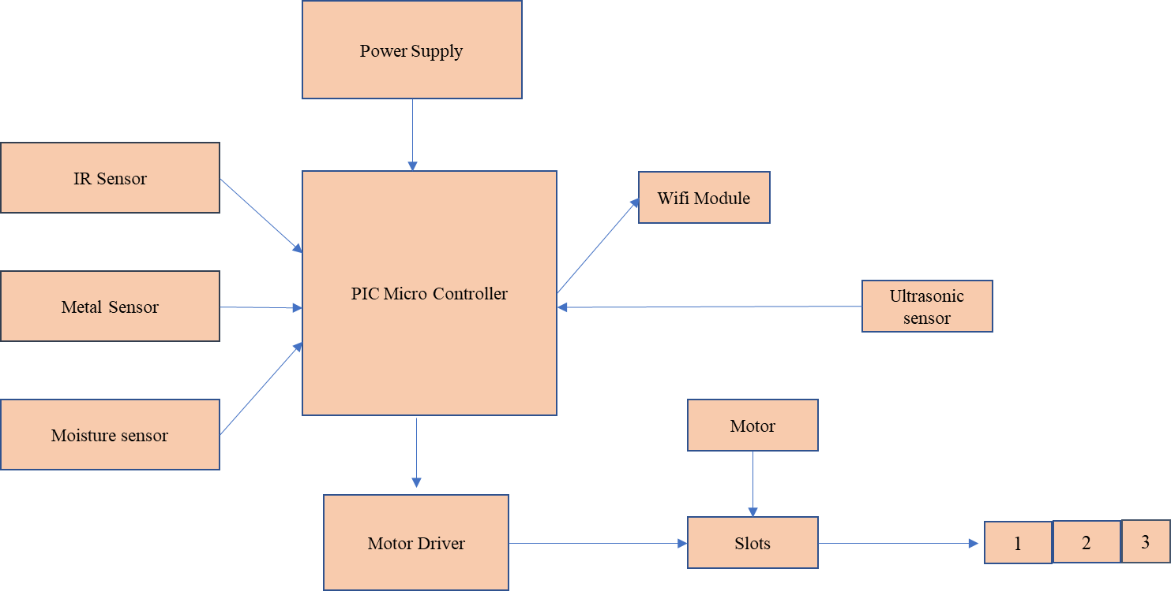

Figure: -4 Waste collection (source -Sowndharya,2019)

Waste monitoring
Navghane et al. (2016) guarantee that the trashcan will be cleaned as soon as the rubbish level reaches a crucial level. If the garbage can is not empty, an alert is sent to higher-ups, who can then take appropriate action. The strategy lowers total costs while also reducing corruption in the management system. The cloud maintains data about the volume and kind of rubbish. As a result, getting data from the cloud is straightforward. Furthermore, based on the state of the waste container, professionals can choose the collecting technique. It increases time efficiency (Aazam et al.,2016).
As a waste management solution, (Zavare et al., 2017) and associates offered a smart container with a distinctive ID. The trash management company is notified of the holder ID and region when the compartment is filled via the (GSM) warning signal. Additionally, after trash collection, the appropriate authorities are informed of the state of the empty container.
Conclusion
Local urban solid waste avoidance and recycling are critical, rather than depending primarily on regional treatment and disposal. Although the specialized collection is necessary, it puts current waste collection systems under strain. In order to close this gap and create an effective, efficient, and sustainable plan, this study established a smart and green system (SGS), which combines the thorough integration of multiple informatics with the strategy of sustainable waste management. Numerous technological developments have created new opportunities for better service delivery. Another area where present technical capabilities may be put to greater use as the population grows and lifestyles change is waste management.A number of environmental authorities and parties are involved in the waste management process. A solid waste management system is essential for improving not just the entire process but also garbage disposal. Resources for waste management may also benefit the food sector, healthcare, tourism, and other businesses. The suggested cloud-based waste management system provides a more effective manner of processing and disposing of garbage, as well as aiding in a variety of future research topics such as food, hygiene, the environment, socio-cultural challenges, lifestyle, and so on.
In the future, this study might be expanded to incorporate case studies or country-specific rubbish-generating trends. Big Data analysis may be used to data from a variety of sources.
References
Akhil, R.N., Valarmathie, P.N. IoT Based Waste Management System for Smart Cities. Int. J. Adv. Res. Ideas Innov. Technol. 2017, 3. [Google Scholar]
Hoornnweg, D. and Bhada-Tata, P., What a Waste a Global Review of Solid Waste Management, Washington, DC 20433 USA, 2012.
Tchobanglas, G., and Kreith, F., Handbook of Solid Waste Management, New York, San Francisco & London, 2002.
Tarandeep Singh, Rita Mahajan and Deepak Bagai “Smart Waste Management using Wireless Sensor Network” IJIRCCE, Vol. 4, Issue 6, June 2016.
Lopes, S. and Machado, S., 2019, December. IoT based Automatic Waste segregator. In 2019 International Conference on Advances in Computing, Communication and Control (ICAC3) (pp. 1-5). IEEE.
Bharadwaj, B., Kumudha, M. and Chaithra, G., 2017, February. Automation of Smart waste management using IoT to support “Swachh Bharat Abhiyan”-a practical approach. In 2017 2nd International Conference on Computing and Communications Technologies (ICCCT) (pp. 318- 320). IEEE.
Glouche, Y. and Couderc, P., 2013, June. A smart waste management with self-describing objects. In The Second International Conference on Smart Systems, Devices and Technologies (SMART'13).
Singh, G.K., Gupta, K. and Chaudhary, S., 2014. Solid waste management: its sources, collection, transportation and recycling. International Journal of Environmental Science and Development, 5(4), p.347.
Lokuliyana, S., Jayakody, J.A., Rupasinghe, L. and Kandawala, S., 2017, January. IGOE IoT framework for waste collection optimization. In 2017 6th National Conference on Technology and Management (NCTM) (pp. 12-16). IEEE.
Islam, M.S., Arebey, M., Hannan, M.A. and Basri, H., 2012, May. Overview for solid waste bin monitoring and collection system. In 2012 International Conference on Innovation Management and Technology Research (pp. 258-262). IEEE.
Kabir, M.H., Roy, S., Ahmed, M.T. and Alam, M., 2020. IoT Based Solar Powered Smart Waste Management System with Real Time Monitoring-An Advancement for Smart City Planning. Global Journal of Computer Science and Technology.
Estrada, Elsa. "Smart city visualization tool for the open data georeferenced analysis utilizing
machine learning." Instituto de Ciencias Sociales y Administración (2018).
Catania, V. and Ventura, D., 2014, April. An approch for monitoring and smart planning of
urban solid waste management using smart-M3 platform. In Proceedings of 15th conference of
open innovations association FRUCT (pp. 24-31). IEEE.
Yusof, N.M., Jidin, A.Z. and Rahim, M.I., 2017. Smart garbage monitoring system for waste
management. In MATEC Web of Conferences (Vol. 97, p. 01098). EDP Sciences.
Kumar, S., Yadav, D., Gupta, H., Verma, O.P., Ansari, I.A. and Ahn, C.W., 2021. A Novel
YOLOv3 Algorithm-Based Deep Learning Approach for Waste Segregation: Towards Smart
Waste Management. Electronics, 10(1), p.14.
Sowndharya, V. and Savitha, P., 2019. Smart waste segregation and monitoring system using
IoT. International Research Journal of Multidisciplinary Technovation, 1(2), pp.1-10.
Jasim, A.M., Qasim, H.H., Jasem, E.H. and Saihood, R.H., 2021. An internet of things based
smart waste system. International Journal of Electrical & Computer Engineering (2088-
8708), 11(3).
Elhassan, R., Ahmed, M.A. and AbdAlhalem, R., 2019, January. Smart Waste Management
System for Crowded area: Makkah and Holy Sites as a Model. In 2019 4th MEC International
Conference on Big Data and Smart City (ICBDSC) (pp. 1-5). IEEE.
Navghane, S.S., Killedar, M.S. and Rohokale, V.M., 2016. IoT based smart garbage and waste
collection bin. International Journal of Advanced Research in Electronics and Communication
Engineering (IJARECE), 5(5), pp.1576-1578.
Aazam, M., St-Hilaire, M., Lung, C.H. and Lambadaris, I., 2016, October. Cloud-based smart
waste management for smart cities. In 2016 IEEE 21st International Workshop on Computer
Aided Modelling and Design of Communication Links and Networks (CAMAD) (pp. 188-193).
IEEE.
Zavare, S., Parashare, R., Patil, S., Rathod, P. and Babanne, V., 2017. Smart City waste
management system using GSM. Int. J. Comput. Sci. Trends Technol, 5(3), pp.74-78.
Shilan Abdullah Hassan,Noor Ghazi M. Jameel,Boran Sekeroglu,Smart Solid Waste Monitoring and Collection System, International Journal of Advanced Research in Computer Science and Software Engineering, Volume 6, Issue 10, October 2016.
Yang, Rebecca Jing. "An investigation of stakeholder analysis in urban development projects: Empirical or rationalistic perspectives." International Journal of Project Management, 32, no. 5, 838-849, 2014.
Kollikkathara, Naushad, Huan Feng, and Eric Stern. "A purview of waste management evolution: special emphasis on USA." Waste Management, 29, no. 2, 974-985, 2009.

