Oropharyngeal Cancers
Dr. Manisha Himthani
MBBS (Gold medalist), MD Radiation oncology
Associate Consultant
Dhararmshila Narayana Superspeciality Hospital, New Delhi
+91-9818218209
drmanisha.oncologist@gmail.com
Synopsis

Oropharyngeal cancers are one of the common cancers worldwide with an annual incidence of 98,400 and mortality of 48,100 in the year 2020¹. The risk factors for development of cancer can majorly be attributed to personal habits such smoking or alcohol, or due to infection of Human Papilloma Virus. The incidence of HPV+ has rapidly increased over last few decades especially in high income countries. AJCC in its 8th edition has unconnected the HPV+ oropharyngeal squamous cell carcinoma (OPSCC) owing to its improved prognosis². Clinical features are predominantly site specific, and an elaborate history and physical examination is crucial in all patients. While CT scan remains the initial diagnostic evaluation other modalities like MRI and PET CT offer their own set of advantages.
In low resource countries, contrast enhanced CT scan remains the preferred imaging choice owing to its good sensitivity and specificity. Biopsy and p16 testing are must in all cases due to different staging, response, and prognosis of HPV+ versus HPV- OPC’s.

Clinical features

The symptoms of OPSCC depends on the size and location of the primary tumor. Approximately 70% of the OPCs occur in tonsillar region or base of tongue³. The symptoms vary in HPV+ and HPV- cancers.
Some of the common reported symptoms are⁴, also depicted in Figure 1a:
- Neck mass (most common symptom of HPV+ OPC) (Figure 1b)
- Pain (most common symptom in HPV- OPC)
- Difficulty in swallowing and speech (“hot potato voice”)
- Sensation of lump in throat

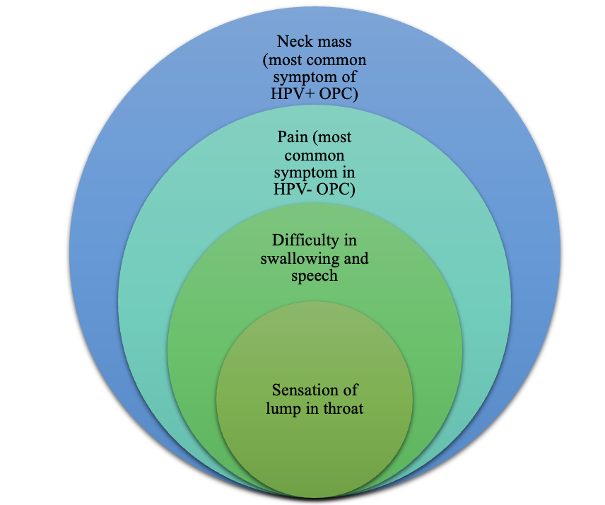
Figure 1a: Illustration depicting common symptoms of oropharyngeal cancers
(Original content, copyright protected, cannot be refurnished without consent)
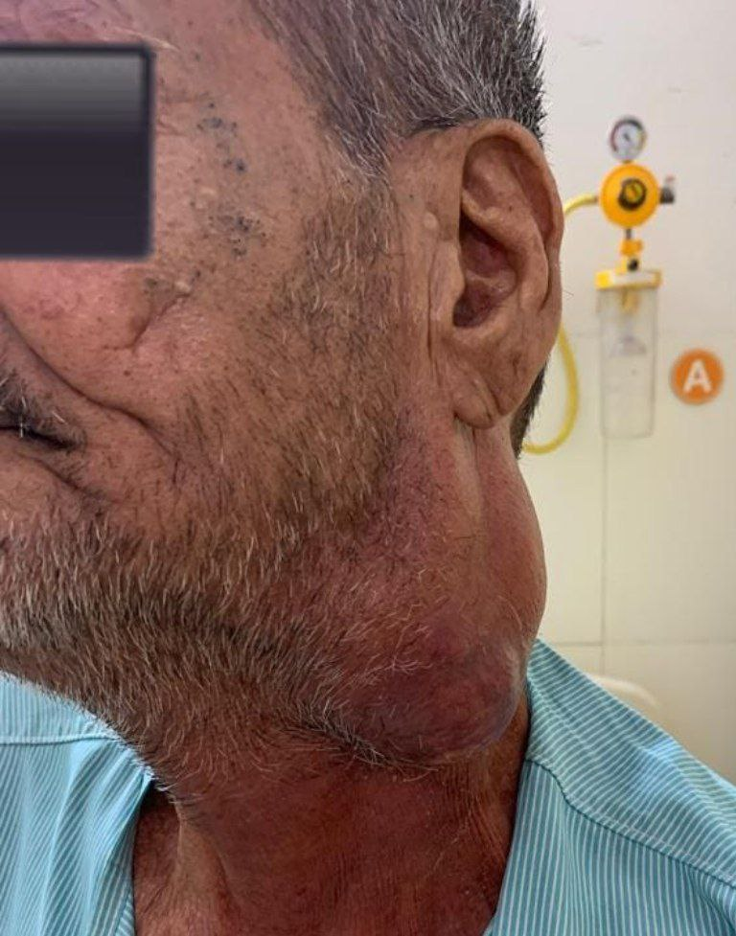
Figure 1b: Patient of oropharyngeal cancer presenting with a huge neck mass

Pain can either present as local pain or sore throat and it might manifest as referred pain to ear. Other common symptoms with which the patient might present trismus and halitosis.
Systemic symptoms are fatigue and unexplained weight loss. Depending on location of primary tumor, symptoms are enumerated in Table 1.

Table 1: Clinical presentation as per different subsites
Subsite | Symptoms
Tonsil | - Pain  - Difficulty in swallowing  - Loss of weight  - Otalgia  - Neck mass
Base of Tongue | - Pain  - Difficulty in swallowing  - Loss of weight  - Referred pain to ear  - Trismus  - Neck mass  - Tongue fixation(in advanced cases)
Vallecula | - Pain  - Difficulty in swallowing
Soft palate | - Pain  - Difficulty in swallowing  - Bad breath
Posterior pharyngeal wall  (symptomatic in advanced stage) | - Pain  - Bleeding  - Difficulty in swallowing  - Weight loss  - Neck mass

Differential Diagnosis

Certain other diseases which cause symptoms like oropharyngeal cancers are:
- Tonsillitis
- Pharyngitis
- Gastroesophageal reflux disease (GERD)
- Tuberculosis
- Benign tumors of tonsil and pharynx like Squamous papillomas
- Oral thrush
- Lymphadenopathy due to other conditions

Clinical Evaluation

Once the patient presents to the OPD careful history and physical examination is indispensable part of clinical evaluation. History should emphasize upon the first presenting symptom along with its duration to assess the primary location of tumor.
Examination should include direct visual inspection and indirect laryngoscopy or flexible fiberoptic laryngoscopy. Palpation of the primary tumor and neck nodes in terms of location and size is vital in clinically staging the disease. The clinical evaluation has been summarized in Figure 2.
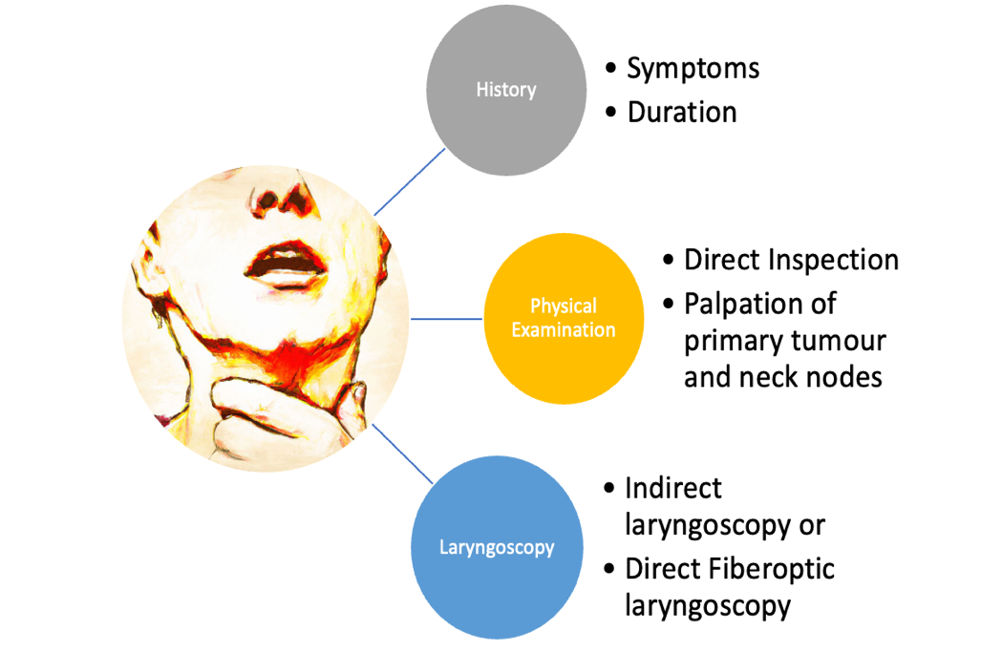
Figure 2: Clinical evaluation of patient of OPC
(Original content, copyright protected, cannot be refurnished without consent)

Complete blood count with basic metabolic panel must be done as laboratory workup.

Radiological evaluation

CT scan or MRI studies of face and neck with contrast are recommended along with chest imaging and dental evaluation⁵. While the former has the advantages of being a faster imaging option at a lower cost, better assessment of bone invasion whereas the latter helps evaluation of soft tissue structures better. CT scan also offers the advantages of availability across centers especially in a lower resource nation.
However, MRI becomes the preferred investigation in cases that involve orbit or skull base and wherever perineural invasion needs to be addressed.
Besides CT and MRI, PET CT scan is another imaging modality which not only assesses the primary tumor and nodal involvement but also provides information about the metastatic status disease.
Nonetheless, imaging plays a crucial role in accurately stage the tumor.
Nodal involvement can be best assessed on PETCT vis a vis CT. MRI is least suited for nodal evaluation^{6,7}.
The sensitivity and specificity of various techniques for cervical nodal detection is highlighted in Table 2.

Table 2. Table depicting sensitivity and specificity values of various imaging modalities (CI: Confidence Interval)
Modality | Sensitivity (95% CI) | Specificity (95% CI)
CT scan | 81% (68-90%) | 76% (62-87%)
MRI scan | 81% (65-91%) | 63% (43-80%)
PET CT scan | 79% (72-85%) | 86% (83-89%)

The comparative details of the imaging techniques are summarized in Figure 3.

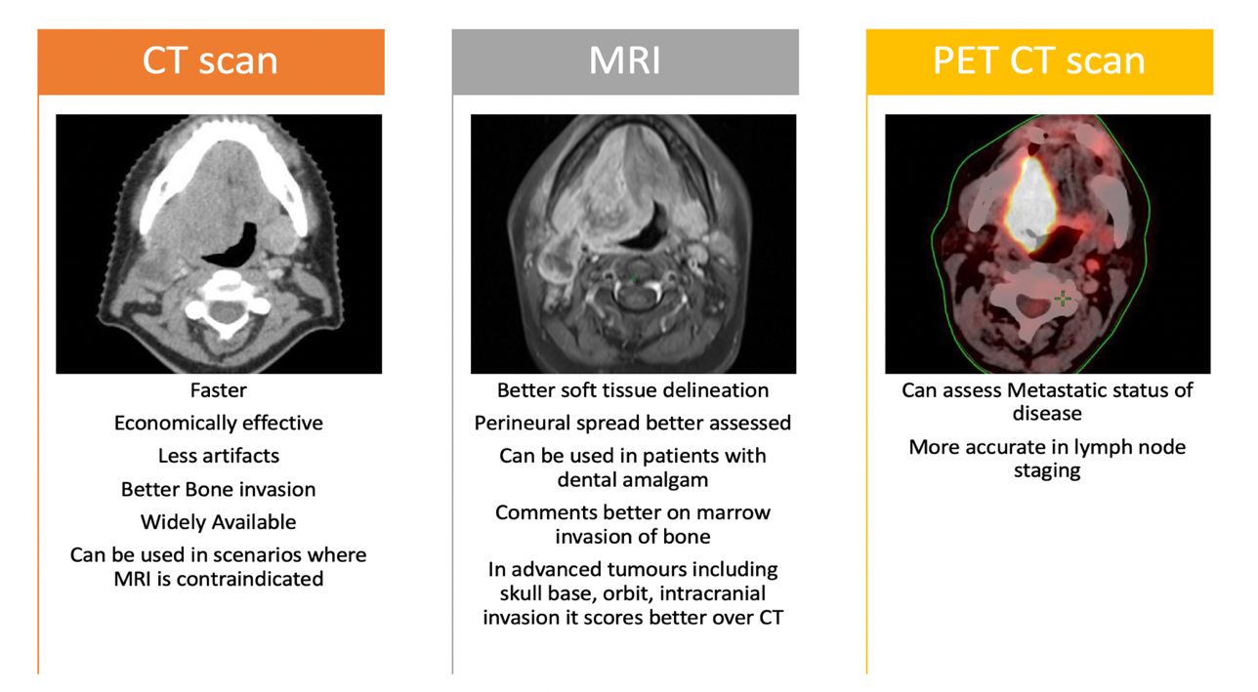
Figure 3: Comparative advantages of various imaging techniques
(Original content, copyright protected, cannot be refurnished without consent)

Pathological evaluation

Biopsy of the disease is mandatory for confirmation of the diagnosis. The AJCC in its 8th edition has modified the staging for HPV+ and HPV- OPC as HPV+ infection responds better to treatment, has a good prognosis and there are enormous studies for dose de-escalation. Therefore, p16 evaluation is also paramount for assessment of HPV infection.
HPV DNA is commonly detected via PCR, in site hybridization (ISH). Its surrogate marker p16 is detected via immunohistochemistry (IHC) on the biopsy specimen⁸.

Furthermore, in the 8th edition of AJCC staging, separate pathological staging has also been introduced as the number of nodes was the sole predictor of disease recurrence whereas other factors like extra nodal extension, laterality of nodes and size of nodes at presentation were insignificant^{9,10}. Sentinel lymph node biopsy using indocyanine green combined with methylene blue mapping is a relatively new method which is reasonably reliable¹¹. It helps in detection of occult metastasis in a clinically negative neck.

History and Futuristic trends

The OPC’s were initially related to etiological agents like tobacco chewing and smoking. The disease used present in advanced stages and treatment initially involved surgery with mandibulotomy. Radiation along with chemotherapy later took over the as preferred treatment modality reserving surgery as salvage¹². The mode of delivery of radiation improved and techniques like IMRT and IGRT took over drastically improving the tumor dose and decreasing the toxicities to the organ at risk such as parotid¹³ and dysphagia aspiration related structures¹⁴. Later, the discovery of HPV as the etiological agent, and differences in diseases presentation, treatment and survival were highlighted. HPV+ OPSCC generally present with a larger cystic node with smaller primary. It responds well to concurrent chemoradiation generally necessitating an adaptive radiation therapy approach due to anatomical regression of the tumor. The surgical techniques have also evolved to a minimally invasive approach with the advent of Transoral robotic surgery (TORS)¹⁵. Immunotherapy has also made advancements and various checkpoint inhibitors like nivolumab and pembrolizumab have their role well established¹⁶. With the advances made so far, it is probable, that a more individualized treatment approach would be adopted in the times to come¹⁷.

Conclusion

Oropharyngeal cancers are on the rise and HPV+ OPC are more commonly seen in younger population. Clinical features are predominantly site specific, and an elaborate history and physical examination is crucial in all patients. While CT scan remains the initial diagnostic evaluation other modalities like MRI and PET CT offer their own set of advantages.
In low resource countries, contrast enhanced CT scan remains the preferred imaging choice owing to its good sensitivity and specificity. Biopsy and p16 testing are must in all cases due to different staging, response, and prognosis of HPV+ versus HPV- OPC’s.

References:
- Lorenzoni V, Chaturvedi AK, Vignat J, Laversanne M, Bray F, Vaccarella S. The current burden of oropharyngeal cancer: a global assessment based on GLOBOCAN 2020. Cancer Epidemiology, Biomarkers & Prevention. 2022 Nov 2;31(11):2054-62.
- Lechner M, Liu J, Masterson L, Fenton TR. HPV-associated oropharyngeal cancer: Epidemiology, molecular biology and clinical management. Nature reviews Clinical oncology. 2022 May;19(5):306-27.
- Martyn Plummer, Catherine de Martel, Jerome Vignat, Jacques Ferlay, Freddie Bray, Silvia Franceschi, Global burden of cancers attributable to infections in 2012: a synthetic analysis, The Lancet Global Health, Volume 4, Issue 9, 2016, Pages e609-e616, ISSN 2214-109X.
- Carpén T, Sjöblom A, Lundberg M, Haglund C, Markkola A, Syrjänen S, Tarkkanen J, Mäkitie A, Hagström J, Mattila P. Presenting symptoms and clinical findings in HPV-positive and HPV-negative oropharyngeal cancer patients. Acta oto-laryngologica. 2018 May 4;138(5):513-8.
- Forastiere AA, Ang KK, Brizel D, Brockstein BE, Burtness BA, Cmelak AJ, Colevas AD, Dunphy F, Eisele DW, Goepfert H, Hicks WL. Head and neck cancers. JNCCN Journal of the National Comprehensive Cancer Network. 2008 Aug;6(7):646-95.
- De Bondt RB, Nelemans PJ, Hofman PA, Casselman JW, Kremer B, van Engelshoven JM, Beets-Tan RG. Detection of lymph node metastases in head and neck cancer: a meta-analysis comparing US, USgFNAC, CT and MR imaging. European journal of radiology. 2007 Nov 1;64(2):266-72.
- Kyzas PA, Evangelou E, Denaxa-Kyza D, Ioannidis JP. 18F-fluorodeoxyglucose positron emission tomography to evaluate cervical node metastases in patients with head and neck squamous cell carcinoma: a meta-analysis. Journal of the National Cancer Institute. 2008 May 21;100(10):712-20.
- Cantley RL, Gabrielli E, Montebelli F, Cimbaluk D, Gattuso P, Petruzzelli G. Ancillary studies in determining human papillomavirus status of squamous cell carcinoma of the oropharynx: a review. Pathology research international. 2011;2011.
- Sinha P, Kallogjeri D, Gay H, Thorstad WL, Lewis Jr JS, Chernock R, Nussenbaum B, Haughey BH. High metastatic node number, not extracapsular spread or N-classification is a node-related prognosticator in transorally-resected, neck-dissected p16-positive oropharynx cancer. Oral oncology. 2015 May 1;51(5):514-20.
- Haughey BH, Sinha P, Kallogjeri D, Goldberg RL, Lewis Jr JS, Piccirillo JF, Jackson RS, Moore EJ, Brandwein-Gensler M, Magnuson SJ, Carroll WR. Pathology-based staging for HPV-positive squamous carcinoma of the oropharynx. Oral oncology. 2016 Nov 1;62:11-9.
- Peng H, Wang SJ, Niu X, Yang X, Chi C, Zhang G. Sentinel node biopsy using indocyanine green in oral/oropharyngeal cancer. World journal of surgical oncology. 2015 Dec;13(1):1-7
- Pignon JP, Bourhis J, Domenge C, Designe L. Chemotherapy added to locoregional treatment for head and neck squamous-cell carcinoma: three meta-analyses of updated individual data. MACH-NC Collaborative Group. Meta analysis of chemotherapy on head and neck cancer. Cancer/Radiothérapie. 2001;2(5):201-2.
- Nutting CM, Morden JP, Harrington KJ, Urbano TG, Bhide SA, Clark C, Miles EA, Miah AB, Newbold K, Tanay M, Adab F. Parotid-sparing intensity modulated versus conventional radiotherapy in head and neck cancer (PARSPORT): a phase 3 multicentre randomised controlled trial. The lancet oncology. 2011 Feb 1;12(2):127-36.
- Petkar I, Rooney K, Roe JW, Patterson JM, Bernstein D, Tyler JM, Emson MA, Morden JP, Mertens K, Miles E, Beasley M. DARS: a phase III randomised multicentre study of dysphagia-optimised intensity-modulated radiotherapy (Do-IMRT) versus standard intensity-modulated radiotherapy (S-IMRT) in head and neck cancer. BMC cancer. 2016 Dec;16:1-0.
- Weinstein GS, O'Malley Jr BW, Magnuson JS, Carroll WR, Olsen KD, Daio L, Moore EJ, Holsinger FC. Transoral robotic surgery: a multicenter study to assess feasibility, safety, and surgical margins. The Laryngoscope. 2012 Aug;122(8):1701-7.
- Dogan V, Rieckmann T, Münscher A, Busch CJ. Current studies of immunotherapy in head and neck cancer. Clinical Otolaryngology. 2018 Feb;43(1):13-21.
- Hay A, Nixon IJ. Recent advances in the understanding and management of oropharyngeal cancer. F1000Research. 2018;7.

