Coupled Map Lattice Model for Edwards-Wilkinson Growth Class

Pratik M. Gaiki
Department of Physics
Shri Shivaji Education Society Amravati's,
Shri Shivaji Arts, Commerce and Science College, Motala, Dist. Buldhana-443103
pmgaiki@gmail.com
Prashant M. Gade
Post Graduate Teaching Department of Physics,
Rashtrasant Tukadoji Maharaj Nagpur
University, Nagpur- 440033
prashant.m.gade@gmail.com

ABSTRACT
We present a coupled map lattice model using coupled diffusive maps. We study coupled map lattice with a nonlinear coupling to neighbours We observe a power-law growth in roughness with time followed by saturation. We carry out standard finite-size scaling analysis. We observe standard scaling corresponding to Edwards-Wilkinson class. We also find persistence exponents in this case.
Keywords—Roughness; power law; coupled map lattice

INTRODUCTION

Interfaces in nature are omnipresent. Every living or non-living body is associated with some surface. From a biological cell, whose membrane forms the surface to heavy water-logged clouds on the earth’s surface are affiliated to the surface. One gets habituated to the shapes of the interface one encounters, so it can be astonishing that their morphologies can appear quite different depending on the scale with which we observe them [1]. Thus, one can say that morphology depends on the length scale of observation [1]. It has been shown that the concepts like roughness can be replaced by exponents which also refer to the fashion in which the roughness changes when the observation scale itself changes. The systems we care for, display essentially the same physics: there is an elastic surface which propagates in a disordered material. The randomness of the surface acts to pin the interface, thereby making the interface rough. These systems are described by the same laws that can be studied using a similar set of numerical and analytical methods. A few deposition processes to name are: atomic deposition, molecular beam epitaxy (MBE), sputter deposition, ballistic deposition (BD), random deposition (RD), random deposition with surface relaxation (RDSR) [1].
II. DEVELOPING STOCHASTIC GROWTH EQUATION
Random deposition (RD) model is simple, all the relevant quantities can be calculated exactly using the microscopic growth rules [4]. A growth equation stochastic in nature with the specified process of growth is one of the successful approaches to analytically study the growth rules. A differential equation can be introduced to describe RD, to illustrate this approach. We seek to determine the relationship between the height h(x, t) and time t at every place x, where x is a part of a d-dimensional substrate. In general, we can describe the growth by making use of the continuum equation.
$\frac{h\left(x,t\right)}{t}=r\left(x,t\right)$ (1)
where r(x, t) represents the number of particles per unit time arriving on the surface at position x and time t. The particle flux is not uniform because the particles are placed in arbitrary/random locations. We consider the randomness that got incorporated into the theory by decomposing ϕ into two terms. The above equation thus becomes:

$\frac{h\left(x,t\right)}{t}=F+η\left(x,t\right)$ (2)

Here, F represents the average number of particles arriving at site x. Random fluctuations in the deposition process are given by η(x,t) , which is an uncorrelated random number that has zero configurational average. ⟨η(x,t)⟩=0 [7].
We mainly explore the RDSR creating a linked surface as a result. In contrast to the RD model, it is smooth. In the RDSR model, the newly deposited atoms can relax to the closest neighbour if it has a lower height rather than adhering permanently to the location where they fell. The deposition in the RD model is rougher than the RDSR model. In order to choose where to stick, the freshly landed particle first assesses the elevations of the surrounding columns. Through this process, the neighbouring heights begin to correlate with one another, eventually correlating the surface as a whole. These correlations eventually lead to the saturation of the interface. Scaling components are the outcomes of a single-dimensional simulation. – the growth exponent α = 0.24 ± 0.01 and the roughness exponent α = 0.48 ± 0.02. Which for random deposition, we had β =0.5 and α = ∞.
We follow the guiding principle that: ‘The equation of motion should be the simplest possible equation compatible with symmetries of the problem’ [5]. Symmetry principles can be applied by deriving the equation describing the equilibrium interface. Equilibrium means that no external field drives the interface. Thus, an equilibrium interface separates two domains that are in equilibrium such that no domain grows at the expense of the other. We observe such surfaces in magnetic systems in immiscible fluids. F = 0 corresponds to the case of an equilibrium interface.
As a first step to obtain the growth equation, the basic symmetries of the problem are:
i) the equation maintains its invariance after the transformation, or invariance under time translation (t) t → t + δ_{h}
ii) translation invariance along the growth direction h → h + δ_{h} [5]
iii) translation invariance in the direction perpendicular to the growth direction x → x + δ_{x} [5]
iv) rotation and inversion symmetry along the growth direction [5] which means we rule out all the odd-ordered derivatives of vectors such as ∇h, ∇(∇² h), etc that are not included in the in the coordinates.
v) Up/down symmetry for h: Since the fluctuations at the interface have comparable in relation to the average interface height, we do not take even powers of h into consideration (∇h)², (∇h)⁴
As discussed earlier, a general method to construct the growth equation from symmetry principles allow us to associate a stochastic equation with the model. In this final form of the growth equation, we consider all terms that can be formed from the combinations of powers of (∇^{n}h). All those terms that violate at least one of the symmetries mentioned above are eliminated. In this way, we find,
$\frac{∂h\left(x,t\right)}{∂t}=\left(∇^{2}h\right)+\left(∇^{4}h\right)+\left(∇^{2n}h\right)+…+\left(∇^{2k}h\right)+{\left(∇h\right)}^{2j}+η\left(x,t\right)$ (3)
where any positive integer number for n, j, and k is possible. We concentrate on the long time (t → ∞), long distance (x → ∞) and behavioural characteristics of functions that define the surface because these are the scaling properties that are of interest to us. The hydrodynamic limit is this. We are able to verify that higher-level derivatives are less significant than the lowest-order derivatives using scaling considerations. By ‘less important term’ we mean that the scaling behavior of the growth equation is not affected by this term. It can be thus shown in the hydrodynamic limit that ∇⁴h term is less important than the ∇²h term. So, in the hydrodynamic limit, ∇⁴h → 0 faster than ∇²h. The stochastic equation is linear and can be solved exactly for the values of the scaling equation. The Edwards-Wilkinson (EW) equation, which has the following form, is the most simple equation to describe fluctuations at an equilibrium interface.
$\frac{∂h\left(x,t\right)}{∂t}=ν∇^{2}h+η\left(x,t\right)$ (4)
In this equation, x denotes the position, t marks the time, h stands for the height of the interface, ν is the surface tension, η is the noise term that incorporates the stochastic character of the fluctuation process.
When non-linear factors are introduced into the growth equation, the anticipated outcomes of the linear model are altered. Kardar, Parisi, and Zhang (KPZ) originally suggested expanding the EW model to induct non-linear components. The KPZ equation is not derivable formally, but one can surely apply i) the physical principles, which motivate the addition of non-linear terms and ii) symmetry principles. For one dimensional case of ballistic deposition (BD), extensive numerical simulations forecast slightly different growth and roughness exponent values than those determined analytically. In RDSR the particle arrives on the surface then relaxes while in BD, falling particle sticks to the first particle it meets. The BD process suggests lateral growth, where growth takes place in a direction of the local normal to the surface. Here, when a particle is added to the surface, growth occurs in a direction locally normal to the interface [5], generating an increase $∂h$ along the h axis, which by the Pythagorean theorem is
$∂h={\left[{\left(ν∂t\right)}^{2}+{\left(ν∂t∇h\right)}^{2}\right]}^{1/2}=ν∂t{\left[1+{\left(∇h\right)}^{2}\right]}^{1/2}$ (5)

If |∇h| << 1, the expansion of the above equation gives

$\frac{∂h\left(x,t\right)}{∂t}=ν+\frac{ν}{2}{\left(∇h\right)}^{2}+….$ (6)
suggesting a non-linear term (∇h)² that must be present in the growth equation.Adding this term to the EW equation, we obtain the KPZ equation:
$\frac{∂h\left(x,t\right)}{∂t}=ν\left(∇^{2}h\right)+\frac{λ}{2}{\left(∇h\right)}^{2}+η\left(x,t\right)$ (7)

The first term on the RHS describes relaxation of the interface caused by a surface tension ν. The KPZ equation is the simplest growth equation that has symmetry principles viz.
i) invariance under translation in time i.e. the equation remains invariant under the transformation t → t + δ_{h}
ii) translation invariance along the growth direction h → h + δ_{h} [5]
iii) translation invariance in the direction perpendicular to the growth directionx → x + δ_{x} [5]
iv) rotation and inversion symmetry along the growth direction [5] which means we rule out all the odd ordered derivatives in the coordinates excluding vectors such as ∇h, ∇(∇²h), etc.
v)the interface fluctuations are dissimilar with respect to the mean interface height, so we also consider the even powers of h, terms such as (∇h)².
The model we work upon is as follows:
$x_{i}\left(t\right)=f\left(x_{i}\left(t\right)\right)+\frac{ϵ}{2}\left[f\left(x_{i-1}\left(t\right)\right)-2f\left(x_{i}\left(t\right)\right)+f\left(x_{i+1}\left(t\right)\right)\right]$ (8)
where,
$f\left(x_{i}\left(t\right)\right)=x_{i}\left(t\right)-μ\sin\left[\left(2πx_{i}\left(t\right)\right)\right]$ (9)
We consider the system for μ = 1 and ϵ = 0.1. This function is known to show diffusive behaviour and was initially analyzed in [3]. We want to explore the possibility that the coupled diffusive maps show behaviour in EW class. Naturally, we study variance given by $ρ\left(t\right)=\sum_{i=1}^{N}{{\left(x_{i}\left(t\right)-\overline{x}\left(t\right)\right)}^{2}}$ where $\overline{x}\left(t\right)=\frac{1}{N}\sum_{i}{x_{i}\left(t\right)}$. Another quantity study is persistence. We denote the sites i such that $x_{i}\left(t\right)>\overline{x}\left(t\right)$ as + spin and if $x_{i}\left(t\right)<\overline{x}\left(t\right)$ it is − spin. The persistence P(t) at time t are the fraction of sites that did not change their spin state even once till time t [6]. For the EW class, we expect roughness to grow as $\sqrt{t }$and saturate at t = N². Persistence is not a universal quantity. However, previous numerical studies in EW class [2] suggest that the persistence $P\left(t\right)∼1/t^{θ}with θ∼1.5$.
First, we consider large size simulation for N = 2 × 10⁵ sites averaged over 20 configurations. We indeed observe that $ρ\left(t\right)∼\sqrt{t }$. Because P(t) decays very fast there are numerical fluctuations at long times. However, if we plot P(t)t^{1.5} as a function of t, we observe a constant value over a few decades confirming the expected persistence.
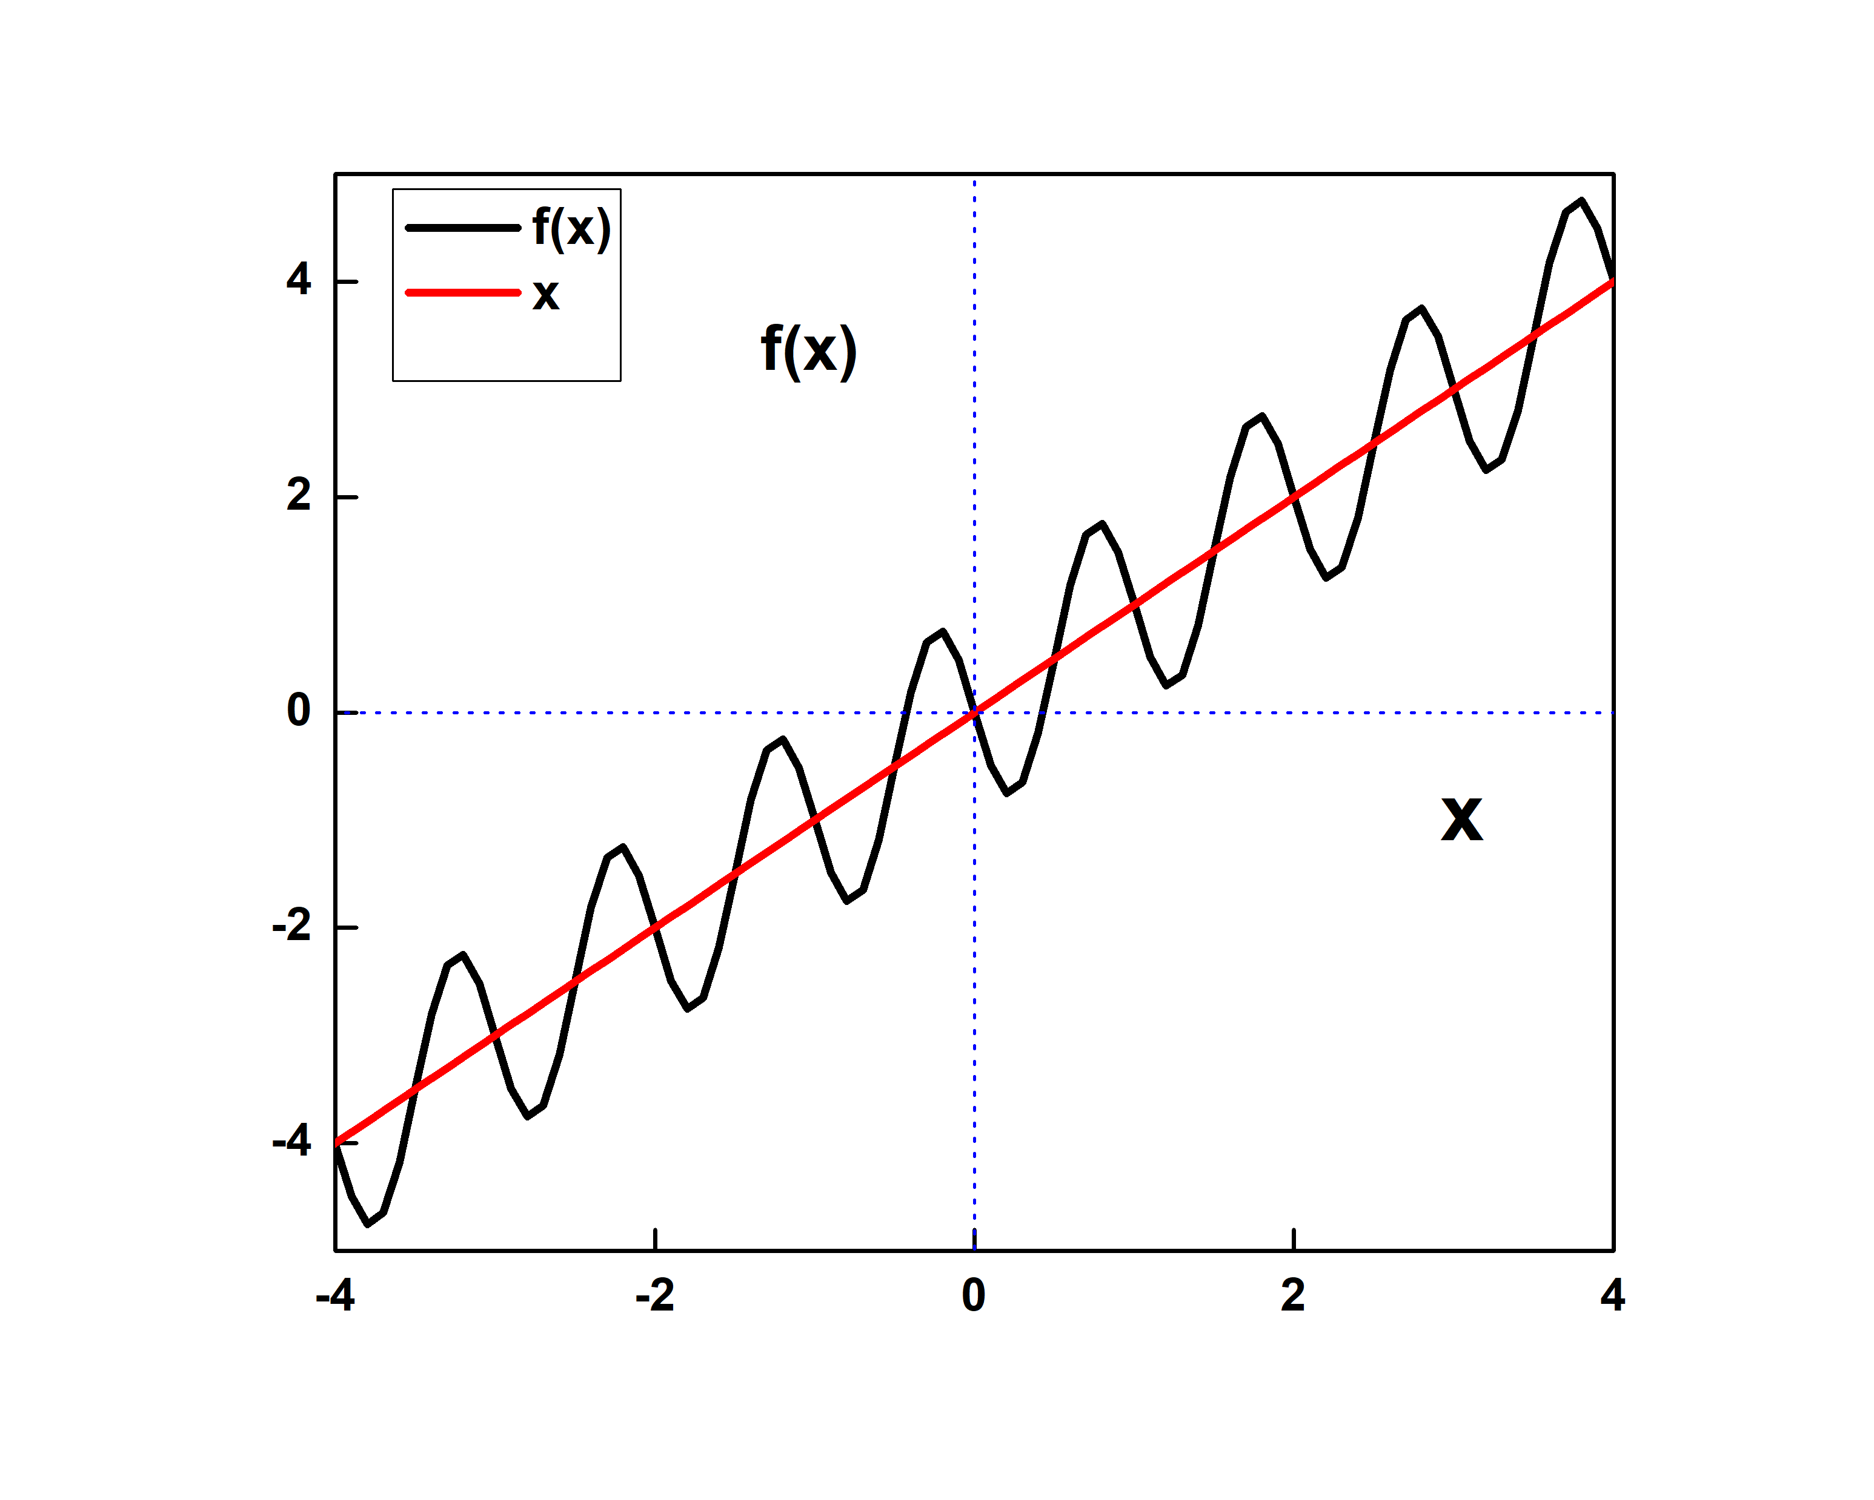
Figure 1: f(x) as a function of x for μ = 1
We simulate this system for finite sizes N = 100 and N = 200. The variance grows as $\sqrt{t }$initially and saturates. We plot $ρ(t)/N$ as a function of t/N² and we find remarkable scaling collapse showing that the system is indeed in EW class.
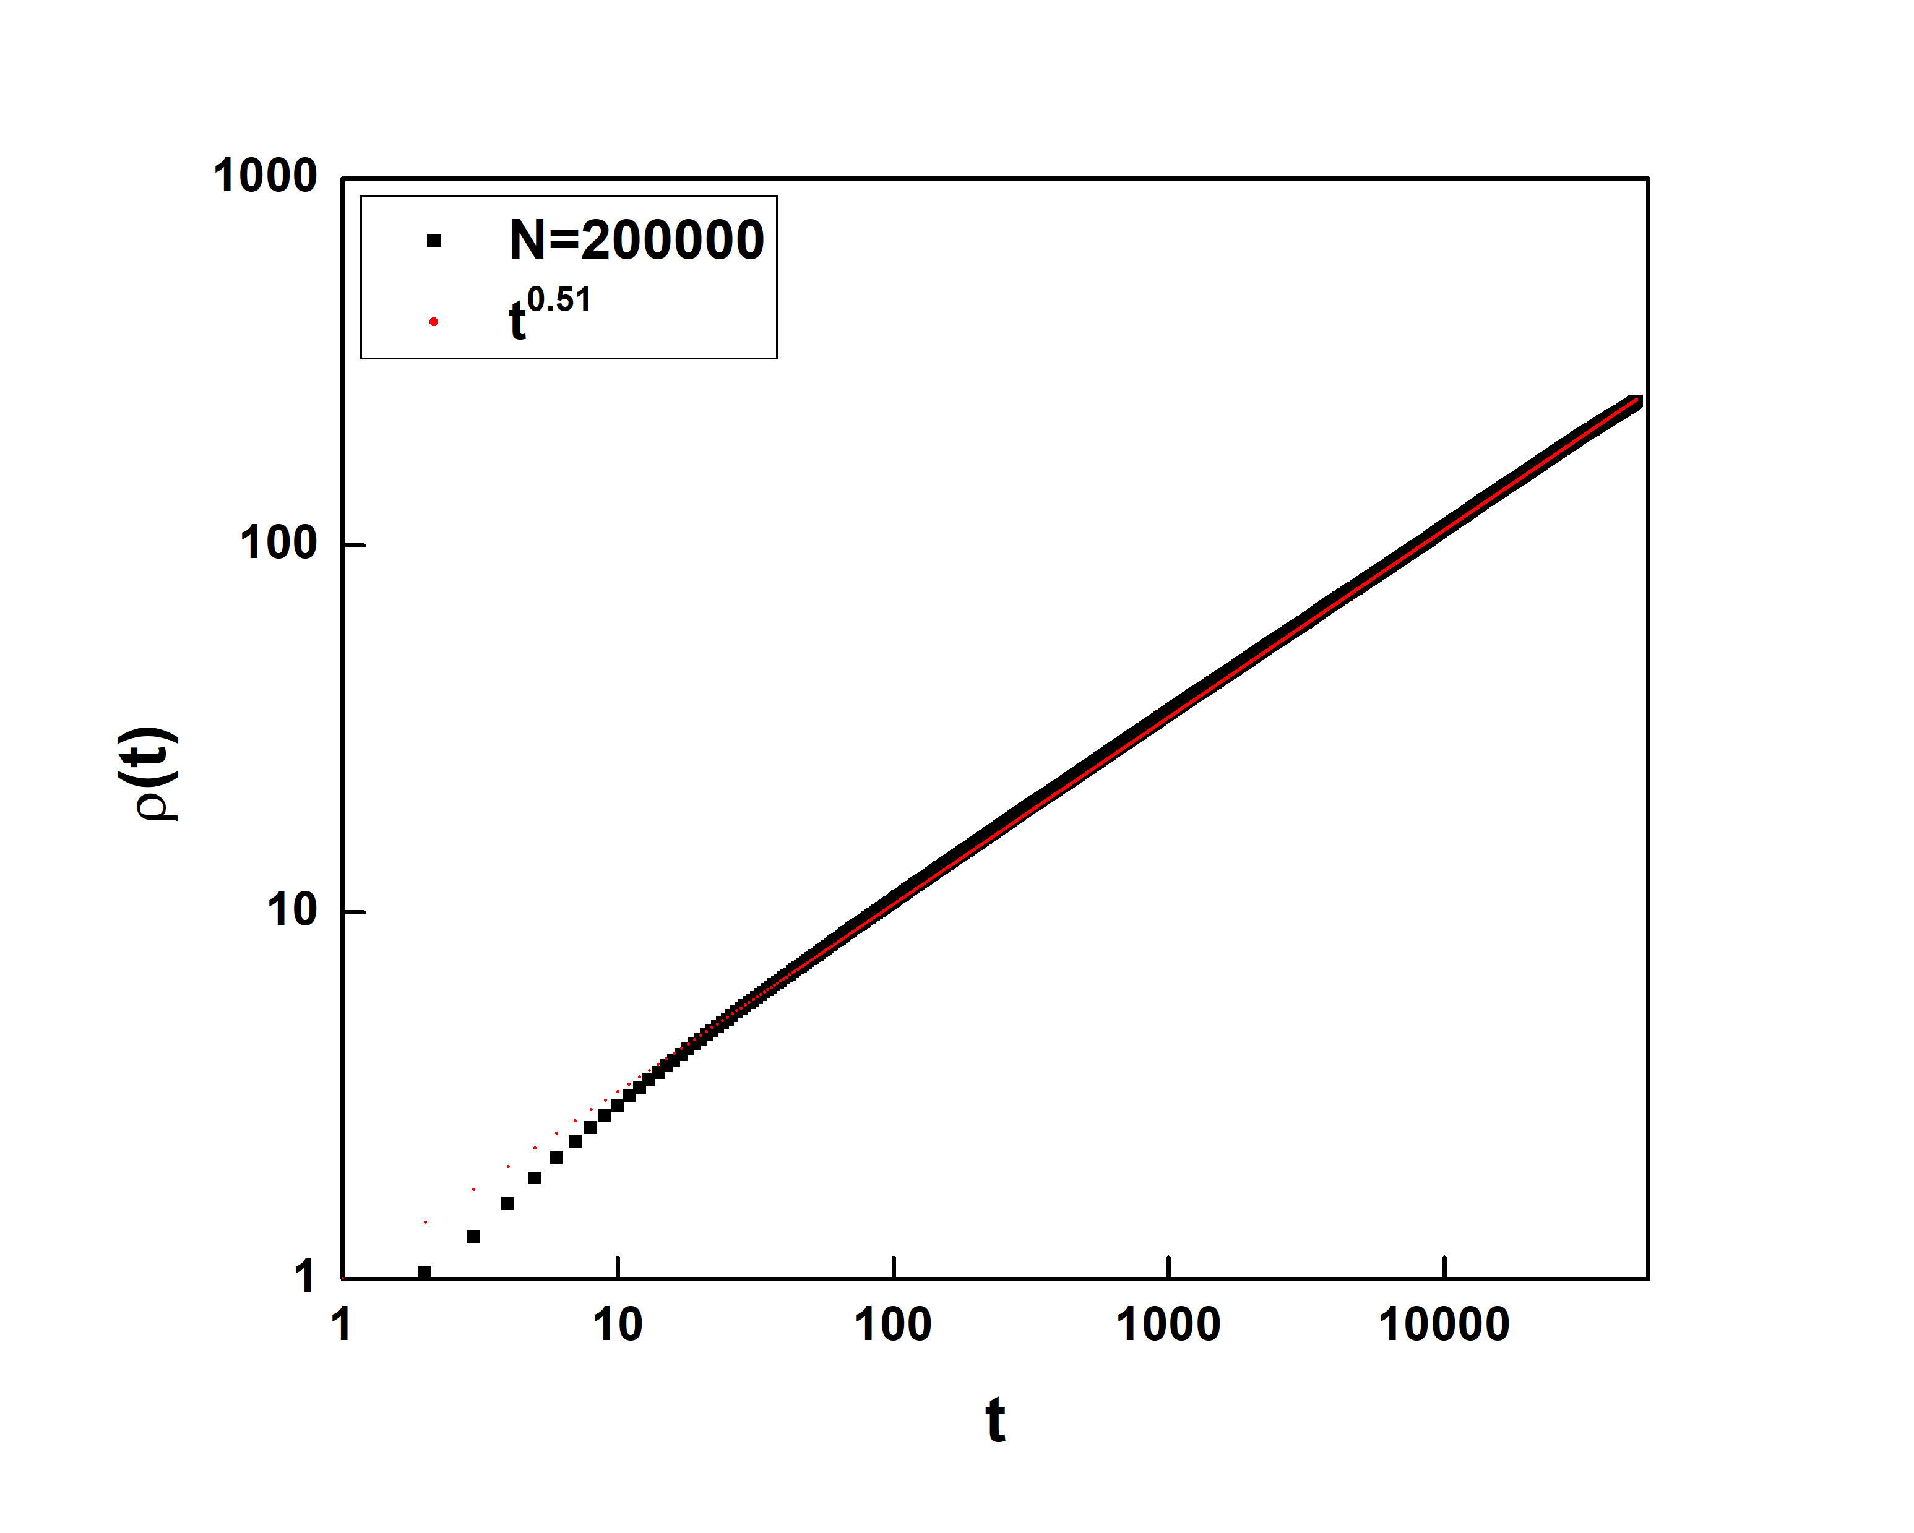
Figure 2: $ρ(t)$is plotted as a function of t for N = 25. We also plot t^{0.51} for comparison.
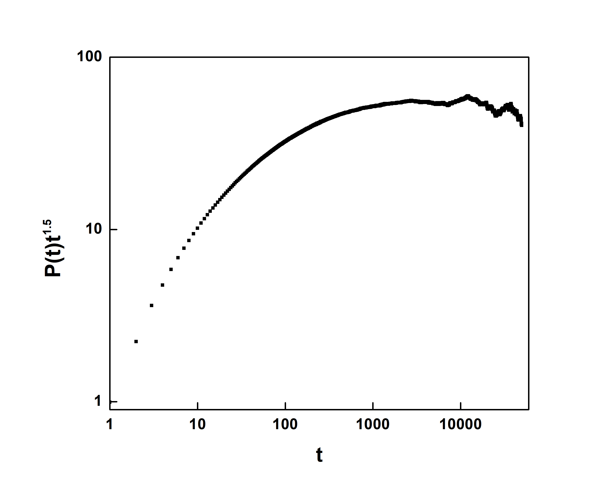
Figure 3: P(t)t^{1.5} is plotted as a function of t for N = 2⁵.

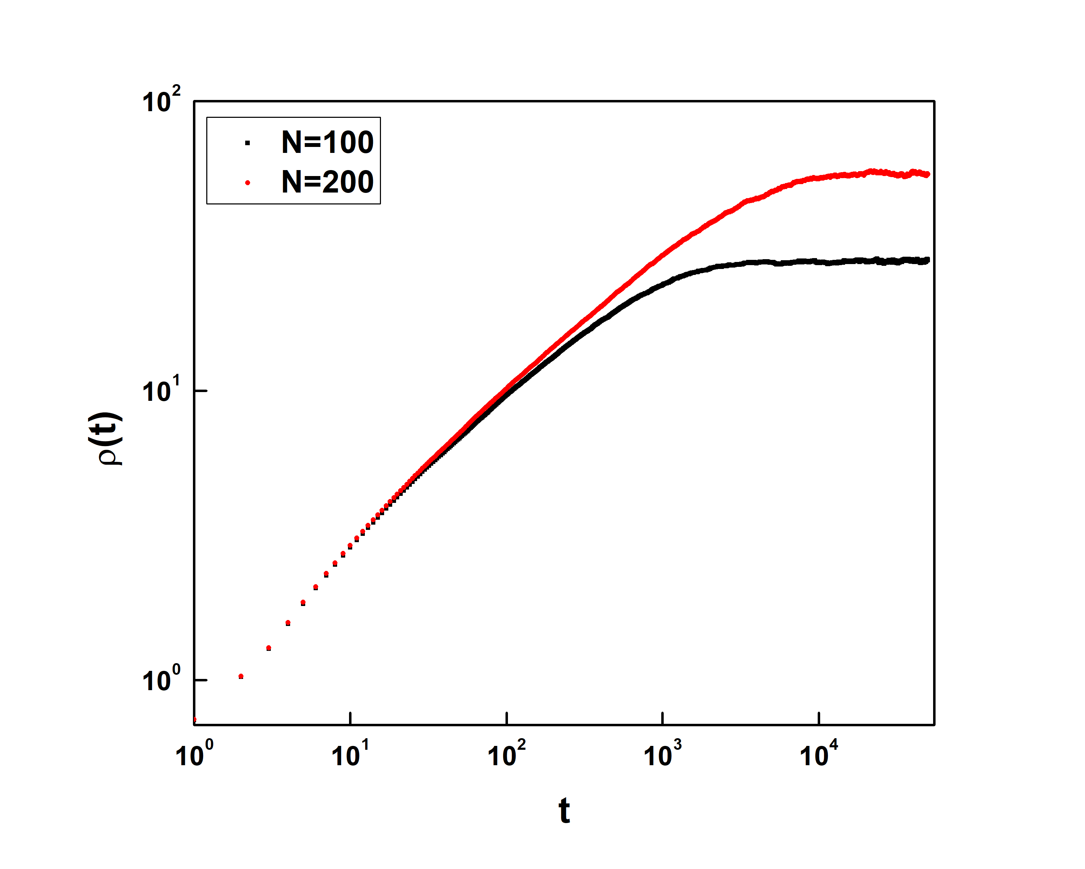
Figure 4: $ρ(t)$ is plotted as a function of t for N = 100 and N = 200.

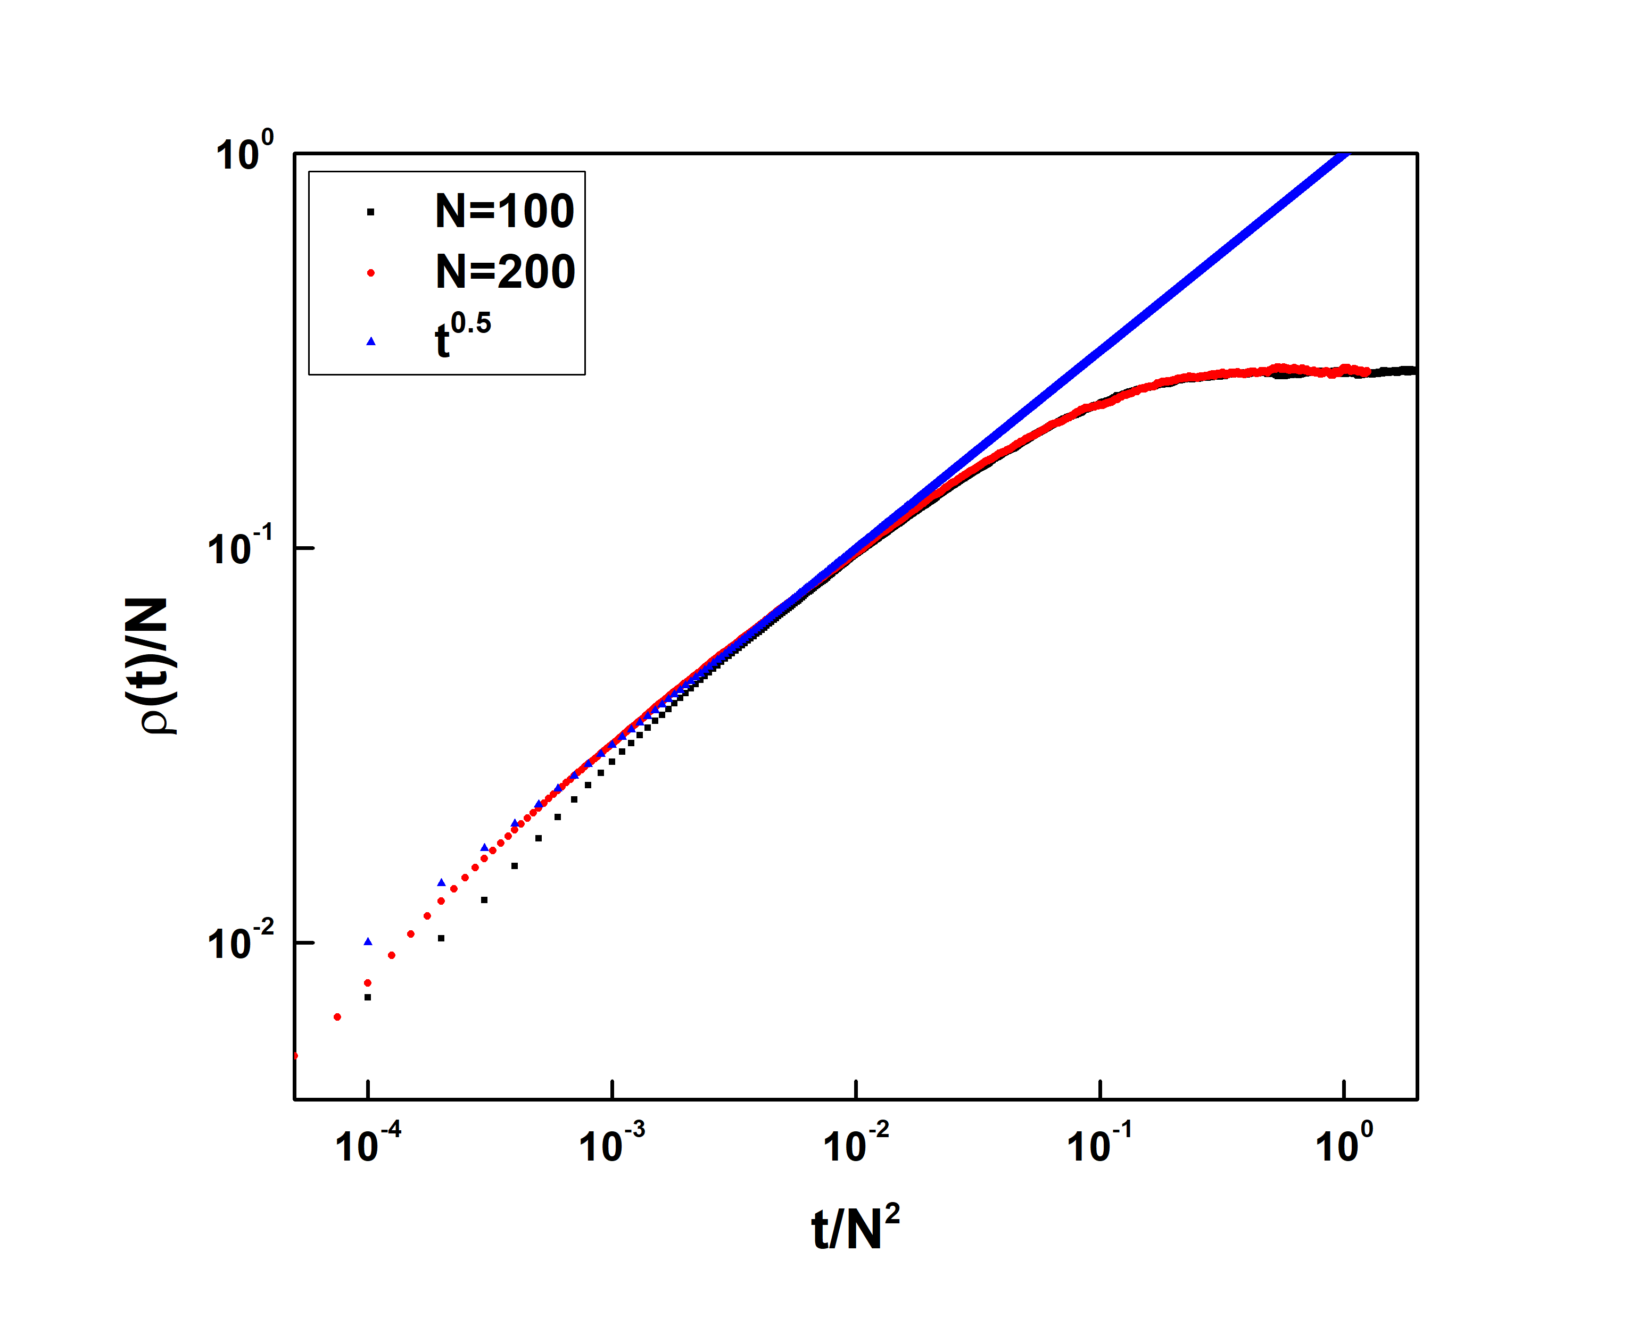
Figure 5: $ρ(t)/N$ is plotted as a function of t/N² for N = 100 and N = 200. Excellent scaling collapse is obtained.

In short, we have shown that coupled diffusive maps are in Edwards-Wilkinson universality class. We thank Divya Joshi for her help in figures. PMG thanks SERB grant CRG/2020/003993.
Author credits: PMGaiki: First draft and introduction. PMGade: Model, softare, visualization.

REFERENCES
[1] A.L. Barabási and H.E. Stanley. Fractal Concepts in Surface Growth. Cambridge University Press, 1995.
[2] M Constantin, Chandan Dasgupta, P Punyindu Chatraphorn, Satya N Majumdar, and S Das Sarma. Persistence in nonequilibrium surface growth. Physical Review E, 69(6):061608, 2004.
[3] Th Geisel and J Nierwetberg. Onset of diffusion and universal scaling in chaotic systems. Physical Review Letters, 48(1):7, 1982.
[4] J.D. Weeks, G.H. Gilmer, and KA Jackson. Analytical theory of crystal growth. The Journal of Chemical Physics, 65(2):712–720, 1976.
[5] J.A. Mann Jr, W.A. Woyczynski, Growing fractal interfaces in the presence of self-similar hopping surface diffusion. Physica A: Statistical Mechanics and its Applications 291, 159-183, no. 1-4 (2001).
[6] P.M. Gade, G.G. Sahasrabudhe, Universal persistence exponent in transition to antiferromagnetic order in coupled logistic maps. Physical Review E 87.5, 052905 (2013).
[7] S Hosseinabadi, A.A. Masoudi, Random deposition with a power-law noise model: Multiaffine analysis. Physical Review E 99, no. 1: 012130 (2019).

