Hydroelectric Power:

Prabhat Singh¹,
Sagarika Kabra²,
Sadique³,
Shikhar Verma⁴
Deepika Saini⁵,

^{1,2,3,4}Maharishi School of Pharmaceutical Sciences, Maharishi University of Information Technology, Lucknow, Uttar Pradesh
⁵Department of Zoology, Chaman Lal Mahavidyalaya, Landhora, Haridwar, Uttarakhand

Introduction
Hydropower is defined as the renewable energy source that generates electricity by altering the natural flow of rivers and other bodies of water using dams and diversion structures. Hydropower produces one-sixth of the world's electricity and will produce around 4,500 TWh by 2020, which is more than all other renewable energy sources and nuclear power combined. Hydropower can provide as much low-carbon electricity as needed and is an important source of safe and clean electricity. The amount of electricity a turbine can produce depends on how much water passes through the turbines (flow) and how much the water "falls” from the height. Hydropower is the largest renewable energy source in the world. When water falls under gravity, it can be used to spin turbines and generators to generate electricity. It plays an important role in many parts of the world, with more than 150 countries producing electricity. The world has approximately 700 GW of installed capacity producing 2,600 TWh per year, about 19% of global electricity production.
The first electric generator was built in 1870 in Cragside, Rothbury, England. The use of electricity began in the 1880s in Grand Rapids, Michigan, with the use of electric generators to light theatres and shops. Electric brushes attached to flour mills provide street lighting in Niagara Falls, New York, 1881. The world's first 12.5-kilowatt hydroelectric power station was commissioned on September 30, 1882, at the Vulcan Street Mill in Appleton, Wisconsin, USA, on the Fox River, using two generators and lighting, with the generator connected to electricity from a generator. house.
Although India built electricity in the first major location, Darjeeling, in 1897, to support the economy, the electricity system was built at Sivasamudrum on the Cauvery coast in 1902 with an initial generating capacity of 7.92 megawatts and in 1902 at the appropriate construction time. increasing level over time. The final installed capacity of the power plant in 1938 was 47 megawatts. Electricity was initially supplied to the Kolar Gold Mine for development and operation, and later to the cities of Bangalore and Mysore. The second development of Darbar in Mysore was in 1940: Shimsapura Hydroelectric power station (2 × 8.6 MW), also on the Cauvery River.

Hydropower Technology

Power is defined as the rate of doing work. Hydropower refers to the amount of hydraulic power extracted from a body of water due to its speed or location or both. The rate of change of the angular momentum of the water falling on the surface of the turbine blade, or the power of the pressure, or both, causes the turbine wheel to rotate. The height of the water level behind the dam is greater than the height of the water level below the dam, which represents the potential energy. As the water flows down through the penstock of the dam operating the turbines, then this potential energy is converted into electricity. The water in the generator is not used as a working fluid and can therefore be used for other uses. Hydropower can be used to power plants or generate electricity, or both.
Large hydroelectric power stations are often used to generate electricity. The turbine output shaft is connected to the generator to generate electricity. Electric machines mainly consist of electric motors in cylinders (called stators) with wire windings (called conductors). During operation, the rotor in the stator rotates to generate electricity using the principle of electromagnetic induction. Produced electricity, switchyards, transformers, and transmission lines, etc. is sent to the payload destination via transmission lines.
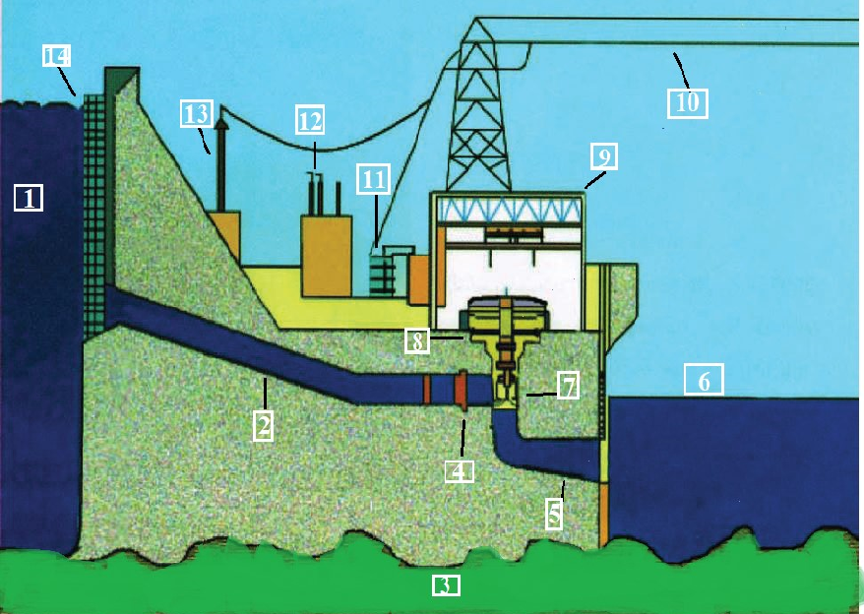
[1] Reservoir [2] Penstock [3] Bed Rock [4] Valve

[5] Draft tube [6] Tailrace water [7] Turbine [8] Generator

[9] Powerhouse [10] Transmission lines [11] Transformer [12] Insulators

[13] Transmission tower [14] Trash rack

Figure 1: Model of a Hydroelectric Power station with its major parts.

Classification of Hydropower Project by Facility type

Hydropower projects are unique in that although the installed power is the same, the design of the hydroelectric power station will be different depending on local conditions. The uniqueness of these water projects makes their distribution important, especially in terms of technology and use. Hydropower projects can mainly be classified into three categories such as Run-of-River, Storage Hydropower (Reservoir), and Pumped Storage.

- Run-of River Type Hydropower (RoR HP):

RoR HP mainly supplies power to generate electricity from existing water resources. Such hydroelectric power plants often include some short duration (hourly, daily, or weekly) to allow for some variation in needs. The electrical output of the flow generator depends on the amount of water in the river. River type power plants are different and can be optimized for large rivers with small currents in large rivers or optimized for small and long bodies of water in mountains. The RoR hydroelectric system will have a variable capacity following the flow of the river. To provide some flexibility in the case of electricity demand, the RoR HP includes some short-term storage (known as water storage) to meet additional electricity demand (least needed) when needed. Without significant storage systems, RoR HP conditions are vulnerable to changes in water flow that affect flow and water quality, such as drought, flooding, and dewatering. The RoR HP concept is said to be suitable for rivers with minor differences or rivers controlled by large dams. In a RoR HP, some of the flow can be diverted to lines or pipes (hanging) that send the water to turbines connected to generators. RoR hydropower plants are relatively inexpensive and generally have a lower environmental impact than larger scale hydro storage facilities.
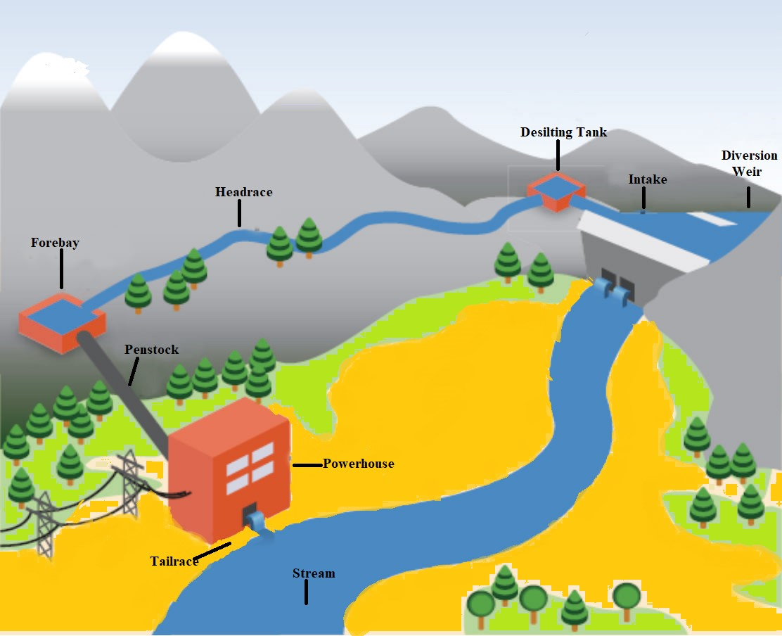
Figure 2: Diagrammatic view of Run-of-River Hydropower Project

- Storage hydropower (Reservoir):

Energy storage plants rely less on natural water flows and instead rely on water storage behind dams. To generate electricity, water is pumped from a reservoir and sent to turbines. The power station can be built directly at the bottom of the swimming pool without running water, or it can continue to the bottom, displacing the river; This station is connected to the lake by channels, tunnels, or penstocks. Storage of hydroelectric power generation has a higher energy efficiency compared to pure water flowing from rivers. One of the key benefits of energy storage is that energy is stored in the form of potential energy in the water behind the dam. This potential energy can be released to generate electricity as needed, allowing generators to be used to provide both basic and advanced equipment. Hydroelectric storage projects control water flow downstream of dams. Hydroelectric power plants with large reservoirs provides the best service. Such facilities can store energy on a large scale during low demand and provide energy when needed during peak demand. Also, their fast response times allow them to meet rapid changes in demand. Small power plants are designed to realize daily or weekly production.
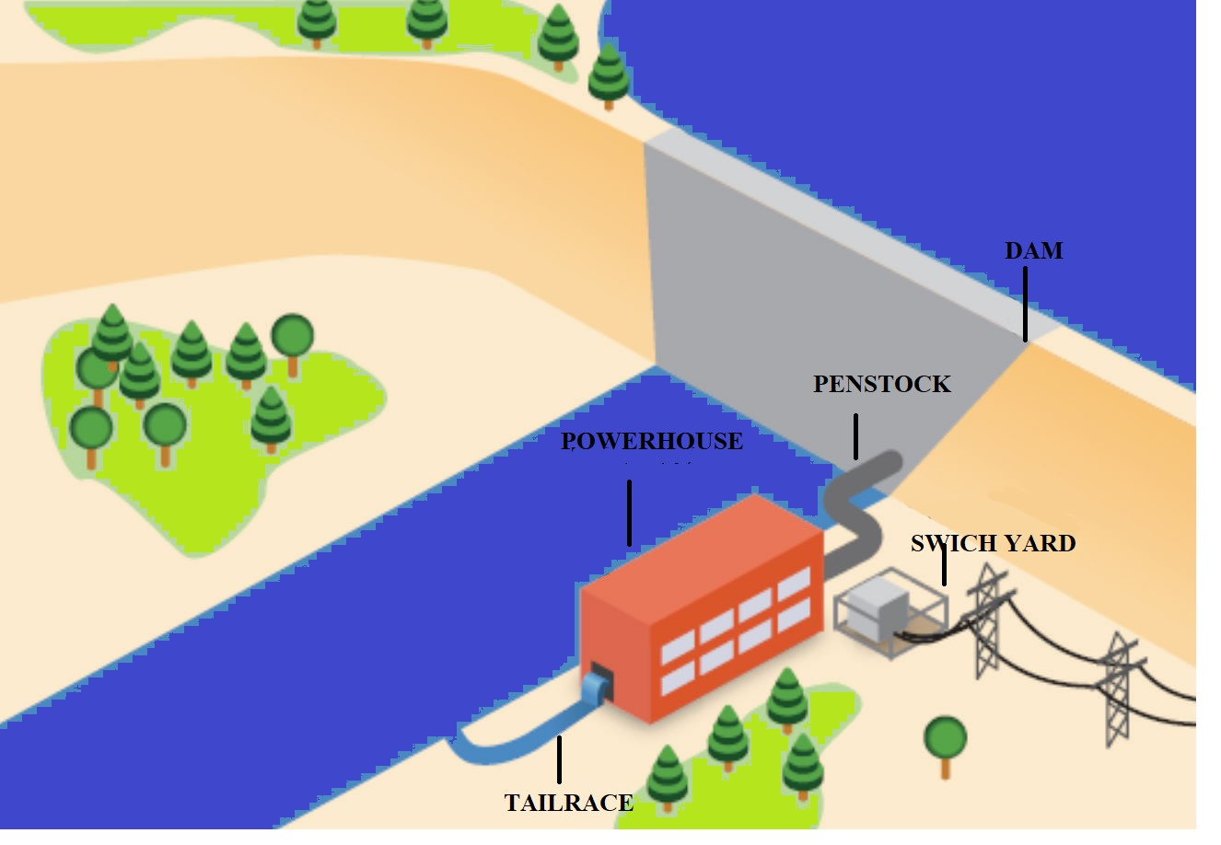
Figure 3: Diagrammatic View of Storage Hydropower (Reservoir).

- Pumped Storage Hydropower (PSH):

Pumped storage power plant is storage, not energy. The pumped storage hydroelectric power station uses two reservoirs - a lower reservoir and an upper reservoir. The two reservoirs are connected by tunnels or locks. In such a system, water flows from the lower chamber to the upper chamber. In the storage pump, water is pumped to provide hydraulic power. During a power outage or at other times when the demand is low, water is used from the lower water to the upper water tank by using the excess electricity from the hydroelectric power plant. During peak load or other times when more power is needed, the water stored in the upper tank is pumped back into the lower reservoir by the turbines, thus generating more electricity. Pumped storage hydroelectric power plants are currently the most efficient and largest form of energy storage, with cycle efficiency of between 70% and 85%. Although losses in the water use process make such facilities all energy consumers, facilities can provide the benefits of large power generation. In fact, pumped hydro is currently the largest source of grid electricity storage available worldwide.

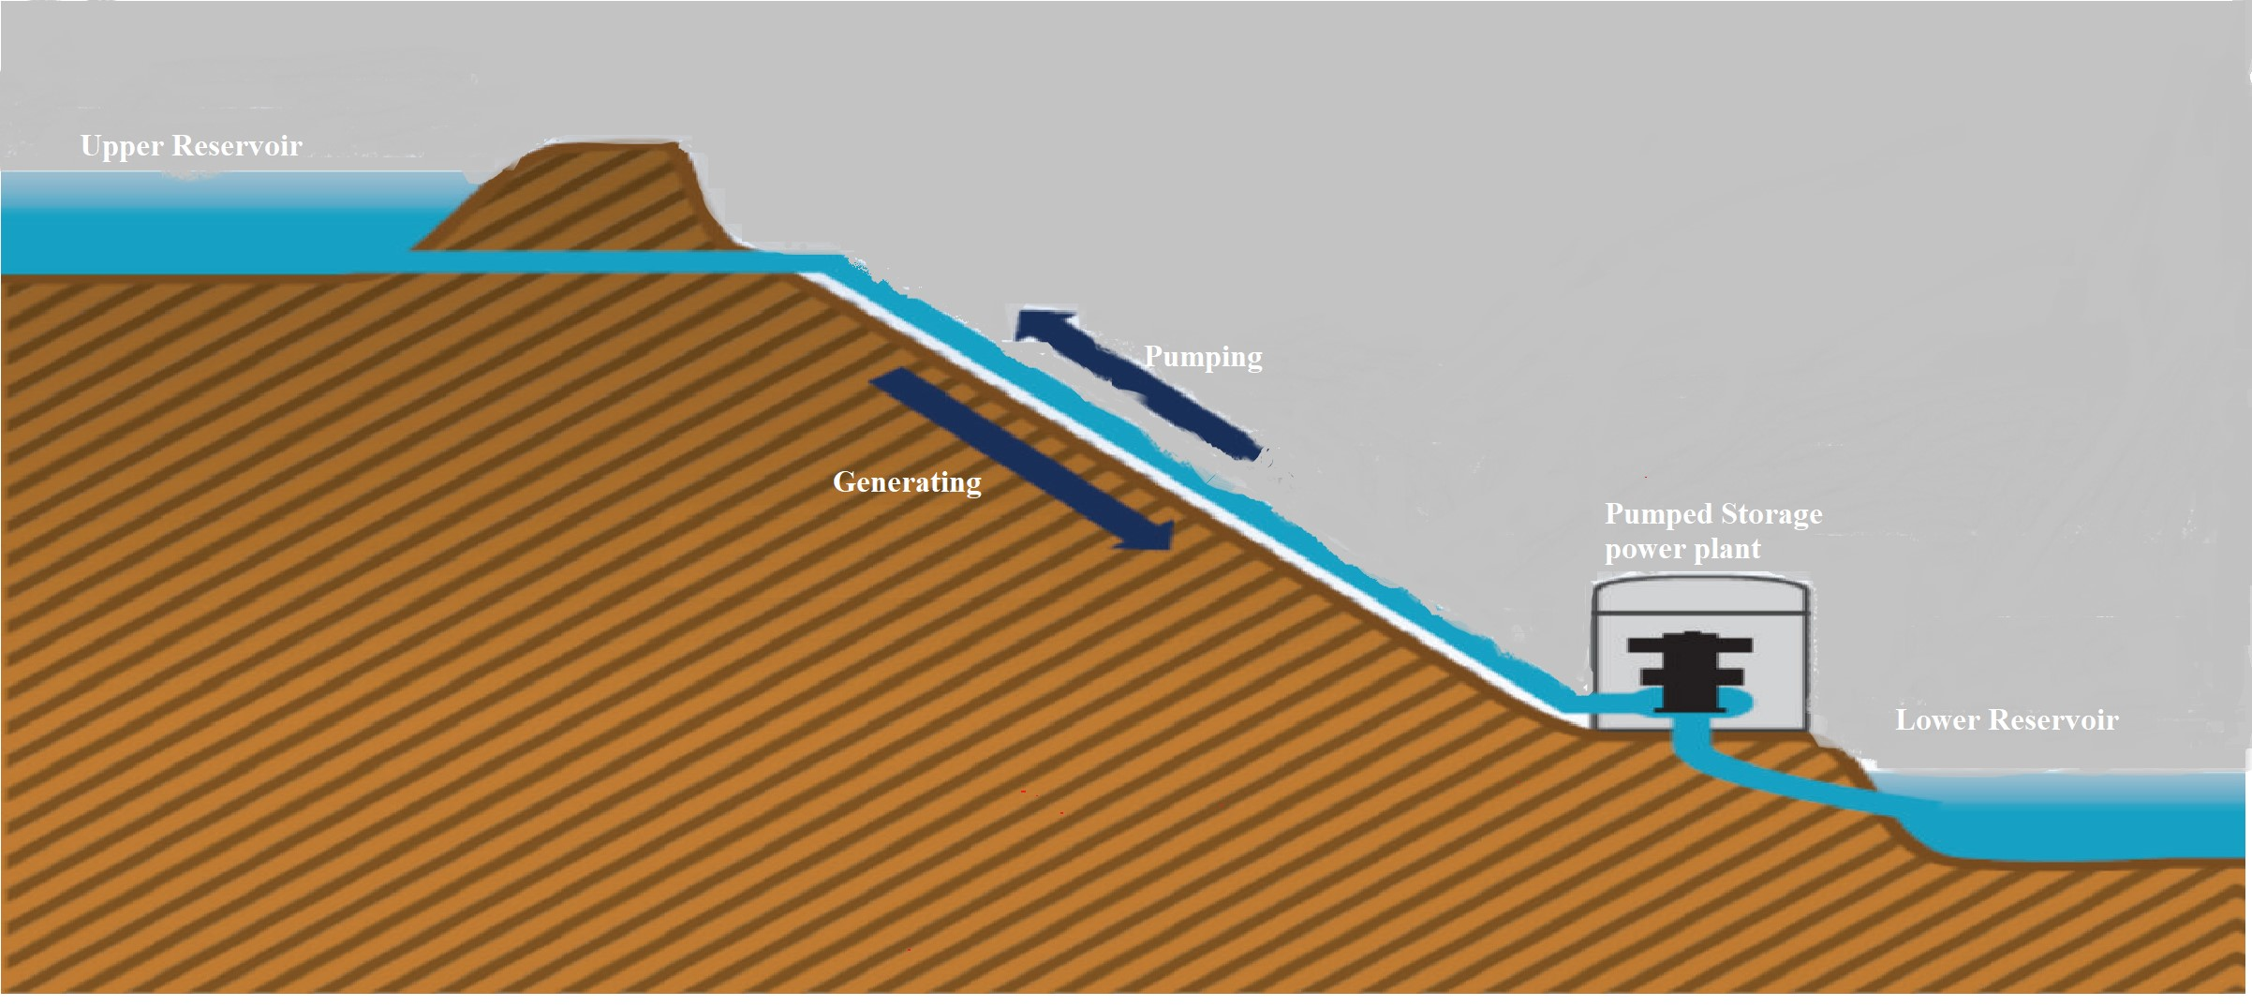

Figure 4: Diagrammatic view of Pumped Storage Hydropower (PSH)

Impact of Hydropower on Environment and Climate Change:

For hydroelectric power projects, social and environmental impacts arise during the construction and operation of the project. The construction phase of a major water system includes infrastructure such as roads, dams, embankments, tunnels, power plants and transmission lines. The land was cleared, and some people moved to make way for construction. Destruction of land by reservoirs will destroy ecosystems, destroy infrastructure, and change habitats. These activities cause regional air and water pollution, loss of biodiversity, damage to infrastructure, landscape change, destruction of habitats and lifestyle and culture of the directly affected area. Changes in water hydrology (low flow and flow changes) affect not only the marine ecosystem but also the local population, which is dependent on water resources for health and economy. Water protection is essential. Regulations should be in place to preserve biodiversity in project affected areas and to protect the health of our population lost due to the project.
However, large hydropower plants are known to release some greenhouse gases (GHG), particularly methane (CH₄) and carbon dioxide (CO₂), as the buried organic matter decomposes due to the lack of sufficient oxygen. Since the main fuel in all gas emissions from hydroelectricity is methane, it is encouraged that GHG emissions from hydroelectric reservoirs should no longer be ignored in the national GHG problem. Methane has a greater global warming potential than carbon dioxide.
Greenhouse gases within sediments can escape into the atmosphere through the formation of bubbles on the surface of the sediments. Dissolved gases in the water can also escape during the process of turbulent degassing where water flows through the turbine runner during operation. Due to high mineralization rates and high-water pressure (high gas solubility), the deep-water layers of reservoirs are typically enriched with CO₂ and CH₄. Passing through the turbine, the gas is subjected to low pressure and high temperature conditions, which causes rapid degassing along with turbulent action and is exhausted into the atmosphere.
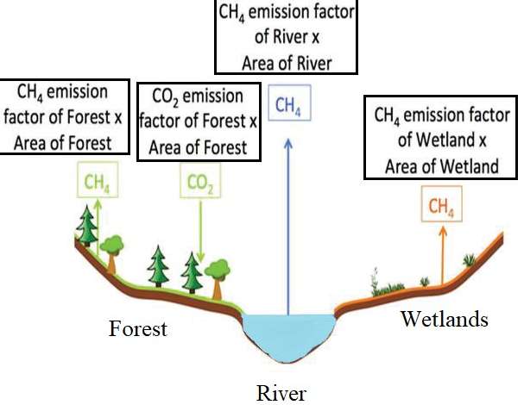
Figure 5: Greenhouse gas behaviour with different Ecological systems

Hydroelectricity Power towards sustainability:

Sustainable development is the development that provides all the necessary needs of the present without loss the ability of future generations, it requires a balance between nature and living being. The term "sustainable energy" means the provision and use of energy in a way that supports development in all its economic, social, and environmental aspects. This means not just expanding energy, but gradually moving to energy sources and technologies that support people's long-term health and safety.
In previous few years, the biggest and most important challenges to the sustainability of hydropower plants have been mainly unmanaged deforestation, mismanagement of agricultural land, housing development and infrastructure development around formerly protected power plants. how to deal with reservoir sedimentation and storage loss caused by Forest catchments. The eroded sediment from the catchment is expected to increase the sedimentation rate in the reservoir. It is estimated that about 1% of the total storage capacity of the world's reservoirs is lost to sedimentation each year.
Hydropower is a resource that does not have life energy and does not emit pollution. Hydropower is considered an efficient, low-cost, and clean energy source. Hydropower has many uses and strong adaptability. Due to the limited capacity involved, a significant route in hydroelectric power can be reserved for years. Flow planning can be done to ensure continuous updates. Accordingly, hydropower can be more economical, reduce non-renewable energy outputs and encourage unregistered energy such as wind power.

Advantages of Hydropower:

- The efficiency of electricity generation is about 90%, and electricity generation is the largest, accounting for about 19% of total energy consumption in the world.
- By building an electric generator, nearby communities can find new jobs and help revive the economy.
- When there is no need of electricity, we can close the water gate to stop generating electricity. Water can be stored for later use when power demand increases.
- The use of hydroelectric dams and dams facilitates the control of floods. But when this water is retained by dams, monitoring and maintenance is easier and reduces the risk of flooding.
- Hydropower is a Flexible form of electricity because power plants can rise and fall rapidly to meet changing energy needs.
- Hydroelectric power plants do not consume fuel, so no carbon dioxide is produced when generating electricity. While project construction initially produces carbon dioxide and the reservoir emits some methane each year, hydropower has one of the lowest lifecycle greenhouse gas emissions.
- The reservoir created by hydroelectric projects often provides water parks and becomes tourist attractions. Seawater production is common in some countries. Multi-purpose dams built for irrigation support agriculture with continuous water supply. Large dams can control flooding that will affect people living downstream.
- The cost of generating electricity from electricity is low, averaging $0.05/kWh.

Disadvantages of Hydropower:

- The cost of generating energy itself is relatively low, but the construction cost of hydroelectric power plants is high. Underwater installation requires the use of special equipment and materials, which is expensive.
- The presence of dams changes available water, which often has a significant impact on the life of the fish, depending on the type and growth of the fish.
- In addition to the temperature change caused by the heat generated during the operation of hydroelectric power plants, the use of hydroelectric power can also affect water flow in communities and cause global warming.
- Physical collisions between wild animals and dam walls.
- Turbines in hydroelectric power plants can make a lot of noise.
- Hydroelectric power plants are very expensive to build. High prices mean that factories must work long-term to make a profit.

Conclusion

The above chapter concludes that the hydroelectric power is the largest renewable source for generating electricity, with very less loss of water. Unlike other renewable energy sources such as solar and wind, hydropower plants provide electricity supply by producing stable and continuous electricity. Small hydropower release no or very a smaller number of harmful gases. On the other hand, large hydropower put a great impact on our environment and even on climate by releasing harmful gases such as CH₄ (Methane) and CO₂ (Carbon di-oxide), these gases are widely disturbed greenhouse and result in global warming. This project has an ability to store energy for a week or a month and or a year along which is utilized when electric demand is high along with this it has disadvantage that it makes too much noise during producing electricity.

References:

- John Twidell, Renewable Energy Resources, Second edition, Taylor & Francis Group.
- Central Board of Irrigation and Power 2012 Publication No. Hydro Electric Projects in India.
- USA Department of Energy, Hydropower Technology Information. Basic Energy Information, http://www1.eere.energy .gov/water/hydro plant types.html, 2012.
- 2005. U.S. Bureau of Reclamation, Hydro Electric Power, department of the interior.
- International Energy Agency, Hydropower, and the Environment: Present Context and Guidelines for Future. Action, Subtask 5 Main IEA Report, Volume 2, International Energy Agency, Amsterdam, The Netherlands, 2000.
- H. Raghunath, Hydrology: Principles, Analysis and Design, New Age International, New Delhi, India, 2nd edition, 2009.
- Intergovernmental Panel on Climate Change, “Special report on renewable energy sources and climate change mitigation, chapter 5: hydropower,” Special Report of IPCC, Cambridge University Printing Press, 2012.
- Peter Gevorkian, 2010. Alternative Energy Systems in Building Design, McGraw- Hill.
- M. Cernea, “Hydropower dams and social impacts: a sociological perspective,” Social Development Papers, World Bank Paper 16, 1997.
- R. Howarth, R. Santoro, and A. Ingraffea, “Methane and the greenhouse-gas footprint of natural gas from shale formations,” Journal of Climatic Change, vol. 106, no. 4, pp. 679–690, 2011.
- A. Kemenes, B. Forsberg, and J. Melack, “Methane release below a tropical hydroelectric dam,” Geophysical Research Letters, vol. 34, article L12809, 2007.
- Kamal M 2017 Scenario of small hydro power projects in India and its environmental aspect International Research Journal of Engineering and Technology 4(10) 228-34.
- World Energy Assessment; UNDP, UNDESA, World Energy Council; 2000.
- Samad E, and Hosien S 2008 Desilting of deposited sediment at the upstream of the Dez reservoir in Iran. J. of Applied Sciences in Environmental Sanitation Surabaya, Jakarta 25-35.
- Askari Mohammad Bagher, Mirzaei Vahid, Mirhabibi Mohsen, Dehghani Parvin, "Hydroelectric Energy Advantages and Disadvantages.," American Journal of Energy Science, pp. 17-20, 2015.
- Atkins, William (2003). "Hydroelectric Power". Water: Science and Issues. 2: 187–191.
- Silva, Sebastian Naranjo, and Javier Álvarez del Castillo, "An Approach of the Hydropower: Advantages and Impacts. A Review," Journal of Energy Research and Reviews, vol. 8, no. 1, pp. 10-20, 2020 Hydroelectric Energy Pros and Cons by Mathias Aarre Maehlum.

