CONDUCTING POLYMERS FOR ELECTRONIC APPLICATIONS

Jesslyn John. P

Department of Chemical Sciences

Indian Institute of Science Education and Research

Kolkata, West Bengal, India

Princy K.G
Department of Chemistry
Carmel College(Autonomous),
Mala, Kerala, India.
Email: princy.k.g@carmelcollegemala.ac.in

ABSTRACT
Investigations into conducting polymers have been thorough due to their remarkable characteristics, such as adjustable electrical property, outstanding optical and mechanical properties, simple synthesis and fabrication processes, as well as superior environmental stability when compared to traditional inorganic materials. The synergistic benefits of utilizing conducting polymer composites have enabled them to be widely implemented in the electrical, electronics and optoelectronic industries. This chapter provide an explanation about the conduction mechanism, methods of synthesis, properties and applications of conducting polymers like polyacetylene, polyaniline, polypyrrole, polythiophene etc. Microwave conductivity and mechanism of electrical conduction in conductive polymers and conductive rubber blends are also discussed.
Keywords-conducting polymers, conduction mechanism, polyacetylene, polyaniline, polypyrrole, polythiophene, poly(p-phenylene), microwave conductivity and conductive elastomers.
- INTRODUCTION
Polymer is a substance or material consisting of very large molecules called macromolecules, composed of many repeating subunits called monomers. Conjugated polymers have the potential to increase their conductivity to metallic levels. This has caught the attention not only of chemists but also of physicists and even of material scientists. Numerous scientists have attempted to combine polymers’ processability and many other attractive properties with the electronic characteristics of metal or semiconductor [1].
As the name indicates, conducting polymers are organic polymers that conduct electricity. These are also referred to as intrinsically conducting (ICP) polymers. Conjugated bonds exist along the backbone of the polymers. These compounds can have metallic or semiconductor conductivity. Generally speaking, these materials are not thermoplastic. They can have high electrical conductivities but do not exhibit similar mechanical properties as other commercially produced polymers. Electromagnetic properties can be altered by the synthesis methods and by advanced dispersal techniques.
In 1977, a major discovery was made in the field of conducting polymers. It was discovered that polyacetylene can be oxidized by the oxidation of electron acceptors (Iodine, Arsenic) or the reduction of the oxidant (Lithium). The resulting material has a conductivity which is orders of magnitude higher than the original untreated sample. Redox reactions can take place in the vapor phase, in the solution, or in the electrochemical phase.
In 1979, it was discovered that poly (p-phenylene) can also be oxidized by AsF₅. This discovery led to the discovery of several new poly aromatic based conducting systems, such as poly p-phenylene sulfide), poly (pyrrole), polythiophenes, polyanilines etc.[1, 2].

- TYPES OF CONDUCTING POLYMERS

Conducting polymers are of two types:- intrinsically conducting polymers and extrinsically conducting polymers. Intrinsically conducting polymers are the polymeric materials which conducts electricity without any addition of impurities. Extrinsically conducting polymers are composites where a conductive material such as carbon black is dispersed in a non-conducting polymer such as poly(ethene)[1, 3].
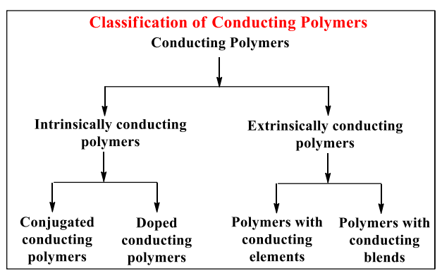
- Intrinsically Conducting Polymers

Conjugated conducting polymers having alternate single and double bonds are called Intrinsically Conducting Polymers. Conjugated polymers have a sigma bond backbone formed by the overlap of sp² hybrid orbitals of carbon atoms. The remaining orbital of the carbon atoms overlap sidewise with the neighbouring p_{z}-orbital to form π –bonds. The electrons involved in π –bond formation are delocalized over the entire polymer chain that results in the formation of valence band and conduction band. When the energy gap between the two bands is low, the electrons undergo excitation from the low energy valence band to the high energy conduction band and show increased conductivity.
Conjugation alone is not sufficient to make a polymer conducting. The conductivities of pristine polymers (pure conjugated polymers) can be increased from insulating type (10⁻¹⁰ – 10⁵S/cm) to conducting type (0.1 – 10⁵ S/cm) by a process called ‘Doping‘.

Doping
The conductivity 'Ϭ', of any conducting material is proportional to the product of the free-carrier concentration, n; and the carrier mobility, µ,
Ϭ = ne µ
where 'e' is the unit electronic charge. Due to the large band gaps in conjugated polymer, the free carrier concentration at normal temperatures is very low. Thus, although conjugated polymer has high carrier mobility the low free carrier concentration leads to low conductivity. [1,3].
Doping is the process of treating a virgin polymer with a powerful oxidizing/reducing agent that either removes electrons from or donates them to the polymer by creating a charge carrier in the polymer to improve its conductivity..
Polymer + acceptor dopant → polymer ⁺ dopant ⁻
Polymer + donor dopant →polymer ⁻ dopant ⁺
The carrier concentration in conjugated polymer molecules increases by doping. Doping in polymer molecules is a redox reaction that involves the transfer of charge and the subsequent generation of charged species. In the case of polymers, an electronic excitation is accompanied by a disruption or loosening of the lattice surrounding the exciton. Structural and electronic excitations will cause structural defects along the polymer chain. When an electron is removed from a polymer molecule, an unpaired spin remains in the valence band. When an electron is added to a polymer molecule, the unpaired spin is in the conduction band. This is called p-doping and n-doping respectively[1,4]
Oxidative dopants are usually electron-attracting substances. The common p-type dopants include Br₂, AsF₅, H₂SO₄, HClO₄, PF₅, SbF₆, CH₃F, NOF, NO₂, NO⁺SbCl₆⁻, SO₃, FeCl₃, etc. Reductive or n-type dopants are electron donating substances. The common n-type dopants include sodium naphthalide, Na/K alloy, molten potassium, Lil etc. Doping can be carried out by different methods. They are solution doping, vapour phase doping and electrochemical doping.
In the case of conducting polymers, it is possible to reverse the doping process, i.e. the conducting polymer can turn into an insulator by neutralizing back to the uncharged state. The return to neutrality is referred to as compensation. Compensation occurs when oxidatively doped polymers are exposed to electron donors, and conversely, reduced polymers exposed to electron acceptors. This property is widely used in the design of rechargeable batteries.[1]
- Extrinsically Conducting Polymers
Extrinsically conducting polymers obtained by dispersing an insulating type of polymer with suitable conducting elements like carbon black, metallic fibers, metallic oxides etc. are called conductive element filled polymers. The minimum amount of the conducting element required for converting an insulating polymer to conducting polymer is called percolation threshold.
By blending a conventional polymer with a suitable conducting polymer, we get blended conducting polymers. Polymers produced by this process have superior properties in terms of physico-chemical, electrochemical and mechanical properties and are also easy to process.
An example of an extrinsically conductive polymer is a matrix made of poly(ethylene) filled with conducting carbon black. When carbon black particles are in contact with each other, they conduct. When they are not in contact with each other, it acts as an insulator. The conductivity of the material depends on the temperature also. At high temperatures, the poly (ethylene) matrix expands, pulling the carbon black particles away from each other. This causes the conductivity to decrease. At lower temperatures, the poly(ethene) contracts, bringing the carbon black particles closer to each other, and the conductivity increases.
- THEORY OF ELECTRICAL CONDUCTIVITY
In conventional polymers such as polyethylene, the valence electrons are a part of sp³ hybridized Carbon atoms. Such “sigma-bonding electrons” are firmly bound and localized. Therefore, they do not add to the electrical conductivity. In this type of polymers, there is a large energy gap between valence band and conduction band (band gap). Due to large energy gap, these materials are insulators.
Conducting polymers are part of sp² hybridized carbon atoms containing an unpaired electron in a p_{z} orbital. Since the p_{z} orbitals are parallel to each other, they can overlap with each other to get a delocalized set of orbitals. The electrons in these delocalized orbitals have high mobility when the material is “doped” by oxidation, by removing some of these delocalized electrons. Thus, the conjugated p-orbitals form a one dimensional electronic band, and when it is partially emptied, the electrons within this band become mobile. Semiconducting polymers (conjugated materials) have the energy gap between the valence band and conduction band (band gap) in between that of insulators and conducyors. At room temperature, they have low conductivity and a small amount of electric current flow through it [2].
- ELECTRICAL CONDUCTIVITY OF COMMON CONDUCTING POLYMERS

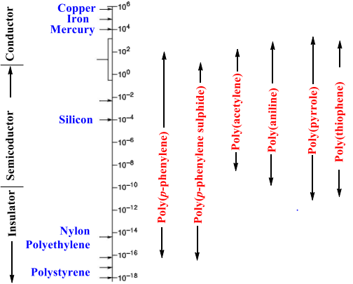
- SYNTHESIS OF CONDUCTING POLYMERS
Due to the fact that conductivity of conducting polymers depend on the way they are synthesized, there are many preparatory methods that can be used to improve their conductivity. The most common and well-known methods are addition, condensation, electrochemical, as well as ring opening and plasma polymerization. Other methods that have been developed in the last few years include: Diels-Alder elimination, Wittig reaction, Ziegler-Natta catalysis, Friedel Craft’s reaction, Nucleophilic displacement reactions etc. In designing polymer synthesis it is important to consider the incorporation of extended pi-electron conjugation.[1].
- Polyacetylene
Poly(acetylene), PA is the simplest conjugated polymer which was first synthesized. Polyacetylene (IUPAC name: polyethyne) is an organic polymer with the repeating unit [C₂H₂]_{n}. It is synthesized by the polymerization of acetylene. It’s conductivity is comparable with metals on doping with oxidizing agents like iodine vapour. Oxidation forms charge carriers on the conjugated polyene structure, especially of p-type conductivity. PA exists in two isomeric forms: trans and cis. The trans form is the thermodynamically stable form at room temperature. Polyacetylene has a conductivity in the range of 10⁻⁵ Scm⁻¹, but when the doping level increases, its conductivity rises drastically to 10² - 10³Scm⁻¹. [1, 5].
Different methods are used to synthesize polyacetylene: catalytic polymerization, non-catalytic polymerization, precursor-assisted synthesis etc., from pure acetylene and other monomers. One of the most common methods uses a Ziegler–Natta catalyst, such as Ti(O-nBu)₄/Al(C₂H₅)₃, with gaseous acetylene. It exists predominantly as the cis isomer with a high degree of crystallinity. Isomerization to the more stable trans form can be induced by heat or dopants.
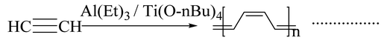
Luttinger catalysts are also used for the preparation of polyacetylene. It consist of a combination of a hybrid reducing agent and a complex of a group [VIII] metal such as nickel chloride and uses hydrophilic solvents like water–ethanol, tetrahydrofuran (THF) or acetonitrile as a solvent for catalytic action.
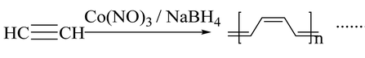
Electrochemical polymerization of acetylene comes under the heading of non-catalytic polymerization. Anodic oxidation of a monomer precursor in the presence of suitable electrolytes on an inert metal surface is regarded as an electrochemical synthesis. Polyacetylenecan also be synthesized by the retro Diels Alder reaction.
Korshak et al. synthesized polyacetylene films by ring-opening polymerization of 1,3,5,7-cyclooctatetraene which is an example of the synthesis of polyacetylene without using an acetylene monomer. Light-induced synthesis, i.e., irradiation of acetylene gas with UV also produces polyacetylene.

Properties of Polyacetylene
- Cis-polyacetylene film is flexible and can be stretched easily, while trans polyacetylene film is much more fragile.
- Cis and trans polyacetylene both exhibit high thermal stability.
- Polyacetylene is insoluble in common solvents.

Applications of Polyacetylene
- The high electrical conductivity of doped polyacetylene makes it suitable for use in electrical wiring or electrode materials in lightweight rechargeable batteries.
- A sensor for measuring glucose concentration can be made using tri-iodide oxidised polyacetylene.
- Poly(diacetylene)s
Poly(diacetylene)s (PDAs) are conducting polymers which are closely related to polyacetylene. They are synthesized by the 1,4 topochemical polymerization of diacetylenes[1].
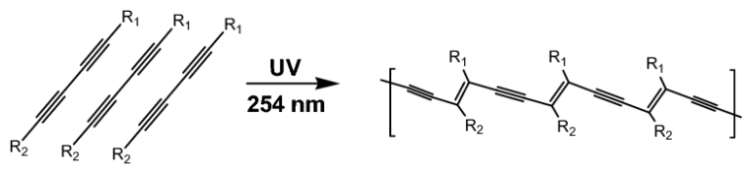
- Poly(p-phenylene)
Phenyl group polymers are a large group of conducting polymers that are thermally and oxidatively more stable compared to other polymers. The phenyl rings((benzoid aromatic nuclei) are present in the backbone of the polymer as repeat units. Direct oxidation of the benzene molecules is commonly used for the synthesis of poly(p-phenylene). The synthesis is done by the use of a reagent consisting of either a binary or a single system. The binary system consists of both a Lewis acid and an oxidant system, and in the case of a single reagent system (FeCl₃), the system acts both as a Lewis acid and an oxidative system by itself. Poly(p-phenylene) is obtained when benzene is coupled by aluminium chloride/cupric chloride at 35⁰ C in benzene solvent[6].
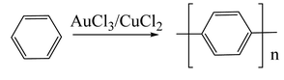
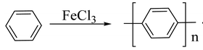
The first chemical synthesis of poly(p-phenylene) was carried out using a Wurtz–Fittig reaction, which is a metal coupling reaction.
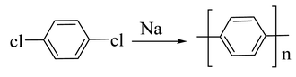
The Ullman reaction can also be used for the preparation of poly(p-phenylene)s.
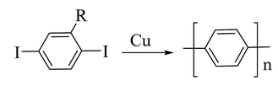
- Polyaniline
Polyaniline(PANI) is a conducting polymer which is the most promising and most explored among conducting polymers, due to its electrical conductivity, optical as well as its mechanical properties. The conductivity of polyaniline depends on concentration of the dopant, and it shows metal-like conductivity when the pH is less than 3. Polyaniline exists in three different forms. According to their oxidation state, they are classified as leucoemeraldine, emeraldine, and pernigraniline. In the fully oxidized state, it acts as an insulator and becomes conductive only when it is in a moderately oxidized state[1, 7].
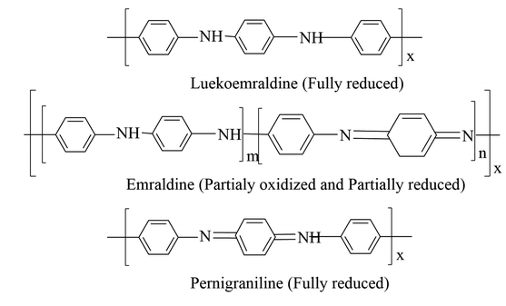
Polyaniline is synthesized using a chemical oxidation method. In this method, the aniline monomer is mixed with a suitable oxidizing agent at low temperature with a suitable acid. The change in color of the reaction medium to green indicates the formation of polyaniline. The oxidizing agent used in this method is ammonium persulfate. Other commonly used oxidizing agents include ceric nitrate, ceric sulphate and potassium dichromate etc.
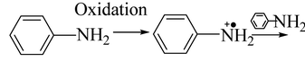
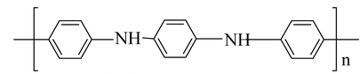
The process of synthesizing polyaniline involves interfacial polymerization, where an aniline monomer is solubilized in an organic solvent like toluene or an oxidant and acid-containing aqueous solution as dopant. Polymerization occurs in the interface between two immiscible liquids in the micro emulsion technique for the synthesis of poly aniline, but the difference is in the surfactant used. The electro polymerization technique and electro spinning method are also used for the synthesis of fibrous polymer morphologies with nano or micro diameters.
Properties of Polyaniline
- The electrical conductivity ranges from10⁻¹⁰ to 10² s/cm.
- In its reduced and oxidized forms, it has band gapes of 4.3 and 2.7 eV respectively.
- High chemical stability
- High thermal resistance
- Electrical properties of polyaniline-based composition do not change even at high temperatures like 230-240 ℃.

Applications of Polyaniline

Polyaniline is a chemical compound that is used in the production of printed circuit boards (PCBs).

It is the base element used to make N-doped (doped) carbon materials.

Polyaniline has the ability to change its color in different oxidation states, which can be used to create sensors or electrochromic devices (electromechanical devices).

Polyaniline based sensors, printed emeraldine, are widely used in the electronic industry

E. Poly(p-phenylene sulphide)
Poly(p-phenylenesulphide), PPS is an organic polymer consisting of aromatic rings with sulphide linkage. PPS is a semi crystalline thermoplastic having high melting point (285 to 296 °C). It has excellent solvent resistance, and it is insoluble in common solvents below 200 °C. The polymer is synthesized by the reaction between sodium sulphide and 1,4-dichlorobenzene in a polar solvent like N-methylpyrrolidone at high temperature (250°C)[1,8]
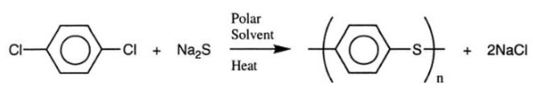
Polyphenylene sulphide can be prepared by homopolymerization of thiophenol in the presence of H₂SO₄ or by oxidative condensation of thiophenol in the presence SOCl₂ and a Lewis acid.
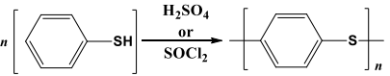
Polyphenylene sulphide can also be synthesized by self-condensation of metal-p-halogenothiophenoxide.
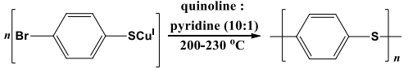

Properties of poly(p-phenylene sulphide) (PPS):
- Polymer (PPS) is a rigid, opaque, high melting point polymer (280 ℃).
- It has high resistance to heat, bleaches, acids, alkalies, sunlight, and abrasion.
- It resists dyeing and absorbs only a small amount of solvent.
- It has good conductive properties if dopants or oxidants are added.
- It has excellent mechanical strength and dimensional stability.

Applications of poly(p-phenylene sulphide) (PPS):
- Uses of PPS in automotive industries include manufacturing of fuel injection systems, electric brakes, water pump impellers, bulb housing, etc.
- Uses of PPS in electronic industries include manufacturing of hard disk drives, connectors, switches, sockets, etc.
- It also find applications in the medical industry for making medical fibers, surgical instruments and membranes.
- It is also used in fiber extrusion and chemical-resistant and non-stick coatings.

- Polypyrrole
Polypyrrole (PPy) is an organic conducting polymer which has good electrical conductivity, high environmental stability and less toxicological problems. In its undoped virgin state, it behaves like an insulating material and when doped with halogenic electron acceptors such as bromine or iodine, it shows an electrical conductivity of 10⁻⁵ Sm⁻¹ [9].
Polypyrrole, as a black powdery material was first prepared by the chemical oxidation of pyrrole monomer in the presence of hydrogen peroxide,
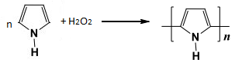
Polypyrrole can also be synthesized by electrochemical method.
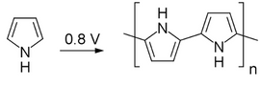
Polypyrrole has been extensively synthesized using chemical polymerization techniques, which involve the oxidative polymerization of the monomer-pyrrole by a chemical oxidant in either an anhydrous or non-anhydrous solvent, or by chemical vapor deposition. Generally, aqueous or anhydrous FeCl₃ or other metal salts, such as iron(III), copper(II) or ammonium sulfate, are commonly used as oxidants. In addition to metallic salts, polypyrrole has also been synthesized with a halogen electron acceptor (e.g., bromine, iodine) in a variety of solvents. But iron (III) chloride is the most effective chemical oxidant. Water is the most suitable solvent for the chemical polymerization process with respect to desirable conductivity characteristics.
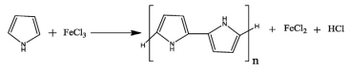
Due to the presence of highly reactive N-H group, in order to prevent side reactions and crosslinking, poly(pyrrole) can also be prepared by Stille Coupling or thermolysis sequence.

Properties of Polypyrrole:
- Polypyrrole in the virgin(undoped) state is an insulator, however, its oxidized derivatives can be used as good electrical conductors with conductivity ranging from 2 to 1,000 S/cm.
- Thermal stability can be improved, when treated with an acid or base such as sulphuric acid or sodium hydroxide.
- Polypyrrole is corrosion resistant and chemically stable due to its cross-linking properties.
- Its glass transition temperature is between 160 and 170 ℃.

Applications of Polypyrrole:
- Polypyrrole, as well as its related polymers, are utilized in a variety of applications, including electronic devices and chemical sensors.
- Polypyrrole is used as catalyst support for fuel cells and as a potential vehicle for drug delivery.
- Polypyrrole is employed in the coating of silica and reverse phase silica to produce anion exchange material..
- Polythiophene
Polythiophenes and their derivatives are of significant importance due to their ability to withstand environmental conditions, their ability to withstand extreme temperatures, and their high optical properties in comparison to other conductive polymers. Polythiophenes were first chemically manufactured in the 1980s through the Yamamoto-Lin-Dudek route [1, 10].
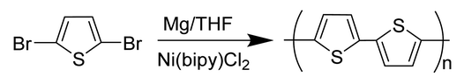
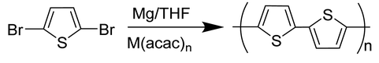
Polythiopene can be made by the standard chemical oxidation process. The oxidizing agent used in this process is Ferric chloride (FeCl₃).
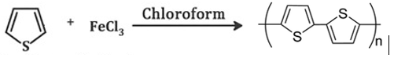
Other sophisticated methods may also be employed, such as organo-molecular coupling reaction, direct sol-gel synthesis, oxidation synthesis, template-assisted synthesis, electrolysis, hydrothermal or solvothermal process.

Properties of Polythiophene:
- Polythiopene is characterized by its high conductivity (generally exceeding 100 s/cm), thermal stability, and chemical stability.
- It is a red solid that does not readily dissolve in a wide range of solvents. However, when treated with oxidizing agents known as electron-acceptors, the material undergoes oxidation, resulting in a dark color.
- It is transparent and has excellent optical properties.
Applications of Polythiophene
- They are commonly used in solar cells due to their capacity to form a more direct connection with metal electrodes.
- They are also employed in the production of polymer batteries and electrochromic devices.
- They can also interact with receptors for detecting metal ions or chiral molecules.
- They have the potential to be used as a therapeutic tool for prion diseases.
- Poly(p-phenylene vinylene)
Poly(p-phenylene vinylene), PPV was the first electroluminescent material used for the fabrication of organic light-emitting diodes because of its high optical property. It is generally prepared by Wittig coupling reaction involving the coupling between an aromatic bisphosphonium salt and a bisaldehyde[1, 11].
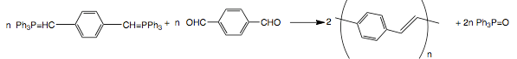
The couplings of ethylene with a variety of aromatic dibromides via a Heck reaction can be used for the synthesis of poly(p-phenylene vinylene).
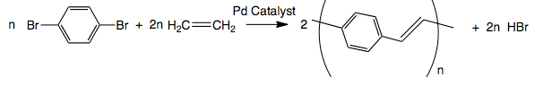
A Suzuki coupling reaction can also be used for the synthesis of poly(p-phenylene vinylene) by Pd-catalyzed coupling of alkyl-substituted aryldiboron acids with dibromo aromatic compounds. Other synthesis methods include electro polymerization, benzoin condensation, ring-opening polymerization, metathesis polymerization, and chemical vapor deposition.
PPV is a diamagnetic polymer and it’s intrinsic electrical conductivity is very low and ranges between 10 and 13 S/cm. The electrical conductivity can be enhanced by doping with ferric chloride, iodine, alkali metals, or acids. But, the stability of these doped materials is relatively low. The low optical band gap and vivid yellow fluorescence of photovoltaic (PPV) technology make it suitable for a variety of applications, including light emitting diodes, photo detectors, optoelectronic devices and photovoltaic devices.
- Poly(p-phenylene oxide)
Poly(p-phenylene oxide)s, PPO are also known as poly(p-phenylene ether)s, or simply as polyphenylene oxides. They are commonly prepared from phenols by a variety of oxidative coupling methods and step-growth polymerization reactions. The copper-catalyzed oxidation of 2,6- dimethylphenol in the presence of oxygen to synthesize PPO was first reported by Hay in 1959[12].
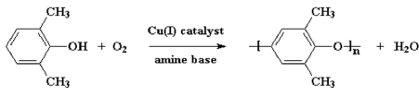
It is an amorphous high-performance plastic. The glass transition temperature is 215°C. Their moisture absorption capacity is very low and resistant towards hydrolysis and can be changed into flame retardant. They are useful materials for engineering thermoplastic applications due to their thermal, oxidative and chemical stability.
- TEMPERATURE CHARACTERISTICS OF CONDUCTORS
Temperature characteristics are important regarding the potential applications of the conductor. Generally, as the temperature increases, the conductivity of the metal decreases due to scattering of charge carriers and this is reflected in an increase in resistance. In this case, the temperature coefficient of resistance is positive (PTC). As the temperature of a semiconductor, such as silicon, increases, the number of carriers increases and therefore the conductivity increases. Such materials are said to have a negative temperature coefficient (NTC). For typical polymeric conductors such as polyacetylene, the situation differs depending on the doping concentration[1].
Although many conductive polymers exhibit metallic conductivity, the temperature dependence of conductivity is not like that of metals. In most cases, dependencies are similar to semiconductor dependencies. The conductive behavior similar to that of a semiconductor can be explained based on the presence of potential barriers between highly conductive regions. These barriers are caused by conjugation defects or other inhomogeneities within the polymer chains. The charge carriers must tunnel or jump over the potential barriers. Since tunneling is independent of temperature, the temperature dependence of conductivity must result from other processes that affect charge transfer between highly conductive regions. Sheng's model takes into account the charge energy in the conduction region and the random thermal motion of the charge carriers on both sides of the tunnel junction. The transport properties derived from that has been most successful in describing the conductivity of heavily doped conjugated polymers[1].
If the size of the highly conductive region or island is small enough (less than 20 nm), the energy required to move an electron away from the electrically neutral island is large. When the voltage between two adjacent islands is small, charge carriers are generated only by thermal activation, so the conductivity is temperature dependent and limited only by the charging energy. Charge carriers move along the path of least resistance[1].
When the size of the highly conductive region is greater than about 20 nm, the charging energy becomes negligible. Sheng's second model for inhomogeneous conductors is based on fluctuation-induced tunneling of charge carriers between highly conductive islands. This model can be applied to larger conductive regions, typically in the order of micrometers. This theory considers that random thermal movement of charge carriers within a conductive island induces randomly varying voltages in the gaps between adjacent islands. The above model can well explain the effects such as doping lead to unevenly distributed charge carriers(dopants), interchain transport, fibrillar morphology, and transport through grain boundaries[1,13,14].
The conductivity value at zero temperature is a clear difference between hopping mechanism and tunnelling. Tunneling between localized electronic states is facilitated by phonons, and the hopping conductivity disappears when the temperature drops to zero. The conductivity cannot be extrapolated to zero because the tunneling process is temperature independent and depends only on the shape and height of the potential barrier separating the charge carriers. As the temperature decreases, fewer states fall into the allowed energy range and the average hopping distance increases. This reduces the possibility of jumping and reduces conductivity[1].
- ELECTRICAL CONDUCTIVITY AND CARRIER TRANSPORT
Many studies have been conducted to characterize and understand electrical transport mechanism in conductive polymers. Charge carrier concentration and charge carrier mobility are the limiting factors for conductivity in conductive polymers . The doping process generates a large amount of potential carriers, but they must be mobile to contribute to conductivity. There are at least three factors that contribute for the career mobility. They are single-chain or intramolecular transport, interchain transport, and interparticle contacts. These three elements form a complex network of resistance that influences the effective mobility of the charge carriers. Therefore, mobility and conductivity are determined at both the microscopic (intra- and interchain) and macroscopic (interparticle) levels[1].
Similar to all organic materials, ionization of the conjugated polymers causes distortion in the lattice around the ionized states. As charge carriers move through the polymer, this lattice distortion reduces their mobility. Because disorder plays such a dominant role in conducting polymer systems, the charge carrier transport mechanism is more similar to that of amorphous semiconductors (hopping transport). [1,15,16]
- CHARGED DEFECTS IN CONJUGATED POLYMERS:
THEORY OF CONDUCTION
Theoretical studies on conducting polymers have mainly focused on radical and ionic sites, called neutral and charged defects, respectively. The motion of the defect can be described mathematically as a solitary wave, or in the language of field theory as a "soliton." Radical defects are called neutral solitons. Anionic and cationic defects are charged solitons. Charged solitons (anions or cations) can account for spinless transport because they carry charge but have no spin[1].
The first species generated upon ionization of a conjugated polymer is a radical ion that has both spin and charge. According to the terminology used in solid state physics, radical ions are called polarons. A polaron can have either a positively charged hole site (radical cation) or a negatively charged electron site (radical anion) and a lattice relaxation (distortion) around the charge. Theoretical models show that two radical ions (polarons) in the same chain react exothermically to form a dication or dianion (bipolaron), which is responsible for the spinless conductivity of these polymers [1, 17-20].
- MICROWAVE CONDUCTIVITY
All dielectric materials are characterized by dielectric parameters such as permittivity, conductivity, dielectric constant and polarization. Similar to all organic materials, ionization of conjugated polymers produces large distortion in the lattice around the ionized state. As the charge carriers move through the polymer, this lattice distortion reduces their mobility. Because disorder plays such a dominant role in conducting polymer systems, the charge carrier transport mechanism is more similar to that of amorphous semiconductors (hopping transport)[1].
Microwave technology has its roots in the design and development of radar. In the early stages of development, phased array technology is used for beam steering in radars. This is a very complex design and requires mechanical work to control the beam. When microwave frequencies are applied, poly(o-toluidine) readily undergoes dipole polarization. These properties find its use to develop radar electron beam shaping systems. Materials with low DC conductivity but high microwave conductivity find applications in the development of microwave communication links. These are also used for satellite communications that prevents stray signals and allows microwave signals to pass through[1].
Perturbation theory is applied in the determination of complex permittivity and conductivity of dielectric materials. If the dielectric material is placed within the cavity resonator at the point of maximum electric field, the contribution of the magnetic field to the disturbance (perturbation) will be minimal[1,21-24].
- CONDUCTING POLYMER BLENDS
Polymer blends are a mixture of a polymer and one or more materials with relatively different physical or chemical properties. This blend helps to improve mechanical, electronic, and thermal properties compared to the pure polymer. Conducting polymer composites have attracted great interest in recent years as they are used for numerous applications in various fields of the electrical and electronic industry. Most of the conducting polymers are insoluble in common organic solvents, making them very difficult to cast into films and other shapes which is essential for a variety of applications. Similarly, conducting polymers such as polyacetylene are unstable in air, and their conductivity changes over time due to interactions with things like air and oxygen. The main drawbacks of conducting polymers, such as instability to environment and processing difficulties, can be overcome by preparing composite materials in combination with other polymers. Incorporating conductive polymers into host polymer substrates to form blends, composites, or interpenetrating bulk networks has been used as an approach to combine electrical conductivity with desirable mechanical strength of polymers. Conducting composites having interpenetrating network can be made by the in situ polymerization of monomers within a conventional linear polymer matrix. [1, 25,26].
Conductive polymer blends having unusually low percolation thresholds have been reported for polyaniline and styrene-butyl acrylate copolymer blends. Polyaniline-epoxy-novolac resin composites have been reported to be useful for antistatic applications. In an electrochemical cell, an interpenetrating network of poly(pyrrole) filaments was fabricated within a swellable insulating plastic matrix[1].
- ELECTRICALLY CONDUCTIVE ELASTOMERS
Elastomers and plastics which are insulators can be made electrically conductive by the addition of particulate or colloidal fillers like carbon black with high intrinsic conductivity. Conductive rubber compounds were used for the first time to prevent corona discharge within cables. Large amounts of coarse carbon blacks, graphite or metal powders are used to make conductive rubber. Conductive rubbers with improved mechanical properties can be prepared by the addition of acetylene black and other conductive blacks. Rubber filled with furnace soot showed antistatic properties. Non-insulating antistatic rubber is currently used in many situations involving the handling of explosive (or flammable) vapors, powders or liquids. The effect of temperature on conductivity follows the Arrhenius equation, allowing estimation of the activation energy for electrical conduction. Conductive rubber is used in various fields such as electrochromic displays,sensors, EMI shielding, electrostatic discharge dissipation (ESDD), fuel cells, conductive pressure sensitive rubber, and circuit boards[1,27,28].
The basic and generally accepted concept of electrical conductivity is based on the fact that carbon black forms aggregates or network structures in the composition. The degree of conductivity depends on the type of these chain structures. Various factors that affect the electrical conductivity of carbon black-containing polymer composites include carbon black concentration, type of carbon black, type of polymer, mixing time, temperature, and degree of carbon black dispersion in the polymer matrix[1].
- ELECTRICAL CONDUCTION IN CARBON BLACK LOADED RUBBER VULCANIZATES
Carbon black particles are not discrete particles, but are "clusters" of individual particles fused together. These clusters are the working units of carbon black loaded rubber vulcanizates. If the amount of carbon black is small, the conductivity of the composite material will be very low. It can be seen that above a certain level, as the amount of carbon black in the composition increases, the conductivity increases significantly and tends to asymptotize to a finite value. The entire area of ​​increased conductivity is called the percolation region. In this region, conductivity is limited by a barrier that prevents charge carriers (electrons) moving from one cluster of carbon black to another cluster that is close to each other but not in contact. Electrons must overcome a potential barrier to exit the carbon black aggregate and pass through the gap. In 1957, Polley and Boonstra reported that electrons "jump" across this gap. Five years later, van Beek and van Pul suggested that the movement of electrons in these systems relies on tunneling, a special case of internal field emission. In the case of composites filled with carbon black, Sheng, Sichel, and Gittleman reported that dominant mechanism invoves a specific type of tunneling activated by thermal fluctuations in potential. [1, 28].
According to Medalia, the tunneling current is an exponential function of the gap width. Tunneling therefore occurs between very closely neighbouring carbon black aggregates, and there is virtually no conduction between aggregates separated by slightly larger gaps. As the concentration of carbon black increases, the aggregates are packed more densely and compacted together. This reduces internal contact resistance and improves conductivity. Once a sufficiently high load is reached that the contact resistance between the aggregates becomes insignificant, further addition of carbon black cannot significantly increase the conductivity. This creates a "continuous chain" during high loads[1].
For composites having normal loads and temperatures, the main conduction mechanism is either thermal activation of electrons across the gap of the potential barrier or tunneling assisted by thermal fluctuations. For conductive carbon black at high frequencies and high charges, conduction is not limited by electron transport across the gap, but rather by the intrinsic conductivity of the carbon black(i.e., within the carbon black aggregate)[1].
Electrical conductivity also depends on the “structure” or bulkiness of carbon black aggregates in a similar way to loading, as aggregates with higher structure actually occupy a larger volume of the composite. Janzen's theory states that the percolation threshold for highly structured carbon blacks is comparatively low. At a given loading, high structure carbon black has higher conductivity than low structure carbon black[1].
The conductivity is highly dependent on the state of carbon black dispersion in the percolation region. The conductivity of carbon black and rubber composites increases rapidly during the early mixing stage due to the formation of channels between islands of carbon black where carbon black is incorporated and filled with rubber. Then, in the later stages of mixing, the aggregates are broken and the conductivity gradually decreases as the distance between individual aggregates increases[1].
The conductivity of rubber filled with carbon black depends on their particle size also. As the particle size of the carbon black increases, the conductivity decreases. On purely geometric grounds, it was argued that smaller particle size should result in smaller gap widths and more conducting paths per unit volume. It is also reported that smaller particles are more easily arranged into chains than coarse particles[1].
The conductivity changes of various elastomer-carbon black composites at temperatures below the percolation threshold are characterized by thermally activated behavior above a certain temperature. The temperature dependence of conductivity above the percolation threshold can be attributed to both the breakdown and reformation of carbon clusters with temperature. At normal and elevated temperatures, rubber compounds with normal carbon black content exhibit a decrease in conductivity with increasing temperature. This is because the gap width increases due to thermal expansion of the rubber. Compounds with very low concentration of carbon black exhibit the opposite behavior. At relatively high temperatures, the conductivity becomes increasingly active as the temperature increases. Rubber behaves like a semiconductor at this temperature. In this region, the distance between the carbon black aggregates is large enough to allow extrinsic conduction, and the conductivity arises primarily from charge carriers in the rubber matrix[1,29, 30].
- CONDUCTIVE ELASTOMER BLENDS

The quantity of electrically conductive fillers needed to impart high electrical conductivity to an insulating polymer can be effectively reduced by the selective localization of the filler in one of the phase or at the interphase of a continuous two-phase polymer blend. In this way, the final cost of the material can be decreased, but the issues related to an excess quantity of filler on the processing and mechanical properties of the final composites are enhanced. The localization of carbon black in an immiscible polymer blend is basically controlled by the mutual polymer-polymer and polymer- filler interaction. If the carbon black is localized at the interface of continuous polyethylene/polystyrene and polystyrene/polyisopreneblends, the addition of carbon black needed for percolation threshold can be reduced up to 0.2 %. Sircar has reported that carbon black initially dispersed in one rubber migrates to the interface with another immiscible rubber. This results in more favourable interactions with the second polymeric material. An increase in electrical conductivity is noticed when (i) the two rubbers are immiscible, (ii) there is a large difference in the carbon black-rubber interactions and (iii) the rubber less interacting with carbon black is less viscous[1,30].

- REFERENCES

Princy K.G, Rani Joseph, C. Sudha Kartha, Conducting Polymers and Conductive Elastomers, LAMBERT Academic Publishing, 2010.[Princy K.G., Ph.D. Thesis, Studies on Conducting Polymers and Polymer Composites, 2002; dyuthi.cusat.ac.in]

Abhishek Kumar Mishra, Conducting Polymers: Concepts and Applications, Journal of Atomic, Molecular, Condensate and Nano Physics Vol. 5, No. 2, 159–193, 2018.

3.
- https://en.wikipedia.org › wiki › Conductive_polymer.
- Hari Singh Nalwa, Handbook of Organic Conductive Molecules and Polymers, Vo!.2, John Wiley and Sons, England, 11, 1997.
- V.A. Lopyrev , G.F. Myachina , O.I. Shevaleyevskii and M.L. Khidekel, Polyacetylene. Review, 30, (10), 2151-2173, 1988.
- Martin B. Jones and Peter Kovacic, Polyphenylene,Comprehensive Polymer Science and Supplements, 5, 465-472, 1989.
- A.G. Macdiarmid, J.C. Chiang, A.F. Richter and A.J. Epstein, Polyaniline: a new concept in conducting polymers, Synthetic Metals, 18, (1–3), 285-290, 1987.
- Peiyuan Zuo, Abbas Tcharkhtchi, Mohammadali Shirinbayan, Joseph Fitoussi and Farid Bakir, Overall Investigation of Poly (Phenylene Sulfide) from Synthesis and Process to Applications-A Review, Macromolecular Materials and Engineering, 304 (5), 1-27, 2019.

Tat'yana V Vernitskaya and Oleg N Efimov, Polypyrrole: a conducting polymer; its synthesis, properties and Applications, Russ. Chem. Rev., 66, 443, 1997.

R. D. McCullough, The chemistry of conducting polythiophenes, Adv. Mater., 10(2), 1998.

Ruyu Li, Yanjiao Mo, Rong Shi, Peng Li, Chengyu Li, Zhenjiang Wang, Xun Wang, and Shengbiao Li, Synthesis and properties of poly(p-phenylene vinylene) derivatives with hyperbranched structure and containing a nitro substituent, Monatsh Chem., 145(1), 85–90, 2014.
- Dwain M. White, Poly(p-phenylene oxide)s, Comprehensive Polymer Science and Supplements, 5, 473-481, 1989.
- P.Sheng and J. Klafter, Hopping conductivity in granular disordered systems, Phys.Rev., B 27 ,2583, 1983.
- Sheng, E.K.Sichel and J. l. Gittleman , Carbon Black Polymer Composites, Phys.Rev. Lett., 40, 1197, 1978.
- Encyclopaedia of Polymer science and Engineering, second edition, Vol.5i Mark Bikales over Berger Menges John Wiley and Sons Inc., 1986.
- N. F. Mott and E. A. Danis, Electronic Processes in Non crystalline Materials, 2 ed., Clarendon press, Oxford, 1979.

W. P. Su, J. R. Schrieffer, and A. J. Heeger, Solitons in Polyacetylene, Phys. Rev. Lett. 42,1698, 1979.
- M. J. Rice, Solitons and polarons in conducting polymers,Phys. Left. A. 71, 152, 1979.
- Y. R. Lin-Liu, and K. Maki, Continuum model for solitons in polyacetylene, Phys. Rev. B 26, 955, 1982.
- J. Tinka Gammel, and J. A. Krumhansl, Theory of optical absorption in trans-polyacetylene containing solitonsPhys. Rev. B 24, 1035, 1981.
- M. Martinetlit P.A. Rolla and E. Tombari, IEEE Trans. Microwave theory and Techniques, 33, 779, 1985.
- Y. Xu, F.M. Ghannouchi and R.C.Bosisio, IEEE Trans. Microwave theory and Techniques, 40, 143, 1992.
- S. Biju Kumar, Honey John, Rani Joseph, M. Hajian, L.P. Ligthart, K.T. Mathew, Journal of the European Ceramic Society, 21, 2677, 2001.
- Honey John, K.T.Mathew and Rani Joseph, Proceedings of the fourteenth Kerala Science Congress, 518, 2002.
- T.A. Skotheim, Handbook of conducting polymers, Marcel Dekker, New York, 1986.
- J. Margolis, Conducting Polymers and Plastics, Chapman and Hall,London, 1993.
- J. A. Chilton, and M. T. Goosey, 'Special Polymers for Electronics and Optoelectronics', London, Chapman and Halt, 18, 1995.
- K. G. Princy, Rani Joseph and C. Sudha Kartha, Studies on conductive silicone rubber compounds ,J. Appl. Polym- Sci., 69 1043 1998.
- A. l. Medalia, Electrical Conduction in Carbon Black Composites, Rubber Chem. Technol., 59, 432, 1986.
- K. Sircar, Electrical conductivity of polystyrene-rubber blends loaded with carbon black . Rubber Chem. Technol., 54, 820, 1981.

