The shoulder accounts for more than half of all joint dislocations, making it the most often dislocated joint. Because of its range of motion, it is unstable. The labrum, ligaments, and surrounding muscles are only a few of the static and dynamic components that contribute to shoulder stability. Instability can be caused by an illness that contains one or more of these stabilizing factors. Trauma is the most common cause of shoulder instability. Depending on the direction of the instability, traumatic shoulder dislocations are frequently classified as anterior, posterior, or inferior. The majority of shoulder dislocations are anterior, accounting for more than 95% of all dislocations. While inferior dislocation is thought to account for as little as 0.5% of all shoulder dislocations, posterior dislocation is thought to occur between 2 and 4% of the time. Although shoulder trauma is the most common cause of instability, soft tissue abnormalities or poor muscle function can induce shoulder instability even when no significant trauma has occurred. Atraumatic instabilities differ from traumatic instabilities in that they are often multidirectional. It's essential to comprehend the failure's underlying mechanism. Missing a contributing factor might result in the instability being treated ineffectively. For long-term care of the illness, the accompanying pathologies should be acknowledged in addition to the instability. Imaging modalities are essential in identifying the pathophysiology behind the instability and measuring the illness to offer a proper treatment, in addition to a thorough evaluation. CT scans and radiography provide vital information regarding the skeletal structure and degree of bone loss. A thorough examination of the soft tissue structures with magnetic resonance imaging identifies prospective concerns that should be addressed in the treatment plan. Treatment options for shoulder instability range from rehabilitative methods to surgical repair or restoration of the damaged processes. In the absence of risk factors, nonoperative therapy is a viable alternative for multidirectional instability and the initial episode of instability. The problem could be repairable if no significant bone loss happens and if there are high-risk factors for recurrence in the initial episode (such as young age, male gender, athletic activity, and the existence of bone insufficiency). However, in situations of significant disruption in bone architecture and in juvenile crash or contact athletes, more complicated and difficult therapies may be required to reconstruct the shoulder girdle. The timing of the operation is also important for optimal management since more advanced procedures are required when the chance of bone disruption rises with recurrent dislocations. Shoulder rehabilitation is particularly important for reestablishing sensory function and the strength of the shoulder's dynamic stabilizers. A recurrence of the instability following conservative or surgical treatment may be unavoidable if proper rehabilitation is not provided. For successful care, the cause of shoulder instability should be thoroughly examined, and treatment plans should be tailored to each patient. To design effective preventative and treatment strategies, potential risk factors should be identified.
Biomechanics of shoulder instability
Surgeons must evaluate the crucial amount of bone loss (glenoid defect and Hill-Sachs lesion), which are often encountered, while treating patients with anterior shoulder instability. Bankart repair is widely recognized as a gold-standard procedure, with multiple articles highlighting its positive clinical outcomes. However, considerable bone loss has been shown to cause postoperative shoulder instability. Numerous biomechanical studies have demonstrated how the quantity of bone loss affects stability.
Bone grafting is advised if the glenoid bone loss is greater than 25% of the glenoid width. Since contact between a Hill-Sachs lesion and the glenoid rim is always present, glenoid bone loss must be taken into account when calculating the critical size of a Hill-Sachs lesion. A unique glenoid track concept was put up in 2007. This concept allows us to account for both bone loss and decide if a large Hill-Sachs lesion is "on-track" or "off-track". This concept has been used several times. The normal glenoid track width has been determined to be 83% of the glenoid width. However, because the glenoid track is defined as the glenoid's contact with the humeral head, the breadth of the glenoid track appears to be impacted by the range of shoulder mobility. An MRI study with healthy volunteers was done to better understand the relationship between range of motion and the glenoid track. The results showed that the narrower the glenoid track width was, the larger the horizontal extension angle in abduction and external rotation. The active horizontal extension angle in the sitting posture can be used to calculate the personalized glenoid track width. The concept of the glenoid track has gained support in the medical community, and glenoid track evaluation is advised for surgical decision-making. 94 patients were examined in order to understand the clinical outcomes of patients who underwent surgery based on this theory. The overall recurrence rate in patients who underwent glenoid track surgery was 4.3% during a 2-year follow-up. The application of the glenoid track concept in surgical decision-making to prevent recurrence and instability after surgery is supported by these findings. An "on-track" lesion with a glenoid defect of less than 25% can be repaired only with arthroscopic Bankart repair. In a patient with an "off-track" lesion and less than 25% glenoid deformity, we should treat a Hill-Sachs lesion with a remplissage approach. In a patient with an "on-track" lesion and more than 25% glenoid defect, we should perform bone grafting, such as the Latarjet procedure, to restore a large loss of glenoid bone. Because bone grafting can change an "off-track" lesion into an "on-track" lesion, it can be employed even when there is an "off-track" lesion with a glenoid defect of more than 25%.
Several categorization schemes for glenohumeral instability have been presented. The patient's signs and symptoms are collected in order to construct a pattern to define their illness. Once categorized, the treatment method should be implemented in a systematic or algorithmic manner. There is no precise categorization that will match every instance since there are so many elements to consider before treating a patient with instability (etiology, instability direction, laxity, patient age, activity, expectations, and bone loss).
The surgeon must thoroughly evaluate the patient's medical history, physical examination, and imaging results in order to administer the proper therapy. According to Thomas and Matsen's classification method, patients with recurrent instability are split into two groups: those with trauma, unidirectional instability, Bankart lesion, and surgery, and those with atraumatic instability and multidirectional instability. Although this method is effective, it does not account for ambiguous situations or individuals who could move between illnesses. Static instability, dynamic instability, and voluntary dislocations are the three categories that Gerber and Nyffeler created to classify instability and hyperlaxity. Class B trauma sufferers are frequently young and active individuals. Three polar types—traumatic and structural instability, atraumatic structural instability, and muscle patterning nonstructural instability—are included in the Stanmore categorization, which is a triangular paradigm. The differences between acute and atraumatic instability, patient posture, muscle patterning, and glenohumeral instability are all treated separately.
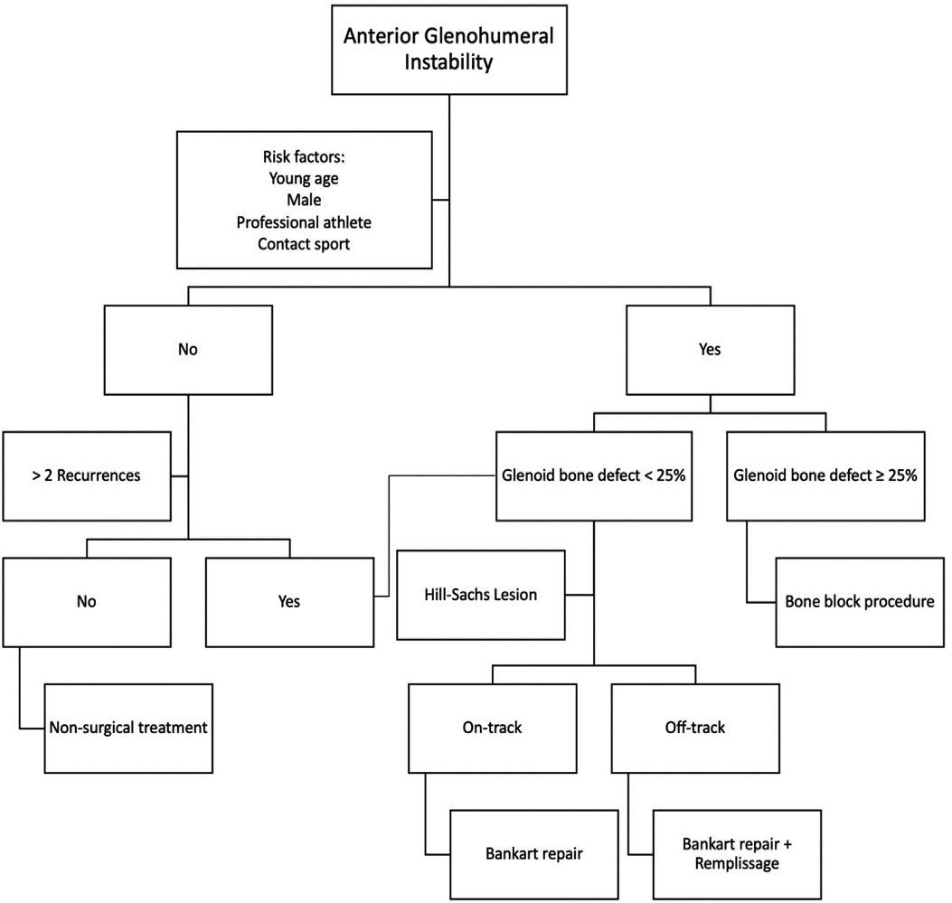
Figure 1 illustrates an algorithm for treating individuals with anterior glenohumeral instability.

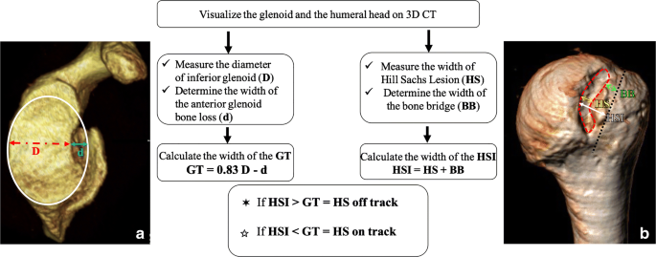
Figure2: -on track – off track
Treatment of glenoid defects surgically: Latarjet-Patte's 1958 open approach, used to treat severe bone loss in glenohumeral anteroinferior instability, was less common from 1990 to 2000 due to Bankart arthroscopic stabilization, but resurfaced after problems with non-consideration of glenoid and humeral bone losses were revealed. Lafosse and Boyle reported a recurrence rate of 2-4.9% and a satisfaction index of 98% for the arthroscopic Latarjet procedure, with greater residual apprehension and less graft reabsorption. Patients with a failed coracoid transfer, aberrant coracoid morphology, or very severe glenoid loss were often thought to be candidates for an Eden-Hybinette operation.
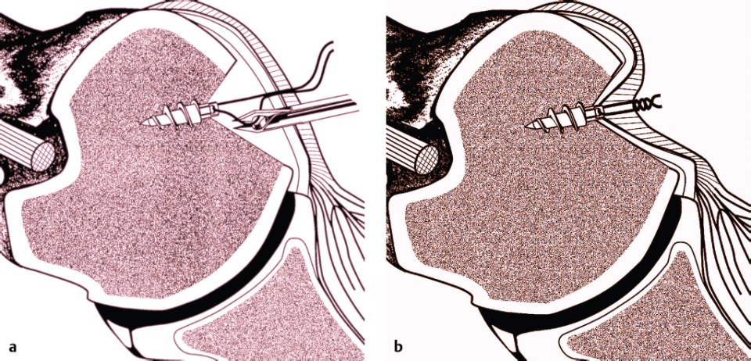
Figure 3: - Remplissage Procedure

The verb "remplissage" in French means "to fill in." Engaging Hill-Sachs bone deficiencies have been treated surgically using a variety of techniques, including bone grafting, retrograde desimpaction, arthroplasty, partial humeral head resurfacing, humeral rotation osteotomy. Remplissage is a common operation that includes an arthroscopic Bankart repair, infraspinatus tenodesis, and posterior capsulodesis to fill the Hill-Sachs lesion. The method was reported in 2007 by Wolf et al. as an add-on to the arthroscopic anterior stabilization operation of the shoulder in order to correct a substantial Hill-Sach's defect. The Remplissage method has been proven to be effective in reducing the incidence of recurrent anterior shoulder instability when used in conjunction with arthroscopic Bankart surgery.
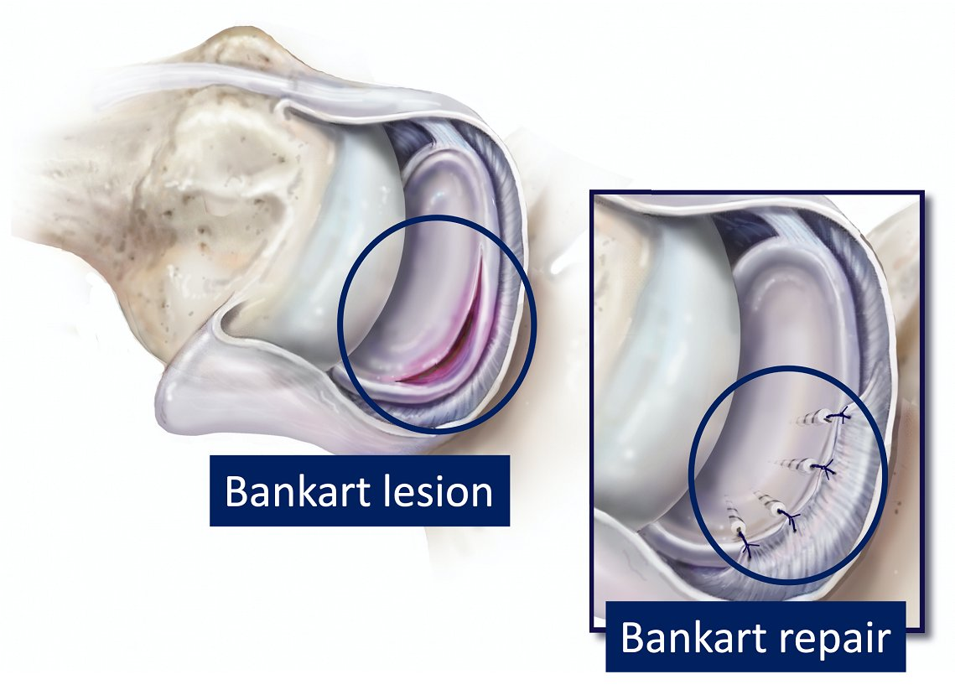
Figure 4: - Bankert lesion and repair

