Enhancing Regional Cooperation to Facilitate Faster Recovery of Trade and Investment in India

Author- Ipsita Roy Chowdhury

Abstract
This paper focuses on the fact of how regional cooperation can help in meeting faster recovery of trade and investments in a country like India. Regional cooperation signifies the policies, reforms, infrastructural development, financial literacy among common people and other political factors that play a crucial role in ensuring that there is smooth and engaging cooperation in promoting national interests. In this paper, existing policies and papers have been used as a secondary form of support that has helped the study to reach a constructive suggestion that will help India in long run in the context of trade and investments.

JEL codes- International Trade and Finance, Open Economy Macroeconomics, International Investment, International Factor Movements and International Business, Financial Literacy, Economy

Table of Contents
1. Introduction 6
1.1 Regional cooperation to facilitate faster recovery of trade and investment in India. 6
1.2 Current scenario of the problem 6
1.3 Current strategies and their intervention 7
1.3.1 Current strategies and their intervention in India 7
1.3.2 Current strategies and their intervention in Asia 9
1.4 Research Gap 10
1.5 Problem Statement 10
1.6 Need of the study 11
1.7 Research Questions 12
1.8 Rationale of the study 12
1.9 Research Objectives 12
2. Methodology 13
2.1 Research Methods 13
2.2.1 Research Onion 13
2.2.2 Research Philosophy: Positivism 14
2.2.3 Research Design: Conclusive 14
2.2.4 Research Approach: Deductive 14
2.2.5 Data Type: Secondary 14
2.2.6 Research Ethics 15
2.2.7 Limitations of the Research 15
3. Literature Review 15
3.1 Depreciation of Local Currency (Indian Rupee) 15
3.2 Political Instability 16
3.3 Investment Policy Reforms (since 1991) 17
3.4 Relaxation of Quantitative Restrictions on Imports and Exports 18
4. Findings 19
5. Way Forward 21
References 24

List of Figures
Figure 1: GDP growth of India in the last 3 years. 8
Figure 2: Performance of India’s GDP growth with other countries in 2022. 10
Figure 3: Research Onion 13
Figure 4: Relationship between FDI and Economic Growth in India 19
Figure 5: Targets to be achieved by 2025 by India 20

1. Introduction

1.1 Regional cooperation to facilitate faster recovery of trade and investment in India.
Regional cooperation is the term that refers to the efforts in strengthening the common interests of political as well as institutional mechanisms by promoting their national interests. Currently, the three priority areas of regional cooperation involve the internet and telecoms, transport and energy (worldbank.org, 2009). Here, regional cooperation in transport is contributing to the meet the trade and investment benefits in the country to some extent. This is because the trade and investment benefits are to a large extent dependent on the proper industrial functionality.
Regional cooperation is a bigger concept that plays a crucial role in catering to the needs of reforms that are to be taken care of to facilitate the faster recovery of trade and investment in India. In this context, it has been seen that a majority of the countries that have shown good trade and investment in their places are stable economies or have strong financial backbones. In short, the countries having good and strong economies are the ones that can foster the growth of trade and investment in their countries. However, there are controversies in this context everywhere that persist and the true essence of how regional cooperation and integration can be done lies in the question of how it would differ in each of the countries. In this context, this paper focuses on the trade policies and reforms that India has taken and how the scenario can be improved for India in the coming years as well.

1.2 Current scenario of the problem
The challenges of trade and investments in India have a wide spectrum and there are various categories through which foreign companies are facing challenges to trade in India. It has been noted that non-transparency and unpredictable tariff policies or regulations are often encountered by U.S. exporters as well as investors (trade.gov, 2022). Also, India is considered to have applied the highest tariff across all the G20 countries. It is also said that India is a country that has applied the highest rate of tariff among all the WTO member countries.
The consumers of the country of India are said to be extremely sensitive towards the price of the commodities that they are going to buy from the market. People prefer to buy things that are having most of the features but are cheap. That is why many foreign companies are finding it difficult to sell their models in the Indian price range. Modification of the product models is being done by those companies to sell the products in the market price range. The willingness of Indian customers to pay for a particular product plays a major role in deciding how many features and size of the availability of product is to be designed and re-modelled.
There is a requirement for proper infrastructural needs for ensuring timely delivery of the products to the consumers in India. There is a sound inefficiency in the development of road congestions, inordinate delays in terms of railway transports, and also inefficiency in turnaround time at the ports as well. Though there is a fast development happening in the Indian airport sector, still there are constraints in terms of capacity as well. Infrastructural development in the airways and the waterways are bound to be done to mitigate the problem of transport and thus, can be one of the ways through which regional cooperation can enhance the culture of trade and investment in the country.

1.3 Current strategies and their intervention

1.3.1 Current strategies and their intervention in India
India has taken up several acts and reforms to enhance the growth and recovery of trade and investments within the country. Extensive reforms have been implemented by the Indian government since 1991 namely the demands for foreign trade, liberalization, privatization, tax reforms, EXIM policies and Globalization. It has been found that between 1991 and 2006, trade liberalization had a positive effect on trade specialization and thus the reduction in tariffs that were associated with various kinds of products also resulted in an increase in the Lafay index (adb.org, 2009). Moreover, it has also been seen that the trade reforms and trade liberalization activities that were implemented between 1991 and 2006 have been found instrumental in enhancing the competitiveness of the country internationally among the industries.
India is currently growing in trade and investments in the country and has been doing exceptionally well in the fields of investments. As per Zameer et al. (2020), India can be considered the fastest economy in the world concerning innovation and growth in the economy. The country of India has shown rapid growth in terms of the economy due to the increase in exports from the country and also due to foreign direct investments. The current strategies and their intervention include the possible reforms and policies that have been already undertaken by the Govt. of India to enhance the trade and investment of the country. In this regard, the GDP of India for Q1 and Q2 of 2022-2023 has reached a level which is more than the Q1 and Q2 of the year 2019-2020 (dea.gov.in, 2022).
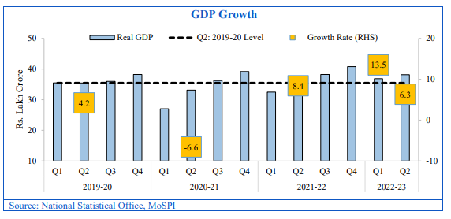

Figure 1: GDP growth of India in the last 3 years.
(Source: dea.gov.in (2022))
According to the figure attached above, it can be seen that the GDP of the country for the year 2022-23 has shown a significant increase in comparison to the previous two years. This picture gives a strong message that the economy of the country is improving and the reforms and policies which have been undertaken during this period have been proved right through the visible results.

1.3.2 Current strategies and their intervention in Asia
From a global perspective, the intervention of the strategies undertaken by most of the countries in the Asia Pacific region has shown to be right as it has grown over the years. It has been said that the Asia- Pacific real exports from a global perspective will increase by 3 per cent by the end of 2022 (unescap.org, 2022). Moreover, inflation will be there in the next year of 2023 but it is expected to have a nominal effect on the exports and import category in Asia. However, despite all the increase in the trade results in 2022, the investments in this region are perhaps the area of focus as it has not fully recovered in 2022.
In context to the G20 countries in the Asia-Pacific region, among most of the countries, India as a country has shown incredible results in economic development over the last few years.
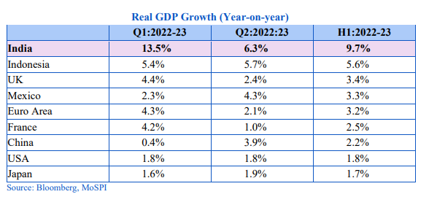

Figure 2: Performance of India’s GDP growth with other countries in 2022.
Source: dea.gov.in (2022)
As per the above figure, India’s performance in terms of GDP growth can be seen in comparison to the other strong economies in the world. It also depicts the fact the country of India is one of the economies which has the potential to do so much more in the coming years provided the fact that there have to be favourable circumstances in terms of export, import and Foreign Direct Investments as well.

1.4 Research Gap
In this research scope, a gap which has been identified in the research is how the increase in the population can strengthen the ability to be a stronger economy. On the contrary, as per Wilmoth (2022), it has been highlighted that there is significant slow progress with an increase in the population in a country. It has also brought to light the fact that there are challenges among the low–income people to sustain and grow based on per capita.
In my opinion, there are challenges associated with the low-income group of people, but at the same time, we are getting so much of the population in a single economy to serve our country. There are several non-governmental organisations and developmental organisations that are working for mainstreaming low-income people and trying to educate them about their ways of life. The relation to how these developmental organisations can contribute to making the economy of the country stronger need to be focused on and considered in order to understand how regional cooperation can be improved to facilitate faster recovery of trade and investment.

1.5 Problem Statement
Regional cooperation in terms of political support can enhance the recovery of trade and investments in the country. For that, all we need to do is to educate the people of India. Being a developing country, India still lags behind the developed countries. Adding to this note, one of the major drawbacks of the growth is not only the political influence but also the lacking of knowledge in terms of finance, investments and trade among the common people of India. In particular, only 21.8% of entire India's population is financially educated (ibef.org, 2022). There is a minimal percentage of people who knows what to do with the money earned.
The majority of the population in India is concerned about earning their daily needs due to their low -income level. Apart from the low-income households, whoever is falling into the middle-income level, also needs to be given a platform where they can get a chance to educate themselves on how to save money, how to invest and where to invest that money. A large number of people are working for the government and are working in the private sector as well. In recent times, there is an increase in the trend of people tending to know more about finance and accounting. However, to date, financial education remains a problem for most people in India. Although India is a developing country becomes very dynamic with huge cultural diversifications among different states, yet, it is one of the major facts of why regional cooperation is required to be enhanced.

1.6 Need of the study
The need for the study is felt to address the challenges and the issues that are present in trade and investments. Hence, the long-term constraints of the growth in the Indian economy can be reduced with the help of regional cooperation Moreover, regional integration and cooperation can also support in achieving the Sustainable Development Agenda by 2030 as the relation between the 2030 Agenda with RECI are bidirectional (ESCAP, 2017). Several ways can be found from this study through which the people have a better understanding of how regional cooperation within the country can be achieved possibly through large employment and income generation opportunities among the youths.

1.7 Research Questions
Research Question 1: To find out the key solutions that can help in enhancing the regional cooperation of the country in a short duration.
Research Question 2: To find out the probable key solutions that may help in enhancing the regional cooperation of the country for the long term in terms of trade and investment.

1.8 Rationale of the study
The reason behind creating a cooperative region where trade and investment can have a faster recovery is because it can help the country to have a better future in terms of economy. In G20 countries, India is one of the economies that is still struggling to have a stable economy and it is growing day by day. According to Park et al. (2019), due to the unexpected emergence of the Covid-19 pandemic worldwide, the economy of the country has seen a down during that period and it is now growing with various strategic reforms and policies. The study is done to identify ways through which regional cooperation can be enhanced as it would help the country to have better growth in the investments that can in turn help the economy of the country to grow.

1.9 Research Objectives
The objective of the research is to identify the probable opportunities that can act as a boon to the development of regional cooperation in India that can help the country to have a better and faster recovery on trade and investments. The objective of the study is also to understand the actions that are to be undertaken as a community to help the country grow in short term as well as in long term.

2. Methodology

2.1 Research Methods
Research methods are the methods that have been used to conduct the study. All the various tools have been described in the following sections to understand better what has helped the study to execute successfully.

2.2.1 Research Onion
The research onion plays an important role in understanding the methods that are followed in the study. There are several layers in the research onion and by unfolding each layer, it is able to arrive at an authentic conclusion in the study. The illustrated view of different layers of the research onion has been attached below:
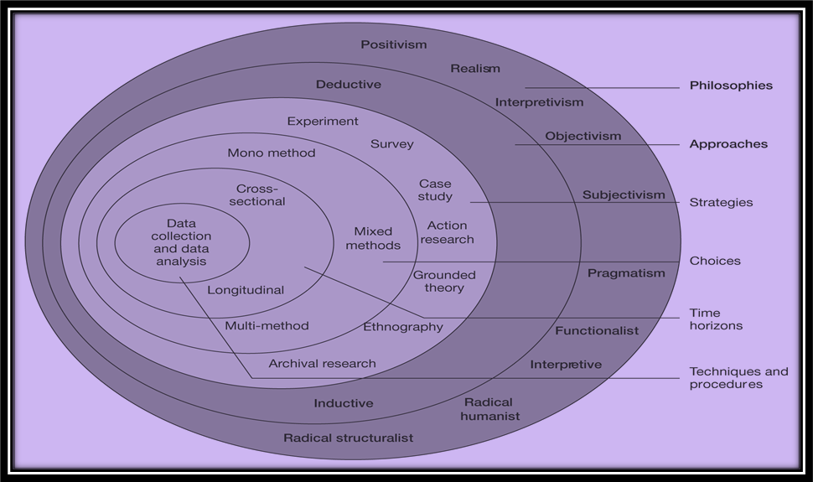

Figure 3: Research Onion
(Source: Brannen, J, 2009, p. 12)

2.2.2 Research Philosophy: Positivism
Research philosophy is generally of three different types namely positivism, realism, and interpretivism. In this study, positivism has been used to understand the study and all types of secondary data sources have been taken to substantiate the observations and interpretation of the study.

2.2.3 Research Design: Conclusive
The research designs are usually of two different types namely explanatory and conclusive. In this study, the conclusive research design is chosen as it supports the usage of a detailed approach. Conclusive research design is useful for generating research findings that are useful for making decisions which include various authentic sources of data and also to understand the cause-and-effect relationship. Hence, a conclusive research design has been chosen for this study.

2.2.4 Research Approach: Deductive
The two common forms of research approaches are inductive and deductive. In this study of finding ways to enhance regional cooperation that can foster greater recovery of trade and investments in India, the deductive approach is the most desired approach that can help the study reach a level through which various conclusions can be drawn. The deductive approach is considered as the actual research starts with a theoretical study in the form of a literature review.

2.2.5 Data Type: Secondary
There are two common forms of data, one is primary and the other one is secondary. In this study, secondary data has been considered for understanding the various regions and how each of the countries is growing with respect to different quarters. Moreover, the data from different years have also been considered to understand how the country is performing during and after the years of Covid-19. Therefore, secondary data sources have been used from trusted sites and can also be cited in order to maintain the transparency and authenticity of the document.

2.2.6 Research Ethics
In order to maintain the authenticity of the research, research ethics are to be maintained while conducting the research. The research tools have not been manipulated for any kind of facility in conducting the research. All the data that have been used in this study are true and their true sources have also been cited to ensure the authenticity and transparency of the study.

2.2.7 Limitations of the Research
As the chosen topic is very vast and consists of a large variation of the sub-topics, different essences and also a large geography, therefore, a limited time frame has been one of the key challenges to the study. In addition to this, collecting authentic information from trusted sources and using them wisely is very time-consuming. However, the best efforts have been put into the study to make it authentic and genuine.

3. Literature Review

3.1 Depreciation of Local Currency (Indian Rupee)
Currency depreciation is perhaps one of the most crucial factors that need to be looked at in the coming years. Currency depreciation refers to the phenomenon of a fall in the value of the currency in terms of exchange rate value concerning the other foreign currencies. It is a floating system of exchange rates where each of the currency's values keeps on changing for one another. Depreciation of currencies depends on various factors within a country such as the economic condition of a country, political instability, differentials in interest rates and risk aversions among the investors.
The devaluation of currency is a common trick that is used by various countries to make their economy survive. For instance, China devalued their currency Yuan for stabilizing its economy in various parts of China. It helped their economy to survive and stabilise as a result of which they have achieved a considerable leadership position in the global economy and helped the currency to move towards a movement that is more market-driven (Wei, 2015). Similarly, there is a possibility to devalue the Indian currency by a considerable percentage in 2022, as a result of which there is an expected growth in the export of products. More export would help in the inflow of money into the current and thus, it may help in the development of the economy to a certain level.

3.2 Political Instability
Political instability refers to the condition of a country when the political condition of the ruling party is found to be unstable and not long-lasting. In such a case, it can be said that political instability may play as one of the major reasons for the economic instability in the country as well. As per Hibbs (1997), it can be seen that the Partisan Theory of Macro-economic policy is based on the idea that the political parties, their performance and the ruling government weigh differently on the economic performance of the country. The economic performance of a country may refer to the performances related to the growth of GDP, its cultivation and how each state is performing at a greater scale.

It has been noticed that the Government of India has promoted the concept of "cooperative and competitive federalism" resulting in the fact that each of the states is competing against each other. The states in a way are competing to attract more and more companies and investments in their states resulting in an unequal distribution of the opportunities for trade and investments among the states of the country. This scenario also gives birth to the fact that the state governments are playing a crucial role in understanding the future of that country and helping cultivate the essence of opportunities that come in and contribute to increasing the Gross Domestic Product of the entire nation.

3.3 Investment Policy Reforms (since 1991)
Several investment reforms have been undertaken each year by the Government of India out of which a few have been discussed here.
Liberalization in foreign trade is one of the major investment policy reforms that has been undertaken by the Government of India. In order to encourage investments within the country, the reform of 1991-92 said that investments which are above 51% of equity are permitted with case-by-case approvals (Bajpai, 2009). In the 1992-93 reform, the Government of India liberalized the provisions for the "Foreign Exchange Regulation Act (FERA)" resulting in the fact that the companies who are holding equities of more than 40% will be treated equally and at par with the fully owned Indian companies.
During the 1993-94 reforms, rationalization has been done on the excise duties that are made on capital goods. Additionally, the import duties have also been reduced in order to stimulate investments and also to lower the costs of capital. In order to strengthen the investment policies within the country, in 1994-95, foreign investments from NRIs and also from people of Indian origin have been allowed concerning real estate activities and constructions. According to Bajpai (2009), during 1996-97, the Foreign Investment Promotion Council has been set up. The Foreign Investment Promotion Board has been made more transparent and streamlined. In 1997-98, the investment in terms of equity has been relaxed up to 100% by the NRIs in the sectors of metallurgical and infrastructure sectors. During 1998-99, India removed all the quantitative restrictions from SAARC countries on imports of around 2300 products.
All the above glimpses of Investment policy reforms undertaken by India during 1991-1999 have been listed. Several reforms were there out of which very few have been highlighted to make the study stronger and to make it understandable that the country has been constantly trying to enable the policies that can help the country build a stronger economy over years.

3.4 Relaxation of Quantitative Restrictions on Imports and Exports
During 1998-1999, the restrictions on most of the imported goods have been removed unilaterally from all the SAARC countries in terms of quantity. In 2020, several sectors have been given 100% equity through the entry route of the Government without any major restrictions (investindia.gov.in, 2020). As per Azhar and KN (2012), Foreign Direct Investments (FDI) have played important role in the country over the years in helping the country to have made several decisions to sustain the economy and GDP the country. In addition to this, the major sectors that have shown the highest inflows of FDI during the FY 2021-2022 are the services sector (12.13%), computer software as well as hardware (24.6%), trading (7.72%), construction (5.52%), automation activities (11.89%) (investindia.gov.in,2022). 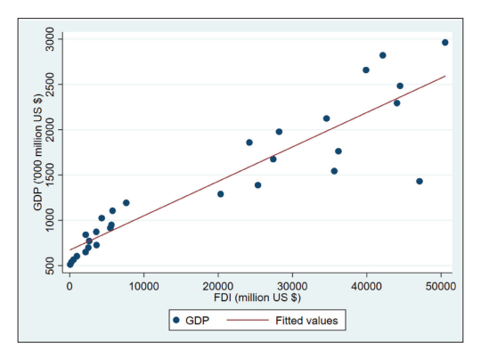

Figure 4: Relationship between FDI and Economic Growth in India
Source: Alam et al. (2022)
The relationship between the FDI and the economic growth of India has been depicted in the above figure. The asymmetric impact of FDI on India's economic growth has been captured from 1991 to 2019. As per Alam et al. (2022), it has been found that the increase in FDI has positively impacted the Indian economy whereas its decrease can have detrimental results.

4. Findings
India is a highly populated country and it is also doing good in the economy. The Foreign Trade Policy of India is one of the major policies on which the economy of the country is dependent enough. Presently, the FTP of the country is responsible for designing pathways so that by the year 2025, India can become a $5 trillion economy. To make the dream come true, there is an urgent need of reforming the labour laws, lower capital costs and also ease out the regulation controls on imports and exports (cogoport.com, 2022). Also, there are required strategies that are to be undertaken in order to ensure that there is a GDP growth rate of around 8% in the coming few years.
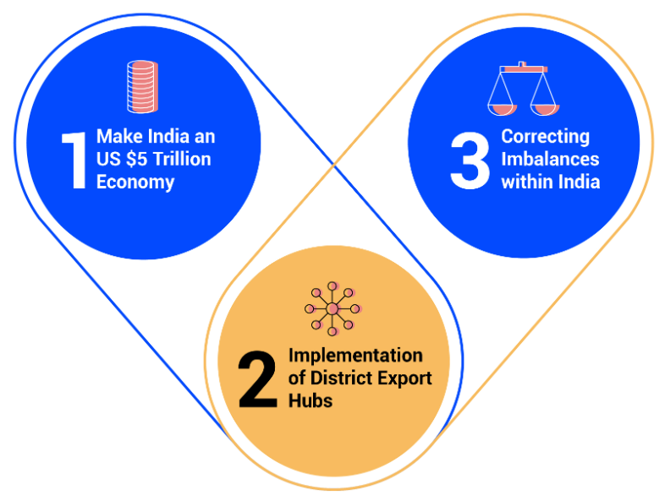

Figure 5: Targets to be achieved by 2025 by India
Source: cogoport.com (2022)
Apart from the FTP, various topics have brought light to the fact that the capacity of the country of India is much more. Bringing light to the fact that the states of the country are having a healthy competition in developing their states. However, there remains the fact that there is an unequal distribution of investments made all over the country. There are shreds of evidence of lateral movement of skilled labour from one state to other because of this situation. On the contrary, India is a highly populous country and if the majority of the population can contribute to the economy, then India should ideally be one of the major powers in the entire globe.
Some studies state that a very nominal percentage of people within India are financially educated. A majority of the Indian population is also lying behind as they belong to the low-income class and most of them are not aware enough of how to educate their children and how to lead a lifestyle. In such a case, it becomes very difficult for a country like India to even think of certain policies that only affect the entire population but whom they have limited knowledge about. Hence, looking forward to the long-term growth of the country, a separate set of solutions can be recommended and looking forward to the short-term future of the country’s economy, a separate set of solutions can be given.

5. Way Forward
From this entire study, it is understood that India is a dynamic country that is constantly trying to do better in terms of economic growth and investment. Since 1991, various types of policy reforms have been undertaken to stabilize economic growth and to ensure that there is constant growth in trade and investments per year in the country. Although there are some reasons for the effect on the economy faced by India due to covid-19 pandemic, the economy has survived and is increasing with the present policies undertaken by the Government. After understanding the entire scenario at present, it can be understood that there is a continuous process of change that will be required with growing times that would evolute as per the situations.
Thinking of short-term solutions to foster faster recovery of trade and investments in the country, infrastructural development can give a better grip on the problems that India is facing right now. For instance, transport costs may be reduced after the successful construction of shipping ports both in waterways and airways. According to Mishra, (2016), good connectivity can help Asian countries to have a scope to expand ties with one of the great Asian powers, China. Depreciation of the Indian currency can also be done to help the economy to grow faster in the coming years. Exports from the country will increase once there is a depreciation in the currency and also, and it will help in trading better. Additionally, influencing new companies to come and invest in India will also help the economy to grow.
Apart from all these short-term solutions, these key areas of discussion can be addressed through some activities that have a long-term impact. Several strategies are to be followed in order to achieve long-term goals as well. There is a need to educate the vast population of India as educated minds help in achieving greater goals. The intervention of government needs to be increased to reach out to the people who cannot reach out to the government and make them educate so that they can also be good enough to put their opinions on the economy of the country. Moreover, the increase in the operational structure of the developmental organizations who are working and willing to work in India in rural areas needs to be encouraged and provided with suitable support so that they can work truly and meaningfully in nurturing and preparing the future of the country. Each child belonging to the rural areas can contribute to the GDP of the country in the coming 15-20 years.
There is also a need of supporting Indian start-ups now as it is the future of the economy. The start-ups that are struggling now if survive can be a boon to the faster recovery of trade and investments in the country. Due to the nationalization of the companies, they will continue to contribute to the Indian economy. Moreover, if the start-ups become successful in operating in foreign countries as well, then it will obviously, it will help the economy to grow. The booming industries to grow presently are the real-estates, start-up businesses, and employment sector. As per Iqbal et al. (2018), Indian organisations are growing internationally in providing services to overseas markets. In order to help start-ups, more such steps need to be taken.
There is a need for change in the curriculum of the schools in each class that is being delivered to the students. The curriculum needs to have a special focus on the areas that are booming and are likely to have a greater impact on society such as robotics, and artificial intelligence along with normal statistics, history, geography and literature. As per today's curriculum, it can be said that most of the focus lies in making the students capable of a good employees in a long term. However, since we have already discussed how much the start-ups can contribute to the economy of the country, therefore, it is now high time to identify and address the business development capacities and knack among the students and help them develop their businesses as per their interests.
Proper guidance needs to be provided to them so that they can sharpen and train their minds in such ways. With the developing youths, we can have the strongest economy with the younger minds of India ruling the entire world in various aspects. Just like we have sports, dance and music in our curriculum, it is highly suggested to have mind-developing sessions where students can get their chances to recreate what they think and nurture their creativity in terms of business. Along with this, people are needed to be educated financially enough to understand the value of investments and trade and how this entire concept works in the market. This is so because, unless and until, people are financially and economically educated, they will not understand the value and the important trade and investments in the country. Hereby, concluding to the fact that the strategies, reforms and policies that are being undertaken each year are necessary but the results can be multiplied with growing minds if the mentioned long-term activities can also be commenced to ensure faster recovery in trade and investments in the country.

References
adb.org (2009) Available at: https://www.adb.org/sites/default/files/publication/28258/economics-wp177.pdf
Alam, W., Ikram, F., Kumar, P., Haseeb, M. and Ali, N., 2022. Asymmetric Effects of Foreign Direct Investment on Economic Growth: Fresh Evidence from India Using NARDL Simulation. Millennial Asia, p.09763996221122205. Available at: https://bit.ly/3YYAf5U
Azhar, S. and KN, M., 2012. An overview of foreign direct Investment in India. ZENITH International Journal of Business Economics & Management Research, 2(1). Available at: https://bit.ly/3YYNymR
Bajpai, N. (2009). Foreign Direct Investment in India. Available at: http://dspace.stellamariscollege.edu.in:8080/xmlui/bitstream/handle/123456789/1455/India.pdf?sequence=1&isAllowed=y
Brannen, J. (2009) ‘Prologue, mixed methods for novice researchers: reflections and themes, International Journal of Multiple Research Approaches, 3(1), 8–12. Available at: https://www.tandfonline.com/doi/abs/10.5172/mra.455.3.1.8?journalCode=rmra20
cogoport.com (2022) Available at: https://www.cogoport.com/blogs/foreign-trade-policy-2021-2026-expectations-for-the-import-export-sector
dea.gov.in (2022) Available at: https://dea.gov.in/sites/default/files/Monthly%20Economic%20Review%20November%202022_1.pdf
ESCAP, U. (2017). Enhancing regional economic cooperation and integration in Asia and the Pacific. Available at: https://repository.unescap.org/bitstream/handle/20.500.12870/3004/ESCAP-2017-RP-Enhancing-regional-economic-cooperation-integration-Asia-Pacific.pdf?sequence=1
ibef.org (2022) Available at: https://www.ibef.org/blogs/india-s-growing-financial-literacy#:~:text=This%20group%20constitute%20about%2021.8,increase%20the%20standard%20of%20living.
investindia.gov.in (2020) Available at: https://static.investindia.gov.in/2020-10/FDI-PolicyCircular-2020.pdf
investindia.gov.in (2022) Available at: https://www.investindia.gov.in/foreign-direct-investment
Iqbal, B.A., Turay, A., Hasan, M. and Yusuf, N., 2018. India’s outward foreign direct investment: emerging trends and issues. Transnational Corporations Review, 10(1), pp.98-107. Available at: https://bit.ly/3jBbRqJ
Kumar, S., & Goyal, P. Analysis of Role of Foreign Direct Investment in India’s Economic Development. Available at: http://www.ijrbs.com/pdf/Full%20IJRBS%20PDF.pdf#page=149
Mishra, R., 2016. Asian Infrastructure Investment Bank: An Assessment. India Quarterly, 72(2), pp.163-176. Available at: https://drupal.alliance.edu.in/drupal/sites/default/files/2021-03/Asian%20Infrastructure%20Investment%20Bank-%20An%20Assessment.pdf
Park, C.Y., Villafuerte, J. and Abiad, A., 2020. An updated assessment of the economic impact of COVID-19 (No. 133). Asian Development Bank. Available at: https://www.adb.org/sites/default/files/publication/604206/adb-brief-133-updated-economic-impact-covid-19.pdf
trade.gov (2022) Available at: https://www.trade.gov/country-commercial-guides/india-market-challenges
unescap.org (2022) Available at: https://www.unescap.org/kp/2022/trade-trends-goods-and-services-asia-pacific-20222023
Wei, L. (2015). China Moves to Devalue Yuan. Wall Street Journal, 10. Available at: http://prasad.dyson.cornell.edu/doc/WSJ.11Aug15.pdf
Wilmoth, M. J., Menozzi, M. C., & Bassarsky, M. L. (2022). Why population growth matters for sustainable development. Available at: https://www.un.org/development/desa/pd/sites/www.un.org.development.desa.pd/files/undesa_pd_2022_policy_brief_population_growth.pdf
Zameer, H., Yasmeen, H., Zafar, M.W., Waheed, A. and Sinha, A., 2020. Analyzing the association between innovation, economic growth, and environment: divulging the importance of FDI and trade openness in India. Environmental Science and Pollution Research, 27(23), pp.29539-29553. Available at: https://core.ac.uk/download/pdf/335440204.pdf

