A nanoreactor micellar assembly promoted an efficient synthesis of 2-thioxo-2,3-dihydroquinazolin-4(1H)-ones

Mayuri V. Patil, Pradeep M. Mhaldar, Dattaprasad M. Pore
Department of Chemistry, Shivaji University, Kolhapur 416004, India
p_dattaprasad@rediffmail.com

ABSTRACT
Surfactant based nanocatalyst emerged as sustainable assembly for organic synthetic methods. Synthesis of heterocyclic scaffolds from two or multicomponent strategy is one of the paramount applications for researchers. In this regard, we developed a novel route to synthesize 2-thioxo-2,3-dihydroquinazolin-4(1H)-ones from isatoic anhydride and isothiocyanate derivatives via in situ formed anthranilic acid in 4-(dimethylamino)-1-hexadecylpyridinium hydroxide [DAHP]+ [OH]- as a surfactant catalyst act as nano-reactor. The critical micelle concentration (CMC) of surfactant was found to be 0.002 mol.dm³ by conductometric method. The small-angle X-ray scattering (SAXS) analysis was performed to demonstrate micellar particle dimensions viz. diameter of micelle and the interspace distance between two micelles were found to be 14.8 and 2.6 nm, correspondingly. TGA study revealed that, the surfactant has good thermal stability up to 250 ºC. The simple procedure, atom economic method, good yields and easy product separation and purification, water as green solvent and catalyst reusability are the notable advantages of the present protocol.
Keywords - Anthranilic acid; Isatoic anhydride; Isothiocyanate; Surfactant; Micelle; Thioxoquinazolinone

INTRODUCTION
Heterocyclic scaffolds with nitrogen as a heteroatom, considered to be a remarkable and an equally imperative class of compounds. A huge number of heterocycles explore its medicinal importance with diverse chemical space. The quinazolinone is found to known as strategic skeleton of diverse range of natural products which was isolated from animals, plant material and various microorganisms (Fig.1).¹ It is one of the most important heterocycles displaying excellent pharmacological properties.²⁻⁸ Febrifugine, quinazolinone based alkaloid extracted from the aseru plant possess antimalarial potential. ⁹
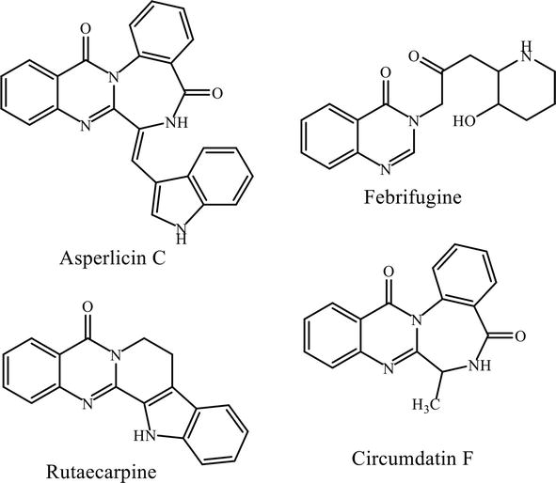
Fig. 1: Structural motifs of alkaloids containing quinazolinone skeleton
The structure of quinazoline is documented with fused benzene and pyrimidine ring. Quinazolinones known as oxo-derivatives of quinazoline are categorized into three class, 2-Quinazolinone, 4-Quinazolinone and 2,4-Quinazolinedione on the basis of point of attachment of carbonyl functionality (Fig. 2).

Fig. 2: Derivatives of quinazoline and quinazolinone
A significant subclass of quinazolinone i.e thioxoquinazolinone and its synthesis has become a keystone for synthetic organic chemists and acquired extensive significance in both pharmaceutical as well as synthetic chemistry. Thioxoquinazolinone is a fused benzene and pyrimidine ring systems with one thiocarbonyl functionality and their physicochemical and biological properties are greatly affected by Substituents nature, their existence on pyrimidine or benzene ring and conjugation in pyrimidine ring (Fig. 3).

R = H, alkyl, alkoxy, halogen;
R₁ = H, alkyl, aryl;
R₂ = alkyl, phenyl, aryl, heteroaryl

Fig. 3: Structure of Thioxoquinazolinone

A) Biological significance of thioxoquinazolinones:
Different substituted thioxoquinazolinone compounds are found to possess antimicrobial (Fig. 4a),¹⁰ antifungal (Fig. 4b)¹¹ antiviral (Fig. 4c), anticonvulsant,¹² antihypertensive,¹³ anti-inflammatory,¹⁴ and phosphodiesterase inhibitor¹⁵ properties. Moreover, they exhibit a wide array of applications aimed at diabetes,¹⁶ cancer¹⁷ and plant growth regulators.^{18,19}
Fig. 4: Bioactive compounds containing thioxoquinazolinone moiety

a) Anti-cancer activity:
Yahia and research group performed reaction of aryl methylene thiopyrimidine and 2-(4-(thiophen-2-yl)-5,6-dihydrobenzo[h]quinazolin-2-ylthio) acetic acid to synthesize dihydrobenzo quinazoline derivatives. Some of the derivatives from synthesized series of compounds found to posseses anticancer and antiviral activities.²⁰ (Fig. 5)
Fig. 5
b) Anti-proliferative:
Sayed et al. synthesized novel quinazolinone(thione) derivatives and discovered its anti-proliferative activity with DFT study having excellent strengths against Hep G2 and MCF-7.²¹ (Fig. 6)

Fig. 6
c) Antimycobacterial activity:
Waisser and coworkers synthesized thioxoquinazolinone scaffolds and evaluated for its antimycobacterial activity. Some of them had potency against pathogenic mycobacteria such as Mycobacterium kansasii and Mycobacterium avium. The sulfur substitution for oxygen showed increased antimycobacterial activity. The chloro substituted compound, (3-(3-chlorophenyl)-6,8-dichloro-2H-1,3-benzoxazine-2,4(3H)-dithione) displayed superior activity.²² (Fig. 7)
Fig. 7
d) Anticonvulsant activity:
Al-Salem reported successful synthesis of hydrazine carbothioamide and phenyl acylacetohydrazide moiety possesing quinazolinone derivatives. Among the prepared derivatives four compounds are more active against PTZ-induced convulsions in comparison with sodium valproate.²³ (Fig. 8)
Fig. 8

e) α-Glucosidase inhibitor activity:
Saeedi et al. explored the synthesis of 1,2,3-triazole hybrid quinazolinone as anti-diabetic agents. They displayed more effective inhibitory activity in contradiction of yeast α-glucosidase as compared to acarbose.²⁴ (Fig. 9)

Fig. 9

f) Monoamine oxidase inhibitor activity:
Qhobosheane successfully synthesized quinazolinone derivatives having IC₅₀ < 1 μM as powerful MAO inhibitors. One of them, 2-[(3-iodobenzyl)thio]quinazolin-4(3H)-one, showed excellent activity with IC₅₀ = 0.142 μM.²⁵ (Fig. 10)
Fig. 10

B) Synthetic methodologies for Thiooxoquinazolinone:
The synthesis of thioxoquinazolinones can be performed by various pathways. Most of the common methodologies are as follow:
1) Isothiocyanates as precursor:
The diverse 3-substituted thioxoquinazolinones were synthesized by reaction of anthranilic acid and alkyl or aryl derivatives of isothiocyanates in presence of various solvents.
Butler and his research group synthesized 3-methyl thioxoquinazolinones by performing reaction of anthranilic acid and methylisothiocyanate catalyzed by CH₃COOH by heating at 150ºC yields 39% of product in pure form.²⁶ (Scheme 1)
Scheme 1
` Castro et al. prepared variety of thioxoquinazolinone scaffolds by reacting methyl anthranilate with isothiocyanates. The methodology gave rise to moderate yields about 20–70%, with prolonged reaction time.²⁷ (Scheme 2)
Scheme 2
Buckley et al. demonstrated triethylamine (TEA) catalyzed reaction of oxazol substituted anthranilate and thiophosgene furnished analogous isothiocyanate derivative, which was further undergo reaction with various primary amines to afford corresponding thioxoquinazoline derivative.²⁸ (Scheme 3)
Scheme 3
Smith’s research group synthesized 3-substituted thioxoquinazolinones by preparing isothiocyanate derivatives in situ by reacting anthranilic acids, primary amines and carbon disulfide. Number of aromatic amines were utilized to obtain the corresponding product in appropriate yield.²⁹ (Scheme 4)
Scheme 4
Dou et al. efficiently synthesized titanium(IV) chloride and zinc catalyzed thioxoquinazolinones from nitrobenzoate derivatives which undergo reductive cyclization with isothiocyanates in tetrahydrofuran (THF) as a solvent with excellent yield.^{30,31} (Scheme 5)
Scheme 5
Wang and co-workers developed copper-catalyzed (CuI) synthesis of thioxoquinazolinones by performing reaction of bromobenzamides and isothiocyanate derivatives in good to excellent yield with optimized reaction conditions involving Cs₂CO₃, N,N-dimethylethane-1,2-diamine, and toluene as a base, ligand and solvent, respectively.³² (Scheme 6)
Scheme 6
Katritzky et al. explored zinc bromide catalysed preparation of thioxoquinazolinones by reacting benzotriazole-1-carboximidamides and potassium thiocyanate in dimethoxyethane as a solvent.³³ (Scheme 7)

Scheme 7
2) Benzo/Thio amides as precursors:
Kakuta and research group explored a 1,8-diazabicyclo[5.4.0]undec-7-ene (DBU) catalyzed novel synthetic methodology for thioxoquinazolinone derivatives by reacting benzamide derivatives with carbon disulfide in DMF furnish 78 % yield of product.³⁴ (Scheme 8)

Scheme 8
Tsuji’s et al. synthesized thioxoquinazolinone derivatives via solid-phase synthesis by reacting arylbenzamides with 1,1’-thiocarbonyldiimidazole (TCDI) catalyzed by 4-dimethylaminopyridine (DMAP) fiurnished an intermediate which was further undergo hydrolysis with aqueous TFA in DCM furnished corresponding thioxoquinazolinone derivatives in excellent yield.³⁵ (Scheme 9)
Scheme 9
Hanusek et al. demonstrated the synthesis of thioxoquinazolines by performing reaction of amino substituted benzothioamides and benzoyl chlorides furnished an intermediate compound which was undergo intramolecular condensation in presence of sodium methoxide gave rise to desired product.³⁶ (Scheme 10)
Scheme 10
Kubicova and co-workers explored silica gel catalyzed condensation of thioanthranilamide derivatives with acetone to synthesize 4-thioxoquinazolines at ambient temperature.³⁷ (Scheme 11)
Scheme 11
Hydrogen bromide catalyzed one step synthesis of 4-thioxoquinazolines were developed by reacting aminobenzonitriles with thioamides in different solvents. The products were obtained in moderate yield because of side product formation.³⁸ (Scheme 12)
Scheme 12
3) Thiourea as starting material:
El-Helby and his group developed two-step synthesis of thioxoquinazolines derivatives by reacting cyclohexanone with aromatic aldehydes by employing potassium hydroxide as base to afford benzylidenes which further undergo reaction with thiourea furnish the corresponding thioxoquinazolines with excellent yield.³⁹ (Scheme 13)
Scheme 13
Gupta et al. improved the synthetic method given in Scheme 13 to build a thioxoquinazolines skeleton by one-pot cyclocondensation reaction of cyclohexanone, thiourea and aromatic aldehydes in presence of methanol at reflux temperature.⁴⁰ (Scheme 14)
Scheme 14
Kidwai synthesized thioxoquinazolines by reaction of dimedone, thiourea and aldehydes in excellent yield under microwave heating.⁴¹ (Scheme 15)
Scheme 15
Kaur and coworkers demonstrated HCl catalysed beginelli type reaction to synthesize thioxoquinazoline by reacting tetralone, thiourea and aldehydes in presence of acetonitrile as solvent under microwave irradiation furnished corresponding product in moderate yield.⁴² (Scheme 16)

Scheme 16
Azizian developed N,N-dimethyl acetamide (DMAC) catalysed microwave heating synthesis of thioxoquinazolinone compounds in good to excellent yield by the reaction of isatoic anhydride, primary amines and thiourea.⁴³ (Scheme 17)
Scheme 17
4) Bis(benzotriazolyl)methanethione as catalyst:
The synthesis of thioxoquinazolinone derivatives were described by reactions of methyl anthranilates with aryl/alkyl amines catalyzed by bis(benzotriazolyl)methanethione in presence of DBU and DCM as solvent under reflux condition.⁴⁴ (Scheme 18)
Scheme 18
5) Miscellaneous syntheses:
Fathalla et al. explored the preparation strategy to form thioxoquinazolines by reaction of N-(2-cyanophenyl) benzimidoyl chloride and thioacetamide furnished desired pure product in excellent yield.⁴⁵ (Scheme 19)
Scheme 19
Thioxoquinazoline derivatives were synthesized by performing reactions of N-(2-cyanophenyl)benzimidoyl chloride and thiourea derivatives in CHCl₃ as solvent led to the formation of resultant product in good yield.⁴⁵ (Scheme 20)
Scheme 20
Ammonium acetate/acetic acid and zinc chloride catalysed synthesis of thioxoquinazolinones were described by cyclocondensation of thiobarbituric acid derivative with malononitrile at reflux condition furnish corresponding pure product with good yield.⁴⁶ (Scheme 21)
Scheme 21

Many of these above mentioned methods have several limits for instance harsh reaction conditions, use of metal catalysts, prolonged reaction times, poor yields and use of costly reagents. Therefore, invention of novel synthetic route which emphasizes green principles of chemistry for making of thioxoquinazolinones is extremely desirable.

Result and discussion
Concept of sustainable chemistry has open new vista for organic chemists that encourage moving towards viable and innovative approach.⁴⁷⁻⁵⁴ Development of green methodologies in terms of choice of solvent and catalyst to minimize the waste formation is a crucial step in organic synthetic chemistry. Certainly, water is universally accepted greener solvent because it is abundant in nature, accessible, non-explosive and environmentally friendly. In many occasions, water play the role of activator for organic functional groups by forming hydrogen bonds.⁵⁵ Majority of the reactions are coming under the type ‘on water’ reactions owing to scanty solubility of organic molecules in water.⁵⁶ Consequently, to renovate these ‘on water’ reactions into ‘in water’ category has become the most demanding job. One of the most practical ways to indorse the reaction in water is to employ surfactant catalysts at concentrations higher than its critical micelle concentration (CMC). The addition of surfactants absolutely increases the solubility of organic substrates in aqueous media. In water as a solvent, hydrophobic reactants are compelled to aggregate⁵⁷ in order to reduce the surface tension⁵⁸⁻⁶⁰ which helps to speed up the reaction.
In this context, to explore ecologically sound synthetic protocol aimed at the synthesis of heterocyclic scaffolds, we have invented a novel synthetic scheme to obtain thioxoquinazolinones. (Scheme 22)

Scheme 22: Synthesis of Thioxoquinazolinone
In the beginning, our efforts were concentrated on the design and synthesis of basic surfactant which forms the micelles and speed up the reactions by making organic reactants more soluble in water. (Fig. 11)
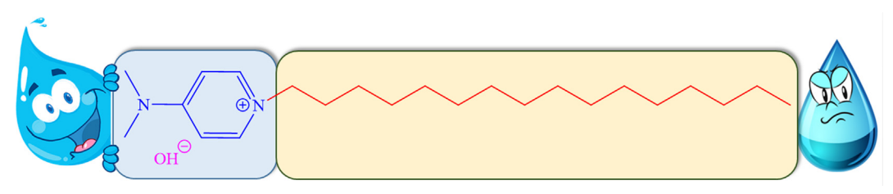
Fig. 11: Bronsted basic surfactant catalyst [DAHP]⁺ [OH]⁻
In Scheme 23, the process for making 4-(dimethylamino)-1-hexadecylpyridinium hydroxide, [DAHP]⁺ [OH]⁻, is described. Primarily, 4-(dimethylamino)-1-hexadecylpyridinium bromide, [DAHP]⁺ [Br]⁻, was prepared by quaternizing 4-dimethylamino pyridine with 1-bromo hexadecane in toluene by heating reaction mixture at 80° C for 12–18 hours. After that, anion exchange of [DAHP]⁺ [Br]⁻ was carried out with KOH in dry MeOH:DCM (1:1) solvent system for 24 hours at room temperature to furnish 4-(dimethylamino)-1-hexadecylpyridinium hydroxide, [DAHP]⁺ [OH]⁻. In presence of AgNO₃, the total exchange of Br⁻ ions by OH⁻ ions was investigated. In presence of AgNO₃ complete exchange of Br⁻ ions by OH⁻ ions was tested. IR, ¹H, ¹³C and TGA measurements corroborated the structure of prepared catalyst. The structure of [DAHP]⁺ [OH]⁻ and obtained spectroscopic results are well consistent with each other.
Scheme 23: Synthesis of [DAHP]⁺ [OH]⁻
The conductometric method was used to demonstrate critical micelle concentration (CMC) of prepared surfactant. Initially, conductivity of deionised water was measured followed by sequential addition of 0.05 M stock solution of [DAHP]⁺ [OH]⁻ surfactant in water was recorded. The CMC calculated by plotting equivalent conductance (k) versus concentration of surfactant is depicted in fig 12 and it was found to be 0.002 mol.dm⁻³.
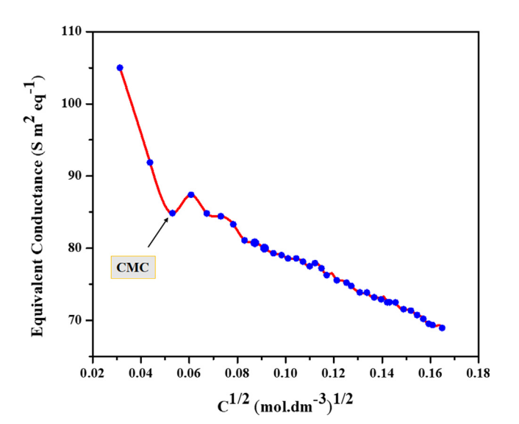
Fig.12: Plot of Equivalent conductance Vs surfactant concentration
The thermogravimetric analysis (TGA) study described the thermal stability of synthesized surfactant [DAHP]⁺ [OH]⁻ as shown in Fig. 13. At first, the moisture present in catalyst was evaporated in the range of 25-100 ºC temperature and showing the 5.066 % weight loss. Next, the decomposition of organic material was observed in the range of 250-350 ºC which is the largest weight loss of about 76.01 % and lastly residual carbonaceous species were degraded in the range of 400-550 ºC with 15.61 % of weight loss.
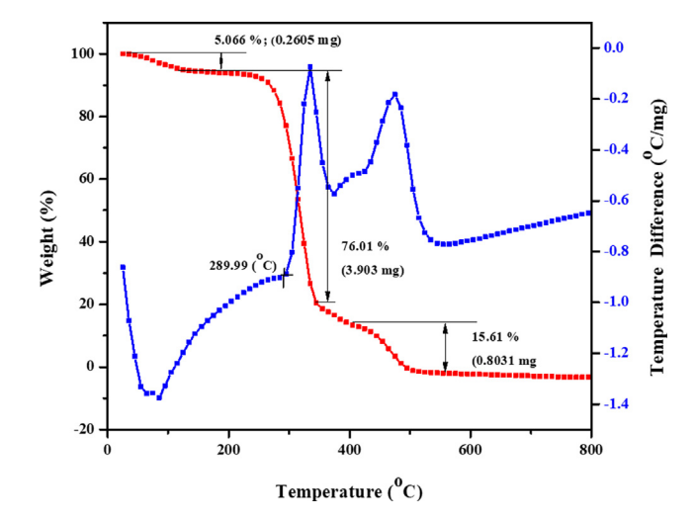
Fig. 13: TGA/DTA plot of [DAHP]⁺ [OH]⁻
Small angle x-ray scattering data of [DAHP]⁺ [OH]⁻ was obtained using Xenocs SA-France (model Xeuss 2.0). X-ray source GeniX3D Cu 30 Watts Cu tube with 50 KV 0.6mA current. The sample to detector distance was 2500 mm. The detector used were Eiger R 1M provided with vacuum lined through a set of high resolution hybrid pixel photon counting detector, 75 µm pixel size. The sample was exposed for 15 minutes interval and scattered waves were collected in the range of momentum transfer q = 0.04 to 4 nm⁻¹.⁶¹

$q=\frac{4π\sin\left(θ\right)}{λ}$ ……. (1)
Where $λ$ is wavelength of X-ray

Fig. 14a represents the small angle x-ray scattering data for the [DAHP]⁺ [OH]⁻ surfactant micelle assembly in water. The X-ray scattering was found at q = 2.42 nm⁻¹. The distance of separation between the two micelle (d_{Bragg}) were found to 2.6 nm ($d_Bragg=2π/q_max )$.
To determine the dimensions of the spherical micelle system, the radius of gyration (R_{G}) of the micelle system was estimated by using a Guinier’s plot (Fig 14c). The Guinier plot is derived using the equation 2.⁶²

$\ln\left[∆\left(q\right)\right]=\ln\left[a_{0}\right]-\frac{R_{G}^{2}q^{2}}{3}$ …….(2)
Where a₀ is zero angle intensity.
Guinier’s plot gives the linear fit regression {ln [Δ(q)] = -2.24-2.95 x 10⁻⁴q2}. The radius of gyration was found to be 0.03 nm. Since all the data points in Guinier’s plot are on the straight line, we conclude the micelles of the same size are formed in the water i.e. homogeneous distribution of equal size micelles formed in water.⁶¹ The average radius of the spherical particle (R) was calculated from the radius of gyration (R_{G}) using$R=\sqrt{\left(5/{3R_{G}}\right)}$ . The average radius of the particle was found to be 7.4 nm and the corresponding diameter 14.8 nm. The average distance of separation was found to be 2.6 nm. The spherical assembly of micelles with the dimensions is depicted in Fig 14(d).
Fig. 14: a) Small angel X-ray scattering data for the [DAHP]⁺ [OH]⁻ surfactant in water acquired in the q range of 0.04 to 4 nm⁻¹; (b) Scattered peak position zoom view of data (a); (c) Guinier’s plot d) Calculate spacing between micelle and diameter of a micelle.

After this successful study of catalyst, we focused our attention to explore the catalytic application of [DAHP]⁺ [OH]⁻ for making the thioxoquinazolinones. In present experiment, we have chosen the reaction of isatoic anhydride and phenyl isothiocyanate as a model strategy for the screening of catalysts. Firstly, we performed model reaction in water without catalyst, but it failed to give desire product in expectable yield (Table 1, entry 1) signifying the necessity of catalyst. Hence, we screened various acidic and basic catalysts for the said transformation. Initially, model reaction was screened by using acidic catalysts viz. NH₂-SO₃H, p-TSA, 1-methyl-3-sulfonic acid imidazolium chloride [Msim]⁺ Cl⁻ but failed to give desire product in good yield. (Table 1, entries 2-4) Afterward, we checked the impact of basic catalyst viz. K₂CO₃, K₃PO₄, KOH, Et₃N, etc. Remarkably, these catalysts exhibited superior results. (Table 1, entries 5-8) We also tested the reaction by applying various surfactants viz. sodium dodecyl sulphate (SDS), Triton X-100, benzethonium tetrachloro aluminate [BZT]⁺ Cl⁻, cetyl trimethyl ammonium bromide (CTAB), sodium dioctyl sulfosuccinate (SDOSS) and synthesized [DAHP]⁺ [OH]⁻ basic surfactant. Among them, [DAHP]⁺ [OH]⁻ displayed superior result in synthesis of resultant thioxoquinazolinone. (Table 1, entries 9-14) The influence of catalyst loading was examined with 10, 15, 20 and 25 mol % and it was observed that, 20 mol % [DAHP]⁺ [OH]⁻ was sufficient to promote the reaction to completion. Increase in amount of catalyst there is no change in yield and reaction time was observed.

Table 1: Optimization of catalysts for the synthesis of 3ª
Sr. no | Catalyst | Catalyst load (mol %) | Time  (h) | Yield ^{b}  (%)
1 | - | - | 12-18 | 20
2 | NH₂-SO₃H | 20 | 10 | 39
3 | p-TSA | 20 | 9 | 43
4 | [Msim]⁺ Cl⁻ | 20 | 12 | 40
5 | K₂CO₃ | 20 | 8-9 | 63
6 | K₃PO₄ | 20 | 9 | 60
7 | KOH | 20 | 5 | 70
8 | Et₃N | 20 | 6 | 71
9 | SDS | 20 | 9 | 40
10 | Triton X 100 | 20 | 10 | 35
11 | [BZT]⁺ Cl⁻ | 20 | 12 | 33
12 | CTAB | 20 | 10 | 40
13 | SDOSS | 20 | 12 | 38
14 | [DAHP]+ [OH]- | 25 | 4 | 81
15 | [DAHP]+ [OH]- | 20 | 4 | 81
16 | [DAHP]+ [OH]- | 15 | 5 | 77
17 | [DAHP]+ [OH]- | 10 | 5 | 72
ª Reaction conditions : Isatoic anhydride (1 mmol), Phenyl isothiocyanate (1mmol), Catalyst [DAHP]⁺ OH⁻ (20 %), Water (10 mL), 50º C. ^{b}Isolated yield

Next, we investigated the impact of reaction temperature on the yield of product, as shown in Table 2. This study revealed that, in catalytic system of [DAHP]⁺ [OH]⁻, as reaction temperature increases, yield of the product goes on increasing. The optimum reaction temperature is 50° C (Table 2, entry 3) and increasing the reaction temperature beyond this led no substantial improvement in the yield.
Table 2: Influence of temperature on the reaction
Sr. No. | Temperature  ºC | Yield ^{b}  (%)
1 | 30 | 25
2 | 40 | 55
3 | 50 | 80
4 | 60 | 80
5 | 70 | 79
6 | 80 | 75
7 | 90 | 73
8 | 100 | 73
ªReaction conditions: Isatoic anhydride (1 mmol), Phenyl isothiocyanate (1 mmol), Catalyst [DAHP]⁺ OH⁻ (20 %), Water (10 mL). ^{b}Isolated yield

After reaction completion the product was obtained by extracting with ethyl acetate and the structure of product was validated by IR, ¹H, ¹³C NMR and GCMS analytical techniques. IR spectrum shows amidic carbonyl and secondary N-H stretching frequency at 1662 and 3251 cm^{–1}, respectively. The C-S stretching band observed at 1211 cm⁻¹. In ¹H NMR, doublet at δ 6.82-6.83 ppm (J = 8.5 Hz), triplet at δ 6.97-7.00, 7.14-7.17, 7.24-7.27, 7.29-7.32 ppm (J =7.5 Hz) and doublet at δ 7.48-7.49, 7.65-7.66 ppm with J = 8 and 7.5 Hz was observed which is corresponding to nine aromatic protons. A -NH proton is appeared at δ 12.67 ppm as a singlet. ¹³C NMR spectrum exhibited the signals at δ 116.13, 116.38, 124.43, 127.74, 128.41, 128.97, 129.20, 135.59, 139.37 and 139.97 ppm due to the existence of twelve aromatic carbons in structure of product. The amidic carbonyl and thiocarbonyl carbon depicted signals at δ 160.23 and 176.46 ppm, correspondingly. In mass spectrum, molecular ion peak detected at (m/z) 254 whereas base peak observed at (m/z) 77 confirmed the structure of desire product 3a.
Then, we concentrated on performing reactions using various substituted isatoic anhydride and derivatives of isothiocyanate, as shown in table 3, to investigate the scope of present protocol. Without any substituents, reaction of isatoic anhydride and phenyl isothiocyanate drive efficiently to produce the desired product in excellent yield. (Table 3, entry a) Notably, isatoic anhydride easily react with both aromatic and aliphatic isothiocyanates and gives the products in good yield. (Table 3, entries b-e) In addition to that, chloro derivative of isatoic anhydride reacts efficiently with various isothiocyanates. (Table 3, entries f- i) For N-methyl derivative of isatoic anhydride, marginally lower yield of product was observed. (Table 3, entries j-m)
Table 3: Synthesis of combinatorial library of thioxoquinazolinones

Entry | R | R₁ | R₂ | Product | Time  (h) | Yield^{b}  (%)
a | H | H | Ph |  | 2 | 84
b | H | H | 4-NO₂Ph |  | 2.3 | 81
c | H | H | CH₂-Ph |  | 2.5 | 81
d | H | H |  |  | 2.2 | 82
e | H | H |  |  | 2 | 80
f | Cl | H | Ph |  | 3 | 79
g | Cl | H | 4-NO₂Ph |  | 4.5 | 77
h | Cl | H |  |  | 6 | 74
i | Cl | H |  |  | 5.3 | 67
j | H | Me | Ph |  | 3 | 75
k | H | Me | 4-NO₂Ph |  | 7 | 69
l | H | Me |  |  | 5 | 60
m | H | Me |  |  | 6 | 57
ªReaction conditions : Isatoic anhydride (1 mmol), Isothiocyanate derivatives (1mmol), Catalyst [DAHP]⁺ OH⁻ (20 %), Water (10 mL), 50º C
^{b}Isolated yield

The scheme 24 demonstrated a plausible mechanism for the present transformation. At first, OH⁻ from [DAHP]⁺ [OH]⁻ catalyst gives nucleophilic attack on isatoic anhydride (1) resulting into the in-situ formation of anthranilic acid as an intermediate (5). Then, isothiocyanate derivative (2) undergo nucleophilic addition of anthranilic acid (5) to furnish the intermediate (6) which further undergo cyclization followed by dehydration afford the desire product (3).
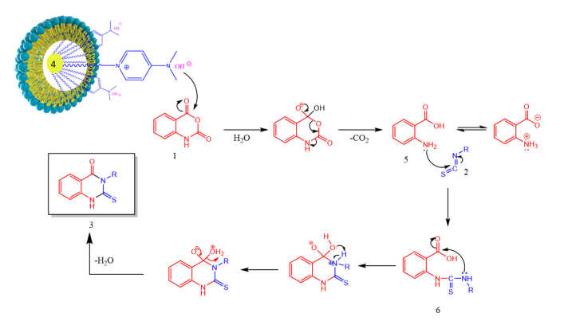
Scheme 24: Proposed mechanism to synthesize thioxoquinazolinones
The in-situ formed anthranilic acid was confirmed by performing separate reaction of isatoic anhydride with [DAHP]⁺ [OH]⁻ surfactant catalyst in water for 45 min and formed intermediate (5) was obtained by extracting reaction mixture with ethyl acetate. Next, we analyzed that intermediate by using ¹H and ¹³C NMR spectroscopic techniques. The ¹H NMR, displayed multiplet at δ 6.67-6.70 ppm owing to NH₃ protons and doublet of doublet at δ 7.30-7.34 and 7.93-7.96 ppm is due to the four aromatic protons. In ¹³C NMR signals observed at δ 109.53, 116.48, 116.81, 132.15, 135.15 and 151.12 ppm confirm the six aromatic carbons and signal at δ 173.82 ppm authorizes the –COO⁻ functionality in intermediate (5). This clearly indicate that, the in-situ formed intermediate is zwitterion of anthranilic acid.
Green chemistry emphasizes the use of reusable catalysts. Under optimal reaction conditions, the recyclability study of [DAHP]⁺ [OH]⁻ surfactant was examined for the model reaction of isatoic anhydride and phenyl isothiocyanate. Final product was separated by extracting reaction mixture in ethyl acetate and water layer containing catalyst was concentrated at vaccum up to 10 mL of solution left behind in the flask which was used for the next reaction cycle. According to this study, [DAHP]+ [OH]- can be recycled four times with no change in catalytic efficiency. (Fig. 15)
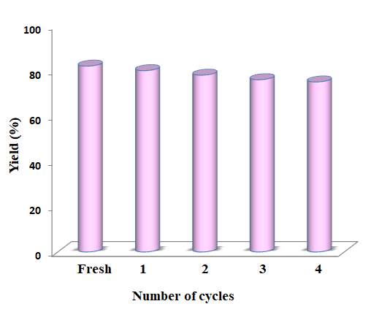
Fig.15: Recyclability study of [DAHP]⁺ [OH]⁻
Conclusion:
For one-pot synthesis of thioxoquinazolinones by reacting isatoic anhydride with isothiocyanate derivatives, we have developed and introduced a unique, very effective Bronsted basic surfactant i.e [DAHP]⁺ [OH]⁻. This present protocol offers numerous prominent advantages such as, operational simplicity, green aqueous medium, wide substrate scope, excellent yield of products, less reaction time made this methodology both ecologically and economically.

Typical procedure:
Synthesis of surfactant [DAHP]⁺ [OH]⁻:
In 100 mL round bottom flask, 4-dimethylamino pyridine (10 mmol) and 1-bromo hexadecane (10 mmol) in toluene (25 mL) was heated at 80º C for 12-18 hour. After completion of reaction resultant compound, 4-(dimethylamino)-1-hexadecylpyridin-1-ium bromide, [DAHP]⁺ [Br]⁻ was isolated by decanting toluene and obtained colourless solid residue was washed thoroughly by ethyl acetate and dried in oven at 60ºC.
Then anion exchange of previously prepared surfactant [DAHP]⁺ [Br]⁻ (10 mmol) was carried out with potassium hydroxide (11 mmol) by stirring in dichloromethane: methanol (1:1) at 0º C for 24 h at room temperature. The formed potassium bromide salt in the form of suspension was removed by filtration and 4-(dimethylamino)-1-hexadecylpyridin-1-ium hydroxide, [DAHP]⁺[OH]⁻ was obtained by evaporating solvent system under vacuum.

Synthesis of thioxoquinazolinone derivatives:
In 25 mL round bottom flask, mixture of isatoic anhydride (1 mmol), isothiocyanate derivative (1 mmol) in aqueous solution of [DAHP]⁺[OH]⁻ was taken (surfactant=20 mol %, water 10=mL) and stirred at 50º C for time mentioned in Table 3. The completion of reaction was checked by TLC and synthesized product was isolated by extracting reaction mixture in ethyl acetate. The collective organic layer was evaporated and obtained product was recrystallized in ethanol.

Spectral data of synthesized novel Bronsted basic surfactant catalyst 4-(dimethyl amino) -1- hexadecyl pyridin-1-ium hydroxide, [DAHP]⁺[OH]⁻

White solid; IR : 3443, 2962, 2923, 2852, 2352, 1643, 1415, 1081, 1013, 957, 930, 891, 798, 681, 643, 567, 450, 394 cm⁻¹ ; ¹H NMR (400 MHz, CDCl₃) : 0.86-0.88 (t, 3H), 1.24-1.25 (m, 26H), 1.84-1.91 (m, 2H), 3.27 (s, 6H), 3.75 (bs, 1H), 4.30-4.34 (t, 2H), 7.02-7.04 (d, 2H, J = 8 Hz), 8.41-8.43 (d, 2H, J = 8 Hz) ppm; ¹³C NMR (100 MHz, CDCl₃) : δ 22.90, 26.37, 26.44, 29.26, 29.31, 29.58, 29.62, 29.73, 29.82, 29.88, 29.91, 31.11, 31.36, 32.14, 40.70, 57.31, 58.70, 76.93, 77.25, 77.57, 108.65, 142.66, 156.54 ppm.
Spectral data of 3-aryl/alkyl-2-thioxo-2,3-dihydroquinazolin-4(1H)-ones
Entry 3a, Table 3: 3-Phenyl-2-thioxo-2,3-dihydroquinazolin-4(1H)-one
White solid; Obs. m.p. 234–236 °C. IR: 3251, 2962, 2914, 1612, 1544, 1469, 1367, 1211, 1096; ¹H NMR (400 MHz, DMSO-d₆): δ 6.82-6.83 (d, 1H, J = 8.5 Hz), 6.97-7.00 (t, 1H, J = 7.5 Hz), 7.14-7.17 (t, 1H, J = 7.5 Hz), 7.24-7.27 (t, 1H, J = 7.5 Hz), 7.29-7.32 (t, 2H, J = 7.5 Hz), 7.48-7.49 (d, 2H, J = 8 Hz), 7.65-7.66 (d, 1H, J = 7.5 Hz), 12.67 (s, 1H, -NH) ppm; ¹³C NMR (100 MHz, DMSO-d₆): δ 116.13, 116.38,124.43, 127.74, 128.41, 128.97, 129.20, 135.59, 139.37, 139.97, 160.23, 176.46; GCMS: Mass calculated for [C₁₄H₁₀N₂OS]: 254.05 (M⁺); Obs. Mass: m/z = 254 (M⁺).
¹H NMR, zwitterion of anthranilic acid (400 MHz, CDCl₃): δ 6.67-6.70 (m, 3H), 7.30-7.34 (m, Ar-2H), 7.938-7.963 (dd, Ar-2H, J = 1.6 Hz, 8.4 Hz) ppm; ¹³C NMR (100 MHz, CDCl₃): δ 109.53, 116.48, 116.81, 132.15, 135.15, 151.12, 173.82 ppm.

Entry 3b, Table 3: 3-(4-nitrophenyl)-2-thioxo-2,3-dihydroquinazolin-4(1H)-one
Pale yellow; Obs. m.p. 288 ºC; IR: 3321, 3036, 2843, 1684, 1599, 1530,1475,1437,1314, 1267, 1205, 1144,1121, 1028, 935, 796, 649 cm⁻¹ ;¹H NMR (400 MHz, DMSO-d₆): δ 7.16-7.18 (d, 1H, J = 8.4 Hz), 7.24-7.28 (m, 1H), 7.75-7.77 (m, 1H), 7.82-7.84 (d, 2H, J = 8 Hz) 7.92-7.94 (m, 1H), 8.22-8.25 (d, 2H, J = 9.2 Hz), 11.61 (s, 1H, -NH) ppm ; ¹³C NMR (100 MHz, DMSO-d₆): δ 115.98, 116.15, 118.59, 118.77, 124.82, 126.10, 129.20, 129.79, 132.29, 140.71, 141.77, 142.72, 161.09, 175.76 ppm ; GCMS: Mass calculated for [C₁₄H₉N₃O₃S]: 299.04 (M⁺) ; Obs. Mass: 299 (M⁺).

Entry 3d, Table 3 : 3-isopropyl-2-thioxo-2,3-dihydroquinazolin-4(1H)-one
white solid; Obs m.p. 176 ºC; IR: 3400, 2970, 2946, 1632, 1515, 1311, 1248, 1155, 1021, 873, 842, 725, 592 cm⁻¹; ¹H NMR (400 MHz, DMSO-d₆): δ 1.47-1.49 (d, 6H), 6.01-6.08 (m, 1H), 7.29-7.37 (m, 2H), 7.69-7.73 (m, 1H), 7.91-7.94 (dd, 1H, J = 7.8 Hz, 1.2 Hz), 12.83 (s, 1H, -NH) ppm; ¹³C NMR (100 MHz, DMSO-d₆): δ 18.50, 52.43, 115.29, 116.65, 124.39, 126.89, 135.18, 138.74, 159.38, 175.92 ppm; GCMS: Mass calculated for [C₁₁H₁₂N₂OS]: 220.29 (M⁺); Obs. Mass: 220 (M⁺).

Entry 3f, Table 3 : 6-chloro-3-phenyl-2-thioxo-2,3-dihydroquinazolin-4(1H)-one
White solid; Obs. m.p. 292 ºC; IR: 3393, 2923, 2845, 2312, 1682, 1600, 1515, 1444, 1327, 1241, 975, 850, 709, 607 cm⁻¹; ¹H NMR (400 MHz, DMSO-d₆): δ 7.45-7.48 (m, 5H), 7.63-7.63 (d, 1H, J = 2.4 Hz), 7.82-7.84 (dd, 1H, J = 8.8 Hz, 2.4 Hz), 7.86- 7.88 (d, 1H, J = 8Hz), 11.02 (s, 1H, -NH) ppm; ¹³C NMR (100 MHz, DMSO-d₆): δ 117.67, 117.92, 118.49, 126.26, 128.14, 128.18, 128.85, 128.90 129.22, 133.74, 135.45, 138.39, 139.05, 166.28, 176.01 ppm; GCMS: Mass calculated for [C₁₄H₉ClN₂OS]: 288.75 (M⁺); Obs. Mass: 288 (M⁺), 290 (M+2).

References:
1. | Mhaske S. B.; Argade N. P.; Tetrahedron 2006, 62, 9787.
2. | Patel B. N.; Patel C. J.; Sci. Pharm. 2010, 78, 171.
3. | Bartroli J.; Turmo E.; Alguero M.; Boncompte E.; Vericat M. L.; Conte L.; Ramis J.; Merlos M.; Garcia-Rafanell J.; Forn J.;J. Med. Chem. 1998, 41, 1869.
4. | Al-Obaid A. M.; Abdel-Hamide S. G.; El-Kashef H. A.; Abdel-Aziz A. A. M.; El-Azab A. S.; Al-Khamees H. A.; El-Subbagh H. I.; Eur. J. Med. Chem. 2009, 44, 2379.
5. | Kamal A.; Vijaya B. E.; Janaki Ramaiah M.; Dastagiri D.; Surendranadha R. J.; Viswanath A.; Sultana F.; Pushpavalli S. N. C. V. L.; Pal-Bhadra M.; Srivastava H. K.; Narahari S. G.; Juvekar A.; Sen S.; Zingde S.; Bioorg. Med. Chem.2010, 18, 526.
6. | Laddha S. S.; Bhatnagar P. S.; Bioorg. Med. Chem. 2009, 17, 6796.
7. | Gokhan Kelekci N.; Koyunoglu S.; Yabanoglu S.; Yelekci K.; Ozgen O.; Ucar G.; Erol K.; Kendi E.; Yes ilada A.; Bioorg. Med. Chem. 2009, 17, 675.
8. | Mohsen M. A.; Yahia A. M.; Elkhairy A. M.; Wahid M. B.; Samir Y. A.; Eur. J. Med. Chem. 2010, 45, 3365.
9. | Wattanapiromsakul C.; Forster P. I.; Waterman P. G.; Phytochemistry 2003, 64, 609.
10. | Rajasekaran A.; Rajamanickam V.; Darlinquine S.; Eur Rev Med Pharmacol Sci. 2013, 17, 95.
11. | Desh D.; Singh V. K.; Tiwari R.; Singh, Sharma G. L.; Dabur R.; bioRxiv, 2018.
12. | (a) Wenzel D. G.; J. Am. Pharm. Assoc. 1955, 44, 550. (b) Hori M.; Iemura R.; Hara H.; Ozaki A.; Sukamoto T.; Ohtaka H.; Chem. Pharm. Bull. 1990, 38, 681.
13. | (a) Hayao S.; Havera H. J.; Stryeker W. G.; Leipzig T. J.; Kulp R. A.; Hartzler H. E., J. Med. Chem.1965, 8, 807. (b) Havera H. J.; J. Med. Chem. 1979, 22, 1548.
14. | Chao Q.; Deng L.; Shih H.; Leoni L. M.; Genini D.; Carson D. A.; Cottam H. B.; J. Med. Chem.1999, 42, 3860.
15. | Witt A.; Bergman J.; Curr. Org. Chem. 2003, 7, 659.
16. | Mhaske S. B.; Argade N. P.; Tetrahedron 2006, 62, 9787.
17. | Koepfli J. B.; Brockman J. A.; Moffat J.; J. Am. Chem. Soc. 1950, 72, 3323.
18. | Choo H. Y. P.; Kim M.; Lee S. K.; Kim S.W.; Chung I. K.; Bioorg. Med. Chem. 2002, 10, 517.
19. | Panchompoo J.; Aldous L.; Kabeshov M.; New J. Chem. 2012, 36, 1265.
20. | Mohamed Y. A. ; El-galil A.; Amrb C.; Mohamed S.F.; Abdalla M. M.; Al-omar M.; Shfik S. H.; J. Chem. Sci. 2012, 124, 693.
21. | El-Sayed A. A.; Ismail M. F.; Amr A. E.-G. E.; Naglah A. M.; Molecules 2019, 24, 3787.
22. | Waisser K.; Gregor J.; Dostál H.; Kuneš J.; Kubicova L.; Klimesova V.; Kaustova J.; Il Farmaco 2001, 56, 803.
23. | El-Salem H. S.; Hegazy G. H.; ElTaher K. F.; El-Messery S. M.; AlObaid A. M.; El-Subbagh H. I.; Bioorg. Med. Chem. Lett. 2015, 25, 1490.
24. | Saeedi M.; Mohammadi Khanaposhtani M.; Pourrabia P.; Razzaghi N.; Ghadimi R.; Imanparast S.; Bioorg. Chem. 2019, 83, 161.
25. | Qhobosheane M. A.; Petzer A.; Petzer J. P.; Legoabe L. J.; Bioorg. Med. Chem. 2018, 26, 5531.
26. | Butler K.; Partridge M.W.; J. Chem. Soc. 1959, 1512.
27. | Castro A.; Jerez M.J.; Gil C.; Calderon F.; Doménech T.; Nueda A.; Martínez A.; Eur. J. Med. Chem. 2008, 43, 1349.
28. | Buckley G. M.; Davies N.; Dyke H. J.; Gilbert P. J.; Hannah D. R.; Haughan A. F.; Hunt C. A.; Pitt W. R.; Profit R. H.; Ray N. C.; Richard M. D.; Sharpe A.; Taylor A. J.; Whitworth J. M.; Williams S. C.; Bioorg. Med. Chem. Lett. 2005, 15, 751.
29. | Abdel-Mageed M. F.; Aly Y. L.; Saleh M. A.; Abdou I. M.; El-Hiti G. A.; Smith K.; Sulfur Lett. 1995, 19, 129.
30. | Dou G. L.; Wang M. M.; Huang Z. B.; Shi D. Q.; J. Heterocycl. Chem. 2009, 46, 645.
31. | Dou G.; Wang M.; Shi D.; J. Comb. Chem. 2009, 11, 151.
32. | Wang F.; Zhao P.; Xi C.; Tetrahedron Lett. 2011, 52, 231.
33. | Katritzky A. R.; Rogovoy B.; Klein C.; Insuasty H.; Vvedensky V.; Insuasty B.; J. Org. Chem. 2001, 66, 2854.
34. | Kakuta H.; Tanatani A.; Nagasawa K.; Hashimoto Y.; Chem. Pharm. Bull. 2003, 51, 1273.
35. | Makino S.; Nakanishi E.; Tsuji T.; Tetrahedron Lett. 2001, 42, 1749.
36. | Hanusek J.; Hejtmankova L.; Kubicova L.; Sedlak M.; Molecules 2001, 6, 323.
37. | Kubicova L.; Sustr M.; Kralova K.; Chobot V.; Vytlacilova J.; Jahodar L.; Vuorela P.; Machacek M.; Kaustova J.; Molecules 2003, 8, 756.
38. | Zoltewicz J. A.; Sharpless T. W.; J. Org. Chem. 1976, 32, 2681.
39. | El-Helby A. A.; Amin M. A.; El-Sawah M. M.; Bayomi A. H.; El-Azab A. S.; Sherbiny F. F.; J. Saudi Chem. Soc. 2006, 10, 77.
40. | Gupta P.; Gupta S.; Sachar A.; Kour D.; Singh J.; Sharma R. L. ; J. Heterocycl. Chem. 2010, 47, 324.
41. | Kidwai M.; Saxena S.; Khan M. K. R.; Thukral S. S.; Eur. J. Med. Chem. 2005, 40, 816.
42. | Kaur B.; Kaur R.; Arkivoc 2007, 315.
43. | Azizian J.; Mohammadi A. A.; Karimi A. R.; Synth. Commun. 2003, 33, 415.
44. | Tiwari V. K.; Singh D. D.; Hussain H. A.; Mishra B. B.; Singh A.; Monatsh. Chem. 2008, 139, 43.
45. | Fathalla W. M.; Pazdera P.; Molecules 2002, 7, 96.
46. | Moirangthem N. D.; Laitonjam W. S. ; Beilstein J. Org. Chem. 2010, 6, 1056.
47. | Anastas P. T.; Warner J. C.; Green Chemistry: Theory and Practice. Oxford University Press, Oxford, 1998.
48. | Anastas P. T.; Crit. Rev. Anal. Chem. 1999, 29, 167.
49. | Namiesnik J.; Crit. Rev. Anal. Chem, 2000, 30, 221.
50. | Armenta S.; Garrigues S.; Guardia M. D. L.; Trends Anal. Chem. 2008, 27, 497.
51 | Koel M.; Kaljurand M.; Pure Appl. Chem. 2006, 78, 1993.
52 | Tobiszewski M.; Mechlinska A.; Namiesnik J.; Chem. Soc. Rev. 2010, 39, 2869.
53. | Dichiarante V.; Ravelli D.; Albini A.; Green Chem. Lett. Rev. 2010, 3, 105.
54. | Galuszka A.; Migaszewski Z.; Namies J.; Trends Anal. Chem. 2013, 50, 78.
55. | Chanda A.; Fokin V. V.; Chem. Rev. 2009, 109, 725.
56. | Narayan S.; Muldoon J.; Finn M. G.; Fokin V. V.; Kolb H. C.; Sharpless K. B.; Angew. Chem. Int. Ed. 2005, 44, 3275.
57. | Akiya N.; Savage P. E.; Chem. Rev. 2002, 102, 2725.
58. | Gawande M. B.; Bonifacio V. D.; Luque R.; Branco P. S.; Varma R. S.; Chem. Soc. Rev. 2013, 42, 5522.
59. | Banerjee B.; J. Serb. Chem. Soc. 2017, 82, 755.
60. | Butler R. N.; Coyne A. G.; Chem. Rev. 2010, 110, 6302.
61. | Sunaina M.S.K.; Ganguli A.K.; Vaidya S.; J. Mol. Liq. 2021, 326, 115302.
62. | Trovati G.; Sanches E.A.; D’Souza S.M.; dos Santos A.L.; Neto S.C.; Mascarenhas Y.P.; Chierice G.O.; J. Mol. Struct. 2014, 1075, 589.

