The Renaissance of Carbon: Novel Nano-Carbon Architectures as Electrode Materials in Energy Storage Devices

AUTHOR

Dr. Samrat Sarkar
Assistant Professor (Physics)
Department of Applied Sciences and Humanities
Faculty of Engineering and Technology
Parul Institute of Engineering and Technology
Parul University, Vadodara, Gujarat, India
Email: samrat.sarkar29592@paruluniversity.ac.in

ABSTRACT
In the current era of energy scarcity, renewable energy has gained eminence as an environment-benign replacement of fossil fuels. Energy storage has also become the principal motivation to store and transmit the harnessed renewable energy via power grid and also for powering portable electronic devices. Research on carbon based nano-materials such as graphene, carbon nanotubes, carbon dots, activated carbon and other carbon nano-architectures have gained attention among the research community owing to their high specific surface area, stability, unique electrical, thermal and chemical properties. This chapter summarises the basics of energy storage devices and the use of novel nano-carbon architectures as electrode materials. Additionally, the challenges of these novel materials have been discussed and suitable research directions have also been highlighted. This chapter thus illuminates the promising future of novel nano-carbon architectures as indispensable electrode materials in the evolving domain of electrochemical energy storage.

Keywords: Energy Storage; Nano-carbon; Supercapacitors; Batteries; Electrode Material

- INTRODUCTION
The global energy demand of the present era continues to escalate due to the ever increasing population growth, urbanization, technological advancements and rapid industrialization. As of 2022, the annual energy consumption of our planet (considering all forms of energy) was about 170,000 TWh. The majority of this energy is derived from fossil fuels (~ 80%) followed by nuclear and renewable sources (cf. Figure 1) [1]. Although we have made a tremendous progress in science and technology, but we are still dependent on fossil fuels. Our natural oil and gas can sustain our energy demands for sixty more years and the underground coal supply will eventually get depleted more or less within two centuries [2]. The main problem with fossil fuels and nuclear power plants are environmental pollution and emission of greenhouse gases like CO₂ and other hazardous chemicals. It is the ultimate need of the hour to exploit renewable energy sources like solar, wind, geothermal and tidal power. However, there are some inherent constraints of utilizing renewable energy on a large scale. Solar energy is intermittent and can be obtained only during the daytime. Moreover, photovoltaic devices have efficiencies still on the lower side. Further research is needed to increase the efficiency of photovoltaic modules and converting the full spectrum of solar energy. Wind, geothermal and tidal energy sources are geographically delocalized and are feasible for supply of power to the nearby areas where they are situated. These renewable energy sources can prove effective if suitable energy storage devices can store the energy in electric form and form an efficient network of grid storage and electricity transmission systems.
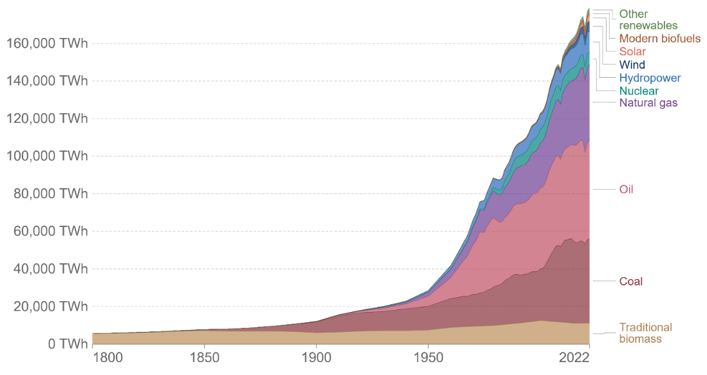
Figure 1. Global primary energy consumption by source (Energy Institute Statistical Review of World Energy, 2023). Adapted from [1].

Table 1: Comparative values of different parameters of energy storage devices. Adapted from [3]
ENERGY STORAGE DEVICE
PHYSICAL PARAMETERS | DIELECTRIC CAPACITOR | SUPERCAPACITOR | LITHIUM-ION BATTERY
Charging Method | Voltage across terminals | Voltage across terminals | Constant current/voltage
Charging Time | 1 μs to 1 ms | 1-30 s | 10-120 min
Specific energy (Wh/kg) | 0.01 to 0.05 | 1 to 5 | 8 to 600
Specific power (W/kg) | < 100,000 | Up to 10,000 | 1000–3000
Coulombic efficiency | > 0.95 | 0.85–0.99 | 0.70–0.85
Cycle life | > 500,000 | ̴ 1000,000 | 500 and higher
Operating temperature | −20 to +100 °C | −40 to +85 °C | −20 to +65 °C

Archetypal energy storage devices are supercapacitors and batteries. Rapid research progress is going on to increase the efficacy of these devices by using advanced nano materials. In this content, carbon is worthy candidate as an electrode material in supercapacitor and batteries on account of its unparalleled versatility and uniqueness. Carbon in its traditional forms (bulk graphite, acetylene black, carbon black or soot) has already been used in electrode devices for a long time. However, the rise of nanotechnology has opened the door for various forms of novel low-dimensional carbon materials. These nanomaterials and the various carbon nano-composites can efficiently transfer electrons and possess rapid charge and discharge rates owing to their high electrical conductivity. Carbon in nano-form is a chemically stable, have large specific surface area, can be easily functionalized, can easily get mixed in composite matrix and in most cases is abundant, scalable and have low-cost of production [3, 4]. Moreover, the strength of various nanostructures of carbon makes them effective fillers for structure resilience. By suitable modifications, carbon nanomaterials such as graphene, carbon nanotubes (CNTs), fullerenes, activated carbon, carbon nano-flakes, carbon nano-sheets, carbon nano-onions, and carbon/graphene quantum dots can show path for advancement in the existing energy storage technologies for advanced battery of supercapacitor electrodes. It is expected that devices made from novel carbon nano-composites will be able to store electrical energy in a more efficient and cost effective form. The advanced nano-composites will amalgamate the exceptional properties of low dimensional carbon with the traditional energy storage materials like metal oxides, chalcogenides, nitrides, hydroxides, MOFs, MXenes etc. Carbon will provide better electrical conductivity, robustness, synergistic effect by augmenting the specific capacitances/capacities of the electrode materials. By exploiting these novel materials, it is expected to address energy challenges of the present and future time. By unravelling the new horizons of energy storage technology, we aim for a sustainable and environment benign energy age with little or no dependency on fossil fuels.

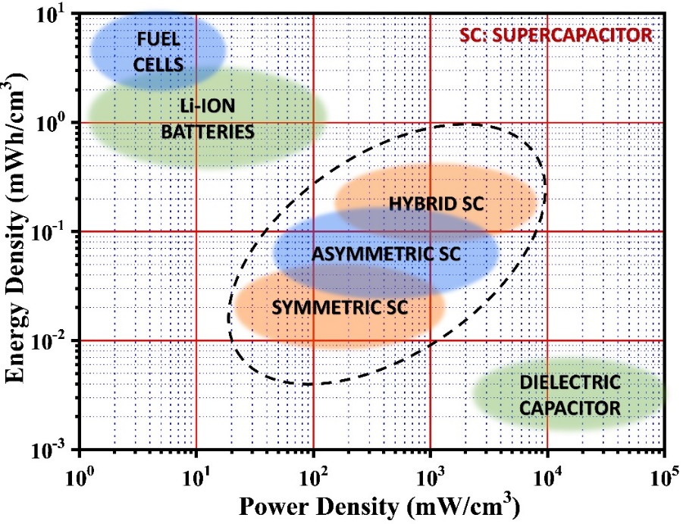
Figure 2. Ragone plot showing the energy density and power density region where various energy storage devices operate.

2. BRIEF DESCRIPTION OF ENERGY STORAGE DEVICES
Supercapacitors: Supercapacitors or Ultracapacitors are prominent energy storage devices which have the characteristic of high power density and fast discharge rate. They are mostly required in scenarios where a large amount of electrical energy is to be delivered in a short time. The energy density of supercapacitors are relatively average, however the rapid advancement of electrode materials has made it possible for some devices to have energy densities at par with batteries. From the construction point of view, they resemble solid electrolyte batteries but have power densities about three order of magnitude higher than the latter, having low maintenance and longer shelf life [5, 6]. A supercapacitor consists of two electrodes and in between there is an electrolyte. The electrodes are partitioned by a separator which prevents the electrons to move inside from one electrode to another (thereby preventing short circuit) but allow the free passage of ions. Based the mechanism of charge storage, supercapacitors can be grouped into mainly two categories (1) Electrochemical Double Layer Capacitor (EDLC) (2) Pseudo-capacitor. EDLC relies on the surface charge storage on the electrode - electrolyte interface (Non-faradaic process) whereas in pseudo-capacitors, the charge is stored by redox reactions (Faradaic process). All the carbon based materials store charge by non-faradaic process and hence are essentially EDLCs whereas the pseudo-capacitive materials like metal oxides, chalcogenides, nitrides, hydroxides, MOF, MXenes store charge by faradaic processes [7]. There some hybrid systems known as asymmetric supercapacitors and supercapattery which use composites of pseudocapacitive materials with carbon derivatives in which, both the processes of charge storage occur and they generally display the best performance due to their enhanced specific capacitance, electrical conductivity and mechanical strength of active material due to synergistic effects, large surface area and inherent strength of the carbon composite fillers.

Batteries: If supercapacitors are known for their high power densities then the electrochemical batteries possess higher energy densities and hence can store a lot of electric energy per unit mass or volume of the active electrode material (cf. Figure 2). Rechargeable batteries such as Lithium / Sodium ion batteries produce electricity by the discharge of the electrical potential energy stored in an electrochemical form. In its simplistic structure, batteries have similarity with a supercapacitor, consisting of a cathode, anode, electrolyte and an insulating porous membrane which acts as the separator. Although structurally similar, battery's working mechanism is strikingly different from the supercapacitors. In lithium ion batteries, the charging and discharging takes place by the reversible shuttling of lithium ions between the electrodes, by the process of intercalation/de-intercalation [8]. The anode is usually made of graphite, the cathode is a lithium compound (LiCoO₂, LiFePO₄) and the electrolyte in a salt of lithium dissolved in some suitable solvent. The first successful LIB was developed in 1991 by Sony corporations and much advancement in battery research has taken place since then [8]. Figure 3 depicts the difference in structure and mechanism of various energy storage devices.
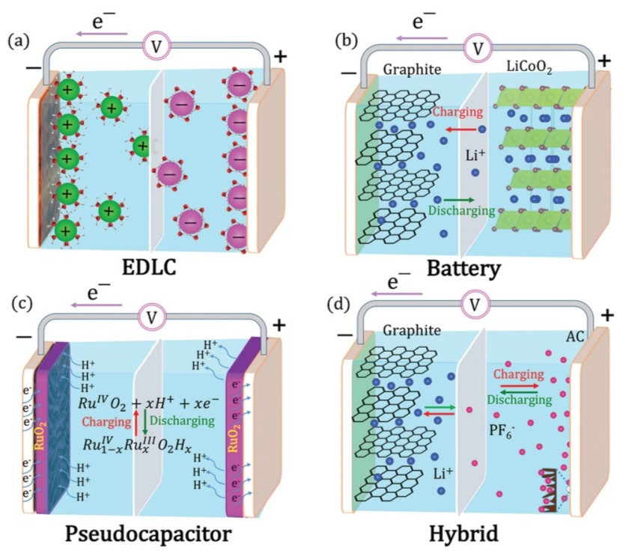
Figure 3. Different electrochemical energy storage systems. Schematic representation of (a) An electric double layer capacitor (EDLC), (b) A battery, (c) A pseudo-capacitor, and (d) A hybrid system that comprises an EDLC and an intercalative charge storage process. Reproduced with permission from [7].

3. CARBON BASED NANO-COMPOSITE MATERIALS
Carbon based ingredients has long been recognized as multifunctional materials for application in material engineering, electrochemical energy storage, catalysis and sensing [9]. Carbon is versatile in many respects. Being an exceptional conductor of electricity it provides easy electron transport, rapid charge-discharge which in crucial for energy storage in electrochemistry. Moreover, some of the carbon composites provide very high specific surface area and hence there are surplus sites for electrochemical reactions at electrode-electrolyte interface. Additionally, carbon materials are stable at normal conditions and their surface properties can be easily modified by surface functionalization. The latter have profound effect the charge storage and the catalytic properties of the composite samples. Traditionally, carbon in the form of bulk graphite, activated carbon and soot black has been used in energy storage devices. Graphite, consisting of its open layered structure, is the most successful anode material of LIBS, by facilitating the rapid intercalation/de-intercalation of lithium ions. Activated carbon is very porous and have colossal specific surface area. They are the sites of surface charge accumulation and are excellent electrode materials for electric double layer capacitors and also the negative electrodes of asymmetric supercapacitors. Again carbon black or soot (which is an agglomeration of fine carbon particles) is the best conductive additive for working electrodes of both batteries and supercapacitors. Although these traditional materials are still used in energy storage devices, their electrochemical performance are still average. Especially the low specific capacitance/capacity of these materials thwarts their use in high performance devices. Particularly, these carbon derivatives cannot compete with the performance of the transitional metal compounds. Moreover, it is difficult to form composites with the traditional bulk materials.
With the growth of nanotechnology, advanced carbon materials are prepared which are characterized by their reduced dimensions in one or more directions. The nanoscale features of these engineered materials enable them to get combined with the pristine compounds for producing some hybrid materials with some interesting emerging properties. These low dimensional nano carbons are usually in the form of nanosheets, nano-flakes, nano tubes, nanoribbons and nano-dots. The recent advances in various synthesis techniques, such as chemical vapour deposition (CVD), solution processing (spin coating, dip coating and spray coating), template-assisted synthesis and chemical synthesis methods (hydrothermal method, sol-gel process and chemical reduction) permit for precise control over composition and structure. Such intricate and accurate synthesis methods can yield novel hierarchical structures with tailored properties which have truly satisfied the demands that are essential for the new-age energy storage systems. As mentioned earlier, the emergent properties like enhanced surface area, structural integrity, rapid charge- discharge capability, ease of functionalization have given the direction of for the exploration of these materials in supercapacitor & battery electrodes. Low-dimensional carbon nano-composites have revolutionised the research field of supercapacitors and electrochemical batteries. The increment in capacitance of the composite electrode materials is mainly attributed to the enhanced surface area. Also the increase in conductivity of samples have resulted in the faster and efficient charge-discharge cycles. The supercapacitors have traditionally been given importance for their enhanced power densities. But with the advent of novel composite materials, supercapacitors can now readily achieve high energy densities. Such advanced supercapacitors with high energy densities may become the worthy substitute of batteries because the former have the added advantages of safer operation and longer life. The various carbon materials that are extensively employed both as the stand-alone as well as composite additives are graphene, carbon nanotubes, fullerenes, carbon nano-fibres and carbon quantum dots. The carbon composites provide boosted capacitance due to their non-faradaic surface charge accumulation and at the same time offer enhanced electrical conductivity and resilience of the working electrodes when subjected to rapid charge-discharge cycles. Efficient carbon composites provide mechanical strength to the active material and hence helps in preventing degradation of the electrodes with time. Figure 4 shows the structure of different forms of nano-carbons.

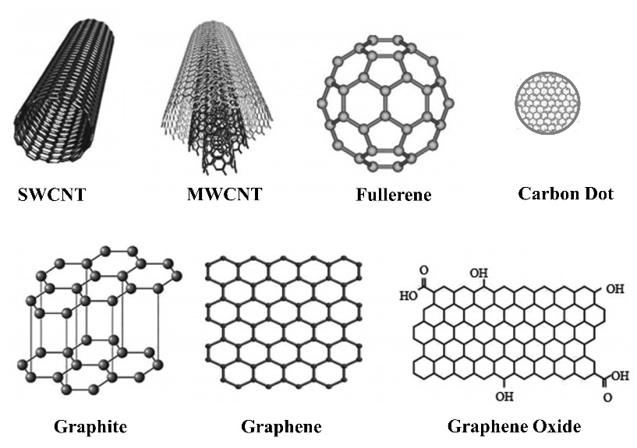
Figure 4. Schematic of different forms of nano-carbons. Adapted from [4].

Graphene
Graphene is a two-dimensional atomically thin hexagonal graphite layer having exceptional electrical conductivity, thermal and chemical stability, mechanical strength and high specific surface area [10, 11]. Synthesis of high quality graphene in scalable quantities is a significant challenge, hence graphene oxide (GO) is synthesized as the precursor material which is later converted to reduced graphene oxide (rGO) to restore the high electrical conductivity. Yoo et al. prepared multilayered GO films as electrodes and obtained a specific capacitance of 247.3 F/g [12]. Xu et al. fabricated 3D graphene hydrogel films having high specific surface area and electrical conductivity. The hydrogel electrode displayed specific capacitance of ~190 F/g. Le et al. developed a TiO₂ / graphene composite material by microwave assisted solvothermal technique. A Na-ion capacitor was fabricated which showed a superior capacity of 268 mAh/g at 0.2 C [13]. Sarkar et al. employed quaternary chalcogenide Cu₂NiSnS₄ as an electrode material of asymmetric supercapacitors. When the chalcogenide was composited with rGO then it resulted in significant enhancement of capacitance (1425 F/g compared to 916 F/g at 5 mV/s) and improvement of electrical conductivity (cf. Figure 5) [14]. Doping graphene with heteroatoms also enhances their charge storage capacity. Reddy and co-workers [15] used chemical vapour deposition to synthesize nitrogen doped graphene which showed better electrochemical behaviour than pristine graphene. Wu et al. [16] synthesized N-doped graphene and B-doped graphene for Li-ion battery electrodes. The introduction of heteroatoms resulted in outstanding specific capacities of 199 mAh/g and 235 mAh/g for the N-doped and B-doped counterparts, respectively. He et al. [17] synthesized a composite of SnO₂, NiO and rGO and employed it as anode material of both Na-ion and Li-ion batteries. The NiO/SnO₂/GO composite achieved a specific capacity of 800 mAh/g at current density of 1000 mA/g.

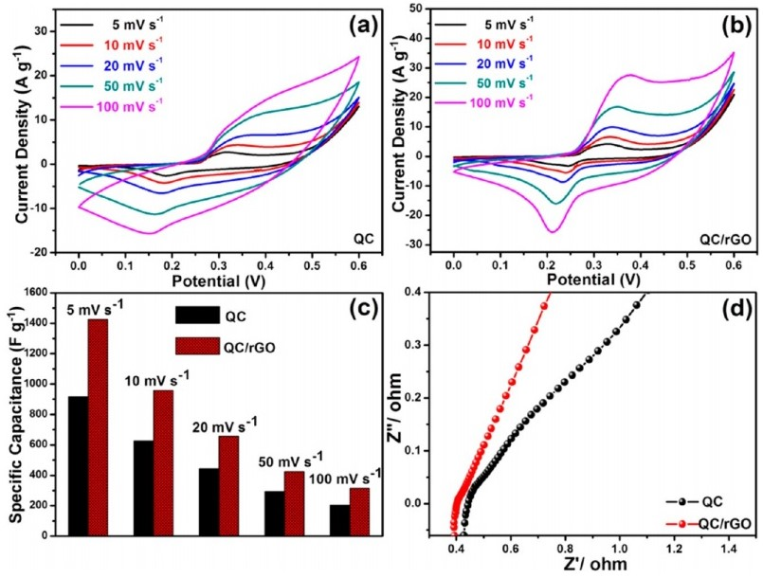
Figure 5. (a, b) CV curves of Cu₂NiSnS₄ and Cu₂NiSnS₄/rGO composite, respectively. (c) Graphical comparison of the specific capacitances of the samples at various scan rates. (d) Nyquist plots of the samples as obtained from the EIS study. Reproduced with permission from [14].

Carbon nanotubes
Carbon nanotubes, due to their unique one-dimensional geometry have excellent chemical, thermal and mechanical properties. Like graphene, they also possess high specific surface area and electrical conductivity. CNTS are not readily dispersible in water or other liquids. But functionalized CNTs can disperse in liquids with ease and hence they can be used for preparation of stable ink dispersion. Gu et al. [18] fabricated MnO₂/CNT and Fe₂O₃/CNT composite films for stretchable electrodes which also showed excellent capacitive performance. Yu et al. [19] fabricated CNT based stretchable films which achieved a specific capacitance of 1147 mF/cm² at 10 mV/s. CNTs can also augment the supercapacitive performance of conducting polymers polyaniline electrode. Introduction of CNT in polyaniline improved the specific capacitance from 308 F/g to 385 F/g. Fe₃O₄/CNT nanocomposites were synthesized by He et al. [20] for application in Li-ion batteries. The discharge capacity obtained was 656 mAh/g which remained stable even after 145 cycles (cf. Figure 6). Core-shell composite structures of CNT based composites by Kim et al. [21] and Jian et al. [22] also showed promising results. The latter displayed excellent efficiency of 79% at a specific current of 100 mA/g. Not only for Li-ion batteries, but CNT based composites (Sn/CNT nano-pillars grown on carbon paper) were utilized as freestanding anodes of Na-ion batteries [23]. The electrodes displayed a superb reversible capacity of 887 mAh/g and cyclability of 100 cycles.

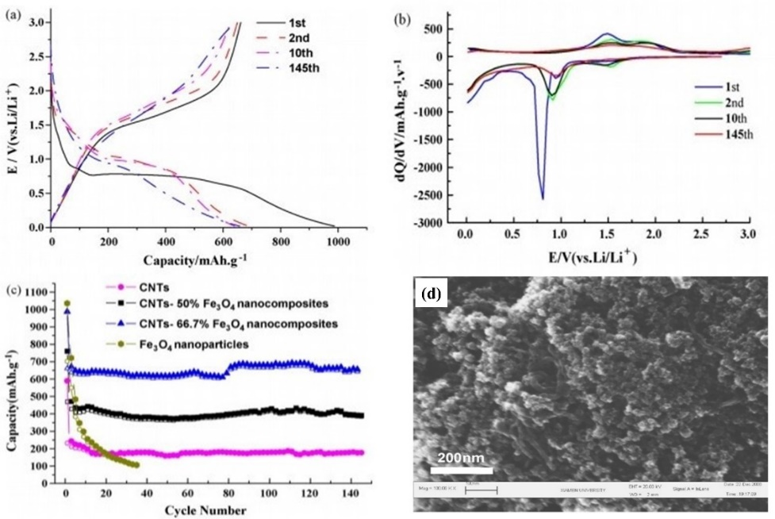

Figure 6. Electrochemical performance of the nanocomposite. (a) Charge–discharge curves of CNTs–66.7 wt.%Fe₃O₄ nanocomposites electrodes. (b) Differential charge–discharge capacity curves of CNTs–66.7 wt.%Fe₃O₄ nanocomposites electrodes. (c) Cyclic performance of different nanocomposite electrodes. (d) FESEM images of CNTs-66.7 wt.% Fe₃O₄ nanocomposite. Reproduced with permission from [20].

Carbon Dots/Carbon Quantum Dots/Graphene Quantum Dots
Carbon dots/Carbon quantum dots/Graphene quantum dots are quasi-spherical nanoparticles having size in the range of 1-50 nm and hence they can be considered as zero-dimensional materials. They generally have a sp² carbon structure and sp³ carbon core. Presence of functional groups, defects and introduction of heteroatoms increases the electrochemical efficiency of CDs/CQDs. These materials possess strong photoluminescence and fluorescence. CDs are efficient substitutes as composite materials for applications in supercapacitors and batteries. Niu et al. [24] first employed GQDs as the replacement of carbon black as conductive agents of supercapacitor electrodes. Li et al. [25] procured nitrogen and oxygen co-doped GQDS (N-O-GQDs) in supercapacitors delivering excellent specific capacitance and electrochemical reversibility. Zhang et al. [26] synthesized a 3D N-doped porous carbon framework (N-PCF) for application in Li-ion battery electrodes. The device demonstrated excellent superior rate capabilities of 1332 mAh/g at 0.1 A/g and retained 840 mAh/g at 2 A/g even after 1000 cycles of operation. Carbon dots can easily be synthesized by the pre-treatment of cellulose followed by high-temperature carbonization. Xie et al. [27] used this material to procure anodes of Na-ion batteries which achieved an admirable specific capacity of 300 mAh/g at an initial Coulombic efficiency of 91%.

Other Forms of Nano-Carbons
Other forms of nano carbons that are extensively used as stand-alone or composite electrode materials of energy storage devices are activated carbons [28], porous carbons [29], carbon nanofibers [30], carbon nanosheets [31] and carbon nano-onions [32]. These are also low-dimensional nanomaterials and can enhance the electrochemical properties of the electrodes by governing the chemical reaction kinetics, providing mechanical resilience and augment the specific capacitance/capacities.

4. CHALLENGES AND MITIGATION STRATEGIES
Although the novel nano-carbon materials have been proving to be game changers in the field of energy storage, however there are few challenges and inadequacies that are needed to be addressed. Firstly, most of these nano-carbons are derived from natural sources and hence the synthesis process is cost effective. But certain materials like single layer defect free graphene and single to few layered CNTs are not easy to synthesize on an industrial scale. More research and technological innovation is needed for procuring industrial grade graphene and CNT in mass scale of production. Secondly, the production cost of certain nano-composites is quite exorbitant and devices fabricated from these nano-composites, although they show excellent performance, are not economically feasible. Thirdly, there are some issues with the long-term structural and electrochemical stability of both the stand-alone and composite electrodes which ultimately dictate their shelf-life and maximum cycle of operations. Fine tuning of various material properties of these novel nanostructures are needed through advanced material engineering. Fourthly, we have to consider about the safety issues related to the nano-composite materials. Especially in the case of batteries, we have to do further research for the prevention of leakage and formation of dendrites by proper assessment of the choice of these carbon nanomaterials which are compatible with the electrolyte and other battery parameters. We can also think in the direction of amalgamating the attributes of both supercapacitors and batteries, having both high specific energy and specific power, with the novel nano-carbon architectures playing the dominant role.

5. CONCLUSION
In conclusion, the chapter explores the application of low-dimensional nano-carbons in the arena of energy storage. These novel nano architectures have opened the doors for new opportunities, by offering strategies for the enhancements of specific capacitances, specific capacities, energy and power densities, rate capabilities and cycle life of both batteries and supercapacitors. As we behold the near future, we can anticipate the challenges that lie ahead of us. This journey is ongoing, and the low-dimensional nano-carbon materials will continue to evolve for making a sustainable and energy abundant future.

References

[1] H. Ritchie, M. Roser, and P. Rosado (2022). Published online at OurWorldInData.org. Retrieved from: https://ourworldindata.org/energy

[2] D. B. Botkin, Powering the Future: A Scientist’s Guide to Energy Independence, Pearson Education, New Jersey, 2010.

[3] R. Dubey and V. Guruviah, Ionics, 2019, 25, 1419–1445.

[4] C. Liu, X. Huang, Y. Wu, X. Deng, Z. Zheng, Z. Xu, and D. Hui, Nanotechnology Reviews, 2021, 10(1), 34-49.

[5] E. Faggioli, P. Rena, V. Danel, X. Andrieu, R. Mallant, H. Kahlen, J. Power Sources. 1999, 84, 261–269.

[6] M. Ates, A.S. Sarac, Polym. Plast. Technol. Eng. 2011, 50, 1130–1148.

[7] A. Noori, M. F. El-Kady, M. S. Rahmanifar, R. B. Kaner and M. F. Mousavi, Chem. Soc. Rev., 2019, 48, 1272-1341.

[8] M. Li, J. Lu, Z. Chen, and K. Amine, Adv. Mater. 2018, 30, 1800561.

[9] S. Ghosh, S. R. Polaki, A. Macrelli, C. S. Casari, S. Barg, S. M. Jeong, and K. Ostrikov, J. Phys. D: Appl. Phys. 2022, 55, 413001.

[10] A. Geim, and K. Novoselov, Nature Mater 2007, 6, 183–191.

[11] C. Lee, X. Wei, J. W. Kysar, J. Hone, Science 2008, 321, 385.

[12] J. J. Yoo, K. Balakrishnan, J. Huang, V. Meunier, B. G. Sumpter, A. Srivastava, M. Conway, A. L. Mohana Reddy, J. Yu, R. Vajtai, P. M. Ajayan, Nano Lett. 2011, 11, 1423.

[13] Y. Xu, Z. Lin, X. Huang, Y. Liu, Y. Huang, X. Duan, ACS Nano 2013, 7, 4042.

[14] S. Sarkar, P. Howli, B. Das, N. S. Das, M. Samanta, G. C. Das, and K. K. Chattopadhyay, ACS Appl. Mater. Interfaces 2017, 9, 22652−22664.

[15] A. Leela, M. Reddy, A. Srivastava, S.R. Gowda, H. Gullapalli, and M. Dubey, ACS Nano. 2010, 4, 6337–6342.

[16] Z.S. Wu, W. Ren, L. Xu, F. Li, H.M. Cheng, ACS Nano 2011, 5463–5471.

[17] Y. He, A. Li, C. Dong, C. Li, L. Xu, Chem. – A Eur. J. 2017, 23, 13724–13733.

18] T. Gu, B. Wei, J. Mater. Chem. A 2016, 4, 12289–12295.

[19] J. Yu, W. Lu, S. Pei, K. Gong, L. Wang, L. Meng, et al., ACS Nano. 2016, 10, 5204–5211.

[20] Y. He, L. Huang, J.S. Cai, X.M. Zheng, S.G. Sun, Electrochim. Acta. 2010, 55, 1140–1144.

[21] S.W. Kim, J. Ryu, C.B. Park, K. Kang, Chem. Commun. 2010, 46, 7409–7411.

[22] Z. Jian, P. Liu, F. Li, P. He, X. Guo, M. Chen, et al., Angew. Chemie - Int. Ed. 2014, 53, 442–446.

[23] X. Xie, K. Kretschmer, J. Zhang, B. Sun, D. Su, G. Wang, Nano Energy 2015, 13, 208–217.

[24] Y. Niu, J. Wang, J. Zhang, Z. Shi. J Electroanal. Chem. 2018, 828, 1‐10.

[25] Z. Li, L. Cao, P. Qin, et al. Carbon. 2018, 139, 67‐75.

[26] X. Zhang, Z. Zhang, F. Hu, et al. ACS Sustainable Chem Eng. 2019, 7(11), 9848‐9856.

[27] F. Xie, Z. Xu, ACS. Jensen, et al. J Mater Chem A. 2019, 7(48), 27567‐27575.

[28] G. Wang, H. Wang, X. Lu, Y. Ling, M. Yu, T. Zhai, Y. Tong, Y. Li, Adv. Mater. 2014, 26, 2676.

[29] F. Zhang, T. Liu, M. Li, M. Yu, Y. Luo, Y. Tong, Y. Li, Nano Lett. 2017, 17, 3097.

[30] L.-F. Chen, Z.-H. Huang, H.-W. Liang, W.-T. Yao, Z.-Y. Yu, S.-H. Yu, Energy Environ. Sci. 2013, 6, 3331.

[31] H. Fan, R. Niu, J. Duan, W. Liu, W. Shen, ACS Appl. Mater. Interfaces 2016, 8, 19475.

[32] C. Zhang, H. Du, K. Ma, Z. Yuan, Adv. Energy Mater. 2020, 10, 43, 2002132.

