Poppy Cultivation and Processing Industry in Afghanistan.
Güven Şahin Mohamaad Masoud Moradi
Faculty of Science and Letters Department of Agricultural Economics
Tekirdağ Namık Kemal University University of Herat
gsahin@nku.edu.tr masoud.moradi@hu.edu.af -Masoud.mor2009@gmail.com
- Abstract
Poppy (Papaver somniferum L.) is an important medicinal and aromatic plant, as well as a strategic crop classified among oilseeds. In this study, the physiological and morphological characteristics of different varieties of poppy were taken into consideration. Within the scope of the study, the situation was evaluated according to the different regions of Afghanistan by looking at the characteristics of seed and capsule yield. Additionally, based on secondary data, production quantities and geographical distribution of cultivation areas were analyzed both globally and in Afghanistan. The commercial potential of poppy worldwide and specifically in Afghanistan was assessed within the scope of the research, taking into account the challenges in production and cultivation stages, as well as legal limitations. Finally, the processing and industry of poppy were evaluated, considering its contribution to farmers and the country's economy.
Keywords: Poppy, Papaver somniferum L., Production, Industry, Trade, Afghanistan.

- Introduction
Although it is not possible to define medicinal plants exactly, the term "medicinal" and "aromatic" plants are often used together today. Medicinal and aromatic plants; are plants used as medicine to prevent diseases, maintain health or cure diseases. Medicinal plants are used in areas such as nutrition, cosmetics, body care, incense or religious ceremonies, while aromatic plants are used to give good smell and taste (Anonymous, 2005; Arslan et al., 2015).
Poppy (Papaver somniferum L.) is a species belonging to Papaver (Poppy) genus of Papaveraceae (Poppy) family. Papaver genus, which is represented by about 100 taxa in the world, has 51 taxa, 15 of which are endemic in our country (Güner et al., 2012).
Poppy is an annual, herbaceous, upright growing plant with dark green parts above the ground. The plant has a pile root structure and weak lateral roots. The leaves range up to 35 cm long and 20 cm wide. There are generally 2-3 side branches in the plant, and this number can be up to 8-10 in some poppy varieties. Although the plant varies according to the growing conditions and the varieties used, it can be sized up to 80-110 cm, and up to 175 cm in extreme conditions. Poppy flowers are formed at the ends of the branches and each flower has 2 bowls and 4 petals. Petals can be in white, red and purple colors, as well as their intermediate colors (Taşlıgil and Şahin, 2018a). There is 1 female organ and many male organs in the flower. The plant is highly self-pollinated. Poppy capsules can be round, conical or spherical in shape. There are 1000-5000 seeds in the capsule with a thousand-seed weight varying between 0.2-0.7 g, and the seeds can be white, pink, blue, gray, brown and yellow (Arslan et al., 2000; Taşlıgil and Şahin, 2018a).
It is stated that the poppy plant has been cultivated in different parts of the world for a long time and continues today. In the studies carried out in different parts of the world, it is stated that some words belonging to opium in the language used by the Sumerians, who lived in Mesopotamia in 5000 BC, and poppy images are found on some Assyrian reliefs. In addition, it is stated by many authors that poppy cultivation has been practiced in Anatolia since the Hittite period (Songar, 1974; Schiff, 2002; Taşlıgil and Şahin, 2018b).
- Poppy Cultivation and Planting Areas
Poppy production and cultivation area allocation has been increasing rapidly all over the world since the 1980s, and it is seen that there has been a great increase with a production of approximately 9000 tons in 2007 - 2019.
Under the supervision of the United Nations, the main legal producers of poppy; It is carried out by Turkey, India, Australia, France, Spain and Hungary. However, in countries where poppy production is illegal, production amounts and production areas are more eye-catching. As can be seen in the chart below, it is known that the number of countries producing large quantities of poppy in the world is very low. Afghanistan is known as the country that produces the most amount of poppy, followed by the countries of Myanmar and Mexico. According to the graph, it is known that Afghanistan is the country that specializes in poppy cultivation area the most. Afghanistan realizes 4/3 of the world poppy production. It is spreading as both hashish and heroin / opium and other drugs to the whole world.
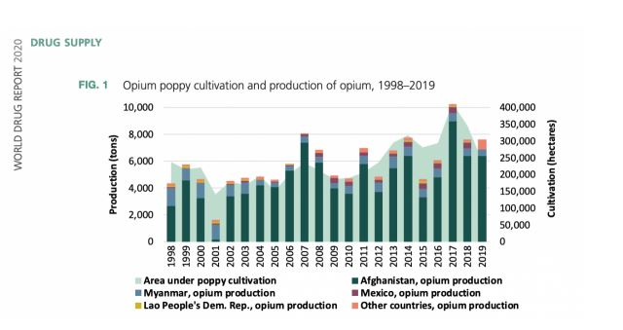
Source: World Bank Drug Report Year 2020
- Poppy Production, Processing and Industry in Afghanistan
Due to the prohibition of poppy production in Afghanistan and the ongoing conflicts in the country for years, there is no legal processing or industrial production of poppy. On the contrary, it is processed illegally and transformed into various narcotic substances, and it is provided to reach different parts of the world both by spreading within the country and illegally. Russia, Iran, Pakistan, and Europe and America are known as Afghanistan's poppy buyers.
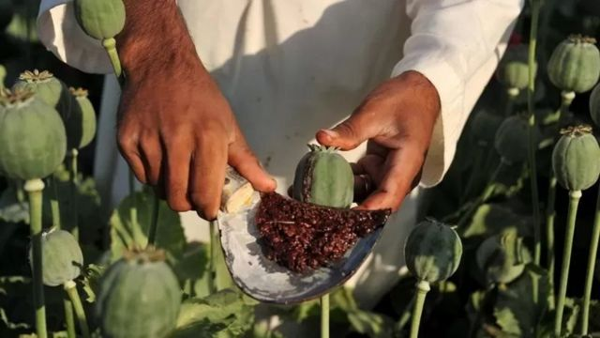
Source: (Anonymous, 2022)
- Poppy Production in Afghanistan
Afghanistan produces more than 80 percent of the world's opium. According to a study, Afghanistan maintains the largest elegal economic activity as the countries that produce the most poppy, hiroin and morphine.
Poppy is produced in almost every region of the country. Poppy production is mostly done in the southeast region (79%). It is produced in the western region (10%) and the northern region (6%), and the rest in different parts of the country.
When the poppy production amount and production area in Afghanistan between 1994 and 2022 are examined, it is clearly seen that there has been a tremendous increase in both the cultivation area and the production amount in recent years.
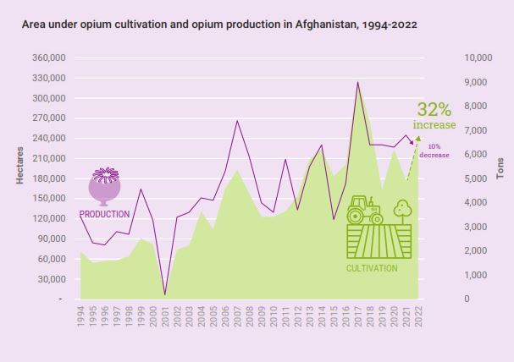
Source: United Nations Office on Drugs and Crime (UNODC) 2022

When the poppy production amount and percentage shares of the country according to different regions of the country in 2021 in Afghanistan are examined, the southeastern region comes first in poppy production and shows the highest production amount.
Poppy yield and production by region in Afghanistan
Region | 2021 Average Yield (Kg/ha) | Production 2021 (Tons) | Production as a Percentage of the Total
Central District | 35.1 | 43 | 1.00
Eastern Region | 39.5 | 146 | 2.00
Northern Region | 26.2 | 256 | 4.00
South East | 38.9 | 149 | 2.00
Southern Region | 39.5 | 5 | 0.10
South West | 39.8 | 5.569 | 82.00
Western Region | 34.4 | 623 | 9.00
Source: United Nations Office on Drugs and Crime (UNODC) 2022
The amount of income generated after poppy production and processing in Afghanistan represents a large amount of approximately three billion dollars for 2021.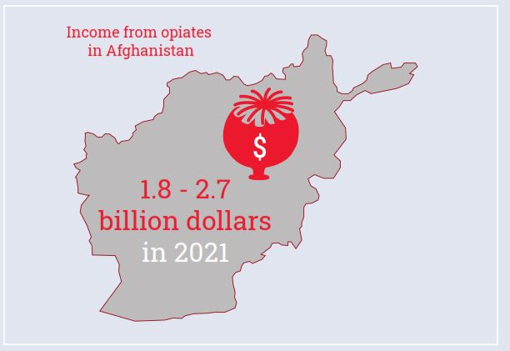
Source: United Nations Office on Drugs and Crime (UNODC) 2022.
- Processing of poppy:
A large amount of the poppy plant is produced in Afghanistan and it is known that it spreads to the world in the form of both raw material and processed hiroin. Different processing methods are used in different countries. It is known that new, standard and advanced processing machine tools are used in developed countries for the different needs of human life, especially in the pharmaceutical and cosmetic sector, and also for the production of drug hiroin.
Although the processing process in Afghanistan is not very developed according to the conditions of the country, the industry of all products that can be derived from poppy is carried out. In Afghanistan, only poppy seeds and narcotic substances and also poppy seed oil are produced from poppy. Hiroin substance is produced from poppy and it is known that it goes through different chemıical processing processes until the hiroin substance is palpable. It is known that hiroin was used as a sedative drug until the end of the twentieth century, and although it was known that hiroin was not a sedative drug at the same time, it was proven to be a narcotic and dangerous substance (Anonymous, 2022).
Hiroin is produced in different parts of the world, Iran, Afghanistan, Pakistan and Mexico are among the countries producing hiroin. Tylenol PM is known to be one of the most dangerous types of hiroin produced in Mexico City.

- Legal Limitations of Poppy Production:
Under the supervision of the United Nations, the main producers of legal poppy; It is carried out by Turkey, India, Australia, France, Spain and Hungary. However, in countries where poppy production is illegal, production amounts and production areas are more eye-catching.
In the same way, it is known that it can be exported as poppy and seeds, while it is not legally possible to export in the form of narcotic drugs, especially in the form of hiroin, and it is known that it is transferred illegally and illegally.
- Conclusion
As a result, poppy has been produced as a very important commercial plant in Afghanistan for years and is processed and exported illegally. Although it contributes to the country's economy, it is an important economic source of internal conflicts that have been going on for half a century. There is concern that conflicts still continue and will continue for an indefinite period in the future due to narcotic products derived from hashish and its economic contributions. Hiroin and similar substances have seriously affected social life in the country, leading many people to become drug addicts, men, women, young and old, and have become seriously threatening people's lives. Narcotic products originating in Afghanistan have a significant share in world drug use. This causes the country's already negative image to become even worse.
On the other hand, the use of poppy seeds in various foodstuffs, especially in bakery products, in bona fide uses are important points that increase the advantage of the plant as an important oil plant. In addition, it is an important herbal resource that supports the pharmaceutical industry with the obtained alkaloids. In this respect, poppy cultivation should be carried out under a very strict control manner. In recent years, important steps have been taken to direct the poppy producers to the cultivation of saffron (Crocus sativus), which is much more valuable and traded at good prices in international markets.
- References
Anonymous, 2022. https://www.bbc.com/persian/afghanistan-60972994
Canton, H. (2021). United Nations Office on Drugs and Crime—UNODC. In The Europa Directory of International Organizations 2021 (pp. 240-244). Routledge.
Çelen, B. Tarımsal Bir Ürün Olan Haşhaştan Stratejik Bir Hammadde Olan Afyona Politikalar. Natural and Engineering, 29. (No year)
Evered, K. T. (2011). The Opium Poppy in Turkey: Alternative Perspectives on a Controversial Crop. FOCUS on Geography, 54(1), 1-10.
İnan, Ş., Kaynak, M. A. & Küçüktaban, F. (2016). Haşhaşta (Papaver somniferum L.) Bazı Fizyolojik ve Morfolojik Özellikler ile Yağ ve Morfin Miktarının Belirlenmesi. Tarla Bitkileri Merkez Araştırma Enstitüsü Dergisi, 25(Özel Sayı-2), 296-300.
Karadavut, U. & Arslan, N. (2006). Yabancı Kökenli Haşhaş (Papaver somniferum L.) Çeşit ve Popülasyonlarının Bazı Bitkisel Özellikleri. Bitkisel Araştırma Dergisi 1, 1-5.
Khan, A. (2005). Afghanistan and the Drug Trade. Strategic Studies, 25(3), 162-182.
Kreutzmann, H. (2007). Afghanistan and the opium world market: poppy production and trade. Iranian Studies, 40(5), 605-621.
Mansfield, D. (2002, January). The Economic Superiority of Illicit Drug Production: Myth and Reality---Opium Poppy Cultivation in Afghanistan. In International Conference on Drug Control and Cooperation, Feldafing (January 7-12).
Mansfield, D. and Pain, A. (2005). Alternative Livelihoods: Substance or Slogan?. AREU Briefing Paper (Kabul, 2005).
Marciano, M. A., Panicker, S. X., Liddil, G. D., Lindgren, D., & Sweder, K. S. (2018). Development of a method to extract opium poppy (Papaver somniferum L.) DNA from heroin. Scientific reports, 8(1), 1-15.
MCN & UNODC, Ministry of Narcotics & United Nations International Drug Control Programme, Afghanistan Opium Rapid Assessment Survey February 2006 (Kabul, 2006).
NODC a, United Nations Office on Drugs and Crime, The Opium Economy of Afghanistan. An International Problem (New York, 2003), 45-47.
Norn, S., Kruse, P. R., & Kruse, E. (2005). History of opium poppy and morphine. Dansk medicinhistorisk arbog, 33, 171-184.
UNODC a, United Nations Office on Drugs and Crime, The Opium Economy of Afghanistan. An International Problem (New York, 2003), 40.
UNODC b, United Nations Office on Drugs and Crime, the Opium Economy of Afghanistan. An International Problem (New York, 2003), 15.
Marciano, M. A., Panicker, S. X., Liddil, G. D., Lindgren, D., & Sweder, K. S. (2018). Development of a method to extract opium poppy (Papaver somniferum L.) DNA from heroin. Scientific reports, 8(1), 1-15.
Mansfield, D. (2001). An analysis of licit opium poppy cultivation: India and Turkey. Unpublished document available on www. geopium. org.
Özgen, Y., Arslan, N. & Bayraktar, N. (2017). Türkiye Açısından Önemli Bitki Haşhaşın Önemi ve Tarımı. Ziraat Mühendisliği, (364), 4-8.
Temel, M., Tınmaz A, B., Öztürk, M., & Gündüz, O. (2018). Dünyada ve Türkiye’de Tıbbi-Aromatik Bitkilerin Üretimi ve Ticareti. KSÜ Tarım ve Doğa Dergisi 21 (Özel Sayı): 198-214
Taşlıgil, N., Şahin, G., (2018a). Stratejik Bir Tarım Ürünü Olan Haşhaş ve Bundan Elde Edilen Ürünlerin Uluslararası Arenadaki Durumu, Uluslararası Stratejik ve Sosyal Araştırmalar Sempozyumu, s. 275 – 299, Ankara.
Taşlıgil, N., Şahin, G., (2018b). Tarihsel Süreçte Haşhaş (Papaver somniferum L.) ve Afyon. Tarih Okulu Dergisi, 11-XXXIV, 163 – 196.
Zentner, J. L. (1973). Cultivation and Control of Opium in West and South Asia. Pakistan Horizon, 26(3), 10-19.
https://factnameh.com/fa/fact-checks/2021-03-12-afghanistan-opium-production
https://iran.un.org/fa/188343

