Secure integration of IoT and Cloud Computing

Shrawan kumar Sharma
Assistant Professor, Department of Computer Science and Engineering
Mandsaur University, Mandsaur (M.P.)India
Shrawansharma3669@gmail.com

Shiv Kumar
Assistant Professor, Department of Computer Science and Engineering
Mewar University,Chittorgarh(Raj.),India
Shivkumar004@gmail.com

ABSTRACT
Cloud Computing and the Internet of Things “IoT” is an extraordinary tool in every aspect of our lives. Their mass adoption and usage are expected to increase, making them an important part of the Internet of Destiny. The new paradigm combining cloud and IoT is expected to create impact and impact in many applications. In this article, we recognize our interest in cloud and IoT, what we call the “cloud-based IoT” paradigm, and various activities in cloud and IoT-based data analysis: their products are important, their features, technologies and open questions. However, to the best of our knowledge, there is no detailed evaluation of the "Cloud-Based IoT" paradigm in these studies. We set out to review and discuss the need for integration in the literature, the extreme conditions associated with integration, and how the problems can be resolved. We will describe platforms (commercial and open source) and projects based on the "IT Cloud" paradigm, as well as software events offered in the products. In the end, we see the open questions, the big problems, and the fate of this hope.

Keywords—Internet of Things "IOT", Mobile Cloud Computing, Cloud Computing, Privacy, Security, MQTT.

INTRODUCTION
It is important to consider the generalizations involved in the calculations. This is true of cloud computing and the Internet of Things (IoT), two concepts that share many characteristics. A combination of these different techniques can help and enhance this tool. Cloud computing is changing the way technology is acquired, managed and delivered. Air usage is guaranteed for future services. Although many people see cloud computing as a new technology, it actually incorporates and integrates many technologies such as grid, computer virtualization, network and data services. The services provided by iCloud computing allow them to provide computing services over the Internet. In fact, it is not surprising that the origins of cloud technology are distributed computing and the same computer, as well as network, computing, communication and software services. The Internet of Things can be thought of as a global network of highly autonomous devices. The Internet of Things is entering a phase where everything around us is connected to the internet and we can communicate with people with minimal effort. The Internet of Things usually consists of many products with limited storage and computing capacity. Cloud computing and the Internet of Things are the future of the internet and new technologies. But while cloud services rely on interchangeable service providers, IoT technology relies on diversity rather than dependency. Cloud computing and the Internet of Things are two different disciplines, but each has its own rules and specific concepts; It has positive effects on our daily life. The combination of cloud and IoT is called the cloud IoT image. By integrating these two technologies into what is called Cloud IoT, we hope to impact the networks of today and tomorrow. Combining cloud and IoT is important, interesting and useful for research, business or education. You can be sure that we will explore the importance of cloud and IoT integration and discuss the integration challenges we face and how to solve them over time. We can also explore similar capabilities and benefits of cloud integration and IoT. Just as not everything is cheap for everyone, not everything is free for everyone. If you are an internet user, you should buy everything. When it comes to IoT devices and cloud servers, it is difficult for everyone to afford it. But using open source is good for us. We use only open source in this article. We use inexpensive IoT tools to integrate IoT and cloud servers and open the cloud to students using Azure virtual machines. This is often the case when we send messages over the Internet. Messages can easily be intercepted by intruders and pose a danger to both the sender and the recipient. Your personal information or comments will be kept confidential and respected. From a security perspective, this is very dangerous. There is a message for you for your safety. We use MQTT protocol here for security. First, we encode all the text or strings of the MQTT protocol. From this point on, if the intruder can view the text in both directions, he will not be able to see the text even if it is encrypted. Your information is completely safe. When the text is sent to the desired destination; receiver can decrypt encrypted data and save secure data. Security is very easy using the MQTT protocol. Here we send images over MQTT protocol and use facial recognition as an application. When we use IoT devices to remotely control and send images during operation, this is quite difficult and can lead to errors. Otherwise, we may send video files or other large files instead of images. It also provides options to transfer your data securely.

BACKGROUND AND LITERATURE REVIEW

Birth of IoT

Although the term IoT is only 16 years old, the original concept of connected devices dates back to at least the 1970s. Before this, the concept was often referred to as “embedded networking” or “synthetic computing.” The first term, "Internet of Things", was used by Kevin Ashton in 1999 while working at Proctor Gamble. Ashton, who was working in the chain at that time, wanted the management to be interested in the new technology, RFID. Since the Internet was brand new in 1999, he called his program "Internet of Things." Some important aspects of physical development and digital integration:

- 2-way radio wristband worn by Dick Tracy and police officers on January 13, 1946; this became the first and most recognizable symbol in comics.
- In 1949, 27-year-old Norman Joseph Woodland of Miami Beach inhaled four drops of sand and the barcode was born. Woodland, who later became an IBM engineer, received his first barcode patent in 1952. More than two decades later, another IBM employee, George Lohrer, was largely responsible for developing the concept used in department stores.
- In 1955, Edward O. was the first person to create the portable computer. Thoreau, an analog device in the form of a pack of cigarettes, served the sole purpose of evaluating roulette cycles.
- On October 4, 1960, Morton Heilig was patented for head-mounted performance.
- In 1967, Hubert Upton invented an analog wearable computer with a mirror display to help read lips.
- On October 29, 1969, the first message was sent to the Internet's predecessor, ARPANET.
- On June 26, 1974, the Universal Product Code (UPC) label was first used to shop in supermarkets.
- In 1977, Sisi Collins assisted the visually impaired, a five-pound wearable with a head-mounted camera that transforms images on a shirt into a tactile grid.
- In the early 1980s, members of the Carnegie-Mellon Computer Science Department installed micro switches in Coke vending machines and connected them to the PDP-10 department computer to see how many bottles were in their machines and whether they were cold.
- in 1990, Olivetti developed an active ID system that uses infrared signals to transmit a person's location.
- In September 1991, Mark Weiser of Xerox PARC published an article in Scientific American entitled "The Computer in the 21st Century," in which he described his vision in terms of "ubiquitous computing" and "embodied vitality." Related to this are specific aspects of hardware and software. "Stars, radio waves and infrared are so ubiquitous that no one notices their presence."
- In 1993, MIT's Thud Starr began using particularly tough computers and head-up displays as wearable.

Internet of Things (IoT)
Simply put, IoT provides an unprecedented way for end users to communicate with each other using the internet and networks. With the rapid development of communication, the Internet of Things is causing major changes, especially in wireless communication. An Internet of Things (IoT) footer based on appropriate content and personalization is more important than a link in the world wide web. You can easily observe and analyze everything in this world and by doing so, how much money, loss, waste, damage, etc. You can calculate that we can reduce it. By integrating smart products with IoT devices, we can bring something greater to our students. IoT devices can connect to the internet and collect and process data from various sources. The "Internet of Things" (IoT) is a network of devices from a variety of physical devices, cars, homes, etc., that can be easily connected to a variety of software, electronic devices, and sensors. It is a network formed. Transmission and security on the Internet, To understand the Internet of Things, we first need to understand the applications of the Internet of Things that you need to know. What happened to the thermos, smart car, smart city, smart hospital, various home appliances, electric alarms and many internet devices? Now we will talk about how these applications can help you use IoT devices easily. Imagine returning home after being away from home for a while. Check the current weather forecast, is the sun shining, are the windows of your house open, are the windows with a fan, or are the windows closed with a fan? How to use some IoT devices that use the internet, you can do this easily. You can easily control a smart hospital or car using the same system.

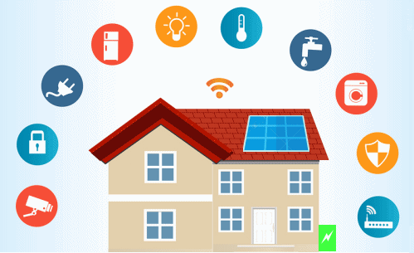
Figure 1: IoT based Smart Home

Cloud Computing
Cloud computing provides computing services with ease, on-demand, and network access. Cloud computing has a small storage capacity and processing power. Some definitions of cloud computing are:

• Cloud computing is a model that provides access to shared services (such as network, servers, storage, applications, and services) with less effort or optionally faster service. The network is on the market. (National Institute of Standards and Technology (NIST)).

• Using technology to provide IT support to external customers is a form of distributed computing. (Gartner).

• Evolving IT development, distribution and delivery models to enable rapid delivery of products, services and solutions over the Internet. (International Information Centre).

• “Cloud computing” describes a service model that includes IT deployment, infrastructure, infrastructure and business models, grid computing, virtualization, utility computing, hosting and software (SaaS) as system services. However, each research group interprets cloud computing from its own angle and perspective, so it is difficult to define more.

• Public cloud computing infrastructure is hosted by a cloud provider in the public cloud. Users cannot view or control the computer's administrative settings. Computing infrastructure is shared between organizations.

• Private Cloud: Computer infrastructure is allocated to a specific organization and cannot be shared with other organizations. Some experts believe that private cloud is not a true example of cloud computing. Private cloud is more expensive and more secure than public cloud.

• Hybrid cloud organizations can host complex applications in a private cloud without the security concerns in the cloud. The use of private cloud and public cloud is called hybrid cloud.

• Social Cloud: It is a different type of cloud where many social organizations such as banks and merchants are gathered in one place. This is a multi-tenant situation shared by a dedicated group of different organizations with similar concerns. Cloud computing is a disruptive technology that has a huge impact on the entire IT industry, including network services. However, many financial and economic problems are still unresolved. Each service model typically has specific concerns regarding security (e.g., data security and integrity, network security), privacy (e.g., information identity), and agreed upon service levels that may impact customers.

• IaaS (Infrastructure as a Service)
• PaaS (Platform as a Service)
• SaaS (Software as a Service)
cloud All financial services (cloud including services). Cloud users (application developers or application users) can access cloud services over the internet, and cloud users pay only for the time and services they use. The cloud can also scale to support multiple requests. Finally, cloud computing allows administrators to oversee application development and maintenance by monitoring the micro-lifecycle of the application. Cloud computing platforms provide a variety of services to build, test, run, operate and manage applications in the cloud. Examples of cloud computing platforms include Amazon Web Services, Google App Engine, and Microsoft's Windows Azure platform.
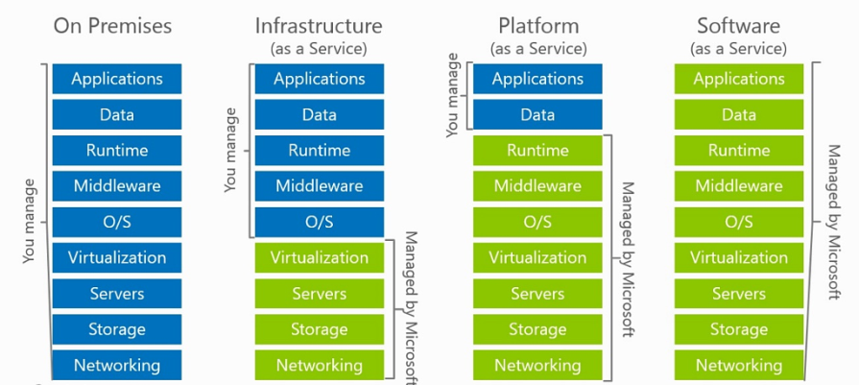
Figure 2: Different types of cloud computing

WHY CLOUD OF THINGS

The number of connected devices has already exceeded the world's total population and is expected to grow even faster. Since Web 3, the Internet reaches almost everywhere, the type of equipment involved has increased, and the amount of information produced is also increasing. As the Internet of Things evolves, it has made a huge impact on big data. Environmental sensors, monitoring sensors, and various actuators all produce data to some degree, to varying degrees and at different speeds. Information about publishing cannot be retained in the Internet of Things. This is a cloud computing application in the Internet of Things, and cloud computing has unique features. However, there are many activities of collaborations that can be found in the documents and will continue to be found in the coming years. It explores the concept of Consistent Cloud (COT) or Cloud IoT paradigm.

INTEGRATION OF CLOUD AND INTERNET OF THINGS
The combination of the Internet of Things and cloud computing creates a new model that we here call the Cloud Internet of Things. Both the cloud and IoT worlds are changing independently of each other. However, some positive results from their combination have been identified in the literature and will be discussed in the future. IoT, on the other hand, can use unlimited resources and resources to overcome the limitations of the cloud (e.g. storage, processing, and power). In general, the cloud provides the best solutions for applications that use IoT services and the data they produce or connectivity and data management. Cloud, on the other hand, can use IoT to provide various services in a distributed and dynamic manner in various ways. These churches are different from each other and, better yet, their values ​​are similar. This relationship is the main reason why many researchers create a combination to benefit certain applications.
Most articles in the literature do not look at clouds in general terms, that is, they believe that clouds make a difference in the region. Internet of Things (e.g. limited storage). Alternatively, find a cloud-based IoT environment (medium scale). Due to the diversity of devices, technologies and processes that IoT has, it lacks important features such as vulnerability, connectivity, simplicity, reliability, functionality, usability and security. IoT in the cloud streamlines the flow of data collection and processing, enabling rapid use and integration of new data while saving on data provisioning and processing costs. Therefore, analysis is not possible and data-driven decision-making and testing algorithms can be used at low cost, helping to increase revenue and reduce risk.Cloud IoT has given birth to new smart services and applications for daily life. Many of the tools described below are useful not only when something needs to be changed and sent to the cloud, but also for machine-to-machine (M2M) communication.
These tools include:
  - Health care
  - Smart cities and communities
  - Smart home and smart metering
  - Video surveillance
  - Motor and cognitive mobility
  - Smart power and smart grid
  - Smart Logistics
  - Environmental monitoring
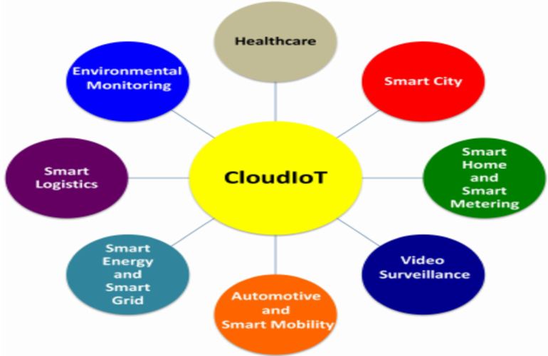
Figure 3 Application scenarios driven by the CloudIoT paradigm

QUALITY OF SERVICE IN THE INTEGRATION OF CLOUD AND THE INTERNET OF THINGS
A heterogeneous network (default) is a heterogeneous network; offering more than one service or services. This does not mean that there are only different types of traffic on the network; It also means that a network can support all applications without affecting quality of service (QoS). There are two groups of applications: navigation and traffic latency (for example, for low-cost monitoring) and bandwidth and latency, where significant inelastic (instantaneous) traffic (for example, noise or maintenance vehicles) can be further differentiated between service-related applications. information. with different QoS (such as high-resolution, low-resolution video). Therefore, a management and appropriate working method must be available for different service providers, each with their own QoS requirements. Providing QoS authentication over wireless networks is not easy because resource allocation and management issues of shared wireless environments often lead to “gaps” in the identification of devices. Service quality in cloud computing is another important research area that needs more attention due to the information and tools provided by the cloud. Dynamic programming and resource allocation algorithms based on the pellet production process are being developed. With the advent of advanced electronic applications and the Internet of Things, it may become a bottleneck. However, although there are benefits to using the cloud; There are problems in the area of ​​quality of service (QoS). QoS refers to the level of performance, reliability and capacity provided by a service or platform or host infrastructure. QoS is important for both cloud users who want service providers to deliver high-quality messages and cloud service providers who need to find the balance between QoS layers and operating costs. Violation of Service Level Agreement (SLA) results in losses for both the cloud service provider and the cloud user. Surgery is generally considered to meet SLAs by service providers, but weatherization in particular is not maximized.
There are currently several ways to achieve and support service level agreement in IoT and cloud. In light of CloudIoT, these processes need to be re-evaluated or redesigned to meet the challenges posed by future CloudIoT applications. However, QIS CloudIoT certification is expected to be difficult when disciplines emerge. This is due to the lack of an end-to-end QoS authentication method (between end users, IoT, and cloud devices), the complexity of multiple layers, and the fact that each layer is limited by numerous QoS issues and issues. From the perspective of CloudIoT implementation, we estimate that traditional QoS authentication methods are insufficient, and although network communication is important, it is only a minor issue. Cloud-related factors (such as I/O power and CPU usage), device (battery), network type, and application, parameters (bandwidth, latency, and jitter) should be used, to determine the overall QoS of CloudIoT applications. A general introduction to CloudIoT, particularly the sensor paradigm, is also important for understanding and carefully establishing QoS metrics and associated SLAs that take into account the complexity of each layer.

Table 1: Benefits of integration IOT with Cloud Computing
Item | IoT | Cloud Computing
Characteristics | IoT is Pervasive (things and everything). These are real world objectives. | Cloud is a ubiquitous (recourse are available is everywhere) These are virtual resources.
Processing capabilities | Limited computational capabilities | Virtually unlimited computational capabilities
Storage capabilities | Limited storage or no storage capabilities | Unlimited storage capabilities
Connectivity | It uses the Internet as a point of convergence | It uses the Internet for services delivery
Big data | It is a source of big data

BENEFITS OF INTEGRATING IOT WITH CLOUD
Performance, security, privacy, reliability and other issues. Integrating IoT into the cloud is the best way to overcome most problems. The cloud can also benefit IoT by extending to real-world applications in a dynamic, decentralized way and providing new services to billions of devices in a variety of ways. Additionally, iCloud provides convenient and low-cost devices and end-user services. The cloud also facilitates the operation and collection of IoT data and enables rapid, cost-effective deployment and integration of complex data processing and distribution. The next section discusses the benefits of integrating IoT into the cloud.

1) Communication: - Application sharing and data are two important aspects of the cloud-based IoT paradigm. Business applications can be delivered through IoT and automation can be used to facilitate the distribution and storage of low-level data. The cloud is an effective and efficient solution that allows you to connect, manage and track everything from integrated services and platforms. The availability of high-speed systems makes it possible to monitor and manage jobs remotely, as well as access real information. It is worth noting that although the cloud can scale and measure IoT connectivity, it is still weak in some areas. Therefore, major limitations will arise when a lot of data needs to be sent from the network to the cloud.

2) Storage: - IoT has a lot of information as it can use millions of devices, Create a large file. Lots of unofficial or random information. This is called Big Data and it has three aspects: Variety (i.e., the type of data), Velocity (i.e. how often data is created) and volume (i.e. the size of the file). Cloud is considered one of the best and easiest solutions when it comes to managing the large amount of data generated by the Internet of Things. It also creates new opportunities for data collection, aggregation and sharing with third parties.

3) Processing: - The power of the Internet of Things tool in reducing resource measurement, influencing the location and location of complex data processing. Instead, the information collected is transferred to the area of ​​expertise; In fact, this is where integration and integration occur. However, achieving scalability without proper infrastructure remains a challenge. The cloud provides an inefficient virtual work and demand model to deliver a solution. Predictive algorithms and decision making from data can be incorporated into the Internet of Things to increase revenue and reduce risk at low cost

4) Scale: - The World is changing rapidly, with thousands of users interacting with each other and collecting all kinds of information Billions We are creating new opportunities and risks by moving into the Internet of Things (IoE), a network of objects. A cloud-based IoT approach provides the cloud with new applications and services based on IoT capabilities, enabling the cloud to work with new real-world environments and enabling new services.

5) New skills: - The Internet of Things is characterized by the diversity of its materials, principles and technologies. As a result, reliability, vulnerability, coordination, security, availability, and performance can be challenging. Integrating IoT into the cloud solves many of these problems. It also has other features such as ease of use and easy access with low shipping costs.

6) New Model: - Cloud-based IoT integration provides a new environment for smart devices, applications and services. Some of the new models are listed as follows:

- SaaS (Sensitivity as a service), which provides access to sensor data;
- EaaS (Ethernet as a Service), the primary role of providing broadband connectivity to control remote
devices;
- SAaaS (Sensitivity and Actuation as a Service), which provides automation management capabilities.
- IPMaaS (identity and policy management as a service), which provides access to policy and
management of identity documents.
- DBaaS (Database as a Service), which provides intelligent data management;
- SEaaS (Sensor Event as a Service), which sends messaging services generated by sensor events;
- SenaaS (Sensation as a Function), which provides remote sensing management;
- DaaS (Data as a Service), which provides full access to any type of data

CLOUD-BASED IOT ARCHITECTURE
According to many previous studies, the architecture of IoT devices is generally divided into three different layers: application layer, understanding layer and network layer. Many people think of the network layer as the cloud layer and call it cloud-based IoT architecture.
The cognitive process is used to identify objects and gather information from the surrounding environment. In contrast, the main purpose of the Internet is to transfer data stored on the Internet/iCloud. Finally, the application layer provides various service connections.

CLOUD-BASED IOT APPLICATIONS
The cloud-based IoT concept has introduced many applications and smart services that impact the daily life of end users. In the table in Chapter 2, we briefly review some of the applications developed by the cloud-based IoT paradigm.

Table 2 Cloud-Based IoT Applications
Application Field | Description
Healthcare | Cloud-based IoT brings many benefits and opportunities to the healthcare industry. It effectively expands and improves healthcare and promotes innovations in this field (such as medicine/medicine management, hospital management).
Smart Cities | In the future, middleware for smart cities can be provided by IoT to collect information from infrastructure, IoT technology and provide transparent information. This will lead to the development of services that can communicate with the environment (such as Smart Street Lights, Big Belly, ShotSpotter).
Smart Homes | Numerous iCoud-enabled IoT applications are already automating home tasks, including a variety of embedded devices and cloud computing (such as home security control, smart meters, energy conservation) to power indoors.
Video surveillance | Using cloud-based IoT, smart video surveillance will be able to easily and efficiently control, collect and process video content from video sensors; this will automatically capture the content in place. CCTV wireless cameras have become one of the best devices for various security-related applications such as surveillance systems.
Automotive and Smart Mobility | The integration of cloud computing with the Global Positioning System (GPS) and other transportation technologies has a promising opportunity to solve many existing problems (e.g. traffic and pre-advertising prediction, remote control of the car).
Smart energy and smart grid | Cloud computing and IoT can work well together to provide customers with efficient energy management (such as smart meters, efficient appliances, renewable energy).
Smart logistics | It allows and reduces the automatic movement of goods between producers and consumers, while also facilitating the delivery of goods (as in the transport industry)
Environmental monitoring | Through the connection between iCloud and IoT, the best data can be combined to move big data. Field monitoring stations are connected to installed equipment (such as air pollution monitoring, water quality monitoring, air monitoring).

CHALLENGES FACING CLOUD-BASED IOT INTEGRATION
There are several challenges that can hinder the integration of cloud-based IoT paradigms. These challenges include:

1) Safety and Privacy: - Cloud-based IoT makes it possible to move data from the real world to the cloud. One of the main unresolved issues is how to assign rules and regulations while ensuring that only authorized users have access to sensitive information; This is crucial when it comes to protecting user privacy, especially when data integrity must be prioritized. When sensitive IoT applications are moved to the cloud, problems may also arise due to lack of trust in service providers, the terms of service level agreements (SLA) and the physical information source. Overloading can also lead to leakage of important information. Additionally, public key encryption cannot be used across layers due to the limited capabilities of IoT devices. New challenges also need attention; for example, decentralized system is characterized by many attacks such as SQL injection, session attacks, cross-border writing, nearest channel, etc. Additionally, high risks such as session hijacking and virtual machine escape are also problematic.

2) Heterogeneity: - One of the main problems with the cloud-based IoT approach is the huge heterogeneity of devices, platforms, operating systems and services available for new or improved applications. Cloud platforms present heterogeneity issues; for example, cloud services often have the necessary connections that allow integration of services by service provider. Additionally, when end users use multiple cloud solutions, such as services that depend on multiple service providers to improve application performance, heterogeneity issues may increase and good work can be done.

3) Big Data: - Considering that many people predict that big data will reach 50 billion IoT devices by 2020, attention needs to be paid to the transmission, access, storage and processing of valuable information. It is the big data produced. In fact, if we advance the technology, it is clear that the Internet of Things will become one of the sources of big data and iCloud will be able to store data over time and put it into complex analysis. Processing big data is a big problem because the performance of the application depends on the characteristics of the service that manages this data. Finding the right data management solution that allows the cloud to manage big data is a big challenge. In addition, the integrity of data is important not only because it affects the quality of services, but also because of security and privacy issues, many factors that affect the transferred data.

4) Performance: -Transmitting large amounts of data generated by IoT devices to the cloud requires a lot of bandwidth. Therefore, since the development of broadband communication is not compatible with redundancy and environmental integration, the main problem is the inability to obtain sufficient network power to send data in the cloud environment. In most cases, service and data transfer should work properly. This is because travel time can be affected by restrictions and the actual use of time can affect the efficiency of the work.
5) Legislation: Legislation is very important in recent research on a particular process. For example, service providers must comply with different international laws. On the other hand, users need to donate money to help collect data.

6) Monitoring: - Cloud monitoring is the first line of work on operations, management, resource planning, security, SLA and problem solving. Therefore, although the cloud-based IoT approach has the same maintenance as the cloud, there are still some challenges in terms of speed, volume and diversity of IoT.

7) Large Scale: - The cloud-based IoT paradigm enables us to create new applications designed to integrate and analyze real-world data from IoT devices. This requires the use of millions of devices distributed across multiple locations. The size of the program seems likely to introduce many new problems that are difficult to solve. For example, it is difficult to meet integration and storage capacity. Additionally, monitoring systems complicate the deployment of IoT as they face communication issues and latency dynamics.

Conclusion
Cloud Computing and Internet of Things came up during the interview. Both technologies provide the ability to access data over a network. 2 This article discusses the integration of cloud and Internet of Things, the privacy of IoTCloud (iCloud), the security issues of the two technologies, and the development of the sharing method combination of cloud and Internet of Things. We also discuss the current challenges facing both technologies.

REFERENCES

[1] T. Dillon, C. Wu, and E. Chang, “Cloud Computing: Issues and Challenges,” 2010 24th IEEE International Conference on Advanced Information Networking and Applications (AINA), pp. 27-33, DOI=20-23 April 2010
[2]Dinh, H. T., Lee, C., Niyato, D., Wang, P., 2013. A survey of mobile cloud computing: architecture, applications, and approaches. Wireless communications and mobile computing 13 (18), 1587–1611.
[3]Santosh Kumar and R. H. Goudar,"Cloud Computing – Research Issues, Challenges,
Architecture, Platforms and Applications: A Survey", International Journal of Future Computer and Communication, Vol. 1, No. 4, December 2012
[4]MohsinNazir,"Cloud Computing: Overview & Current Research Challenges",IOSR Journal of Computer Engineering (IOSR-JCE), ISSN: 2278-0661, ISBN: 2278-8727Volume 8, Issue 1 (Nov. - Dec. 2012), PP 14-22
[5]Vandana Sharma, Ravi Tiwari,"A review paper on “IOT” &It‟s Smart Applications", International Journal of Science, Engineering and Technology Research (IJSETR), Volume 5, Issue 2, February 2016
[6] Christos Stergiou, Kostas E. Psannis, Byung-Gyu Kim , Brij Gupta ",Secure integration of IoT and Cloud Computing", Future Generation Computer Systems, http://dx.doi.org/10.1016/j.future.2016.11.031
[7] Isaac Odun-Ayo, Member, IAENG, Chinonso Okereke, and Hope Orovwode",Cloud Computing and Internet of Things: Issues and Developments",Proceedings of the World Congress on Engineering 2018 Vol I WCE 2018, July 4-6, 2018, London, U.K.
[8] Abdel Rahman, H. Hussein",Internet of Things (IOT): Research Challenges and Future Applications",(IJACSA) International Journal of Advanced Computer Science and Applications, Vol. 10, No. 6, 2019

