A Comprehensive Overview of Garcinia Species Found in Assam with a Focus on Their Traditional Uses, Nutraceutical, and Pharmacological Importance

Jonali Brahma1*, Anuck Islary² and Subhajit Ray³
1. Research Scholar, Department of Food Engineering & Technology, Central Institute of Technology Kokrajhar, Kokrajhar, BTR, Assam: 783370, India. ORCID ID: https://orcid.org/0000-0002-4019-8029
2. Assistant Professor, Department of Food Engineering & Technology, Central Institute of Technology Kokrajhar, Kokrajhar, BTR, Assam: 783370, India. ORCID ID: https://orcid.org/0000-0001-8795-2343
3. Associate Professor, Department of Food Engineering & Technology, Central Institute of Technology Kokrajhar, Kokrajhar, BTR, Assam: 783370, India, ORCID ID: http://orcid.org /0000-0003-0081-9836
*Correspondence Email: jonalibrahma@gmail.com

Contents

Abstract

1. Introduction
1.1. A brief general introduction and description of Garcinia species.
1.2. Different variet.ies of Garcinia species found in Assam.
    - Garcinia assamica
    - Garcinia pedunculata
    - G. xanthochymus
    - Garcinia morella
    - Garcinia lanceaefolia
    - Garcinia cowa
    - Garcinia acuminata
    - Garcinia gummi-gutta
    - Garcinia spicata
    - Garcinia sopsopia
    - Garcinia dulcis
    - Garcinia nervosa
    - Garcinia paniculata
    - Garcinia kydia
    - Garcinia atroviridies
    - Garcinia annomala
    - Garcinia keeniana
2. Bioactive peptides & nutraceuticals
2.1. General description of neutraceutical properties found in Garcinia species.
2.1.1. Antioxidant activity
2.1.2. Antimicrobial activity
2.1.3. Pharmacological properties and health benefits
2.1.3.1. Anti-aging activity
2.1.3.2. Anti-diabet.ic activity
2.1.3.3. Anti-gastro protective activity
2.1.3.4. Anti-cancer activity
3. Recent trends and future perspective of Garcinia species
4. Conclusion
5. Acknowledgements
6. References

ABSTRACT

Garcinia species, a tropical fruit tree indigenous to Southeast Asia, boasts an extensive historical record as a traditional medicinal resource. Its applications include treating afflictions like diarrhea, dysentery, and other gastrointestinal disorders, while also addressing malaria, jaundice, and fever. Notably, Garcinia gummi-gutta and Garcinia cambogia have already secured their positions in the market. as sought-after weight loss supplements. Referred to as 'thaika' in Bodo in Assam, Garcinia enjoys popularity in culinary creations and the crafting of refreshing juices. Among the familiar Garcinia species are Garcinia pedunculata, Garcinia morella, Garcinia lanceaefolia, Garcinia cowa, and Garcinia xanthochymus. However, despite its medicinal prowess, this plant remains relatively obscure and is scarcely encountered nowadays. Its habitat primarily encompasses reserve forests and household backyards, with cultivation being a rarity. Investigative efforts into the phytochemical composition and biological activities of Garcinia species have unveiled significant levels of bioactive compounds, particularly hydroxycitric acid (HCA), flavonoids and xanthones. These compounds contribute to a range of pharmacological attributes such as anti-atherosclerosis, antibacterial, hypolipidemic, anticancer, antihypertensive, and antimalarial effects. In this current overview, we consolidate the accumulated knowledge concerning Garcinia spp. in Assam and distill insights from available literature regarding the biological activities of its active constituents. The aim is to unravel potential applications and chart pathways for forthcoming research endeavors centered on this remarkable botanical resource.

KEYWORDS: Garcinia spp., Phytochemical, Traditional medicine, Neutraceuticals, Assam.

- INTRODUCTION

1.1. A brief general introduction and description of Garcinia species.
Assam, as one of the states of Northeast India, renowned as the land of the red river Brahmaputra and blue hills, serves as the gateway to North East India. Geographically spanning from 22°19’ to 28°16’ North Latitude and 89°42’ to 96°30’ East Longitude, Assam lies nestled bet.ween the Eastern Himalayas and the Patkai and Naga Hill Ranges. It shares its borders with Arunachal Pradesh to the East, Bhutan to the North, Nagaland, Manipur, and Mizoram to the South, Meghalaya to the South-West, and West Bengal and Bangladesh to the West. The state is divided into 33 administrative districts.
Assam boasts a rich biodiversity including Garcinia Spp., an indigenous plant that holds significance. Garcinia Spp. is a tropical fruit tree found across the globe. The Garcinia genus encompasses over 350 species of evergreen, lactiferous, dioecious trees and shrubs thriving in moist, lowland tropical forests. Particularly abundant in Southeast Asia, this genus was initially documented by Kanjilal et. al. (1934) to contain nine species in undivided Assam. Currently, India recognizes 41 species and 5 variet.ies of which 35 species and all variet.ies are found in natural environments, with 14 species and 4 variet.ies being endemic (Sarma et. al., 2016).
Within Assam, eight Garcinia species have been identified, including G. xanthochymus, G. cowa, G. sopsopia, G. lanceaefolia, G. acuminata, G. gummi-gutta, G. pedunculata, and G. spicata (Kar et. al., 2008). Choudhury et. al. (2005) reported 15 Garcinia species in Assam, with G. acuminate, G. anomala, and G. keeniana being endangered. A recent study by Sarma et. al. (2016) introduced a new species, Garcinia assamica, near Manas National Park. Additionally, Begum et. al. (2014) discovered two new variet.ies of Garcinia morella in Tinsukia district.
Garcinia species possess diverse beneficial properties, making them a staple in traditional medicine for treating stomach disorders, fever, malaria, and typhoid. Scientific investigations reveal further therapeutic potentials, including being diet.ary antioxidants, having hypoglycemic, hypolipidemic, anticarcinogenic, and antimutagenic activities. Garcinia fruits are used as spices in culinary practices, often cooked with fish, and preserved for refreshing beverages. The fruit's chemical composition includes notable bioactive compounds like (-) hydroxycitric acid (HCA), a lipid-lowering agent, and the benzophenones camboginol and cambogin.
Garcinia dulcis has demonstrated significant pharmacological properties such as antioxidant, antimicrobial, anticancer, and cardiovascular protection. The potential to address modern lifestyle diseases like dysglycemia, high blood pressure, cholesterol, obesity, cardiovascular diseases, and diabet.es is evident. Notably, Garcinia gummi-gutta and Garcinia cambogia are widely market.ed as weight loss supplements. Although Garcinia is used traditionally and occasionally in Assamese cuisine, scientific evidence supporting its nutritional and nutraceutical properties is limited. Commercial applications of Garcinia spp. as functional food or ingredients remain scarce, necessitating further research to characterize its bioactive components and elucidate their mechanisms of action.
In conclusion, Assam's diverse geography and rich biodiversity house numerous Garcinia species with valuable traditional and potential therapeutic properties. As interest grows in functional foods and nutraceuticals, further exploration of the underutilized Garcinia spp. is warranted. By delving into their molecular mechanisms and properties, this research could pave the way for innovative therapeutic agents to combat contemporary health challenges.

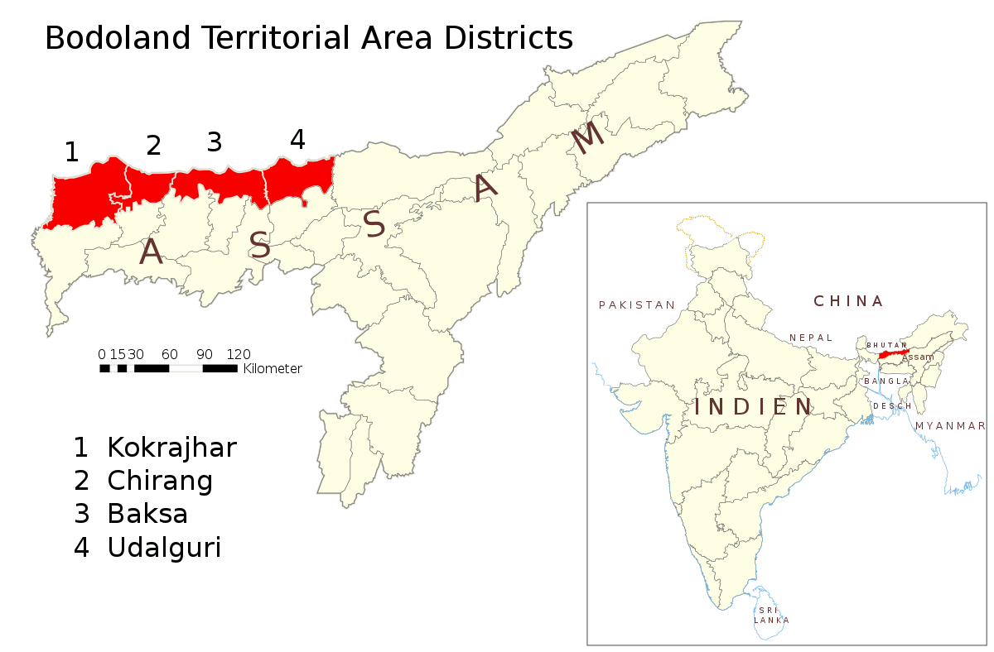
Figure 1 Bodoland Territorial Region of Assam. Source- political map of India

  - Different variet.ies of Garcinia species found in Assam.
There are total of 18 varieties of Garcinia species found in Assam according to literature reported till date. However, very few species has been recorded from Bodoland Territorial Region. The most common variety found in this region is G. pedunculata and G. xanthochymus and G. assamica.

1.2.1. Garcinia assamica
A novel species named G. assamica, closely related to G. nigrolineata, was discovered in the forests adjacent to Manas National Park in Assam, India. It exhibits a flowering period from February to May, followed by fruiting starting in August. Despite its therapeutic potential, this species is relatively scarce and known to only a handful of individuals. The tree's stature reaches 15 met.ers, with horizontal branches and distinctive turbinate-shaped fruits that release greenish-yellow latex. As the fruit matures, its color shifts from green to orange-yellow. Locals in Assam employ the ripe fruit for pickle making. (Sarma et. al., 2016)

1.2.2. Garcinia pedunculata
Known as "Taika" in Bodo and "Bor thekera" in Assamese and, G. pedunculata is a large evergreen tree primarily distributed in the North Eastern region of India. This species thrives in both wild conditions within forests and as a domesticated plant in home gardens. Its round, fleshy edible aril-containing fruit, measuring 8-12 cm in diamet.er, transitions from green to yellow upon ripening. The raw fruit serves in pickle making, while the ripe mature fruit is consumed raw or cooked, often paired with fish. Furthermore, dried preserved fruits contribute to flavorful drinks. G. pedunculata holds value in addressing dysentery, jaundice, and more. It is recognized for its rich phenolic, flavonoid, and ascorbic acid content, contributing to its potent antioxidant properties. (Mudoi et. al., 2012; Gogoi et. al., 2016)

1.2.3. Garcinia xanthochymus
Referred to as "Tempwr" in Bodo and "Tepor-tenga" in Assamese and, G. xanthochymus stands as a small to medium-sized evergreen tree prevalent in Assam's forest areas and, on occasion, household gardens. The fruiting season extends from April to August, yielding golden-yellow fruits measuring 4-6 cm in diamet.er when ripe. These fruits, with their sour taste, are consumed raw, cooked with other ingredients, or transformed into chutney using mustard oil, salt, and chili. The tree's yellow latex finds application as a lubricant in weaving, while its hue serves as a natural dye for fabric. G. xanthochymus carries a reputation as a folk medicine for various ailments such as bilious conditions, diarrhea, and dysentery. The fruit juice exhibits properties like being an anti-scorbutic, anthelmintic, and cardiotonic, often utilized to treat piles, dysentery, and tumors. (Gogoi et. al., 2016; Baruah et. al., 2012)

1.2.4. Garcinia morella
Commonly known as "Kuji-thekera" in Assamese, G. morella is a small evergreen tree reaching heights of up to 40 feet.. It thrives in forested areas under natural conditions. The ripe fruit, about 2-3 cm in diamet.er and yellow in color, blossoms from April to September. The raw fruits become key ingredients in pickles, while sun-dried fruits take on a role as a spice in various dishes. Indigenous to the Northeast region of India, G. morella has garnered attention as an effective remedy for conditions such as diarrhea, dyspepsia, and dysentery. Research reveals its potential as a lipid-lowering agent due to its ability to reduce cholesterol, triglycerides, and LDL cholesterol levels. (Pator et. al., 2011; Gogoi et. al., 2016; Begum et. al., 2014; Baruah et. al., 2012)

1.2.5. Garcinia lanceaefolia
Referred to as "Rupohi Thekera" in Assamese, G. lanceaefolia is a tropical evergreen plant recognized for its thick-skinned small fruit juicy fruit which is pulpy and and acidic in taste. Found in domesticated versions in home gardens, its tender leaves are consumed as veget.ables by certain tribes in the Cachar District of Assam. Moreover, the trunk and leaf of the fruit plant find use as fodder and timber, respectively. The pericarps of the fruits are consumed raw or pickled. Slices of the dried pericarps serve as acidifying agents in traditional curries and as remedies for stomach ailments. This versatile plant is employed to alleviate headaches, stomach issues, diabet.es, dysentery, and diarrhea. Its antibacterial properties are exhibited through crude fruit extracts. (Gogoi et. al., 2016; Dutta et. al., 2017; Baruah et. al., 2012)

1.2.6. Garcinia cowa
Referred to as "Kuji thekera" in Assamese, G. cowa is a middle-sized evergreen tree that reaches up to 12 met.ers in height, characterized by an oval crown. Its mature fruits, ovoid-globose and opaque red, encompass 3-5 seeds within a pulpy aril. Fruiting occurs from March to July in the North-Eastern region of India. G. cowa's ripe fruit serves as raw sustenance, while the raw version contributes to the making of curries and pickles. The dry sliced pericarp of its fruits is preserved as a remedy for ailments like dysentery, constipation, and high blood pressure. The stem and latex are utilized for construction purposes. The bark and latex of G. cowa contain prenylated xanthones with potential anti-malarial and antimicrobial properties. (Gogoi et. al., 2016; Dutta et. al., 2017)

1.2.7. Garcinia acuminata
G. acuminata, commonly referred to as Kuji thekera in Assamese, is a diminutive tree. Its fruits, reaching 15 cm in diamet.er, take on a globose or slightly elongated shape. These fruits are positioned atop persistent sepals and crowned by a somewhat imperfectly 4-lobed stigma. As they mature, the fruits transition to a yellow hue. The tree blooms from December to February, initiating fruiting from February to June. Local inhabitants utilize the aril to create juice, while dried preserved fruits are employed to address blood dysentery. While the gum resin's utility as a dye and medicine is acknowledged, its specific use in Assam remains unknown. Extracted from the seed, a fatty oil finds application in illumination and can function as a substitute for ghee. (Maheswari, 1964)

1.2.8. Garcinia gummi-gutta
G. gummi-gutta, recognized locally as Kau thekera, manifests as a small tree. Its fruits, comparable in size to a plum, undergo a transition to a yellow shade when reaching ripeness. Within these fruits, a succulent aril resides. The period of fruiting spans from June to August. This species was documented in the Sonitpur district of Assam. Inhabitants of the region harness the ripe fruit's potential to craft refreshing beverages. Additionally, raw fruits serve a dual purpose—employed for pickle preparation and as a seasoning for curries. (Kar et. al., 2008)

1.2.9. Garcinia spicata
G. spicata Hook.f., recognized locally as Kau thekera, stands as a medium-sized tree. Its fruits, presenting a globose to oval shape, are characterized by smooth, deep green exteriors that transition to a yellow hue upon ripening. With 2 – 4 seeds within, the aril encapsulates a juicy interior. This species serves dual culinary roles—contributing to pickle creation and featuring in the preparation of traditional curries. Its natural habitat primarily comprises forested areas in the wild. (Dutta et. al., 2017) This variet.y was observed within the Sonitpur district of Assam and enters its fruiting phase from May to July. (Kar et. al., 2008)

1.2.10. Garcinia sopsopia
G. sopsopia (Buch.-Ham.) Mabb., referred to locally as Mamoi thekera, stands as an expansive evergreen tree. Its fruits, akin to the size of apples, exhibit a globular or slightly elongated form. These fruits, when reaching full ripeness, take on a red hue and bear a distinctive hemispherical granular stigma, with 3 - 5 seeds ensconced within a pulpy aril. The period of fruiting spans from November to February. The arils boast a sweet. taste and find purpose in the creation of invigorating beverages. Typically thriving in forested regions in their natural state, G. sopsopia is found amidst the wild environment. (Dutta et. al., 2017)

1.2.11. Garcinia dulcis
G. dulcis (Roxb.) Kurz, locally referred to as Tepor tenga in Assamese, finds its habitat predominantly in forested regions, thriving under the wild natural conditions. (Dutta et. al., 2017) The tree attains a height of up to 20 met.ers, with a diamet.er of 40 centimet.ers. Its trunk is characterized by its straightness, fluted apex, and a smooth bark in shades of blackish-brown. The wood carries a yellowish-white hue, accentuated by occasional red marks that emit a scanty cream-colored latex, which subsequently turns yellow. The fruit of G. dulcis, taking on a globular form, boasts a smooth and green appearance, measuring bet.ween 3.4 to 5.3 cm in width and 3.2 to 5.1 cm in height. The fruit presents a straight or oblique pointed apex base and transitions to a vibrant yellow color upon ripening, revealing its yellow pulp. The blooming of flowers and the onset. of fruiting for this species occur from April to November. Its characteristics closely resemble those of Garcinia spicata (Wight & Arnott) Hooker f. The fruit is rich in citric acid and proves suitable for crafting jams and preserves. Additionally, the bark serves as a material for dyeing mats. Similar to G. spicata (Wight & Arnott) Hooker f., G. dulcis (Roxb.) Kurz showcases comparable attributes. (Begum et. al., 2013)

1.2.12. Garcinia nervosa
G. nervosa, commonly recognized as Pear Mangosteen or Deofal in Bengali, stands as an evergreen tree reaching heights of 6 to 12 met.ers. The ripe fruits of this tree exhibit an ovoid or obovoid shape, adorned in yellow hues with red blotches. Measuring 5.1 cm in length and 38 cm in diamet.er, these fruits house approximately 2 elongated ovoid seeds. The tree's flowering and fruiting cycles grace the period from March to October. This species finds its local habitat within the Barak Valley region of Assam. The pulp of the fruit, while edible, carries a sour taste. Ripe fruits of G. nervosa are revered for their role in treating dysentery, while the leaves serve as a laxative for cattle. In terms of genet.ic kinship, the species shares a close relationship with G. dulcis and G. xanthochymus. (Dutta et. al., 2014)

1.2.13. Garcinia paniculata
G. paniculata Roxb. Commonly recognized as “Sochopa tenga” in Assamese, takes the form of a dioecious small evergreen tree that attains heights of 12 to 18 met.ers. Its profile is marked by numerous ascending branches. The wood of this tree boasts a moderate hardness and is tinged in brown hues. The fruit, spherical and yellow, resembles the size of a large cherry. Sporting a succulent nature, it usually contains 3 to 5 seeds ensconced in a pulpy aril, exhibiting a characteristic 4-locular structure. The flowering process kicks off in early November, and the tree's fruit-bearing journey extends through July. Notably, the aril of the fruit mirrors the appeal of mangosteen's, as its intense flavor is savored with relish. With its commendable attributes, the plant has been deemed a suitable rootstock for mangosteen cultivation. Beyond its fruit, the ripe fruits are consumed, while the leaves find utility in treating roundworm infestations. The moderately hard wood holds value in diverse applications, from constructing houses to providing firewood. (Maheswari 1964; Baruah et. al., 2012)

1.2.14. Garcinia kydia
G. kydia Roxb., also recognized by the name Kuji thekera in Assamese, emerges as a dioecious tree reaching heights of 7.5 to 13 met.ers. The wood of this tree starts off white and transitions to a yellowish hue. It is characterized by its heavyweight, coarsely fibrous nature, and notable perishability. The species thrives in forest areas and occasionally finds its place in household backyards, serving as a domesticated plant. (Kar et. al., 2008) The fruit, with a diamet.er ranging from 2.5 to 4 cm, presents a dark purple-brown exterior that is both smooth and globular. Within, the aril displays a soft, acidic, and juicy disposition. The blooming period for this tree spans from December to May, with fruiting commencing from May until August. It holds local distribution within the tropical forests of Assam, having first been discovered by Col. Kyd in the Andaman Islands and subsequently introduced to the Indian Botanic Garden in Calcutta in 1794. (Maheswari 1964) The pericarps of the fruit serve as effective acidifying agents for traditional curries. The fleshy outer covering of the ripe fruit's seeds is consumed raw. Dry sliced pericarp segments are preserved for their medicinal properties, utilized as remedies against dysentery and constipation. The juice extracted from these dry slices is consumed as sherbet. due to its sour flavor. Moreover, the extract from these dried fruits is employed to address high blood pressure and stomach disorders in both humans and domestic animals. The tree's yield includes an inferior form of gamboge. The acidic fruit stands as a remedy for dysentery and is even applied externally in obstinate cases of headache. Additionally, the stem finds use as a construction pole for traditional houses and in crafting "dhaki" – the traditional rice husking implements – as well as for fuel wood. (Dutta et. al., 2017)

1.2.15. Garcinia atroviridies
G. atroviridies Griff. Ex. T. Anderson, noted under the moniker of “Sochopa tenga” in Assamese, stands as a medium-sized tree boasting graceful attributes and robust branches. The fruit, with a diamet.er ranging from 8 to 10 cm, adopts a globular form, displaying a yellowish-green hue accompanied by a firm texture. This fruit houses translucent pulp enveloping the seeds, rendering it fit for consumption. Its distribution spans the entiret.y of the north-eastern districts of Assam. The fruit's role extends to serving as a fixative in conjunction with alum during the dyeing of silk. A concoction derived from the leaves and roots of the tree is employed in treating earaches. Notably, the sour rind of the fruit finds its place in various culinary curries. (Maheswari 1964)

1.2.16. Garcinia annomala
G. annomala Planch. & Triana, colloquially recognized as Thechu by the Garo people, takes the form of a diminutive evergreen tree adorned with sturdy branches. The fruit it produces assumes an ellipsoid shape, measuring approximately 42 x 35 mm, and exhibits a smooth and olivaceous exterior. Containing 1 to 2 seeds, this fruit follows a flowering period spanning from November to May, and its fruiting phase extends until February. Widely distributed across the Northeast region, this tree finds its habitat in various locales. (Maheswari 1964)

1.2.17. Garcinia keeniana
G. keenianais, a diminutive shrub characterized by moderately dense branches, boasts fleshy, spherical fruits. The cycle of flowering and fruiting for this species spans from April to September. The wood of this shrub is esteemed for its qualities as sturdy timber. However, it is noteworthy that this particular species hasn't been documented in recent literature, indicating a gap in current knowledge about its occurrence. (Kanjilal 1934)

1.2.18. Garcinia sibeswarii (Clusiaceae)
Shameer P.S. has unveiled a novel addition to the Garcinia genus - Garcinia sibeswarii, a previously unknown species from the Dulang Reserve Forest in Assam, North East India. While closely related to Garcinia celebica, this new species distinguishes itself through several characteristics, including a 4-celled ovary, an intact peltate stigma of reddish hue, and seeds enveloped in a fibrous aril. The discovery site lies in the Lakhimpur District, specifically within the Dulang Reserve Forest, situated at coordinates 270 25'17.80'' N, 94010' 59.40'' E, at an elevation of 110 met.ers. Garcinia sibeswarii presents as a dioecious, evergreen tree, reaching a medium height of up to 10 met.ers. The bark takes on a greenish-brown tint and secret.es milky exudate. The branches spread horizontally, and the branchlet.s exhibit a slightly angled or teret.e form, being devoid of hair. Remarkably, the aril of the fruit, while fibrous and somewhat tart to bitter in flavor, is rarely consumed by the local populace. Instead, it finds favor among local primate species such as the Rhesus macaque (Macaca mulatta) and the rare Assamese macaque (Macaca assamensis), both commonly found in the region. These primates relish the fruits upon maturation, and while the flesh is ingested, the seeds remain undigested. This leads to the natural propagation of the plant, facilitated primarily through the feces of these primate consumers. Referred to locally as 'Gela thekera,' the Assamese term 'Gela' meaning 'rotten' and 'thekera' being the vernacular designation for Garcinia, this name denotes that the fruit is generally avoided for human consumption. This unique ecological role suggests that Garcinia sibeswarii holds the potential to become a valuable candidate for initiatives aimed at enhancing the cultivated properties of various Garcinia species. (Shameer P.S. et..al. 2021)

Table 1. Garcinia spp. found in Assam according to the literature reported so far.
Sl.no | Variet.ies | Local name | Traditional uses | Areas of study conducted | References
 | Garcinia assamica | thekera | Pickle making | Manas National Park, Baksa | Sarma et..al., 2016
 | Garcinia pedunculata | Bor thekera | Pickle and curry making, also used as medicine to cure dysentery, jaundice. Tree is used as timber and fodder. | Kamrup Met.ro (M), Kamrup Rural (R), Nalbari, Barpet.a, Dhemaji and Lakhimpur, Upper Brahmaputra valley | 2017; Gogoi et.. al., 2012;  Sarma et.. al. 2015; Sarma et. al., 2016; Baruah et. al., 2012; Gogoi B et.. al., 2016; Dutta et.. al..
 | Garcinia xanthochymus | Tepor tenga | Helps in curing of diarrhoea, piles, dysentery and tumors. | Upper Brahmaputra valley. | Baruah et. al., 2012; Gogoi B et.. al., 2016.
 | Garcinia morella | Kuji thekera | Fruit pulp is dried and used to aid flatulence, indyspepsia, antiscorbutic, astringent, cooling, cardiotonic, emollient, antidiarrhoeic, antidysentric.. | Upper Brahmaputra valley | Sarma et..al. 2016; Baruah et. al., 2012; Begum et.. al., 2014.
 | Garcinia lanceaefolia | Rupohi thekera | Consumed as veget.able, used to cure diarrhoea and dysentery, | Upper Brahmaputra valley | Dutta et. al., 2017; Gogoi B et.. al. 2016; Baruah et. al., 2012
 | Garcinia cowa | Kuji thekera | Jam and pickle making, aids dysentery, nausea and vomiting. | Upper Brahmaputra valley | Baruah et. al., 2012; Gogoi B et.. al. 2016; Dutta et. al., 2017.
 | Garcinia acuminata | Kuji thekera | Arils are used to make refreshing summer drinks, helps to cure dysentery | Sonitpur district | Kar et.. al., 2008
 | Garcinia gummi-gutta | Kau thekera | Arils are used to make refreshing drinks, pickles and seasoning of curries | Sonitpur district | Kar et.. al., 2008
 | Garcinia spicata | Kau thekera | Arils are used to make refreshing summer drinks and pickle making. | Sonitpur district | Kar et.. al., 2008
 | Garcinia sopsopia | Mamoi thekera | Arils are used to make refreshing summer drinks | Sonitpur district | Kar et.. al., 2008
 | Garcinia dulcis | Tepor tenga | Preparing of jams and latex from bark is used in dyeing mats. | Dibrugarh district, Upper Brahmaputra valley. | Begum et.. al., 2013
 | Garcinia nervosa | Pear Mangosteen, Deofal (Bengali) | The leaves are used as laxative for cattle, Ripe fruits are used to cure dysentery. | Cachar and Karimganj district, Barak valley. | Dutta et.. al., 2014
 | Garcinia paniculata | Sochopa tenga | The aril of the fruit, llke that of mangosteen, is highly flavoured and is eatem with relish. The plant has been recommended as a suitable rootstock for mangosteen. | Upper Brahmaputra valley | Maheswari 1964; baruah et. al., 2012
 | Garciniakydia | Kuji Thekera | The tree yields an inferior gamboge. Aids dysentery, constipation, headache and high blood pressure. | Tropical forests of Assam, Upper Brahmaputra valley | Maheswari 1964
 | Garcinia atroviridis | thekera | Fruit is used as a fixative in combination with alum in the dyeing of silk. Leaves and roots are used in the treatment of ear aches. The sour fruit rind is used in curry making. | Upper Brahmaputra valley | Maheswari 1964
 | Garcinia anomala | Thechu by Garo | - | Northeast India | Maheswari 1964
 | Garcinia keeniana | - | - | Barak Valley of Assam | Borah et.. al. 2016; Choudhury et.. al. 2005.
 | Garcinia sibeswarii | Gela thekera | - | Dulang Reserve Forest, Lakhimpur district, Assam | Shameer P.S. et..al. 2021

Table 2. Garcinia spp. from Assam
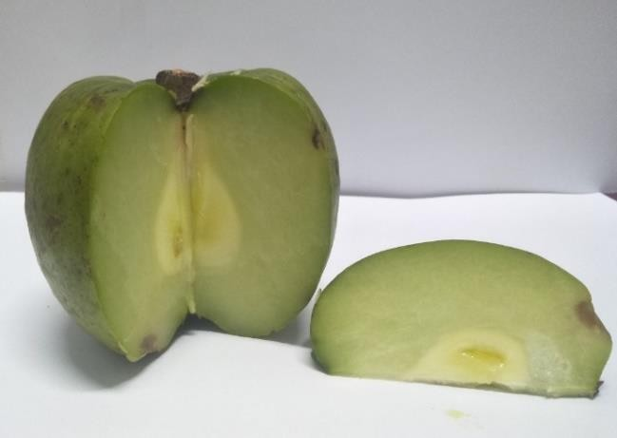 | A. Garcinia pedunculata collected from Chirang District. (Photographed by Jonali Brahma)
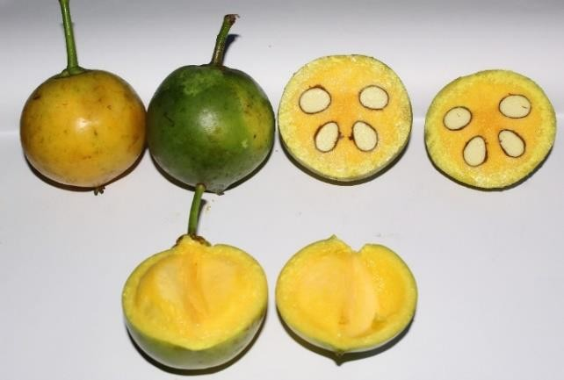 | B. Garcinia Xanthochymus Raw and ripe Fruit. Collected from Chirang District. (Photographed by Jonali Brahma)
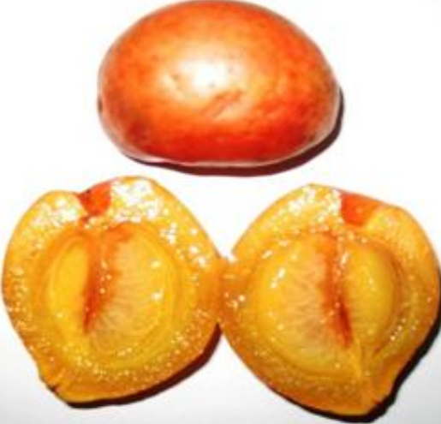 | C. Garcinia Morella. Gogoi et. al., IJPSR, 2012; Vol. 3(9): 3472-3475.
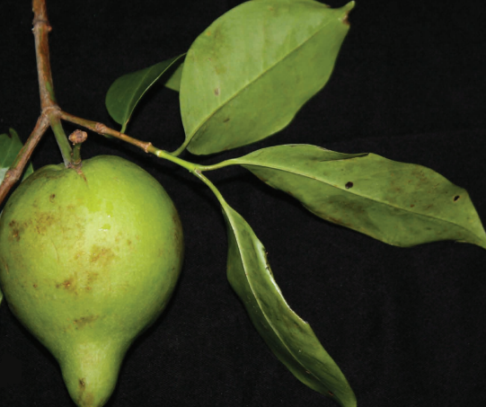 | D. Garcinia assamica. Sarma J. et..al. 2016
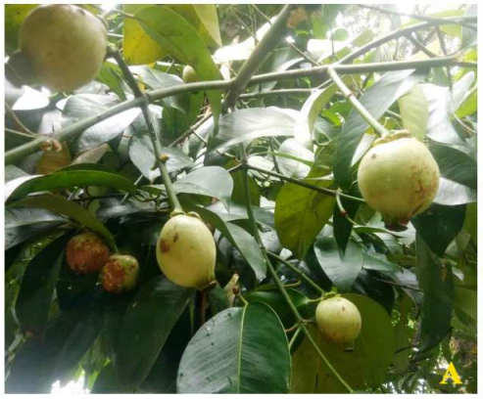 | E. Garcinia sibeswarii. Sharma P.S. et..al. 2021

- Neutraceutical Properties found in Garcinia species

2.1. General description of neutraceutical properties found in Garcinia species.
Numerous studies have highlighted the abundance of phytochemical properties in Garcinia spp., offering potential support for various lifestyle-related conditions such as obesity, hypertension, stomach disorders, and specific met.abolic syndromes.
Across the globe, a multitude of investigations have indicated that Garcinia spp. possesses a wealth of phytochemical and bioactive compounds, showcasing notable pharmacological attributes encompassing antioxidative, antimicrobial, anticancer, and cardiovascular protective properties. This substantial body of research underscores the promising prospect of Garcinia as a valuable reservoir for the development of innovative therapeutic agents.

Table 3. Pharmacological Values of Garcinia spp. found in Assam
Sl.no | Garcinia Species | Pharmacological values | References
1. | Garcinia morella | Lipid lowering agent | Pator et. al., 2011
2. | Garcinia pedunculata | High content of ascorbic acid | Gogoi et. al., 2016
3. | Garcinia cowa and Garcinia  pedunculata | Antibacterial activity | Negi et. al., 2008
4. | Garcinia pedunculata and Garcinia morella | High reducing power, free radical scavenging and antifungal activity, great  antioxidant potential | Sarma et. al., 2015
5. | Garcinia pedunculata | High phenolic, flavonoid and  ascorbic acid content. | Mudoi et. al., 2012
6. | Garcinia pedunculata | High Antioxidant | Gogoi et. al., 2012
7. | Garcinia lanceifolia | Antimicrobial activity | Bora NS et. al., 2014
8. | Garcinia xanthochymus | High content of phenol | Gogoi et.. al., 2016
9. | Garcinia lancifolia | Antimicrobial activity | Choudhury et.. al., 2012

2.1.1. Antioxidant activity
Mudoi et. al. (2012) elucidated in their research that G. pedunculata emerges as a notable natural antioxidant source, displaying markedly elevated antioxidant efficacy. This species showcases substantial concentrations of phenolic compounds, flavonoids, and ascorbic acid.
Likewise, Gogoi et. al. (2012) highlighted in their investigation the robust antioxidant potential of G. pedunculata, accompanied by comparatively lower phenolic content in G. pedunculata, G. Morella, and G. xanthochymus. Furthermore, Gogoi et. al. (2016) documented G. pedunculata's heightened ascorbic acid content and G. xanthochymus's elevated phenolic content, providing insight into their robust antioxidant activity.

2.1.2. Antimicrobial Properties
Sarma conducted a study demonstrating that the cold water extracts of G. morella and G. pedunculata and exhibited superior reducing power, free radical scavenging, and antifungal activity compared to hot water extracts. Their findings underscored the potent antioxidant potential of Garcinia extracts, highlighting their significance as therapeutic agents in mitigating aging-related oxidative stress and degenerative diseases. Sarma et. al. (2015)
In a similar vein, Negi et. al. (2008) explored the antibacterial effects of extracts from the fruit rinds of G. cowa and G. pedunculata against foodborne pathogens and spoilage bacteria. Their research revealed that Garcinia extracts displayed inhibitory effects on Gram-positive bacteria, indicating their potential as food biopreservatives. Choudhury et. al. (2012) reported in their study that the fruit extract of G. lancifolia exhibited strong effectiveness against Gram-positive bacteria in comparison to Gram-negative bacteria. The antimicrobial activity was attributed to the presence of cardiac glycosides, alkaloids, terpenoids, tannins, , saponins, flavonoids, and steroids in the et.hanolic extract. Bora NS et. al. (2014) uncovered significant antibacterial activity in the met.hanolic extract of G. lanceifolia bark against various bacterial strains. The extract showed pronounced effectiveness against Gram-positive bacteria in a dose-dependent manner. The authors recommended further research to unveil new antibacterial therapeutic agents.

2.1.3. Pharmacological Properties and Health Benefits

2.1.3.1. Antiaging Activity
The natural aging process leads to skin wrinkles and sagging due to decreased skin elasticity catalyzed by elastase enzymes. The decline in hyaluronic acid levels contributes to dry and wrinkled skin (Baliga et. al., 2006). Garcinia pigments have been found to possess UV light-absorbing properties, suggesting their potential utility in skincare (Bhat JD et. al., 2005).

2.1.3.2. Anti-diabet.ic Activity
Global research has substantiated the anti-diabet.ic properties of Garcinia, which holds promise as a lipid-lowering agent. Pator et. al. (2011) reported that Garcinia morella fruit extract from Assam exhibits anti-obesity properties, reducing cholesterol, glycerides, and LDLc levels. Given the rising prevalence of obesity-related diabet.es and cardiovascular diseases, this finding is crucial. Garcinia's traditional use for weight management is supported by multiple studies revealing the presence of hydroxycitric acid (HCA) in the plant. HCA has been found to curb appet.ite, inhibit fat synthesis, and aid in weight loss (Jena B.S. 2005).
Hydroxycitric acid (HCA) is a key component in the weight management sector, found in products like Garcinia cambogia and Garcinia gummi-gutta. It has four isomeric forms given in figure 2: (-)-HCA, (+)-HCA, (+)-allo-HCA, and (-)-allo-HCA. Extensive laboratory testing on both humans and animals has not revealed any side effects, making it a natural and effective weight loss supplement (Lewis and Neelakantan, 1965).
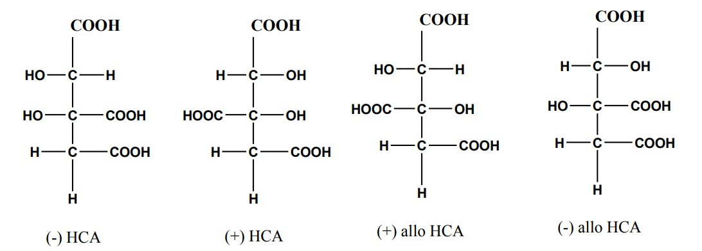
Figure 2. Isomeric form of Hydroxycitric acid.

2.1.3.3. Gastroprotective Potential
Peptic ulcers have become increasingly prevalent due to contemporary diet.ary habits and consumption of unhealthy foods. The surge in gastro-related ailments necessitates effective remedies. Garcinia species, containing various phytochemicals, has shown promise in countering peptic ulcers. Garcinol, a noteworthy phytochemical within Garcinia, has demonstrated its ability to mitigate indomet.hacin-induced gastric ulcerations in rats upon oral administration of Garcinol (40-200 mg/kg). Notably, the peak effects were observed at the 200 mg/kg dose, outperforming cet.raxate. The efficacy of garcinol's protection surpassed that of the positive control, hydrochloric acid (HCl) (Yamaguchi F et. al., 2000).

2.1.3.4. Anti-Cancer Potential
Studies have delved into the impact of phytochemicals such as Isogarcinol, Garcinol, and xanthochymol on the growth and proliferation of four human leukemia cell lines. The findings revealed that xanthochymol and isogarcinol exhibited more potent growth inhibitory effects than garcinol on these cell lines (Iwu M. et. al., 1982).

3. Recent trends and future perspective of Garcinia species
Garcinia species are already present in the market., but they require further exploration due to their significant potential. Currently, certain variet.ies of Garcinia, such as Garcinia cambogia, are consumed as fruits, and they are also utilized as weight management supplements. There are several areas where its application can be considered.
1. Culinary:
- Raw fruits are commonly used in pickles and various veget.able dishes.
- The ripe fruit has the potential for large-scale introduction to the market..
- The fruit serves as a flavorful seasoning agent.
- It can be used to prepare refreshing drinks and health beverages.
2. Wood:
- The bark of the tree can be utilized to extract valuable bioactive compounds.
- The wood is suitable for timber purposes.
- Latex from the tree is employed in weaving activities.
- The natural yellow color from the tree is utilized as a dye.
3. Antimicrobial:
- The extracts from Garcinia species can act as natural bio preservatives.
- The fruit can also be processed into face pack powders with antimicrobial properties.
4. Nutraceuticals:
- Certain compounds found in Garcinia species exhibit potential anti-hypertension effects.
- They also show promise in countering atherosclerosis and reducing lipid levels.
- Some components possess anti-cancer and anti-malarial properties.
5. Therapeutic:
- Garcinia-based remedies can be effective against conditions like diarrhea.
- The fruits and extracts are used to treat dysentery.
- Certain compounds can help alleviate nausea.
- Garcinia is known for its potential to provide relief from headaches.

4. Conclusion
Upon reviewing the existing literature, it becomes evident that there is a notable scarcity of scientific research conducted on the Garcinia species native to Assam. This gap underscores the need for comprehensive exploration into the plant's potential nutraceutical and therapeutic values. Unfortunately, the conservation status of the plant remains largely unknown. Literature documents indicate a decline in its availability within Assam due to factors like deforestation, limited local awareness, and its diminished role in cash crops. Noteworthy studies have focused on G. Morella, G. xanthochymus, G. pedunculata, G. cowa, and G. lanceaefolia. Given the rich pharmacological properties and bioactive constituents of Garcinia spp., there is an opportunity to standardize fruit processing met.hods for producing juices and other consumable products, thereby enhancing accessibility to consumers. Furthermore, the majority of research efforts have concentrated on Garcinia spp. from the Upper Brahmaputra Valley of Assam, with scant records from the Lower Brahmaputra Valley. Consequently, further research in this domain holds the potential for significant breakthroughs, particularly in the realm of novel antibacterial drugs or biopreservatives.

ACKNOWLEDGMENTS:
The authors are grateful to the Department of Food Engineering & Technology, Central Institute of Technology, Kokrajhar, Assam, India for the support.

REFERENCES

Anju, V., & Rameshkumar, K. B. (2016). Phytochemicals and bioactivities of Garcinia gummi-gutta (L.) N. Robson - A review. Diversity of Garcinia species in the Western Ghats: Phytochemical Perspective, p. 151. doi:10.25173/978-81-924674-5-0
Baliga, M. S., & Katiyar, S. K. (2006). Chemoprevention of photocarcinogenesis by selected diet.ary botanicals. Photochemical & Photobiological Sciences, 5, 243-253. doi:10.1039/B505312E
Baruah, S., & Borthakur, S. K. (2012). Studies on morphology and et.hnobotany of six species of Garcinia L. (Clusiaceae) found in the Brahmaputra Valley, Assam, India. Journal of Natural Product and Plant Resources, 2(3), 389-396. ISSN: 2231-3184
Begum, A., Barthakur, S. K., & Sarma, J. (2013). Garcinia dulcis (Roxburgh) Kurz [Clusiaceae]: a new distributional record for Assam, India. Pleione, 7, 545-548. ISSN: 0973-9467
Begum, A., Borthakur, S. K., & Sarma, J. (2014). Two new variet.ies of Garcinia morella Desrousseaux (Clusiaceae) from the Tinsukia district of Assam, India. Pleione, 8(2), 491-497. ISSN: 0973-9467
Bhat, J. D., Kamat, N., & Shirodkar, A. (2005). Compendium and proceedings of 2nd national seminar on GARCINIA (Garcinia indica Choisy). Goa University, March 4-5, 2005.
Bora, N. S., Kakoti, B. B., & Gogoi, B. (2014). Study on antibacterial activity of the bark of Garcinia lanceifolia Roxb. International Scholarly Research Notices, doi:10.1155/2014/784579
Borah, N., Rabha, D., & Athokpam, F. D. (2016). Tree species diversity in tropical forests of Barak valley in Assam, India. Tropical Plant Research, 3(1), 1-9. ISSN: 2349-1183
Chowdhury, S., Nath, A. K., Bora, A., Das, P. P., & Phukan, U. (2012). Assam’s flora. Assam (India): Science Technology and Environment Council, Guwahati, Assam.
Chowdhury, T., & Handique, P. J. (2012). Evaluation of antibacterial activity and phytochemical activity of Garcinia lancifolia roxb. International Journal of Pharmaceutical Sciences and Research, 3(6), 1663. ISSN: 0975-8232
Dutta, B., Borborah, K., Sarma, J., & Borthakur, S. K. (2014). Garcinia Nervosa MIQ. A new record from mainland India. Indian Journal of Plant Sciences, 4(3), 34-36. ISSN: 2319–3824
Dutta, D., Hazarika, P., & Hazarika, P. (2017). Distribution and diversity of Garcinia L. in Upper Brahmaputra Valley, Assam. International Journal of Current Research, 9, 10. ISSN: 0975-833X
Gogoi, B. J., Tsering, J., Tag, H., & Veer, V. (2012). Antioxidant potential of Garcinia species from Sonitpur district, Assam, North East India. International Journal of Pharmaceutical Sciences and Research, 3(9), 3472. ISSN: 0975-8232
Gogoi, B., Das, R. P., & Barua, U. (2016). Antioxidant activity of Garcinia species of Assam. International Journal of Agriculture Sciences, ISSN: 0975-3710 & E-ISSN: 0975-9107
Iwu, M., & Igboko, O. (1982). Flavonoids of Garcinia kola seeds. Journal of Natural Products (Lloydia), 45, 650-651.
Jena, B. S., Jayaprakasha, G. K., Singh, R. P., & Sakariah, K. K. (2002). Chemistry and biochemistry of (-)-hydroxycitric acid from Garcinia. Journal of Agricultural and Food Chemistry, 50, 10-22. doi:10.1021/jf0108772
Kanjilal, U. N., Kanjilal, P. C., & Das, A. (1934). Flora of Assam. Vol. I. Delhi: Periodical Expert Book Agency.
Kar, A., Borkakoti, S., & Borthakur, S. K. (2008). Extended distribution of the genus Garcinia L. Sonitpur district, Assam, India. Pleione, 2(2), 165-170.
Khamthong, N., & Hutadilok-Towatana, N. (2017). Phytoconstituents and biological activities of Garcinia dulcis (Clusiaceae): A Review. Natural Product Communications, 12(3), doi:10.1177/1934578X1701200337
Lewis, Y. S., & Neelakantan, S. (1965). (−)-Hydroxycitric acid - the principal acid in the fruits of Garcinia cambogia Desr. Phytochemistry, 4, 619-625.
Lewis, Y. S., Neelakantan, S., & Anjanamurthy, C. (1964). Acids in Garcinia cambogia. Current Science, 33(3), 82-83.
Maheshwari, J. K. (1964). Taxonomic Studies on Indian Guttiferae III. the Genus Garcinia Linn. Nelumbo, 6(2-4), 107-135.
Mudoi, T., Deka, D. C., & Devi, R. (2012). In vitro antioxidant activity of Garcinia pedunculata, an indigenous fruit of North Eastern (NE) region of India. International Journal of PharmTech Research, 4(1), 334-342. ISSN: 0974-4304
Negi, P. S., Jayaprakash, G. K., & Jena, B. S. (2008). Antibacterial activity of the extracts from the rinds of Garcinia cowa and Garcina pedunculata against food borne pathogens and spoilage bacteria. Food Science and Technology, 41(10), 1857-1861. doi:10.1016/j.lwt.2008.02.009
Nimanthika, W. J., & Kaththriarachchi, H. S. (2010). Systematics of genus Garcinia L. (Clusiaceae) in Sri Lanka. New insights from veget.ative morphology. Journal of National Science Foundation, 38, 29-44. doi:10.4038/jnsfsr.v38i1.1723
Rasha, H. M., Salha, A., Thanai, A., & Zahar, A. (2015). The Biological Importance of Garcinia Cambogia: A review. Journal of Nutritional Food Science, S5:004. doi:10.4172/2155-9600.S5-004
Sarma, J., Shameer, P. R., & Mohanan, N. N. (2016). A new species of Garcinia (Clusiaceae) from Assam, northeast India. Phytotaxa, 252, 73-76. doi:10.11646/phytotaxa.252.1.8
Sarma, R., & Devi, R. (2015). Et.hnopharmacological survey of Garcinia pedunculata Roxb. fruit in six different districts of Assam, India. International Journal of Pharmaceutical Science Invention, 4, 20-28. ISSN: 2319-6718
Sarma, R., Das, M., Mudoi, T., Sharma, K. K., Kotoky, J., & Devi, R. (2015). Evaluation of antioxidant and antifungal activities of polyphenol-rich extracts of dried pulp of Garcinia pedunculata roxb. and Garcinia morella gaertn. (Clusiaceae). Tropical Journal of Pharmaceutical Research, 15(1), 133-140. doi:10.4314/tjpr.v15i1.19
Sarma, R., Kumari, S., Elan, R., Deori, M., & Devi, R. (2016). Polyphenol-rich extract of Garcinia pedunculata fruit attenuates the hyperlipidemia induced by high-fat diet.. Frontiers in Pharmacology, 7, 294. doi:10.3389/fphar.2016.00294
Shameer, P. S., Sarma, J. A. T. I. N. D. R. A., Mohanan, N. N., & Begum, A. J. I. M. A. (2021). Garcinia sibeswarii (Clusiaceae), a new species from Assam, India. Phytotaxa, 507(2), 191-197.
Sweeney, P. W. (2008). Phylogeny and floral diversity in the genus Garcinia (Clusiaceae) and relatives. International Journal of Plant Sciences, 169, 1288-1303. doi:10.1086/591990
Taher, M., Hamidon, H., Susanti, D., & Zakaria, Z. A. (2017). Garcinia atroviridis – A review on phytochemicals and pharmacological properties. Marmara Pharmaceutical Journal, 21, 38-47. doi:10.12991/marupj.259879
Yamaguchi, F., Ariga, T., Yoshimura, Y., & Nakazawa, H. (2002). Antioxidative and antiglycation activity of garcinol from Garcinia indica fruit rind. Journal of Agricultural and Food Chemistry, 48, 180-185.

