Chapter 1: Multiband Frequency Reconfigurable Antennas for 5G and Satellite Communication
The ever-increasing demand for wireless communication technologies has driven the need for antennas with versatile characteristics that can adapt to different operating frequencies, polarizations, and radiation patterns. Frequency reconfigurable antennas have emerged as a promising solution, providing the capability to switch between resonating frequencies and enabling efficient operation in various frequency bands. This chapter introduces a novel design for a dual-band frequency reconfigurable antenna, offering high bandwidth to cover both 5G and satellite communication applications. The antenna's Reconfigurability is achieved through the use of PIN diodes, which facilitate frequency switching among different frequency bands. The proposed design features key advantages such as multiband operation, high gain, cost-effectiveness, lightweight construction, and extended coverage range.
1. Introduction
In the era of modern wireless communication, there is an escalating demand for antennas that can adapt to the changing needs of different frequency bands. Multiband frequency reconfigurable antennas have become a subject of intense research due to their ability to dynamically switch between multiple operating frequencies, thereby accommodating the requirements of diverse wireless communication standards. This chapter presents a frequency reconfigurable antenna design that supports both 5G and satellite communication frequency ranges.
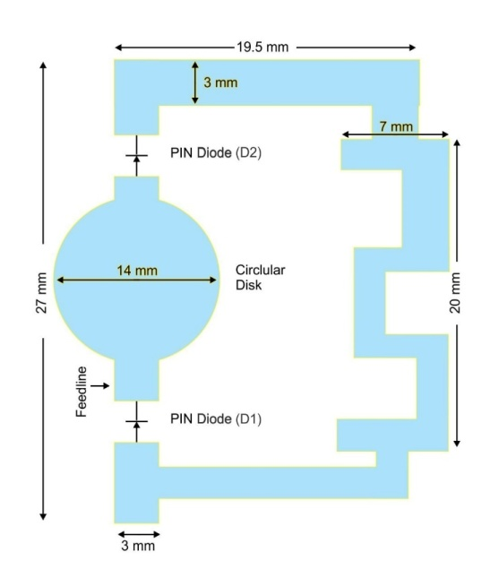
2. Frequency Reconfigurability Using PIN Diode
Frequency Reconfigurability in the proposed antenna is achieved through the utilization of PIN diodes. PIN diodes act as switching devices, enabling the antenna to change its resonating frequency by toggling between ON and OFF states. In the ON state, the PIN diode alters the antenna's slot elements, allowing it to operate at specific resonant frequencies, while in the OFF state; the antenna exhibits a different set of resonant frequencies.

3. Antenna Design and Characteristics
The proposed antenna is designed on a low-cost FR4 substrate, with dimensions of 28×32×1.625 mm³, making it compact and cost-effective. Its key features include:
3.1 Dual-Band Frequency Reconfigurability
The antenna achieves dual-band frequency Reconfigurability, making it suitable for operating in both 5G and satellite communication frequency bands. In the ON state of the PIN diode, the resonating frequencies with reference to -10 dB are achieved at 9.7 GHz (s11=-27 dB) and 13.5 GHz (s11=-27.7 dB). Additionally, in the switching state (OFF state) of the PIN diode, the antenna exhibits dual-band resonance at 24.5 GHz (s11=-14.7 dB) and 30 GHz (s11=-15.6 dB).
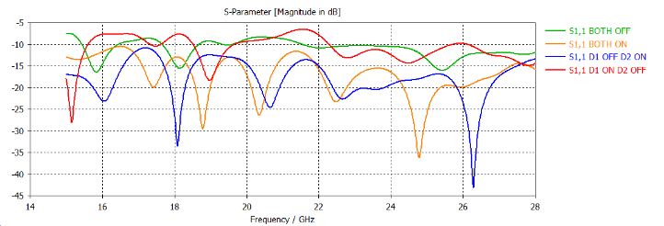

3.2 Ultra-Wide Band Range
The frequency Reconfigurability of the antenna allows it to cover an ultra-wide band range, further enhancing its versatility and compatibility with various communication standards.
3.3 Coverage Range
With its high gain and frequency agility, the proposed antenna achieves an extended coverage range, making it an excellent choice for next-generation wireless communication applications.
4. Application in 5G and Satellite Communication
The multiband frequency Reconfigurability of the antenna makes it ideal for 5G and satellite communication applications. The frequency range covered by the antenna aligns with the FR2 frequency band of 5G applications, while the frequency switching capability allows operation in the satellite frequency range. Thus, the antenna serves as a reliable solution for modern communication systems that require flexibility and adaptability.

5. Conclusion
This chapter presented a comprehensive study on multiband frequency reconfigurable antennas with a focus on a dual-band design catering to 5G and satellite communication. Utilizing PIN diodes as switching devices, the proposed antenna demonstrated remarkable frequency switching capability, achieving high gain and wide bandwidth. Its lightweight and cost-effective design further enhances its practicality for various wireless communication applications. The integration of this antenna into 5G and satellite systems showcases its potential to revolutionize modern communication networks, enabling seamless connectivity and robust performance.
Reference:
- M. Jenath and V. Nagarajan, “Review on frequency Reconfigurable antenna for Wireless Application,” IEEE International conference on communication and signal processing April 6-8, 2017, India.
- Liping Han, Caixia Wang, “Compact frequency Reconfigurable Slot Antenna for Wireless Application”, IEEE Antenna and Wireless Propagation Letters, Vol:15, P.N 1795, March 2016.
- N.O. Parchin. “Recent development of Reconfigurable antennas for current and future Wireless communication systems,” Electronics, vol. 8, P.N 1-17, 2019.
- L.H Trinh et al, “Reconfigurable antenna for future spectrum reallocation in 5G communication,” IEEE Antenna wireless propagation lett., vol 15, pp 1297-1300,2015

