Laser The Light in Dermatology, Advancements, and Limitations - A Review

Sejal Kodwani¹ , Rishabh Kandwal²
sajalkodwani@gmail.com rishabhsinghk@gmail.com
+91 8817861318 +91 9166132577
Spartan Health Sciences University Spartan Health Sciences University
PO BOX 324, Vieux Fort, St Lucia PO BOX 324, Vieux Fort, St Lucia
PO BOX 989, Santa Teresa, NM 88008, USA PO BOX 989, Santa Teresa, NM 88008, USA

^{ABSTRACT}
Laser technologies allow for correcting almost every skin condition. In dermatology, in recent years we have seen lasers evolving and their uses are also broadly expanding in a vast spectrum. It is used in many skin conditions from reversing the aging of the skin to treating skin conditions like pigmentation, scars, and vascular skin lesions, It is also seen for the use of permanent hair removal for unwanted hair in hirsutism and PCOD in girls, another quite common use is in tattoo removal. Since Laser is a noninvasive process it is seen that the use is very common and it's mostly for cosmetic use like skin rejuvenation to skin brightening and the demand is also markedly increasing. So far we have seen pretty low side effects and good silhouette yet we see many limitations along with advancements. In this review, the article brings out the principle, application, and advancements of Laser technology in dermatology along with an emphasis on their limitations.

^{I. INTRODUCTION}
Laser is Light amplification by stimulated emission of radiation. The effects of laser light on the skin can be understood by knowing the science behind laser light. A fundamental understanding of how lasers interact with tissue will enable the physician to choose the most appropriate laser for a given clinical situation[8]. Laser being a light therapy is a light having a single uniform wavelength hence it is monochromatic[3]. It is a source of electromagnetic radiation capable of cutting, coagulating, destroying, or re-presenting tissues[3,4]. The article is classified into three sections overall, firstly The principles of the Laser, and then the uses and applications in various skin conditions followed by the advancements and limitations.

II. THE SCIENCE BEHIND THE LASER LIGHT THERAPY - UNDERSTANDING THE PRINCIPLE
As discussed before Laser light is a monochromatic light with a single wavelength[3] picturized in Figure 1. The skin interacts with the laser light in different ways, a better understanding of this interaction is crucial. There are four ways skin interacts i.e., reflection, scattering, absorption, and transmission[5] shown in Figure 2.
When the Laser beam hits the skin some of it will be reflected whereas some of it will go deeper and then be reflected, Depending upon the molecule it hits in the skin tissue like melanin, fat, and collagen, not all of it will be reflected some of it will be absorbed which decides the appropriate result, it depends on the energy as well as the wavelength of the light according to which the absorption happens. The light that is not absorbed and gets reflected back will exit the skin.
We can emphasize here that depending on the wavelength and the target molecule wide array of applications can be possible. Figure 3 shows the lights with different wavelengths and their corresponding penetrance in skin layers. In the epidermis, there is minimal light scattering, whereas in the dermis there is significant scatter due to the high concentration of collagen fibers [3].

A. Photothermolysis - Thermal Effect seen in Laser
A simple, predictive model in which selective damage to cutaneous microvessels and to melanosomes within melanocytes is done by R R. Anderson, J A Parrish[10] along with other models like Non-invasive laser microsurgery, which selectively damages populations of labeled mouse neurons by Madison RD, Macklis JD, Frosch MP[11] elucidate the thermal effects of laser. In laser tissue interaction, thermal coagulation causes cell necrosis, homeostasis, welding, ceiling of nerve endings, and gross alteration of the extracellular matrix[5]. This is because the laser converts into heat and this phenomenon is used to target skin pigments such as pigmented cells, blood vessels, and tattoo particles.
For a better insight, we should have a perceptive understanding of skin tissue chromophores. Chromophore is a material, present either endogenous in the tissues or exogenous i.e. brought from outside, which absorbs particular wavelengths depending on its absorption coefficient[12]. The three main chromophores (hemoglobin, water, and melanin) in human skin all have broad absorption peaks of light energy, allowing them to be targeted by a range as well as a specific wavelength of light[13]. When these chromophores absorb the light wavelength it causes the cutaneous target to heat and cause sectional and desirable damage. There are many Lasers used in dermatology with an appropriate wavelength targeting a specific tissue chromophore which gives a desired clinical outcome which is discussed in the application of laser in a wide array of skin conditions.

^{III. THE LASER LIGHT USES}
^{A. Pigmented lesions}
Most of the pigmented lesion involves melanin production seen in melanoma, Freckles, Lentigines Melasma, seborrhoeic keratoses, skin tags, moles, café au lait macules, etc. These pigmentary lesions can be corrected by targeting the pigment with the appropriate wavelength of light. The most common lasers used to target pigment are ruby, KTP, and Cooper vapor. It is noted that wavelengths in the range of 630 to 1100nm account for both a preferential absorption of melanin over hemoglobin as well as an effective dermal penetration depth[13]. The study by G. A. Moreno Arias J Ferrando evaluated the clinical effects on melanocytes after treatment with an intense pulsed light source[14]. Superficial and deep melanocytic lesions were treated by an intense pulsed light source with the following parameters: filters of 590, 615, and 755 nm, Two treatment sessions were applied to superficial lesions, while deep ones received four with the results it was concluded that Intense pulsed light is an effective treatment for superficial melanocytic lesions; however, those with a deep component improve only if repetitive treatment sessions are applied.
The only effective way of tattoo ink removal is the guided selection of light therapy with the appropriate wavelength specified in the study done by M Haedersdal, N Bech-Thomsen, H C Wulf [15]. The background and design of the study was a fundamental idea of laser treatment of tattoos is that the wavelength must be well absorbed by the tattoo color. In this study, absorption by different tattoo colors was therefore measured in vivo by skin reflectance to establish optimal laser wavelengths for different tattoo colors.
^{B. Vascular lesion}
Three major categories of vascular lesions: Hemangiomas, Vascular Malformations, and Pyogenic Granulomas[16]. Mostly with vascular malformation, we see middle-aged females with quite concerning veins in their legs because of normal aging causing wear and tear of valves. The regulation of backflow is lost which causes unwanted bulging veins. Noninvasive treatments most commonly seen are excision, and cryotherapy with a lot of complications. The IPLS is a safe and effective modality to treat leg veins ranging in size from 0.1 to 3 mm in diameter seen in the study by M. P. Goldman, and S. Eckhouse[17]. Vessel necrosis occurs from an intense pulsed light that penetrates through the skin in one hundred fifty-nine patients with 369 lesions in this multicenter trial[17].
The Pulsed Dye Laser treatment is yet there to put emphasis on, it has been successful in treating many vascular skin lesions. They use the same principle of converting light into heat and are called “pulsed-dye” because they use a solution with an organic dye to create the laser effect. They have been seen as effective for a variety of skin conditions, including rosacea, facial redness, port wine stains, hemangiomas, hypertrophic scars, keloids, and telangiectasis[18]. 10 children with capillary hemangiomas treated with the flashlamp-pumped pulsed dye laser demonstrated some diminution in the size and color of their hemangiomas after the treatments, and there were no ill effects, such as ulceration, hemorrhage, infection, or scarring in the study done by R Ashinoff, R G Geronemus[19].

C. IPL devices - The Most Customary Use in Hair Removal and Skin Rejuvenation
The growing cosmetic industry has made everyone at ease with the use of FDA-approved IPL devices as domestic appliances with the comfort of in-home use. It has drawn the attention of many and use has been markedly increasing for the removal of unwanted body hair to correcting wrinkles, and spots. A clinical trial has shown no serious adverse events and confirmed the safety and efficacy of this device for hair removal at home, In the trial overall hair reduction was 78 percent at the one-month follow-up and 72 percent at the three-month follow-up [20]. It also has been noted that IPL can be used in dark skin types giving us favorable outcomes in all skin types.

IV. Limitations and Indications Of The Laser Light
Although we have seen many uses and advancements in Laser therapy in recent years, yet there are quite limitations as well as indications one has to focus on. In broad terms, we do see burns, blisters, itching, rubor, and color which are temporarily seen, on the other scaring can be a long-term effect seen with Laser therapy
A. Anti-inflammatory drugs affecting laser therapy.
A proper evaluation of patient profile is a must because many drugs including amiodarone, minocycline, warfarin, isotretinoin, aspirin, niacin, and vitamin E cause delayed healing, bleeding, scarring, increased bruising, hyperpigmentation, and localized chrysiasis after laser therapy[21],[22].

B. Other miscellaneous effects of laser therapy
We see quite a few metabolic effects and other epidermal skin reactions with Laser therapy which are postulated precisely in the study, Evaluation of Laser Effects on the Human Body After Laser Therapy[22].
Along with that, proper use of the laser is significant since from hospitals it has become available to clinics, and private enterprises, where the safety is uncertain, the skills of the person performing the laser treatment, and the consultation are very crucial. It has been noted that many clinicians and nurses who choose to work with lasers, without a solid foundation in this science, are unable to perform risk assessment on a daily operational basis[23]. For risk management, there are many control measures established i.e., engineering, procedural, and administrative controls [23] which have to be taken care of.

^{CONCLUSION}
This review provides evidence-based insights into how lasers are effective, their application, and advancements in recent years with limitations and indications. It explores the diverse uses in skin conditions and the effect seen in them with light therapy. Overall it concludes, that good sets of protocols and a proper safety guide with the use of Lasers can promise a better delivery of clinical results along with a good safety profile and improved knowledge and management will contribute to better outcomes for individuals.
Light therapy has been a phenomenon in giving the best results so far with the proper skilled use by the operator and we may see new advancements along the way since it is a never-ending evolution we humans have to technologies.

^{III. FIGURES AND TABLES}

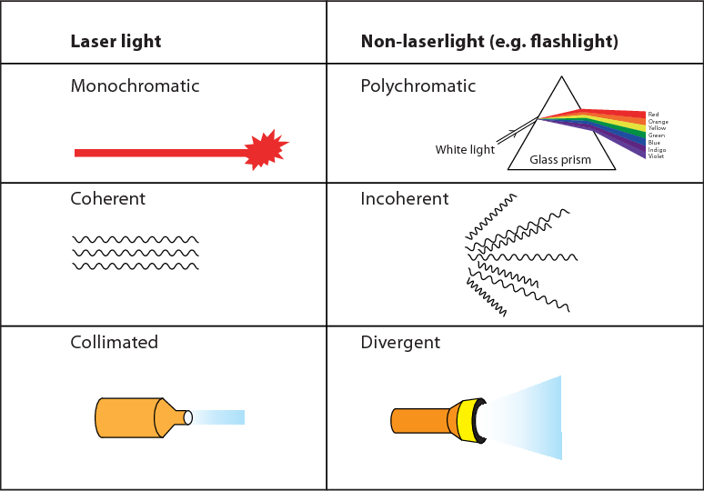
Figure 1: Laser the Monochromatic Light [6]
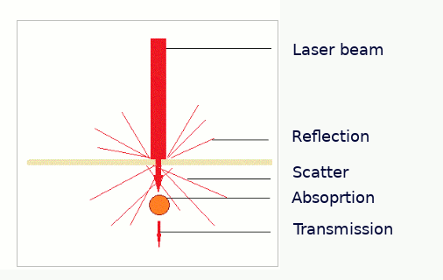
Figure 2: Skin and Laser Interaction[7]
Reflection: There is always a degree of reflection of laser light from the epidermis.
Absorption: Absorbed laser light may cause tissue coagulation or vaporization.
Scattering: Most light entering the tissue is scattered by a complete interaction
with water lipids and cellular membranes. Scattering is greater for short wavelengths
^{of visible light.}
Transmission: The laser light is transmitted through tissues to their target.[5]

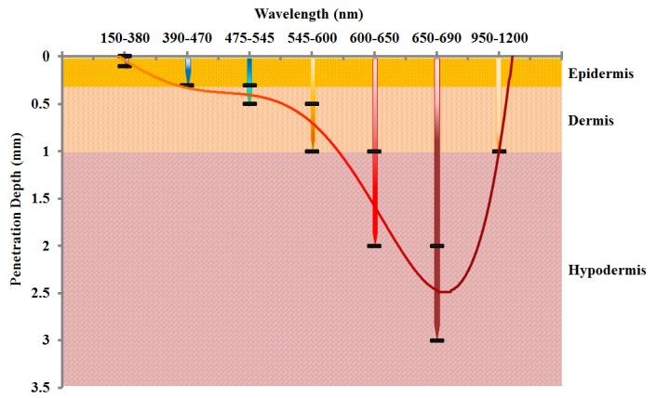
Figure 3: The lights with different wavelengths and their corresponding penetrance in skin layers.[9]

^{REFERENCES}

- Spartan Health Sciences University, St Lucia, West Indes
sajalkodwani@gmail.com
- Spartan Health Sciences University, St Lucia, West Indes
rishabhkandwal1@yahoo.com
- The role of lasers and intense pulsed light technology in dermatology
Zain Husain & Tina S Alster
https://doi.org/10.2147/CCID.S69106
- Laser Management and Safety in Dermatology
Yasmina El Arabi,Fouzia Hali, and Soumiya Chiheb
- Effect of Laser on Skin - A review
Shaunak Ghosh, Shila Ghosh
https://www.researchgate.net/publication/320841862_Effect_of_Laser_on_Skin-A_Review
- Semantic Scholar
https://www.google.co.in/url?sa=i&url=https%3A%2F%2Fwww.semanticscholar.org
- Laser beam Interaction with the skin
https://www.lasercollege.org/laser-beam-interaction-with-the-skin/
- Laser-Tissue Interaction
Lisa Carroll, Tatyana R. Humphreys
https://pubmed.ncbi.nlm.nih.gov/16427500/
- Evaluation of absorbed light dose in human skin tissue during Light Therapy by 630nm LED light
Yi-Han Chang, Kuo-Cheng Huang, author H. Tsai
https://www.semanticscholar.org/paper/Evaluation-of-absorbed-light-dose-in-human-skin-by-Chang-Huang/fc946510ccb0b616fa66ab7d7324197564492533
- Selective photothermolysis: precise microsurgery by selective absorption of pulsed radiation
R R Anderson, J A Parrish
https://pubmed.ncbi.nlm.nih.gov/6836297/
- Non-invasive laser microsurgery selectively damages populations of labeled mouse neurons: dependence on incident laser dose and absorption.
Madison RD, Macklis JD, Frosch MP.
https://pubmed.ncbi.nlm.nih.gov/3365549/

- Overview of lasers
Uddhav A. Patil and Lakshyajit D. Dhami
https://www.ncbi.nlm.nih.gov/pmc/articles/PMC2825126/#:~:text=Chromophore%3A%20Chromophore%20is%20a%20material,depending%20on%20its%20absorption%20coefficient.

- Current Trends in Intense Pulsed Light
David J. Goldberg
https://www.ncbi.nlm.nih.gov/pmc/articles/PMC3390232/#:~:text=The%20three%20main%20chromophores%20(hemoglobin,a%20specific%20wavelength%20of%20light.

- Intense pulsed light for melanocytic lesions
G A Moreno Arias 1, J Ferrando
https://pubmed.ncbi.nlm.nih.gov/11298715/

- Skin reflectance-guided laser selections for the treatment of decorative tattoos
M Haedersdal , N Bech-Thomsen, H C Wulf
https://pubmed.ncbi.nlm.nih.gov/8629843/

- SSM Health
https://www.ssmhealth.com

- Photothermal sclerosis of leg veins. ESC Medical Systems, LTD Photoderm VL Cooperative Study Group
M P Goldman 1, S Eckhouse
https://pubmed.ncbi.nlm.nih.gov/8624656/

- Stanford Health Care
https://stanfordhealthcare.org/medical-treatments/p/pulsed-dye-laser-treatment.html

- Capillary hemangiomas and treatment with the flashlamp-pumped pulsed dye laser
R Ashinoff 1, R G Geronemus
https://pubmed.ncbi.nlm.nih.gov/1990985/

- Low-Energy Intense Pulsed Light for Hair Removal at Home
Michael H. Gold, MD, Amy Foster, RN, and Julie A. Biron, BS
https://www.ncbi.nlm.nih.gov/pmc/articles/PMC2921762/#B4

- Laser induced wounds and scarring modified by antiinflammatory drugs: a murine model
M Haedersdal, T Poulsen, H C Wulf
https://pubmed.ncbi.nlm.nih.gov/8426528/

- Evaluation of Laser Effects on the Human Body After Laser Therapy
Ensieh Khalkhal, Mohammadreza Razzaghi, Mohammad Rostami-Nejad, Majid Rezaei-Tavirani, Hazhir Heidari Beigvand,and Mostafa Rezaei Tavirani

https://www.ncbi.nlm.nih.gov/pmc/articles/PMC7008747/#:~:text=When%20the%20tissue%20chromophores%2C%20often,and%20then%20causes%20localized%20damage.

- Laser safety: Risks, hazards, and control measures
Penny J. Smalley, RN, CMLSO
https://www.ncbi.nlm.nih.gov/pmc/articles/PMC3799025/

