Influence of Alchemy on Modern Chemistry

Prof. Mohini C. Khindkar
SNBP ACS & MS Morwadi, Pimpri .
ABSTRACT
This paper is intended to understand the “Influence of Alchemy on Modern Chemistry”. Alchemy performed a vital role in the development of modern chemistry, The refining of mineral deposit and the production of gunpowder are the work led by alchemists. The aim of alchemy was to find a mythical and magical substance called ‘Philosopher’s Stone” not a literal stone but wax , liquid or powder with magical power, which on heating with a base iron and copper metals would turn into gold. The present paper clarifies that, Alchemy contributed to a huge part to Modern Chemistry with alchemist heart, They had theories about the nature of metals that made them believe they could manipulate their structure, which similar to the building blocks we known as atoms today.

KEYWORDS: Alchemy, Alchemist, Philosopher’s stone, Gunpowder

Introduction:

ISSAC NEWTON would not have said he was a scientist, but he would have said he was an alchemist, or someone who practiced alchemy. In fact, it was not until 1833 that people began calling themselves “scientists”. The building block of modern chemistry is the ancient scienceknown as Alchemy. Around 300 BC Greek Philosophers come up with the concepts how to examine the properties of different substances and this ancient practice till the 18th century known as Alchemy.
In the 17th centurywith more prominence on logical thoughts and experimentation and by giving less importance to spiritualities and mysticism, this eventually leads to modern chemistry. Alchemist gave the foundation to the modern chemistry. Such as many chemical processes they were doing for example refining of mineral deposition, preparation of ink, dyes, Alchemist also organized the chemical substances to classify them logically which gave the foundation for the ‘Modern Periodic Table’.
.
Influence of Alchemy on Modern Chemistry

- Philosopher’s Stone
According to alchemist Philosopher’s stone is a magical, fictitious stone which converts any metal into Gold or silver. Its discovery was highest gadget for the alchemy. For the transmutation, transmutating agents are required that is Philosopher’s stone and it should have taken in the powder form of various colors.
Alchemist said that, Philosopher’s Stone was the magical substance which increases the life span of human beings and on the basis of that, today’s chemist prepare drugs and both the terms Philosopher’s stone and drugs prepared in pharmaceutical industries considered as elixir of life

- Alchemy and Modern Medicines

The process of mixing chemicals and substances together to create potions or drugs is alchemy or pharmaceutical development. Some modern medicines are mainly derived from some natural plant or root and then altered in some way by adding other agents to it and mixing them together to create a liquid, pill, or inhalant.
Alchemist invented antiplaque medicine which one has foul taste, milky tonic.Alchemist hasprepared some body balms, clear ear suspensions for the healing purposes.
Alchemy has inspired many scientistssuch as Isaac Newton, Robert Boyle who would go on to pioneer the experimental scientific method. In addition to these influences, alchemy has also had an effect on the modern development and the chemical process for making dyes.
Alchemy gives tremendous applications in medicine to the modern world, they provide information regarding how transformation takes place within a body, In addition they provide other options for healing.

- Alchemical Workplace and Nowadays chemistry Labs
Alchemy and Alchemist gave base and pillars to the Modern chemistry. In the excavation of alchemist laboratory of sixteenth century, Carrie out in 1980 and 1994 at lower Austria in that more than 1000 objects were found.To study natural world and parallel to prepare some drugs, medicines or substances for the welfare of mankind, Since the 19 ^{th} century laboratories are established.
Alchemy originated in ancient Egypt, Alchemist lab work mainly depend upon three primary components, that were cucurbits, alembics and lutes tools that were assembled into complex apparatuses. Alchemy’s experimental space functions as a pioneer to the modern Scientific labs.
Alchemy mainly focused on transmutation of the substances. For that they did sublimation, distillation, crystallization processes, they explored various tools to carried out such a experiments and modern well equipped labs grabs that tools and technologies for scientific means and methods.

4. Alchemy affected to the Alchemist body
Nowadays laboratories are more adhered by the safety measures In that, It is ensured that , the chemist will obey all the safety rules and such a safety equipments, facilities are provided.but when we gain knowledge about the history of alchemy will understand that , Alchemist worked in their laboratories without todays protective equipment. Some alchemist body was affected by the experimentation. The death of ancient science gives birth to the modern science.

- Alchemy Symbols
Alchemical symbols, originally devised as part of alchemy, were used to denote some elements and some compounds until the 18th century. Although notation like this was mostly standardized. Nowadays on the each chemical substances some information is provided mostly the information is in symbolic form, Alchemy planted the system of symbols for the substances.
Alchemy made use of symbolic languages, Most of the alchemical texts snakes are found which signs regeneration, and fire represents purification,Some frequent images of male and female body is also there which shows attraction between opposite things, nature of opposite things and polarity.
Alchemical and Astrological symbols nearly similar which shows planetary system.As we see our planetary system and atomic structure, we find the resemblance in between planetary orbitals and atomic orbitals. 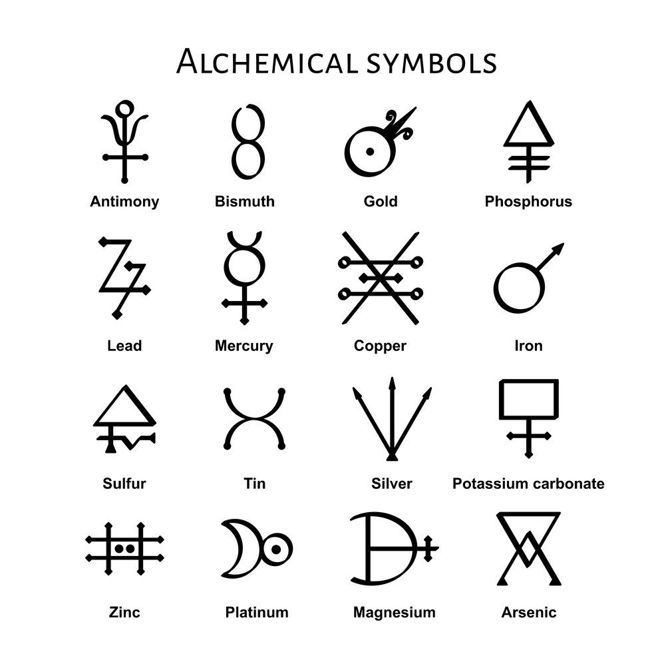

Conclusion

Alchemy’s influence will always remain on today’s society and modern world, It gives base to the nowadays laboratories, for the Pharmaceutical Industry Alchemy gives various predictions and theories Modern chemistry is adhered with such a alchemical theories which have become a legacy for chemistry, and in fact for all of us.
Alchemical symbols give the birth to the modern periodic table. Alchemy will always remain as a core part of the Modern Chemistry.

References

1. Szabadváry F (1966) History of analytical chemistry. Pergamon Press, Oxford

2. The Chymistry of Isaac Newton. www. chymistry. org. Accessed 8 May 2021

3. von Osten S (1998) Das Alchemistenlahoratorium von Oberstockstall.EinFundkomplex des 16.JahrhundertsausNiederösteireich.Universitätsverlag Wagner, Innsbruck

4. Soukup RW, Mayer H (1997) Alchemistisches Gold, ParacelsistischePharmaka: Laboratoriumstechnikim16. Jahrhundert.Böhlau, Wien

5. Spargo PE, Pounds CA (1979) Notes Rec R SocLond 34:11

6. Newman WR (2019) Newton the alchemist: science, enigma, and the quest for nature’s “secret fire.” Princeton University Press, Princeton

