Bioinformatics: Decoding Life's Digital Secrets
Ankur Dahayat
Research scholar, Forest Research Institute (Deemed to be) University Dehradun (FRI)
Corresponding mail: ankurdahayat1990@gmail.com
Mobile: +918770613988, +919424361641
Tropical Forest Research Institute, P.O. – RFRC, Jabalpur (Madhya Pradesh) – 482021, India

Introduction
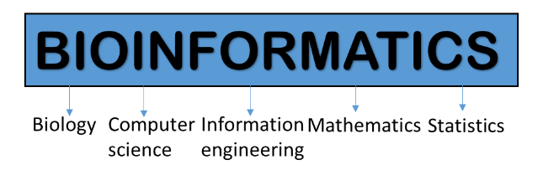
Bioinformatics stands as a groundbreaking convergence of 20th-century molecular biology and computer revolutions. This burgeoning discipline centers on harnessing the power of computer databases and advanced algorithms to dissect and interpret the intricate realms of proteins, genes, and an organism's complete DNA composition, commonly known as its genome. The formidable challenge in biology lies in comprehending the sheer magnitude of sequence and structural data emanating from genome-sequencing initiatives, proteomics, and other large-scale molecular biology endeavors. In response, bioinformatics equips researchers with a repertoire of sophisticated computer programs that unveil the fundamental mechanisms underpinning biological enigmas, ranging from macromolecular structure-function relationships to intricate biochemical pathways, disease mechanisms, and the marvels of evolution. Following the National Institutes of Health (NIH) definition, bioinformatics represents a realm of research and development that leverages computational tools and approaches to extend the frontiers of biological, medical, behavioral, and health data utilization. This encompasses the acquisition, storage, organization, analysis, and visualization of such data, revolutionizing the way we perceive life's complexities. Computational biology, close kin to bioinformatics, advances the application of data-analytical and theoretical methods, mathematical modeling, and computational simulations in studying the multifaceted systems of biology, behavior, and society.
While bioinformatics primarily focuses on molecular sequence analysis, genomics, and functional genomics form essential allies in this quest for biological understanding. Genomics, at its core, seeks to unravel and explore the entire DNA sequence of an organism, its genome, a repository of genetic information that encodes genes. These genes, in turn, have the potential to be transcribed into ribonucleic acid (RNA) transcripts, and in many instances, translated into the intricate machinery of proteins. Functional genomics, on the other hand, leverages genome-wide assays to illuminate the roles and functions of genes and proteins, thereby painting a holistic picture of biological complexity.
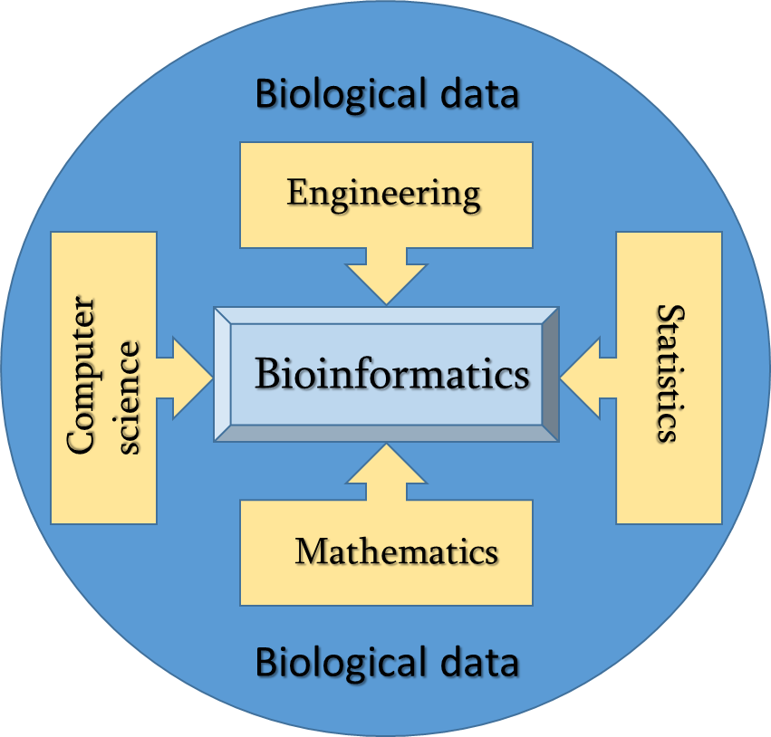
This chapter is to elucidate both the theoretical underpinnings and the practical applications of bioinformatics and genomics. Designed with the biology student in mind, our approach facilitates the seamless integration of computer programs and databases as indispensable tools in tackling biological enigmas related to proteins, genes, and genomes. As an integrative discipline, bioinformatics embarks on an ambitious journey to unravel profound questions in biology, such as the intricate interplay between structure and function, the enigmatic realms of development and disease, and the marvels of life's evolutionary tapestry. Moreover, for the computer scientist, here offer compelling insights into the motivations behind the development and utilization of algorithms and databases, empowering them to make transformative contributions at the interface of biology and technology.
Bioinformatics is an interdisciplinary field that applies computational and statistical techniques to analyze and interpret biological data. It involves the development and application of algorithms, software tools, and databases to store, retrieve, and analyze biological information. Bioinformatics plays a crucial role in managing and interpreting the vast amounts of data generated from high-throughput sequencing technologies, such as DNA sequencing, RNA sequencing, and proteomics.
Key areas of bioinformatics include:
Sequence Analysis: Analyzing DNA, RNA, and protein sequences to identify genes, regulatory elements, and functional motifs.
Structural Bioinformatics: Predicting and analyzing the three-dimensional structures of proteins and nucleic acids.
Comparative Genomics: Comparing genomes of different organisms to understand evolutionary relationships and identify conserved regions.
Functional Annotation: Assigning biological functions to genes and proteins based on experimental and computational evidence.
Systems Biology: Integrating and analyzing data from multiple levels (genomic, transcriptomic, proteomic) to understand complex biological systems.
History
The history of bioinformatics is a fascinating journey that intertwines advancements in molecular biology, computational science, and information technology. The origins of this field can be traced back to the 1960s when the biological sciences began to intersect with computer science. Here is a brief overview of the key milestones in the history of bioinformatics:
Early Beginnings (1960s-1970s): The term "Bioinformatics" was first coined in the early 1960s by the Russian scientist Anatoliy Ivanovich Youssef. During this period, the focus was on developing computational tools and algorithms to handle biological data, primarily DNA and protein sequences. Early pioneers laid the groundwork for the field by creating databases and tools for sequence analysis.
GenBank and the Birth of Sequence Databases (1980s): In 1982, GenBank, the first publicly accessible DNA sequence database, was established by the National Institutes of Health (NIH) in the United States. This marked a significant milestone in the field of bioinformatics, as it provided researchers with a centralized repository for storing and sharing DNA sequences.
Rapid Expansion of Sequence Databases (1990s): The 1990s witnessed a surge in genome sequencing projects, including the Human Genome Project, which aimed to decipher the entire human genome. This explosion of genomic data necessitated the development of more sophisticated bioinformatics tools for sequence alignment, assembly, and annotation.
Structural Bioinformatics (The late 1990s): As researchers gained access to 3D structures of biomolecules like proteins through techniques such as X-ray crystallography and NMR spectroscopy, the field of structural bioinformatics emerged. This branch of bioinformatics focused on predicting and analyzing protein structures and their functions.
Post-Genomic Era (Early 2000s): With the completion of several genome-sequencing projects, the focus of bioinformatics shifted from merely storing and analyzing sequences to understanding the functions of genes and their interactions in complex biological systems. Functional genomics and systems biology gained prominence during this time.
Big Data and Omics Integration (Mid-2000s): The advent of high-throughput technologies, such as next-generation sequencing and microarray-based gene expression profiling, led to the generation of vast amounts of biological data. Bioinformatics played a critical role in handling and analyzing these "omics" data, including genomics, transcriptomes, proteomics, and metabolomics.
Personalized Medicine and Bioinformatics (2010s): Bioinformatics became instrumental in the era of personalized medicine, where genetic information is used to tailor medical treatments to individual patients. Analyzing genetic variations and identifying disease-related genes became routine tasks in clinical settings.
AI and Machine Learning in Bioinformatics (Present): In recent years, the integration of artificial intelligence (AI) and machine learning has revolutionized bioinformatics. These technologies have enabled the development of sophisticated algorithms for tasks such as protein folding prediction, drug discovery, and disease classification.
As we continue to advance into the future, bioinformatics remains a dynamic and ever-evolving field, driven by ongoing advancements in technology and our relentless quest to unravel the complexities of life at the molecular level. It has become an essential pillar in modern biology, enabling breakthroughs in diverse areas like medicine, agriculture, environmental science, and beyond.
Bioinformatics gateway
Bioinformatics, a captivating discipline at the forefront of modern biological research, finds its core strength in the vast expanse of the Internet an indispensable realm that grants access to a treasure trove of sequence data, molecular analysis tools, and a seamless integration of diverse biological resources. Within this illuminating journey through the chapters of this book, we embark on a voyage that commences with the venerated National Center for Biotechnology Information (NCBI), steward of the esteemed GenBank, and purveyor of an array of captivating bioinformatics tools. Our quest then leads us to the European Bioinformatics Institute (EBI), guardian of the complementary DNA database (EMBL) from the revered European Molecular Biology Laboratory. Accompanying this revelation is the unveiling of the DNA Database of Japan (DDBJ), harmoniously connected with its GenBank and EMBL counterparts through a daily exchange of precious sequence data. Throughout our odyssey, we find ourselves in awe of the ingenious University of California, Santa Cruz (UCSC) genome browser—a beacon of knowledge that guides our understanding of the intricate genetic landscapes. As we delve further into this transformative realm of bioinformatics, we discover the tapestry of interconnected databases—where a rich and expansive network of over 1,000 additional websites reveal their relevance, providing profound insights into the complexities of life's molecular wonders. Each digital thread woven into this vast web of knowledge contributes to our collective pursuit of unlocking nature's secrets and enhancing our understanding of the intricacies of life itself.
Bioinformatics tools
Listing and discussing all bioinformatics tools is an enormous task, as the field of bioinformatics is vast and continuously evolving with new tools and software being developed regularly. Instead, here provide an overview of the major categories of bioinformatics tools and some examples within each category
Sequence Analysis Tools | BLAST | For sequence similarity searches
 | Clustal Omega | Multiple sequence alignment tool
 | HMMER | Profile hidden Markov model searches
Structural Bioinformatics Tools | PyMOL | Visualization and analysis of protein structures
 | SWISS-MODEL | Homology modeling of protein structures
 | GROMACS | Molecular dynamics simulations
Genomics Tools | Ensembl Genome Browser | Comprehensive genome annotation and visualization
 | BEDTools | Genomic interval operations and analysis
 | ANNOVAR | Functional annotation of genetic variants
Transcriptomics Tools | DESeq2 | Differential gene expression analysis
 | StringTie | Transcript quantification and differential expression analysis
 | Cufflinks | Transcript assembly and abundance estimation from RNA-Seq data
Proteomics Tools | MaxQuant | Identification and quantification of proteins from mass spectrometry data
 | Skyline | Targeted proteomics data analysis
 | Proteome Discoverer | Proteomic data analysis suite
Metabolomics Tools | MetaboAnalyst | Comprehensive metabolomics data analysis and visualization
 | XCMS | Data processing and peak detection for LC-MS metabolomics
 | MassBank | Mass spectral database for metabolite identification
Systems Biology Tools | Cytoscape | Visualization and analysis of biological networks
 | BioPAX | Exchange format for biological pathway data
 | SBML | Standard for representing computational models in systems biology
Phylogenetic Tools | PhyloBayes | Bayesian inference of phylogenetic trees
 | RAxML | Maximum likelihood phylogenetic analysis
 | MEGA | Phylogenetic analysis software with a user-friendly interface
ChIP-Seq Analysis Tools | MACS2 | Peak calling for ChIP-Seq data
 | SICER | Identification of broad domains in ChIP-Seq data
 | HOMER | Motif discovery and ChIP-Seq data analysis
Epigenetics Tools | Bismark | Bisulfite mapping and methylation analysis
 | DMAP | Differential methylation analysis pipeline
 | Segtools | Segmentation analysis of epigenomic data

Genomics
Genomics is the study of an organism's entire DNA sequence, including all of its genes and non-coding regions. It encompasses various approaches to understanding the structure, function, evolution, and organization of genomes. Genomic research has been instrumental in advancing our understanding of genetics, evolutionary biology, and human health.
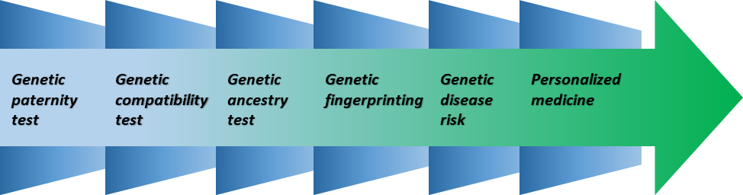
Key areas of genomics include:
Genome Sequencing: Determining the complete DNA sequence of an organism's genome.
Genome Assembly: Piecing together short DNA sequences obtained from sequencing into a complete genome.
Comparative Genomics: Studying similarities and differences between the genomes of different species to gain insights into evolutionary processes and gene function.
Functional Genomics: Investigating gene functions, expression patterns, and regulatory mechanisms on a genome-wide scale.
Population Genomics: Analyzing genetic variation within and between populations to understand the genetic basis of traits and diseases.
Structural Genomics: Studying the three-dimensional structures of proteins and other macromolecules encoded by the genome.
Cancer Genomics: Studying the genomic alterations associated with cancer development and progression.
The integration of bioinformatics and genomics has revolutionized many areas of life sciences, including personalized medicine, agriculture, biotechnology, and environmental research. By leveraging computational tools and big data analysis, researchers can gain valuable insights into the genetic basis of various biological phenomena, leading to numerous practical applications and advancements in our understanding of life itself.
Proteomics
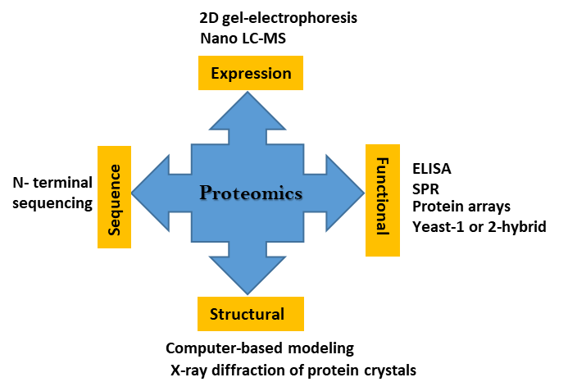
Proteomics is the study of the entire set of proteins produced or expressed by a cell, tissue, or organism. It is a branch of molecular biology that aims to understand the structure, function, and interactions of proteins. Proteins play a crucial role in virtually all cellular processes, including enzymatic reactions, signal transduction, gene regulation, cell structure, and immune responses.
Key aspects of proteomics include:
Protein Identification: Proteomics involves the identification of proteins present in a biological sample. This is typically done using techniques such as mass spectrometry, which can accurately measure the mass and charge of proteins, allowing for their identification and quantification.
Protein Characterization: Proteomics aims to understand the properties and functions of identified proteins. This includes studying post-translational modifications (PTMs), such as phosphorylation, glycosylation, and acetylation, which can greatly affect a protein's activity and stability.
Protein-Protein Interactions: Proteomics helps identify protein-protein interactions, revealing how proteins interact and form functional complexes within cells. This information is crucial for understanding cellular pathways and regulatory networks.
Functional Proteomics: Functional proteomics involves studying how proteins contribute to cellular processes and responses to different stimuli or conditions. This may include investigating changes in protein expression levels under specific conditions or disease states.
Structural Proteomics: This area focuses on determining the three-dimensional structures of proteins, which is essential for understanding their function and how they interact with other molecules.
Clinical Proteomics: Proteomics has important applications in clinical research and diagnostics. By analyzing protein expression patterns in biological samples, such as blood or tissue, researchers can identify biomarkers associated with diseases and monitor treatment responses.
Systems Biology: Integrating proteomics data with genomics, transcriptomics, and other omics data allows for a comprehensive understanding of biological systems, leading to the emerging field of systems biology.
Proteomics plays a significant role in various fields, including medicine, drug discovery, agriculture, and biotechnology. It provides valuable insights into disease mechanisms, drug targets, and the development of personalized medicine approaches. By understanding the complex interactions and functions of proteins within biological systems, researchers can gain a deeper understanding of cellular processes and potentially find solutions to various human health and environmental challenges.
Global genomic market
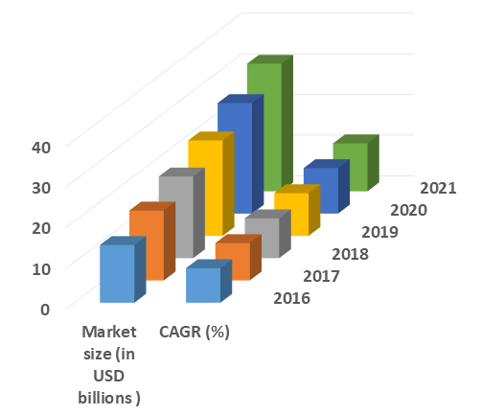
The global genomic market was experiencing rapid growth and was expected to continue expanding in the coming years. The genomics market encompasses various technologies, products, and services related to the study and analysis of genomes, including DNA sequencing, gene editing, and other genomic tools and applications.
Some key factors driving the growth of the global genomic market include:
Advancements in DNA Sequencing: Technological advancements in DNA sequencing techniques, such as next-generation sequencing (NGS), have significantly reduced the cost and time required for genome sequencing. This has made genomic analysis more accessible and affordable, leading to increased adoption in research and clinical applications.
Precision Medicine and Personalized Genomics: The growing emphasis on precision medicine, which tailors medical treatments based on individual genetic profiles, has fueled the demand for genomic testing and analysis. Personalized genomics aims to provide customized healthcare solutions, including disease risk assessment and treatment selection.
Rising Prevalence of Genetic Disorders: The increasing prevalence of genetic and hereditary disorders has led to a higher demand for genetic testing and screening. Genomic technologies play a vital role in identifying disease-causing genetic mutations and enabling early diagnosis and intervention.
Biotechnology and Pharmaceutical Applications: Genomic tools are widely used in biotechnology and pharmaceutical research for drug discovery, target identification, and biomarker development. These applications contribute to the growth of the genomic market.
Agricultural and Environmental Genomics: Genomics is applied in agriculture to improve crop yields, develop genetically modified organisms (GMOs), and enhance livestock breeding. Additionally, environmental genomics helps in studying biodiversity and understanding ecosystems.
Government Initiatives and Funding: Many governments around the world have invested in genomics research and initiatives to promote innovation, healthcare advancements, and economic growth.
Direct-to-Consumer (DTC) Genetic Testing: The availability of DTC genetic testing kits has allowed individuals to access information about their ancestry, health traits, and potential genetic risks, contributing to the expansion of the genomic market.
References
Boguski, M. S. Bioinformatics. Curr. Opin. Genet. Dev. 4, 383–388 (1994).
Brenner, S. E. Practical database searching. Bioinformatics: A Trends Guide 1998, 9–12 (1998).
Searls, D. B. Bioinformatics tools for whole genomes. Annu. Rev. Genomics Hum. Genet. 1, 251–279 (2000).
Scha¨ffer, A. A., Aravind, L., Madden, T. L., Shavirin, S., Spouge, J. L., Wolf, Y. I., Koonin, E.V., and Altschul, S. F. Improving the accuracy of PSI-BLAST protein database searches with composition-based statistics and other refinements. Nucleic Acids Res. 29, 2994–3005 (2001).
International Human Genome Sequencing Consortium. Initial sequencing and analysis of the human genome. Nature 409, 860–921 (2001).
Luscombe, N. M., Greenbaum, D., and Gerstein, M. What is bioinformatics? A proposed definition and overview of the field. Methods Inf. Med. 40, 346–358 (2001).
Ideker, T., Galitski, T., and Hood, L. A new approach to decoding life: Systems biology. Annu. Rev. Genomics Hum. Genet. 2, 343–372 (2001).

Goodman, N. Biological data becomes computer literate: Newadvances in bioinformatics. Curr. Opin. Biotechnol. 13, 68–71 (2002).
Henikoff, S. Beyond the central dogma. Bioinformatics 18, 223–225 (2002).
Yu, U., Lee, S. H., Kim, Y. J., and Kim, S. Bioinformatics in the post-genome era. J. Biochem. Mol. Biol. 37, 75–82 (2004).
Altschul, S. F., Wootton, J. C., Gertz, E. M., Agarwala, R., Morgulis, A., Schaffer, A. A., and Yu, Y.-K. Protein database searches using compositionally adjusted substitution matrices. FEBS J. 272, 5101–5109 (2005).
Yu, Y.-K., and Altschul, S. F. The construction of amino acid substitution matrices for the comparison of proteins with nonstandard compositions. Bioinformatics 21, 902–911 (2005).
Gerstein, M., Greenbaum, D., Cheung, K., and Miller, P. L. An interdepartmental Ph.D. program in computational biology and bioinformatics: The Yale perspective. J. Biomed Inform. 40, 73–79 (2007).
Edwards, D., Stajich, J. and Hansen, D. eds. Bioinformatics: tools and applications. springer science & business media (2009).
Chojnacki, S., Cowley, A., Lee, J., Foix, A. and Lopez, R. Programmatic access to bioinformatics tools from EMBL-EBI update: 2017. Nucleic acids research, 45(1), 550-553 (2017).
Chen, L., Heikkinen, L., Wang, C., Yang, Y., Sun, H. and Wong, G. Trends in the development of miRNA bioinformatics tools. Briefings in bioinformatics, 20(5), 1836-1852 (2019).
Chen, L., Wang, C., Sun, H., Wang, J., Liang, Y., Wang, Y. and Wong, G. The bioinformatics toolbox for circRNA discovery and analysis. Briefings in bioinformatics, 22(2), 1706-1728 (2021).
Varshney, S., Bharti, M., Sundram, S., Malviya, R. and Fuloria, N.K. The Role of Bioinformatics Tools and Technologies in Clinical Trials. In Bioinformatics Tools and Big Data Analytics for Patient Care (pp. 1-16). Chapman and Hall/CRC (2022).
Rather, M.A., Agarwal, D., Bhat, T.A., Khan, I.A., Zafar, I., Kumar, S., Bhat, R.A., Sundaray, J.K. and Qadri, T. Bioinformatics approaches and big data analytics opportunities in improving fisheries and aquaculture. International Journal of Biological Macromolecules, 123549 (2023).

