NANOCARRIERS IN DRUG DELIVERY
Srinivas Murthy BR^{1*}, Alagumurugan A¹, Muthukumar S¹, Vinesha R¹, Jamal Basha D², Prakash P³

Affliations
¹ Formulation Research and Development, Maiva Pharma Private Limited, Hosur, TN
² Department of Pharmacognosy, Amity Institute of Pharmacy, Amity University, Gwalior
³Department of Pharmaceutics, Sri Padmavathi School of Pharmacy, Tiruchanoor, Tirupati, AP

*Corresponding author
Dr. Srinivas Murthy BR
Formulation Research and development
Maiva Pharma Private Limited,
Hosur, IN – 635126
Email: seenu46@gmail.com
Mobile: +91-9059782806

ABSTRACT
Nanotechnology is an advanced extension in the field of science. Introducing nanotechnology into drug delivery system has resulted in development of nanocarriers. Nanocarriers is a drug delivery approach sized in nanometers. Reduced size of the carrier lead to better targeting and improved efficacy. It enables the carrier to easily get into the tissues and reach the target site, overcoming the cellular obstacles like physical barriers. Despite of the cost of production and stability issue, nanocarriers are beneficial in terms of therapeutics. In the past two decades, nanocarriers are widely being used and approved by the regulatory bodies. Nanocarriers additionally offer the brightest advantage of being feasible to variety of routes of administration like topical, injectables and oral liquids. This chapter discuses in brief about the types of nanocarriers, preparation, evaluation, and their applications.

- INTRODUCTION
Nanotechnology is a contemporary scientific field that has a significant impact on many elements of daily life. Nanotechnology is a fancy term revolving around the materials in nanometer range. The term "nanoparticle" refers to a particulate carrier system having a size between 1 and 1000 nm. Colloidal sub-nanoscale structures known as nanoparticles are made of synthetic or partially synthetic polymers. Chemicals can be delivered to the body's small units more effectively with nanoparticles.[1] Nanoparticles (NPS) are commonly used to carry medications, release medications at the target, which typically results in degradation in the body, and for medications that are unable to diffuse over a barrier. They are employed to regulate and control medications that are crucial for enhancing human health as well as biomolecules that are necessary for life and to enhance quality of life [2]. These systems have mainly been researched for regulated drug delivery, site-specific drug delivery, and improving the bioavailability and dissolving rate of medicines that are poorly water soluble. [3].
Nanoparticles carry several advantages like ease of particle size manipulation along with the surface modification. They are commonly involved in active and passive drug targeting. These nanocarriers can be modified to attain the most maximum therapeutic beneficence. Another advantage of the introducing nanotechnology in carrier system is that it can offer controlled release and minimize the degradation of the drug. A carrier must ensure high amounts of drug loading which directly contributes to the therapeutic efficacy.
A carrier is intended to achieve site specific drug delivery which is supported by the use of ligands or an external-stimuli. The polymer-based nanoparticles are usually biodegradable and are safe in general.
In contrast, small sized nanocarriers result in aggregation. Nanoparticles in the liquid and dry forms, this could result in compliance issues. [4] These carriers can be easily scavenged by RES leading to reduced half-life.

2.TYPES OF NANOCARRIERS
Nanocarriers are be broadly based on the structure and material used. Few such nanocarriers are listed in the table 1.
Table 1: Nano carriers in drug delivery
Sl.no | Type of Nanoparticles | Material used
 | Nanocrystals | Drug + surfactants
 | SLN (Solid lipid Nanoparticles) | Solid lipid is molten with aqueous surfactant
 | Polymeric micelles | Use of amphiphilic block co-polymers
 | Magnetic Nanoparticles | Magnetite (Fe3O4); maghemite (γ-Fe2O3)
 | Polymeric nanoparticles | Biodegradable polymers
 | Carbon Nanotubes | Metals or carbon
 | Liposomes | Phoshpolipids
 | Ceramic Nanoparticles | Silica,alumina,titania

2.1. Nano suspension
A suspension is a biphasic system in which the solid state is dispersed in liquid medium. When the size range of the solid phase is reduced to nanometer range, it is denoted as nanosuspension. The particle size lies in between 200 to 500nm. A nanosuspension demonstrates increased solubility and dissolution. [5] Another noticeable phenomenon is that it can induce changes in crystalline structure which increases the amorphous fraction or conversion to crystalline structure. They also exhibit good adherence or adhesiveness to the human tissue. [6] Devising a nanosuspension for oral route offers improved absorption rate and bioavailability.

2.2. Solid lipid Nanoparticles (SLN)
Solid Lipid Nanoparticles are gaining a lot attention in the recent research. They are sub micron colloidal carriers (50-1000 nm). They are made up with lipids and surfactants. Lipids in lipids come with various disadvantages which can be overcome by the use of solid lipids. [7]

2.3. Polymeric nanoparticles
The components of polymeric nanoparticles include biodegradable, biocompatible, and non-toxic synthetic poly esters like poly(d, l-lactide), poly cyano acrylate, and related polymers like poly(lactide-co-glycolide), pla, or poly(lactid acid), as well as advanced modifications of natural polymers. Chitosan, a natural polymer, is the one that is being utilized the most frequently. In addition to chitosan, numerous other substances, including sodium alginate and gelatin, help synthetic polymers overcome some toxicity issues. In terms of efficiency and effectiveness, natural polymer-based nanoparticles significantly outperform conventional drug delivery system. [7]

2.4. Polymeric micelles
Micellar systems are beneficial for the systemic delivery of drugs that are not soluble in water. Drugs can be partitioned in the hydrophobic cores of micelles and the outer hydrophilic layer, which can then be administered intravenously, starting from stable dispersion in aqueous medium. Due to their smaller size and hydrophilic shell, which hinders reticuloendothelial system uptake, drug-loaded polymeric micelles (less than 100 nm in diameter) have been found to have a prolonged systemic circulation time after intravenous injection. Compared to free medications, those that are incorporated into polymeric micelles have a more constrained distribution in areas that are not specifically targeted and may accumulate more in tumors. [8]

2.5. Nanopores
Materials with defined pore-sizes in the nanometer range are of particular interest for a wide range of industrial applications due to their exceptional properties in terms of thermal insulation, controllable material separation and release, and their suitability as templates or fillers for chemistry and catalysis. The sol-gel chemical method is used to produce a particular form of nanoporous material called aerogel.

2.6. Nanowires
Nanowires are small, crystalline particles that are either conductive or semi-conductive and have a high length to diameter ratio. Copper, gold, cobalt, silicon, and other metals have all been used to make nanowires. They are used to transport electrons in nanoelectronics and can be made of many metals, including oxides, sulfides, and nitrites.

2.7. Quantum dots
Quantum Dots are colloidal semiconductor nanocrystals with diameters between 2 and 10 nm. Colloidal synthesis or electrochemistry are two methods that can be used to create QDS from different kinds of semiconductor materials. The most often used QDS are indium phosphide (INP), indium arsenide (INAS), cadmium selenide (CDSE), and cadmium telluride (CDTE). The number of electrons in a quantum dot might range from one to thousands. The size, shape, and number of electrons can be precisely regulated to attach therapeutic molecules for simultaneous drug administration and in vivo imaging, tissue engineering, and other applications. [9]

3. PREPARATION OF NANOPARTICLES
The preparation technique for nanocarriers is based on the structure and complexity, which includes,
- Nano precipitation
- Solvent evaporation
- Solvent diffusion
- Salting out technique
- Super critical fluid
- Polymerization
- Ionic gelation technique
- Spray drying method
- Micro emulsion

3.1. Nanoprecipitation
Nanoprecipitation is known by the name solvent displacement technique. The preformed polymer, typically PLA, is dissolved in a water-miscible solvent of moderate polarity, resulting in the precipitation of nanospheres. This process also involves the diffusion of the organic solvent takes place in the aqueous medium in the presence or absence of a surfactant. This phase is added to an aqueous solution that has been agitated and contains a stabilizer as a surfactant. Instantaneous polymer deposition on the organic solvent–water interface, caused by rapid solvent diffusion, leads to the creation of a colloidal suspension. To aid in the creation of colloidal polymer particles during the first step of the process, phase separation is performed using a fully miscible solvent that is also anon solvent of the polymer. The solvent displacement method enables the production of nano capsules when a small amount of nontoxic oil is added to the organic phase. Given that the interior cavities of the nanocapsules are made of oil, high loading efficiencies. When nanocapsules are manufactured, high loading efficiencies for lipophilic medicines are typically observed due to the oil-based central chambers of the nano capsules. Only water-miscible solvents, where the diffusion rate is sufficient to achieve spontaneous emulsification, are suitable for using this straightforward procedure. Additionally, even though some water-miscible solvents exhibit significant instability when mixed with water, spontaneous emulsification is not seen if the coalescence rate of the generated droplets is high enough. [10]

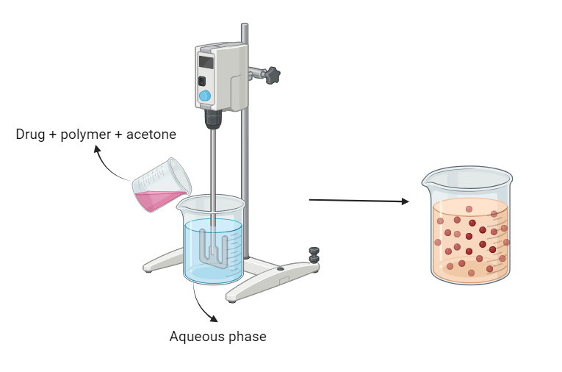

Figure 1: Nanoprecipitation method
3.2. Solvent evaporation
Solvent evaporation was the first method developed to make polymeric nanoparticles. Using this method, emulsions are made by combining polymer solutions with volatile solvents. Utilizing organic solvents like dichloromethane, chloroform, or ethyl acetate, the hydrophobic medicine is dissolved. The drug is first dissolved and distributed in a polymer solution, which is then emulsified in an aqueous solution with a surfactant to produce an oil-in-water emulsion. [11]
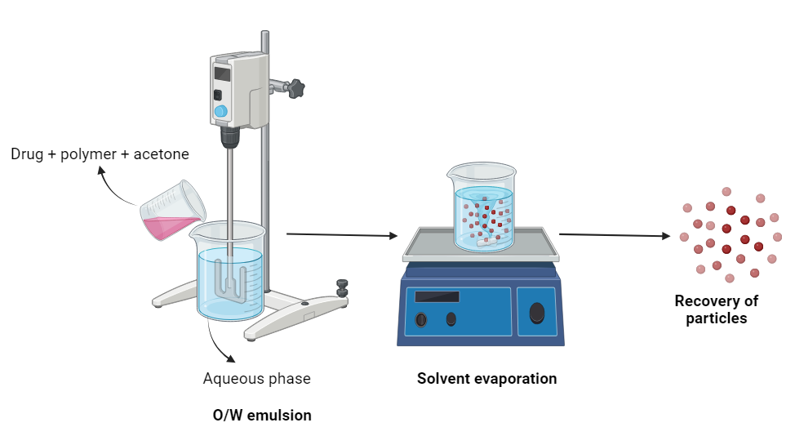
Figure 2: Solvent evaporation technique
3.3. Solvent diffusion
When an organic phase is added to a chitosan solution containing a stabilizing agent (i.e., polyoxamer) while being mechanically stirred, high pressure homogenization is used to create an o/w emulsion. This technique also uses a small amount of the water immiscible organic solvent as an oil phase. To overcome the miscibility of the organic solvent in water, the emulsion is subsequently greatly diluted with water. When an organic solvent diffuses into water, it causes the creation of nanoparticles, which leads to polymer precipitation. According to Alleman et al. (1993), this approach works well with hydrophobic drugs. [12]

3.4. Polymerization
In this process, monomers are polymerized to create nanoparticles in an aqueous solution that allows for the dissolution of pharmaceuticals. Drugs can also be added by adsorption to the nanoparticle suspension, which is subsequently purified by ultracentrifugation to get rid of different stabilizers and surfactants employed in polymerization, and resuspended in an isotonic surfactant-free media. It has been shown to produce poly butyl cyano acrylate or poly alkyl cyano acrylate nanoparticles. [13]

3.5. Ionic gelation
It is the simplest and most convenient approach for creating nanoparticles. Nanoparticle production is caused by electrostatic interactions between the cationic amino group of chitosan and the negatively charged anions of cross-linking agents like s-tpp. Acetic acid is used to dissolve chitosan to create a polymer solution. Water is mixed with a cross-linking agent to create a solution. The polyethylene glycol cross linking agent is added to the chitosan solution to instantly create the nanoparticles while stirring at room temperature, whether stabilizing chemicals like tween 80 are present or not. By adjusting the chitosan to stabilizer ratio, it is possible to change the size and surface charge of the particles. [14]

4. EVALUATION OF NANOCARRIERS

4.1. Visualization by SEM analysis
Analyze the size, morphologies, and shapes of newly produced nanoparticles. SEM provides the needed high resolution images of a sample's surface. Similar to an optical microscope, a scanning electron microscope examines dispersed electrons from the material rather than photons. An electric potential can accelerate electrons, which allows for a shorter wavelength than that of a photon. As a result, the SEM can magnify images up to 200.000 times. uses a conductive or sputter-coated sample, measures particle size and characterization, and has a sensitivity of 1 nm or less. [15]

4.2. Particle size analysis
The particle size distribution and shape are the two elements that are most important in the characterization of nanoparticles. Drug delivery and targeting are the main uses of nanoparticles. Particle size has been demonstrated to have an impact on medication release. Smaller particles provide larger surface areas. Rapid drug release occurs as a result of the majority of the medication that has been applied to them being exposed to the particle surface.. [16]

4.3. Zeta potential
Nanoparticles' interactions with the biological environment and their electrostatic interactions with bioactive chemicals depend greatly on the type and strength of their surface charges. Zeta potential of nanoparticles is used to examine the colloidal solubility. Potential is an indirect measurement of surface charge. It relates to the potential difference between the shear surface and the outer Helmholtz plane. Colloid dispersion's storage stability can be predicted using the zeta potential measurement. To promote stability and prevent particle aggregation, high zeta potential values—whether positive or negative—should be attained. The values of zeta potential can then be used to predict the degree of surface hydrophobicity. The type of the material contained within the nanocapsules or coated on the surface can also be determined using the zeta potential.
4.4. Dynamic light scattering
When a laser is used to illuminate a suspension of spherical particles moving with Brownian motion, the incoming light undergoes a Doppler shift, which alters its wave length. The size of Brownian nanoparticles in colloidal suspensions in the nano- and submicron ranges is commonly determined using this technique. This change is influenced by the particle's size. It is possible to extract the size distribution and give a description of the motion of the particle in the medium by figuring out the particle's diffusion coefficient and using the autocorrelation function. Photon correlation spectroscopy (PCS) is the most widely used technique for precise particle size and size distribution estimation based on DLS. [17]

4.5. Yield
When manufacturing nanoparticles, the raw materials, active compounds, and other process parameters all play a role in the final result. Weighing the nanoparticles and calculating the weight of the medication and polymer that were utilized as additional materials yielded the results that were achieved. [18]

4.6. Entrapment efficiency
The amount of free drug in the dispersion was evaluated spectrophotometrically at max to determine entrapment efficiency (EE). The amount of drug that was successfully entrapped inside the nanoparticles was calculated by subtracting this from the formulation's total drug concentration. [17]

4.7. Drug release
Knowing how and how much drug molecules are released is important because one of the key applications of nanotechnology is drug delivery. Although it can alternatively be given as a percentage relative to the polymer, drug loading of nanoparticles is commonly described as the amount of drug bound per mass of polymer (often moles of drug per mg polymer or mg drug per mg polymer). Classical analytical techniques such as UV spectroscopy or high performance liquid chromatography (HPLC) are utilized for this analysis after ultra-centrifugation, ultra-filtration, gel filtration, or centrifugal ultra filtration.
5. NANOCARRIERS IN CANCER
Nanocarriers are being used widely in clinical cases. The primary usage of nanoparticles in biomedical applications, including the delivery of drugs and genes, the development of diagnostic and therapeutic instruments for cancer, the production of food, etc.
Nanoparticle systems currently under investigation to be applied in biomedical with the emphasis on cancer therapeutics. Nanoparticle systems involved in drug delivery - the nanoparticle get entrapment of drugs are either enhanced delivery to, or uptake by, target cells, and/or a reduction in the toxicity of the free drug to non-target organs. In the fields of information and communication technology, power engineering, industrial engineering, environmental engineering, chemical industry, medicine, pharmaceuticals, and cosmetics, among others, a number of nanoparticle systems are now being researched and studied for biological application. Application of nanoparticles in food, often known as "nanofood," is a phrase used to describe foods that incorporate manmade nanomaterials into the growth, production, processing, or packaging of the food. The efficient introduction of a gene of interest to express its encoded protein in an appropriate host or host cell is made possible by the use of nanoparticles in gene delivery. Nanomedicine helps with disease early detection and prevention, improved diagnosis, and follow-up care. Gene sequencing has become easier thanks to the development of nanotechnology, such as gold nanoparticles. [19]
Silver nanoparticles are widely employed in the electronics sector, as an antibacterial agent in medicine, and other fields. Nanotechnology is a way to manipulate matter at the molecular level. Nanoparticles in nutritional aspects.
In colon targeting, since eudragit degrades in the colon, it was successfully used for colon medication administration. Compared to the uncoupled nanoparticles, these particles showed improved cellular absorption by ht-29 colon cancer cells. Nanoparticles designed for colon-targeted administration that have unique biodegradability and pH-sensitive characteristics. [20] In case of liver cancer, by using either active targeting based on identification between hepatic receptor and ligand-bearing particulates, or passive trapping of nanoparticles by reticuloendothelium, eudragit nanoparticles were employed for liver delivery. [21] Drug carrier conjugates made of chitosan have been utilized to target medications for the kidney. After being administered intravenously to mice, the low molecular weight chitosan (lmwc) specifically collected in the kidneys, notably in the renal tubes. [22] A lung cancer cell line (a549) significantly absorbed more of the nanoparticles in-vitro thanks to the chitosan modification. Chitosan nanoparticles changed their charge to become more positive in an acidic tumor environment, where they aggressively interacted with the tumor cells' negative charges. The acidic microenvironment promotes greater interactions between C-NPS and tumor cells. The blood brain barrier (BBB), which regulates the movement of endogenous and exogenous substances and serves the neuroprotective role, makes the brain one of the least accessible organs for the delivery of medications. Modified polybutylcyanoacrylate (PBCA) nanoparticles have the ability to transfer drugs to the brain after adhering to the surface. [23]

- BIOSYNTHESIZED NANOPARTICLES
In the recent research, biosynthesized nanoparticles are found to control the rapid tumor growth and induce apoptosis in cancer cells. They come with the advantage of easy internalization by tumor cells. Biogenic nanoparticles are made from biological sources like plants, animals, and microorganisms. Nanoparticles produced using bacteria like E.Coli demonstrated impressive results against ovarian cancer. Biological sources come with multiple targets and choosing a selective agent with high specificity towards each cancer type can be seen as a promising solution. [24, 25]

- NANOCARRIES IN PHOTODYNAMIC THERAPY
Photodynamic therapy is a dual targeted drug delivery systems that uses energy in the form of light. A drug, also known as photosensitizer is administered into the body. Due to the affinity, the drug gets absorbed into the cancer cells. After incubation period, the patient is exposed to light at predetermined wavelength. The light activates the photosensitizer to produce oxygen which results in destruction of cancer cells. [26] This procedure is minimally invasive and provides targeted cytotoxicity. Clinical studies have shown that it is highly effective in early stages of cancer.
The anticancer effect occurs as a result of photochemical reaction between the light and the photosensitizer leads to formation of singlet oxygen which is highly toxic to the surrounding cancerous cells via necrosis and apoptosis. The photosensitizers are mostly based on tetrapyrrole. It is highly active in 600-800nm range. This light range is sufficient to activate the agent and produce oxygen singlet. [27, 28] Mixture of porphyrin, hematoporphyrin derivative was the first clinically used photosensitizer and still remains as the most widely used photo sensitizer. A light source is selected based on the extend of penetration. Blue lights are sufficient for topical or surface tissues while infrared lights are required for deeper tissue penetration. [29] The choice of the light is also dependent on the structure of the photosensitizer, target site and disease condition.
Liposomal carriers are being used as carriers for water-insoluble photosensitizers. The use of magnetic ceramic, metallic and polymeric nanoparticles, are used in this fashion. [30]

C. SELF THERAPEUTIC NANOCARRIERS
Most of the nanocarriers require an external stimuli to reach the target or for activation. Self therapeutic nanocarriers can directly exert anticancer effect without the use of external and even without an therapeutic agent. [31] These carriers rely on free radical generating species which can scavenge the tumor cells. Copper, silver and gold are good examples of self therapeutic carriers that possess impressive anticancer properties. [32] These metals act as deoxygenating agents that cut down the oxygen supply to the tumor site, restricting its growth. Majority of the self therapeutic system is based on peptides. One big example is (KLAKLAK)2 (KLAK) is a popular peptide in anticancer self therapeutic therapy and an ampiphilic peptide with positive in vitro and in vivo results.
7. CONCLUSION
The modern medication is constantly working on the drug delivery systems to improve therapeutic action of the active pharmaceutical agent. Delivering a drug with effective delivery system enables better therapeutic outcome. By bringing the down the size of the carrier, an effective outcome can be achieved. Nanotechnology is the talk of the hour. Use of nanocarriers help overcome formulation hurdles like solubility. Nanocarriers offer enormous potential in targeting tumor cells and result in better outcome. We believe that further research in nanocarrier can lead to development of newer carriers which can be helpful in treating complex diseases.
8. REFERENCES
- Ravat M , sing D ,and staff S.nanocarriers: promising veghicle for bio active drugs .Bio.pharma 2006: 1790-1798
- Majeti Ravikumar NV. A review of chitin and chitosan applications. Reactive and functional polymers. 2000:1-27.
- Chen DB, Yang T Z, Lu WL, Zhang Q, in-vitro and in-vivo study of two types of long circulating solid lipid nanoparticles containing pacitaxel. Chem. Pharma. 2001:1444-1447.
- Bernkop-Schneurch A, Guggi D, pinter Y. Review of chitosan nanoparticles .J Control release. 2004:94-117
- Muller RH, Bohm B etal. Nanosuspensions: A formulations approach for poorly soluble and poorly bioavailable drugs. In: DL Wise, Editor, Handbook of pharmaceutical released technology I st Edn, Marcel Dekker, New York, 2002: 345-357.
- Duchene D, ponchel G. Bioadhesion of solid oral dosage forms ,Biopharma 1997:15-23
- Liversidge GC. Drug Nanocrystals for Improved Drug Delivery, In : Int Symp Control Release Bioact Matter ,Workshop on particulate drug delivery system 1996, pp.23.
- Nagasaki Y. Block copolymer micelles for drug delivery: Design, characterization and Biological significance Adv Drug Delivery Rev 2001; 47:113-15
- Larson DR, Zipfel WR, Williams RM, Clark SW, Bruchez MP, Wise FW. Water soluble quantum dots for multiphoton fluorescence imaging in vivo. Science direct.2003:1434-6.
- Ganachand F, Katz JL. Nanoparticles and nanocapsules created using the ouzo effect: Spomtaneou semulsification as an alternative to ultra sonic and high-shear devices.Chem Phys Chem. 2005: 209-16.
- Catarina Costa Moura, Marcela A Segundo. Co-association of methotrexate and SPIONs into anti-CD64 antibody-conjugated PLGA nanoparticles for theranostic application. Int. Journal of Nanomedicine.2014; 9; 4912-22.
- L.Y Alleman et al. Isotopic evidence of contaminant lead in the South Atlantic troposphere and surface waters Deep-Sea Research II (2001)
- Niwa T, Takeuchi H, Hino T, Kunou N,Kawasshima Y, preparation of biodegradable nanoparticles of water soluble and insoluble drugs with D,L lactide / glycolide by a novel spontaneous emulsification solvent diffusion method and the release behavior .J.control release. 1993: 89-98.
- Calvo P., Remunan-Lopez C., Vila-Jato JL., Alonso MJ. Novel Hydrophilic Chitosan–Polyethylene Oxide Nanoparticles as Protein Carriers. Journal of Applied Polymer Science, 1997; 63: 125–132.
- Asim Umer, Shahid Naveed, Naveed ramzan. Selection of suitable method for the synthesis of copper nanoparticles. World Sci. 2012: 10-18.
- Redheed HM, Dvis SS, Illum L, Drug delivery in poly (lactide-co-glycolide) nanoparticles surface modified with polaxamer 407 and polaxamine 908: In-vitro characterization and in-vivo evaluation. J. control release.2001:353-365.
- Das S, Banerje R, Belare J. Aspirin loaded albumin nanoparticles by cocervation: implications in drug delivery. Trends Bio Artif Organs, 2005: 203-1.
- Susana Rodriguesa, Ana Rosa da costab M, Ana Grrenha. Chitosan/carragenam nanoparticle: Effect of cross-linking with tripolyphosphate and charge ratios.Carbohydrate polymers. 2012: 282-289.
- Nishikant C Shinde, Nisha J Keskar, Prashant D Argade Nanoparticles: Advances in Drug Delivery Systems Research Journal of Pharmaceutical, Biological and Chemical Sciences,2012;3-1;922.
- Jain SK, Jain A. Target-specific drug relese to the colon. Expert Opin Drug Deliv.2008:452-483.
- Ogawara K, Yoshida M, Higachi K, Kimura T, Shiraishi K, Nishikawa M, Takakura Y,Hashida M. Hepatic uptake of polystyrene microspheres in rats : effect of particle size on intrahepatic distribution. J control Release. 1999: 15-22.
- Barnabas Wilson, Malay kumar samata. Targeted delivery of tacrine into the brain with polysorbate 80-coated poly (n-butylcyanoacrylate) nanoparticles. E. J of Pharmaceutics and Biopharma.2008:75-84.
- Hedly M, Curely J, Urbar R. Microspheres containing pasmid encoded antigens elicits cytotoxic T-cells responces. Nature madicine. 1998: 365-368.
- Busi S, Rajkumari J. Microbially synthesized nanoparticles as next generation antimicrobials: scope and applications. In: Grumezescu AM, editors. Nanoparticles in pharmacotherapy. Bucharest, Romania: Elsevier, 2019: 485–524.
- Chaturvedi VK, Sharma B, Tripathi AD, Yadav DP, Singh KR, Singh J and Singh RP. Biosynthesized nanoparticles: a novel approach for cancer therapeutics. Front. Med. Technol. 2003; 5:1236107
- Agostinis P, Berg K, Cengel KA, Foster TH, Girotti AW, Gollnick SO, Hahn SM, Hamblin MR, Juzeniene A, Kessel D, Korbelik M, Moan J, Mroz P, Nowis D, Piette J, Wilson BC, Golab J. Photodynamic therapy of cancer: an update. CA Cancer J Clin. 2011; 61(4): 250-81.
- Dolmans DE, Fukumura D, Jain RK. Photodynamic therapy for cancer. Nat Rev Cancer. 2003;3:380–387.
- Allison RR, Sibata CH. Oncologic photodynamic therapy photosensitizers: a clinical review. Photodiagnosis Photodyn Ther. 2010;7:61–75.
- Juzeniene A, Nielsen KP, Moan J. Biophysical aspects of photodynamic therapy. J Environ Pathol Toxicol Oncol. 2006;25:7–28.
- Chatterjee DK, Fong LS, Zhang Y. Nanoparticles in photodynamic therapy: an emerging paradigm. Adv Drug Deliv Rev. 2008;60:1627–1637.

