A New Approach for Finger Knuckle Print Recognition using DWTHT with KNN Classifier

L.sathiya1, V.Palanisamy2

1Teaching Assistant, Department of Computer Applications, Alagappa University, Karaikudi, India,

<sathyass660@gmail.com>

2Senior Professor and Head, Department of Computer Applications, Alagappa University, Karaikudi, India, [vpazhanisamy@yahoo.co.in](mailto:vpazhanisamy@yahoo.co.in)

**ABSTRACT**

In Present Numerous scientific research based on biometric applications like face, iris, voice, hand-based biometrics traits like palm print and fingerprint technique are employed for maculating the individuals. These distinct biometrics habits have their development and flaw so that no particular biometrics can pleasantly enough to opt for all terms like the accuracy and cost of all applications. In recent times, distinct hand-based biometrics technique such as Finger Knuckle Print (FKP) has been addressed for booming the attention among biometric researchers. The image template pattern formations of FKP cradle the report which is suitable for streaking the uniqueness of individuality. This FKP trait observes a person based on the knuckle print with the framework based on their outlooks. This FKP feature determines the line anatomy and finger structures which are entrenched and persistent throughout the lifetime of an individual. In this paper, an innovative method for personal identification is introduced, along with the angle pattern based on the Hough transform has been proposed. Here discrete wavelet transform (DWT) plays a vital role in decomposing the FKP into various sub-bands. This proposed system is recognized based on the FKP framework with the query template to achieve a higher accuracy rate as 89%.

Keywords—Finger Knuckle Print(FKP); Discrete Wavelet Transform(DWT); Hough Transform; K-Nearest Neighbour(KNN) classifier; Accuracy; Error Equal Rate(EER); False Acceptance Rate(FAR); False Reject Rate(FRR); Sensitivity; Specificity; Precision; Recall.

# INTRODUCTION

Biometrics technology consolidates the identification and authentication of individuals by dismembering of the human body characteristics like Palm-print, Fingerprint, Iris etc [1]. In Comparison with fingerprint, the finger knuckle surface has some profit as a unique biometric identifier due to the template pattern of skin folds and crimps in the outer finger knuckle surface which is highly scarce and which can avail as a specific biometric identifier. Foremost it is not easy to be distorting since people usually cling to stuff within the inner side of the hand. Also with various use of fingerprint, there is no stain of criminal analysis associated with the FKP, therefore it has greater user acceptance. Thus, the finger knuckle feature has an elegant potential to be widely accepted as a biometric identifier. The matching of finger knuckle patterns helps to tag the suspects and line out authorizing scientific proof from the images, particularly in cases once no evidence about fingerprints, FKP helps to find suspect image among other criminal data sets [2]. This Fig.1 has high textured region and it has no stigma associated with a criminal investigation, voter registration etc. It has U-shaped joint characterizing the number of lines, length and spacing between lines. Knuckle has a ridge and wrinkle pattern with stray marks based on Photographic identification. These features are exclusive and prefer for personal authentication. It has three joints or bones in each finger named as proximal phalanx, PIP and DIP joints [3].

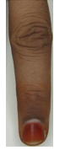  

(a)

(b)

(c)

**Figure 1: Sample FKP image of original finger image, Major knuckle and minor knuckle images.**

This will happen because of the propitious happenings of these biometric traits such as minimum cost, low-resolution imaging, and other firm features. In the above biometrics technologies, FKP has dazzled much concern in the biometrics research community. Meanwhile, FKP is also highly distinct so that it can be evaluated as a unique one when compared with traditional biometrics techniques like faces, fingerprints, and voices. There is no overlay of illegal acceptance rate associated with FKP. Hence FKP has a prominent user acceptance rate. Hence this work acknowledged that FKP is examined to be one of the persuading biometric techniques for personnel identification in the present and future [4]. Likewise, many authors have described DWT and Hough in various outcomes. It is noteworthy that Selma elnasir [5] describes in recognizing palm vein image using 2D discrete wavelet transform. In this work, approximate low-frequency subbands are utilized as an input to the LDA algorithm. The main aim of the LDA algorithm of this work helps in maximizing the inter-class variance and also to reduce the intraclass variance for the purpose reduced features from the input. This work achieved the highest identification rate of 99.74%, 100% verification rate and 0% EER value. DR Shashi Kumar [6] defines the iris recognition system performed by DWT. This DWT image is applied to a histogram equalized iris image. The Approximate band of the DWT coefficients given as input to the PCA classifier. Several classifiers are used for Matching. This work yields 99.07% accuracy in this work. Hassan Masood [7] demonstrates palm print authentication by utilizing different wavelet transform techniques such as Biorthogonal, symlet and discrete. This method achieved 97.21% GAR value and 4.0702% EER value. Ganorkar Sanjay [8] estimates iris recognition using DWT technique with techniques is matched using Hamming distance. The accuracy checked among two different database images such as UPOL and CASIA and the accuracy is 100%. Sujatha [9] develops a human face recognition system using DWT and SVM classifier. In this work, were calculated the approximation and detail bands. Finally, Approximation band (LL) is used as an input to the SVM classifier. Arithmetic addition helps into the fusion of DWT and SVM features. The Comparison of test and training images done with Euclidean Distance. Finally, EER values are verified by different face database. Rajbhoj [10] explained the combination of iris and fingerprint image by utilizing DWT and matching is done by Hamming distance. The overall EER rate of this work is 0.4573. In multi-model traits helps in provides higher security. Biradar [11] discussed palm print recognition using DWT. The features are extracted from DWT with matching difference calculation by the Canberra and Euclidean distance. Harshad [12] explored contourlet transform based palmprint recognition. The multi-resolution and multidirectional transform techniques are taken with the palm features. Genetic algorithm is used for feature selection. Prasad [13] proposed DWT and contourlet based recognition. This work mainly focused on shift and rotation invariant feature extraction using DWT concept. The average EER value is 0.41%. Sahoo [14] denotes hand gesture recognition using DWT and F-ratio feature descriptor. This method is always invariant to translation and rotation of the hand gesture. A linear support vector machine is used for classification. The proposed work accuracy is 94.06. Subasi [15] explore EEG signal classification using DWT and mixture of expert model. In this work EEG signals are decomposed using DWT and MLPNN is for classification. Kandaswamy [16] define the lung sound signals are decomposed using DWT and ANN used for classification. The statistical features are extracted from the lung sounds. Ye Huashan [17] proposed Hough transform-based detect geometric objects from on images. Different objects can easily detect from this work. Zorski [18] explained fingerprint and iris identification based on the Hough transform. This work mainly explained on irregular objects. Nair [19] describes Hough transform-based ellipse detection. Kazhagamani [20] utilized elliptical Hough transform-based FKP feature extraction. The feature points are transformed into the fine dimensional parametric space then only find out ellipse form the FKP. This paper produced the lower EER value is 0.78%. Bhatia [21] discovers human gait recognition using DWT and Hough transform. This is one of the new models for gait recognition. Anoop TR [22] proposed fingerprint detection using Hough transform. The normal and altered fingers are easily detected using this method. Saroha [23] explained Hough transform-based fingerprint matching. False matching is reduced in this method. Overhead is a limitation of this work. Hegde et.al[24] describes in authentication of finger knuckle print using Gabour wavelets, Random transform, correlation coefficient. In this work randon points and magnitude of the gabour wavelets are used for wavelet graph. This work gave 95% accuracy of the authentication system. Gomaa et.al [25] demonstrates the finger knuckle print by utilizing HAAR, k-means and Bayesian classifier. This method yields good recognition rate. Aoyama et.al [26] defines FKP recognition using 2D-DFT, BLPOC and and this work yields the EER value of 6.352%. Amraoui et.al [27] develops FKP recognition system using HOG and SVM classifier and produced 98% accuracy. Michal et.al [28] explains FKP Recognition using PHT and KNN classifier and produced the EER value of 1.02%. chandrakiransahu et.al [29] discussed random transform and RBFN based FKP recognition with 97.25 accuracy. Nanni et.al [30] estimates the combined approach of HAAR and random wavelet transform based recognition of FKP and produced the EER values is 0.3%. zhang et.al [31] proposed Fourier transform and BLPOC based FKP recognition with 0.3% EER value. Kekere et.al [32] explore Finger knuckle print recognition using kekere wavelet transform and ANN classifier. This work proposed TAR value of 80%. meroumia et.al [33] yields 2D block DCT and GMM based Finger knuckle print recognition with EER value of 0.37%. Raut et.al [34] explained KWT and Euclidean distance based Finger knuckle print recognition with FRR 10.01%. Jeyapriya et.al [35] describes FKP recognition using Gabour wavelet transform and KNN classifier. This work proposed some accuracy.

Based upon the literature review, in FKP recognition line based features are more important. Because each and every human being have an some distinct features of finger knuckle lines such as major knuckle lines, minor knuckle lines and border lines of the finger. So, to extract the correct line features from the FKP image, code based approach, texture based approach, geometrical based approach and line based approach are applied in the existing work. In coding based approach, it doesn’t preserve the all orientation of the edge information against image rotation. In subspace based approach, subspace coefficients do not hold the high dimensional features correctly and take more computational time. But in the texture and line based approach provides satisfactory performances because cost of computational time is less and the image is transformed into a specific domain that corresponds the characteristics of the original texture with multiple direction. But in the existing work, there is no known work used in finger knuckle print recognition regarding combination of texture and line based approach. In this work, the combination of the both approaches are used to extract the features from the input FKP image such as DWT and Hough transform. The texture based approach DWT can separate the image into multiple direction and line based approach Hough transform can detect the necessary line features from the image. The rest of the paper is organized as follows. Section 2 introduces the overview of proposed work. Experimental results and discussions are finally explained in Section 3 and in Section 4 helps in compiling the future work with various parameters.

# **P**ROPOSED WORK

In this proposed work, the input images are determined from the Database. Region of interest of the FKP input images is done as basic because pre-processing step for developing correct ridges and creases. Next, the ROI Finger Knuckle Print images are enhanced by using Contrast Limited Adaptive Histogram (CLAHE) technique. The pre-processed images are decomposed using discrete wavelet transform(DWT) technique into various subbands such as low-low(LL), Low-High(LH), High-Low(HL), High-High(HH). These sub-bands are normally represented as Approximation Image, Horizontal Image, Vertical Image and Diagonal Images. The decomposed image is taken as an input to the Hough transform for feature extraction process. Hough transform helps in detecting from the input image. These values are called as angle and position of the line in this image or Feature vector of the image. Then only the angle and positions () based on input to the K-Nearest Neighbour Classifier (K-NN). Finally, the K-NN classifier calculates the distance score between input and query image. Based upon the distance score the matching was done. Matching helps in determine the genuine or impostor from the image. The overall proposed work explained below in this block diagram with performance analysis result.

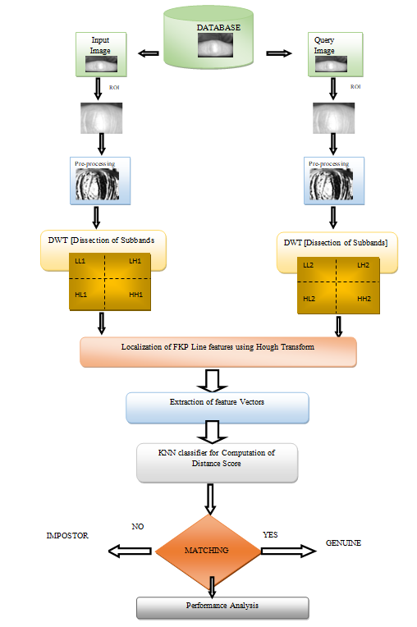

**Figure 2: Proposed block diagram of FKP using DWT and Hough Transform.**

**2.1 PREPROCESSING**

In my case, canny edge detector is used in preprocessing edge detection and for this reason, as the Canny method identifies edges by searching for local maximums of image gradient. The gradient is computed using a Gaussian filter derivative.This approach is also less likely to be fooled by noise than the others, and more likely to detect true weak edges. The method for edge detection begins with weak edges and then shifts to solid edges. In the observed edges, this helps fill in gaps.

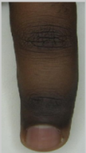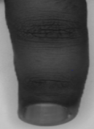

**Figure 3: Original FKP image and its Grayscale image.**

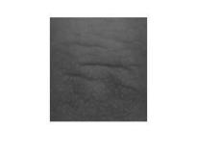 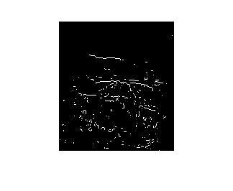

(a). Original FKP image

(b). Robert edge image

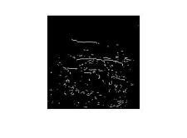 

(c). Prewitt edge image

(d). Sobel edge image

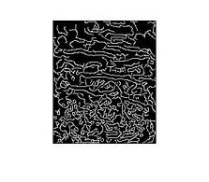 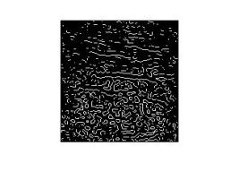

(e). Canny edge image

(e). LoG edge image

**Figure 4: Edge Detected with various edge detection techniques.**

In the above fig. 4., discontinuities can be observed in edges even after detecting edges form canny edge. Such discontinuities give rise to false extractions of features. So the false feature extraction always affect the accuracy of the overall recognition system that why to solve the problem in our work we used Discrete wavelet transform and edge detection of the transformed image.

**2.2 OVERVIEW OF DISCRETE WAVELET TRANSFORM WITH FKP**

Since human eye is less sensitive to changes edges in images. Edge discontinuities in images it always gave some false results [36]. So discontinuities removal in an image is very essential in FKP recognition system. Therefore in our work discrete wavelet transform used in the input image. Because discrete wavelet transform can find out exact instant whenever the signal alteration and also it provides some interesting structures from the image such as edges and details with good resolution for less coefficients [37]. In image processing, DWT used for many applications available like de-noising, restoration and compression. This DWT function can be implemented by using a sub-band coding concept. The sub-band coding concept can divide the image into two regions such as approximation and detail form. The approximation form and detail form always takes average information of the image as well as edge information from the image correctly [38]. In 2D signal analysis, the DWT scaling function ɸ and wavelet function Ψ in x and y directions are,

 (1)



 (2)

 (3)

 (4)

Where is an approximation form, also called horizontal, vertical and diagonal forms respectively[15].

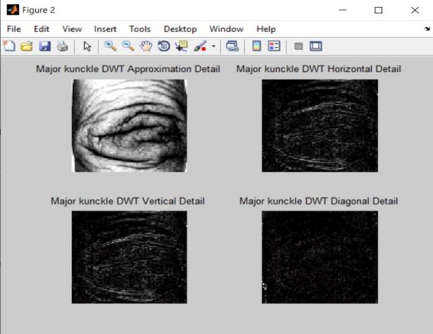 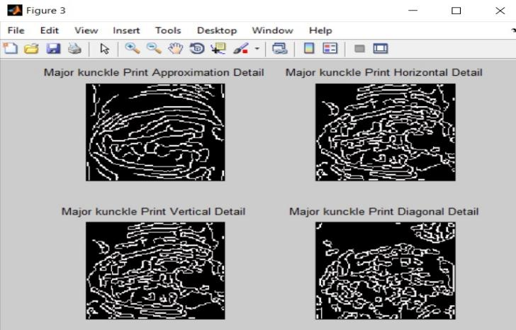

**Figure 5: DWT and Canny edge detection of the DWT transformed image.**

In this work, the DWT technique mainly used to decompose the input image. That decomposed images are called as approximation details, vertical details, horizontal details and diagonal details. So discrete wavelet transform (DWT) is a better option to extract such patterns owing to its space-frequency localization, multiresolution analysis (MRA) capability, and computational efficiency. FKP recognition system may be incorrectly determined using these edge discontinuities and also affect the accuracy of the recognition system. To correct it, the first wavelet transformation is applied over the input image and the wavelet transformation approximation coefficient, with the highest energy so that is enter into canny edge detection algorithm.

# **FEATURE EXTRACTION OF FKP USING HOUGH TRANSFORM**

Hough transform is one of the important feature extraction techniques for images. It is a global technique which was originally designed to identify straight lines, circles and ellipse from an input image [39]. It is widely used to detect lines, circles and ellipse from a digital image so we also used this method in this work for feature extraction. It is broadly used in many applications such as scar detection fingerprint matching of low-quality images, latent fingerprints although popularly it is used for the detection of lines and objects in the form of circles and ellipse [40]. The Hough transform standard equation for line detection is,

 (6)

Where are intersection points of the plane. is the length of the normal line and  is the angle of the normal line with the positive axis. The sinusoidal curve with corresponding values is called Hough transform space. The knuckle points are lying on a single line have the same value of and. These values are recorded on a 2D array that is called Hough accumulator. The and axes of the accumulator are divided into several equal divisions of resolution and respectively [41]. At the number of knuckle points lying on a single line increases, values in the corresponding cell of Hough accumulator also increases. The Hough transform also used to locate the unique coordinates of a straight line is. The steps of the Hough transform is:

**Step1**: Estimate parameter space completely depends upon the image size in space. The line l can be represented by the equation.

 (7)

**Step2**: To create an accumulator array with all elements are starting set to zero.

**Step3:** To find feature points of the input image.

**Step4:** For each point explored, then calculate the corresponding and values that the point may be added. For each value find out, and add one to the position in the accumulator array.

=  (8)

**Step5:** Calculate the accumulator array for global and local maxima values that takes significantly more votes. At these maxima is a collinear point. In accumulator array the longest value l has a maximum value, these maximum values give how many points lie on the line. The  value can be reconstructed by the equation is

. (9)

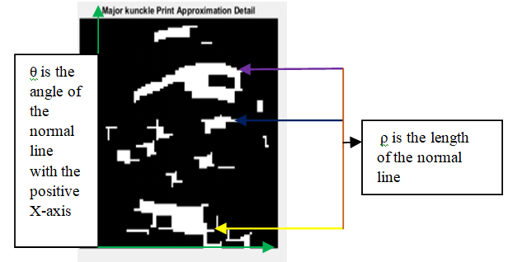

**Figure 6: Feature extraction of the Hough tranform based image.**

In our work FKP feature extraction using hough transform. In this algorithm the Cartesian coordinates are [SxN, SyN, FxN, FyN, ρ , θ].

Where, SxN, SyN, FxN, FyN are the starting and ending points of the line, ρ calculated by the equation (7) and θ calculated by this equation



Finally the feature vector of the finger knuckle information’s are stored in the form of VXk stored image and VYk input image, VXk  illustrates the vector attained from the stored finger knuckle image andVYk illustrates the vector attained from the input finger knuckle image respectively.

In FKP feature extraction process Hough transform can extract global features and the final outputs of the Hough features are as a given input to the K-NN classifier.

**13f**

**Figure7: Results of Hough Transform for approximation Sub-band**

# **KNN CLASSIFICATION**

The extracted features are used as an input into the classifier for deciding the class membership. Classification phase is one of the decisions making phase of a finger knuckle print recognition. In this work, K-NN(nearest neighbour) classifier is used for classification purpose. In the K-Nearest Neighbour classifier, to find out the distance of the current candidate vector and stored vector by using Euclidean distance. The Euclidean distance of a current candidate vector and a stored vector is calculated of this below equation,

 (15)

Here N is the total number of features in the feature set. VXk is the feature value of the stored library template and VYk is the current candidate feature value. KNN find out the nearest neighbour among all the instances in the particular instance of time.

**Feature Vectors of KNN classifier**

**Step 1 :** Extract the knuckle print information from Hough transformation as the feature vector of the KNN

**Step 2:** Set K value using square root of size of feature vector

**Step 3 :** Train the KNN using these feature vectors

**Step 4:** Find the Euclidean distance between train feature and test feature

**Step 5:** Sort the minimum distance values

**Step 6:** Choose K number of minimum distance

**Step** 7**:** Get class value by choose majority class value in step 6.

# **RESULTS AND DISCUSSION**

**Experimental details**

The results and discussion section completely analysis the performance of the proposed system. The images are taken from the publicly available larger FKP database from Hong Kong Polytechnic University (PolyU). This database holds 7920 FKP images taken from 165 subjects. In this work, we used 2515 images for further processing. This work represents the multi-angle representation of FKP using Hough transform. This proposed approach for this biometric system is developed based on DWT for calculation of sub-bands as LL, LH, HL, HH as the input dataset. Classification of this technique is based on KNN classifier for the case of unimodal identification system using PolyUFKP database. To measure the effectiveness of our proposed finger knuckle print DWTHT based recognition scheme, a database containing finger knuckle print images are required. The approach DWTHT was applied form the images and the image is classified by using KNN classifier. This algorithm effective and some advantages: computational cost, efficient feature extraction, analyze the images with multiple direction and minimum features. Here the images are analyzed with multiple direction with less computational cost using DWT. Hough transform also take efficient line features and geometrical invarience. Finally KNN classifier easily recognized those who are geniune or imposter into the database.

This basic algorithm steps explain the FKP analysis in a detailed manner.

**Step1**: Acquiring the training and testing of FKP images in a separate dataset.

**Step2:** Pre-processing images for detecting edges .

**Step3:** analyzing the images into various sub-bands that is Approximation, Horizontal, vertical and Diagonal bands.

**Step4**: Calculations of knuckle feature using Hough transform.

**Step5:** calculation of KNN classification based on feature points.

**Step6:** classification based on Genuine and impostor.

**Step7:** Repeat steps 2 to 6 for various test images until recognition is achieved.

Considerable experiments were carried out and performance analysis was finished based on some parameter viz, such as Accuracy, Sensitivity, Specificity, Precision recall, False Acceptance Rate(FAR), False reject rate(FRR) and Equal error rate(EER). The proposed finger knuckle print biometric recognition system was done by DWT, Hough transforms and K-NN classifier based techniques and Accuracy and EER values of the proposed system compared with various Existing methods. In existing work, the FKP recognition system used different techniques with more number of features to find out the accuracy of the system. In our proposed work, to find the accuracy of the system using less number features and good accuracy level. Because the combination of DWT and Hough transform is one of the efficient extraction algorithm with multiple direction.

The performance measures are calculated by using these parameters such as True Positive (TP), True Negative (TN), False Positive (FP) and False Negative (FN). Based on these values calculated the following parameters.

**Sensitivity = TP**

**TP+FN**

**Specificity = TP**

**TP+FP**

**Accuracy = sensitivity + specificity**

**2**

**False Acceptance Rate (FAR):** Imposter person wrongly accepted as a genuine person.

**FAR = FP**

**FP+TN**

**False Rejection Rate (FRR):** Genuine person wrongly rejected as imposter person.

**FRR = FN**

**TP+FN**

**Equal Error rate:** The intersection between the FAR and FRR values. Lower EER values always give better efficiency of the algorithm.

**Table 1 Performance Analysis of the proposed work**

|  |  |
| --- | --- |
| PARAMETERS | VALUES |
| True positive | 1126 |
| False-positive | 153 |
| True negative | 1107 |
| False-negative | 129 |
| Sensitivity | 0.8979 |
| Specificity | 0.8785 |
| Precision | 0.8803 |
| Recall | 0.8972 |
| False Acceptance rate | 0.1214 |
| False Reject rate | 0.1027 |
| Equal error rate | 0.11 |
| Accuracy | 0.8878 |

**Table 2 Comparison of the proposed method compared with various existing methods.**

|  |  |  |
| --- | --- | --- |
| References | Methods | Accuracy |
| Wu et al. [42] | DWT(Palmprint) | 99.24% |
| Rangaswamy et.al [43] | DWT(iris) | 97.50% |
| Dr.shashikumar et.al [6] | DWT + PCA(iris) | 99.07% |
| Prasad et.al [13] | OCDWT+Contourlet transform(palmprint) | 99.59% |
| Subasi et.al [15] | DWT+ME(EEG signal) | 94.5% |
| Sahoo et.al [14] | DWT+F-ratio(Hand) | 99.08% |
| Varun et.al [44] | Hough transform(face ) | 99.95% |
| Ray et.al [45] | Hough transform(palmprint) | NA |
| Meng et.al [46] | Hough transform(character recognition) | 83.5% |
| Paulino et.al [47] | Descriptor based HT(fingerprint) | 53.5 %(rank 1 accuracy) |
| Lopez et.al [48] | Hough transform(iris) | 78.5% |
| proposed method | DWT+HT | 89% |

**Table 3 Demonstrates the comparative analysis of Equal Error Rate value of the Existing and proposed techniques.**

|  |  |  |
| --- | --- | --- |
| References | Methods are already used for recognition | Results |
| Kumar et.al [49] | PCA(principle component analysis), LDA(Linear discriminant analysis and IPCA(Independent component Analysis) | EER – 1.39% |
| Zhang et.al [50] | Band limited phase only correlation method(BLPOC) | EER – 1.68% |
| Ajay et.al [51] | Local binary pattern, 1D log gabour filter, BLPOC | EER – 3.62% |
| jing et.al [52] | Orthogonal Complex locality preserving approach | EER – 4.28% |
| Lin zhang et.al [53] | Resize transform | EER –1.26% |
| Meraoumiaet.al [54] | Fourier Transform | EER – 1.72% |
| Kazhagamani et.al [20] | Elliptical hough transform based feature extraction | EER – 0.78% |
| A.Muthukumar et.al [55] | Gabour filer with SVM | EER – 0.19% |
| Proposed work | DWT with Hough transform | EER – 0.11% |

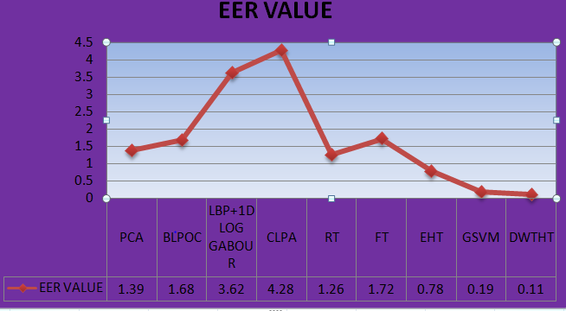

**Figure 8: EER Values of the various methods.**

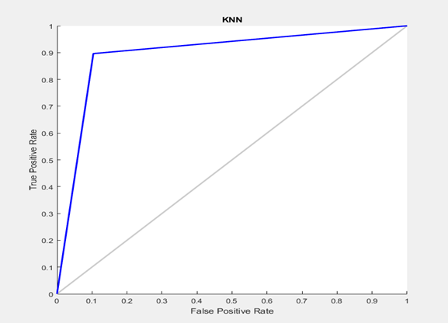

**Figure 9: ROC curve for K-NN classifier of this proposed work.**

# **CONCLUSION**

This paper introduced a novel method for feature extraction using DWT and Hough transform to develop efficient biometric based authentication system using Finger knuckle print Image. We applied these two techniques in our proposed system it can extract efficient features and recognizing a person with best recognition rates. Compare to existing methods, our proposed work gives better recognition rate of 89% and low EER rate. In future work we will improve the accuracy of our proposed system using various techniques and we will enlarge our work with multimodal system such as FKP with face, fingerprint, iris and palmprint etc.

##### REFERENCES

1. Kumar, Ajay. "Importance of being unique from finger dorsal patterns: Exploring minor finger knuckle patterns in verifying human identities." *IEEE transactions on information forensics and security* 9.8 (2014): 1288-1298.
2. Jaswal, Gaurav, Amit Kaul, and Ravinder Nath. "Knuckle Print Biometrics and Fusion Schemes--Overview, Challenges, and Solutions." *ACM Computing Surveys (CSUR)* 49.2 (2016): 1-46
3. Kusanagi, Daichi, et al. "A practical person authentication system using second minor finger knuckles for door security." *IPSJ Transactions on Computer Vision and Applications* 9.1 (2017): 8.
4. Brindha, V. Evelyn. "Finger knuckle print as unimodal fuzzy vault implementation." *Procedia Computer Science* 47 (2015): 205-213.
5. Elnasir, Selma, and Siti Mariyam Shamsuddin. "Palm vein recognition based on 2D-discrete wavelet transform and linear discrimination analysis." *Int. J. Advance Soft Compu. Appl* 6.3 (2014): 2074-8523.
6. DR, Shashi Kumar, et al. "PCA based Iris Recognition using DWT." *Int. J. Comp. Tech. Appl* 2.4 (2011): 884-893.
7. Masood, Hassan, et al. "Wavelet based palmprint authentication system." *2008 International Symposium on Biometrics and Security Technologies*. IEEE, 2008.
8. Ganorkar, Sanjay, and Mayuri Memane. "IRIS recognition using discrete wavelet Transform." *International Journal of Advances in Engineering & Technology* 4.1 (2012): 356.
9. Sujatha, B. M., et al. "Compression Based Face Recognition Using DWT and SVM." (2016).
10. Rajbhoj, S. M., and P. B. Mane. "An Approach of Combining Iris and Fingerprint Biometric At Image Level in Multimodal Biometrics System."
11. Biradar, Uma, et al. "Palmprint recognition using wavelet." *Thinkquest~ 2010*. Springer, New Delhi, 2011. 266-269.
12. Harshad, Faseela, and Alphonse Devasia. "Optimized multispectral palmprint recognition system based on contourlet transform." *International Journal of Computer Applications* 71.23 (2013).
13. Prasad, S. M., V. K. Govindan, and P. S. Sathidevi. "Palmprint authentication using fusion of wavelet and contourlet features." *Security and Communication Networks* 4.5 (2011): 577-590.
14. Sahoo, Jaya Prakash, Samit Ari, and Dipak Kumar Ghosh. "Hand gesture recognition using DWT and F-ratio based feature descriptor." *IET Image Processing* 12.10 (2018): 1780-1787.
15. Subasi, Abdulhamit. "EEG signal classification using wavelet feature extraction and a mixture of expert model." *Expert Systems with Applications* 32.4 (2007): 1084-1093.
16. Kandaswamy, A., et al. "Neural classification of lung sounds using wavelet coefficients." *Computers in biology and medicine* 34.6 (2004): 523-537.:
17. Ye Huashan, et al. "A new method based on hough transform for quick line and circle detection." *2015 8th International Conference on Biomedical Engineering and Informatics (BMEI)*. IEEE, 2015.
18. Żorski, Witold, et al. "Fingerprint and iris identification method based on the hough transform." *Biuletyn Instytutu Automatyki i Robotyki* 7 (2001): 43-54.
19. Nair, P. S., and A. T. Saunders Jr. "Hough transform based ellipse detection algorithm." *Pattern Recognition Letters* 17.7 (1996): 777-784.
20. Kazhagamani, Usha, and Ezhilarasan Murugasen. "A Hough transform based feature extraction algorithm for finger knuckle biometric recognition system." *Advanced Computing, Networking and Informatics-Volume 1*. Springer, Cham, 2014. 463-472.
21. Bhatia, Isha, and A. Kumar. "Gait recognition using Hough transform and DWT." *Int. J. Adv. Res. Comput. Sci. Softw. Eng* 4.6 (2014).
22. Anoop, T. R., and M. G. Mini. "Hough transform-based technique for fingerprint alteration detection and classification." *International Journal of Biometrics* 7.4 (2015): 309-325
23. Saroha, Nitika, and Nasib Singh Gill. "Hough Transform Based Fingerprint Matching Using Minutiae Extraction." *International Journal of Advanced Research in Computer Science* 4.10 (2013).
24. Hegde, Chetana, et al. "FKP biometrics for human authentication using Gabor wavelets." *TENCON 2011-2011 IEEE Region 10 Conference*. IEEE, 2011.
25. Gomaa, Ibrahim A., Gouda I. Salama, and Ibrahim F. Imam. "Biometric OAuth service based on finger-knuckles." *2012 Seventh International Conference on Computer Engineering & Systems (ICCES)*. IEEE, 2012.
26. Aoyama, Shoichiro, Koichi Ito, and Takafumi Aoki. "A finger-knuckle-print recognition algorithm using phase-based local block matching." Information Sciences 268 (2014): 53-64.
27. Meraoumia, Abdallah, et al. "Finger-Knuckle-Print identification based on histogram of oriented gradients and SVM classifier." *2015 First International Conference on New Technologies of Information and Communication (NTIC)*. IEEE, 2015.
28. Choras, Michal, and Rafal Kozik. "Knuckle biometrics based on texture features." *2010 International Workshop on Emerging Techniques and Challenges for Hand-Based Biometrics*. IEEE, 2010.
29. ChandrakiranSahu, et.al. “A Novel Finger Knuckle Print Recognition Algorithm Using Radon Coefficients.” *International Journal of Engineering and Techniques -* Volume 3 Issue 5, Sep-Oct 2017.
30. Nanni, Loris, and Alessandra Lumini. "A multi-matcher system based on knuckle-based features." *Neural computing and applications* 18.1 (2009): 87-91.
31. Zhang, Lin, Lei Zhang, and David Zhang. "Finger-knuckle-print verification based on band-limited phase-only correlation." *International Conference on Computer Analysis of Images and Patterns*. Springer, Berlin, Heidelberg, 2009.
32. Kekre, H. B., and V. A. Bharadi. "Finger-Knuckle-Print verification using Kekre's wavelet transform." *Proceedings of the International Conference & Workshop on Emerging Trends in Technology*. 2011.
33. Meraoumia, Abdallah, Salim Chitroub, and Ahmed Bouridane. "On-line finger-knuckle-print identification using Gaussian mixture models & discrete cosine transform." (2013).
34. Raut, R. D., Sujata Kulkarni, and Neha N. Gharat. "Biometric authentication using kekre's wavelet transform." *2014 International Conference on Electronic Systems, Signal Processing and Computing Technologies*. IEEE, 2014.
35. Jayapriya, P., and R. Manimegalai. "Finger Knuckle Biometric Authentication using Texture-Based Statistical Approach." *2018 International Conference on Intelligent Computing and Communication for Smart World (I2C2SW)*. IEEE, 2018.
36. Sejpal, Shveti, and Nikesh Shah. "Performance Analysis for Authentication in Digital Gray Scale Image using DWT Domain." *International Journal of Scientific and Research Publications* 5.12 (2015).
37. Armas Vega, Esteban Alejandro, et al. "Digital images authentication technique based on dwt, dct and local binary patterns." *Sensors* 18.10 (2018): 3372.
38. Panguluri, Sumanth Kumar, and Laavanya Mohan. "Efficient DWT based Fusion Algorithm for Improving Contrast and Edge Preservation."
39. Illingworth, John, and Josef Kittler. "A survey of the Hough transform." *Computer vision, graphics, and image processing* 44.1 (1988): 87-116.
40. Anoop, T. R., and M. G. Mini. "Hough transform-based technique for fingerprint alteration detection and classification." *International Journal of Biometrics* 7.4 (2015): 309-325.
41. Żorski, Witold, et al. "Fingerprint and iris identification method based on the hough transform." *Biuletyn Instytutu Automatyki i Robotyki* 7 (2001): 43-54.
42. Wu XQ, Wang KQ, Zhang D. Wavelet energy feature extraction and matching for palmprint recognition. Journal of Computer Science and Technology 2005; 20(3): 411--418.
43. Rangaswamy, Y., and K. B. Raja. "The Biometric Algorithm based on Fusion of DWT Frequency Components of Enhanced Iris Image."
44. Varun, R., et al. "Face recognition using hough transform based feature extraction." *Procedia Computer Science* 46 (2015): 1491-1500.
45. Ray, Kasturika B., and Rachita Misra. "Palm print recognition using hough transforms." *2015 International Conference on Computational Intelligence and Communication Networks (CICN)*. IEEE, 2015.
46. Meng, Yifei, et al. "Hough Transform with Guidance of Endpoints for the Purpose of Tangut Character Recognition." *Proceedings of the International MultiConference of Engineers and Computer Scientists*. Vol. 1. 2018.
47. Paulino, Alessandra A., Jianjiang Feng, and Anil K. Jain. "Latent fingerprint matching using descriptor-based hough transform." *IEEE Transactions on Information Forensics and Security* 8.1 (2012): 31-45.
48. López, Fabián Rolando Jiménez, Camilo Ernesto Pardo Beainy, and Oscar Eduardo Umaña Mendez. "Biometric iris recognition using Hough Transform." *Symposium of Signals, Images and Artificial Vision-2013: STSIVA-2013*. IEEE, 2013.
49. Kumar, Ajay, and Ch Ravikanth. "Personal authentication using finger knuckle surface." *IEEE Transactions on Information Forensics and Security* 4.1 (2009): 98-110.
50. Zhang, Lin, Lei Zhang, and David Zhang. "Finger-knuckle-print verification based on band-limited phase-only correlation." *International Conference on Computer Analysis of Images and Patterns*. Springer, Berlin, Heidelberg, 2009.
51. Kumar, Ajay. "Can we use minor finger knuckle images to identify humans?." *2012 IEEE fifth international conference on biometrics: theory, applications and systems (BTAS)*. IEEE, 2012.
52. Jing, Xiaoyuan, et al. "Orthogonal complex locality preserving projections based on image space metric for finger-knuckle-print recognition." *2011 International Conference on Hand-Based Biometrics*. IEEE, 2011.
53. Zhang, Lin, Hongyu Li, and Ying Shen. "A novel Riesz transforms based coding scheme for finger-knuckle-print recognition." *2011 International Conference on Hand-based Biometrics*. IEEE, 2011.
54. Meraoumia, Abdallah, Salim Chitroub, and Ahmed Bouridane. "Fusion of finger-knuckle-print and palmprint for an efficient multi-biometric system of person recognition." *2011 IEEE International Conference on Communications (ICC)*. IEEE, 2011.
55. Muthukumar, A., and A. Kavipriya. "A biometric system based on Gabor feature extraction with SVM classifier for Finger-Knuckle-Print." *Pattern Recognition Letters* 125 (2019): 150-156.