NANO BIOSENSOR: CONCEPT TO APPLICATIONS
V. Pravallika¹, Naga Jogayya Kothakota¹, Bikash Ranjan Jena²

¹Assistant Professor,
Department of Forensic Science
Centurion University of Technology and Management,
Nellimarla, Vizianagaram, Andhra Pradesh, India.
E-Mail: pravalikav@cutmap.ac.in

¹Associate Professor,
Department of Forensic Science,
Centurion University of Technology and Management,
Nellimarla, Vizianagaram, Andhra Pradesh, India.

²Associate Professor,
School of Pharmacy and Life Sciences,
Centurion University of Technology and Management
Jatni, Bhubaneswar, Odisha.

Abstract
The field of nanotechnology is significantly influencing the advancement of a novel category of biosensors referred to as nanobiosensors. Nanobiosensors typically consist of a biological recognition molecule that is mounted onto the surface of a signal transducer. Consequently, the efficacy of the nanobiosensor is contingent upon the careful design of the biosensing interface. Nanobiosensors are currently being widely employed for the purpose of molecular detection of biomarkers that are connected with the diagnosis of various diseases. The utilization of novel nanomaterials in the field of biosensing has had a significant impact on biosensing research. The utilization of nanomaterials with large surface area has played a significant role in the development of nanobiosensors characterized by enhanced sensitivity and reduced response times. Current review intensifies a comprehensive overview of the recent advancement, and categories of nanobiosensors and broadest applications of Nanobiosensors in diverse sectors of biomedical and healthcare.

Key words: Nanoparticle, Graphene, Electrochemical, Nanozymes, Carbon nanotubes

1.Introduction
Nanosensors are very powerful devices that play a key role in the field of nanotechnology. They make it possible to measure and analyze chemicals and other things directly and are used in many different scientific processes. These sensors are made to react all the time and give data in real-time without hurting the sample being tested. Nanosensors use nanostructures to pick up on gases, chemicals, biological agents, electric fields, light, heat, and other things. When nanoparticles are added to the system, nanosensors become even more sensitive, which improves their accuracy and performance. In the field of biosensors, for example, DNA strands, antibodies, enzymes, or whole cells are used to find and identify the sample. Nanosensors can be used in the same way. The use of nanoparticles to make biosensors has changed the way that medicine and biology are used. Nano biosensors are a huge step forward in technology. They use the qualities of nanomaterials to find and analyze biological molecules with great accuracy and sensitivity. Nano biosensors have made a big difference in the field of biosensing by taking advantage of the unique qualities of nanomaterials, such as their high surface area-to-volume ratio and better optical or electrical properties. These new sensors have made it possible to make detection platforms that are both sensitive and selective. This lets biomarkers be tracked in real-time in a variety of settings, such as healthcare, environmental monitoring, and industrial uses. These nano biosensors could change how diseases are found and treated because they can find biomarkers in very low amounts. This means that diseases can be found early and correctly. Adding nanotechnology to biosensors has also led to improvements in single-molecule analysis, real-time detection, low power usage, and miniaturization, which makes them perfect for use in living organisms.

2. Biosensors
The word Biosensors is a combination of two words called ‘Bio’ and ‘Sensors’. Bio refers to biological systems which include plant systems, animal systems, bacterial systems and human systems. Sensors refer to sensing or detecting something. Here, Biosensor detects the physio-chemical changes in biological systems (plants, animals, bacteria, and human systems). Simply, a biosensor is defined as an analytical tool that comprises immobilized biological components, such as enzymes or antibiotics, that interact with an analyte (the concentration of which must be determined) and generate measurable physical, chemical, or electrical signals. The breath analyzer is the best example of a Biosensor which detects acetaldehyde concentration (analyte) which is significantly present in the breath of an alcoholic person and it shows the measurable signals as an indication.
- Nanoparticles:
The particles of matter whose diameter is in the range between 1- 100 nanometers are considered Nanoparticles. Nanometers (1 nm = 10⁻⁹ meters) are the units used to measure the ultra-fineness of nanoparticles. Nanoparticles are produced both naturally and as a result of human activity. They're crafted from unique, tiny materials. Engineering, catalysis, medicine, and even environmental cleaning could all benefit from using synthetic nanoparticles. Nanoparticles can be classified in numerous ways based on their size, shape, and material properties. Some classification systems place dendrimers, liposomes, and polymeric nanoparticles in the organic category, while others place fullerenes, quantum dots, and gold nanoparticles in the inorganic group. Nanoparticles can also be classified based on whether they are made of carbon, ceramic, semiconducting material, or polymer. Liposomes, vesicles, and nanodroplets are examples of soft nanoparticles, while titania and silica nanoparticles are examples of hard nanoparticles. Whether a nanoparticle is classified as a therapeutic, diagnostic, or research nanoparticle may depend on its intended application, its manufacturing process, or both [1]. In biosensors, Nanoparticles are used as a sensing element for rapid detection and ultra-sensitivity of responses.
- Nano-Biosensors
In simple terms, nano biosensors are nanomaterial-based sensors that detect the analyte in the biological system. Interestingly these Nano-biosensors are not specialized sensors that can detect tiny events and happenings [2].
Components of Nano-biosensors: There are four basic parts that make up a biosensor, which is an analytical instrument that produces a quantifiable electrical output signal in response to a biological or chemical analyte. The bioreceptor, also known as the recognition layer, which is coupled to the analyte and binds to the target component with high selectivity properties, causes the electronic reaction whether the analyte is made of chemical or biological materials. The transducer, which serves as an interface, measures the reaction's production while the bio-receptor converts that energy into a measurement signal. A detector is a component that will present the results after recognition in an understandable manner. (3). Biosensors evoke the biological element, that enables biological reactions. It can be achieved by biological recognition elements. Biosensors are of two types namely ‘Gen X’ and ‘Gen Y’ biosensors. Gen X biosensors are rapid in detection and specific to the reaction with no need for pretreatment of sampling. Whereas, Gen Y biosensors are nano biosensors, where nanoparticles are used as a sensing element, Ultrasensitive to the responses, and rapid in the detection of the analyte (Figure 1).

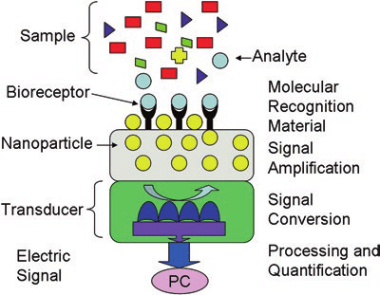
Figure 1: showing the components of the Biosensor along with its function. Blue color balls are the analytes, yellow color balls are Nanoparticles, and Y-shaped black color receptors are Bioreceptors [14].

3.Nano Particles used for Biosensors
- Graphene Nanoparticles in Biosensors
A 2D structural material known as "wonder material" in nanotechnology is graphene. Graphene is a preferred material for the transducer in Nano biosensors because of its exceptional physicochemical qualities, which include high conductivity, low charge carrier resistance, and a high surface volume ratio. graphene sheets provide easy exposure to environmental variations due to their conductivity and dimensionality which is crucial for a sensing application. Using graphene-based FET biosensors, real-time COVID-19 viral identification from nasopharyngeal swab samples of afflicted patients has been reported [4].

b. Gold Nanoparticles in Biosensors – Gold Nanoparticles provide an easy environment for the proper functionalization of biosensors with various biological analytes such as nucleic acids, amino acids, and Ag-Ab interactions. Gold nanoparticles embedded working electrodes have special optical properties. It makes them bring higher coefficient values that can be detected by the naked eye even at lower concentrations. When these highly coefficient optical signals were passed inside the biosensors, sufficient electrical signals were produced for ultra-sensitive detection of the analyte [5, 6].
c. Carbon Nanotubes (CNT) in Biosensors – The surface of CNTs can be used as a substrate to immobilize biomolecules. Carbon nanotubes (CNTs) are one of the greatest materials for potentially improving the transduction of signals related to the detection of analytes, metabolites, or disease biomarkers due to their remarkable chemical, physical, electrical, and optical capabilities. CNTs also have a Good electrical conductivity property that enhances the response of biosensors.
4.Nano Biosensor Types
As all Nano Biosensors are having common components, transducers make a difference among one of the other nano biosensors. Based on transducer types, Nanobiosensors are of 4 types.
- Optical Biosensors
- Electrochemical Biosensors
- Thermometric Biosensors
- Piezoelectric Biosensors

Table 1: Showing Application of Nanoparticles in different types of Biosensors and Its Applications in the Biological Field

S. No | Type of Biosensor | Type of Nanoparticles used | Application
1. | Electrochemical | Graphene Nano Particles, Gold Nanoparticles | Disease Diagnosis, DNA analysis
2. | Optical/fluorescent | Gold Nanoparticles, Optical Fibres | Drug Development, DNA analysis, and Biosensing
 | Thermometric | Gold plated with Iron, Gold Plated with Copper Nanoparticles | Bioimaging, DNA analysis and Biosensing
 | piezoelectric | Metal Nanoparticles | Bioimaging and Antigen and Antibody (Ag-Ab) interaction
 | DNA Biosensor | Carbon Nanotubes | Immuno sensing in agribiotech

- Electrochemical Nano biosensors –The electrochemical (EC) biosensor is based on an enzymatic catalytic reaction that either uses up or produces electrons. electrochemical transducers are used as a sensing material which is only applicable in redox reactions associated with metabolites/enzymes and conveys a chemical signal to the electrodes that can be used to measure the concentration of the analyte. The EC is used to detect the analytes Used to detect key analytes such as neurotransmitters, lactic acid, glucose, blood ketones, hemoglobin, Uric acid, cholesterol, hemoglobin, amino acids, immunoglobulin, and soluble gases, in vibrant body liquids. Cancer is just one of several disorders that can be detected with its help. Magnetic nanomaterials, Metals, and Oxides were used as nanomaterials in the EC Nano biosensors [7-9].
- Optical Biosensors – Since their commercial availability in 1990, optical biosensors have been small analytical instruments are having biorecognition components coupled with the system of the transducer. Optical biosensors produce an optical signal that is exactly proportional to the analyte concentration by detecting changes in the properties of light (fluorescence, Raman scattering, plasma resonance, or merely changes in spectral properties). In most cases, components from biology such as antibodies, enzymes, antigens, nucleic acids, receptors, entire tissues, and cells are used as elements for biorecognition. Either label-based or label-free optical biosensing can be used. The analyte is labeled in label-based procedures, and an optical signal is generated by colorimetric, fluorescent, or luminescent approaches; in contrast, the analyte interacts with the transducer directly in label-free protocols [10]. It is evident that the application of these biosensors for tracking molecular interactions has grown significantly during the past two years.
- Thermometric Biosensors – Thermometry essentially means the measurement of temperature. Thermometric biosensors detect certain temperature changes in the biological reaction and indirectly detect the concentration of the analyte by the degree of change in temperature. For example, When the cholesterol (biological element) is breakdown with the enzyme cholesterol oxidizes, it liberates or releases some heat. Thermometric transducers detect this heat and convert it into a digital signal.
- Piezoelectric Biosensor – It is also known as a Physical biosensor. Assume that the Antibody is sitting on the oscillating board (as shown in the figure), When the Antigen comes and binds with that antibody the frequency of the oscillation decreases. These physical changes in the frequency of oscillations will be detected by the piezoelectrical transducer. Simply, piezoelectric or physical biosensors detect the rate of frequency of oscillations and it will be telling us the concentration of the analyte (Figure 2).

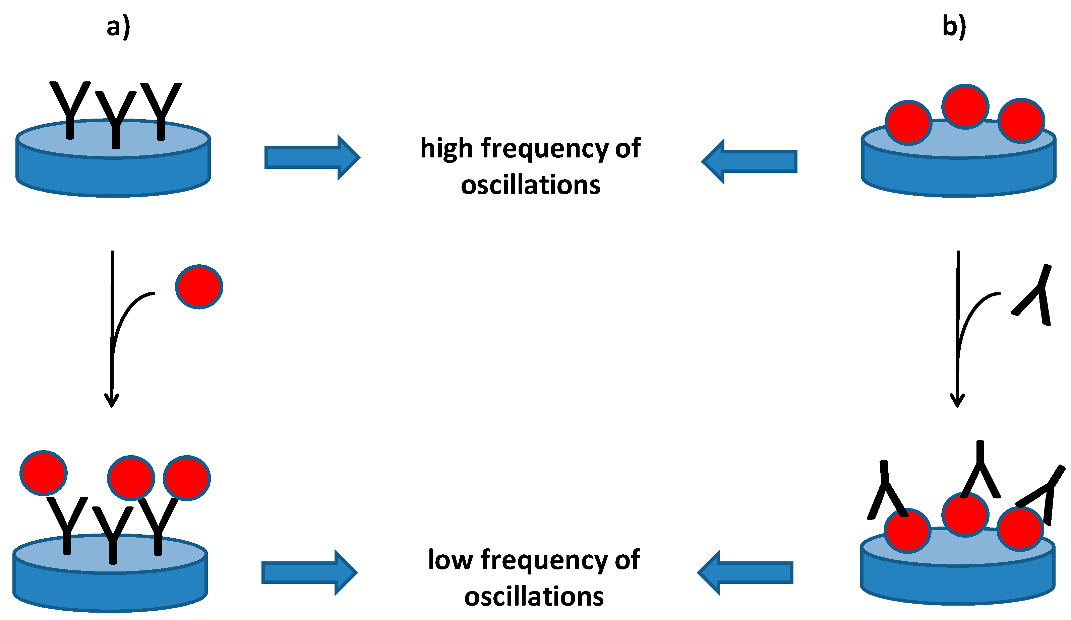
Figure 2: Piezoelectric Nano Biosensor for the detection of a) Antigen or b) Antibody. Piezoelectric crystals are represented as a blue color disc, Antigens are represented as red color balls, and Antibodies are represented as Y due to the appearance of immunoglobulin’s [13]
5.Advancement and Applications in diverse domains
a.Biological Application: The field of nanotechnology has speed up the integration of numerous scientific disciplines, facilitating the breakdown of boundaries between already established disciplines. The new multidisciplinary science of nanotechnology and its connected biology branch, nanobiotechnology, finally resulted from this. The result of this branch's advancements and breakthroughs was the creation of nanomedicine, which encompasses, among other things, regenerative medicine, molecular imaging, diagnostic tools and materials, and drug delivery systems [11].
b.Environmental Application: Nanobiotechnology has spread its wings to all the fields of biology. It encounters the solutions for Environmental hazards by Sensing the health of plants, soil, and soil diseases, detecting metabolites and plant hormones, and quantifying the pesticides, fungicides, fertilizer compounds, and heavy metal ions present in the soil are examples. Electrochemical, optical biosensors are mostly used for the purpose of environmental safety.
c.Food Processing, Air and Water Quality Control: Diagnostic instruments for detecting pests during storage and ensuring final quality assurance; applications span the entire agri-food chain; detection of soil conditions; diagnosis of crop illnesses caused by pests/pathogens; management of severe infections [12].
d.Medical Application: Medical industry has wide operating fields such as disease diagnosis, disease treatment, drug delivery testing, bioimaging, DNA analysis, etc, Nanobiotechnology can satisfy all the needs in the medicinal field by providing Nano biosensors. Nano biosensors have been used to detect, monitor, and treat some of the deadliest non-communicable and communicable diseases, including SARS, diabetes, Ebola, Cancer, Avian influenza, Hendra, Tuberculosis, Nipah, AIDS, Malaria, and the recently popular SARS-CoV-2. Electrical Nano biosensors and Optical Nano biosensors have been used in treating diseases [13,14].
e.Nanozymes centered biosensor for Healthcare: Nanozymes have become a viable alternative to natural enzymes in the past couple of decades. Enzyme-mimicking nanomaterials have been getting a lot of attention now-a-days. Nanozyme-based biosensors possess a brightful future and hold the aptitude of revolutionizing biomolecular sensing [15]. The construction of highly sensitive and low-biofouling biosensors could result from the development of extremely selective, multi-enzyme mimicking nanozymes. By raising the accuracy and sensitivity of diagnostic instruments while cutting expenses and improving the treatment of patients, the incorporation of nanozymes into point-of-care diagnostics has the potential to revolutionize healthcare [15]
References:
- Ambhorkar P, Wang Z, Ko H, Lee S, Koo KI, Kim K, Cho DD. Nanowire-Based Biosensors: From Growth to Applications. Micromachines (Basel). 2018 Dec 19;9(12):679. doi: 10.3390/mi9120679. PMID: 30572645; PMCID: PMC6316191.
- Parth Malik, Varun Katyal, Vibhuti Malik, Archana Asatkar, Gajendra Inwati, and Tapan K. Mukherjee. Nano biosensors: Concepts and Variations. Internationally Scholarly Research Notices (hindawi.com). 2023; Volume 2013; Article ID 327435. Doi: https://doi.org/10.1155/2013/327435
- Meenu Thakur, Bo Wang, Madan L. Verma, (2022); Development and applications of nano biosensors for sustainable agricultural and food industries: Recent developments, challenges, and perspectives, Environmental Technology & Innovation, Volume 26, May 2022, 102371. https://doi.org/10.1016/j.eti.2022.102371.
- Afsahi S, Lerner MB, Goldstein JM, Lee J, Tang X, Barozzi DA Jr, Pan D, Locascio L, Walker A, Barron F, Goldsmith BR. Novel graphene-based biosensor for early detection of Zika virus infection. Biosensor Bio electron. 2018 Feb 15; 100:85-88. Doi: 10.1016/j.bios.2017.08.051.
- Eliza Hutter, Dusica Maysinger (2013); Gold-nanoparticle-based biosensors for detection of enzyme activity, Trends in Pharmacological Sciences, Volume 34, Issue 9, September 2013, Pages 497-507. https://doi.org/10.1016/j.tips.2013.07.002
- Davis L. Basic methods in molecular biology. Elsevier; 2012 Dec 2.
- Ramesh M, Janani R, Deepa C, Rajeshkumar L. Nanotechnology-Enabled Biosensors: A Review of Fundamentals, Design Principles, Materials, and Applications. Biosensors. 2023; 13(1):40. https://doi.org/10.3390/bios13010040
- Meenakshi Choudhary, Kavita Arora (2022), Electrochemical biosensors for early detection of cancer, Biosensor Based Advanced Cancer Diagnostics From Lab to Clinics 2022, Pages 123-151. https://doi.org/10.1016/B978-0-12-823424-2.00024-7.
- Ankur M. Kumar, Kavita Kachhawa (2023), Biomedical applications of bioelectrochemical sensors, Multifaceted Bio-sensing Technology Volume 4 in Bio electrochemical Systems: The way forward 2023, Pages 239-260. https://doi.org/10.1016/B978-0-323-90807-8.00014-2
- Pedro Estrela, Pavel Damborský, Juraj Švitel, Jaroslav Katrlík; Optical biosensors. Essays Biochem 30 June 2016; 60 (1): 91–100. doi: https://doi.org/10.1042/EBC20150010.
- Duncan R., Gaspar R. Nanomedicine(s) under the microscope. Mol. Pharm. 2011;8:2101–2141. doi: 10.1021/mp200394t
- Rai M.C., Ribeiro L., Mattoso N., Duran Nanotechnologies in Food and Agriculture Springer International Publishing Switzerland (2015).
- Pohanka M. Overview of Piezoelectric Biosensors, Immunosensors and DNA Sensors and Their Applications. Materials. 2018; 11(3):448. https://doi.org/10.3390/ma11030448.
- Marcelo R. Romero & Matías L. Picchio (2020), Biosensors Based on Nanomaterials: Transducers and Modified Surfaces for Diagnostics, Nanobiomaterial Engineering, pp-15-47.
- Swain, S., Ghose, D., Jena, B.R., Sahu, A. and Rao, G.S.N., 2023. Modern Advancements, Patents and Applications of Futuristic Nanozymes: A Comprehensive Review. Nanoscience & Nanotechnology-Asia, 13(2), pp.43-63.

