INTRODUCTION:
The amniotic fluid is the protective liquid contained by the amniotic sac of a gravid amniote. It has a number of important roles in embryo and subsequently fetal development. One of the main functions is to permit fetal movement and the development of the musculoskeletal system. This fluid serves as a cushion for the growing fetus, but also serves to facilitate the exchange of nutrients, water and biochemical products between mother and fetus.. In the 2nd trimester, the fetus begins to breathe and swallow the amniotic fluid. In some cases, the amniotic fluid may measure too low or too high. If the measurement of amniotic fluid is too low it is called oligohydramnios and if the measurement of amniotic fluid is too high it is called polyhydramnios.
NORMAL AMNIOTIC FLUID VOLUME:
10 weeks: 30ml
20 weeks: 250ml
30-40 weeks: 500-1500 ml
NORMAL AMNIOTIC FLUID INDEX:
8-24 cm
OLIGOHYDRAMNIOS:
It is extremely rare condition where the liquor amnii is deficient in amount to the extent of less than 200ml at term.
Sonographically, it is defined when the maximum vertical pocket of liquor is less than <2 cm or when amniotic fluid index (AFI) is less than 5 cm.
TYPES:
- Early onset oligohydramnios: It is developed early in pregnancy and is less common and frequently has a poor prognosis.
- Late pregnancy oligohydramnios: It is associated with increased risk of adverse perinatal outcomes compared to normal amniotic fluid index (AFI).
ETIOLOGY:
Maternal condition:
- Hypertensive disorders
- Uteroplacental insufficiency
- Dehydration
- Idiopathic
- Post term pregnancy
- Premature rupture of membrane
Fetal condition:
- Renal agenesis
- Urinary tract obstruction
- Spontaneous rupture of membranes
- Intrauterine infection
- IUGR
- Postmaturity
- Drugs: PG inhibitors, ACE inhibitors
- Fetal chromosomal and structural abnormalities
- Amnion nodosum
DIAGNOSIS:
- Uterine size is much smaller than the period of amenorrhea
- Less fetal movements
- The uterus is ‘full of fetus’ because of scanty liquor
- Malpresentation (breech) is common
- Evidences of intrauterine growth retardation of the fetus
- Sonographic diagnosis is made when largest liquor pool is less than 2 cm.
- Visualization of normal filling and emptying of fetal and bladder essentially rules out urinary tract abnormality
- Oligohydramnios with fetal symmetric growth restriction is associated with increased chromosomal abnormality.
COMPLICATIONS:
Maternal:
- Prolonged labor due to inertia
- Increased operative inference due to malpresentations
- Chorioamnionitis
Fetal:
Due to etiology:
- Congenital anomalies
- Chromosomal abnormalities
- Fetal growth restriction
- IUD
- Intra uterine infection following ROM
- Prematurity
Due to reduced amniotic fluid volume:
- Skeletal deformities
- Contractures
- Amniotic bands and autoamputation
- Pulmonary hypoplasia
- Umbilical cord compression
- Meconium aspiration
- FHR abnormalities
- Low APGAR scores
- Intrapartum death
MANAGEMENT:
First trimester:
- Counselling
- Serial USG
Second trimester:
- Counselling
- Consider amnioinfusion
- Serial USG
- Exclude preterm premature rupture of membrane (PPROM)
- Termination of pregnancy SOS
Third trimester:
- Deliver post term cases
- Serial USG and Doppler in IUGR
- Conservative management for PPROM till 34 weeks
- Idiopathic cases: NST, serial USG
Specific measures to increase amniotic fluid volume:
- Maternal hydration: 1500-2000 ml/day (oral/IV)
- Amnioinfusion (abdominally/trans cervically)
POLYHYDRAMNIOS:
- Anatomically, polyhydramnios is defined as a state where liquor amnii exceeds 2000 ml.
- Clinical definition states, the excessive accumulation of liquor amnii causing discomfort to the patient and/or when an imaging help is needed to substantiate the clinical diagnosis of the lie and presentation of the fetus.
ETIOLOGY:
Fetal anomalies: (20%)
- Anencephaly: Excessive amount of liquor amnii may be due to–
- Transudation from the exposed meninges
- Absence of fetal swallowing reflex
- Possible suppression of fetal antidiuretic hormone leading to excessive urination
- Open spina bifida: Increased transudation from the meninges.
- Esophageal or duodenal atresia: Preventing swallowing of the liquor.
- Facial clefts and neck masses: By interfering normal swallowing
- Hydrops fetalis: due to Rhesus isoimmunisation, non-immune hydrops, cardiothoracic anomalies, fetal cirrhosis and fetal infections with TORCH and parvovirus B19 infection are often associated with hydramnios.
- Aneuploidy and genetic syndromes.
Placenta:
Chorioangioma of the placenta: Tumor growing from a single villus consisting of hyperplasia of blood vessels and connective tissue results in increased transudation.
Multiple pregnancy:
Multiple pregnancy is 10 times more common than its overall incidence. Hydramnios is more common in monozygotic twins, usually affecting the second sac.
Maternal: (30%)
- Diabetes:
It is presumed that a raised maternal blood sugar

Raised fetal blood sugar

Fetal dieresis

Polyhydramnios

- Cardiac or renal disease: May lead to edema of the placenta leading to increase in transudation.
Idiopathic: (50-60%)
TYPES:
Depending on the rapidity of onset, polyhydramnios may be classified into 2 types:
- Acute polyhydramnios (extremely rare): Onset is sudden, within few days or may appear acutely on pre-existing chronic variety.
- Chronic polyhydramnios (most common): Onset is insidious taking few weeks.
Polyhydramnios can also be classified into 3 types:
- Mild: Deepest vertical pocket more than 8-11cm.
- Moderate: Deepest vertical pocket 12-15cm.
- Severe: Deepest vertical pocket more than or equal to 16cm.

ACUTE POLYHYDRAMNIOS:
It is extremely rare. The onset is acute and the fluid accumulates within a few days. It usually occurs before 20 weeks of pregnancy. It is usually associated with monozygotic twins with twin-twin transfusion syndrome (TTTS) or chorioangioma of the placenta.
SIGNS AND SYMPTOMS:
Symptoms:
- Abdominal pain
- Nausea
- Vomiting
Signs:
- The patient looks ill
- Absence of features of shock
- Edema of the legs or presence of other associated features of pre-eclampsia
- Abdomen is hugely enlarged more than the period of amenorrhea; the wall is tense with shiny skin
- Fluid thrill is present
- Fetal parts cannot be felt normal but the fetal heart sound audible
- Internal examination reveals– taking up of the cervix or even dilatation of the os through which the bulged membranes are felt
- Sonography shows multiple fetuses or at times fetal abnormalities.
TREATMENT:
Most often, spontaneous abortion occurs. In case with severe TTTS, repetitive amnioreduction until the AFI is normal may improve the perinatal outcome. Laser ablation may cure the cause of TTTS whereas amnioreduction only treats the symptoms.
CHRONIC POLYDRAMNIOS:
In the majority of cases, the accumulation of liquor is gradual and as such, the patient is not very much inconvenienced.
SIGNS AND SYMPTOMS:
Symptoms:
- Respiratory: The patient may suffer from dyspnea or even remain in the sitting positing for easier breathing.
- Palpitation
- Edema of the legs
- Varicosities in the legs or vulva
- Haemorrhoids
Signs:
- The patient may be in a dyspneic state in the lying down position.
- Evidence of pre-eclampsia (edema, hypertension and proteinuria) may be present.
Abdominal examination:
Inspection:
- Abdomen is markedly enlarged, looks globular with fullness at the flanks.
- The skin is tense, shiny with large striae.
Palpation:
- Height of the uterus is more than the period of amenorrhea.
- Girth of the abdomen round the umbilicus is more than normal.
- Fluid thrill can be elicited in all directions over the uterus.
- Fetal parts cannot be well-defined; so also the presentation or the position. External ballottement can be elicited more easily.
Auscultation:
Fetal heart sound is not heard distinctly, although its presence can be picked up by Doppler ultrasound.
Internal examination:
The cervix is pulled up, may be partially taken up or at times, dilated, to admit a fingertip through which tense bulged membranes can be felt.
INVESTIGATIONS:
- Sonography: It is helpful:
- To detect abnormally large echo-free space between the fetus and the uterine wall (largest vertical pocket more than 8 cm). Amniotic fluid index is more than 25cm.
- To exclude multiple fetuses.
- To note the lie and presentation of the fetus.
- To diagnose any fetal congenital malformation (especially the central nervous system, gastrointestinal system and musculoskeletal system).

- Blood:
- ABO and Rh grouping– Rhesus isoimmunisation may cause hydrops fetalis and fetal ascites.
- Postprandial sugar and if necessary glucose tolerance test.

- Amniotic fluid: Estimation of alpha fetoprotein which is markedly elevated in the presence of a fetus with an open neural tube defect.
DIFFERENTIAL DIAGNOSIS:
- Twins: The diagnosis is often confused and difficult because of its association with polyhydramnios.
- Abdomen is markedly enlarged.
- Too many fetal parts.
- Fluid thrill absent.
- Straight X-ray or sonography confirms the diagnosis.

- Pregnancy with huge ovarian cyst:
- The gravid uterus can be felt separate from the cyst.
- Internal examination shows the cervix to be pushed down into the pelvis. In polyhydramnios, the lower segment has to ride above the pelvic brim, so that the cervix is drawn up.
- X-ray of the abdomen or sonography is helpful.

- Maternal ascites:
- Presence of shifting dullness.
- Resonance on the midline due to floating gut whereas in polyhydramnios, it becomes dull.
- Internal examination and palpation of the normal size uterus, if possible, can give the clue.
- Straight X-ray of the abdomen or sonography helps to exclude pregnancy.
COMPLICATIONS:
Maternal:
During pregnancy:
- Pre-eclampsia
- Malpresentation and persistence of floating head
- Premature rupture of the membranes
- Preterm labor either spontaneous or induced
- Accidental hemorrhage due to decrease in the surface area of the emptying uterus beneath the placenta, following sudden escape of liquor amnii.
During labor:
- Early rupture of the membranes
- Cord prolapse
- Uterine inertia
- Increased operative delivery due to malpresentation
- Retained placenta
- Postpartum hemorrhage
- Shock
During puerperium:
- Subinvolusion
- Increased puerperal morbidity
Fetal:
There is increased perinatal mortality to the extent of about 50%. The deaths are mostly due to prematurity and congenital abnormality (40%). Other contributing factors are cord prolapsed, hydrops fetalis, effect of increased operative delivery and accidental hemorrhage.
MANAGEMENT:
- Early detection and control of diabetes.
- Rhesus isoimmunisation is now preventable.
- Genetic counselling in early months and detection of fetal congenital abnormalities with ultrasound and their termination, reduce their number in late pregnancy.
Treatment of polyhydramnios is usually tailored according to the underlying cause:
- Mild polyhydramnios: It is commonly found in midtrimester and usually requires no treatment, except extra bed rest for a few days.
- Severe polyhydramnios: In view of the risks involved and the high perinatal mortality rate, the patient should be shifted in a hospital equipped to deal with high risk patients.
Principles:
- To relieve the symptoms.
- To find out the cause.
- To avoid and to deal with the complication.

Supportive therapy:
It includes bed rest, if necessary, with a back rest and treatment of the associated conditions like pre-eclampsia or diabetes on the usual line. The use of diuretics is of little value. Sulindac, 200mg every 12 hours (under supervision) has been found to be most effective in unexplained cases. It has been found to decrease amniotic fluid as it reduces fetal urine output.
Investigations:
Investigations are done to exclude congenital fetal malformations with the available gadgets and also to detect such complications like diabetes or Rhesus isoimmunisation.
Further management:
Further management depends on:
- Response to treatment
- Period of gestation
- Presence of fetal malformation
- Associated complicating factors
Scheme of management of chronic polyhydramnios:
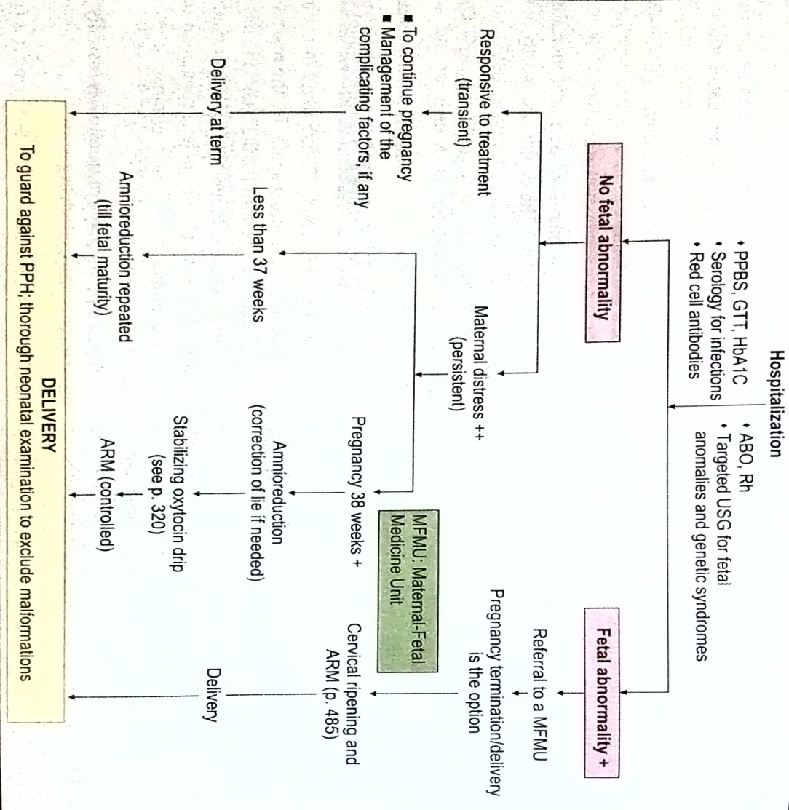
Uncomplicated cases (no demonstrable fetal malformation):
- Response to treatment is good: The pregnancy is to be continued awaiting spontaneous delivery at term
- Unresponsive (with maternal distress):
- Pregnancy less than 37 weeks: An attempt is made to relieve the distress with a hope of continuation of pregnancy by amniocentesis (amnioreduction).
- Pregnancy more than 37 weeks: Induction of labor is done.
With congenital fetal abnormality:
Referral to a maternal fetal medicine unit should ideally be done. When decision for termination is made, it is to be done irrespective of duration of pregnancy. Amniocentasis is done to drain good amount of liquor. Thereafter induction of vaginal PGE₂ gel insertion followed by low rupture of membranes is done. If accidentally, low rupture of the membranes occurs, escape of gush of liquor should be immediately controlled by placing the palm over the introitus to avoid accidental hemorrhage. The lie should be checked and if found longitudinal, oxytocin infusion may be started.
During labor:
Usual management is followed as outlined in twin pregnancy. Internal examination should be done soon after the rupture of the membranes to exclude cord prolapsed. If the uterine contraction becomes sluggish, oxytocin infusion may be started, if not contraindicated. To prevent post partum hemorrhage, intravenous methergine 0.2 mg should be given with the delivery of the anterior shoulder. One must remain vigilant following the birth of the baby for retained placenta, post partum hemorrhage and shock. Baby should be thoroughly examined for any congenital anomaly.
RESEARCH STUDY:
A clinical study of fetomaternal outcome in pregnancy with polyhydramnios. The study was conducted by R. A. Aditi, B. R. Kiran and G. M. Amruta in Wardha, Maharashtra in 2016.
Abstract:
Background: Amniotic fluid not only provides protection to the fetus from traumatic forces, cord compression, and microbial pathogens, but also plays an integral role in the normal development of the fetal musculoskeletal, pulmonary, and gastrointestinal systems. Polyhydramnios, defined as an excessive amount of amniotic fluid, complicates approximately 0.4-3.3% of all pregnancies. Fetal conditions that are associated with polyhydramnios include major congenital anomalies and both the immunologic and non-immunologic forms of hydrops foetalis. Maternal medical conditions are also known to be associated with polyhydramnios and subsequently alter perinatal outcome. So by diagnosing these cases as early as possible, these maternal complications can be prevented and advise proper prenatal counseling in relevant cases. Methods: This study was conducted in obstetrics and gynaecology department at a tertiary care hospital, over the period of from September 2015 to September 2016. After a thorough physical examination and detailed history of the patients, clinical diagnosis of polyhydramnios was confirmed by ultrasound after which they were included in the study and proforma was filled. Routine lab investigation was done. Complete labor record was made along with mode of delivery and duration. Complete physical examination of baby by obstetrician and pediatrician with recording of Apgar score and any anomalies found. Data thus collected was analyzed for results and compared with international as well as local studies.
Results: Polyhydramnios is commoner in primigravida. Causative factor are mainly idiopathic after which the most important is fetal defects. Diabetes is also associated finding with polyhydramnios in 8.3% cases. The occurrence of fetal congenital abnormality was directly proportional to the gestational age of pregnancy. Incidence of congenital abnormality was found to be 1.25 %. Congenital heart disease and cleft lip and cleft palate (3%) were the commonest congenital abnormality associated with polyhydramnios followed by anencephaly and spina bifida (3.3%).
Conclusions: In our study Idiopathic polyhydramnios was found to be the most common cause of polyhydramnios. A careful study must be done for detection of etiological factors in all cases of polyhydramnios, careful screening, prenatal and antenatal counseling will help to improve the foetal outcome as well as to prevent the maternal complication.
CONCLUSION:
Amniotic fluid is a highly complex and dynamic system that should be utilised in the interpretation of fetal well-being. It is vital to the well-being of the fetus. These disorders may result from abnormal fetal or maternal conditions and conversely, may be responsible for alterations of fetal well-being as well. When abnormalities of fluid like oligo or polyhydramnios exist, appropriate workup to uncover the underlying etiology should be initiated as adverse fetal outcomes are sometimes associated with these variations from normalcy.
BIBLIOGRAPHY:
- Dutta D.C. textbook of Obstetrics. Jaypee brothers medical publishers (P) Ltd. 2018. 9th ed. 200-206.
- Jacob Annamma. Textbook of Midwifery. Jaypee publishers. 2005. 1st ed. 232-236.
- Rao Kamini. Textbook of Midwifery and Obstetrics for nurses. Elsevier publishers. 2011. 1st ed. 112-115.
- Sharma J.B. Midwifery and Gynaecological nursing. Avichal publishing company. 2015. 1st ed. 135-140.
- Pillitteri Adele. Maternal and child health nursing. Wolter Kluwer publishers. 2010. 6th ed. 162-166.
- https://medlineplus.gov>MedicalEncyclopedia
- https://www.stanfordchildrens.org>topic>id=amniotic-fluid-problemshy
- https://en.wikipedia.org>wiki>Polyhydramnios

