A Case Study on The Effects of Plan Aspect Ratio on Seismic Responses of RCC Buildings Using ETABS

Shruthi B.K.
Department of Civil Engineering, Amity School of Engineering and Technology, Amity University Maharashtra, Mumbai.
Mumbai – Pune Expressway, Bhatan Post – Somathne, Panvel, Mumbai, Maharashtra 410206, India
e-mail:bkshruthi@mum.amity.edu

S. Sangita Mishra
Department of Civil Engineering, Amity School of Engineering and Technology, Amity University Maharashtra, Mumbai.
Mumbai – Pune Expressway, Bhatan Post – Somathne, Panvel, Mumbai, Maharashtra 410206, India
e-mail:ssmishra@mum.amity.edu

Vedprakash Maralapalle
Department of Civil Engineering, Amity School of
Engineering and Technology, Amity University
Maharashtra, Mumbai.
Mumbai-Pune Expressway, Bhatan Post –
Somathne, Panvel, Mumbai, Maharashtra 410206
India
e-mail:vcmaralapalle@mum.amity.edu

ABSTRACT

Seismic design is a critical aspect of constructing safe and resilient buildings in earthquake- prone regions. The layout and design of a building play a significant role in determining its behavior under seismic forces. The aspect ratio, defined as the ratio of a building's width to its height, is an important parameter that affects its structural response during earthquakes. The placement of the core within the building is crucial as it directly impacts the distribution of lateral forces and stiffness of the structure. Therefore, it is essential to investigate the effects of plan aspect ratio on the seismic performance of RCC buildings. This study investigates the effects of plan aspect ratio on the seismic responses of reinforced concrete (RCC) buildings using ETABS software. The research aims to assess the impact of core placement in structures with different aspect ratios and analyze various parameters such as story drift, shear forces, and other relevant factors. The findings of this study contribute to a better understanding of how the placement of the core within a building influences its response to seismic loads. The results obtained from the analysis of the seismic responses of RCC buildings with different aspect ratios and core placements indicate significant variations in their behavior. Story 7 consistently exhibits the highest displacement values in both the X and Y directions across different aspect ratios, suggesting that this story is more vulnerable to seismic loads. Aspect Ratio 1:1.5 and Story 4 generally demonstrate the lowest displacement values, indicating a more favorable response to seismic forces. Additionally, Story 1 exhibits the highest shear force, whereas Aspect Ratio 1:2 experiences the lowest shear force in Story 1. The maximum lateral load occurs in Aspect Ratio 1:1, while Story 7 experiences the highest lateral load in both directions. These findings emphasize the influence of core placement on the impact of seismic loads on the structure.

Keywords— Aspect ratio, Core placement, RCC buildings, Seismic responses, Seismic design.

INTRODUCTION

Earthquakes are one of the most devastating natural disasters that can cause considerable damage to the built environment, resulting in the loss of life and property. The design of earthquake-resistant buildings is therefore of immense importance, particularly in regions prone to seismic activity. The seismic response of buildings is affected by several factors, including the characteristics of the ground motion, the properties of the building materials, and the structural configuration of the building [1,2]. One of the critical aspects of seismic-resistant design is the plan aspect ratio of the building, which is defined as the ratio of the length to the width of the building. [3] The plan aspect ratio can significantly affect the seismic response of the building, as it affects the distribution of mass and stiffness along the longitudinal and transverse directions of the building. [4] Buildings with different aspect ratios may have different natural periods of vibration, which can lead to different responses to seismic forces. [5] The seismic response of buildings can be evaluated in terms of inter-story drift, acceleration, and displacement. Inter-story drift is the relative displacement between adjacent floors of the building, while acceleration is the rate of change of velocity of the building during an earthquake whereas displacement refers to the total displacement of the building during an earthquake. [3-5]
Several studies have been conducted to investigate the effect of plan aspect ratio on the seismic response of RC buildings. [6-8] Most of these studies have focused on low-rise buildings with up to four stories. [7,8] However, with the increasing demand for taller buildings, there is a need for further research to investigate the effect of plan aspect ratio on the seismic response of tall RC buildings. The use of computer-aided design (CAD) tools such as ETABS has made it easier to investigate the seismic response of buildings with different aspect ratios. ETABS is a widely used software for the analysis and design of buildings, particularly in seismic zones. The software allows for the creation of detailed 3D models of buildings, which can be used to evaluate the response of the building to seismic forces. This study aims to investigate the effect of plan aspect ratio on the seismic response of tall RC buildings using ETABS. The study will develop several building models with different plan aspect ratios and analyze their seismic response using ETABS. The study will evaluate the inter-story drift, acceleration, and displacement of the buildings and compare the results to investigate the effect of plan aspect ratio on the seismic response of tall RC buildings. The results of this study will provide valuable insights into the design of earthquake-resistant tall RC buildings and help engineers make informed decisions regarding the plan aspect ratio of the building.

ETABS
ETABS (Extended Three-Dimensional Analysis of Building Systems) is a widely used finite element analysis software specifically designed for the analysis and design of building structures. The ETABS software is utilized for modelling and analysis. ETABS offers several features and capabilities that make it suitable civil engineering applications are:
- Modelling Tools: ETABS provides a user-friendly interface for creating 3D models of buildings. It allows for the efficient and accurate representation of the building geometry, including the different aspect ratios considered in the study. The software supports the creation of structural elements such as columns, beams, slabs, and walls.
- Material Properties: ETABS allows the specification of material properties for concrete and reinforcement. The software accommodates the input of parameters such as compressive strength, modulus of elasticity, Poisson's ratio, and yield strength, which are crucial for accurately simulating the behaviour of RCC structures.
- Dynamic Analysis: ETABS has the capability to perform both linear and nonlinear dynamic analyses. In this research project, dynamic analysis is crucial for evaluating the seismic responses of the RCC building models with varying aspect ratios. The response spectrum analysis method available in ETABS can be employed to calculate the building's response to seismic excitation.
- Load Application: ETABS enables the application of diverse types of loads, including gravity loads and lateral loads. Gravity loads, such as dead loads and live loads, can be easily incorporated into the model. The software also provides options for applying lateral loads, such as seismic loads, based on the design spectra and the selected ground motion records.
- Post-Processing and Results Analysis: ETABS offers a range of post-processing tools to visualize and analyse the results of the analysis. It provides comprehensive output reports, including displacement, inter-story drift, shear forces, and moments, which are essential for evaluating the seismic responses of the RCC building models with different aspect ratios.

Input of Data
Input ground motion data is required to simulate the seismic loads acting on the building models. The following steps are undertaken to obtain the necessary input ground motion data:
- Seismic Hazard Analysis: A comprehensive seismic hazard analysis is required to be conducted for the project location. This analysis involves assessing the regional seismicity, geological characteristics, and historical earthquake data. The seismic hazard analysis helps to determine the design spectrum that represents the expected ground motion levels for different return periods.
- Selection of Ground Motion Records: A suite of ground motion records is selected based on their compatibility with the design spectrum and their representativeness of the seismic hazard at the project location. It is crucial to ensure that the selected records cover a wide range of earthquake magnitudes, distances, and source-to-site conditions.
- Scaling of Ground Motion Records: The selected ground motion records are scaled to match the desired seismic hazard levels for the research project. Scaling is performed based on the design spectrum, target response spectra and peak ground acceleration values. The scaling process aims to simulate various levels of ground motion intensity for the analysis of buildings with various aspect ratios.
- Format Conversion: The ground motion records are converted into the appropriate format compatible with the analysis software, such as ETABS. Format conversion tools and scripts are used to ensure the compatibility of the ground motion records with the analysis software.
- Application of Ground Motions: The scaled ground motion records are applied to the building models in the dynamic analysis. ETABS provides options to apply ground motions as input loads, allowing for the simulation of the actual earthquake excitations on the building models.
It is essential to consider enough ground motion records that capture the variability and uncertainty associated with seismic events. The selection and scaling of ground motion records are performed carefully to ensure a representative and realistic assessment of the seismic responses of the RCC building models with different aspect ratios.

Analysis Procedure
The following analysis procedure can be employed to investigate the effects of plan aspect ratio on the seismic responses of RCC buildings using ETABS.
- Building Model Creation: The building models are created in ETABS based on the design and construction details of typical RCC buildings. The models are designed for different plan aspect ratios, including square, rectangular, and elongated shapes.
- Definition of Material Properties: The material properties of concrete and steel are defined based on the relevant codes and standards. The concrete is modelled using a nonlinear material model, and the steel reinforcement is modelled using a plastic hinge model.
- Assigning Loads and Boundary Conditions: The gravity loads, such as dead loads and live loads, are applied to the building models according to the design specifications. The boundary conditions are defined on the support conditions and the assumptions of the structural system.
- Dynamic Analysis: The dynamic analysis is conducted using ETABS to simulate the seismic response of the building models under the applied ground motions. The response spectrum analysis method is employed to evaluate the maximum responses of the structures, such as the base shear, roof displacement, and inter-story drift.
- Results Interpretation and Comparison: The result of the dynamic analysis is interpreted and compared for the different building models with various aspect ratios. The effects of aspect ratio on the seismic responses are evaluated in terms of the maximum responses and the mode shapes.
- Sensitivity Analysis: Sensitivity analyses is performed to investigate the effects of other parameters, such as the building height, structural system, and damping ratio, on the seismic responses of the building models. The results of the sensitivity analyses are compared to the base case scenarios to assess the influence of these parameters on the research findings.
- Statistical Analysis: Statistical analyses is performed to quantify the variability and uncertainty associated with the results of the dynamic analysis. The statistical analyses include probability distribution fitting, confidence interval estimation, and regression analysis.
C. Validation
The following steps outline the validation process:
- Comparison with Analytical Solutions: The analytical models used in the study is compared with known analytical solutions or simplified hand calculations for specific cases. This step helps validate the accuracy of the modelling assumptions, boundary conditions, and solution techniques used in the analysis.
- Comparison with Experimental Data: If available, experimental data from previous studies or shake table tests on similar building configurations is used for comparison with the analytical results. The measured responses, such as inter-story drifts, base shear, and acceleration, is compared with the predicted responses from the building models. This step helps assess the accuracy and reliability of the numerical models and their ability to capture the seismic behaviour of the buildings.
- Sensitivity Analysis: Sensitivity analysis is performed by varying input parameters and comparing the resulting responses. The sensitivity analysis involves changing parameters such as material properties, damping ratios, or boundary conditions. The obtained responses from the sensitivity analysis are compared to expected trends or theoretical behaviour to verify the consistency and validity of the model.
- Peer Review and Expert Consultation: The research findings and methodology are shared with peers and experts in the field of structural engineering. Their feedback, suggestions, and critiques provide an external validation of the research approach and conclusions.
- Code Compliance Check: The analysis results are evaluated against the requirements and recommendations of relevant design codes and standards, such as IS 1893 or ASCE
- The building models' responses, such as inter-story drift ratios, comply with the code provisions for different plan aspect ratios and seismic hazard levels. Any discrepancies or deviations from the code requirements are carefully examined and addressed.
- Sensitivity to Modelling Assumptions: The sensitivity of the results to different modelling assumptions, such as the element types, mesh density, and modelling simplifications, are assessed. Multiple analyses with varying modelling approaches are performed to evaluate the robustness of the results and ensure that they are not overly dependent on specific modelling assumptions.
- Limitations and Uncertainties: The limitations and uncertainties associated with the analysis and the obtained results are identified and clearly stated. These include simplifying assumptions, modelling uncertainties, or limitations of the software used. Acknowledging and addressing these limitations provides a balanced perspective on the research findings.

CREATING 3D MODEL
Creating a 3D model in ETABS involves several steps to accurately represent the RCC building geometry. The following outlines the process for creating a 3D model in ETABS:

Project Setup
- Open ETABS software and create a new project.
- Define the project units (e.g., length, force, time) based on the design requirements and standards.
- Set the project preferences and analysis settings, such as seismic design codes and analysis methods as shown in fig. 1.
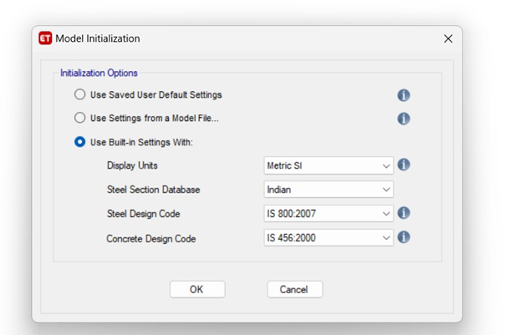
Figure 1: ETABS model initialization

Define Material properties
- Specify the material properties for concrete and reinforcement.
- Input the concrete compressive strength, modulus of elasticity, Poisson's ratio, and reinforcement yield strength as shown in fig. 2.
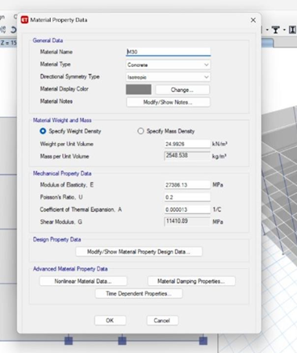

Figure 2: Defining material properties.

Create Building Geometry
- Define the building's overall dimensions, including plan aspect ratio, number of stories, and floor-to-floor heights.
- Use the drawing tools in ETABS to create the structural elements (columns, beams, slabs, walls) in the desired layout.
- Ensure that the elements accurately represent the building's geometry, including column locations, beam depths, slab thicknesses, and wall locations as shown in fig. 3.

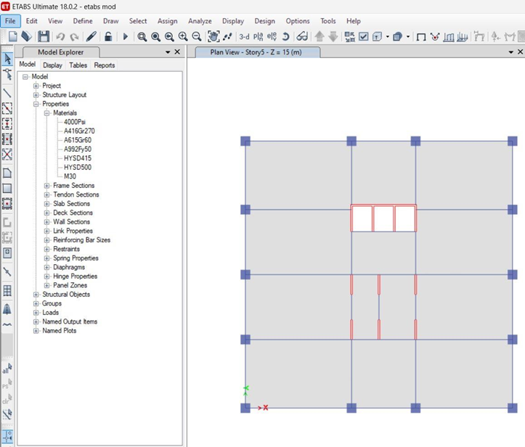
Figure 3: 2-D plan of ETAB model

Assign Material Properties
- Assign the previously defined material properties to the respective structural elements.
- Specify the appropriate concrete grade and reinforcement details for each element as shown in fig. 4.
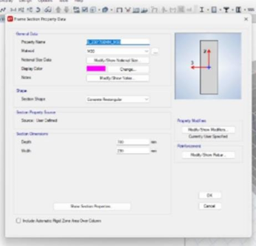
Figure 4: Defining reinforcement details.

Define Supports and Constraints
- Assign appropriate supports to the structural elements, considering the boundary conditions of the building.
- Define fixed supports at the base or other locations where the building is connected to the foundation.
- Apply rotational and translational constraints to the appropriate elements to represent their connections.

Apply Loads
- Define gravity loads such as dead loads (self-weight) and live loads based on the design specifications.
- Apply the loads to the corresponding elements (e.g., slabs, beams) based on their load-bearing capacity.
- Consider any eccentricities or load distribution factors as required as shown in fig. 5.

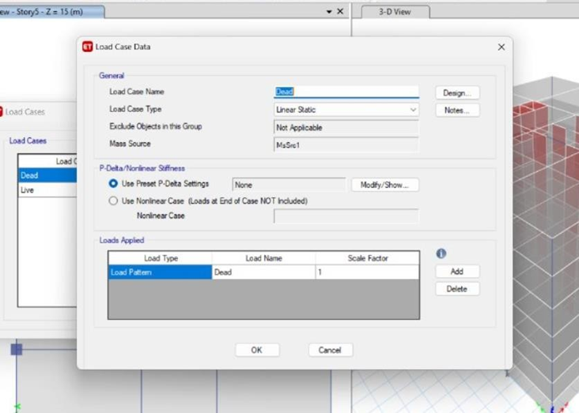

Figure 5: Defining Load combinations.

Define Seismic Loads
- Specify the seismic design parameters, such as the design seismic coefficient or the site-specific design spectra.
- Assign the seismic loads to the appropriate elements, such as beams and columns, based on their lateral load-resisting capacity.
- Consider the effects of plan aspect ratio on the distribution and magnitude of seismic loads.

Perform Analysis
- Run the analysis using the defined load cases and combinations.
- Select the appropriate analysis method, such as response spectrum analysis or time history analysis, based on the research objectives.
- Monitor the convergence and accuracy of the analysis results.

Review and Interpret the Results
- Evaluate the analysis results, including inter-story drifts, base shear, and other relevant response parameters.
- Visualize the results using the graphical output tools in ETABS, such as displacement plots, moment diagrams, and mode shapes.
- Compare and analyze the results for different plan aspect ratios to determine the effects on the seismic responses.
By following these steps, a 3D model of the RCC building is accurately created in ETABS, allowing for subsequent analysis and evaluation of the effects of plan aspect ratio on seismic responses, a sample 3 D model for model 1 has been illustrated in figure 6.
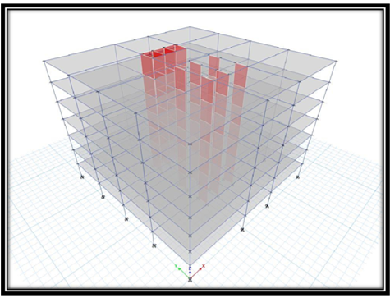
Figure 6: 3-D model for Model 1

IV. ANALYSIS AND INTERPRETATION OF DATA

Interstorey Drift
Inter-story drift refers to the relative horizontal displacement between consecutive floors of the building. It indicates the building's flexibility and its ability to withstand lateral forces during seismic events. The inter-story drift results have been examined to assess the deformations and potential damage in different plan aspect ratios. In this case, the building has a total of seven stories, including a base level. Each story is assigned a number (Story1 to Story7) along with its corresponding elevation, X direction drift and Y direction drift values. The X direction and Y direction values represent the horizontal and vertical displacements, respectively, experienced by each story during a seismic event. These values indicate the relative movement or deformation in the respective directions for each story. Figure 7 and 8 represents the story drift of a building with a 1:1 aspect ratio for X and Y direction. The highest value of the X direction occurs at Story4, which has an X direction value of 0.001881. This signifies that Story4 experienced the greatest horizontal displacement among all the stories. It is also found that the highest Y direction value occurs at Story4, with a value of 0.000795. This signifies that Story4 experienced the greatest vertical displacement among all the stories. Figures 9 and 10 represents the story drift of a building with a 1:1.25 aspect ratio for Model 2. In the X direction it is observed that the highest value of 0.001875 occurs at Story4. This indicates that Story4 experienced the most significant horizontal displacement among all the stories. In the Y direction table, Story4 also stands out with the highest value of 0.0008. Story4 exhibited the greatest vertical displacement among all the stories.
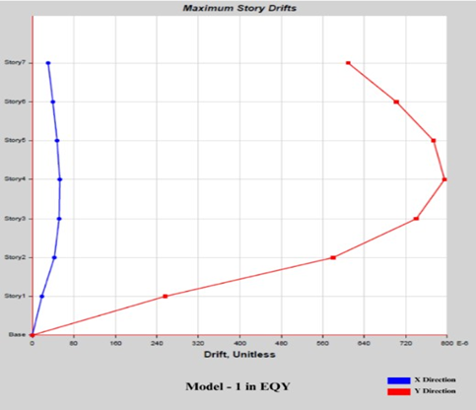
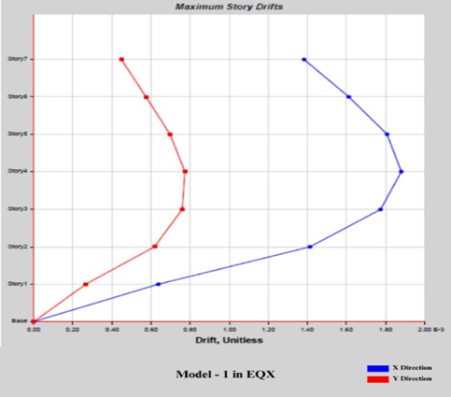

Figure 7: Story drift in X direction Figure 8: Story drift in Y direction
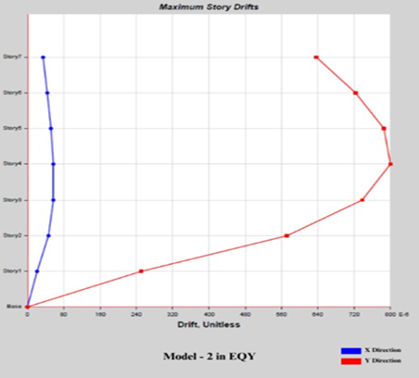
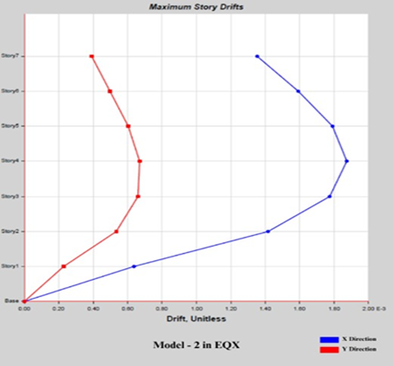

Figure 9: Story drift in X direction Figure 10: Story drift in Y direction
Figures 11 and 12 represents the story drift of a building with a 1:1.5 aspect ratio in X and Y direction respectively for Model 3. It is observed that the highest X direction value of 0.001284 is associated with Story4. This indicates that Story4 experienced the greatest horizontal displacement among all the stories. The highest Y direction value of 0.000692 is also attributed to Story4. This indicates that Story4 exhibited the highest vertical displacement among all the stories. Figures 13 and 14 represents the story drift of a building with a 1:1.75 aspect ratio in X and Y direction respectively for Model 4. Story4 has the highest X direction value of 0.001742. This indicates that Story4 experienced the greatest horizontal displacement among all the stories. Story4 also exhibits the highest Y direction value of 0.001056. This suggests that Story4 encountered the greatest vertical displacement among all the stories. Figures 15 and 16 represents the story drift of a building with a 1:2 aspect ratio in X and Y direction respectively for Model 5. Story4 has the highest X direction value of 0.001597. This indicates that Story4 experienced the greatest horizontal displacement among all the stories. Story4 also exhibits the highest Y direction value of 0.001136. This suggests that Story4 encountered the greatest vertical displacement among all the stories.

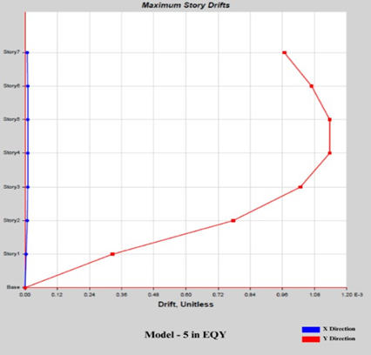
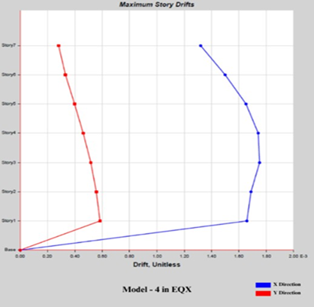
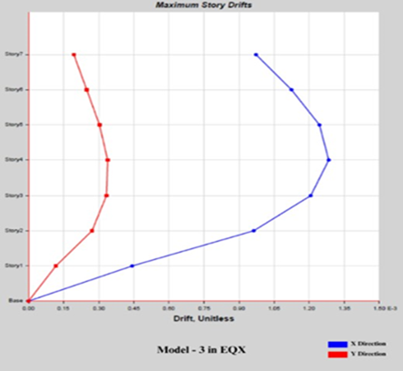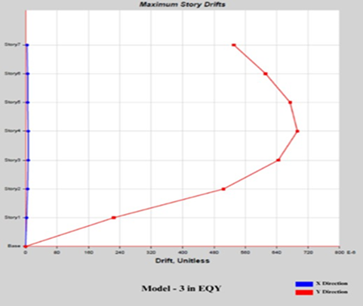 Figure 11: Story drift in X direction Figure 12: Story drift in Y direction

Figure 13: Story drift in X direction Figure 14: Story drift in Y direction
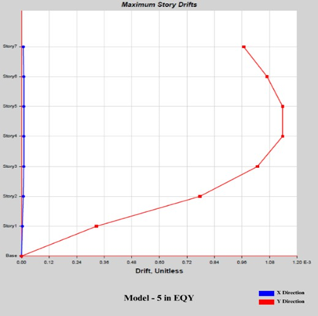

Figure 15: Story drift in X direction Figure 16: Story drift in Y direction

Base Shear
The base shear represents the total lateral force exerted at the base of the building due to seismic loading. It is a critical parameter for structural design as it determines the design requirements for the foundation and the overall stability of the building. The base shear results have been compared for different plan aspect ratios to understand the variations in lateral force distribution. In Fig. 17 with an aspect ratio of 1:1, Story7 exhibits the highest X direction value of 32.049 mm. For the corresponding Y direction, Story7 has the highest value of 13.593 mm. In Fig. 18. with an aspect ratio of 1:1.25, Story7 has the highest X direction value of 31.844 mm, and in table no.15, Story7 has the highest Y direction value of 13.743 mm. In Fig. 19 with an aspect ratio of 1:1.5, Story7 has the highest X direction value of 22.076 mm. Story7 has the highest Y direction value of 11.837 mm. In Fig. 20 with an aspect ratio of 1:1.75, Story7 demonstrates the highest X direction value of 34.476 mm. For the corresponding Y direction, Story7 has the highest value of 18.523 mm. Lastly, in Fig. 21 with an aspect ratio of 1:2, Story7 has the highest X direction value of 27.74 mm, and Story7 has the highest Y direction value of 19.63 mm. To summarize, for each aspect ratio scenario, Story7 consistently exhibits the highest direction value. Similarly, Story7 consistently has the highest Y direction value. These findings provide insights into the extent of horizontal and vertical displacement experienced by Story7 across different aspect ratios, highlighting its significance in understanding the building's structural response during seismic events.
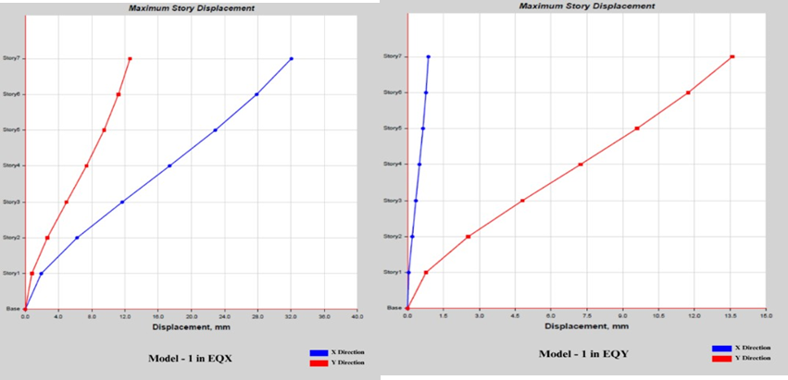
Figure 17: Story Displacement in X and Y direction for Model 1
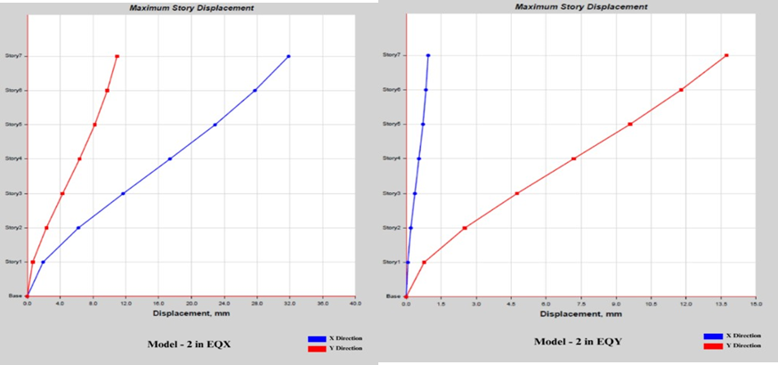
Figure 18: Story Displacement in X and Y direction for Model 2
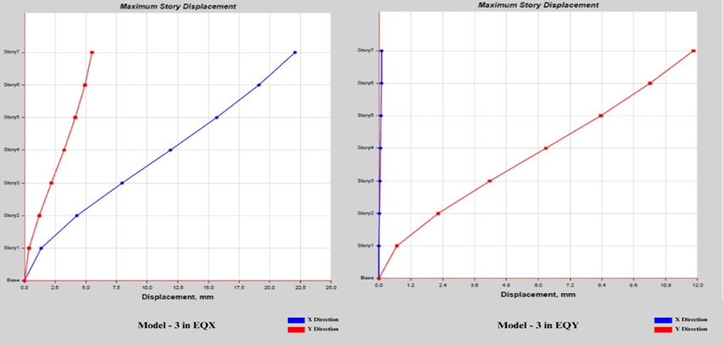
Figure 19: Story Displacement in X and Y direction for Model 3
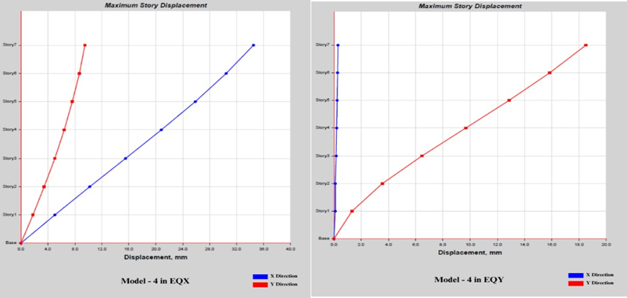
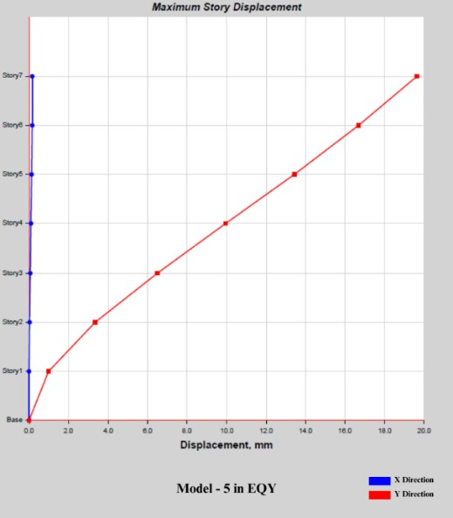
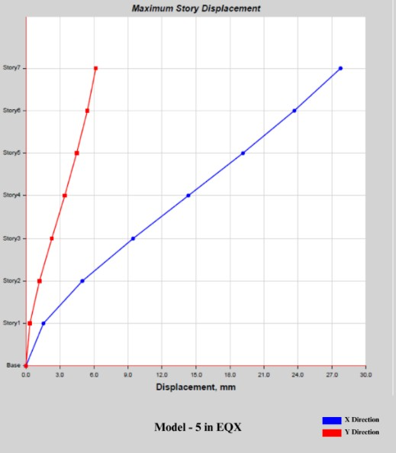
Figure 20: Story Displacement in X and Y direction for Model 4

Figure 21: Story Displacement in X and Y direction for Model 5

Mode Shapes
Mode shapes illustrate the vibrational characteristics of the building at different natural frequencies. Analysing the mode shapes can help identify potential modes of vibration and understand the building's dynamic behaviour. The mode shapes should be examined for each plan aspect ratio to observe any significant differences in the building's response. For the buildings with an aspect ratio of 1:1 the highest X direction value is 3285.217 kN, which occurs at the top of Story1. Similarly, the highest Y direction value is 3285.217 kN, found at the bottom of Story1 as shown in Figure 22. In the case of buildings with an aspect ratio of 1:1.25 the highest X direction value is 3203.7618 kN, located at the top of Story1. For the Y direction, the highest value is 3283.8558 kN, observed at the bottom of Story1 as depicted in Figure 23. The building with an aspect ratio of 1:1.5 shown in Fig. 24. the highest X direction value is 3167.812 kN, present at the top of Story1. In the Y direction, the highest value is 3405.3979 kN, occurring at the bottom of Story1. For the buildings with an aspect ratio of 1:1.75 in the Fig. 25. the highest X direction value remains 3052.1091 kN at the top of Story1. In the Y direction, the highest value is 3357.32 kN, found at the bottom of Story1. Lastly, in building with an aspect ratio of 1:2 as shown in Fig. 26.the highest X direction value is 3178.6202 kN, located at the top of Story1. The highest Y direction value is 3496.4822 kN, which occurs at the bottom of Story1. It is important to note that for each aspect ratio, the highest X direction value is consistently found in Story1, while the highest Y direction value is also consistently found in Story1.
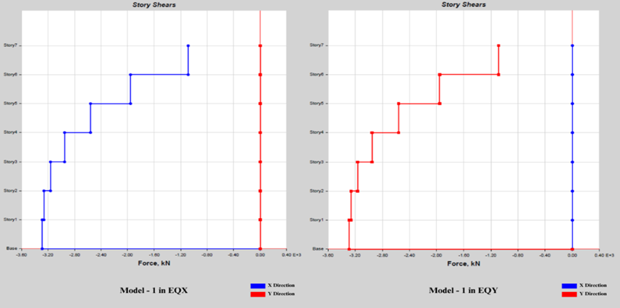
Figure 22: Story Shear in X and Y direction for Model 1
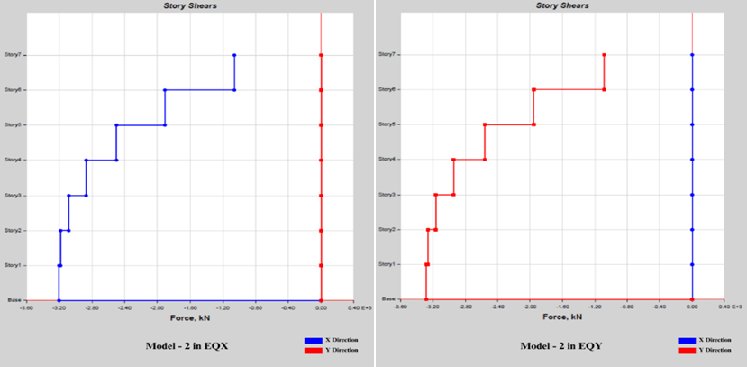
Figure 23: Story Shear in X and Y direction for Model 2

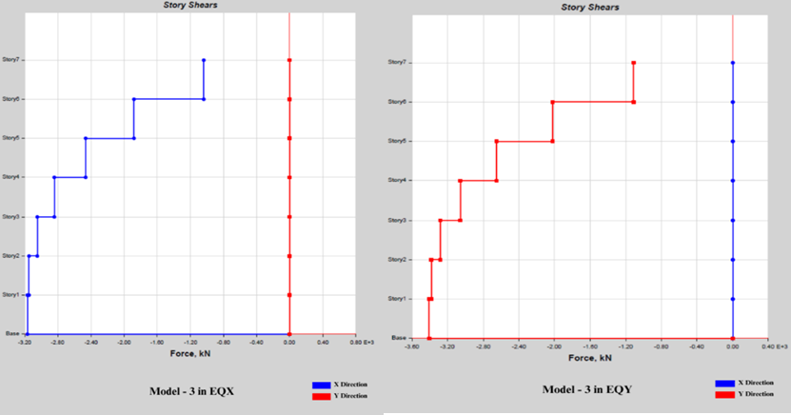
Figure 24: Story Shear in X and Y direction for Model 3
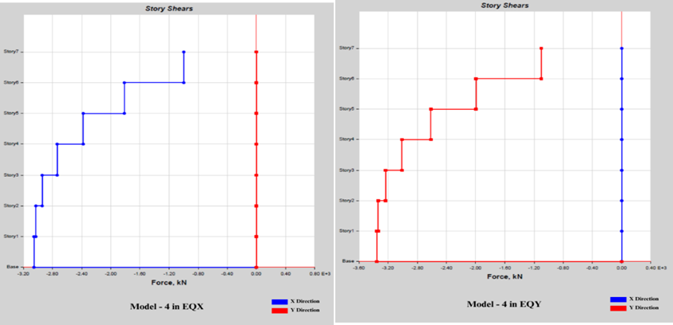
Figure 25: Story Shear in X and Y direction for Model 4
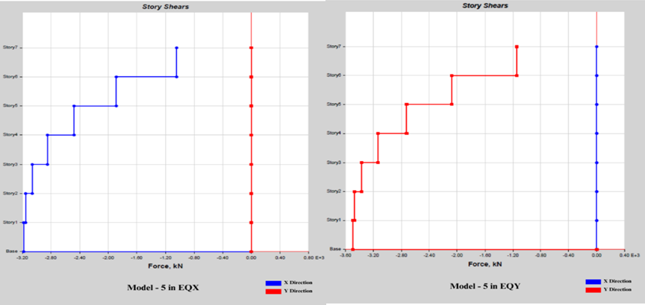
Figure 26: Story Shear in X and Y direction for Model 5

D. Lateral Load
Lateral load analysis refers to the evaluation and assessment of the effects of horizontal forces or loads on a structure. These lateral loads typically result from wind, earthquakes, or other external forces that act parallel to the ground surface. Lateral load analysis is an essential step in the design of buildings and structures to ensure their stability and safety. Fig. 27. represent an aspect ratio of 1:1 for Model 1 in X and Y direction respectively. Fig. 28 represent an aspect ratio of 1:1.25 for Model 2 in X and Y direction respectively. Fig. 29 represent an aspect ratio of 1:1.5 for Model 3 in X and Y direction respectively. Fig. 30 represent an aspect ratio of 1:1.75 for Model 4 in X and Y direction respectively. Fig. 31. represent an aspect ratio of 1:2 for Model 5 in X and Y direction respectively. These values indicate the stories that experience the highest lateral loads in the X and Y directions for each respective aspect ratio. It is important to consider these findings when designing and reinforcing the structure to ensure its stability and safety.

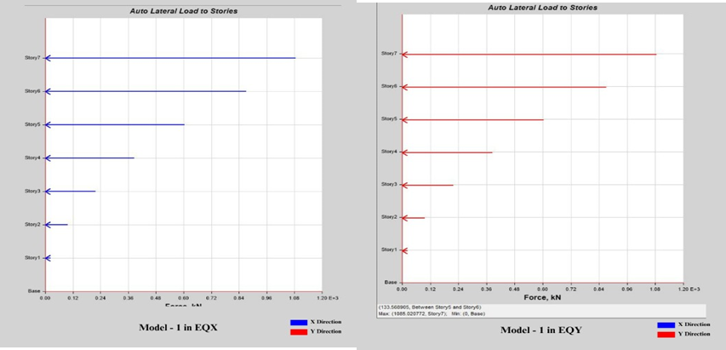

Figure 27: Lateral Load in X and Y direction for Model 1

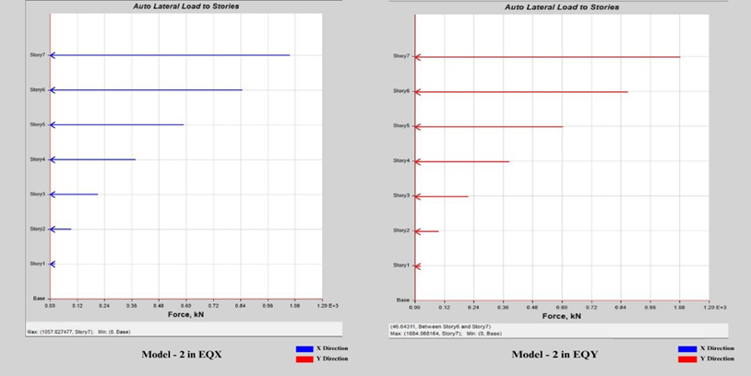
Figure 28: Lateral Load in X and Y direction for Model 2

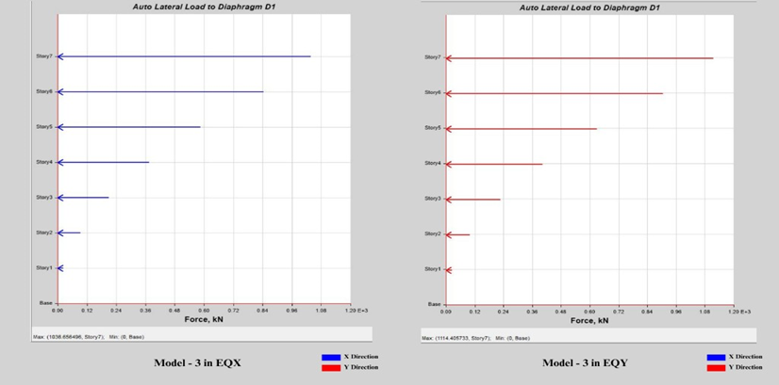
Figure 29: Lateral Load in X and Y direction for Model 3

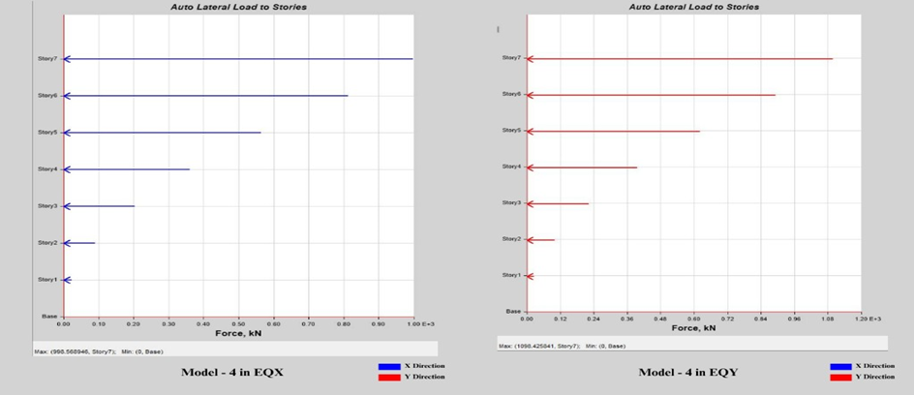

Figure 30: Lateral Load in X and Y direction for Model 4
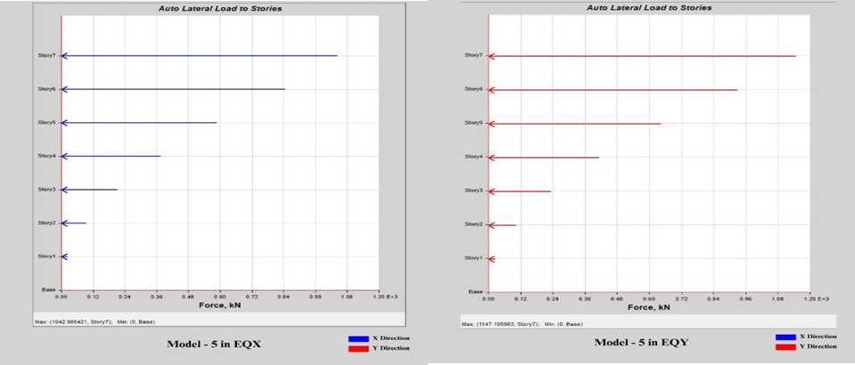

Figure 31: Lateral Load in X and Y direction for Model 5

V. CONCLUSION

Among all the stories, Story 7 has the lowest displacement in both the X and Y directions in Aspect Ratio 1:1.5 for story displacement. Aspect Ratio 1:1.5 and Story 4 exhibit the lowest drift values in both the X and Y directions for story drift. Precautionary measures need to be taken in Story 1 as it experiences the maximum shear force in all the aspect ratios. Among the aspect ratios, 1:2 exhibits the lowest story shear in Story 1 in story shear. Story 7 experiences the maximum lateral load in both the X and Y directions, indicating the need for precautionary measures.Story 7 consistently exhibits the highest displacement values in both the X and Y directions across different aspect ratios. Aspect Ratio 1:1.5 and Story 4 generally demonstrate the lowest displacement values. Story 1 shows the highest shear force, and Aspect Ratio 1:2 has the lowest shear force in Story 1. The maximum lateral load occurs in Aspect Ratio 1:1, while Story 7 experiences the highest lateral load in both directions. This implies that the core placement does affect the impact of seismic load on the structure.

REFERENCES

[1]. Md. Mohiuddin Ahmed , Sumsunnaher Tonny, Maqsuda Haque, Subrata Roy, Nazmus Sakib Ahmed, “A Comparative Study on Influence of Various Vertical Aspect Ratios on Influence of Seismic Performance of Regular Shape Multi-storied R.C.C. Buildings” Journal of Structural Engineering, its Applications and Analysis , Issue 1 Vol 2 , pp 1-8, 2019
[2]. T. B. Sajed & M. R. Mukhlis, “Effects of plan aspect ratio on seismic responses of RC buildings by time history analysis”, Proceedings of the 5th International Conference on Advances in Civil Engineering (ICACE 2020) pp 4 2021,
[3]. Jia H., Song Y., Chen X., Liu S., Zhang B., “Seismic Performance Evaluation of a High-Rise Building with Structural Irregularities”, Buildings 12, 1484, 2022 https://doi.org/10.3390/ buildings12091484
[4] Seonwoong Kim, “Seismic performance evaluation of high-rise steel buildings dependent on wind exposures”, Advances in Mechanical Engineering Vol. 11(3) pp 1–12, 2019
[5] Lei Zheng , Zonghui Liu , Hongwei Dang , Xin Guo , and Yonghua Wu, “Seismic Performance of Super High-Rise Building Structure with Dual Lines of Defense Based on Response Surface Optimization Algorithm”, Shock and Vibration, 2464675, 2022 https://doi.org/10.1155/2022/2464675
[6] Seung Yong Jeong , Thomas H.-K. Kang , Jang Keun Yoon , Ron Klemencic, “Seismic performance evaluation of a tall building: Practical modeling of surrounding basement structures”, Journal of Building Engineering 31, 101420, 2020
[7]. Redwan-Ul-Islam, Zeba Fariha , M A Bashar Bhuiyan and Rafszanul Islam, “Analysis of RC buildings under seismic zones in Bangladesh concerning shear wall, aspect ratio and breadth to length ratio”, Journal of Physics: Conference Series 2521, 012005, 2023 doi:10.1088/1742-6596/2521/1/012005
[8]. Barkha Verma, Bhavika Baghel, Aditi Chakradhari, Abhishek Agrawal, Prince Wanjari, “Analysis of Wind Load on Tall Building of Various Aspect Ratios”, IRJET, issue 1, Vol 9, pp 595-602, 2022
[9]. Indian Standard Code of Practice for Plain and Reinforced Concrete (IS 456:2000). Bureau of Indian Standards.
[10]. Indian Standard Code of Practice for General Construction in Steel (IS 800:2007).
[11]. Bureau of Indian Standards.

