ASSESSMENT OF ADDITIONAL FLOOR OVER THE EXISTING PARTIALLY CONSTRUCTED BUILDING AT SRINGERI, CHIKKAMAGALURU DISTRICT KARNATAKA

Pramod K R
Asst.Prof Civil Engineering
¹pramodraghu619@gmail.com,
Sapthagiri College of Engineering, Bangalore57

N Lakshminarasimaiah
Professor & Head of the Civil Engineering
2laknar_05@yahoo.com
APS College of engineering,
Bangalore-82r

M.B. Ananthayya
Professor & Head of the Civil Engineering
, ³ananthayya.mb@saividya.ac.in
SVIT College of engineering, Bangalore-64

LATHA M S
³Professor & Head of the Civil Engineering
⁴lathamsm@yahoo.co.in
SVCE College of engineering, Bangalore-57

Siddesh B H
Structural engineer
Siddeshbanghera@outlook.com
Enstructura Consultants (Pvt) Ltd
Bangalore- 560 062

ABSTRACT

To assess the primary sufficiency and achievability study for the development of number of floors on the current to some extent built building, nitty gritty actual perceptions were made to comprehend the current underlying framework, Layered estimation of the current RC individuals was checked at different levels. Non-disastrous/Semi-damaging tests were done to evaluate the strength/state of primary individuals. The outlining format at various levels and consequences of the non-damaging tests were utilized as in-put information for completing free hypothetical examination and configuration check of the current basic underlying individuals utilizing primary investigation programming "ETABS". In view of the perceptions, aftereffects of Non-disastrous tests, hypothetical confirmation/configuration check, fitting reclamation measures are suggested for the lacking underlying individuals.

Keywords—RC frame,load bearing wall,existing building

INTRODUCTION

The current SBI building working at Sringeri Taluk, Chikkmagalur region is a mix of RC outlined and loadbearing wall structure (size-stone workmanship walls) containing part-cellar and segments are brought up in ground floor level up-to lintel level. It was accounted for that, the development work was quit during the year 2002 (20 years back) because of some regulatory issue.Now the concerned specialists are intending to proceed with the development work. Considering this, they wanted to survey the underlying sufficiency and practicality study to check the quantity of floors which can be developed on the current to some degree built building.Hence, a reference was made to Enstructura Experts (Pvt) Ltd., Bengaluru, by the concerned specialists to survey the primary sufficiency and to assess the possibility study for development of number of floors over the current building.In reaction to this, a definite assessment study was completed by us on thirteenth and fourteenth August, 2022. This report, in a word, sums up the result of the examination did.

II. OBSERVATIONS MADE PHYSICALLY
Building subtleties:
Following are the underlying subtleties gathered at site.
1. structure contains part-cellar and GF (Without rooftop)
2.The normal ground level, descending incline (roughly 5 to 6 mt) was seen from front side to raise side of the structure. Thus part cellar floor was given.
3. Part of the storm cellar floor is proposed to be utilized areas of strength for as/depository.
4. Plinth pillar was not given in longer range/course at ground floor level.
5. Building is a mix of RC outlined and size stone workmanship load-bearing wall structure, where the fringe RC Segments are upheld on strip establishment (1.0m Width) and size stone work wall establishment was noticed all through the outskirts of the structure.

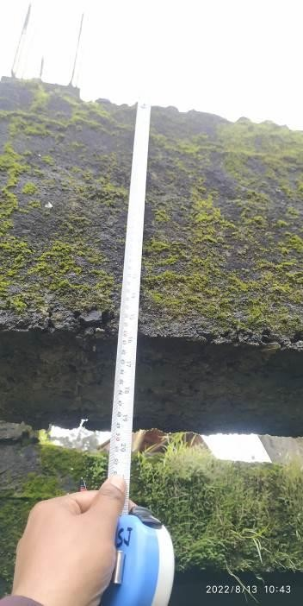

Fig-1 Actual layered estimation is underway

Examination of establishment framework and check of soil at establishment level.

To inspect the establishment framework and to check the dirt at establishing level, preliminary pits indiscriminately/available district were exhumed (two areas) nearby the section up to establishing level.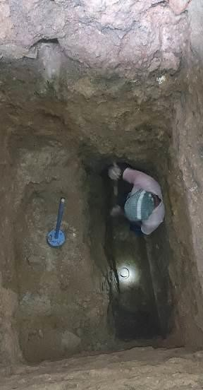 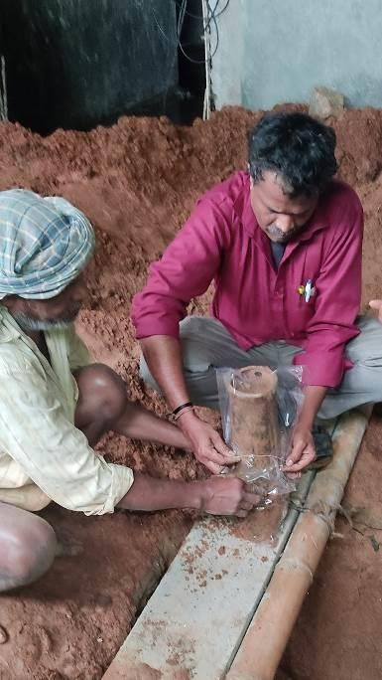

Fig-2 Assessment of existing establishment and soil test assortment
From the aftereffects of soil examination test, it is uncovered that the dirt is Blackish/Yellowish Sandy
Sediment with mica and Safe bearing limit is 15 t/m2 at 3.0 m profundity from the storm cellar floor level.

1.Semi-direct test on RC sections to evaluate the compressive strength of in-situ concrete.
To survey the strength of cement, Semi-damaging test, for example, center test was turn. The center examples were extricated from recognized RC sections for research facility tests. The extricated center examples were exposed to compressive strength test after fundamental managing and covering according to the rules in IS: 516: Section 4: 2018.

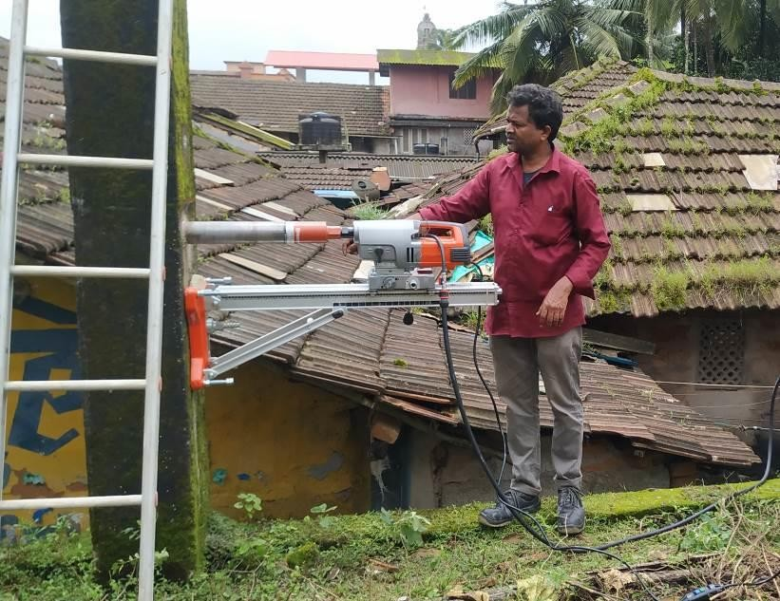

Fig-3 Center extraction in process
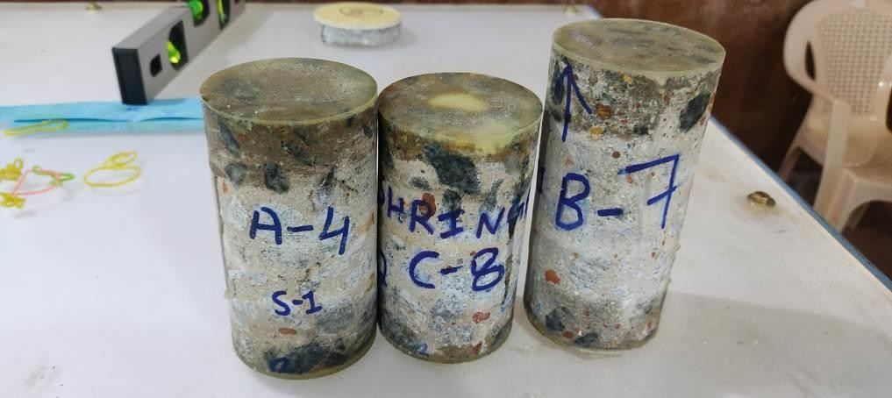
Fig-4 Extricated center examples

From the aftereffects of the Semi-direct test, it is gathered that the compressive strength of in-situ concrete in tried RC segments is viewed as in the scope of 21 N/sq.mm to 24 N/sq.mm.

Non-Damaging tests to survey the quality/strength of in-situ concrete in RC individuals.

Rebound Hammer test on RC members:
Rebound Hammer test was completed on the RC individuals at irregular to evaluate the surface hardness/quality and strength of in-situ concrete. The tests were directed utilizing Schmidt rebound hammer from M/s. Proceq, Switzerland according to the rules in Indian Standard IS: 516-(Section 5/Segment 4)- 2020. Position of sledge during testing was flat/vertical.

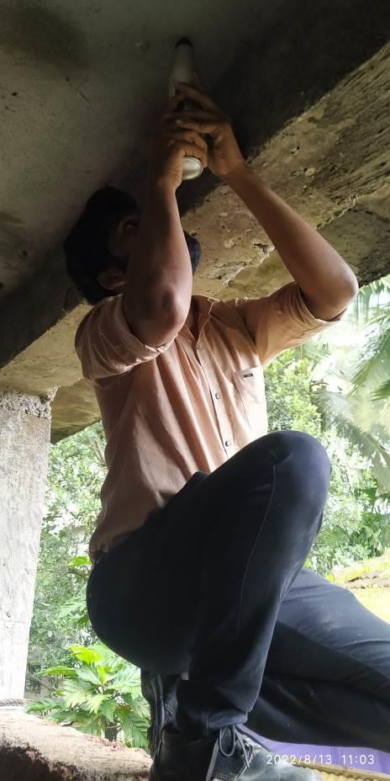
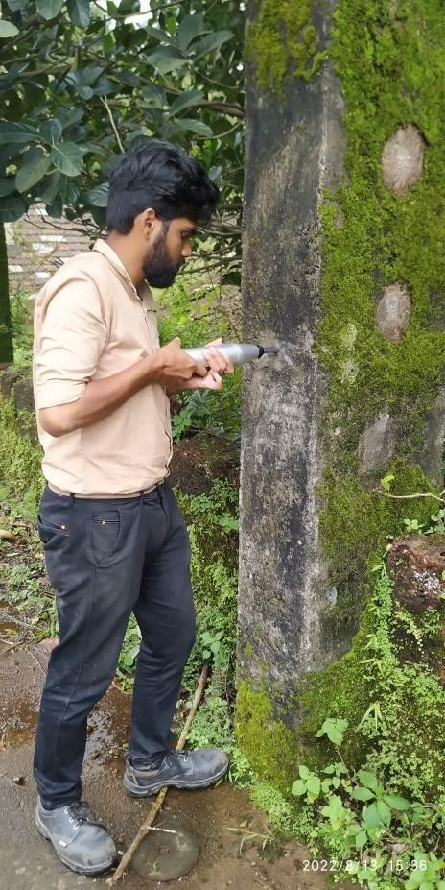

Fig-5 NDT test on rc individuals in the works.

- From the aftereffects of the rebound hammer test, it is uncovered that the assessed strength of cement in the tried RC segments is viewed as in the scope of 23 to 28 N/sq.mm, where as in piece and in RC Wall it is in the scope of 18 to 20 N/sq.mm.
- Covermeter examinations to plan the demeanor of support in RC individuals.

Fig-5 Cover meter observaation on RC Section

From the results of Cover meter test, it is revealed that the cover concrete provided to the rebars is as mentioned below at unaffected regions.
- columns clear cover varies 30 to 45 mm
- beams clear cover varies – 20 to 30 mm
- Slabs clear cover varies – 20 to 25 mm

In unaffected areas, the cover concrete in RC members is satisfactory

Carbonation test for columns.
Carbonation test was carried out on rc column using phenolphthalein indicator in dilute methyl alcohol to assess the extent of carbonation in cover concrete as per the guidelines in Indian Standards IS:516-(Part-5/Section 3)-2021.
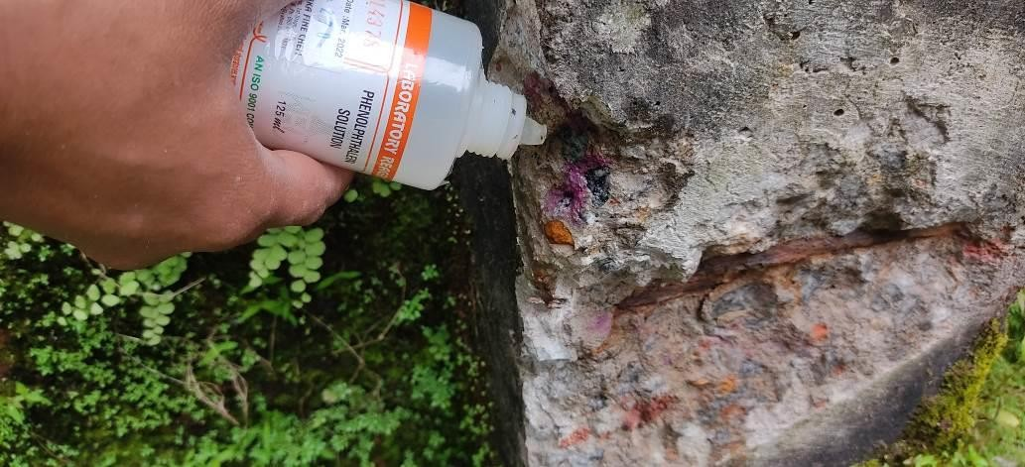
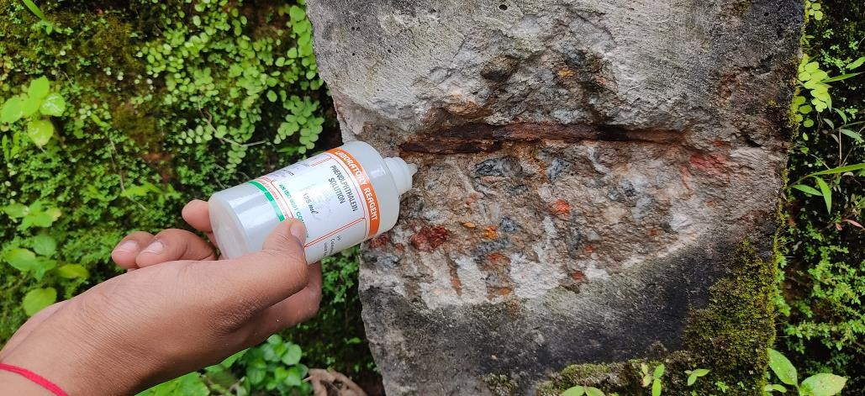

Fig-6 Carbonation test

According to the instructions in Indian Standards IS:516-(Part-5/Section 3)-2021, a carbonation test was performed on an RC column using phenolphthalein indicator in diluted methyl alcohol to determine the degree of carbonation in cover concrete.

III. Theoretical Analysis And Design Verification

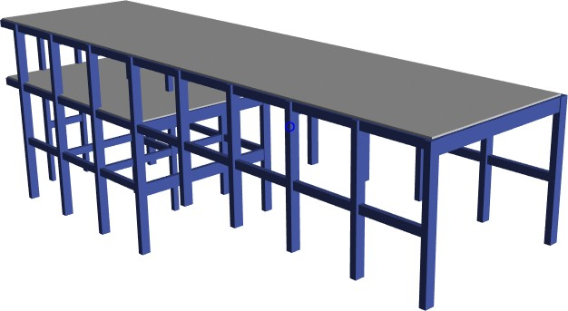
The current building is subjected to independent analysis and design review as part of the theoretical verification process. Using the structural analysis programme ETABS, a three-dimensional analytical model was created based on the planned frame design and the dimensions data gathered on site. According to the instructions in the applicable Indian standards, the design loads are taken into account. According to the findings of the performed non-destructive tests, the material attributes are allocated.

Fig-7 - D view of the ETABS software-generated analytical model of the structure.
- The material grades considered for analysis is as follows
M₂₀ grade concrete and Fe415 grade steel

Design standards for the theoretical verification
In accordance with the following "Indian Standard specifications or codes of practise," a design check was performed for all design loads.
Loads
All levels of the design loads were taken into account as commercial building loadings.
Dead load

Self-weight of existing rc members
Self-weight of the slab | : | = 3.75 kN/m²

Live load

Live load on ground floor | : | 4.0 kN/ m²
Live load (Terrace) | : | 2.0 kN/ m²

VI Conclusion

A mix of RC framed and load-bearing wall structure (size-stone masonry walls), the current SBI building in Sringeri Taluk, Chikkmagalur district, has columns elevated to lintel height in the ground floor. According to reports, a managerial issue caused the building work to cease in the year 2002 (20 years ago).
According to the theoretical analysis and design review, the existing footings and columns are structurally suitable for a portion of a basement plus ground floor when only gravity loads are taken into account.Weathering activity is primarily responsible for the distress features that have been noticed, such as the spalling of cover concrete, the exposing of rebars in RC members, and the growth of fungus and algae on the interior and exterior surfaces of walls.
If the current distress characteristics are not addressed, they will have an impact on the members' long-term safety, durability, and serviceability. The same cannot thus be disregarded. To make the affected members durable and safe, it is crucial to implement the proposed corrective steps.
The disturbed members can be made safe and useful by successfully implementing the recommendations made by an expert agency under the supervision of an experienced technical staff.

REFERENCES

[1] Carlos E Ventura, Mahmoud Rezai, Helmut Prion, Aug 2004, Simplified and detailed finite element models of steel late shear walls, 13th world conference on earthquake engineering, Canada.
[2] Jeffrey W. Berman, Patricia M. Clayton, Laura N. Lowes, Michel Bruneau, Larry A. Fahnestock, and Keh-Chyuan Tsai, 2010, Development of a recentering steel plate shear wall and addressing critical steel plate shear wall research needs, 10th Canadian conference on earthquake engineering, Canada.
[3] Gangisetty Sri Harsha, Dr. H. Sudarsana Rao, Aug 2015, Shear wall analysis & design optimization in high rise buildings, International journal of engineering sciences & research technology (IJESRT).
[4] Kai Hu, Yimeng Yang, Suifeng Mu, Ge Qu, 2012, Study on High-rise Structure with Oblique Columns by ETABS, SAP2000, MIDAS/GEN and SATWE, Elsevier, Vol 31, pages 474-480.
[5] Khushbu Jani, Paresh V. Patel, 2013, Analysis and design of diagrid structural system for high rise steel building, Elsevier, Vol 51, pages 92-100.
[6] Pundkar R. S, Alandkar P. M, 2013, Influence of steel plate shear wall on multi-storey building, international journal of Engineering Research and Applications (IJERA).
[7] Mohammad Anwar-Us-Saadat, Mahmud Ashraf, Shameem Ahmed, 2016, Behaviour and design of stainless steel slender cross-sections subjected to combined loading,Elsevier, Vol 104, pages 225-237.
[8] Masoumeh Gholipour, Mohamad Mehdi Alinia, 2016, Behaviour of multi-story codedesigned steel plate shear wall structures regarding bay width, Elsevier, Vol 122, pages 40-56.
[9] Mohammad hossein Akhavan, Abdolreza Joghataie, Nader K.A.Attari, 2016, Analysis and design recommendations for diagonally stiffened steel plate shear walls, Elsevier, Vol103, pages 72-80.
[10] Ricky Chana, Faris Albermanib and S. Kitipornchai, 2011, Stiffness and strength of perforated steel plate shear wall, Vol 14, pages 675-679.

