Biotechnology Trends and Innovations: Shaping the Future
Dr. Praveen Garg
Assistant Professor, Vindhya Institute of Management and Science, Satna (M.P.)
Email: praveengarg1983@gmail.com

ABSTRACT
Biotechnology is a fast evolving field that holds immense assure for shaping the future of medicine, agriculture, environmental sustainability, and more. This chapter explores the latest trends and innovations in biotechnology, highlighting their potential impact on various sectors. From gene editing and synthetic biology to personalized medicine and sustainable biofuels, biotechnology is driving unprecedented advancements that are poised to revolutionize industries and improve quality of life. This chapter delves into key trends such as CRISPR-based technologies, 3D bioprinting, bioinformatics, and the ethical considerations surrounding these innovations. By examining the current landscape and future possibilities, we gain insights into how biotechnology is reshaping the world as we know it.
Keywords- Biotechnology, Recent trends of Biotechnology, Gene Editing, Bioinformatics

- INTRODUCTION
Biotechnology is a most active and innovative sectors in the world, with the scientific as well as technological advancements. Biotechnology is mostly role play in the healthcare sector, agriculture, energy, and also in environmental sustainability industries. According to Smith, in 1996, biotech is an important and unique role play in the field of Genetic Engineering like as “The formation of new combinations of genetic material by the insertion of nucleic acid molecules which produced by whatever means outside of the cell, into any virus, plasmid (bacterial) or other vector system. Therefore as to allow their inclusion into a host organism, they do not naturally occur but in which they are capable of continued propagation”. Biotechnology is at the forefront of scientific and technological progress, enabling humanity to harness the power of living organisms for a multitude of applications. From the modification of genes to the engineering of entire biological systems, biotechnology innovations are rapidly transforming industries and pushing the boundaries of what is possible. In this chapter we discuss about the new trends and innovations that are shaping the future in the field of biotechnology and the implications these advancements have for various sectors.
- DEVELOPMENT OF BIOTECHNOLOGY:
If we look back at the beginnings of biotechnology, it can be traced to the dawn of human civilization. We can observe its progress in two distinct stages-
- The Traditional Biotechnology
- The New Biotechnology
Traditional Biotechnology: The traditional biotechnology is a part of predictable technologies which have been used for no of centuries. Many foods, Beer, Wine, and Cheese have been produced using the traditional biotechnology. This type of biotechnology was an art not only a Science. The traditional biotechnology was associated with fermentation with industrialized.
Modern Biotechnology:
Modern Biotechnology is very advance field of Science. The two main features of this technology which explain the process of Classical biotechnology moves to modern biotechnology-
- This technology having capability of science to change in the genetic level and develop modified genetic material for getting new products by using recombinant DNA technology.
- It’s having self ownership and also rights of this technology, its generate a good result against socio-political impact.
The modern biotechnology is embraces all the methods which responsible for genetic modification by the recombinant DNA technology and also by cell fusion technologies.
At present there are approximately 35 biotechnology derived vaccines which approved by the USFDA it’s only for the medical use. More than 500 drugs and vaccines both are available in the markets. Similarly, around 600 biotechnology diagnostics are available in the worldwide for clinical practices. US authorities have been approved ~130 gene therapy protocols. India continuously imports a lot of immunodiagnostic kits, therefore modern biotechnology play very important role in our life.

- NEEDS FOR FUTURE DEVELOPMENT:
The future development of few developed countries like India required Scientist and expert technologists whose specialized in biotechnology field, where implementation of biotechnology could be done for the development of all national strategies. The aim of this concept that increase the expertise in biotechnology that is established a team for scientific and technical manpower which shifted towards new area of biotechnology.
- GLOBAL SCENARIO
When considering the biotech industry globally, Vision Research Reports data indicates that it is anticipated to reach a value of over $3.44 trillion by 2030. This growth can be attributed to the swift creation and uptake of novel technologies, goods, and services that tackle significant global issues and prospects. Biotech is dealing how we access people health, medicine, and agriculture. Numerous trends in biotechnology have provoked rapid innovation without the impact of COVID-19. The development of industry has followed such type of innovation like the market of global biotechnology is in present valued at 752.8 Billion . The growth of advanced health initiatives in the field of biotechnology will transform our future and we can challenges various global problems including disease, food management and environmental pollution.
The concept of biotechnology trend can help companies and industries both, and obtain the rapid growth potential. But before you can utilize the potential of these new technologies and practices, it is necessary to understand the perspective and many challenges around biotech. It is very essential for biotechnology companies to develop new market of biotechnology. In this review paper, we will explore trends and innovations of the topmost biotechnology industry that shaping the future and set to change the world.

- SCOPE OF BIOTECHNOLOGY
- To use the available land to produce a large amount of food in order to feed the expanding population.
- To produce mostly disease-resistant.
- To introduce biofertilizers that is safe and can be used in place of hazardous chemical fertilizers.
- Mostly, role-playing is used to introduce biopesticides for pest management in the agricultural sector.
- To save any germplasm, including bacteria, plants, and animals.
- To manufacture a wide range of pharmaceutical items to cure severe illnesses in all living organisms.
- To produce large amount of biofules for reducing the felling of forest trees for fuel wood.

- TRENDS IN BIOTECH
Biotechnological innovations are a part of our lives and it is developed in pharmacies as well as supermarkets by us, along with many other places. Furthermore, because biotechnology has made significant progress in deciphering the DNA of the corona virus and understanding how our body's defense mechanisms interact with infectious organisms, it is currently leading the charge in combating the COVID-19 pandemic.
Biotechnology will thus play a major role in our society in future to preventing and containing all probable pathogens their diagnosis and protect all of us. This is just one it’s have many applications.
Below, we reviewed biotechnology most applicable in different fields:
- In Medicine field:- In the field of medicine biotechnology has continuously grow for the development of many medicines such as insulin, different types of growth hormone, molecular identity, diagnostics, gene therapies and vaccines are some of the milestones of biotechnology and its involvement with genetic engineering.
- In Industry:- In industrial field biotechnology play a very advanced role. The new smart materials that go hand in hand with biotechnology are just starting to rise to prominence. Currently, there are materials that can heal themselves. Examples include plants that may change color in response to explosives, footwear and clothes made of artificial spider web, etc.
- In Food: - Biotechnology is used in the food industry to create genetically modified foods and hybrid goods. Products like water competent maize for Africa (WEMA), a kind of drought- and insect-resistant grain that may be essential in the fight against hunger in Africa, have been made possible thanks to biotechnology.
- In Environment:- Biotechnology is used extensively in the realm of environmental remediation. The catabolic characteristics of microorganisms, such as fungus, plants, and enzymes, are employed to rebuild contaminated habitats, making it highly beneficial for ecological recovery.

- TRENDS IN BIOTECHNOLOGY IN YEAR 2021-2022
The field of biotechnology is evolving globally. Personalized medicine, drug research, artificial intelligence, big data, and synthetic biology are some of the most notable biotech advancements.
- Gene Editing: - It is known as genetic engineering which is a modern technology. This technique is responsible for eliminates faulty gene and placed it with desired gene. The development of engineered nucleases has increased gene editing effectiveness, and CRISPR is now being used as a molecular scissors in the healthcare industry. This editing technology has enabled different applications in the field of gene therapy to treat genetic disorders and include complex editing techniques for adding, replacing, or silencing specific genes.

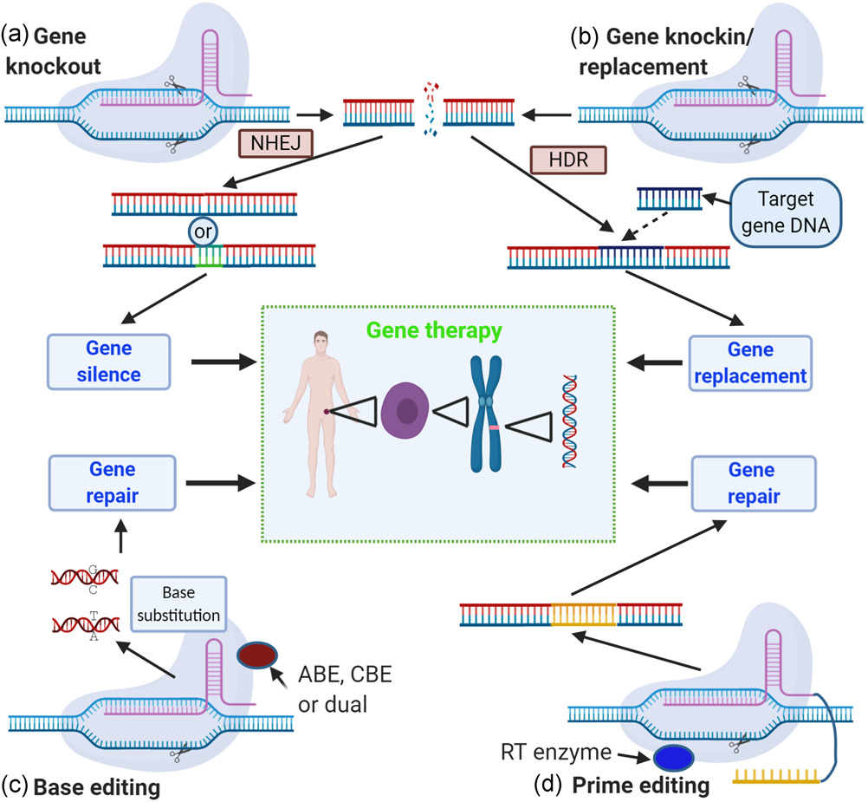

- Bio-printing: - Generally speaking, bioprinting in the context of modern biotechnology refers to the computer-assisted production of cells and tissues to form organs. By printing cells and one layer of biomaterials on top of the other, it creates a three-dimensional structure for tissue. This technique is used in develop building tissue and organ structure bio-printers that work with accessible bio-inks made from biomaterials. These cells will act as substrates which allowing the development of various body parts from the patient's cells, such as bone skin, etc.
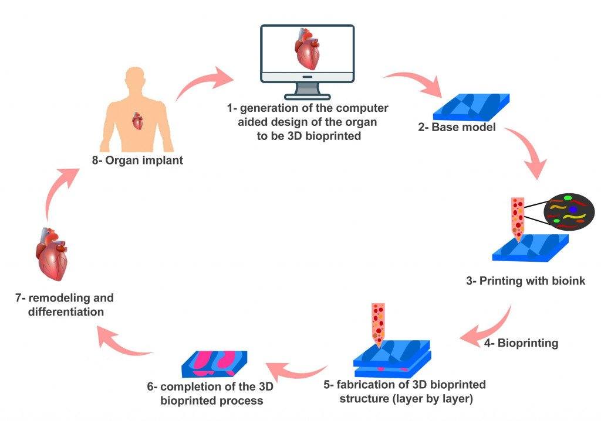

- Telemedicine: - Telemedicine technology is very useful technology in the future health and care industry prospects. It is defined as medical people treating and diagnosing by keeping their distance from the patients. There is no. of telemedicine software like Doxy.me, OhMD, Whereby, Mend, Updox, etc.

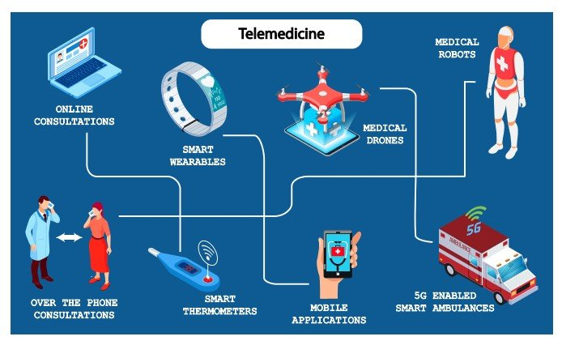

- Precision Medicine: - Both gene editing and gene sequencing are becoming more and more affordable, and clinical procedures frequently use them. It makes precision medicine possible, an advancement that enables doctors to ascertain which preventive measures are most effective for a certain population. Additionally, it makes tailored medicine possible for the treatment of various illnesses, including cancer. Accuracy medicine is being used by biotechnology startups to find new drug targets, find innovative medications, provide gene therapies, and create new drug delivery systems.
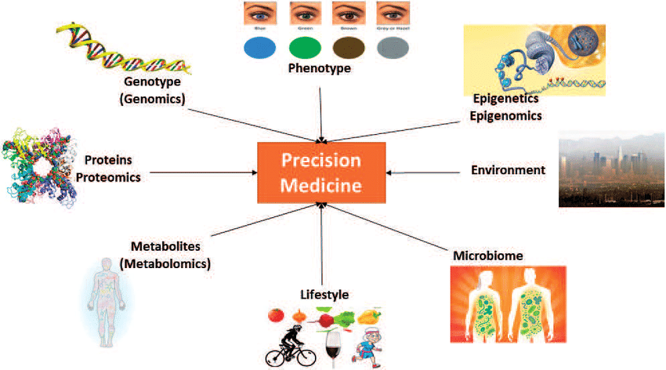

- Big Data:- It is a means of acquiring biological data; biotechnology currently has access to a unique amount of data due to the growth of omics technologies, the addition of sensors, and Internet of Things (IoT) devices. Startups in the biotechnology industry can leverage this abundance of data to generate innovative ideas through the use of big data and analytics technologies. It makes it possible for biopharma businesses to more successfully recruit people for various clinical studies. Both startups and established businesses launch the bioinformatics field to solve various issues, create better feed for crop improvement, create animal kinds, and investigate previously unidentified microorganisms.
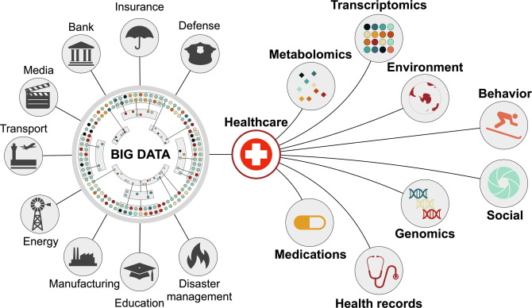

- Synthetic Biology: - It is an exceptional form of sophisticated biology, referred to as such. It is a genome reader and writer. It enables biotechnology startups and businesses to produce a greater number of goods more quickly than in the past. Because of synthetic biology's increasing reproducibility and uniformity, it is now possible to control organisms at the gene network level. Startups in synthetic biology tackle a wide range of issues, from microbiome-based solutions to computational range and cellular agricultural design.

- Drug Research:- One of the most potential biotech prospects for smart technology improvements nowadays is medication research. Drug development typically faced numerous obstacles, such as finding enough volunteers for clinical trials and lengthy production schedules that could last years. The subject of drug research has enormous potential thanks to machine learning technology, which can also be used to improve medicine diagnosis and therapy.

- 4D printing and Tissue Engineering:- Although 4D printing has seen little use in agriculture and farming applications, it is proving to be quite effective in the fabrication of self-healing materials for the tissue engineering and other manufacturing applications. The shape of 4D materials changes as they are exposed to specific settings, yet the materials that are now on the market have relatively little cell compatibility. However, the Eben Alsberg research team developed new 4D materials based on hydrogels that resemble gelatin. Tissue engineering enhances cell compatibility and 4D printing which provides 4D structures.

Development of Vaccines: - As far as we are aware, the coronavirus was formerly associated with less severe illnesses like the common cold. However, three variations, including SARS-CoV and MERS-CoV, have since been associated with serious illness and mortality in those who contract it, leading to the creation of global pandemics. Developing fresh, long-term approaches is essential to halting the global viral epidemic. Thus, a great number of scientists and researchers have been able to create trustworthy vaccinations with the aid of biotechnology.

SIX EMERGING BIOTECH TRENDS

1. CRISPR-Cas and Gene Editing:
One of the most groundbreaking innovations in biotechnology is the development of the CRISPR-Cas gene-editing technology. This revolutionary tool allows scientists to precisely modify DNA sequences in a wide range of organisms, from microbes to plants and animals. The potential applications of CRISPR-Cas are vast, including the treatment of genetic diseases, the creation of genetically modified organisms for agriculture, and advancements in drug discovery. However, ethical concerns surrounding gene editing, such as the potential for unintended consequences and designer babies, raise important ethical questions that society must address.

2. Personalized Medicine:
The era of personalized medicine is upon us, thanks to advancements in genomics, proteomics, and bioinformatics. Biotechnology allows for the analysis of an individual's genetic makeup, enabling tailored medical treatments and therapies. Precision medicine holds promise for more effective disease prevention, diagnosis, and treatment. However, challenges related to data privacy, regulatory frameworks, and equitable accesses to personalized treatments need to be addressed to fully realize the potential of this approach.
3. Synthetic Biology:
Synthetic biology involves designing and engineering biological components to create novel biological systems with desired functions. This field has the potential to revolutionize industries such as pharmaceuticals, agriculture, and energy production. From designing microorganisms that produce biofuels to engineering bacteria that can sense and clean up pollutants, synthetic biology offers innovative solutions to pressing global challenges. As with any emerging technology, careful consideration of ethical, safety, and environmental implications is essential.
4. 3D Bioprinting and Tissue Engineering:
Advancements in 3D bioprinting are poised to transform the field of regenerative medicine. Researchers can now create intricate three-dimensional structures of tissues and organs using bioinks composed of living cells. This technology holds promise for organ transplantation, drug testing, and disease modeling. However, challenges such as vascularization of printed tissues and the mimicking of complex organ structures remain to be addressed for clinical applications.
5. Agricultural Biotechnology:
Biotechnology is revolutionizing agriculture through genetically modified crops that offer increased yields, enhanced nutritional profiles, and improved resistance to pests and diseases. These innovations have the potential to address food security challenges and reduce the environmental impact of agriculture. Public acceptance, regulatory frameworks, and coexistence with conventional farming practices are critical factors in the successful adoption of agricultural biotechnology.

6. Ethical and Societal Considerations:
As biotechnology advancements continue to accelerate, ethical considerations become paramount. Balancing the benefits of innovation with potential risks and unintended consequences is a complex challenge. Issues such as biosecurity, intellectual property rights, and equitable access to biotechnological advancements require global collaboration and thoughtful policymaking.

Artificial Intelligence (AI) in Biotechnology
While artificial intelligence helps find biomarkers for medication development, it also provides many other possibilities, such as smart manufacturing and improved analytics.
The following biotech AI trends are progressively reshaping the contemporary world:
- Speedy evaluation of medical data
- Utilizing bioinformatics to sequence genomes
- Eliminating duties related to manual data entry and analysis
- Agricultural data
- Accurately identifying compounds for specific medications
Artificial Intelligence (AI) technologies are revolutionizing biotechnology by enhancing data optimization, analysis, and scientific model correctness. This biotechnology trend has enormous potential to transform the fields of agriculture and medicine.

CONCLUSION
Biotechnology's transformative potential is reshaping industries and societies, offering solutions to pressing challenges and unlocking new possibilities. From healthcare to agriculture, the innovations discussed in this chapter represent just a glimpse into the future of biotechnology. As we navigate this rapidly evolving landscape, interdisciplinary collaboration, ethical foresight, and responsible innovation will be crucial in harnessing the power of biotechnology for the betterment of humanity.

- Srivastava, M., (2007). Biotechnology Tools and Techniques. Shree Publishers and Distributers: New Delhi; 2–81.

- https://www.hult.edu/blog/biotech-innovation-6-exciting-developments

- https://www.cell.com/trends/biotechnology/fulltext/S0167-7799(22)00005-1

- https://www.cell.com/trends/biotechnology/home

- https://www.sciencedirect.com/journal/trends-in-biotechnology

- Charlotte, V. T., Thierry, V., Jeroen L., Dragana, S., (2023). Imaging the unimaginable: leveraging signal generation of CRISPR-Cas for sensitive genome imaging. Trends in Biotechnology. Volume 41, Issue 6, Pages 769-784https://doi.org/10.1016/j.tibtech.2022.10.003

