Gonococcal and Chlamydial Urethritis
Tanisha Bharara^{1*,} Preena Bhalla², Abhishek Yadav³
- *Assistant Professor, Department of Microbiology, NDMC Medical College and Hindu Rao Hospital
- Ex-Professor, Department of Microbiology, NDMC Medical College and Hindu Rao Hospital
- Assistant Professor, Department of Microbiology, NDMC Medical College and Hindu Rao Hospital
Corresponding author: Dr. Tanisha Bharara
Microbial urethritis is one of the most common sexually transmitted infections (STI) in men. Its prevalence and rising incidence worldwide makes it a subject of intense research.¹ The most remarkable sign of male urethritis is mucopurulent or purulent urethral discharge. Sometimes the discharge, and even other signs and symptoms of urethral infection (dysuria, urethral discomfort, etc.) may be absent or very mild.² In these cases, urethral inflammation may be confirmed by Gram stain of urethral secretions demonstrating >5 polymorphonuclear leukocytes (PMN) per oil immersion field.³ CDC considers a lower cut off value for PMN’s i.e. 2 PMN / oif irrespective of symptoms.⁴
The primary pathogens associated with urethritis are Neisseria gonorrhoeae and Chlamydia trachomatis. The symptoms in men are distinctly different from those in women. Because it is one of the most common STI in men, diagnosis and treatment remain clinical and public health priorities. The goals of treatment are to alleviate symptoms, prevent complications, and reduce transmission of co-infections (particularly human immunodeficiency virus), identify and treat contacts, and encourage behavioural changes to reduce the risk of recurrence.⁵
The classification of urethritis as gonococcal or nongonococcal is based on the traditional Gram staining of urethral discharge for gram-negative intracellular diplococci. However gonococcal and nongonococcal infections often coexist, confounding these terms.⁵
Gonococcal urethritis usually presents with severe and profuse mucopurulent discharge, the external urethral meatus is often erythematous and oedematous. Nongonococcal urethritis on the other hand presents with scanty mucoid / purulent discharge / may be completely asymptomatic. However these conditions are difficult to differentiate on clinical grounds alone, therefore the importance of various diagnostic techniques comes to light. ⁶
Nongonococcal urethritis (NGU) is one of the commonest sexually transmitted infections affecting men, yet a pathogen is not identified in a significant proportion of cases (20%–50%). In a study conducted by Catriona et al on patients with nongonococcal urethritis, it was found that C. trachomatis typically accounts for 30%–50% of cases of NGU and Mycoplasma genitalium accounts for 10%– 30%;⁷ Ureaplasma urealyticum, Haemophilus species, Streptococcus species, and Gardnerella vaginalis have been associated with NGU, but their role is unproven.⁸ Few studies have investigated potential viral causes of acute NGU, such as herpes simplex virus (HSV) and adenoviruses.⁹ In a similar study of 52 patients carried out by CM Gupta et al. at Department of Dermatology & Venereology, Armed Forces Medical College, Pune (India), incidence of Gonococcal and Non gonococcal Urethritis (NGU) were found to be 65% and 35% respectively. In this study also the commonest organism causing NGU was found to be C.trachomatis (28%).¹⁰ In yet another study conducted by Bharara et al at Maulana Azad Medical College, New Delhi, India gonococci were detected in 58.1% cases, and C. trachomatis was detected in 14% cases. While, their co-infections was detected in 12% cases. ¹¹
In patients with confirmed urethritis, concurrent treatment for gonorrhoea and chlamydia is recommended unless test results are already known or rapid results can be obtained to narrow treatment.¹²
GONOCOCCAL URETHRITIS
Gonorrhoea is the second most commonly reported notifiable disease in the United States.¹² Although the national gonorrhoea rate decreased 21.7% during 2000–2010, from 128.7 to 100.8 cases/100,000 population, future progress in gonorrhoea control and prevention is threatened by resistance to an increasing number of antimicrobial agents and limited remaining treatment options^{.13} The Centers for Disease Control and Prevention (CDC) estimates that more than 15,68,000 persons in the United States acquire gonorrhoea each year.¹²
STIs have a profound impact on sexual and reproductive health worldwide. More than 1 million STIs are acquired every day. In 2020, WHO estimated 374 million new infections with 1 of 4 STIs: chlamydia (129 million), gonorrhoea (82 million), syphilis (7.1 million) and trichomoniasis (156 million).¹³
In an Indian study conducted by Manju Bala et al., the number of isolates decreased every year, from 119 in 2002 to 55 isolates in 2006. It may be either due to actual decreasing incidence of gonorrhoea over the years or due to the fact that gradually fewer patients were reporting to the clinic because of easy availability of antimicrobials as a part of syndromic management of STDs in peripheral and private health set-ups.¹⁴
The most common manifestation of gonococcal infection in men is an acute anterior urethritis. Most infected people, up to 80% of women and 10% of men, are asymptomatic. Co-infections with chlamydia and other STDs are very common. Among women, gonococcal infections might not produce recognizable symptoms until complications such as pelvic inflammatory disease have occurred.¹⁵
The incubation period ranges from 1 to 14 days or even longer. Symptoms develop in most cases within 2 to 5 days.¹⁵ The predominant symptoms are urethral discharge and dysuria. Initially, urethral discharge is scant and mucoid or mucopurulent, but the urethral exudate becomes frankly purulent and relatively profuse within 24 hours of onset.¹⁶ Approximately 25% of patients develop only a scant or minimally purulent exudate, grossly indistinguishable from the nongonococcal urethritis, and a minority never develop overt signs.¹⁷ Dysuria usually begins after the onset of discharge. Edema and erythema of the urethral meatus are common. Without treatment, the usual course of gonococcal urethritis is spontaneous resolution over a period of several weeks, and 95% of untreated patients become asymptomatic within 6 months. Complications of gonococcal urethritis include epididymitis, acute or chronic prostatitis, seminal vesiculitis, and infections of Cowper’s and Tyson’s glands.¹⁸
The incidence of gonorrhoea varies with age. Seventy-five percent of cases occur in persons aged under 30 years. Its incidence is almost twice as high for sexually active adolescents as for sexually active women in the 20-24-year-old age group.¹⁹ Other risk factors are low socioeconomic status, early onset of sexual activity, marital status, and a history of past gonorrhoea.²⁰ The incidence of gonorrhoea in men who have sex with men may still be higher than in exclusively heterosexual persons.²¹ For Human immunodeficiency virus (HIV) positives, a gonococcal infection may also lead to dramatically increased shedding and accordingly transmission of HIV, probably through an increase of the viral load in the semen.²²

CHLAMYDIAL URETHRITIS
Nongonococcal urethritis (NGU) brings more men to public sexually transmitted disease (STD) clinics than any other clinical entity and probably is the most common STD syndrome in either men or women^{.23} The patients with NGU probably acquire gonorrhoea and chlamydial infection simultaneously, but, because of the longer incubation period of C. trachomatis, post gonococcal chlamydial urethritis may develop after the gonorrhoea is treated with an agent that cannot eradicate chlamydia.²⁴ Among men infected with both chlamydia and N.gonorrhoeae who are treated with penicillin, ampicillin, gentamicin, or spectinomycin, 80% or more develop symptomatic post gonococcal chlamydial urethritis or urethral leucocytosis without symptoms. ²⁵
C. trachomatis is an obligate intracellular parasite; it has a unique developmental cycle which takes place within a specialized cytoplasmic compartment known as an inclusion. The obligate intracellular nature of chlamydial development places severe restrictions on studying the biology of these micro-organisms.²⁶ Currently, more than 18 different serovars of the organism have been identified based on conventional serotyping, while more than 29 variants have been recognized by employing monoclonal antibodies or genotypic methods.²⁷ Infections of the genital tract are primarily caused by serovars D, E, F, G, H, I, J, and K.²⁸ Among rectal infections in homosexual men, the D and G serovars are particularly prevalent^{.29}
C.trachomatis is the major pathogen causing nongonococcal urethritis, estimated to account for 30% to 50% of cases. Clinically, chlamydia-positive and chlamydia-negative NGU cannot be differentiated on the basis of signs or symptoms alone.³⁰ Both usually present after an incubation period of 7 to 21 days with dysuria and mild-to-moderate whitish or clear urethral discharge. Examination reveals no abnormalities other than the discharge in most cases. Most men with asymptomatic chlamydial urethral infection exhibit persistent urethral leukocytosis on Gram stain of urethral secretions or persistent pyuria in a first-void urine. ³¹
Asymptomatic chlamydial infection is common in women, but approximately 70% of men have symptoms such as urethral discharge, dysuria, penile irritation, and signs of epididymo-orchitis or prostatitis.²⁰ C.trachomatis genital infection in heterosexual men, particularly when asymptomatic and undiagnosed, may have potentially serious consequences, not only for themselves but for their partners. The sequelae worldwide, particularly upper genital tract complications and facilitation of HIV infection, can seriously affect women’s future health and burden welfare services.³²

LABORATORY DIAGNOSIS OF URETHRITIS
Worldwide, there is an estimated annual incidence of 25 million cases of gonorrhoea and 50 million cases of chlamydia. In an effort to prevent the spread of these diseases, increased attention is being focused on early diagnosis and treatment of symptomatic or asymptomatic infected individuals.³³
Urethritis can be documented on the basis of any of the following signs or laboratory tests:
- Mucopurulent or purulent discharge on examination.
- Gram stain of urethral secretions demonstrating ≥5 WBC per oil immersion field.
- Positive leukocyte esterase test on first-void urine or microscopic examination of first-void urine sediment demonstrating ≥10 WBC per high-power field.³⁴
The Gram stain is the preferred rapid diagnostic test for evaluating urethritis and is highly sensitive and specific for documenting both urethritis and the presence or absence of gonococcal infection. Gonococcal infection is established by documenting the presence of WBC containing Gram negative intracellular diplococci (GNID). ³⁴
If clinic based diagnostic tools (e.g., Gram-stain microscopy, first void urine with microscopy, and leukocyte esterase) are not available, patients should be treated with drug regimens effective against both gonorrhoea and chlamydia. Further testing to determine the specific aetiology is recommended by CDC because both chlamydia and gonorrhoea are reportable to health departments and a specific diagnosis might improve partner notification and treatment.³⁴
LABORATORY DIAGNOSIS OF GONOCOCCAL URETHRITIS
The diagnosis of gonococcal urethritis in the laboratory can be established by
- Direct microscopy
- Isolation of N.gonorrhoeae by culture on selective and non-selective medium
- Nucleic Acid Amplification Tests
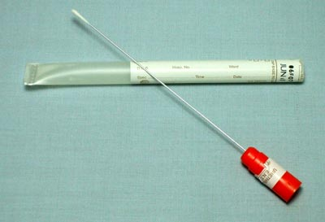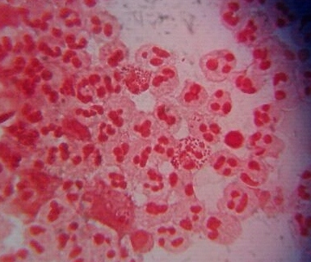
1a. 1b.
Figure 1a: Urethral swab Figure; 1b: Direct Gram stained smear of urethral discharge showing intracellular gram negative diplococci within polymorphonuclear leucocytes

Conventional diagnosis of N.gonorrhoeae infection requires isolation on selective media or observation of gram-negative diplococci in Gram smears of urethral discharge.³ 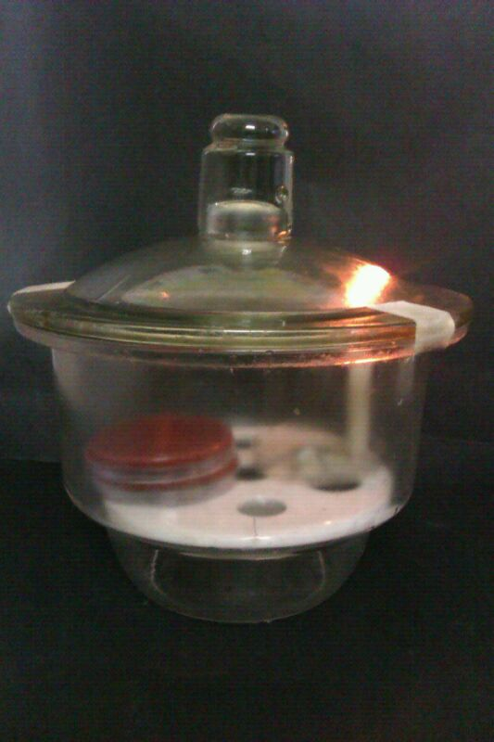 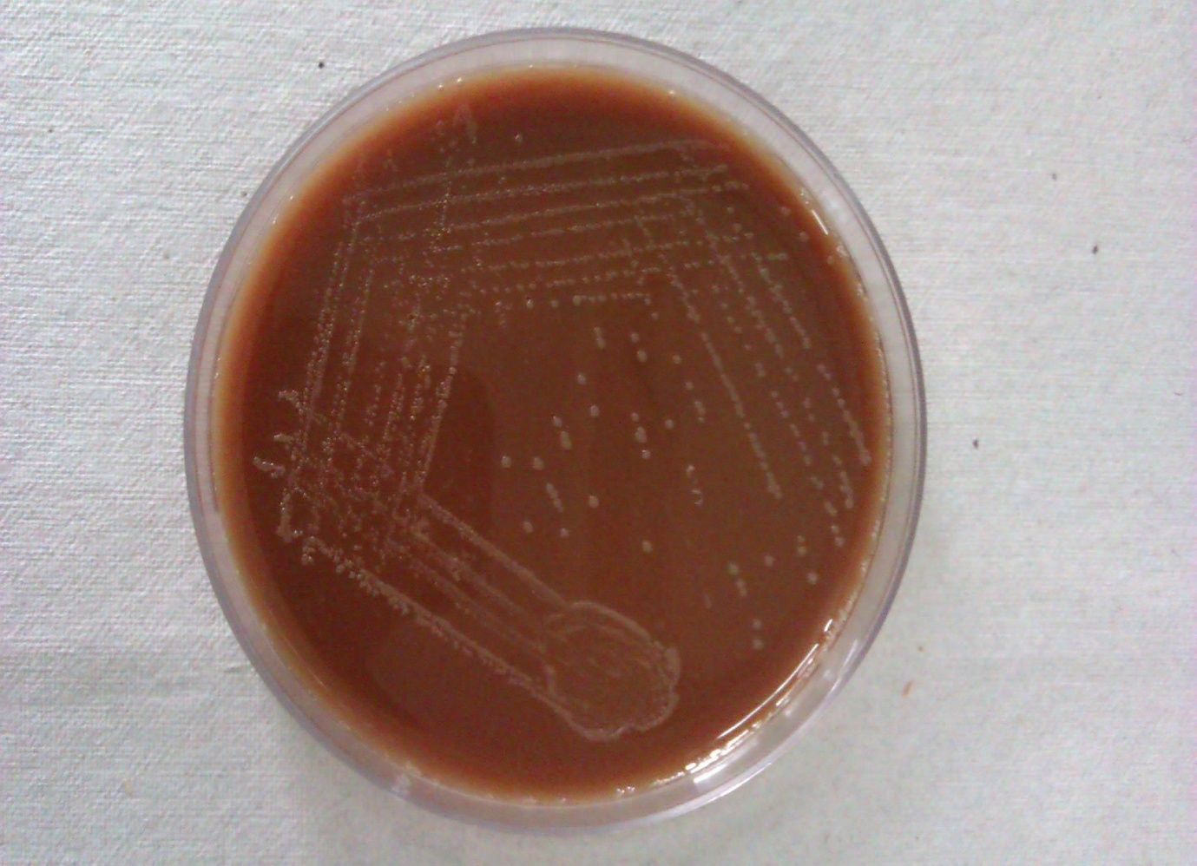
- b.
Figure 2a: Candle jar used for incubation of culture plates in the laboratory; 2b: Growth of N.gonorrhoeae on Modified Thayer Martin medium
Gram staining of urethral smear is considered as preferred rapid diagnostic test for evaluating urethritis and is highly sensitive and specific for documenting both urethritis and presence of gonococci. Correlation between gram staining and PCR was found to be 99.6% in a study conducted by El-Gamal et al.³⁵ Both CDC and the WHO guidelines accept the use of microscopy for definitive diagnosis of gonorrhoea in urethral samples from symptomatic men. However, in asymptomatic men or in women with genital infection, the Gram stain is less useful, because of lower sensitivity.
Specific diagnosis of infection with N. gonorrhoea can be performed by testing urethral or urine specimens^{.21} Although in vitro culture is still the reference method, low sensitivity has been found ranging from 50-84% in several studies. Reasons could include prior antimicrobial therapy, loss of viability of organism during transport, low concentration of organisms or sampling error.³⁶ The gonococci are very fastidious; therefore, best results are achieved by direct inoculation of culture plates followed by immediate incubation under suitable conditions. When direct plating and immediate incubation is impracticable several transport and culture systems are available.³⁷
Several systems have been developed for transport of cultures for gonorrhoea which permit shipment on appropriate media in a C0₂-enriched environment. Two of the most commonly used systems are the C0₂- containing bottle system, commonly referred to as the Transgrow (TG) system, and the bag plate method in which a self-contained C0₂-generating system is used eg. JEMBEC (John E. Martin Biological Environmental Chamber). In a study conducted by Dowda et al. there were no significant differences in the recovery rates of the two systems, however, statistically significant decreases in recovery rate were noted when each system was compared with the traditional plate-candle jar technique. Of the 252 cultures positive by one of the methods, 79.8% were detected by the JEMBEC, 83.3% were detected by TG, compared to 95.2% detected by traditional plate (MTM)-candle jar technique.³⁷
The importance of culture methods in the diagnosis of gonorrhoea is well established. Although today's culture media and procedures have evolved through many stages, the basic constituents were introduced in 1891 by Werthheim.³⁸ Early modifications of his medium included heating blood agar for 5 min at 80 C, which resulted in "chocolate agar", the use of commercial peptone, and replacement of animal fluids with yeast extracts. Recent modifications have involved the introduction of antibiotics into the chocolate agar base and the resulting development of a selective medium (Thayer-Martin medium) for the isolation of pathogenic Neisseria. Later, the antibiotic combination was altered and the yeast extract was replaced with a defined supplement; these changes improved the selectivity and sensitivity of this medium for isolation of gonococci.³⁹
Although selective media are not absolutely selective, the high degree of specificity and sensitivity of Thayer-Martin (TM) agar permitted presumptive positive identification of Neisseria gonorrhoeae on the basis of. cultural characteristics, oxidase tests, and Gram stains. More recently, a modified TM medium (MTM) was employed. This medium contained twice as much agar as did TM medium, additional dextrose, and 5.0 mg of trimethoprim per ml. In MTM medium the increased agar content produces a more rigid transport medium; the increased dextrose content permits optimum growth of certain gonococci; the addition of trimethoprim (5.0 mg/ml) suppresses growth and spreading by frequently found Proteus species.⁴⁰
Another media employed for culture of N.gonorrhoeae is NYC medium. Although primarily designed for isolation of pathogenic Neisseria, it also readily supports the growth of mycoplasmas. The transparency of the medium allows for convenient direct observation of large-colony variants of mycoplasma, therefore, if used in gonorrhoea screening programs, this medium can be valuable in establishing the frequency of association of mycoplasmas with urogenital tract infection.⁴¹
The importance of a partial carbon dioxide environment for enhancing primary growth of the gonococcus was first reported by Wherry and Oliver.⁴² Chapin introduced the candle jar extinction method for providing this atmosphere, and Spink and Keefer confirmed that this procedure supplied adequate carbon dioxide for primary growth of gonococci.⁴³ Although various methods for providing carbon dioxide in a closed container were shown to be as effective as the candle jar, this procedure is the one most widely used today for incubating primary cultures of gonococci. Unfortunately, the candle jar, although inexpensive, is cumbersome, easily breakable, and requires a large amount of incubator space. This restricts its use by the average practitioner or small laboratory.⁴⁴
In a study conducted by John E Martin et al on use of the plastic bag with the carbon dioxide tablet, for providing partial carbon dioxide environment, showed that this incubation
system is equally as effective as the candle jar. However, the plastic bag and tablet system
has the advantage of requiring less incubator space, being far less cumbersome, and being
relatively unbreakable. In addition, the system has potential as an alternate transport system for gonococci and might be applicable to other pathogenic bacteria that prefer special conditions of incubation, e.g., streptococci or meningococci.⁴⁵
An important and essential measure for monitoring the effectiveness of recommended drugs for the treatment of gonorrhoea is surveillance of the in vitro antimicrobial susceptibilities of clinical isolates of N.gonorrhoeae. Currently, agar dilution and disk diffusion testing are most commonly done procedures for antimicrobial susceptibility testing.⁴⁵ Agar dilution susceptibility testing is considered the “gold standard test”. However, this method is cumbersome, is difficult to standardize, and is performed only in research laboratories, mainly in industrialized countries. The technology is generally beyond the technical abilities of laboratories in developing countries. When performed correctly, the disk-diffusion and Etest susceptibility tests can be used to identify isolates of N. gonorrhoeae that exhibit decreased susceptibility, intermediate resistance, and resistance to antimicrobial agents.⁴⁵
In the disk-diffusion susceptibility test, disks containing known amounts of an antimicrobial agent are placed on the surface of an agar plate containing a non-selective medium (Chocolate agar) that has been inoculated with a suspension of a strain of N. gonorrhoeae to give a confluent lawn of growth. The antimicrobial agent diffuses into the medium, causing a zone of inhibition of growth of the strain around the disk corresponding to the susceptibility of the strain to the agent. Interpretative inhibition zone diameters have been established for susceptibility test results to permit classification of an isolate as being susceptible, intermediate (or exhibiting decreased susceptibility), or resistant to an antimicrobial agent.⁴⁵
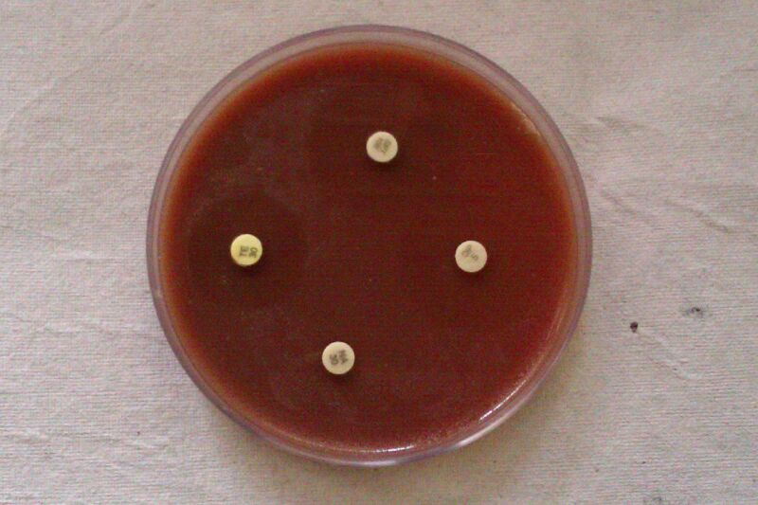
Inhibition zone diameter
Figure 3: Antimicrobial susceptibility testing for N.gonorrhoeae by disc diffusion method
The E test is a strip containing a known gradient of an antimicrobial agent and calibrated to give results as minimal inhibitory concentrations (MICs) of the agents. E test strips are placed on the surface of a 150-mm plate (containing a nonselective medium inoculated as in the disk diffusion method) in a radial pattern with the lowest concentration of the agent toward the center of the plate and the highest concentration of the agent toward the edge of the plate).⁴⁵

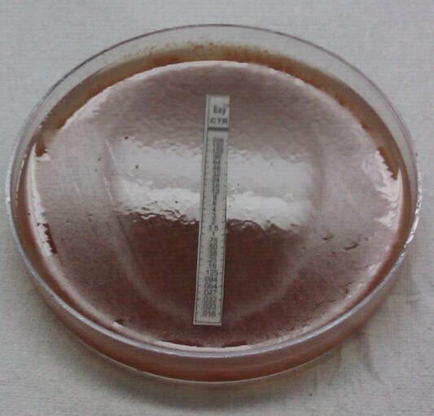
Figure 4: Minimum Inhibitory Concentration (MIC) of ceftriaxone by E test
Asymptomatic gonococcal infections contribute to the persistence and transmission of gonorrhoea in a community. Asymptomatic infection occurs in both males and females.⁴⁶ One approach to eliminating sexually transmitted diseases (STDs) in a community is to screen high-risk persons, followed by the treatment and education of people who test positive. This has been difficult to achieve in the past because of the low sensitivity of diagnostic tests for asymptomatic infections and the need for invasive specimen collection procedures, which results in reduced patient compliance with testing.⁴⁷
NAATs are very sensitive and work well in any sample type used (i.e. urine/ rectal swabs/urethral swabs). Nucleic acid amplification tests, which have increased sensitivities over those of conventional tests, and the option to use urine as a specimen provide valuable tools in the screening of asymptomatic persons for STDs.⁴⁷ The use of hybridisation with DNA probes as a tool for detection of gonococci in urogenital specimens has been investigated extensively in recent years. The sensitivity of NAATs for the detection of N. gonorrhoeae in genital and non-genital anatomical sites is superior to culture but varies by NAAT type.¹⁸ In a study conducted by Kimberly a. et al. the sensitivity of N. gonorrhoeae PCR was found to be 94.4% for male urine specimens and 97.3% for male urethral swab specimens, much higher than the culture sensitivity for N. gonorrhoeae in men, which was 76.6%.³⁴
However, by using NAATs, Antimicrobial susceptibility testing is not possible and hence assessing treatment outcome is hard to do, especially for patients not presenting symptoms upon initiation of treatment.⁴⁸ The genetic relatedness between N. gonorrhoeae, N. meningitidis and the commensal Neisseria species, coupled with extensive exchange of genetic elements, make it difficult to find DNA sequences conserved and unique for N. gonorrhoeae. For this reason, specificity is a major concern, especially in extra-genital specimens. Many Neisseria species are genetically very similar and exchange DNA promiscuously, making molecular assays prone to reduced specificity.⁴⁹ Both commercial and in-house NAAT assays have documented specificity problems There is also a difference in what kind of nucleic acid target that is used. Probes using nucleotide sequences of the pilin gene, the IgAl protease gene, ribosomal RNA and the cryptic plasmid have been reported. The rRNA-derived oligonucleotide probes to different regions of the 16 S ribosomal RNA have been reported to have a sensitivity and specificity of 100%.⁵⁰

LABORATORY DIAGNOSIS OF CHLAMYDIAL URETHRITIS
Diagnosis of Chlamydial urethritis in the laboratory can be established by
- Direct microscopy
- Culture in cell monolayers
- Antigen detection tests like Enzyme Linked Immunosorbant Assay (ELISA), Direct Fluorescent Antibody Test (DFA)
- Nucleic Acid Amplification Tests

Increased number of polymorphonuclear cells in the direct grams smear of urethral discharge establishes a diagnosis of nongonococcal urethritis, more than 5 pus cells / oil immersion field are considered to be significant.⁵¹ Testing for chlamydia is strongly recommended because of the increased utility and availability of highly sensitive and specific testing methods (e.g., NAATs) and because a specific diagnosis might enhance partner notification and improve compliance with treatment, especially in the exposed partner.¹²
C.trachomatis is an intracellular parasite of columnar epithelial cells rather than polymorphonuclear cells, therefore, for cytology, isolation in culture or antigen detection methods, epithelial cell specimens should be collected by vigorous swabbing or scraping of the involved sites. Purulent discharges that lack infected epithelial cells are inappropriate and should be cleaned from the site before the sample is collected.⁵²
Cytological testing is relatively insensitive when diagnosing adult genital tract infections, however, when used for diagnosis of acute inclusion conjunctivitis of the newborn its sensitivity exceeds 90%. Diagnosis is based on detection of typical intracytoplasmic inclusions in smears stained with Giemsa stain. The inclusions are and stain pinkish-blue.³³
Culture for C.trachomatis was earlier considered the gold standard however the procedure requires careful specimen collection and stringent transport conditions and requires at least 48 to 72 h to perform.³⁴ Cell lines that have been used to cultivate C. trachomatis include certain clones of HeLa-229, McCoy, BHK-21, and Buffalo green monkey kidney cells. C. trachomatis EBs are released from intact host cells and separated from each other by vortexing or sonicating the clinical specimen prior to inoculation of the host cell monolayer.
Staining monolayers with Giemsa or iodine following incubation of cultures for 48 to 72 h is the traditional method of detecting C. trachomatis inclusions. Giemsa-stained monolayers may be examined by dark-field microscope, by which chlamydial inclusions are brilliantly illuminated. Cell layers can be stained with DFA 48 h after infection to achieve sensitivity comparable to iodine staining. Based on currently available data, the most sensitive practical method for culturing C. trachomatis that permits clinical laboratory reporting within a few days is the shell vial method of Ripa, in this, cycloheximide treated McCoy cell monolayers are inoculated with the specimen, centrifuged, and stained with fluorescein-conjugated
monoclonal antibody^{.53}
Owing to the inadequacies, cost, and technical difficulties of cell culture, many nonculture diagnostic tests have been developed for C. trachomatis. The most widely used of these assays are the direct fluorescent antibody (DFA) and enzyme immunoassay (EIA) tests. In general, these tests detect between 60% and 85% of infections relative to culture.⁵⁴
The target for these tests is either the major outer membrane protein (MOMP) of the chlamydial elementary body (EB) as this is particularly conserved, or the lipopolysaccharide. The former is commonly detected by direct immune-fluorescence tests using monoclonal antibodies (for example, MicroTrak, Syva), and the latter by enzyme immunoassays (for example, IDEIA, Novo Nordisk). Compared to culture, these methods are faster and simpler. There are also disadvantages, however, eg. MicroTrak requires skilled interpretation and, therefore, the reliability of results may vary among laboratories. Furthermore, the number of samples that can be processed each day is limited. Immunoassays, on the other hand, have unsatisfactory predictive positive and negative values in populations with a low prevalence of chlamydial infection.⁵⁵
DFA is an important test aiding the diagnosis of chlamydial urethritis, however, it involves staining of the elementary bodies in epithelial cell scrapings from infected sites and requires a trained microscopist. It is the only diagnostic test that permits simultaneous assessment
of specimen adequacy by visualisation of cuboidal columnar epithelial cells.⁵⁴ It does not require the maintenance of a cold chain for specimen shipment and provides results faster than culture. When 10 or more elementary bodies are seen in a background of reddish-brown counterstained cells, the test becomes quite specific, although some bacteria can bind immunoglobulins to their surfaces and appear fluorescent specially in rectal specimens.⁵⁶ When compared to more specific molecular methods, DFA is cheap, less time consuming and easily available.⁵⁷

Figure 5: MicroTrak® Chlamydia trachomatis Direct Specimen- Positive slide showing brick red fixed mammalian cells and apple green fluorescent elementary bodies
Antibody detection by ELISA is a convenient diagnostic tool in developing countries.⁵⁶ When compared with DFA serological tests including enzyme immunoassay are not of much value in the diagnosis of C.trachomatis because a positive antibody test does not always distinguish past from current infection.⁵⁷
With advances in DNA technology, laboratory methods for the amplification and detection of the multicopy plasmid DNA present in all C. trachomatis serovars have been introduced for the diagnosis of C. trachomatis infection. When compared to the more sensitive molecular methods, sensitivity of the culture even in expert laboratories is found to be as low as 75 to 85%.⁵⁸ The NAATs are demanding with respect to laboratory facilities and equipment, but standardized easy-to-use kits are available. Furthermore, partially automated assays (e.g., the LCx Chlamydia trachomatis assay; Abbott Laboratories, North Chicago, Ill.) and fully automated assays (Cobas Amplicor Chlamydia trachomatis [CT/NG] test; Roche Diagnostic Systems Inc., Branchburg, N.J.) have been developed and are available for routine use.⁵⁹
Testing of first-void urine (FVU) specimens has been a major breakthrough in the detection of chlamydial infection in both symptomatic and asymptomatic males and females.⁶⁰ Since 30 to 70% of all chlamydial infections may be asymptomatic, routine, non-invasive screening of individuals at risk was highly desirable.³⁴ In a study conducted in National Public Health Institute, Finland by Mirja Puolakkainen et al on FVU samples, 96% and 93% of the infections could be detected by PCR and LCR, respectively, when the results for symptomatic and asymptomatic patients were analyzed together. When performed on FVU, PCR test has been found to be cost beneficial as a screening test for chlamydial infections in population with low-prevalence of infection.⁵⁹
Molecular techniques have been shown to be very sensitive in the diagnosis of chlamydial infection of the male urethra and in detecting chlamydial DNA in male urine specimens. Lower sensitivity has usually been observed when female specimens have been tested, possibly due to the more frequent occurrence of inhibitors in the specimens.⁵⁹
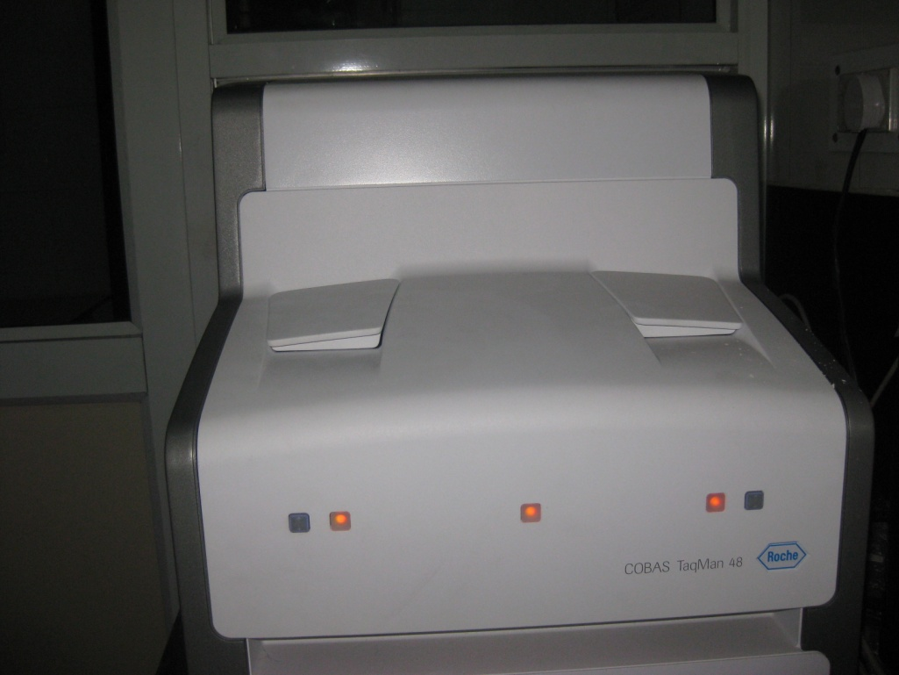
Figure 6: COBAS® TaqMan® 48 Analyzer
In 2006, a new variant of C. trachomatis (nvCT), carrying a 377 bp deletion within the plasmid, was reported in Sweden. This deletion included the targets used by the commercial diagnostic systems from Roche and Abbott. Failure to detect nvCT in samples submitted for routine diagnosis resulted in false-negative reports with a consequent huge impact on the overall national detection rates in Sweden. The nvCT was then rapidly and widely transmitted due to the strong diagnostic selective advantage.²⁶
Abbott and Roche subsequently designed new dual-target assays that simultaneously target the affected sequence of the nvCT plasmid and another sequence of the plasmid and the chromosomal DNA (ompA); these are Abbott RealTime CT/NG and the Roche Cobas TaqMan CT v2.0, respectively.²⁶ Reports on the higher incidence of Chlamydia trachomatis infection and the emergence of plasmid-less isolates in developing countries have raised concern. In the Indian context, Gupta et al. (2008) have raised concern on the existence of a plasmid-less clinical isolate of C.trachomatis in a patient from New Delhi, India and has suggested the use of real-time PCR in reviewing the C. trachomatis prevalence rates in the Indian population. Also, Sachdeva et al. (2009) has suggested the possible occurrence of plasmid free variants of C. trachomatis in the Indian population.²⁹

TREATMENT OF URETHRITIS
Centre of Disease Control and Prevention (CDC) has issued guidelines (2021) on testing, treatment and referral for further evaluation of patients with possible/confirmed STI, including men with possible Chlamydia and or gonococcal urethritis. According to CDC If clinic-based diagnostic tools (e.g., Gram-stain microscopy) are not available; patients should be treated with drug regimens effective against both N.gonorrhoeae and C.trachomatis. Further testing to determine the specific aetiology is recommended because both chlamydia and gonorrhoea are reportable to health departments and a specific diagnosis might improve partner notification and treatment.⁶⁰
World Health Organization (WHO) has placed emphasis on syndromic approach for case management, particularly in high-prevalence areas having inadequate laboratory facilities but continuous analysis of risk assessment and prevention-based screening studies are necessary to evaluate and monitor the performance of syndromic management.¹³
According to CDC guidelines, men returning for evaluation of persistent or recurrent urethral symptoms can be challenging to diagnose and treat. Considerations include a recurrent infection, usually because of a lack of simultaneous treatment of partners or reinfection by a new partner; an untreated infection, such as Mycoplasma, Ureaplasma, Trichomonas, HSV, Enterobacteriaceae, or adenovirus; a resistant organism; or a non-infectious cause.⁴ Azithromycin is the drug of choice for mycoplasmal, ureaplasmal, and chlamydial infections.⁶² In areas with a high prevalence of trichomoniasis, metronidazole or tinidazole may be added to usual regimens.⁶³ Men should also be advised to abstain from sex for one week following initiation of therapy. Patient education should be aimed at awareness and reduction of risk factors for STIs.⁴
Expedited partner treatment is a CDC-recommended strategy for situations in which the patient’s sexual partners are otherwise likely to go untreated.⁶⁰ In this approach, patients with STIs are given prescriptions or medications for partners who have not been evaluated by
the physician. Among patients with urethritis, expedited partner treatment has been shown to decrease recurrence.⁶¹ As men with documented chlamydial or gonococcal infections have a high rate of reinfection within 6 months after treatment.⁶²

GONOCOCCAL URETHRITIS
Gonorrhoea is one of the oldest known diseases of humans. The major clinical manifestations of gonorrhoea in men were described in ancient Chinese, Egyptian, Roman, and Greek literature^{.44} In the second century, Galen coined the word gonorrhoea, by which he meant “flow of semen.” Neisser demonstrated N. gonorrhoea in 1879, and Leistikow and Loffler cultured the organism in vitro in 1882.⁶³
USE OF ANTIMICROBIAL AGENTS AND EMERGENCE OF RESISTANCE
Sulfanilamide, under the name Prontosil, was tested as a treatment of gonorrhoea. Many
studies were published between 1937 and 1940, and the outcomes were quite varied. In some series, there was a >90% improvement or cure rate, while in others, there was some benefit to treatment in about half the patients but a fair number of relapses.⁶⁴ The development of penicillin had an enormous impact on the management of patients with gonorrhoea, and the rapid curative properties of this drug were quickly appreciated.⁶⁵ Over time, some authors reported poor results with a very low dose of penicillin. At the same time, physicians noted the community-wide spread of strains of N. gonorrhoeae with increasing MICs. This
increase in MIC was definitely associated with an increased failure rate following penicillin therapy.
It is now widely recognized that there are distinct resistance mechanisms to consider when clinical failure based on lowered susceptibility follows treatment with penicillin. Chromosomal resistance is the result of serial changes in the structure of penicillin-binding proteins and/or outer membrane permeability that culminate in penicillin MICs that exceed
1 ug/ml. The other mechanism for stable, heritable penicillin resistance is the elaboration of ß-lactamase enzyme. The initial epidemiology of these PPNG strains showed a spread from Asia and Africa throughout the world. In a study conducted by Manju Bala et al. an alarming increase in antimicrobial resistance in N. gonorrhoeae to penicillin and ciprofloxacin from 1996 to 2001was reported, 21.2% of isolates were found to be PPNG. The results compared well with other studies from India.¹⁴ Adverse reactions to penicillin and reluctance to accept parenteral therapy were the most common contraindications to penicillin use. In addition, the occurrence of post-gonococcal genital infection made the search for alternative therapies important.⁴⁵
A large clinical study conducted in Africa showed that treatment of 83 adult men with ciprofloxacin (a single, oral 250-mg dose) was 100% effective, the success rate for ceftriaxone was found to be 98.7%.⁶⁶ Since newer fluoroquinolones were generally very active against gram-negative bacteria, quite safe when administered to adults, and have good absorption and tissue penetration, it was logical to consider them for the treatment of gonorrhoea. Regrettably, resistance to fluoroquinolones appeared quickly,⁴⁵ now fluoroquinolone resistant isolates are very prevalent in Asia and have been isolated with increasing frequency in the United States.⁴⁵
Another drug that was used for treatment of gonococcal urethritis was tetracycline. One of
the biggest problems with the use of tetracyclines in the treatment of gonorrhoea is that single-dose oral therapy (even with very high doses) is prone to failure.⁴⁵ In 1984 and 1985, a new, high-resistance (MIC, > 16 p.g/ml) phenotype was discovered in the United States. This was attributed to a new tetracycline resistance gene that was plasmid borne. This gene spread fairly quickly through N. gonorrhoeae strains in the United States and abroad.⁶⁷ An increasing trend of TRNG was observed from 6.7% in 2002 to 22.9% in 2005 in a study conducted in India ¹⁴
A new drug spectinomycin, was developed and marketed with only one indication: treatment of infection caused by N. gonorrhoeae. While spectinomycin does not show the degree of potency associated with penicillin in terms of very low MICs, there is a consistently narrow range of MICs that indicates a high probability of clinical efficacy. Resistance to spectinomycin was first described in 1973 and emerged in the early 1980s as a widespread phenomenon, though it is relatively rare in most parts of the world, including developing countries like India.⁴⁵
Over the years ß-Lactamase-stable cephalosporins have acquired an important role in the treatment of gonorrhoea in direct proportion to the reduced efficacy of penicillin. Like penicillin, cephalosporins provide the ease and security of single-dose therapy with high confidence in a good clinical outcome. Ceftriaxone has a significant contemporary role in the
treatment of gonorrhoea because of its very high intrinsic potency, lack of resistant strains, and long half-life. A single dose of 250 mg, which can be injected into a deltoid muscle, has a cure rate comparable or superior to that of any other therapy.⁴⁵ Thus, ceftriaxone has become the drug of choice in current Centers for Disease Control recommendations.¹²
An oral cephalosporin, cefixime, showed clinical activity equivalent to that of ceftriaxone (96 to 98% cure) after a single 400- or 800-mg dose. The greater ease and patient acceptance of oral therapy may well favour such an agent.⁴⁵ Cefixime treatment failures were first reported from Japan in 2003and have subsequently been reported from Norway, the United Kingdom, Austria, and France.⁶⁸ More recently, and of great concern, a gonococcal isolate with high-level ceftriaxone resistance was identified in a Japanese woman with pharyngeal infection and apparent ceftriaxone treatment failure in 2009.⁶⁹ Gonococcal isolates with high-level ceftriaxone resistance have subsequently been identified in men with urogenital infections in France and in Spain.⁷⁰ While confirmed cephalosporin treatment failures have not yet been identified in the United States, GISP has detected recent increases in minimum inhibitory concentrations (MICs) for cephalosporins among gonococcal isolates. From 2006 to the first six months of 2011, the proportion of Gonococcal Isolate Surveillance Project (GISP) isolates with an elevated cefixime MIC (MIC ≥0.25 μg/ml) increased from 0.1% to 1.7%, and the proportion with an elevated ceftriaxone MIC (MIC ≥0.125 μg/ml) increased from 0.05% to 0.5%.These increases were most notable in the western United States and among MSM^{.71}
In 2010, 27.2% of all GISP isolates were resistant to penicillin, tetracycline, ciprofloxacin, or some combination of those antimicrobials and 6.9% of isolates were resistant to all three antimicrobials.¹ Reduced susceptibility to third-generation cephalosporins used at present as first-line therapy, although rare, has been reported from some countries, but not from India.¹⁴
In a recent study by Unemo et al published in lancet, the maximum AMR rates of 22% for cephalosporins, 60% for azithromycin, and 100% for ciprofloxacin were reported from all over the world.⁷²
CURRENT RECOMENDATIONS FOR TREATMENT
N. gonorrhoeae usually develops resistance to antimicrobial agents within a few years of their introduction for gonorrhoea therapy. Antimicrobial resistance in N. gonorrhoeae occurs as chromosomally mediated resistance to a variety of antimicrobial agents, including penicillin, tetracycline, spectinomycin, and fluoroquinolones, and high-level, plasmid-mediated resistance to penicillin and tetracycline.¹² The WHO has, therefore, established a surveillance programme in different regions of the world known as the Gonococcal Antimicrobial Surveillance Programme (GASP) in 1990. GASP is important in assisting health providers in making recommendations regarding effective antibiotics for treatment.
Whenever possible, the treatment for gonorrhoea should be a safe, highly effective, single-dose, and affordable regimen. The safety and efficacy of gonorrhoea treatment are important because of the large number of patients who are treated for gonorrhoea and the high proportion of them who become reinfected and require repeated courses of therapy.⁷³
Currently, the Centers for Disease Control and Prevention (CDC 2021) recommends single therapy with ceftriaxone (an injectable cephalosporin) 500 mg intramuscularly. In case of cephalosporin allergy, alternative regimen of gentamicin 240 mg IM in a single dose plus azithromycin 2 g orally in a single dose can be given.¹²
A test-of-cure-follow-up testing to be sure the infection was treated successfully-is not needed for genital and rectal infections; however, if a person’s symptoms continue for more than a few days after receiving treatment, he or she should return to a health care provider to be revaluated. For patients allergic to cephalosporins, Gentamicin 40 mg intramuscular plus azithromycin 2 grams orally is the only alternative treatment option available.¹²

IDENTIFICATION OF TREATMENT FAILURE CASES
According to CDC, treatment failure due to Ceph-R NG infection should be considered in following cases:
• Patients whose symptoms do not resolve within 3-5 days after appropriate treatment and who report no sexual contact during the post-treatment follow-up period
• Patients with a positive test of cure (positive culture ≥72 hours or positive nucleic acid amplification test [NAAT] ≥7 days after appropriate treatment) when no sexual contact is reported during the post-treatment follow-up period
• Patients with a positive N. gonorrhoeae culture within 30–60 days (but ≥72 hours) after treatment for gonorrhoea who are found to have elevated cephalosporin MICs on AST (see laboratory criteria for suspect or probable Ceph-R NG cases, regardless of whether sexual contact is reported during the post-treatment follow-up period^{.12}

CHLAMYDIAL URETHRITIS
The most active drugs against C. trachomatis in tissue culture are rifampin and the tetracyclines, followed by macrolides, sulfonamides, fluoroquinolones, and clindamycin.
Penicillin, ampicillin, cephalosporins, and spectinomycin for treatment of gonorrhoea do not eradicate concomitant chlamydial infection.¹⁸ Azithromycin and doxycycline are highly effective for chlamydial infections. Azithromycin has a half-life of 5 to 7 days and excellent intracellular and tissue penetration. It is the only single-dose agent for the treatment of chlamydial infection.¹² The recommended length of therapy for NGU using tetracycline or doxycycline ranges from 7 to 21 days.¹²
CDC, therefore, recommends Azithromycin 1g orally in a single dose or Doxycycline 100 mg twice daily for 7 days for treatment of Chlamydial urethritis. Single-dose regimens have the advantage of improved compliance and directly observed treatment. To maximize compliance with recommended therapies, medications should be dispensed on-site in the clinic, and the first dose should be directly observed.¹²
There have been no descriptions either of isolation of C. trachomatis strains that display stable resistance to antimicrobial agents recommended for therapy or of mechanisms of putative antimicrobial resistance for isolates obtained from patients with treatment failures.
In a study conducted by Susan A. Wang et al., C. trachomatis isolates were shown to have some degree of in vitro antimicrobial resistance, however, they were difficult to propagate and were eventually lost through continued cell culture. These observations suggest the possibility that antimicrobial-resistant C. trachomatis may not survive as well as non-resistant organisms in cell culture, suggesting that they may be “less fit.” ⁷⁴
REFERECES
- Masari V, Retel O, Flahault A. A recent increase in the incidence of male urethritis in France. Sex Transm Dis. 2002;29:319-23.
- Maw RD, Robinson A. Asymptomatic urethritis: the case considered view. Int J STD AIDS. 2004;15:849-50.
- Vesic S, J. Vukicevic J, Ðakovic Z, Tomovic M, Dobrosavljevic D, Medenica L et al. Male urethritis with and without discharge: relation to microbiological findings and polymorphonuclear counts. Acta Dermatoven. 2007;16:53-7.
- Brill JR. Diagnosis and Treatment of Urethritis in Men. Am Fam Physician. 2010 April;81:873-8.
- Pavithran K. Urethritis in males. Indian J Dermatol Venereol Leprol 2001;67(5):255.
- Workowski KA, Bachmann LH, Chan PA, Johnston CM, Muzny CA, Park I, et al. Sexually transmitted infections treatment guidelines, 2021CDC. MMWR Recomm Rep. (2021) 70:1–187. doi: 10.15585/mmwr.rr7004a1
- Horner P, Thomas B, Gilroy CB, Egger M, Taylor-Robinson D. Role of Mycoplasma genitalium and Ureaplasma urealyticum in acute and chronic nongonococcal urethritis. Clin Infect Dis. 2001;32:995–1003.
- Schwartz MA, Hooton TM. Etiology of nongonococcal nonchlamydial urethritis. Dermatol Clin. 1998;16:727–33.
- Uuskula A, Raukas E. Atypical genital herpes: report of five cases. Scand J Infect Dis. 2004;36:37–9.
- Gupta CM, Sanghi S, Sayal SK, Das AL, Prasad GK. Clinical and bacteriological study of urethral discharge. Indian J Dermatol Venereol Leprol. 2001;67:185-7.
- Bharara T, Bhalla P. Study of gonococcal and chlamydial urethritis: Old culprits with a new story. Journal of Family Medicine and Primary Care. 2022 Sep;11(9):5551.
- Centers for Disease Control and Prevention. Sexually Transmitted Disease Surveillance 2021. Atlanta: U.S. Department of Health and Human Services, 2021. https://www.cdc.gov/std/statistics/2021/default.htm. [Last accessed on 2023 September 23].
- World Health Organisation. Sexually Transmitted Infections 2023. https://www.who.int/news-room/fact-sheets/detail/sexually-transmitted-infections-(stis). [Last accessed on 2023 September 23].
- Bala M, Ray K, Gupta SM, Muralidhar S, Jain RK. Changing trends of antimicrobial susceptibility patterns of Neisseria gonorrhoeae in India and the emergence of ceftriaxone less susceptible N. gonorrhoeae strains. J Antimicrob Chemother. 2007; 60(3):582-6.
- Harrison WO, Hooper RR, Wiesner PJ, Campbell AF, Karney WW, Reynolds GH, et al. A trial of minocycline given after exposure to prevent gonorrhoea. N Engl J Med. 1979;300:1074-8.
- Holmes KK, Johnson DW, Trostle HJ. An estimate of the risk of men acquiring gonorrhoea by sexual contact with infected females. Am J Epidemiol 1970;91:170-4.
- Handsfield HH, Lipman TO, Harnisch JP, Tronca E, Holmes KK. Asymptomatic gonorrhoea in men. Diagnosis, natural course, prevalence and significance. N Engl J Med. 1974;290:117-23.
- Shim BS. Current Concepts in Bacterial Sexually Transmitted Diseases. Korean J Urol. Korean J Urol. 2011 April;52:589-97.
- Centers for Disease Control and Prevention. Sexually Transmitted Diseases Surveillance, 2005. Atlanta, GA; U.S. Department of Health and Human Services, Public Health Service, Nov. 2006.
- Barnes RC, Holmes KK. Epidemiology of gonorrhoea: Current perspectives. Epidemiol Rev. 1984;6:1-30.
- Lafferty WE, Hughes JP, Handsfield HH. Sexually transmitted disease in men who have sex with men: Acquisition of gonorrhoea and nongonococcal urethritis by fellatio and implications for STD/HIV prevention. Sex Transm Dis. 1997;24:272-8.
- Cohen MS, Hoffman IF, Royce RA, Kazembe P, Dyer JR, Daly CC, et al. Reduction of concentration of HIV-1 in semen after treatment of urethritis: implications for prevention of sexual transmission of HIV-1. AIDSCAP Malawi Research Group. Lancet. 1997;349:1868-73.
- Handsfield HH. Nongonococcal Urethritis: A Few Answers but Mostly Questions. J Infect Dis. 2006;193:333–5.
- Oriel JD, Reeve P, Thomas BJ, Nicol CS. Infection with Chlamydia group A in men with urethritis due to Neisseria gonorrhoeae. J Infect Dis. 1975;131:376-82.
- Holmes KK, Handsfield HH, Wang SP, Wentworth BB, Turck M, Anderson JB, et al. Etiology of nongonococcal urethritis. N Engl J Med. 1975;292:1199-205.
- Unemo M, Smith HMBS, Cutcliffe LT, Skilton RJ, Barlow D, Goulding D et al. The Swedish new variant of Chlamydia trachomatis: genome sequence, morphology, cell tropism and phenotypic characterization. Microbiology. 2010;156:1394–1404.
- Bandea CI, Debattista J, Joseph K, Igietseme, Timms P, Black CM. Chlamydia trachomatis serovars among strains isolated from members of rural indigenous communities and urban populations in Australia. J Clin Microbiol. 2008;46:355–6.
- Brunham RC, Pourbohloul B, Mak S,White R, Rekart ML. The unexpected impact of a Chlamydia trachomatis control program on susceptibility to reinfection. J Infect Dis. 2005;192:1836-44.
- Barnes RC, Rompalo AM, Stamm WE. Comparison of Chlamydia trachomatis serovars causing rectal and cervical infections. J Infect Dis. 1987;156:953-8.
- Hillis SD, Coles FB, Litchfield B, Black CM, Mojica B, Schmitt K, et al. Doxycycline and azithromycin for prevention of chlamydial persistence or recurrence one month after treatment in women. A use-effectiveness study in public health settings. Sex Transm Dis. 1998;25:5-11.
- Schafer MA, Schachter J, Moncada J, Keogh J, Pantell R, Gourlay L, et al. Evaluation of urine based screening strategies to detect Chlamydia trachomatis among sexually active asymptomatic young males. JAMA. 1993;270:2065-70.
- Tait IA, Hart CA. Chlamydia trachomatis in non-gonococcal urethritis patients and their heterosexual partners: routine testing by polymerase chain reaction. Sex Transm Infect. 2002;78:286–8.
- Chernesky M, Castriciano S, Sellors J, Stewart I, Cunningham I, Landis S, et al. Detection of Chlamydia trachomatis antigens in urine as an alternative to swabs and cultures. J Infect Dis. 1990;161:124–6.
- Crotchfelt KA, Welsh LE, Debonville D, Rosenstraus M, Quinn TE. Detection of Neisseria gonorrhoeae and Chlamydia trachomatis in Genitourinary Specimens from Men and Women by a Coamplification PCR Assay. J Clin Microbiol. 1997;1536–40.
- El-Gamal AHF, Al-Otaibi SRS, Alshamali A, Abdulrazzaq A, Najem N, Fouzan AA. Polymerase chain reaction is no better than Gram stain for diagnosis of gonococcal urethritis. Indian J Dermatol Venereol Leprol. 2009;75:101.
- Buimer M, Doornum GV, Ching S, Peerbooms P, Plier P, Ram D et al. Detection of Chlamydia trachomatis and Neisseria gonorrhoeae by ligase chain reaction-based assays with clinical specimens from various sites: implications for diagnostic testing and screening. J Clin Microbiol. 1996;34:2395–2400.
- Dowda H, Nelson CF. Evaluation of Two Transport Systems for Gonorrhoea Cultures. J Clin Microbiol. 1979;9:441-3.
- Werthheim E. Reinzuchtung des gonococcus Neisser Mittels des Plattenverfahrens. Deut. Med. Wochenschr. 1891;17:1351.
- Martin JE, Billings TE, Hackney JF, Thayer JD. Primary isolation of N. gonorrhoeae with a new commercial medium. Pub Health Rep. 1967;82:361-3.
- Martin JE, Lester A. Transgrow, a medium for transport and growth of Neisseria gonorrhoeae and Neisseria meningitidis. HSMHA Health Rep. 1971;86:30-3.
- Faur YC, Weisburd MH, Wilson ME, May PS. NYC Medium for Simultaneous Isolation of Neisseria gonorrhoeae, Large-Colony Mycoplasmas, and T-Mycoplasmas. Applied Microbiol. June 1974;27:1041-5.
- Wherry WB, Oliver WW. Adaptation to certain tensions of oxygen as shown by the gonococcus and other parasitic and saprophytic bacteria. J Infect Dis. 1916;19:288-98.
- Spink WW, Keefer CS. Studies of gonococcal infection. J Clin Invest. 1947;16:169-76.
- Martin JE, Armstrong JH, Smith PB. New System for Cultivation of Neisseria gonorrhoeae. Applied Microbiol. 1974;27(4):802-5.
- Fekete T. Antimicrobial Susceptibility Testing of Neisseria gonorrhoeae and Implications for Epidemiology and Therapy. Clin Microbiol Rev. 1993;(6):22-33.
- Handsfield HH. Principles and practice of infectious diseases. 3rd edition. Mandell, Douglas RG, Bennett JE (Eds). Neisseria gonorrhoeae. Churchill Livingstone, New York. 1990;1613–31.
- Farrell DJ. Evaluation of Ampicor Neisseria gonorrhoeae PCR Using cppB Nested PCR and 16S rRNA PCR. J Clin Microbiol. 1999;37:386–90.
- Hjelmevoll SO. Molecular diagnostics and characterization of Neisseria gonorrhoeae. [Internet]. North Noeway; 2012. [cited 2012 January]. Available from: http://munin.uit.no/bitstream/handle/10037/3816/thesis.pdf?sequence=2
- Tabrizi, S. N., M. Unemo, A. E. Limnios, T. R. Hogan, S. O. Hjelmevoll, S. M. Garland, and J. Tapsall. Evaluation of Six Commercial Nucleic Acid Amplification Tests for Detection of Neisseria gonorrhoeae and Other Neisseria Species. J Clin Microbiol. 2011;49:3610-5.
- Ho BSW, Feng WG, Wong BKC, Egglestone SI. Polymerase chain reaction for the detection of Neisseria gonorrhoeae in clinical samples. J Clin Pathol. 1992;45:439-42
- Bradshaw CS, Tabrizi SN, Read TRH, Garland SM, Hopkins CA, Moss LM et al. Etiologies of Nongonococcal Urethritis: Bacteria, Viruses, and the Association with Orogenital Exposure. J Infect Dis. 2006; 193:336–45.
- Chernesky MA. The laboratory diagnosis of Chlamydia trachomatis infections. Can J Infect Dis Med Microbiol. 2005;16(1):39-44.
- Barnes RC. Laboratory Diagnosis of Human Chlamydial Infections. Clin Microbiol Reviews. 1989;2:119-36.
- Black CM. Current methods of laboratory diagnosis of Chlamydia trachomatis infections. Clin Microbial Reviews. 1997;10:160-84.
- Palmer HM, Gilroy CB, Thomas BJ, Hay PE, Gilchrist C, Robinson DT. Detection of Chlamydia trachomatis by the polymerase chain reaction in swabs and urine from men with non-gonococcal urethritis. J Clin Pathol. 1991;44:321-5.
- Langone JJ. Protein A from Staphylococcus aureus and related immunoglobulin receptors produced by streptococci and pneumococci. Adv Immunol 1982;32:157.
- Agrawal SK, Reddy BS, Bhalla P, Kaur H. Utility of Direct Fluorescent Antibody Test for detection of Chlamydia trachomatis and its detection in male patients with non gonococcal urethritis in New Delhi. Indian J Dermatol, Venereol Leprol. 2003;69:144-7.
- Chernesky MA, Jang D, Lee H, Burczak JD, Hu H, Sellors J, et al. Diagnosis of Chlamydia trachomatis infections in men and women by testing first-void urine by ligase chain reaction. J Clin Microbiol. 1994;32:2682–5.
- Puolakkainen M, Back EH, Reunala T, Suhonen S, Lahteenmaki P, Lehtinen M et al. Comparison of Performances of Two Commercially Available Tests, a PCR Assay and a Ligase Chain Reaction Test, in Detection of Urogenital Chlamydia trachomatis Infection. J Clin Microbiol.1998;36(6):1489-93.
- Centre for Disease Control and Prevention. Sexually transmitted infections treatment guidelines 2021. https://www.cdc.gov/std/treatment-guidelines/default.htm. [Last accessed on 2023 September 23]
- Kissinger P, Mohammed H, Richardson-Alston G. Patient-delivered partner treatment for male urethritis: a randomized, controlled trial. Clin Infect Dis. 2005;41(5):623-9.
- Fung M, Scott KC, Kent CK. Chlamydial and gonococcal reinfection among men: a systematic review of data to evaluate the need for retesting. Sex Transm Infect. 2007;83:304–9.
- Kampmeier RH. Identification of the gonococcus by Albert Neisser. Sex Transm Dis. 1978;5:71-2.
- Lich R, Rowntree GR. Sulfanilamide therapy in acute neisserian urethritis. Am J Syph Gonorrhea Vener Dis. 1939;23:323-31.
- Miller CP, Scott WW, Moeller V. Studies on the action of penicillin- The rapidity of its therapeutic effect on gonococcic urethritis. JAMA. 1944;125:607-10.
- Bryan JP, Hira SK, Brady W, Luo N, Mwale C, Mpoko G, et al. Oral ciprofloxacin versus ceftriaxone for the treatment of urethritis from resistant Neisseria gonorrhoeae in Zambia. Antimicrob Agents Chemother. 1990;34:819-22.
- Dewitt WE, Thomas ML, Johnson SR, Morse SA. Frequency and distribution in the United States of strains of Neisseria gonorrhoeae with plasmid-mediated, high-level resistance to tetracycline. J Infect Dis. 1987;155:819-22.
- Unemo M, Golparian D, Syversen G. Two cases of verified clinical failures using internationally recommended first-line cefixime for gonorrhoea treatment, Norway, 2010. Eurosurv. 2010;15(47).
- Ohnishi M, Saika T, Hoshina S. Ceftriaxone-resistant Neisseria gonorrhoeae, Japan. Emerg Infect Dis. 2011;17:148-9.
- Unemo M, Golparian D, Nicholas R, Ohnishi M, Galay A, Sednaoui P. High-level cefixime and ceftriaxone-resistant N. gonorrhoeae in Europe (France): novel penA mosaic allele in a successful international clone causes treatment failure. Antimicrob Agents Chemother. 2012;56(3):1273-80.
- Bolan GA, Sparling PP, Wassherheit JN. The emerging threat of untreatable gonococcal infection. N Engl J Med. 2012;366(6):485-7.
- Unemo M, Lahra MM, Escher M, Eremin S, Cole MJ, Galarza P, et al. WHO global antimicrobial resistance surveillance for Neisseria gonorrhoeae 2017-18: a retrospective observational study. Lancet Microbe. (2021) 2:e627–36. doi: 10.1016/ S2666- 5247(21)00171- 3.
- Newman LM, Moran JS, Workowski KA. Update on the Management of Gonorrhoea in Adults in the United States. Clin Infect Dis. 2007;44:84–101.
- Wang SA, Papp JR, Stamm WE, Peeling RW, Martin DH, Holmes KK. Evaluation of Antimicrobial Resistance and Treatment Failures for Chlamydia trachomatis: A Meeting Report . J Infect Dis. 2005;191:917–23.

