EFFECT OF TEMPERATURE AND CARBON CHAIN LENGTH ON THE ACOUSTIC PARAMETERS OF AMMONIUM SOAPS IN 2-PROPANOL
Arvin Panwar
Department of Chemistry, S.D. (P.G.) College, Muzaffarnagar, U.P.-251001
(India)
Email: arvindrpanwar@gmail.com

ABSTRACT: Ultrasonic velocity of ammonium soaps, i.e., laurate, myristate, palmitate and stearate have been measured in 2-Propanaol at temperature 308-323K. Acoustic parameters such as: adiabatic compressibility, molar sound velocity, molar sound compressibility intermolecular free length, relative association constant, specific acoustic impedance, salvation number and apparent molar compressibility have been evaluated in order to determine the micellar aggregation of these ammonium soaps. The effects of temperature and carbon chain length on these parameters have been discussed.
INTRODUCTION: In order to learn crucial information about the structural alterations in soap properties, researchers have examined the impact of temperature on the acoustic characteristics of alkali metal soaps in water (1). In order to investigate micellar aggregation and the soap-solvent interaction, the acoustic characteristics of lithium abietate and oleate in water have been investigated at various frequencies and temperatures (2). According to ultrasonic measurements(3) on gadolinium soap solutions in benzene-methanol mixtures (7:3 v/v), temperature and soap chain length both increase the value of C.M.C. The acoustic behaviour (4) of chromium soap solutions in xylene-methanol mixtures is affected by the chain length. The results indicate that there are significant interactions between the soap and solvent in the diluted solution, and that the soap molecules do not aggregate significantly below the C.M.C.
The current study aims to investigate the impact of temperature and the length of the ammonium soap chain on the acoustic properties of the ammonium soaps (stearate, myristate, palmitate, and lauric acid) in 2-propanol
EXPERIMENTAL: Fatty acids (C12–C18) were reacted with ammonium hydroxide to create ammonium soaps after the chemicals were purified. The product was dried at 323K in an air oven after being recrystallized in 2-propanol. Two ingredients were used: freshly prepared conductivity water and distilled 2-propanol (b.p. 355.4K). The density of ammonium soap solutions in methanol and the ultrasonic velocity measurement techniques were previously discussed (5).
RESULT AND DICSUSSION: The ultrasonic velocity, or u, of solutions containing ammonium soap rises as the temperature rises, but it falls as the carbon chain length and ammonium soap concentration rise. The order of variation in ultrasonic velocity is as follows: stearate > palmitate > myristate > laurate. The interaction between two straight lines at C.M.C., or 0.10, 0.04, 0.04, and 0.03M for laurate, myristate, palmitate, and stearate solution, is depicted in the u-C plots (Fig. 1). Concentration showing the C.M.C.'s derived from u-C plots are likewise consistent with what was seen in earlier solvents. As the temperature rises, the C.M.C. values don't change. The following relation can be used to determine the adiabatic compressibility, β, of a solution:
$β=\frac{1}{u^{2}d}$ ----(1)
where ‘d’ is the density of ammonium soaps solution.
As the temperature rises, the adiabatic compressibility β (Table –1) increases, signifying a reduction in the interaction between the ions and solvent. It also decreases as the concentration of ammonium soap and the length of the carbon chain increase. It explains on the basis of ionic head groups close-packing in the micelles, which increases ionic repulsion and, ultimately, internal pressure. As the soap's carbon chain size increases, repulsion likewise increases, leading to a decrease in values of β.
.
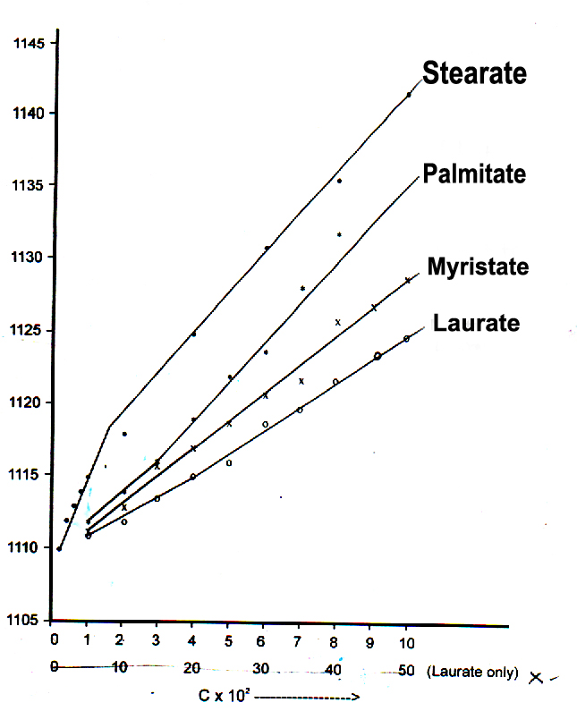
Fig. 1 : Plots of ultrasonic velocity, u (ms⁻¹) vs. concentration, C (mol dm⁻³) of ammonium soaps in 2-propanol at 308K.
The ultrasonic velocity, u is related with ammonium 2-propanol soap concentration, ‘C’ is :
u = u₀ + GC ----(2)
where u₀ is the ultrasonic velocity for zero soap concentration and ‘G’ is Garnsey’s constant(6). The values of G are 1.00 × 10², 1.33 × 10² and 2.00 × 10², respectively for laurate, myristate, palmitate and stearate respectively. There is no effect of temperature on the value of ‘G’. The values of u₀ 1.109 × 10³, 1.094 × 10³, 1.075 × 10³ and 1.053 × 10³ at 308, 313, 318 and 323K respectively are in agreement with the experimental values of ultrasonic velocity in methanol. It shows that soap molecules do not aggregate to an appreciable extent below C.M.C.
The molar sound velocity, R (Rao’s constant) and molar sound compressibility, W (Wada’s constant) have been calculated for solutions using the equation:
R = $\frac{\text{M}}{\text{d}}$ u^{1/3} = V.u^{1/3} ----(3)
where ‘V’ is the molar volume of the soap solution.
TABLE 1
VALUES OF ALLIED PARAMETERS ADIABETIC COMPRESSIBILITY, $β$ INTERMOLECULAR FREE LENGTH, L_{f} AND RELATIVE ASSOCIATION CONSTANT OF AMMONIUM SOAPS IN 2-PROPANOL AT DIFFERENT TEMPERATURES (308-318K).
Conc.(C). (mol dm⁻³) | Adiabatic compressibility  ($β×10$¹⁰) (m²N⁻¹) |  |  | Intermolecular free length  (L_{f} × 10⁻¹⁰) (m) |  |  | Relative association constant (R_{A})
 | 308K | 313K | 318K | 308K | 313K | 318K | 308K | 313K | 318K
Laurate
0.01 | 10.460 | 10.781 | 11.244 | 47.8 | 40.40 | 33.0 | 1.0002 | 1.0002 | 1.0003
0.03 | 10.396 | 10.733 | 11.172 | 47.7 | 40.30 | 33.90 | 1.0000 | 1.0004 | 1.0002
0.10 | 10.200 | 10.592 | 11.001 | 47.4 | 40.0 | 32.6 | 1.0019 | 1.0009 | 1.0005
0.30 | 9.980 | 10.330 | 10.721 | 46.7 | 39.6 | 32.4 | 1.0050 | 1.0052 | 1.0043
0.50 | 9.728 | 10.045 | 10.451 | 46.1 | 39.1 | 31.7 | 1.0063 | 1.0085 | 1.0086
Myristate
0.01 | 10.438 | 10.757 | 11.219 | 47.8 | 40.40 | 32.9 | 1.0001 | 1.0002 | 1.0004
0.03 | 10.386 | 10.685 | 11.121 | 47.7 | 40.20 | 32.8 | 1.0009 | 1.0007 | 1.0005
0.04 | 10.344 | 10.660 | 11.095 | 47.6 | 40.20 | 32.7 | 1.0008 | 1.0008 | 1.0007
0.07 | 10.236 | 10.528 | 10.954 | 47.3 | 39.9 | 32.5 | 1.0007 | 1.0006 | 1.0005
0.10 | 10.129 | 10.415 | 10.815 | 47.1 | 39.7 | 32.3 | 1.0010 | 1.0009 | 1.0055
Palmitate
0.01 | 10.435 | 10.735 | 11.195 | 47.8 | 40.3 | 32.9 | 1.0004 | 1.0002 | 1.0003
0.03 | 10.324 | 10.678 | 11.073 | 47.5 | 40.2 | 32.7 | 1.0006 | 1.0013 | 1.0005
0.04 | 10.300 | 10.633 | 11.026 | 47.5 | 40.1 | 32.6 | 1.0018 | 1.0012 | 1.0009
0.07 | 10.183 | 10.474 | 10.838 | 47.2 | 39.8 | 32.4 | 1.0021 | 1.0016 | 1.0005
0.10 | 10.034 | 10.298 | 10.693 | 46.9 | 39.6 | 32.1 | 1.0022 | 1.0023 | 1.0006
Stearate
0.01 | 11.098 | 10.732 | 11.193 | 47.7 | 40.3 | 32.9 | 1.0004 | 1.0005 | 1.0005
0.03 | 11.024 | 10.653 | 11.047 | 47.5 | 40.2 | 32.7 | 1.0009 | 1.0016 | 1.0007
0.04 | 11.954 | 10.566 | 10.955 | 47.4 | 40.0 | 32.5 | 1.0012 | 1.0013 | 1.0008
0.07 | 11.788 | 10.328 | 10.703 | 47.0 | 39.5 | 32.1 | 1.0018 | 1.0010 | 1.0009
0.10 | 11.520 | 10.262 | 10.630 | 46.9 | 39.4 | 32.0 | 1.0020 | 1.0012 | 1.0010

W = $\frac{M}{d}β^{-1/7}=V. β^{-1/7}$ ----(4)
where M is the average molecular weight of the soap solution calculated from the relation M = X₁ M₁ + X₂ M₂, where X₁ and X₂ are mole fractions of solute and solvent of molecular weights M₁ and M₂.
The value of R and W increase with increase in soap concentration and also increase with increase in carbon chain length but are unaffected by temperature.
The intermolecular free length, L_{f} has been calculated by using the following relation:
L_{f} = $\sqrt{ \frac{β}{k}}$ ----(5)
where ‘k’ is temperature dependent Jacobson constant(7). L_{f} decrease (Table 1) with increase in chain length of ammonium soap and temperature. It also decrease with increase in concentration of ammonium soap solution showing significant interaction between soap and solvent molecules and that the structural arrangement is considerably affected.
The relative association constant, R_{A} has been calculate from the relationship:
R_{A} = $\frac{d}{d_{0}} {\left(\frac{u_{0}}{u}\right)}^{\frac{1}{3}}$ ----(6)
Either the solvent molecules are broken up in the presence of electrolyte, or the ions are saved and soap is added, affecting the relative association constant (Table 1). The values of RA rise as concentration rises, indicating that soaps aggregate and ions are saved. As temperature rises, RA values essentially stay the same. According to the formula Z = u.d, the specific acoustic impedance (8) Z rises with temperature but decreases with carbon chain length and ammonium soap solution concentration (Table 2). Lyophobic interaction between solvent and soap molecules increases the intermolecular distance between molecules, leaving relatively wider gaps between them, which explains why the value of Z increases with soap concentration. As temperature rises, Z values fall, but as chain length increases, they rise.
The solvation number(9), Sn has been calculated by using Passynsky’s relation.
S_{n} = $\frac{n_{1}}{n_{2}} \left[1-\frac{Vβ}{n_{1}V_{1}^{0}β^{0}}\right]$ ----(7)
where n₁ and n₂ are the moles of solvent and solute and V₁⁰ is the molar value of solvent respectively and V is the molar volume of solution containing ‘n₂’ moles of solute.
S_{n} (Table – 2) decrease with increase in temperature and concentration of ammonium soap indicating ion-ion interaction. The higher values of salvation number suggest a considerable dissociation of ammonium soaps.
The apparent molar compressibility, $Φ_{k}$ of the solution has been calculated by using the relation.
$Φ_{k}$ = $\frac{1000 [βd_{0}-β^{0}d]}{dd_{0}}+\frac{βM}{d}$
where ‘M’ is the molecular weight of soap, d₀ and $β$⁰ are densities and compressibilities of the solvent respectively.
The values of $Φ_{k}$ increase with increase in temperature and carbon chain length of soap. The value of $Φ_{k}$ decreases with increase in soap concentration. The plots of $Φ_{k}$ against C^{1/2} (Fig. 2). Show an intersection of two straight lines at C.M.C. The values of $Φ_{k}^{0}$ are positive which shows considerable soap-solvent interaction below C.M.C.

TABLE 2
VALUES OF ALLIED PARAMETER, SPECIFIC ACOUSTIC IMPEDANCE, ‘Z’ AND SOLVATION OF NUMBER, ‘S_{n}’ OF AMMONIUM SOAPS IN 2-PROPANOL AT DIFFERENT TEMPERATURES
Conc. (C)  (mol dm⁻³) | Specific acoustic impedance (Z)  Kg m⁻²s⁻² |  |  |  |  | Solvation number,  (S_{n})
 | 308K |  | 313K | 318K | 323K | 308K | 313K | 318K | 323K
Laurate
0.01 | 8.613 |  | 8.463 | 8.265 | 8.055 | 1290.5 | 1284.1 | 1277.4 | 1270.8
0.03 | 8.643 |  | 8.485 | 8.296 | 8.086 | 430.2 | 428.0 | 425.8 | 423.6
0.10 | 8.701 |  | 8.552 | 8.370 | 8.145 | 129.0 | 128.4 | 127.7 | 127.1
0.30 | 8.859 |  | 8.682 | 8.526 | 8.297 | 43.0 | 42.8 | 42.6 | 42.4
0.50 | 9.001 |  | 8.826 | 8.667 | 8.449 | 25.8 | 25.7 | 25.5 | 25.4
Myristate
0.01 | 8.623 |  | 8.474 | 8.276 | 8.066 | 1290.5 | 1284.1 | 1277.4 | 1270.8
0.03 | 8.651 |  | 8.508 | 8.318 | 8.101 | 430.2 | 428.0 | 425.8 | 423.6
0.04 | 8.670 |  | 8.520 | 8.330 | 8.120 | 322.6 | 321.1 | 319.3 | 317.7
0.07 | 8.722 |  | 8.581 | 8.390 | 8.180 | 184.3 | 183.4 | 182.5 | 181.6
0.10 | 8.776 |  | 8.634 | 8.452 | 8.249 | 129.0 | 128.4 | 127.7 | 127.1
Palmitate
0.01 |  | 8.626 | 8.484 | 8.286 | 8.076 | 1290.5 | 1284.1 | 1277.4 | 1270.8
0.03 |  | 8.679 | 8.514 | 8.339 | 8.129 | 430.2 | 428.0 | 425.8 | 423.6
0.04 |  | 8.692 | 8.534 | 8.359 | 8.148 | 322.6 | 321.0 | 319.3 | 317.7
0.07 |  | 8.752 | 8.609 | 8.442 | 8.231 | 184.3 | 183.4 | 182.5 | 181.6
0.10 |  | 8.828 | 8.677 | 8.525 | 8.322 | 129.0 | 128.4 | 27.7 | 127.1
Stearate
0.01 |  | 8.636 | 8.486 | 8.288 | 8.085 | 1290.5 | 1284.1 | 1277.4 | 1270.8
0.03 |  | 8.685 | 8.526 | 8.351 | 8.148 | 430.2 | 428.0 | 425.8 | 423.6
0.04 |  | 8.715 | 8.565 | 8.390 | 8.187 | 322.6 | 321.0 | 319.3 | 317.7
0.07 |  | 8.804 | 8.676 | 8.502 | 8.322 | 184.4 | 183.4 | 182.5 | 181.6
0.10 |  | 8.836 | 8.709 | 8.533 | 8.364 | 161.3 | 160.5 | 158.1 | 127.1

The $Φ_{k}$ is related with soap concentration, “C” by the relationship:
$Φ_{k}$ = ${Φ^{0}}_{k}$ + S_{K}C^{1/2} ----(9)
Where ${Φ^{0}}_{k}$ is the limiting apparent molar compressibility and S_{K} is experimental slope. The result show the values of ${Φ^{0}}_{k}$ (Table 3) increases with increase in temperature and chain length of soap. The values of S_{K} are negative and differ very much below and above C.M.C. showing micellar aggragation. The values of –S_{K} increases with increase in temperature and carbon chain length of soap. Measurements of allied parameters (densities, ultrasonic velocities and viscosities) have been carried out for binary mixtures of 2-methyl aniline with 1-alcohols (1-Propanol, 1-butanol, 1-pentanol, 1-hexanol) at different temperatures(10). Allied Parameters (ultrasonic-velocity, density and viscosity) of binary liquid mixtures with Acetone with Toluene, chlorobenzene and nitrobenzene measured at 303K(11). The studies on ultrasonic velocity, density and viscosity in binary liquid mixture have been used to evaluate the different thermo acoustical parameters along with the excess properties from these parameters molecular interaction such as existence of strong molecular association and weak interaction among the molecular liquids has been observed in present study.12 By using ultrasonic velocity, density and concentration data various Acoustic parameter are calculated and results are explained in terms of the interaction between the solute and the solvent. Many insights into the behaviour and interactions of molecules can be gained from ultrasonic studies.(13) The ultrasonic interferometer, 30 ml gravity bottle, and Ostwald's viscometer were used to measure the ultrasonic velocity, density, and viscosity of the binary liquid mixture of methanol and chloroform at a frequency of 2 MHz and constant temperature of 295 K, respectively(14). Measurements have been made of the density, viscosity, and ultrasonic velocity of aqueous sodium propionate at various temperatures (15). Experimental measurements have been made using ultrasonic research on ternary liquid mixtures of certain-1-alkanols with metamethoxy phenol and n-hexane at 313K. In light of molecular interaction, the variation of acoustical parameters with respect to different concentration at constant temperature for the three systems has been discussed (16).
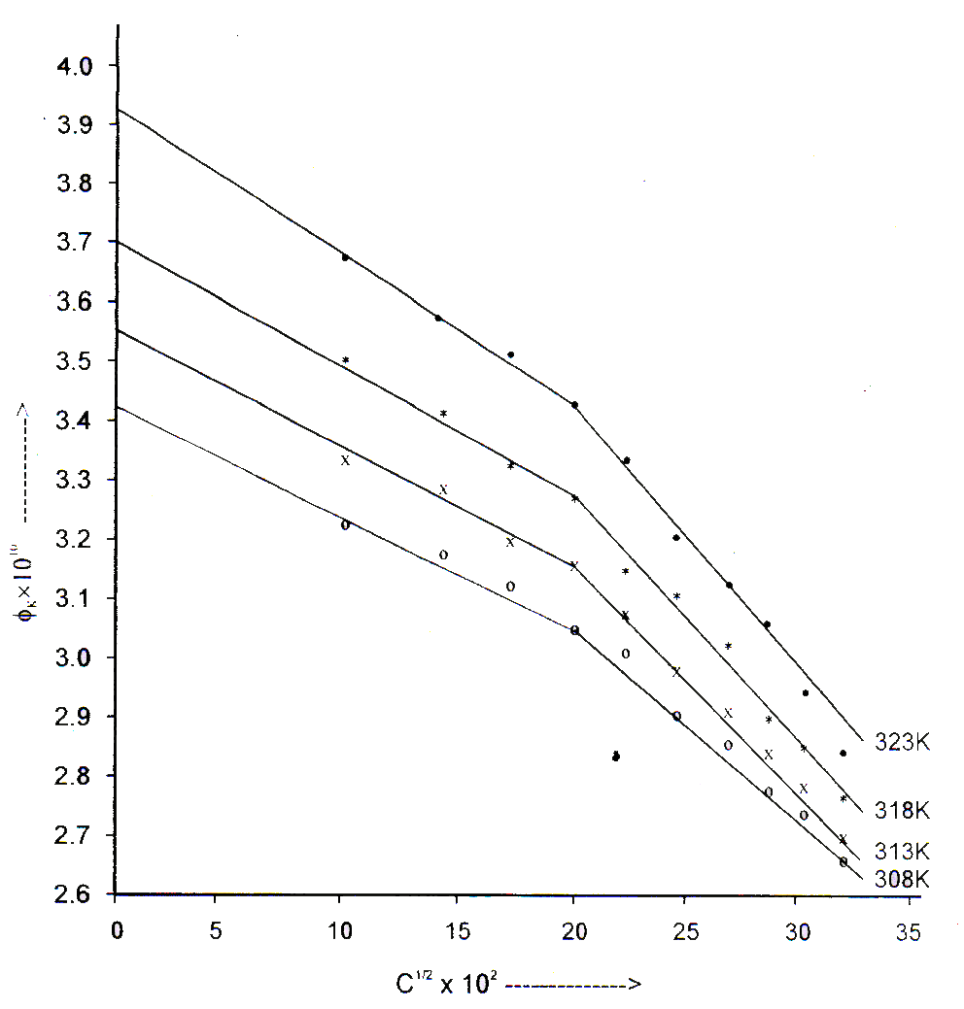
$$Φ_{K}×{10}^{10} →$$
C^{1/2} × 10² (mol-dm⁻³)^{1/2} $→$
Fig. 2- Plots of $Φ_{k}$ vs. C^{1/2} of ammonium myristate in 2-propanol at different temperatures (308-323K).

TABLE-3
VALUES OF ${Φ^{0}}_{k}$ AND S_{K} OF AMMONIUM SOAPS IN 2-PROPANOL AT DIFFERENT TEMPERATURES (308-323K)
Ammonium Soap | 308 K |  |  | 313 K |  |  | 318 K |  |  | 323 K
 | ${Φ^{0}}_{k}$-S_{K} × 10¹⁰  ×  10¹⁰ a b |  |  | ${Φ^{0}}_{k}$-S_{K} × 10¹⁰  ×  10¹⁰ a b |  |  | ${Φ^{0}}_{k}$-S_{K} × 10¹⁰  ×  10¹⁰ a b |  |  | ${Φ^{0}}_{k}$-S_{K} × 10¹⁰  ×  10¹⁰ a b
Laurate | 3.05 | 1.6 | 2.95 | 3.20 | 1.8 | 3.15 | 3.34 | 1.9 | 3.20 | 3.50 | 2.0 | 3.30
Myristate | 3.44 | 1.9 | 3.5 | 3.57 | 2.0 | 4.0 | 3.72 | 2.2 | 4.2 | 3.94 | 2.5 | 4.7
Palmitate | 3.86 | 2.5 | 4.5 | 4.01 | 2.6 | 5.0 | 4.18 | 3.2 | 5.2 | 4.41 | 3.5 | 6.6
Stearate | 4.25 | 2.8 | 5.6 | 4.43 | 3.0 | 7.0 | 4.65 | 4.0 | 7.2 | 4.89 | 4.2 | 8.4

a : Values below C.M.C. b : Values above C.M.C.

ACKNOWLEDGEMENT: The authors would like to thank the college authorities for providing laboratory facilities.
REFERENCES:
- R.P. Varma, S.N. Gour and O.P. Choudhary, Tenside Surf Det. 29, 429, (1992).
- R.P. Varma and H. Goel, Acoustic, 80, 183 (1994).
- K.N. Mehrotra and S. Gupta, Acoustic Letters, 16, 266 (1993).
- K.N. Mehrotra and Mamta Jain, Colloids Surf., A 95, 229 (1995).
- S.N. Gour, J.S. Tomar and R.P. Varma, Indian J. Pure and Appl. Phys., 24, 602 (1986).
- R. Garnsey, R.J. Boe, R. Mohoney and T.A. Litovitz, J. Chem. Phys., 24, 602 (1986).
- B. Jacobson, Acta Chem. Scand, 6, 1485 (1952).
- L.E. Elpimer, Ultrasound Physico-Chemical and Biological Effects Consultants Bureau (1964).
- A Passynsky, Acta Physicochem. (USSR), 8, 385 (1938); J. Phys. Chem. (USSR), 11, 608 (1938).
- V.Venkatalakshmi, M. Gowri Shankar and K.S. Reddy; International Journal of Physics and Research (IJPR), Vol. 3, pp. 33-44, Dec. (2013).
- R. Kavitha, S. Jaya Kumar and R. Uma, International Journal of Chemistry and Applications, Vol. 3, No. -1, pp. 19-33, (2011).
- S.N. Yadav, Bimal Kanth, S.A. Afsah, Journal of Applied Chemistry (IOSR-JAC) Volume -12, pp. 16-18 (2019).
- P.B. Agrawal, I.M. Siddiqui and M.I. Narwade, Indian Journal of Chemistry, Vol. 42, No. 5, pp. 1050-1057 (2003).
- Kirandeep Kaur, Kailash C. Juglan, Der-Pharma Chemica 7(2), pp. 160-167 (2015).
- K.C. Patil, Priyanka Manusmare, Journal of applicable chemistry, Vol.-8(3), pp. 1385-1393, (2019).
- P.S. Syed, S. Chidambara Vinayagam, J. Senthil Murugan; Journal of Molecular liquids, Vol. 304, 15 April (2020).

